**Instructions – network (k-1-2)**

Hi everyone. How are you guys doing? My name is [insert]. How many of you have played games with us before? Who wants to play and get toys?

Today, we are going to play games, and you are going to win points. At the end, you are going to exchange the points for toys in our toy shop. You will all get many toys, but the better you do, the more points you earn, and the more points you earn the more toys you get. In fact, you will get one toy for every 10 points. So, pay attention.

**NETWORK**

Now, listen very carefully to the instructions. It is important that you understand well the rules of the game. Otherwise, you will not know how to play.

The computer is going to form several groups of **SIX**, but you will not know who is in your group and it is not the point to find out **[slide 2]**

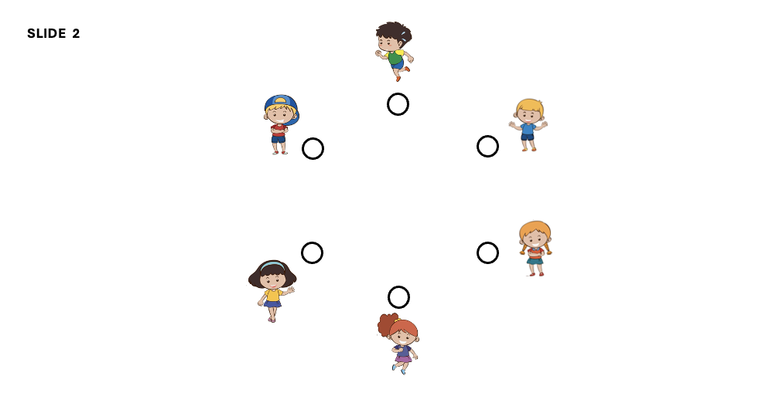

Each of you will be connected to some people in your group but not to others. When you are connected to someone, it means that you can see their choices. For example, here Bob sees the choices of John and James but not the other kids in his group **[slide 3]**

John sees the choices of Bob and Ann but not James or the others, and so on **[slide 4]**

In some games, each of you will see the choices of two other people in your group **[slide 5]**

. In some other games, you will see the choices of 3 other people **[slide 6]**

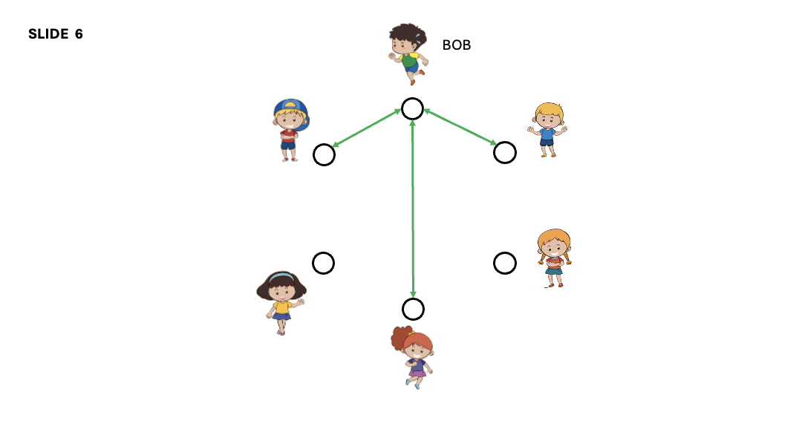

This is an example of what the people in a group will see **[slide 7]**

What you have to do in this game is very simple! You have to choose a color. That’s it. If you all choose the same color at the same time, you all win **TWO** points! Otherwise, you will only win **ONE** point. So, it’s not about choosing your favorite color but about choosing the same color as others. The good news is that you can change the color as many times as you want. So, you can choose a color, see what others chose and you can change (or not) trying to get everyone choose the same color. But there is one rule: you cannot talk.

Let me give you an example. This is what you will see in your iPad **[slide 8]**

This is you [point at the “you” node], and these are the people around you [point]. You are always at the center of your own group. In this case how many other people can you see? 2. Very good. Remember there are other people in your group. It’s just that you can’t see them.

This is the screen when you can see how many other people in your group? 3 very good **[slide 9]**

Let’s go back to the case where you see two people. Now, this is where you choose a color **[slide 10]**

In this case, everyone chooses between two colors, **BLUE** and **RED**, but in different rounds you will see different colors. As soon as you choose a color, it will appear here [point]. And the people connected to you will be able to see it. In this example, you chose RED **[slide 11]**

Here you see that one person next to you chose BLUE and the other chose RED **[slide 12]**

Then, you can change your color as few or as many times as you want. It is totally up to you. Remember the goal is to have everyone in your group of SIX choose the same color. This means not only the people you can see but also the others you do not see. So, for example, imagine you are Bob. In this case, **[slide 13]**

everyone you see is choosing blue (including yourself), but you are still not winning two points because these two guys [point] are choosing red. While here **[slide 14]**

Everyone in your group is choosing blue, so you all get two points. Does that make sense to everyone? Now two more things.

Every time you play, you will see a clock at the top of the screen **[slide 15]**

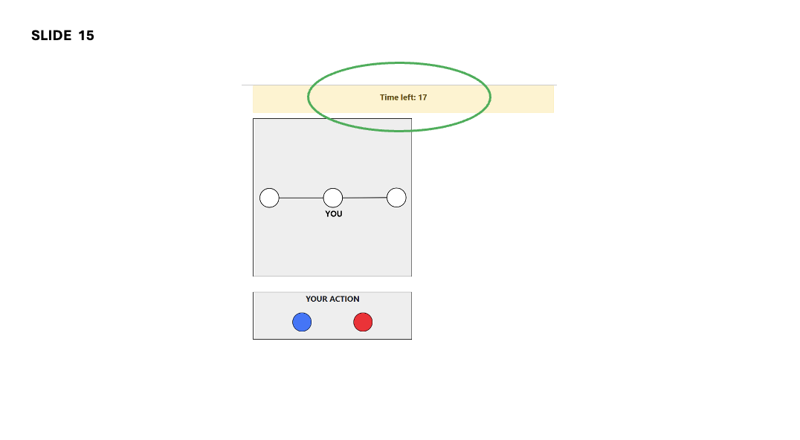

This tells you the amount of time left to play. You start with a certain amount of time and the clock runs backwards. Everyone can change their action as many times as they want. When everyone is in the same color, the clock stops, and you get two points. As long as everyone is not in the same color, the clock keeps running. If it hits 0 and not everyone is in the same color, you will only get one point in that round.

You are going to play many rounds. Sometimes, you will see the choices of two people and sometimes you will see the choices of two people. Also, sometimes you will choose between two colors as in this example [point to slide 15] , and sometimes you will choose between four colors as in this example **[slide 16]**

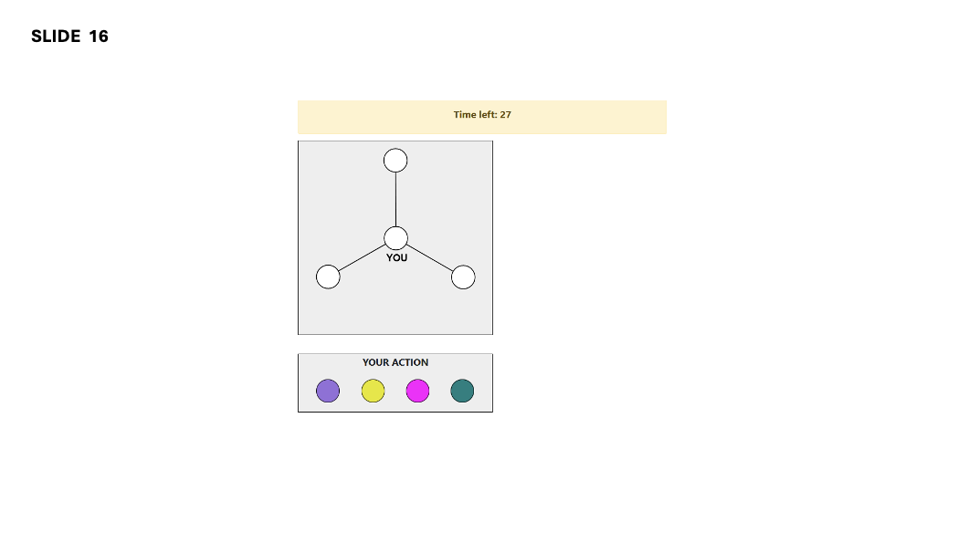

But the rules are always the same: everyone has to be in the same color., it does not matter which one. At the end of each round, you will know how many people chose each color. You will see a screen like this **[slide 17]**

In this example, did you get two points? [No, that’s right] Why? [because 3 people chose each color]. How about this one? **[slide 18]**

[Yes! That’s right. Because everyone chose the orange color].

After you see if you won that round, you press the green button and move to the next round to win more points.

Are you ready to play?

You are going to play many times, so you are going to have many chances to win points. Before we start, we are going to play a pretend round. This is only to make sure you understand the game. This round does not count for real so feel free to try different things. If you don’t understand what’s going on, raise your hand and we’ll be happy to come and help you. Any questions?

We are going to start the real game. We will start with 2 colors. Ready?

**[remember to stop after each block of 4 and tell them about the change in the number of colors]**

We are done. Thank you for playing with us. You are going to see in your screen how many points you earned and how many toys you can get with these points. We can go now to the toy shop to get our toys. Did you guys have fun?