**Network-jc-gui Codebook**

Session configuration  
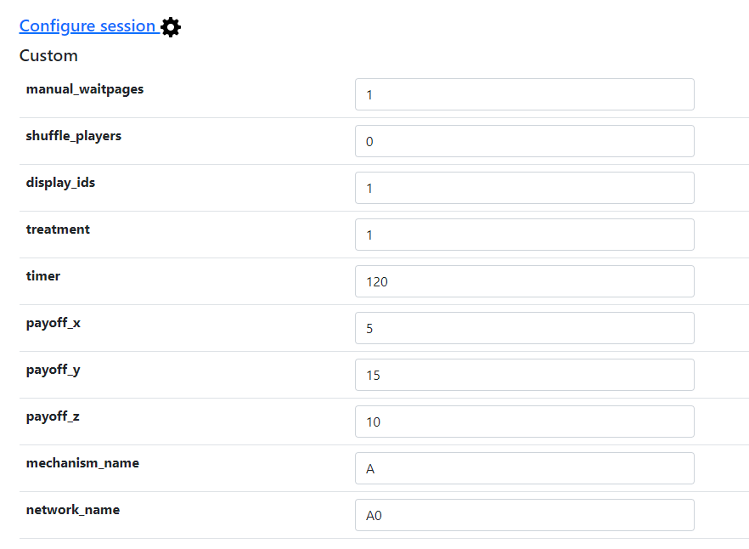  
  
manual_waitpages:  
This variable set to 1 hides the buttons of the waitpages before each part of the experiment. The only way of advancing the pages with this option enabled is by using the ”Advance slowest user” button. Set it to 0 to display the buttons.  
  
shuffle_players:  
This variable set to 1 shuffles the players in the group each round. This means that every round each subject will probably have a different node at the network. Set it to 0 to make all players have ordered positions on the network, for example the first link will always have node 1, second link will have node 2...

display_ids:  
This variable set to 1 displays the ids of the subjects in the network during the game. Set it to 0 to hide all ids, leaving only the You label on the network.

treatment:  
Treatment 1 has no subgroups related interfaces. Treatment 2 shows additional information on the feedback page, and an additional payoff if all players of the same subgroup got into a consensus during the round. Treatment 2 needs a correct configuration of the network file to be able to assign players to subgroups.

timer:  
Time in seconds that players have to play the main part of the game.

payoff_x:  
Base round payoff obtained just by playing.

payoff_y:  
Payoff obtained if all the players in the group select the correct signal at the same time.

payoff_z:  
Payoff obtained if all players in the same subgroup reach a consensus during the round. It is not needed to maintain this state until the end of the game to obtain this bonus. It is ignored if treatment = 1.

mechanism_name:  
Label used to identify which mechanism file has to be loaded. For example “mechanism_name = A” will look for the file “mechanism_A.csv”.  
  
network_name:  
Label used to identify which network file has to be loaded. For example “network_name = A0” will look for the file “network_A0.csv”.

File input configurations

The software requires two csv files as inputs to work as expected:

mechanism_XX.csv  
This file contains the behaviour of the mechanism that decides if a subject receives the correct information from the nature or not. Valid options are “correct”, “wrong”, “nothing”. The file has to have enough rows to cover all the rounds of the experiment and enough columns to cover all the subjects playing the experiment.

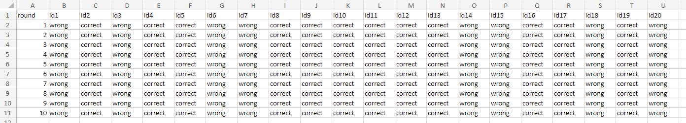  
  
network_XX.csv:  
This file contains the design of the network. Each row contains the id of each of the nodes, the nodes that it can see and the subgroup it will be if the treatment selected has subgroups.  
Position x and y are not needed for this experiment. They are needed to draw the whole network but using placeholders here will have no effect during the experiment.  
The file needs to have one row for each player in the experiment.  
If there are more rows than players there may be nodes drawn on the network that are not controlled by an actual player and will remain always white.  
  
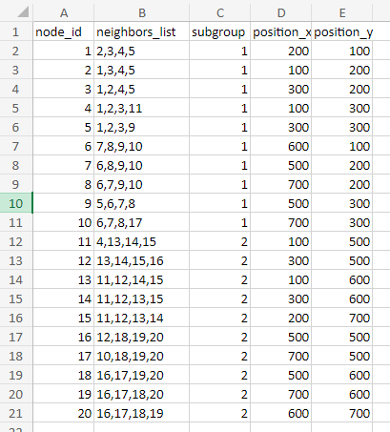

CSV Data Export

All: Participant

|  |  |  |
| --- | --- | --- |
| **Name** | **Description** | **Value** |
| id_in_session | Subject's ID during all the experiment. | 1 to N |
| code | Subject's code. |  |
| label | Not used. |  |
| _is_bot | 1 = Subject is a bot  0 = Subject is human | 0 or 1 |
| _index_in_pages | ID of the last page that the subject has visited.  0 = Subject has not started | 0 to _max_page_index |
| _max_page_index | Total number of pages. |  |
| _current_app_name | Name of the current app. |  |
| _current_page_name | Name of the current page. |  |
| time_started | Server time when the subject opened the link. |  |
| visited | 1 = Subject has started  0 = Subject has not started | 0 or 1 |
| mturk_worker_id | Not used. |  |
| mturk_assignment_id | Not used. |  |
| payoff | Number of the prize obtained. | 1 to 20 |

All: Session

|  |  |  |
| --- | --- | --- |
| **Name** | **Description** | **Value** |
| code | Code of the session. |  |
| label | Not used. |  |
| mturk_HITId | Not used. |  |
| mturk_HITGroupId | Not used. |  |
| comment | Not used. |  |
| is_demo | 1 = Session is demo (will be deleted)  0 = Session is normal | 0 or 1 |
| Config vars | | |
| real_world_currency_per_point | Not used. |  |
| participation_fee | Not used. |  |
| treatment | 0 = There are not subgroups  1 = There are subgroups | 0 or 1 |
| manual_waitpages | 0 = Waitpages have to be advanced  1 = Waitpages have buttons | 0 or 1 |
| shuffle_players | 0 = Players are ordered  1 = Players are shuffled each round | 0 or 1 |
| timer | Time that players have to play the main game |  |
| payoff_x | Default payoff for each round |  |
| payoff_y | Additional payoff if all players sellect the correct color |  |
| payoff_z | Additional payoff if all players in the same subgroup converge on the same color |  |
| display_ids | 0 = Only the You label is displayed  1 = ids are displayed in each node of the network | 0 or 1 |
| mechanism_name | Identifier of the mechanism file |  |
| network_name | Identifier of the network file |  |

main: Player

|  |  |  |
| --- | --- | --- |
| **Name** | **Description** | **Value** |
| id_in_group | Unique ID of the player in their group. | 1 to N |
| role | Not used. |  |
| payoff | Final payoff of the player. Set in last page. |  |
| first_name | First name of the player |  |
| last_name | Last name of the player |  |
| email | Email of the player |  |
| signal_behaviour | Behaviour of the signal the player receives. “correct”: The same as subsession.nature  “wrong”: The opposite as subsession.nature  “nothing”: Always “white” | “correct”  “wrong”  “nothing” |
| signal | Signal that the player sees after being altered by signal behaviour. | “red”  “blue”  “white” |
| neighbors | List of other nodes that the player can see. The id represents the player.id_in_group |  |
| connections | Number of total connections to be able to draw the network correctly |  |
| action | Action that the player has currently selected.  “white” only if the player has not taken an action yet. | “red”  “blue”  “white” |
| action_correct | “yes” the action that the player has currently is correct  “no” the action that the player has currently is not correct | “yes”  “no” |
| group_correct | “yes” all the actions of the players in the group are correct. The round ends when this happens.  “no” the action of at least one player in the group is not correct. | “yes”  “no” |
| subgroup | Id of the subgroup of the player. Players with the same number are in the same subgroup. |  |
| subgroup_red | Number of players in the subgroup that have red selected. |  |
| subgroup_blue | Number of players in the subgroup that have blue selected. |  |
| subgroup_converged | “yes” the players in the subgroup have converged with the same color at least one time  “no” the players in the subgroup have never converged with the same color | “yes”  “no” |
| payoff_round | Money earned by this player this round |  |
| payoff_total | Total money earned by this player up to the current round |  |

main: Group

|  |  |  |
| --- | --- | --- |
| **Name** | **Description** | **Value** |
| id_in_subsession | Not used |  |
| nature | “red” The color red has been selected for Nature this round  “blue” The color blue has been selected for Nature this round | “red”  “blue” |
| red_count | Number of players in the group that have red selected. |  |
| blue_count | Number of players in the group that have blue selected. |  |
| group_correct | “yes” all the actions of the players in the group are correct. The round ends when this happens.“no” the action of at least one player in the group is not correct. | “yes”  “no” |

main: Subsession

|  |  |  |
| --- | --- | --- |
| **Name** | **Description** | **Value** |
| round_number | Round number | 1 to 30 |
| treatment | 0 = There are not subgroups  1 = There are subgroups | 0 or 1 |
| manual_waitpages | 0 = Waitpages have to be advanced  1 = Waitpages have buttons | 0 or 1 |
| shuffle_players | 0 = Players are ordered  1 = Players are shuffled each round | 0 or 1 |
| timer | Time that players have to play the main game |  |
| payoff_x | Default payoff for each round |  |
| payoff_y | Additional payoff if all players sellect the correct color |  |
| payoff_z | Additional payoff if all players in the same subgroup converge on the same color |  |
| display_ids | 0 = Only the You label is displayed  1 = ids are displayed in each node of the network | 0 or 1 |
| mechanism_name | Identifier of the mechanism file |  |
| network_name | Identifier of the network file |  |
| mechanism_file_name | Complete name of the mechanism file |  |
| network_file_name | Complete name of the network file |  |