This document is a small guide on how to use the script to generate the movie html files of the Network experiment.

The default files of the software are the following ones (do not delete this files):

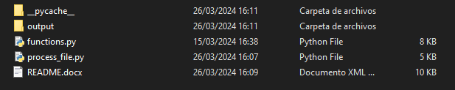

__pycache__  
Python configuration folder. It can be ignored.

output  
Output folder where all the html files will be stored after the script is executed.

functions.py  
Auxiliar python file that collects some functions required for the execution of the main script. It can be ignored.

process_file.py  
Main python script that will extract the data from the files gathered from oTree and convert them to html files. This is the script that has to be executed to create the html files.

To execute the process_file.py we will need two files from the session:  
> (input file name) The history table of all the subject actions stored at the extra_model file.  
> (network file name) The network structure file.

For easy use you can drop those files in the same folder than the process_file.py so you will have something like this:

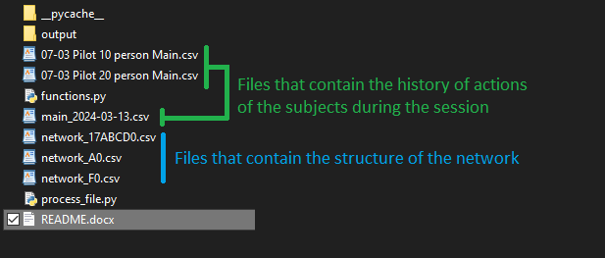

**To run the script you need to have Python installed in your computer.**

Open a cmd and go to the folder of the script and run the following command:

python process_file.py <input_file_name> <network_file_name>

If any of the files have spaces then the command should have that file between “”. For example:  
python process_file.py "07-03 Pilot 10 person Main.csv" network_F0.csv

The files should have been created into the folder “output”.