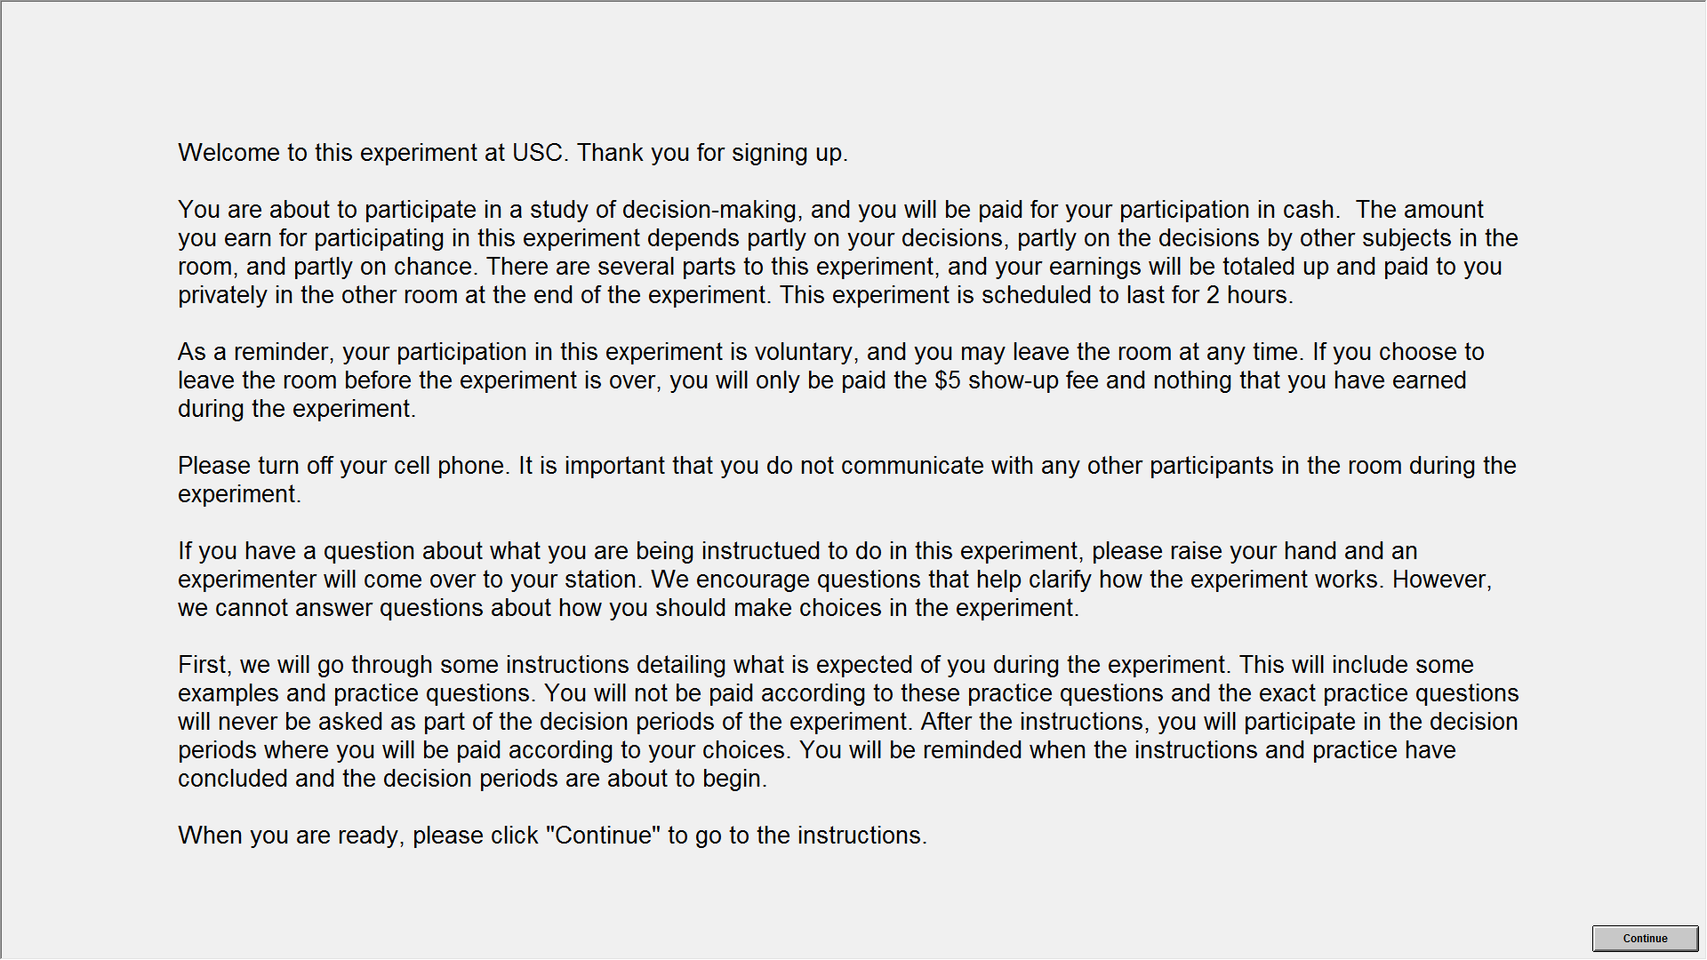 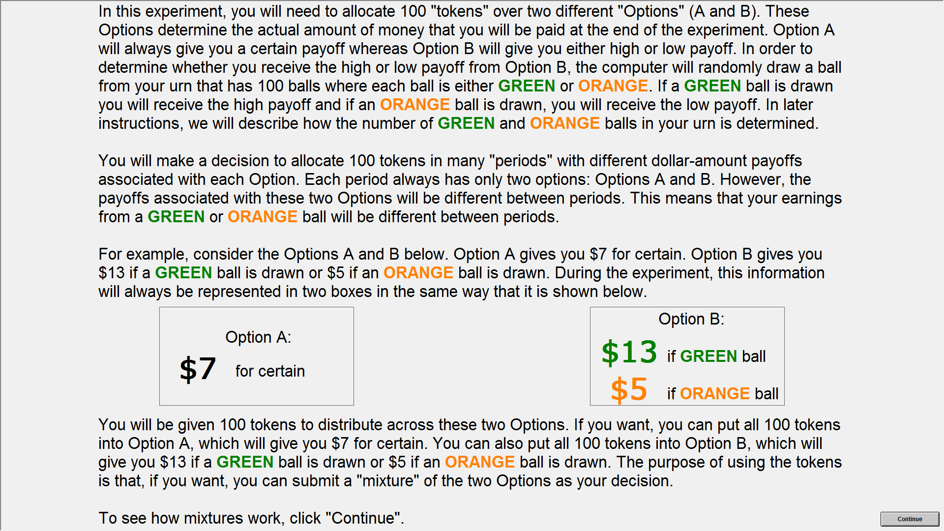 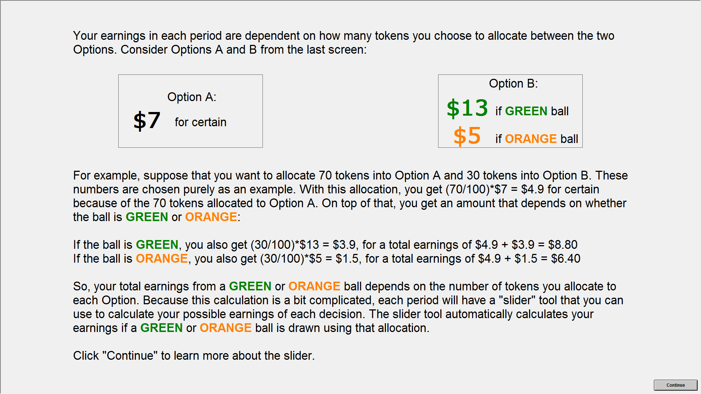 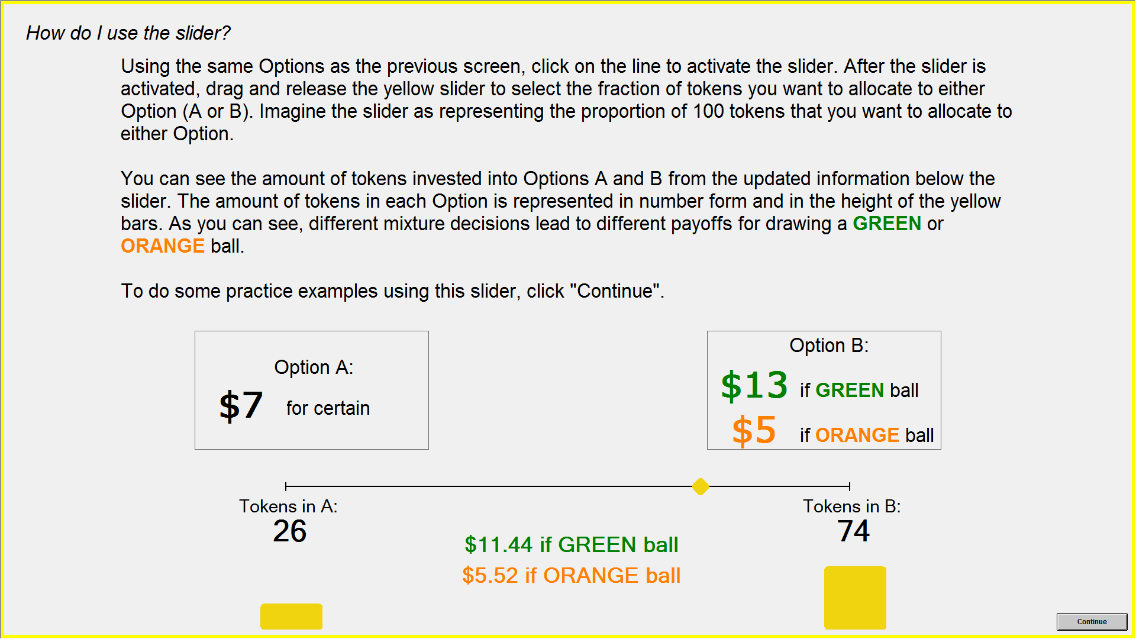 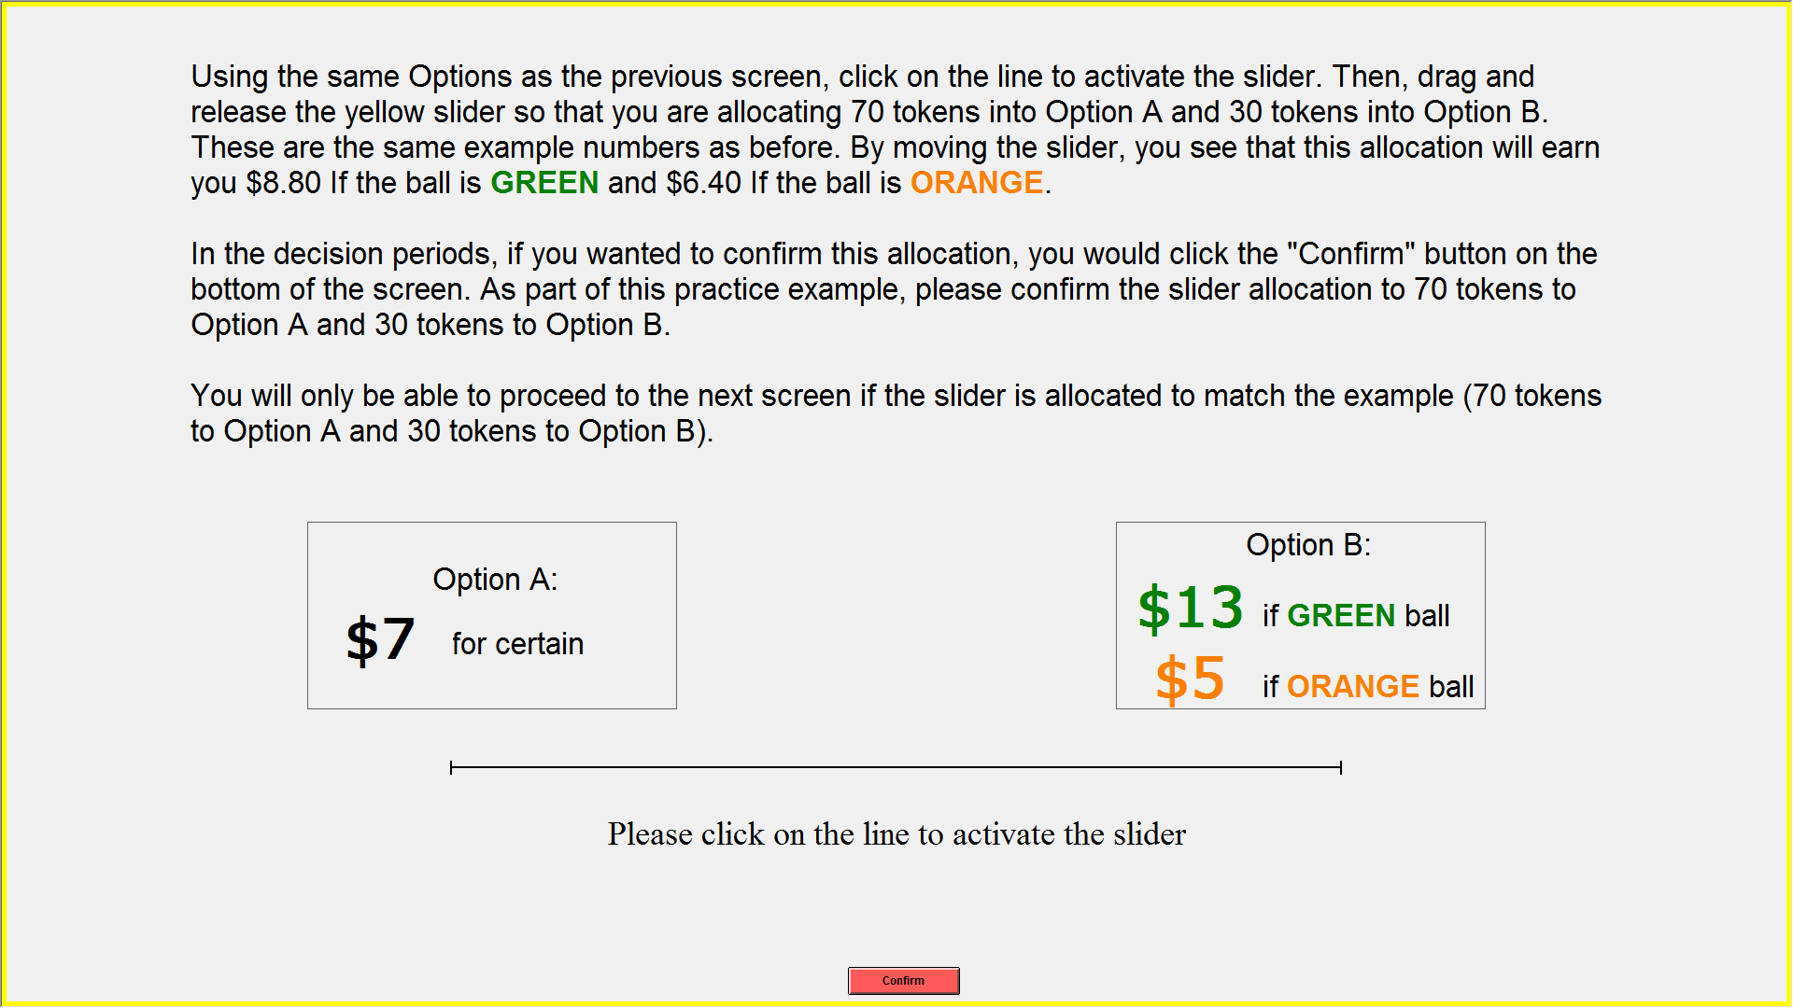 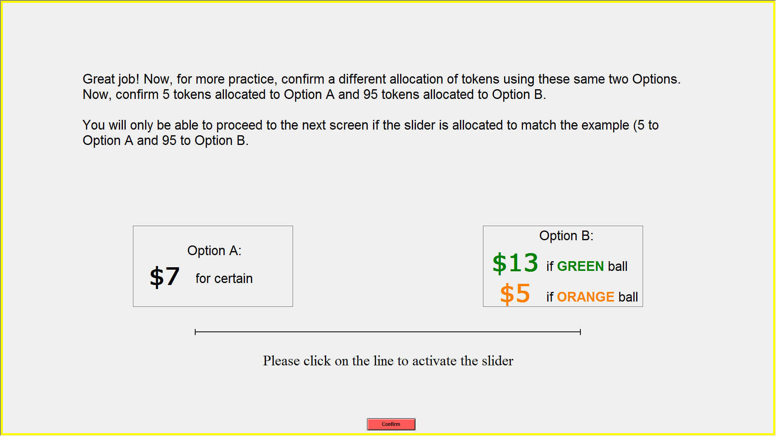 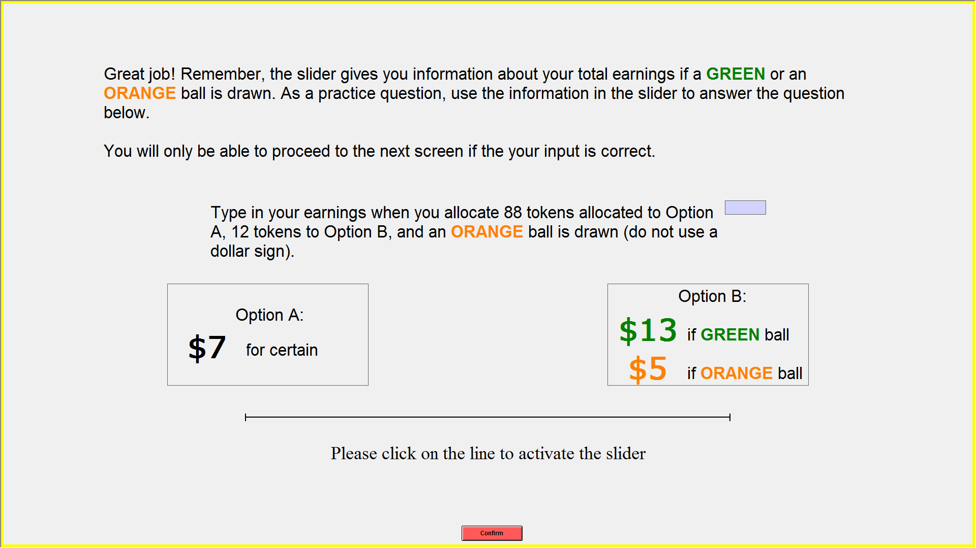 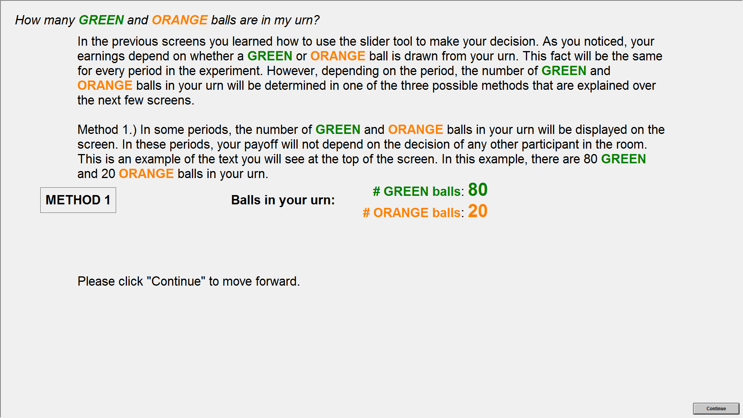 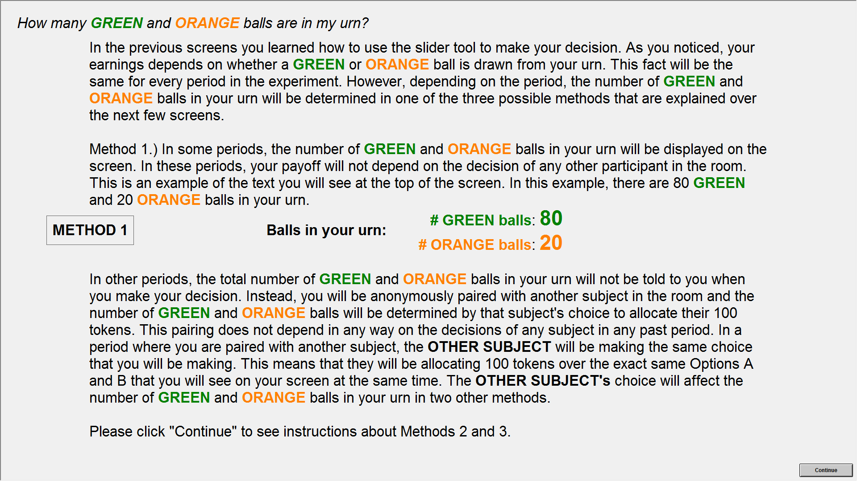 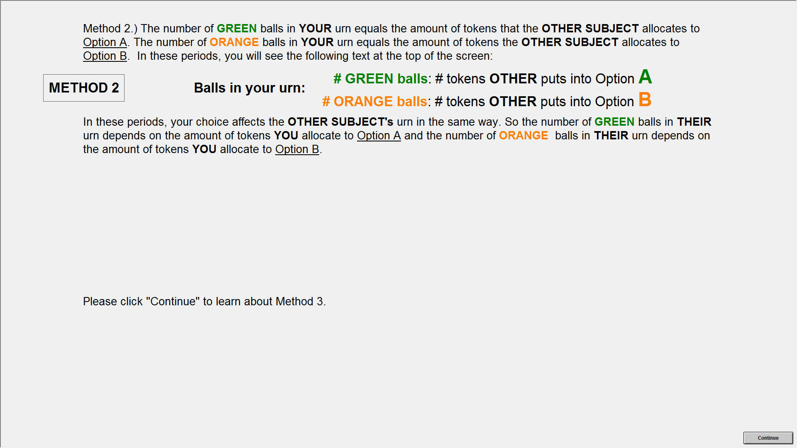 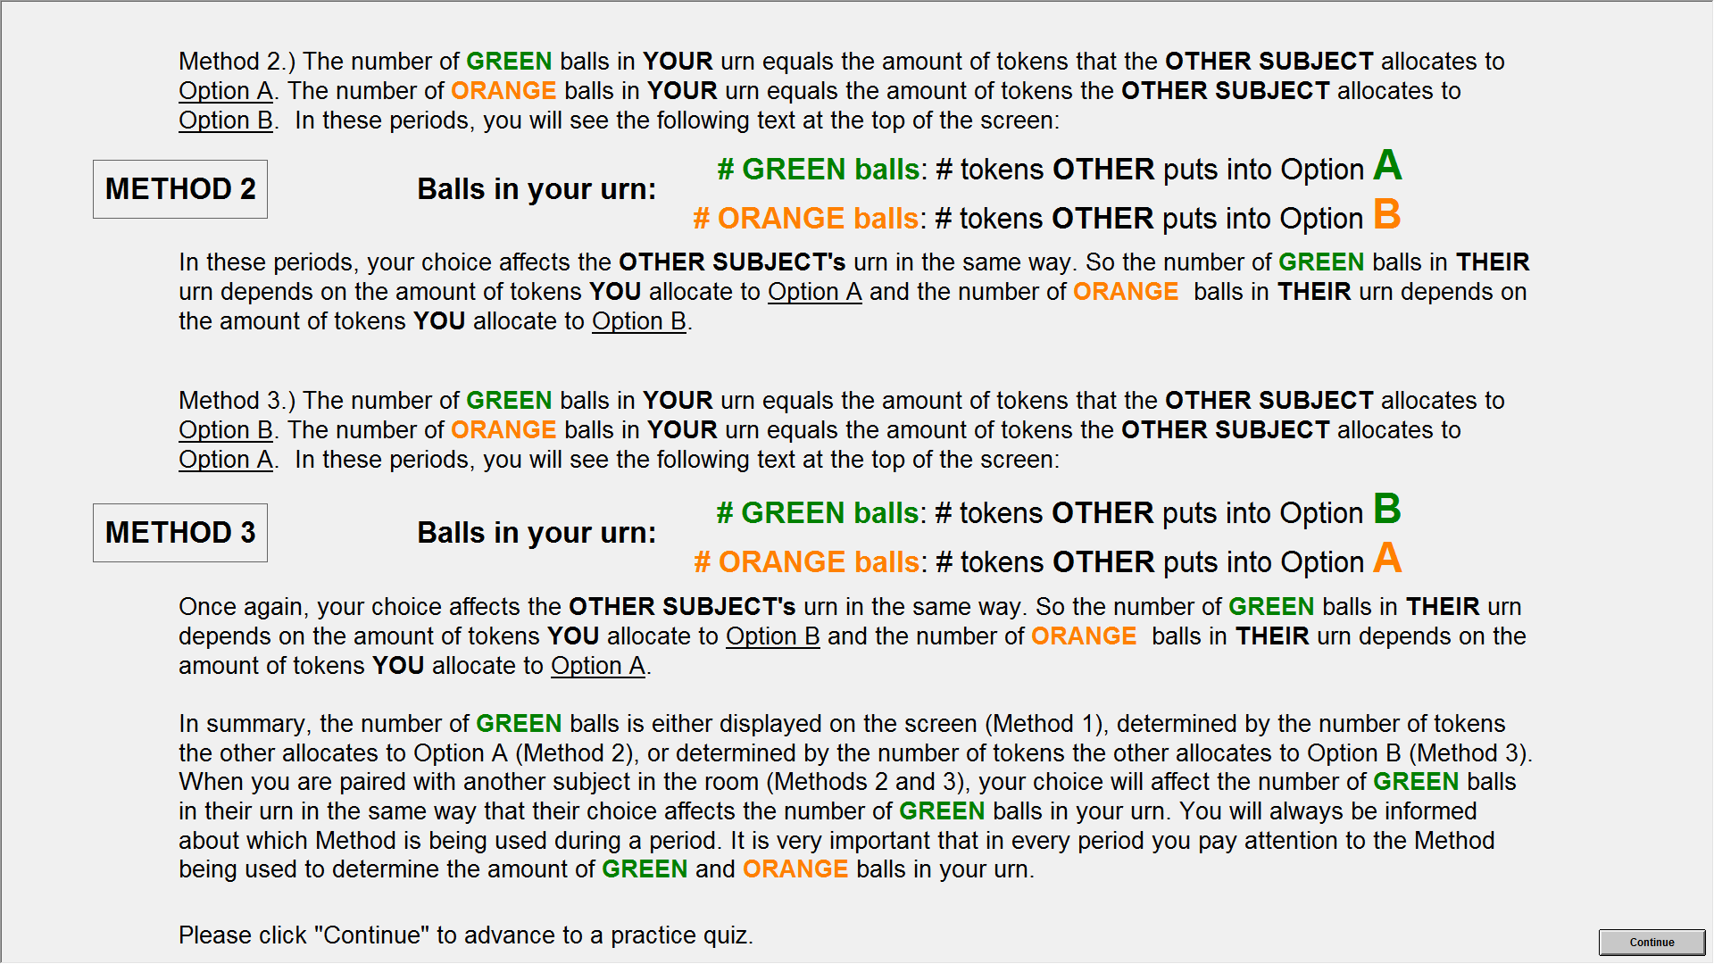 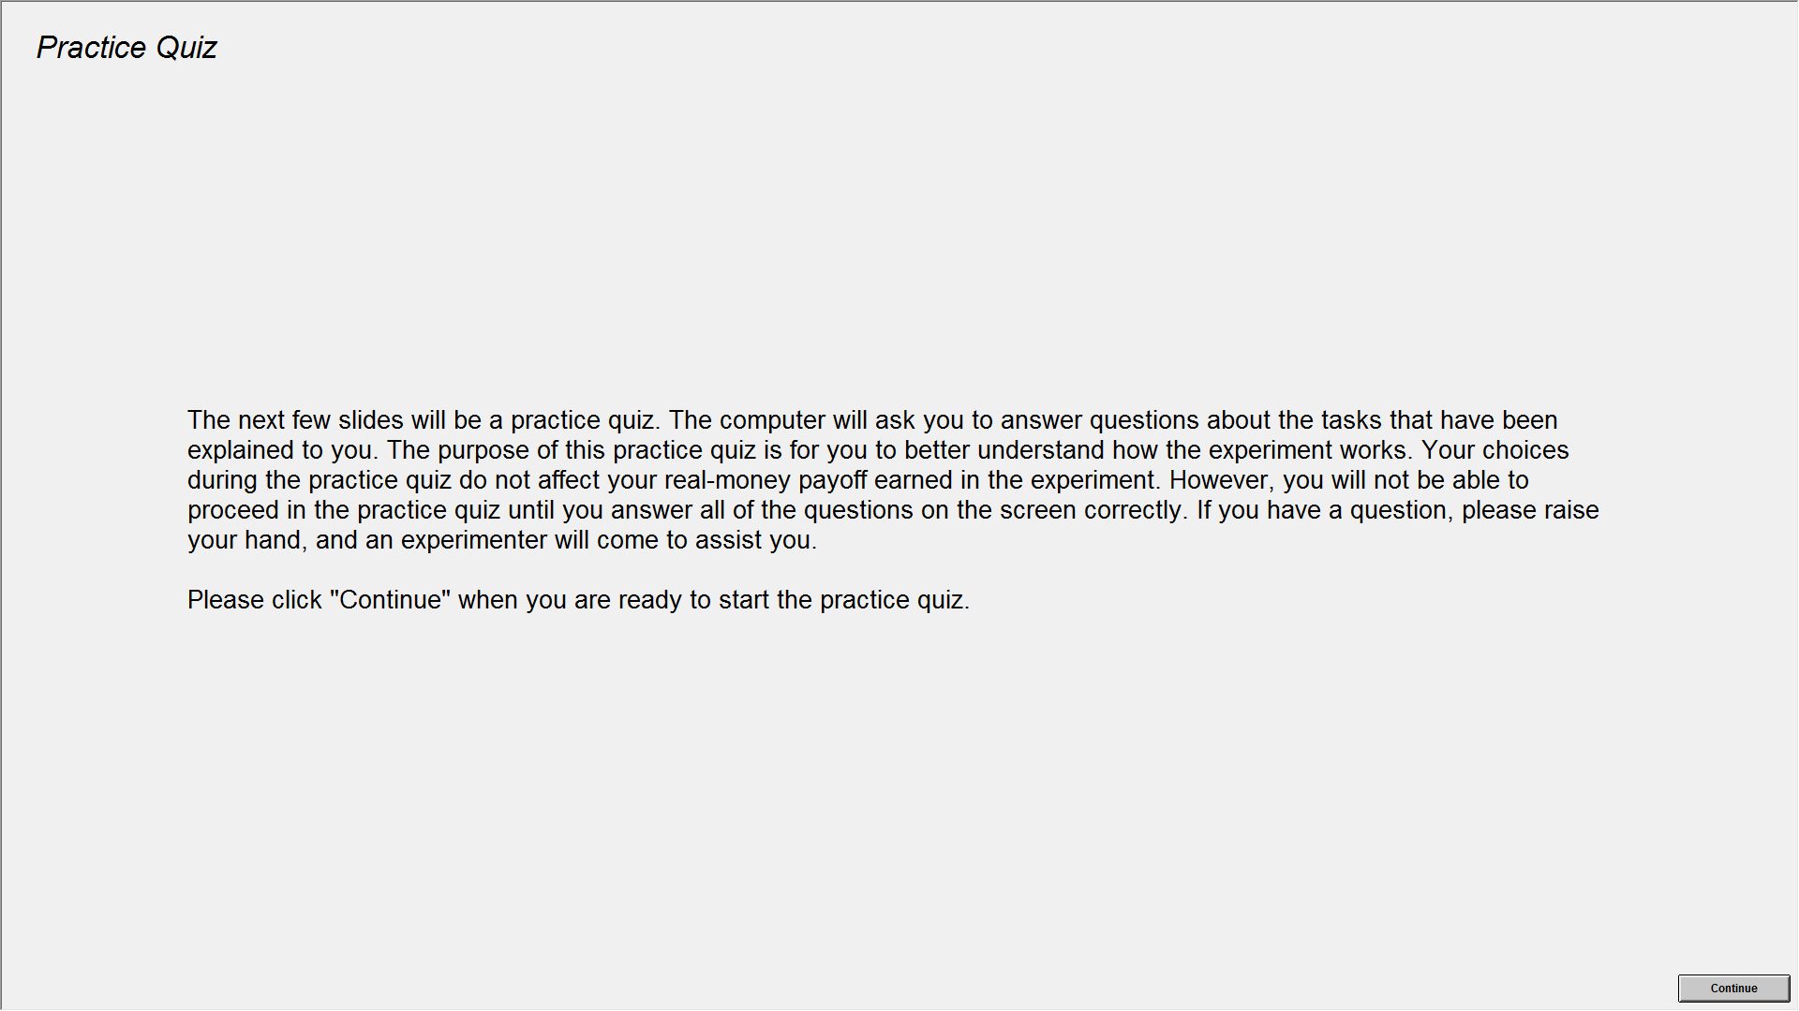 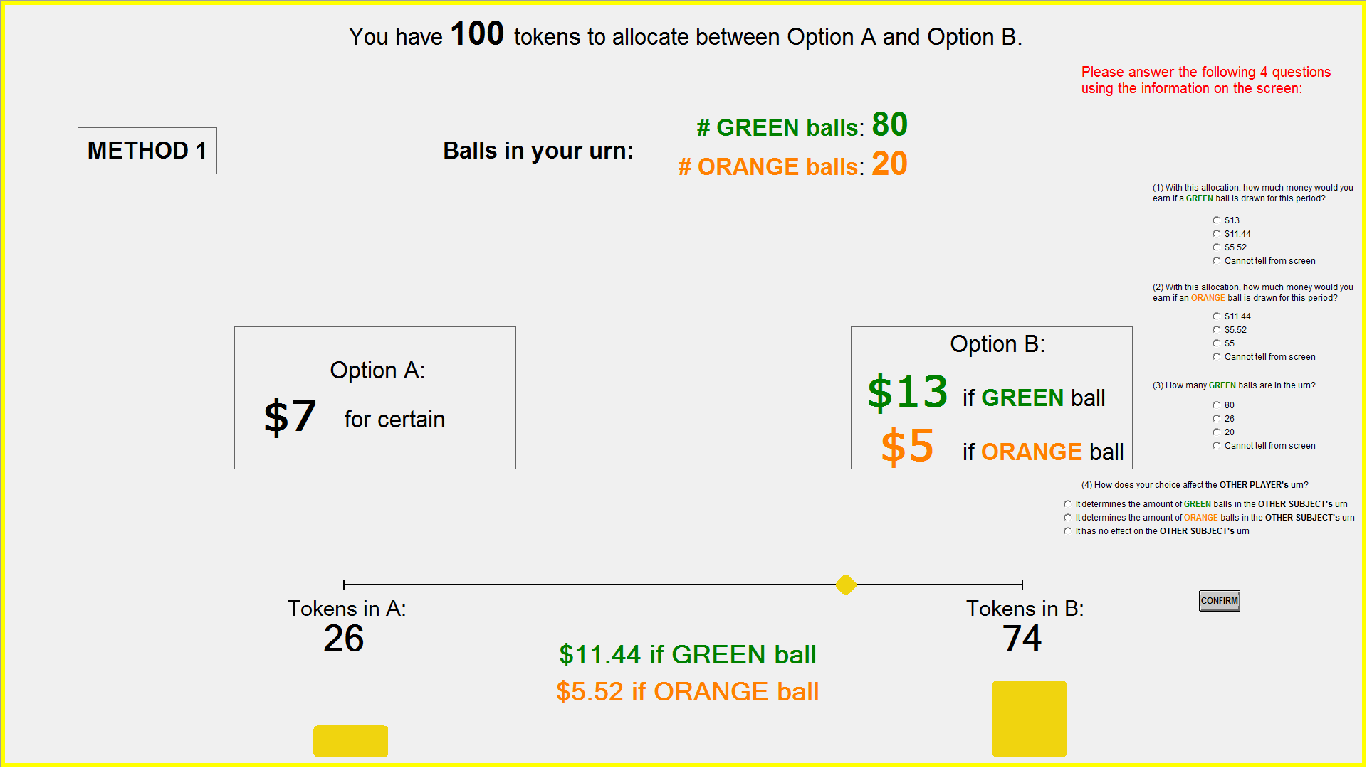 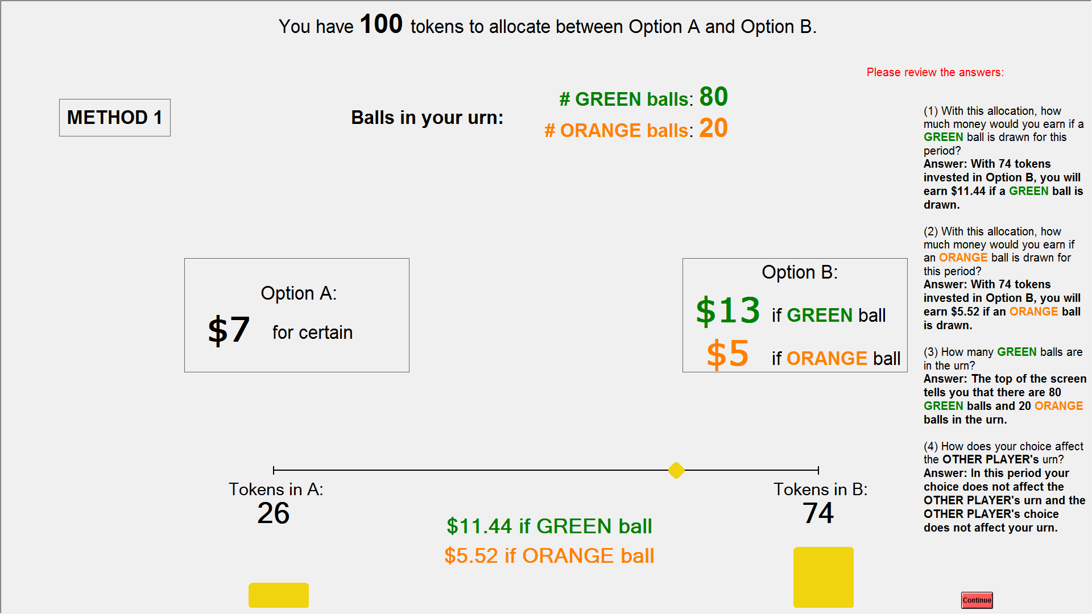 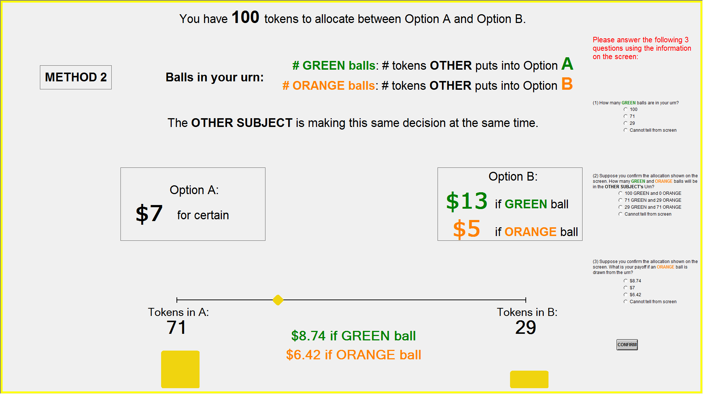 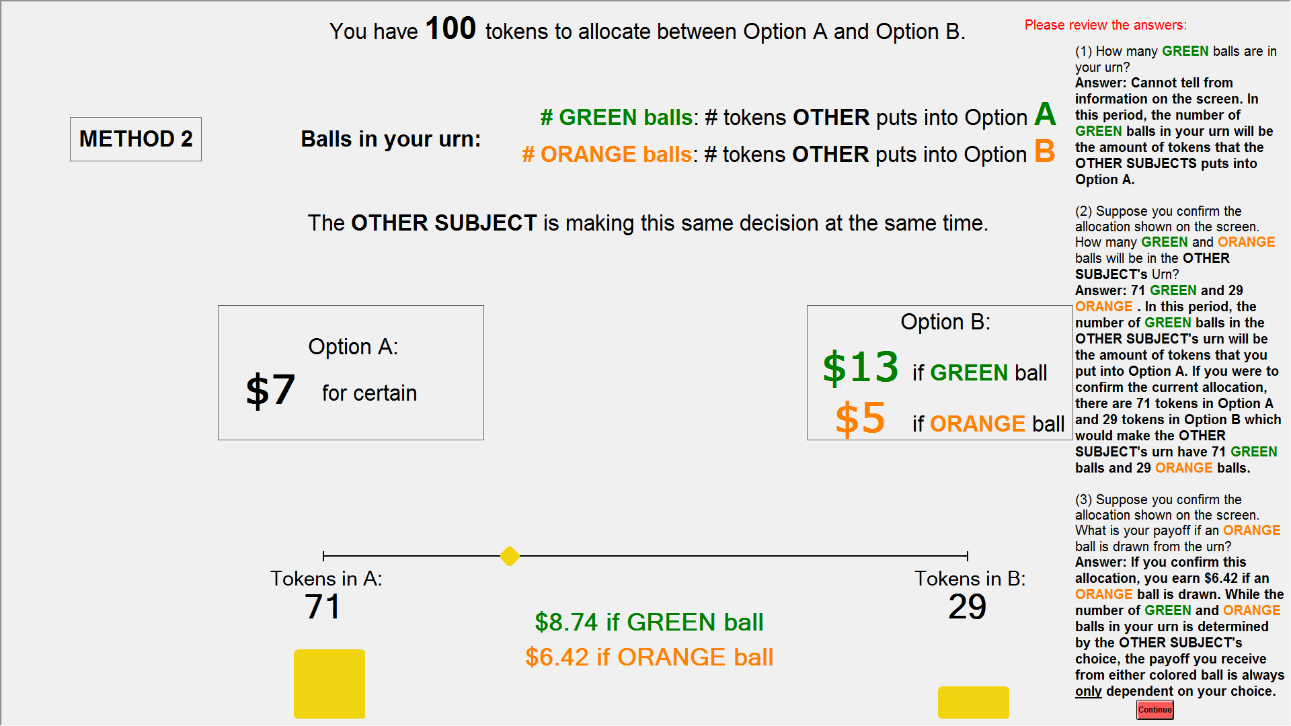 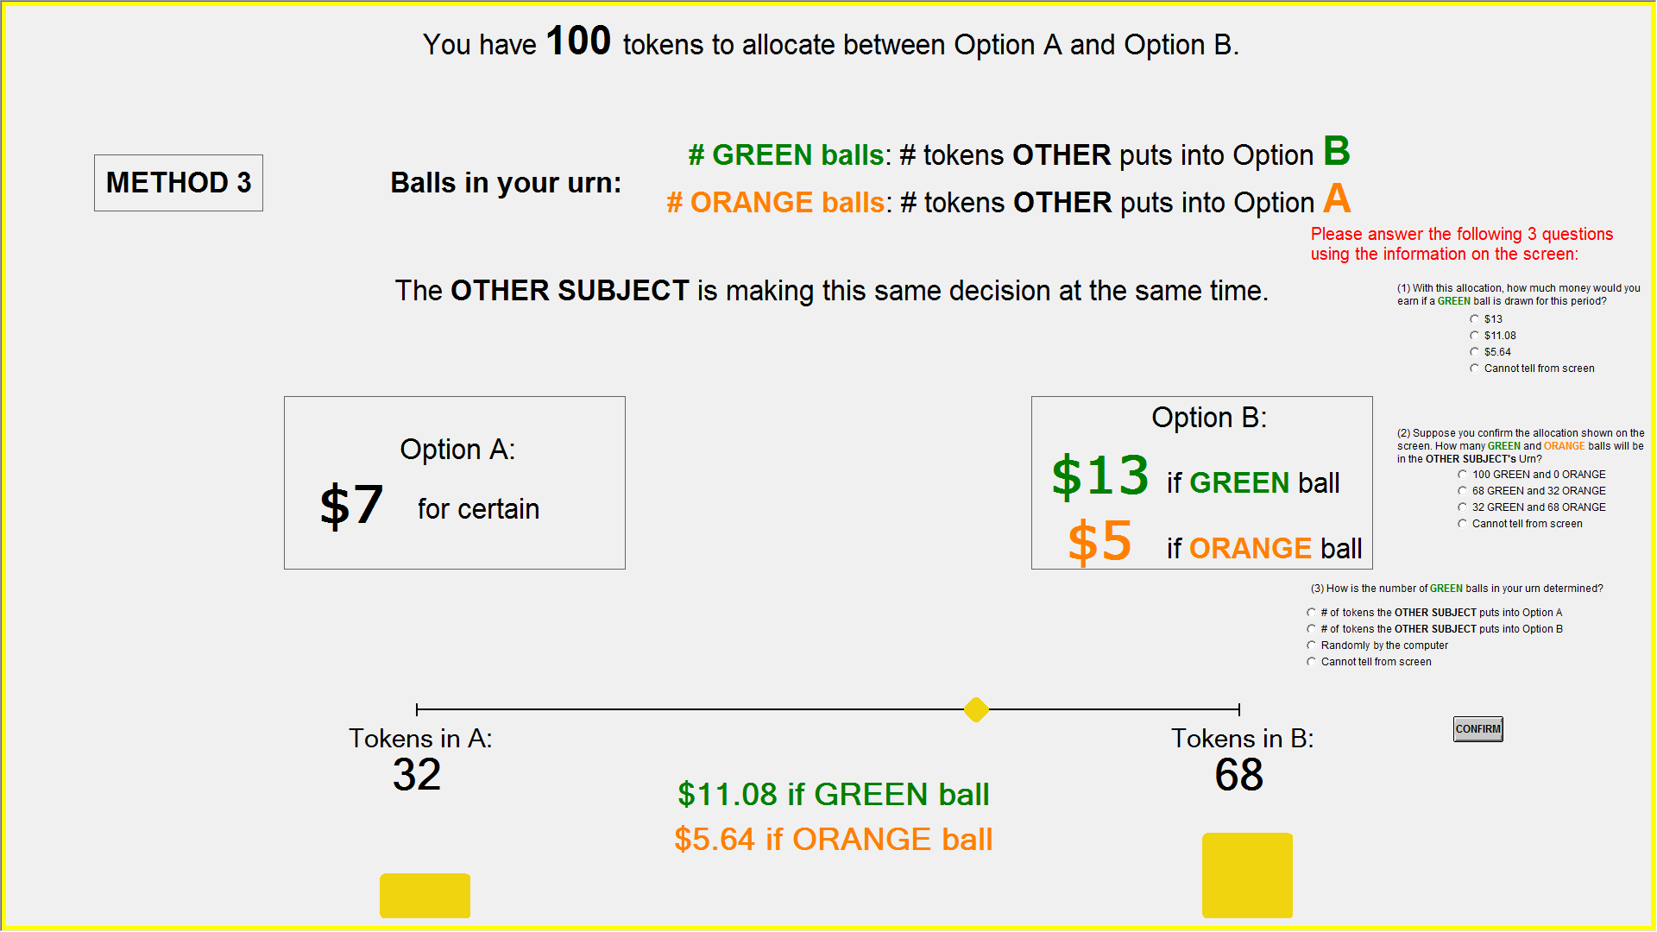 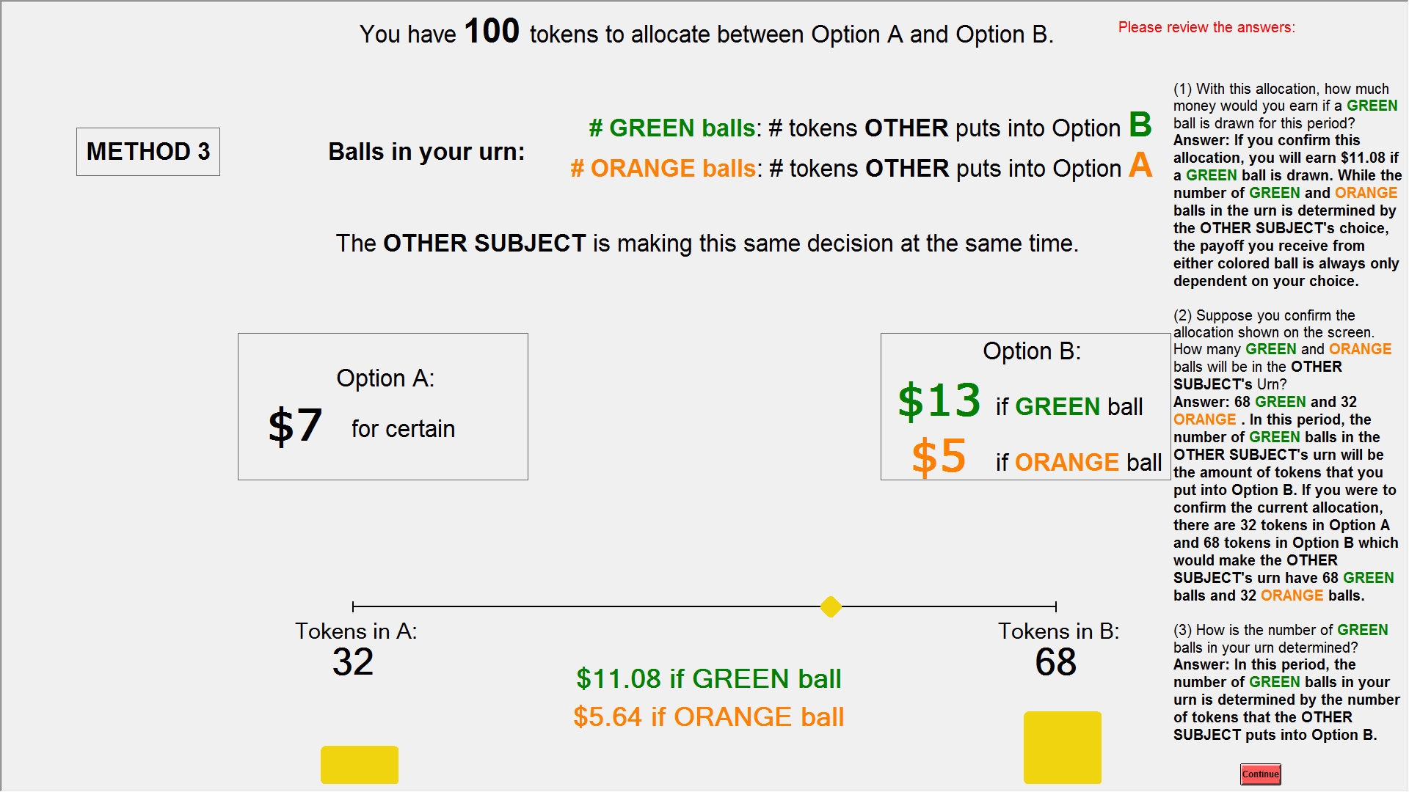 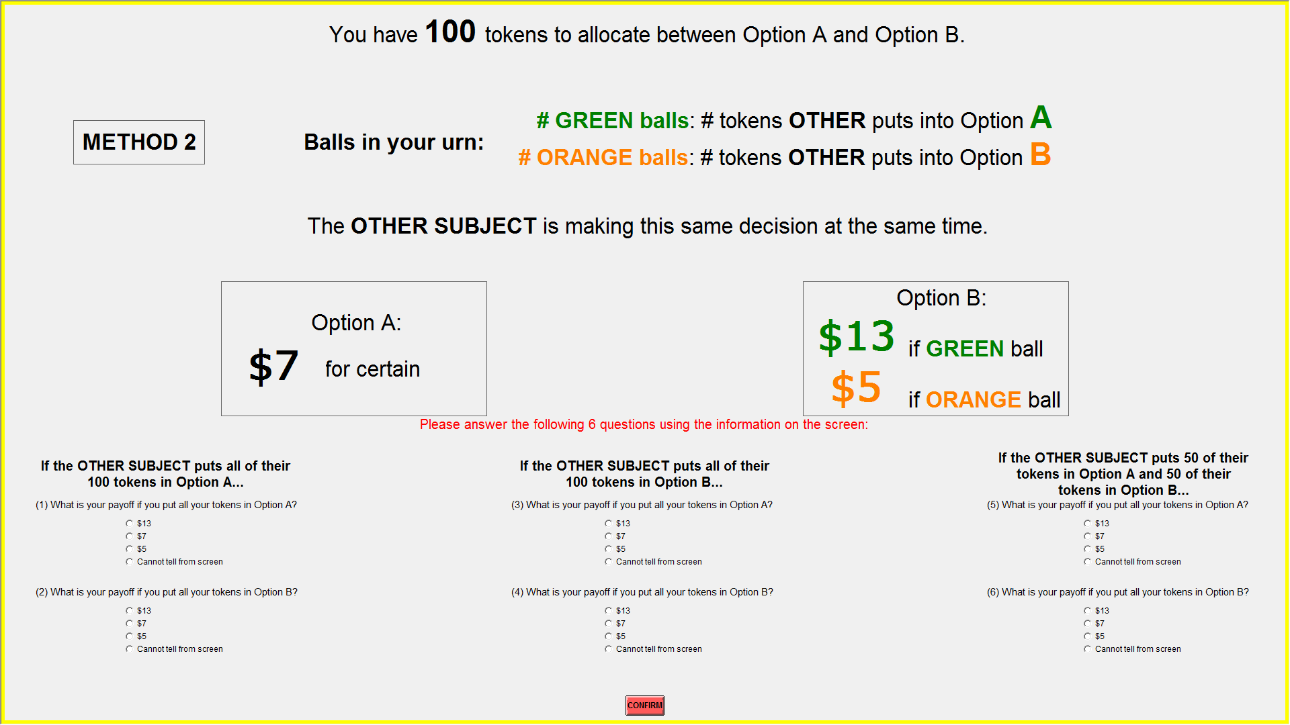 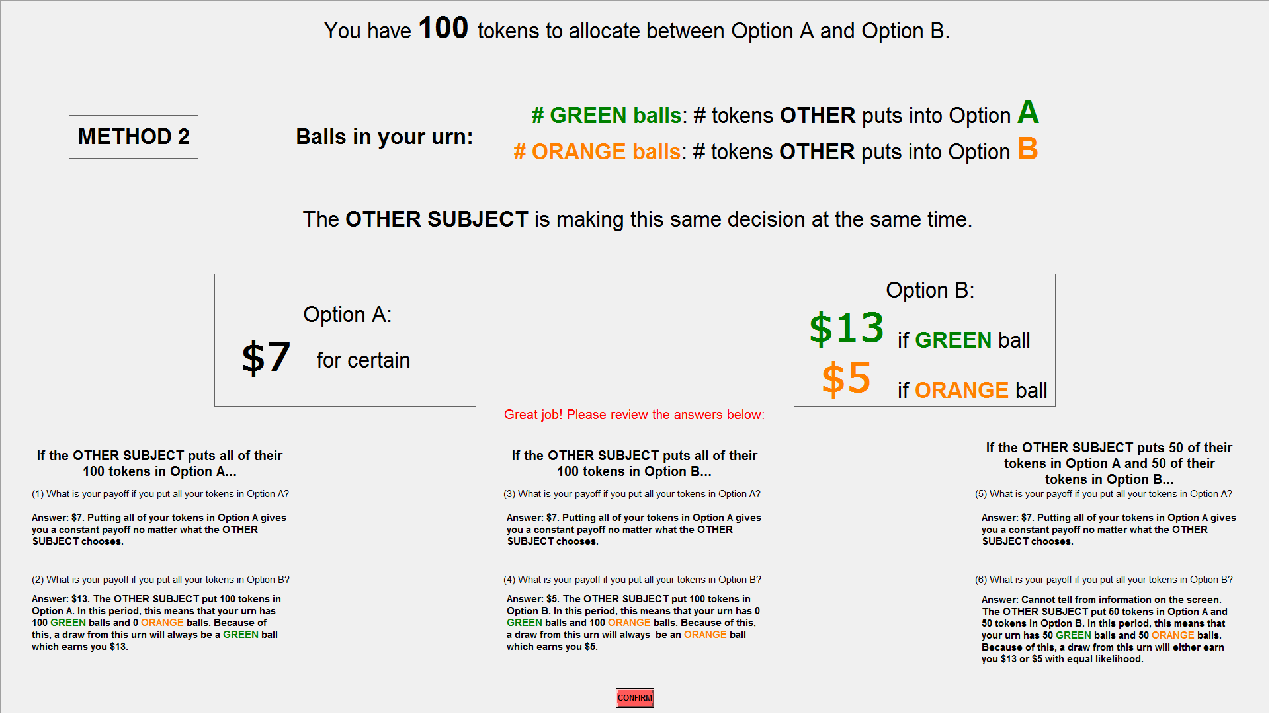 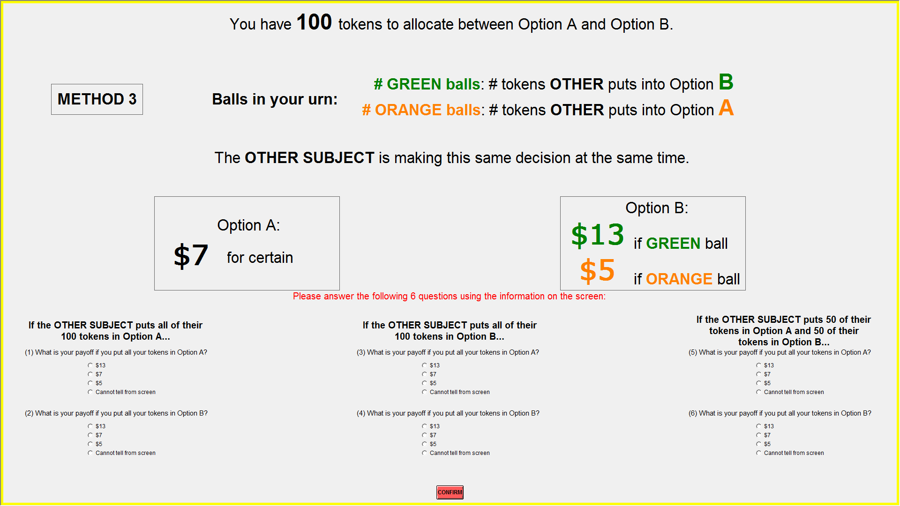 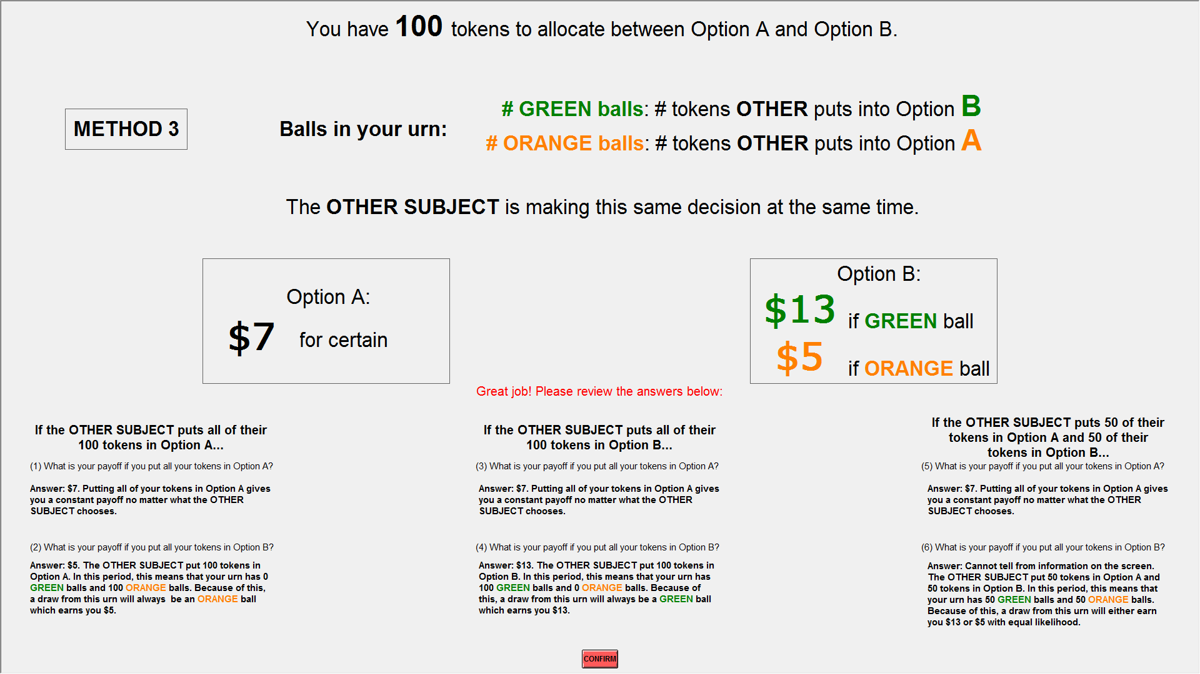 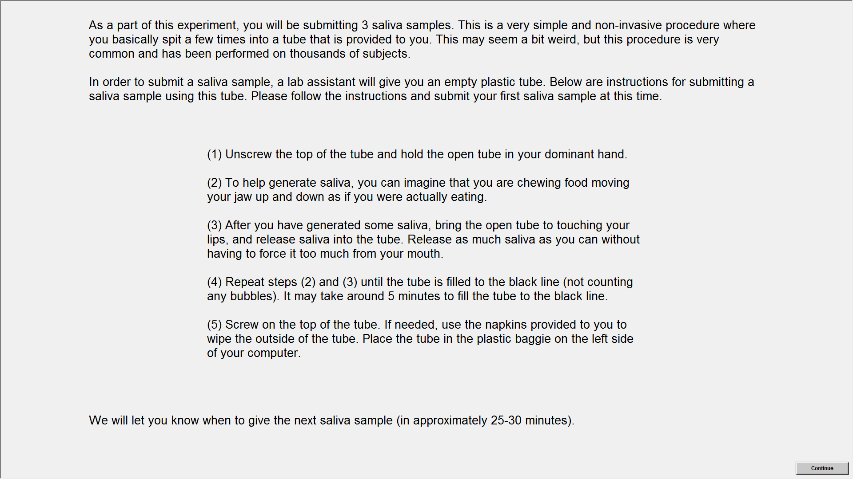 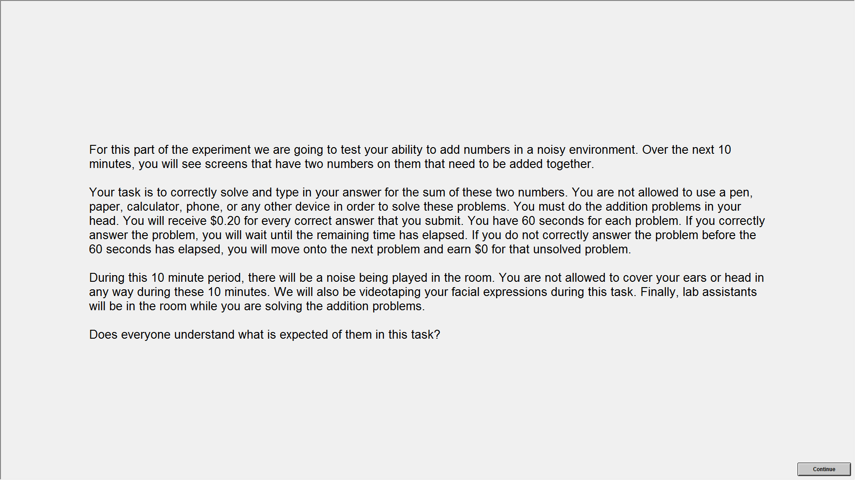

\*\*\*CPT or Noise task\*\*\*

Final Instructions:

{\rtf \fs40 \ql {\colortbl;\red0\green0\blue0;\red0\green128\blue0;\red255\green128\blue0;}

The cameras are turned off and you will not be videotaped at any other time during the experiment.

\par \par

Now we are ready to begin the decision periods that will determine your dollar-amount earnings. After you have completed ALL of the periods, you will be shown a list displaying the choices that you made in every period. From this list, the computer will randomly select ONE PERIOD. Using the choices made in this period, the computer will then randomly draw ONE BALL from that period's urn. The earnings from this draw in this period will determine what you receive in the experiment (on top of the $5 show-up fee).

\par \par

Because you will be paid based on the outcome of one of the upcoming periods, it is important to take your time in each period and make a choice that you are satisfied with.

\par \par

If you have questions at any time during the experiment please raise your hand and an experimenter will come to assist you. Please click "Continue" to start the decision periods.

}