E1: Experimenter 1, main

E2: Experimenter 2, helper

**[E1: As they arrive, give them 2 copies of the consent form and ask them to sign both copies. One will be for them and one for us. Check their ID and check them from the list as they arrive.]**

[After everyone has signed and turned in their consent forms, E1 will take the first four people in line to the side entrance to the lab. E1 will measure the maximum grip strengths of the Producers; E2 will take photos of the consumers and then upload them.]

**[E2: One person at a time, take each person separately into the anteroom, take a headshot (try to isolate their face and include as little background noise as possible) and assign a number. Assign them in the order that they arrived.]**

For this experiment, I need to take a photo of your face. It will be used only during the current experimental session and will be deleted immediately after the session ends. If you are not comfortable having your photo taken, you may not participate in the session. Is it ok to take your photo?

*Yes* –Please make your face as neutral as possible and look right at the camera. [Click!] Thank you. Please take this number and go to the computer with the matching number. [Hand them a number card.]

*No* – Thank you for coming. Please fill out this record sheet in order to receive your $5 show-up fee. Please wait just outside and I will process it once we are done checking participants in. Please do not talk to anyone outside.

**[E1: One at a time, bring each Producer in and seat them at their assigned computer. Make sure they know that this is where they will be sitting during the experiment. Ask them to pick up the grip. Press "calibrate" on the java program and tell them when to squeeze. Tell them to squeeze as hard as they can with both hands. Once calibration stops, press "apply calibration" to save the value. Click "start data acquisition loop." Then click on the z-leaf, which should be open in the background.]**

**[Once all 8 participants are seated and waiting]**

**[E2: On the computer in the office, get the photos off the camera. Name them 05.jpg, 06.jpg, 07.jpg, and 08.jpg.Place all photos into each of the 8 individual participant folders located in G:\usr\econ-expt-user-3\Desktop\MalloryPilot). In each folder, also place an extra copy of that subject's own photo and name it selfie.jpg. For example, in Subject 7's folder, there should be 05.jpg, 06.jpg, 07.jpg, 08.jpg, and selfie.jpg, where selfie.jpg is the same as 07.jpg. Every folder should contain all 4 subject photos, plus one selfie.jpg, which is that subject’s own face. Wait for E1's instruction to start the experiment.]**

**[E1] We’re about to begin. Please put your cell phones and other electronic devices on silent or airplane mode and in your bag, and do not use them until you leave the laboratory.**

Please double-check that you are sitting at the correct computer. The number on the computer should match the number on the card you received. Does anyone need to switch computers?

Good. Can everyone see the screen up here? If you cannot see the entire projection screen, please move so that you can see it.

[SLIDE: biopac electrodes on fingers]

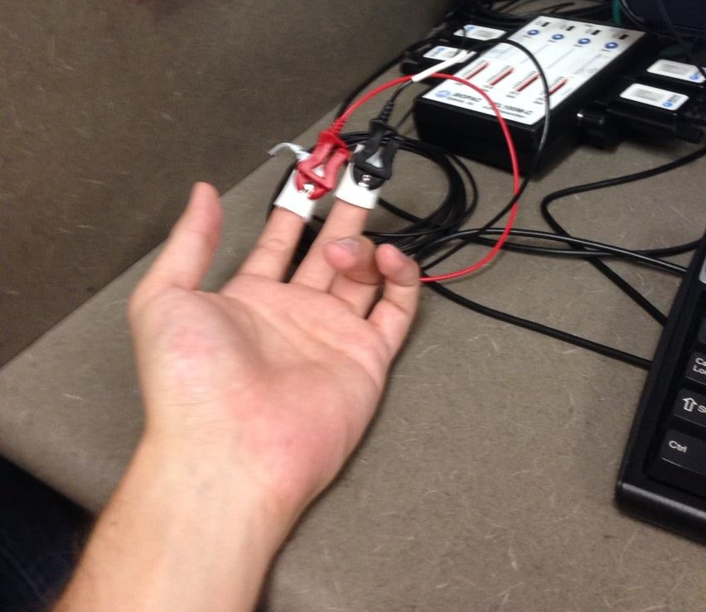

Now, for those of you seated at computers5, 6, 7, and 8, I will attach a small device to 2 fingers on your left hand, like so [indicate slide].

This small device measures skin conductance, which is related to perspiration. It measures the electrical conductivity of your skin, and how that conductivity changes. It is *only* a measurement device; it cannot do anything on its own. I will also place a long strip of tape over your forearm. This is so that you don’t move around – it’s important for the measurement that you do not move that hand. Once I have attached the pieces, please try not to move your hand at all, unless I specifically say it is ok to move it.

**[E1: Go to each person. Use an alcohol swab to clean the index and middle fingers. Tell them each step as you go through: “now I’m going to clean your fingers,” “now I’m going to put a small amount of gel,” etc. Apply a small amount of electrode gel to the soft side of each finger. Remove the backing from the electrodes (the cables should already be connected) and apply the red to the index finger and the black to the middle finger. Use tape to secure the electrodes. Use painter's tape to put a strip across the forearm.]**

Are there any questions?

We will now begin with a brief instruction period where you will be given a description of the experiment and shown how to use the software. While I explain, you may move your fingers.

Please, pay attention to the instructions, as it is important for you to understand the details of the experiment. There will be a quiz at the end of the instructions that everyone needs to answer correctly before we can proceed to the actual experiment. Participants who are unable to answer the quiz will not be allowed to participate in the experiment. If you have any questions during the instruction period, raise your hand and your question will be answered so everyone can hear. If any difficulties arise after the experiment has begun, say “experimenter,” and I will come and assist you.

For this experiment, you will each be assigned to one group, Consumers or Producers. You will remain in the same group for the entire experiment. There are 2 parts to the experiment. I will give you instructions for each part at the beginning of that part. Part I will consist of several rounds, as will part II. At the end of part II the computer will select randomly one round out of all rounds completed in parts I and II. The amount of money you obtained in that round is what you will be paid for completing parts I and II of the experiment.

**PART I**

I will now explain how Part I of the experiment will proceed. Every round, each Producer is matched with exactly one Consumer, and vice versa, so that there are 4 pairs. There is no way to know who you have been matched with. The pairings are random, and you are rematched at the start of every round.

To begin each round, each Producer will perform a task. This task requires some effort. Once the task is performed correctly, the Producer will be entitled to a digital good worth $20 for the Consumer they have been matched with. If you are sitting at computer 1, 2, 3, or 4, you are Producer. At your desk there is a black device that looks like this:

[Slide: hand grip]

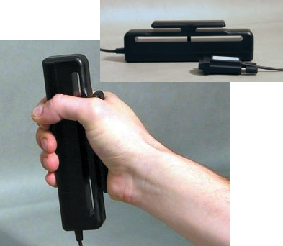

This is a device that measures grip strength. Your taskeach round will entail squeezing this grip as hard as you can for 7 seconds. If you squeeze hard enough to pass the thresholdyou will be able to move on. Now, I will bring a hand grip around to each Consumer so that you can all squeeze it for yourselves. **[Bring unattached hand grip to each consumer and ask them to squeeze it as hard as they can. Say “this is the task the Producers will complete.”]**

This is what the Producer will see each round:

[Slide: producer's effort screen.]

Once the task is completed, the good has been created.

Once the good has been obtained by the Producer, it is worth $20 to the Consumer they are matched with. The good does not have direct value to the Producer, only the Consumer. The Consumer will then choose how much to pay for the good. Consumers may choose to pay $7 or steal the good by paying $0. This is the screen they will see when they make their choice:

[Slide: baseline consumer's choice.]

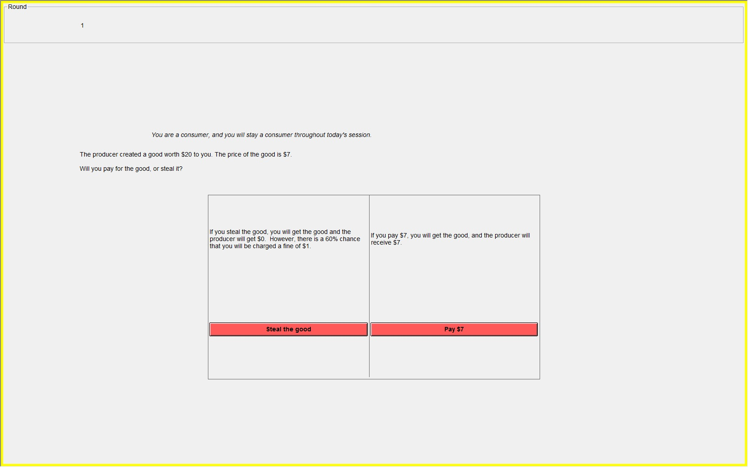

**[E1: wait a few seconds]**

The amount they pay goes to the Producer they were matched with, and who obtained the good. However, if they choose to steal the good, there is a 60% chance that they will be charged a fine of $1. This $1 fine does *not* go to the Producer but is deducted from the $20 value of the good.

Once the Consumer has made their choice, the Producer will see whether the Consumer paid or stole the good. Again, there is no way to know which Producer has been matched with which Consumer.

If the Consumer paid $7, the Producer will see this screen

[Slide: baseline producer results],

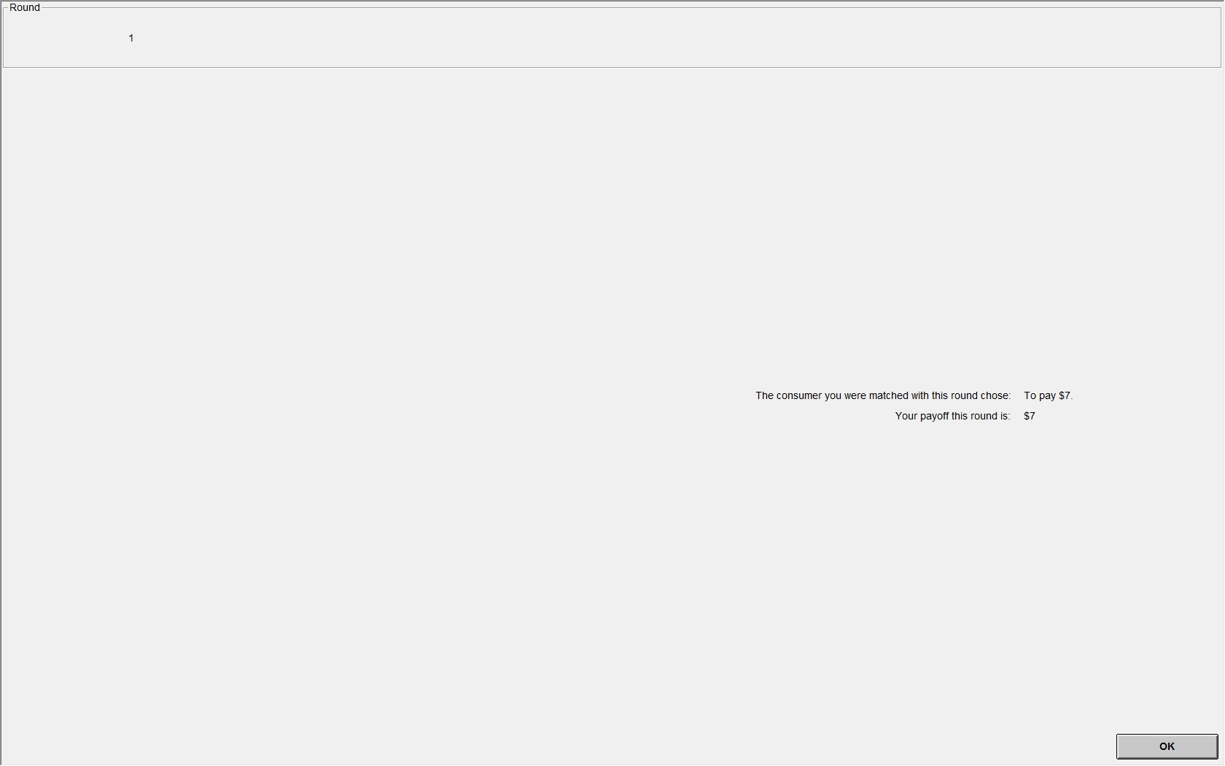

which says "The consumer you were matched with this round chose to pay $7. Your payoff this round is $7." Meanwhile, the Consumer will see this screen

[Slide: baseline consumer results,no cheat].

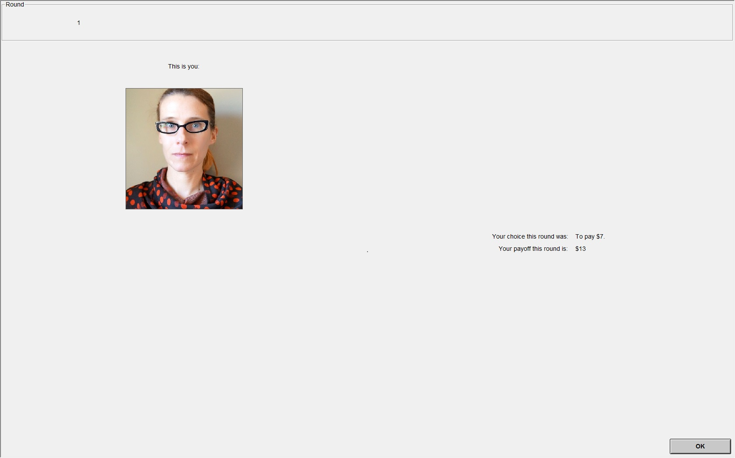

which says, "Your choice this round was to pay $7. Your payoff this round is $13." As you can see, the Consumer’s screen has a photo. It is a photo of their own face, the same one taken at the start of the experiment. This photo is shown *only* to that consumer, and not to anyone else in the room. The face pictured here is a sample.

If the Consumersteals the good, there is a 60% chance that they will be fined, and a 40% chance that they will not be fined. If the consumer stole the good and was *not* fined, the Producer will see this screen

[Slide: baseline producer results, stolen],

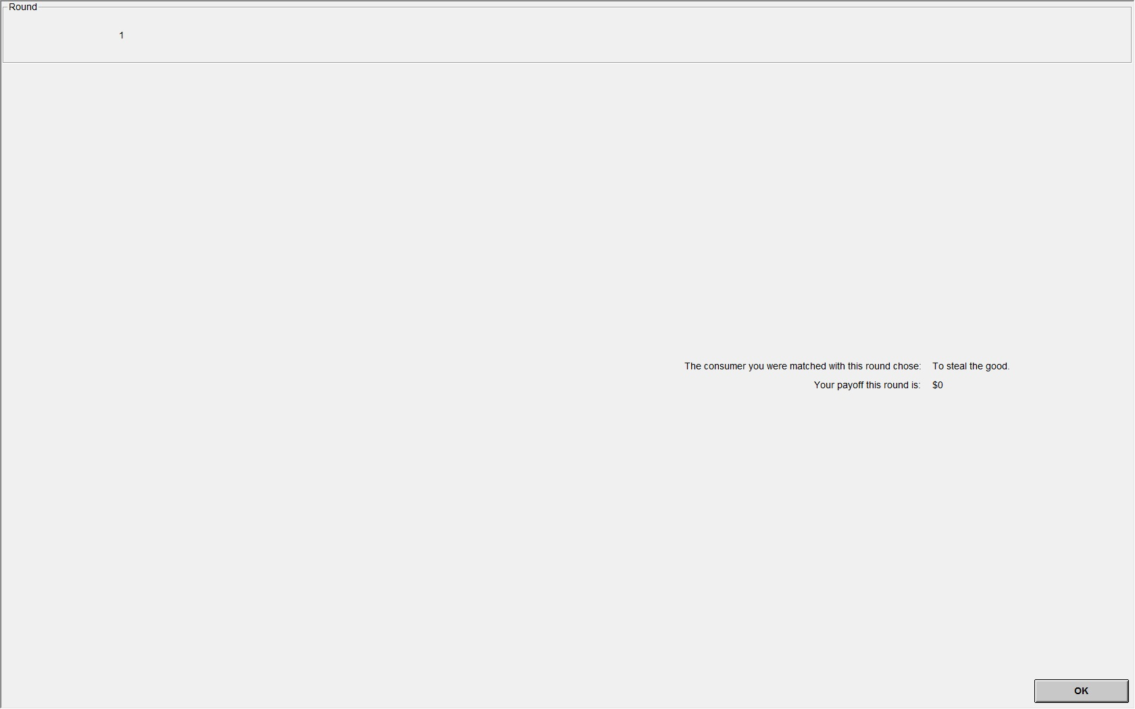

which says "The consumer you were matched with this round chose to steal the good. Your payoff this round is $0." The Consumer will see this screen

[Slide: baseline consumer results, no fine].

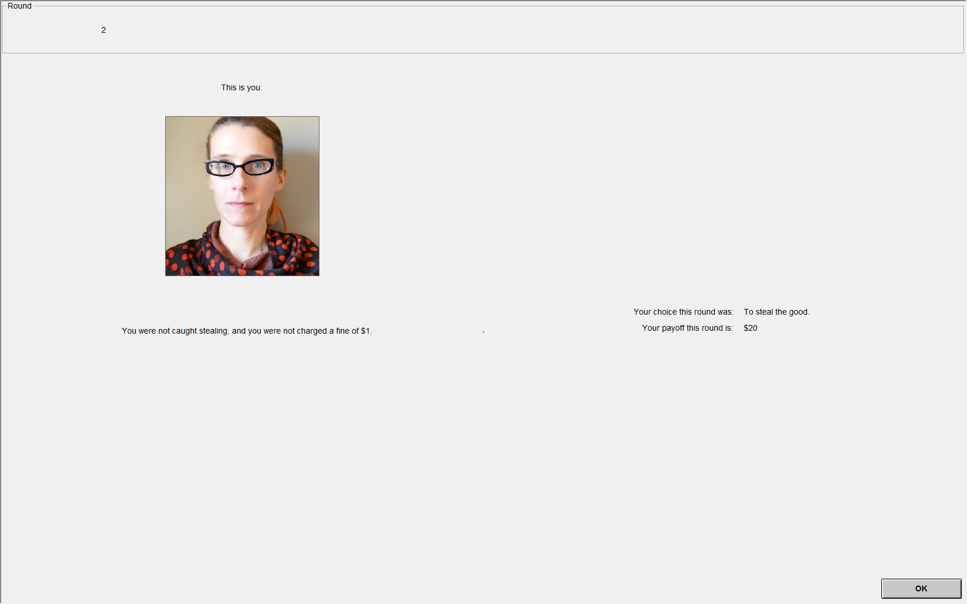

which says "Your choice was to pay $0. Your payoff this round is $20. You were not charged a fine of $1."

If the Consumerstole the good and *was* fined, the Producer will see this screen, which is the same as if the Consumer was *not* fined:

[Slide: baseline producer results],



Itsays "The consumer you were matched with this round chose to steal the good. Your payoff this round is $0." The Consumer will see this screen

[Slide: baseline consumer results, with fine].

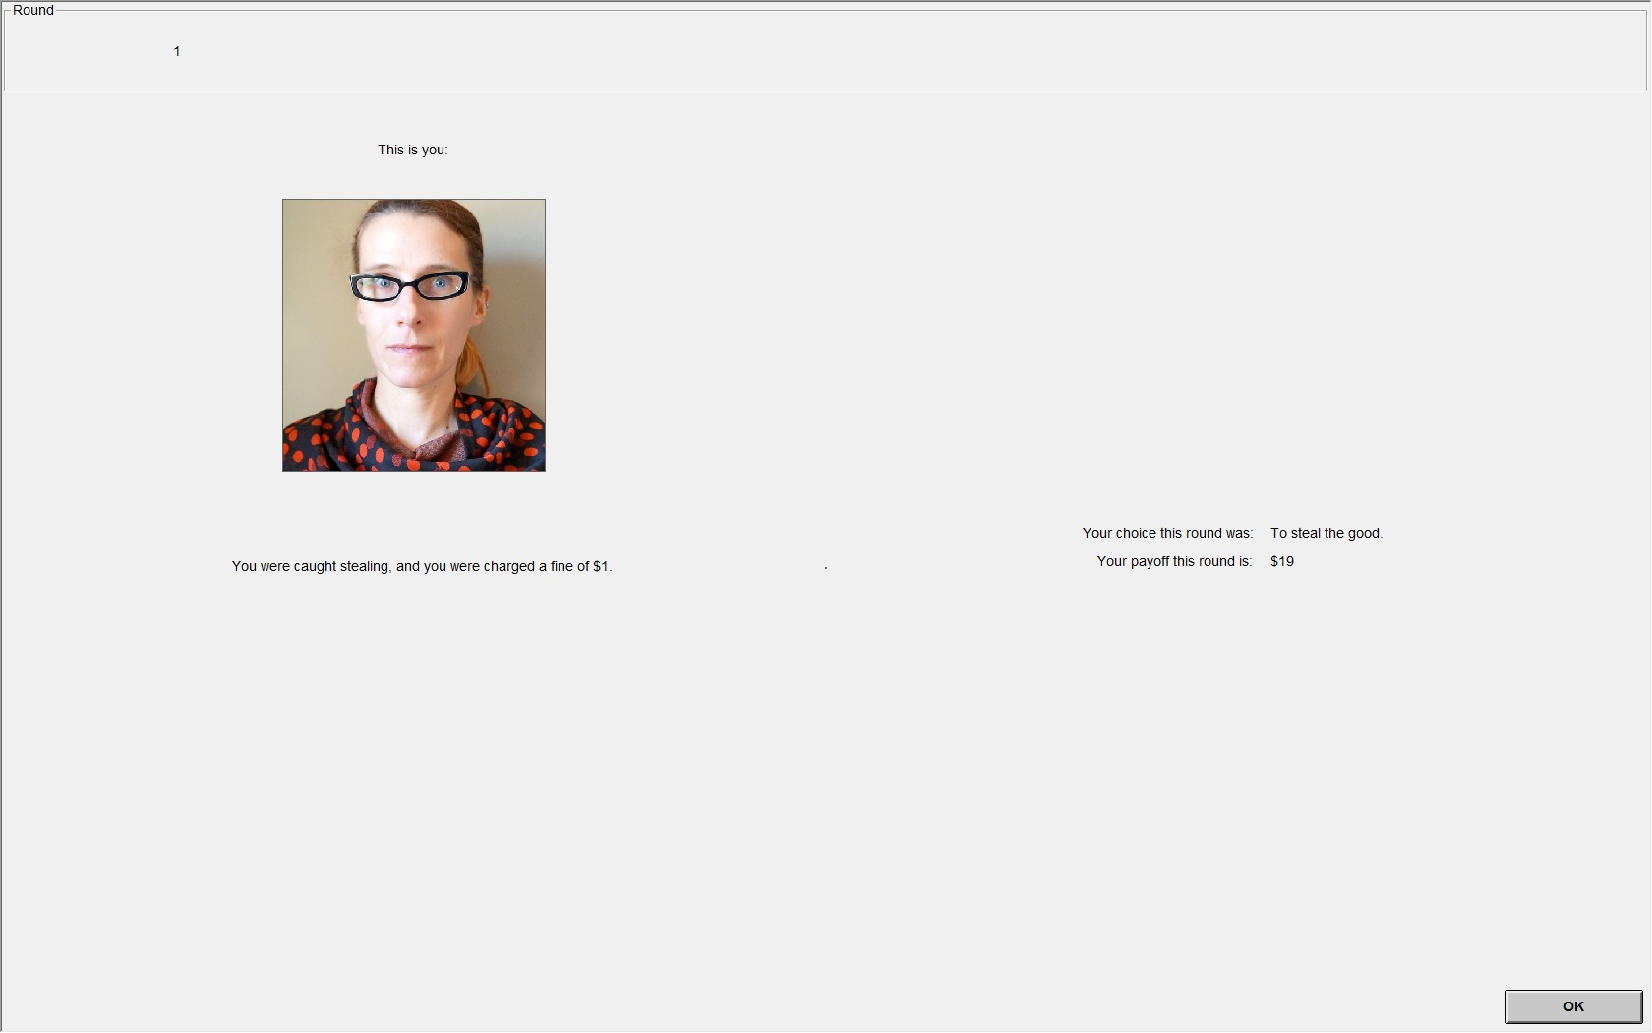

which says "Your choice was to steal the good. Your payoff this round is $19. You were charged a fine of $1."

In a moment, we will do one practice round.Consumers, please take a sharp, deep breath – I will confirm that the measurement is working.

**[E1: Step into the back office and check with E2 that the photos are all in the right places and ready to go.Check that AcqKnowledge appears to be recording correctly, particularly SCR.Place a marker at the breath SCR increase.]**

We will now begin the practice round. This practice round does not affect the experiment in any way;it is only for practice and to familiarize you with the software. I will walk you through what to do during the practice round. If you have any questions during the practice round, please raise your hand. Everyone, click OK to begin.

[Slide: Effort screen]

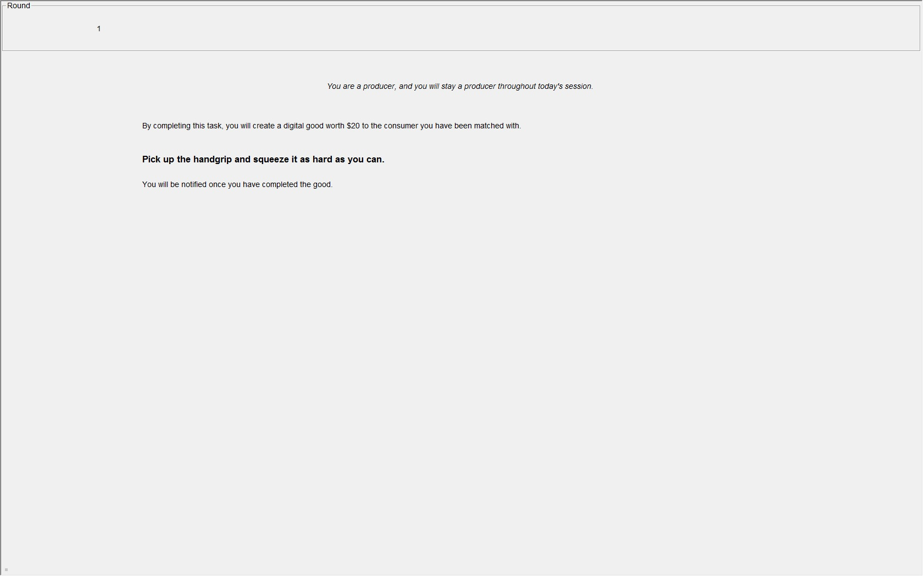

**[E1: Say the practice round instructions slowly and deliberately! It's ok to walk among them as they do this part.]**

The Producers will first perform the task. Pick up the hand grip and squeeze it as tightly as you can. If you squeeze hard enough for 7 straight seconds, you will automatically move on. [Walk among them – see when they have all done it.] Now it tells you that you have created the good. (Click OK.)

Consumers, you are now given the choice to pay $7 or steal the good. If you are at an odd-numbered computer, please click “pay $7.” If you are at an even-numbered computer, please click “steal the good.” There will be a brief delay, and then you will see results. Producers, you will see whether the Consumer stole the good or paid $7. Consumers, you will see your own picture along with whether you stole the good or paid $7, and whether you were charged the fine.

**[E1: check that all photos are correct.]**

Everyone, please click OK to exit the results screen.You have now completed the practice round. Are there any questions?

If not, we will proceed to the quiz. Please pay close attention to answering the questions, as you will not be permitted to continue with the experiment if you do not answer the questions correctly. Raise your hand if you have any question during the quiz.

(Please click OK on the current screen to begin the quiz.)If any answer on the quiz is incorrect, the OK button will not work. If you click OK and nothing happens, it is because one or more of the answers is incorrect. Check your answers and try again.

**[QUIZ]**

You have now completed the quiz.

Let me remind you how you will be paid. The computer will randomly select one of the rounds from Part I or Part II and you'll be paid thedollar amount you earned in that round.

Are there any questions? I will be in the next room while you complete Part I. If there are any problems or questions from this point on, say "experimenter," and I will come out and assist you.

We are ready to start the experiment. Please pull your dividers all the way out.

Now, if you have the recording device attached to your fingers, please keep that hand perfectly still while you complete Part I.

Click OK on the waiting screen to begin.

**[Run Part I]**

**PART II**

You have now completed Part I of the experiment. Please push in the dividers.

**[Pause and make sure they pushed in their dividers]**

While we go over the instructions for Part II, you may move your fingers.

This is the last part of the experiment. As before, every round, each Producer is paired with exactly one Consumer, and vice versa, so that there are 4 pairs. The pairs are random, and you are rematched every round.

In Part II, if the Consumer chooses to steal the good, there is a 60% chance they will be charged a fine of $1, *and* their photo will be displayed to all Producers, with the text, "Consumer(s) who stole the good and were charged a fine this round." All Consumers who are charged the fine will appear on the Producer's screen, which means that if a consumer is charged a fine, theirphoto will be shown on the screens of all Producers. Here is an example of what a Producer will see on their screen. Please note these are sample pictures only.

[Slide: p-only producer’s results, some charged]

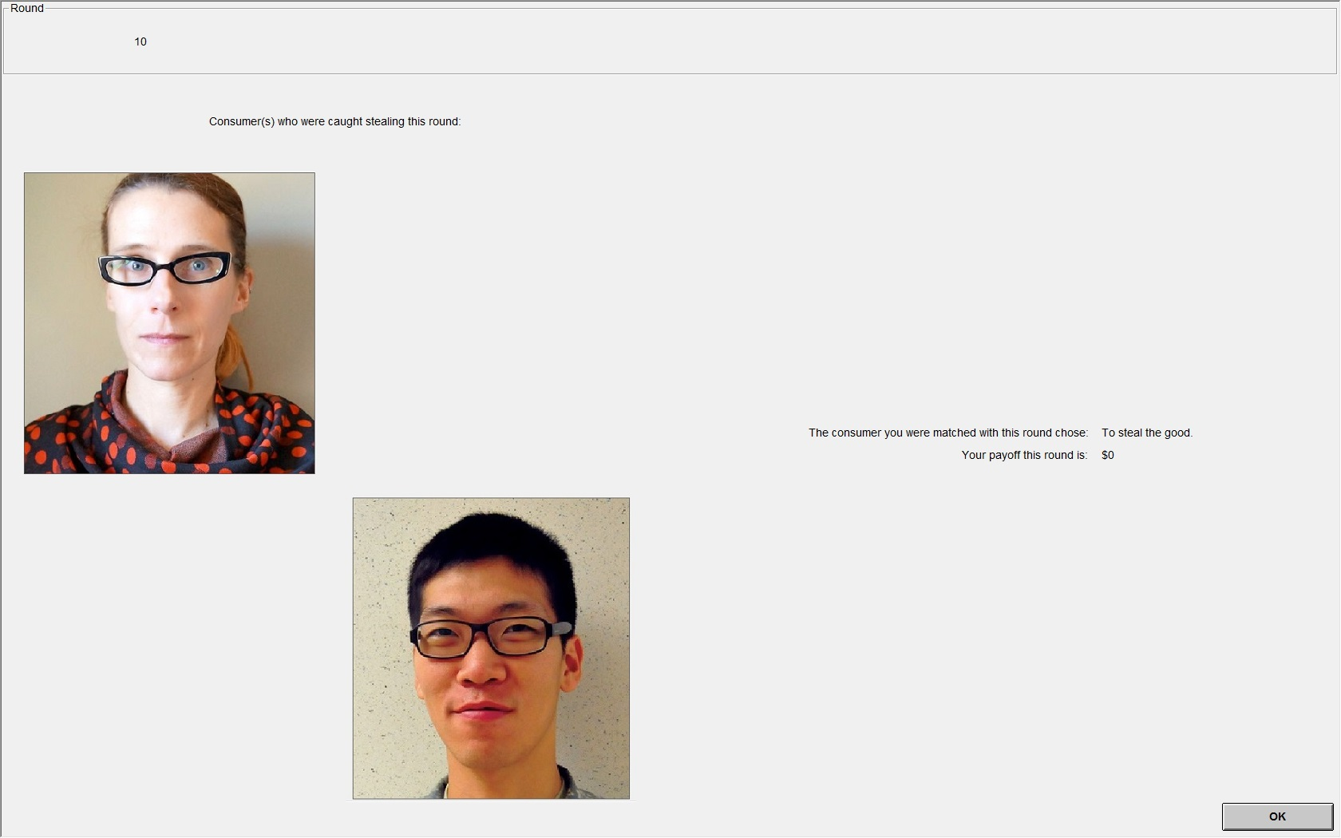

In this example, these two Consumers were charged a $1 fine and had their photos shown to the Producers. We cannot tell from this screen whether the other Consumers stole the good or paid $7, since there is only a 60% chance that they will be fined and have their photo shown. That means that if they did steal the good, there is a 40% chance that they are not fined, and their photo is not shown. If they paid $7, they cannot be charged the fine, and their photo cannot be shown.

On the Consumer's result screen is their own photo, as in Part 1.However, and unlike Part I, if the Consumer steals the good and is charged the $1 fine, they will see the following notice: "All producers are currently seeing your photo (above), and the photos of all consumers charged a fine, with the text 'Consumers who stole the good and were charged a fine this round.'"

[Slide: p-only consumer’s result: caught]

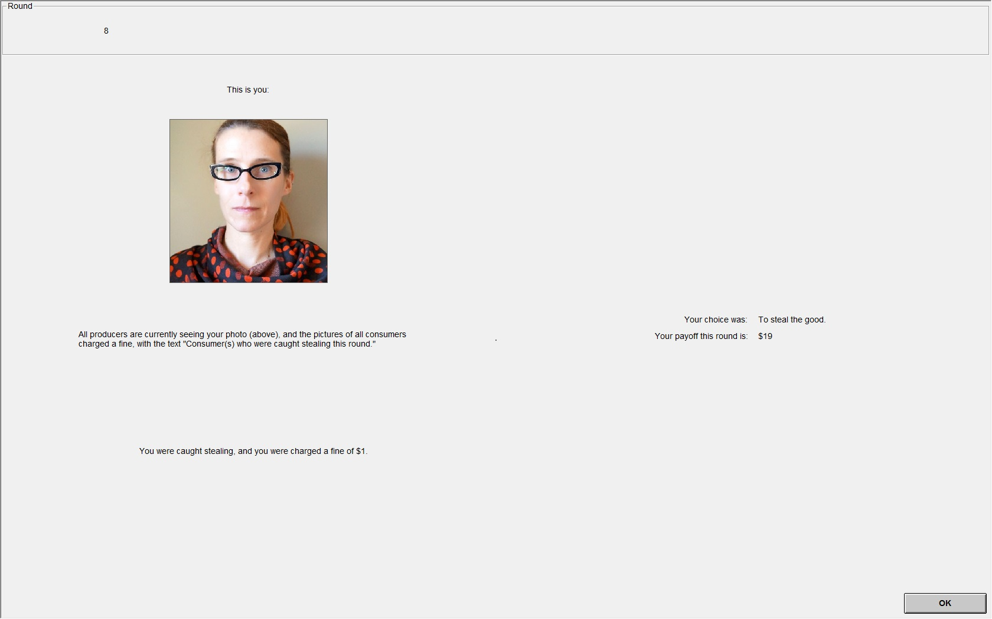

If a Consumer pays $7, their photo will not be shown.

Are there any questions?

Before we begin Part II, we will have a short quiz.(Please click OK on the waiting screen)

**[QUIZ]**

You have now completed the quiz. Are there any questions before we move on? During Part II, I will be in the next room. If there are any problems or questions, say "experimenter," and I will come out and assist you.

We are ready to start Part II. Please pull your dividers all the way out.

Once again, if you have the recording device attached to your fingers, please keep that hand perfectly still while you complete Part II.

**[Run Part II]**

**QUESTIONNAIRE & PAYMENT**

**[E1: Before heading back into the room, minimize AcqKnowledge and open z-tree to the questionnaire file for E2.]**

You have now completed the last part of the experiment. Please push in your dividers.

I will detach the leads from your fingers if you have them and hand you a paper towel to wipe your fingers.I will also hand out a record sheet for you to complete.

**[E1: Take off the biopac leads, but let them remove the electrodes themselves. Give each one a paper towel. Give everyone a record sheet and a pencil.]**

This was the last part of the experiment. Your final payoff in the experiment is equal to the show-up fee of $5, plus one independently randomly selected trial from Parts I and II. It was displayed on the last screen you saw in Part II. Please write down the amount on your record sheet. Write down the total by adding the $5 show-up fee.

Lastly, a questionnaire will appear on the screen, please fill it out. Remember, your answers will remain anonymous. Please submit your answers once you are finished. Once you submit your answers, please put the mouse on the side of the computer and do not use either the mouse or the keyboard.

**[E1 to E2] Please start the questionnaire.**

**[E2: Start the PilotQuestionnaire in z-tree by making sure PilotQuestionnaire is the active window, then pressing F5]**

**[E2: The payment file is in the Pilot folder and it's named YYMMDD_HHMM.xls, that is, it's named for the date and start time it was run. Prepare the payments. Both Producers and Consumers receive $5 show-up fee, plus the variable randomProfit. Go to the last period of the spreadsheet and scroll right until you see the variable randomProfit. The earnings appear in order of subject ID.]**

We will pay each of you in private in the next room in the order of your Subject ID number. Remember you are under no obligation to reveal your earnings to the other participants. Please remain seated until we call you to be paid.

**[E2: Call all the participants in sequence by their ID #. Check their record sheet for accuracy and have them sign.]**

**AFTER THE EXPERIMENT ENDS**

1. Turn off the SCR box and hand grip box to conserve the battery.
2. Make sure everything is clean and tidy!