**Exp-03 Jenkins Setup on AWS**

**Step-1**

* Open aws account
* Select EC2 instance
* Click on launch instance
* **Select ubuntu OS**

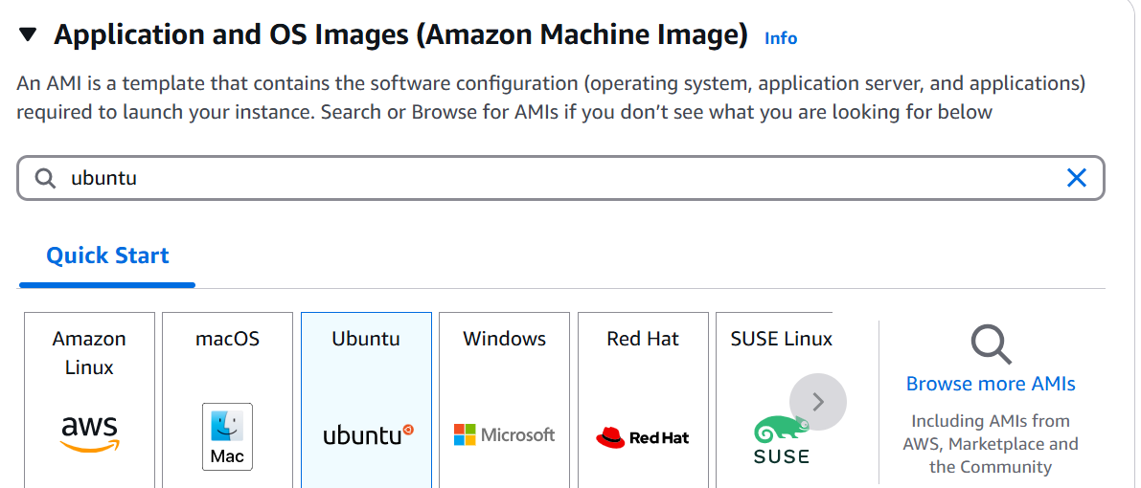

**Step-2**

* **Select ubuntu free tier as amazon in image**

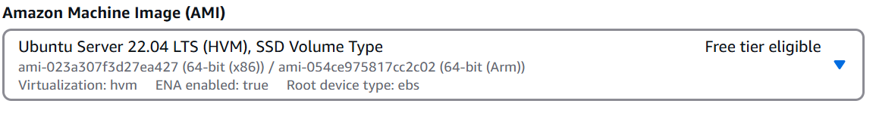

**Step-3**

* **Select instance type t2.micro**

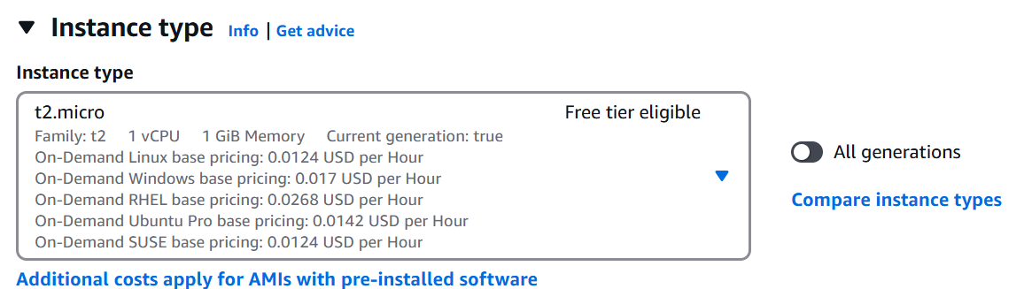

**Step-4**

**Create key pair**

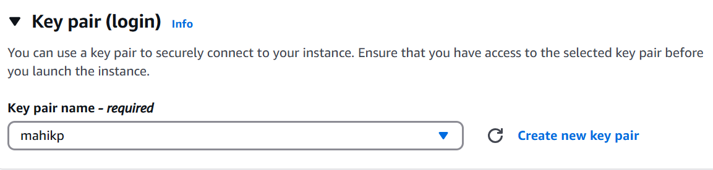

**Step-5**

Network add the below rule

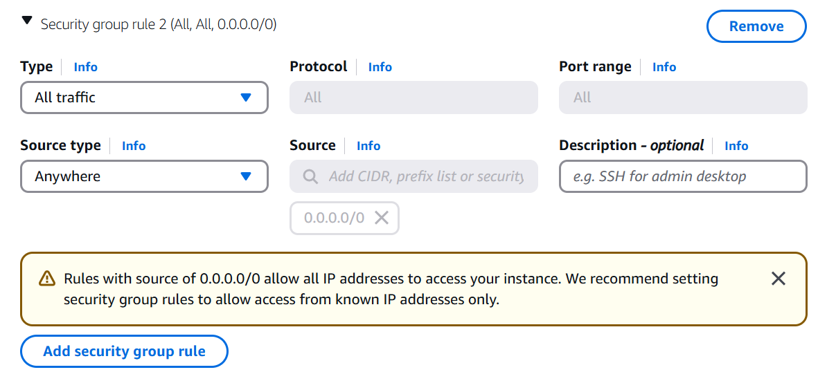

Goto the .pem file location from there open gitbash (before you need to download and install gitbash in your computer)

Goto aws click on the connect take the ssh id copy and paste in the gitbash

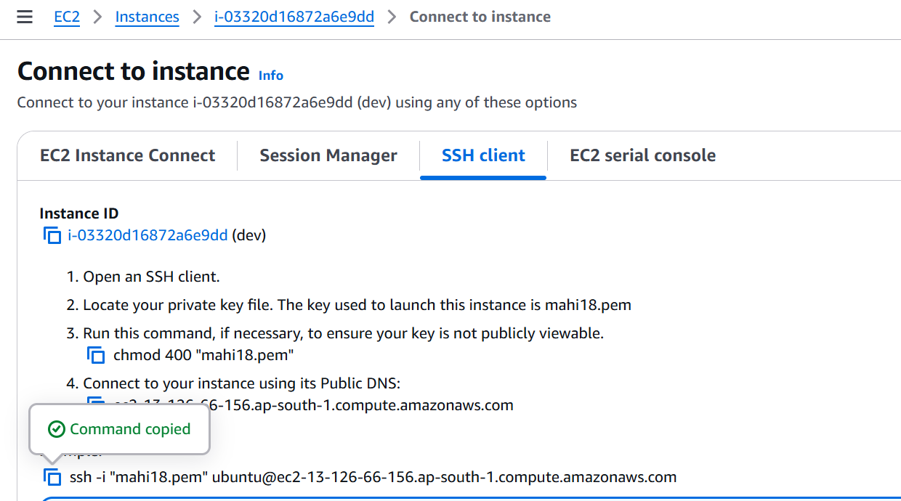

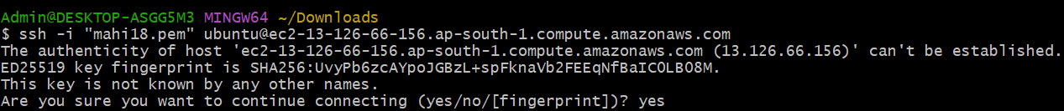

**Step-6**

Now u need to install jenkins

First u need to update the apt repository

$ sudo apt update

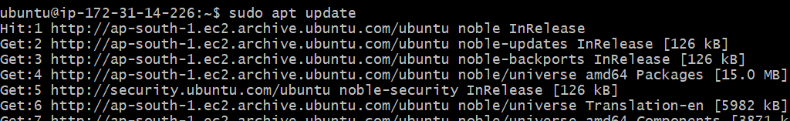

**Step-7**

Install java

sudo apt install openjdk-21-jdk -y

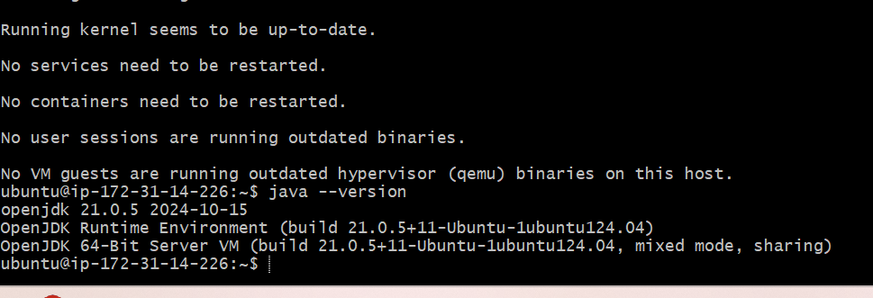

**Step-8**

U need to install git and maven and check it

sudo apt-get install -y git maven

git --version

mvn --version

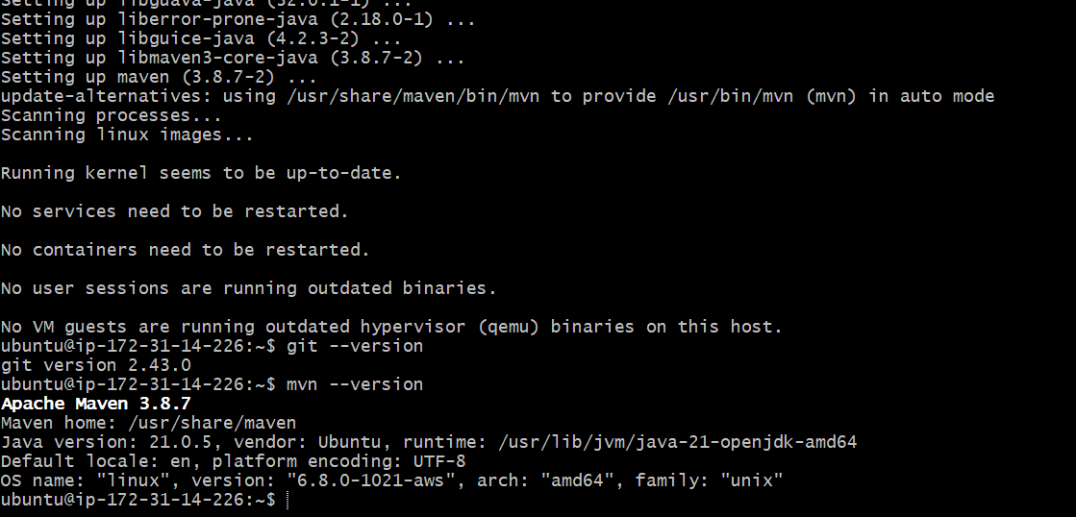

**Step-9**

Open jenkin.io ([Download and deploy](https://www.jenkins.io/download/)) in browsedr and select the generic java package(.war)

Copy and paste link addrest

$wgetlinkaddress

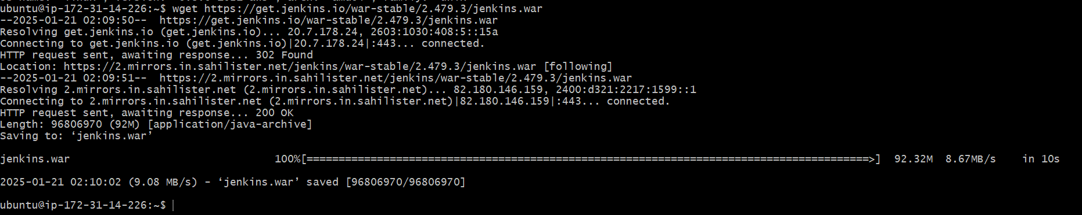

Start the jenkins services

$ java -jar jenkins.war

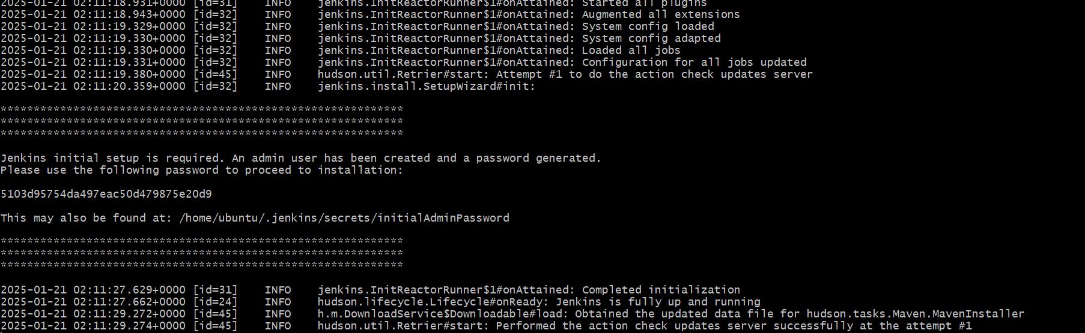

**Step-10**

we access the jenkin take the public ip of dev server

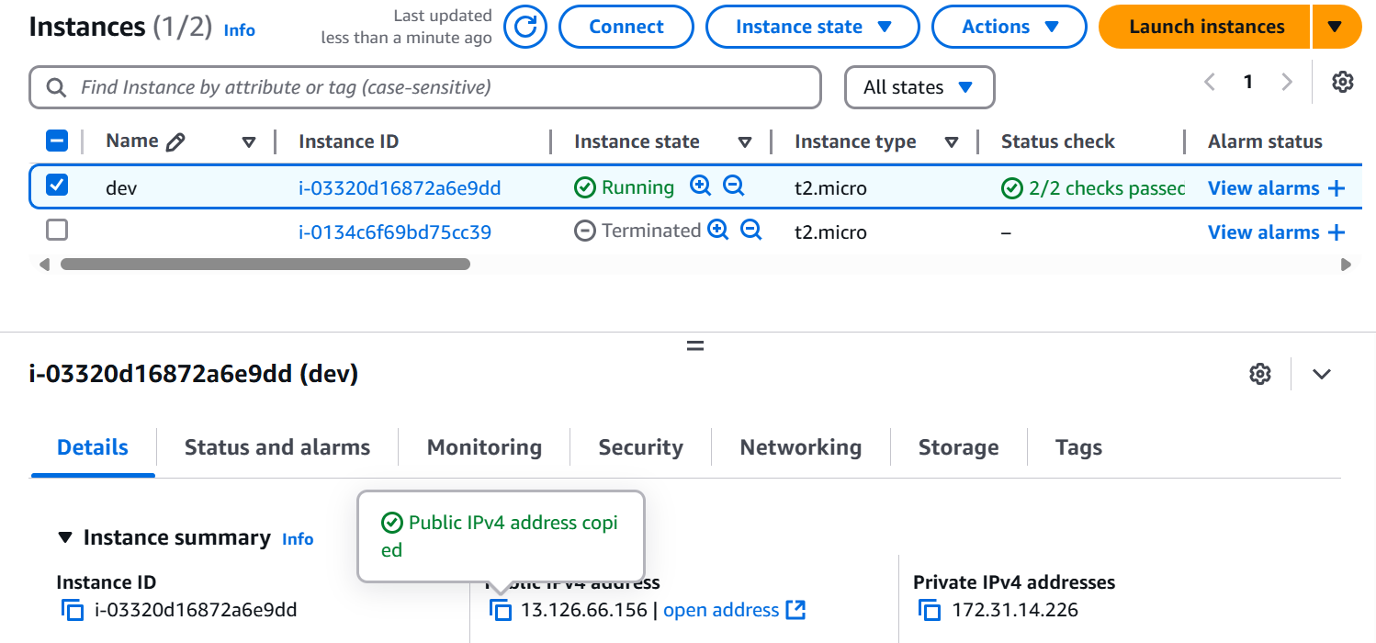

Copy and paste in the browser add :8080 as port number

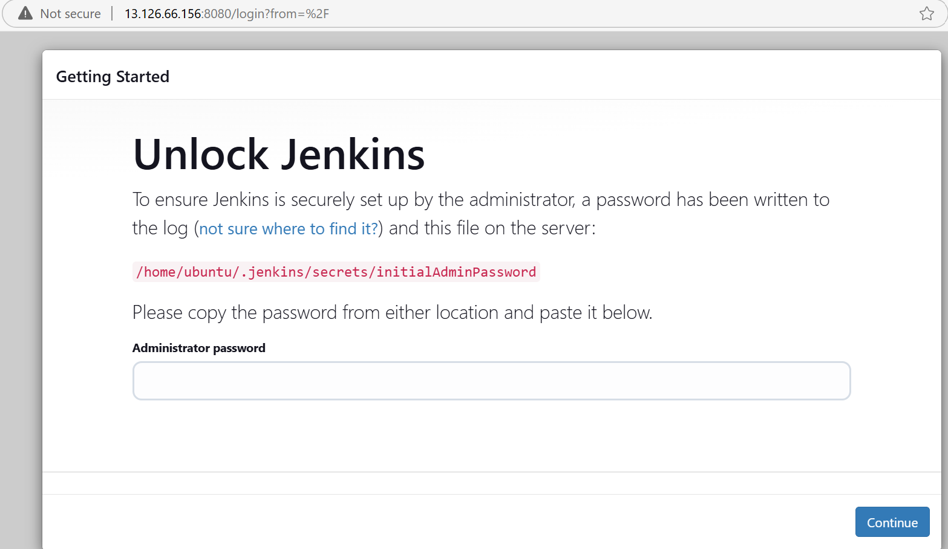

Unlock the jenkins with password which is present in the gitbash

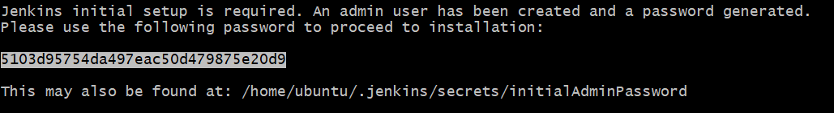

Select the install suggested pluggins

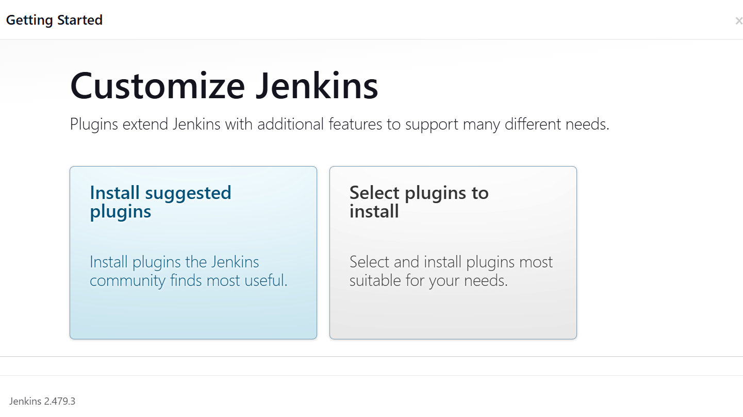

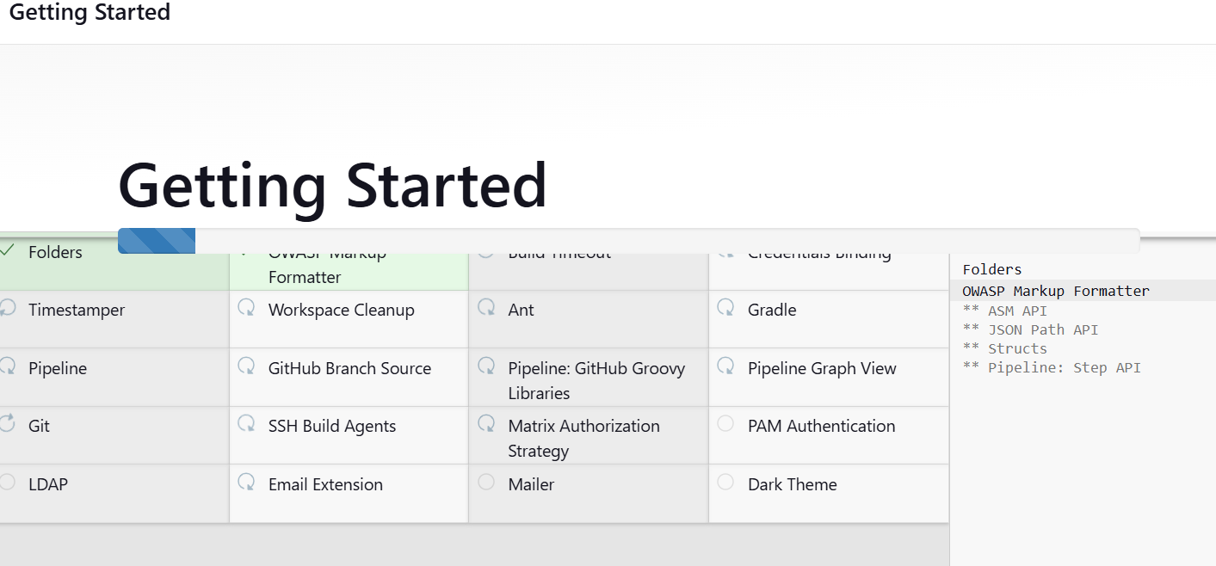

You can give all admin

Click on save and continue

Click on save and finish

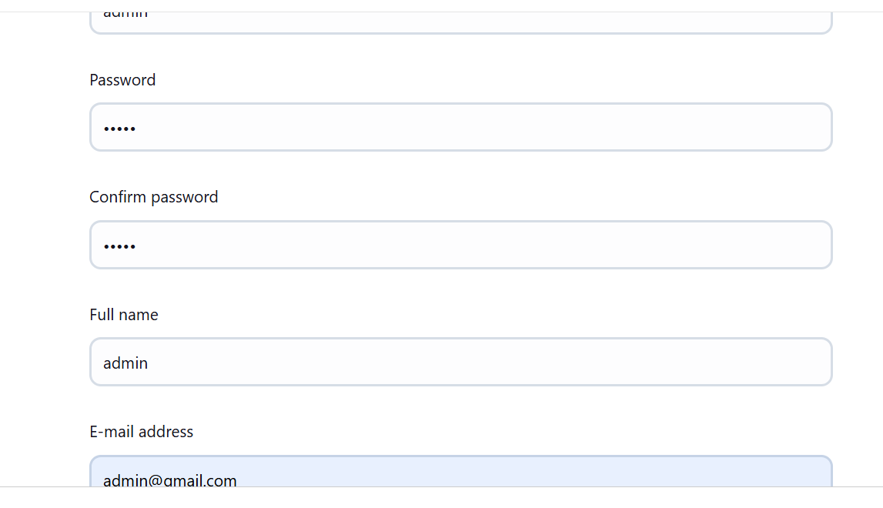

Your jenkins is ready

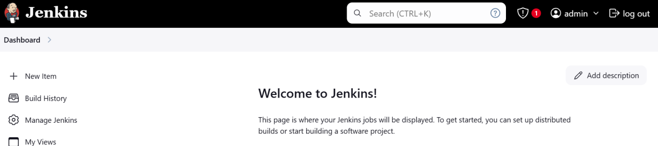

Note: don’t close the jenkins server