Graph ql Documentation (Linux)

Go to Git of Graph protocol: https://github.com/graphprotocol

Find graph client folder and go through the installation process: https://github.com/graphprotocol/graph-cli

Install the followings beforehand:

1. Node

2. NPM

3. Docker

After that create account in “Infura”

Create a new project in Infura.

Go to “project settings” and copy the https link in the “Endpoints” section confirming the “Mainnet” option in the scroll down menu(Mainnet is selected by default)

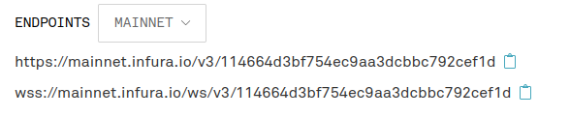Then go to your docker installation folder and find the “docker-compose.yml” file.

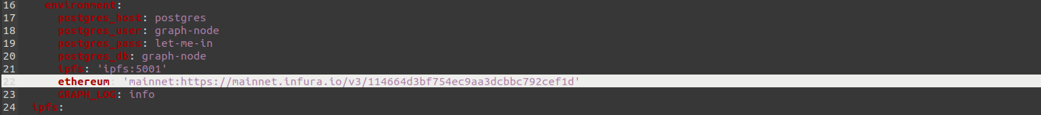Paste the copied link in the “ ethereum: ‘paste link here’ ” line. Be sure to keep the indentation and apostrophe marks similar to how it was, just paste the link between the two apostrophes of the “ethereum” variable.

Then watch this 30 min video: https://www.youtube.com/watch?v=jxhNsSicEzA