**Reason of Project Selection:**

Autism is a life-long brain disorder that is normally diagnosed in early childhood.People with autism have difficulties communication,forming relationships with others and find it hard to make sense of the world around them.

Due to lack of trained professionals we are unable to reach autistic children.They dont have easy access to a tertiary level hospital and often misdiagnosis and mistreatment occurs.

We now have many adolescents on the spectrum who are not going to school and there is no occupational training for them.So most of them stay home living with their parents which creates a big stress for the family.Without knowing the possible causes of autism,we can not stop the autism boom.

So,we are selecting this project to try to make the life of those autistic children easier and also help the parents to detect any behaviour regarding autism.Also we will try to help them to go to the right direction to take care of these special children properly.

**Project Goals:**

* Making people aware of the symptoms of autism so they can detect it at an early stage.
* Helping the parents with necessary information about how to approach and take care of these special children.
* Making a user friendly interface so the children can handle this app easily.
* Informative mini game for them to learn in a fun and easy way.
* Building an easy emergency system so they can use it if needed ex:calling parents or elder for an emergency or if they want something as we know most children with autism have problem expressing themselves.
* Helping parents to keep track of the daily routine handling them.
* Video guides and suggestions regarding treatment and taking care of them.

**Project Feasibilities:**

**Technical:**

Operating System:

We will be using Windows 10 as the operation system as we are developing a windows based PC application.Moreover,windows 10 is the latest and arguably the fastest windows which has reliable compatibility to all the softwares and features we are going to use for making the app.

Software:

For building the application,we are going to use Microsoft Visual Studio 2017 as it is being the best IDE to develop windows based apps supporting a wide range of programming language with rich and powerful presentation framework for building apps with visually stunning UI.

We will also get an opportunity to join a vibrant developer community which enables us to use a large number of third party and open source libraries to polish our project furthermore.

This being a group project,maximum interaction with each and every group member with minimum effort is desired for the progression.Visual studio team services is a great help in that regard.

For Back-End/Coding:

We will be doing the back end or coding portion of our project using the C Sharp language.C sharp is a modern,simple,object-oriented and general purposr programming language.One prominent benefit is that it works within the .NET framwork so while writing the codes,one doesn't have to worry about extra coding for things such as managing memory,performing garbage collection,handling exceptions,etc.

For front end design/UI:

For the most interactive and visually appealing UI,we will use the combination of WPF(Windows Presentation Foundation) and XAML offered by the visual studio.

For Database:

We are going to use Microsoft SQL server 2017 for its scalability,performance and availability for mission-critical,intelligent applications.Also this is known as one of least vulnerable database.

**Economical:**

* Cost of programmer,debugger,tester.
* Cost of full system study.
* Cost of packaged software.
* Salary of operators.

**Operational:**

* Whether the system will operate properly.
* Providing a friendly interface to the users.
* Creating social awareness about autism.

**Cost Benefit Analysis:**

Let present value, p.v = 40000 tk.

We know,

p.v = f.v/(1+i)^n where, f.v = future value, i = rate of interest = 9%,

n=no. Of years=5;

Therefore,

f.v = 40000*(1+0.09)^5= 61545 tk.

**Project Scheduling:**

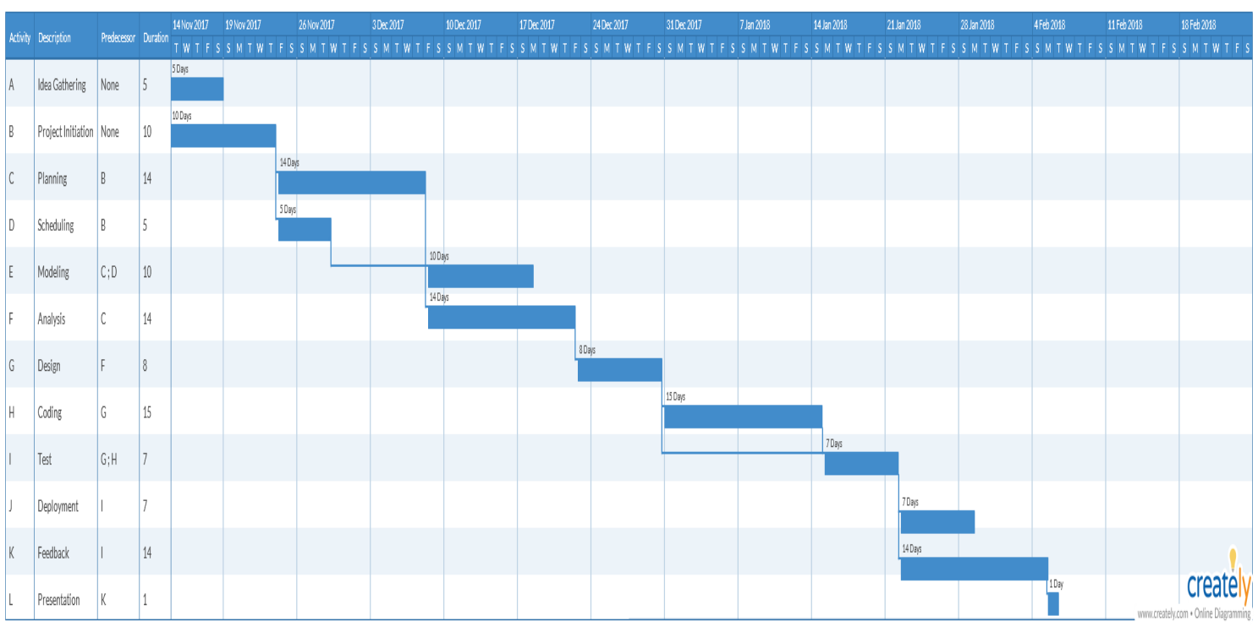

**Risk Analysis:**

* To not be able to implement all the mentioned features within the deadline.
* Taking more time in one part causing hamper in the whole project schedule.
* Crash occurring due to unknown bugs.
* Delay in rolling out updates and providing customer service.
* Performance or UI design not according to the taste of the client leading to more cost.
* Hard disk or other storage failure resulting in a wiped out database.

**Conclusion:**

Currently the rate of people suffering from autism is low but for lack of proper knowledge,superstition,medical facilities specially in the rural area,people often misunderstand them and they are not treated properly.So we are keen to work on this project and if we can change the view of people towards autism,make the lives of the autistic children and their parents or supervisors a little bit easier,we will take that as a step towards success.