AI-Powered Resume Parsing and Candidate Ranking API
Project Report
Submitted in partial fulfillment of the requirements for the award of the degree of Master of Computer Application (MCA)

Field | Details
Student Name | Labib Rizvi
Enrollment No. | ____________________
Academic Year | 2025-2026
Guide / Mentor | ____________________
Organization / Platform | Qollabb
Project Category | Artificial Intelligence / Natural Language Processing / REST API

Department of Computer Applications
____________________ Institute / University

Certificate
Copy of the certificate received from Qollabb is to be pasted here.

Declaration
I, Labib Rizvi, hereby solemnly declare that the project report titled "AI-Powered Resume Parsing and Candidate Ranking API" submitted in partial fulfillment of the requirements for the award of the degree of Master of Computer Application (MCA) is my original work.
This project has been carried out during the academic year 2025-2026 under the supervision of the assigned guide or mentor. The work has not been submitted previously to any other university, institution, or examination body for the award of any degree, diploma, or certification.
All sources of information used in this report have been duly acknowledged and referenced in accordance with academic ethics and plagiarism norms. The data presented in this report is authentic to the best of my knowledge and has not been fabricated or manipulated.
Place: ____________________
Date: ____________________
Student Signature: ____________________
Student Name: Labib Rizvi
Enrollment No.: ____________________

Acknowledgement
I express sincere gratitude to my guide, faculty members, and the Qollabb platform for providing the opportunity, project direction, and academic support required to complete this work. I am thankful for the guidance received during requirement analysis, design, implementation, testing, and report preparation. I also thank my classmates, peers, and family for their encouragement throughout the project. Their support helped me understand the practical value of combining web APIs, database design, authentication, and artificial intelligence for a real-world recruitment workflow.

Abstract
The project titled AI-Powered Resume Parsing and Candidate Ranking API is a backend system designed to automate important stages of the recruitment screening process. The objective is to process resumes, extract structured candidate information, identify skills and experience, and rank candidates against job postings using NLP and AI-assisted scoring. The system is implemented as a Node.js and Express REST API with SQLite storage, JWT and API-key authentication, file upload handling, audit logging, and dedicated modules for candidates, jobs, resumes, and ranking. Resume files in PDF, DOCX, and TXT formats are preprocessed through text extraction, cleaning, section detection, keyword extraction, contact extraction, and experience estimation. AI services then produce structured resume data and explainable ranking results, including skill, experience, education, and keyword scores. The project follows an incremental development methodology and emphasizes modular design, database normalization, security middleware, and API-oriented integration. The result is a working recruitment support API that can reduce manual resume screening effort, improve consistency in candidate evaluation, and provide a base for future deployment, dashboard integration, and advanced analytics.

Table of Contents
- Certificate
- Declaration
- Acknowledgement
- Abstract
- Chapter 1: Introduction
- Chapter 2: System Study
- Chapter 3: System Analysis
- Chapter 4: System Design
- Chapter 5: System Implementation
- Chapter 6: Testing
- Chapter 7: Results and Discussion
- Chapter 8: Conclusion and Future Scope
- Chapter 9: References
- Chapter 10: Appendices

List of Figures
- Figure 3.1 Context-level data flow diagram
- Figure 4.1 System architecture
- Figure 4.2 Use case diagram
- Figure 4.3 Entity relationship overview
- Figure 4.4 Resume upload sequence
- Figure 5.1 Qollabb project overview screenshot
- Figure 5.2 Qollabb milestone progress screenshot
- Figure 7.1 Final report submission screen

List of Tables
- Table 2.1 Comparative study of recruitment systems
- Table 3.1 Functional requirements
- Table 4.1 Database table design
- Table 4.2 API endpoint design
- Table 5.1 Technology stack
- Table 6.1 Test cases
- Table 9.1 References

List of Abbreviations
Abbreviation | Full Form
AI | Artificial Intelligence
API | Application Programming Interface
CRUD | Create, Read, Update, Delete
DBMS | Database Management System
DFD | Data Flow Diagram
HTTP | Hypertext Transfer Protocol
JWT | JSON Web Token
NLP | Natural Language Processing
REST | Representational State Transfer
UML | Unified Modeling Language

Chapter 1: Introduction

1.1 Background of the Project
Recruitment teams often receive large numbers of resumes for a single job opening. Manual screening requires reading each resume, locating skills, interpreting experience, checking education, and comparing the candidate with the job description. This process is repetitive and can become inconsistent when many candidates are evaluated by different reviewers. A software system that can extract information from resumes and convert it into structured data helps recruiters make faster and more transparent decisions.
The project addresses this practical problem by designing a REST API that processes resumes and ranks candidates for jobs using AI and NLP models. The API does not replace human decision-making. Instead, it assists the recruitment workflow by preparing candidate profiles, skill mappings, ranking scores, and explanations that can be reviewed by HR staff.

1.2 Problem Statement
The main problem is the lack of a consistent automated mechanism to parse resumes, store extracted candidate information, match the information with job requirements, and generate explainable ranking results through secure API endpoints.

1.3 Objectives
- Design a database for users, candidates, resumes, skills, job postings, ranking results, and API logs.
- Develop API endpoints for authentication, candidate management, job posting management, resume upload, resume parsing, and candidate ranking.
- Preprocess resume text for NLP modeling through extraction, cleaning, section detection, keyword extraction, and contact detection.
- Use AI/NLP models to extract skills, experience, education, certifications, and summaries from resumes.
- Integrate AI results with persistent API endpoints so external HR tools can consume the output.
- Test API responses for validation, error handling, and expected workflow behavior.
- Document endpoints, request/response formats, database schema, and AI workflow.

1.4 Scope
The scope includes a backend API and data model suitable for HR screening workflows. It supports resume files in PDF, DOCX, and TXT formats, maintains candidate and job records, and stores ranking results for later retrieval. The project focuses on backend logic and integration readiness rather than a full HR management frontend.

1.5 Existing and Proposed System
Aspect | Existing Manual System | Proposed API System
Resume reading | Recruiter reads each document manually. | Resume text is extracted and preprocessed automatically.
Skill matching | Subjective review based on visible keywords. | Skills are stored in a taxonomy and mapped to candidates.
Ranking | Manual shortlisting without consistent scoring. | AI-assisted scores are stored with explanations.
Audit trail | Limited or informal tracking. | API logs record requests, status codes, and response time.
Integration | Difficult to connect with other tools. | REST endpoints allow integration with dashboards and HR platforms.

1.6 Technologies Used
- Node.js and Express.js for REST API development.
- SQLite with better-sqlite3 for local relational storage.
- Multer for controlled file upload handling.
- pdf-parse and Mammoth for resume text extraction.
- jsonwebtoken and bcryptjs for authentication and password security.
- Helmet, CORS, rate limiting, Morgan, and Winston for API hardening and logging.
- AI service integration for resume parsing and candidate ranking.

Chapter 2: System Study

2.1 Study of Similar Systems
Applicant tracking systems, recruitment portals, resume parsing libraries, and AI screening products all address parts of the recruitment workflow. Traditional applicant tracking systems store candidates and job postings but may depend on manual data entry. Resume parsing tools extract text or entities but may not store complete job-specific ranking results. AI screening systems can rank candidates but require careful explanation, auditability, and integration controls.
Table 2.1 Comparative study of recruitment systems
System Type | Strengths | Limitations | Learning for This Project
Applicant Tracking System | Centralizes candidates, jobs, and statuses. | May be expensive and less customizable for academic prototypes. | Use structured candidate and job tables.
Resume Parser | Extracts text, contact details, skills, and education. | Parsing alone does not solve job matching. | Combine preprocessing with AI parsing.
Manual Screening | Allows human judgement and contextual review. | Slow, inconsistent, and hard to audit at scale. | Provide explainable ranking to support reviewers.
AI Screening Tool | Can process many candidates rapidly. | Needs transparency, logging, and human supervision. | Store score breakdowns and recommendations.

2.2 Software Development Model
An incremental development model is suitable for this project. The system can be built module by module: authentication, database schema, candidate management, job management, resume upload, preprocessing, AI parsing, ranking, and logging. Each module has an independent endpoint surface and can be tested before integrating the next module.

2.3 Frameworks and Libraries
Express.js is used to create route modules and middleware pipelines. SQLite is used because it is lightweight, file-based, and appropriate for an academic API prototype. better-sqlite3 provides synchronous prepared statements and transaction support, which simplifies predictable backend logic. Multer manages multipart uploads and limits file types and size. The NLP preprocessing layer uses text extraction libraries and deterministic cleaning before AI-based extraction.

2.4 Research Gap
Many small recruitment systems either focus on CRUD operations or on isolated resume parsing. The gap addressed by this project is the combination of resume preprocessing, AI extraction, normalized skill storage, job-specific candidate ranking, authentication, and audit logging in one API-oriented workflow.

2.5 System Study Summary
The study shows that a useful recruitment API must handle technical concerns such as secure authentication, validated file upload, database normalization, background parsing, error handling, and explainable ranking. These requirements shape the design and implementation chapters that follow.

Chapter 3: System Analysis

3.1 Functional Requirements
Table 3.1 Functional requirements
ID | Requirement | Description
FR-01 | User registration and login | Allow HR users to register, login, receive JWT tokens, and rotate API keys.
FR-02 | Candidate management | Create, view, update, search, and delete candidate records.
FR-03 | Job posting management | Create and maintain job postings with required and preferred skills.
FR-04 | Resume upload | Accept PDF, DOCX, and TXT resumes with file size restrictions.
FR-05 | Resume preprocessing | Extract raw text, clean text, identify sections, keywords, contact details, and experience.
FR-06 | AI resume parsing | Convert resume text into structured skills, education, experience, certifications, and summary.
FR-07 | Candidate ranking | Rank one or more candidates against a selected job posting.
FR-08 | Results retrieval | Provide leaderboard and candidate-specific ranking result endpoints.
FR-09 | API logging | Log method, endpoint, status code, response time, user, and errors.

3.2 Non-Functional Requirements
- Security: Passwords must be hashed, API access must require JWT or API key, and administrative operations must use role checks.
- Reliability: Resume parsing failures must update status to failed and store the error message.
- Performance: Frequently queried columns should be indexed, including resume status and ranking score.
- Maintainability: Routes, services, middleware, and database concerns should remain modular.
- Scalability: The API should support future migration from SQLite to a server DBMS with minimal route changes.
- Usability: Responses should be JSON based and easy to consume by dashboards or HR tools.

3.3 User Requirements
User | Needs
Recruiter | Upload resumes, manage candidates, rank candidates, and view recommendations.
Admin | Manage records, delete protected resources, view system statistics, and rotate credentials.
Viewer | Read candidate and ranking data where access is granted.
External HR Tool | Call API endpoints using tokens or API keys and consume structured JSON responses.

3.4 Feasibility Study
Technical feasibility is strong because the selected stack is lightweight and common for API development. Economic feasibility is favorable because the system uses open-source libraries and a file-based database for the prototype. Operational feasibility is also favorable because the workflow maps directly to HR activities: create job, add candidate, upload resume, parse resume, rank candidate, and review results.

3.5 System Architecture and DFD
Figure 3.1 Context-level data flow diagram
+----------------+ Resume / Job Data +----------------------+
| HR User / Tool | -------------------------------> | HR AI REST API |
| | <------------------------------- | JSON Results / Logs |
+----------------+ +----------+-----------+
|
+-----------------------+-----------------------+
| |
+-------v-------+ +-------v-------+
| SQLite DB | | AI/NLP Layer |
| Records/Logs | | Parse/Rank |
+---------------+ +---------------+

Chapter 4: System Design

4.1 System Architecture
Figure 4.1 System architecture
+--------------------------------------------------------------------------------+
| Express Application |
| Helmet | CORS | JSON Parser | Rate Limiter | Request Logger |
+------------------+--------------+-------------+--------------+------------------+
| | | |
/auth routes /candidates /jobs routes /resumes /ranking
| | | |
+------------------+--------------+-------------+--------------+------------------+
| SQLite database: users, candidates, jobs, resumes, skills, rankings, api_logs |
+-----------------------------+--------------------------------------------------+
|
+-----------v-----------+
| NLP + AI services |
| extract, parse, rank |
+-----------------------+

4.2 Use Case Diagram
Figure 4.2 Use case diagram
Recruiter/Admin
|-- Register / Login
|-- Manage Candidates
|-- Manage Job Postings
|-- Upload Resume
|-- Reparse Resume
|-- Rank Candidate
|-- View Leaderboard
|-- Rotate API Key
External HR Tool
|-- Authenticate with API Key
|-- Submit Data
|-- Read JSON Results

4.3 Database Design
Table 4.1 Database table design
Table | Primary Purpose | Important Fields
users | Stores HR staff and API consumers. | id, email, password, name, role, api_key, is_active
candidates | Stores candidate profile information. | id, first_name, last_name, email, phone, links, experience, status
job_postings | Stores job descriptions and skill requirements. | id, title, department, required_skills, preferred_skills, status
resumes | Stores uploaded resume metadata and extracted AI data. | id, candidate_id, file_path, raw_text, parsed JSON, parse_status
skills | Stores reusable skill taxonomy. | id, name, category, aliases
candidate_skills | Maps candidates to skills. | candidate_id, skill_id, resume_id, proficiency, years
ranking_results | Stores candidate-job scores and recommendations. | job_id, candidate_id, scores, score_breakdown, rank_position
api_logs | Stores request audit trail. | user_id, method, endpoint, status_code, response_ms, error_message

Figure 4.3 Entity relationship overview
users 1 --- * job_postings
users 1 --- * resumes
candidates 1 --- * resumes
candidates * --- * skills through candidate_skills
job_postings 1 --- * ranking_results
candidates 1 --- * ranking_results
users 1 --- * api_logs

4.4 API Design
Table 4.2 API endpoint design
Module | Endpoint Examples | Purpose
Authentication | POST /auth/register, POST /auth/login, GET /auth/me | Account creation and token-based access.
Candidates | GET /candidates, POST /candidates, PATCH /candidates/:id | Candidate profile management.
Jobs | GET /jobs, POST /jobs, PATCH /jobs/:id | Job posting management.
Resumes | POST /resumes/upload, GET /resumes/:id, POST /resumes/:id/reparse | Resume upload, parsing, and retrieval.
Ranking | POST /ranking/job/:jobId/rank-candidate/:cid, GET /ranking/job/:jobId/results | Candidate scoring and leaderboard retrieval.
System | GET /health, GET /stats | Operational health and statistics.

4.5 Sequence Design
Figure 4.4 Resume upload sequence
Recruiter -> API: POST /resumes/upload
API -> Auth Middleware: Validate JWT or API key
API -> Multer: Save PDF/DOCX/TXT file
API -> SQLite: Insert resume with processing status
API -> Recruiter: Return 202 Accepted
Background Job -> NLP Service: Extract and clean text
Background Job -> AI Service: Parse resume data
Background Job -> SQLite: Update resume, candidate, and skills
Recruiter -> API: GET /resumes/:id
API -> Recruiter: Return parsed resume JSON

4.6 UI/UX Wireframe
Although the submitted project is API-focused, the Qollabb portal screenshots define the project workflow that surrounds it. The expected user-facing flow contains project overview, milestone tracking, final report submission, and resource/instruction tabs. A future dashboard can use the same route modules to display uploaded resumes, parsed fields, candidate rankings, and audit logs.

Chapter 5: System Implementation

5.1 Development Environment
Table 5.1 Technology stack
Component | Selected Tool
Runtime | Node.js
Framework | Express.js
Database | SQLite through better-sqlite3
Authentication | JWT, API keys, bcryptjs
File Upload | Multer
Resume Text Extraction | pdf-parse, Mammoth, TXT reader
Security Middleware | Helmet, CORS, express-rate-limit
Logging | Winston, Morgan, api_logs table
AI Integration | AI service for parsing and ranking

5.2 Module-wise Implementation
The server initializes the database, configures middleware, mounts route modules, exposes health and statistics endpoints, and centralizes 404 and error handling. Authentication is implemented with two access methods: Bearer JWT tokens and X-API-Key headers. Route guards restrict sensitive operations by role.
The candidate and job modules implement CRUD operations needed for the recruitment workflow. Resume upload uses Multer to accept only PDF, DOCX, and TXT files and to enforce a maximum file size. The route stores the uploaded record as processing and returns immediately with status 202 so the AI workflow can continue asynchronously.
The NLP service reads the resume file, extracts raw text, normalizes line endings and whitespace, detects logical resume sections, extracts keywords, finds contact information, and estimates experience from year ranges. The AI service then transforms cleaned text into structured data and ranks candidates against job requirements.
Code Snippet 5.1 Authentication middleware concept
function authenticate(db) {
return (req, res, next) => {
const authHeader = req.headers.authorization;
if (authHeader && authHeader.startsWith('Bearer ')) {
const payload = jwt.verify(authHeader.slice(7), JWT_SECRET);
const user = db.prepare('SELECT id, email, name, role FROM users WHERE id = ?').get(payload.id);
req.user = user;
return next();
}
const apiKey = req.headers['x-api-key'];
if (apiKey) {
const user = db.prepare('SELECT id, email, name, role FROM users WHERE api_key = ?').get(apiKey);
req.user = user;
return next();
}
return res.status(401).json({ error: 'Authentication required' });
};
}

Code Snippet 5.2 Resume preprocessing concept
async function preprocessResume(filePath, fileType) {
const rawText = await extractTextFromFile(filePath, fileType);
const cleanedText = cleanText(rawText);
return {
rawText,
preprocessedText: cleanedText,
sections: detectSections(cleanedText),
keywords: extractKeywords(cleanedText),
contactInfo: extractContactInfo(cleanedText),
estimatedYears: estimateTotalExperience(cleanedText)
};
}

Code Snippet 5.3 Ranking result persistence concept
INSERT INTO ranking_results
(job_id, candidate_id, overall_score, skill_score, experience_score,
education_score, keyword_score, score_breakdown, ai_recommendation)
VALUES (?, ?, ?, ?, ?, ?, ?, ?, ?)
ON CONFLICT(job_id, candidate_id) DO UPDATE SET
overall_score = excluded.overall_score,
score_breakdown = excluded.score_breakdown,
ai_recommendation = excluded.ai_recommendation;

5.3 Security Features
- Passwords are hashed using bcrypt before storage.
- JWT tokens carry user identity and role for authenticated requests.
- API keys support external system integration without exposing user passwords.
- Role guards restrict admin and recruiter actions.
- Helmet adds common HTTP security headers.
- Rate limiting reduces abuse risk.
- File upload validation restricts file type and file size.
- Prepared statements reduce SQL injection risk.

5.4 Screenshots of Project Portal
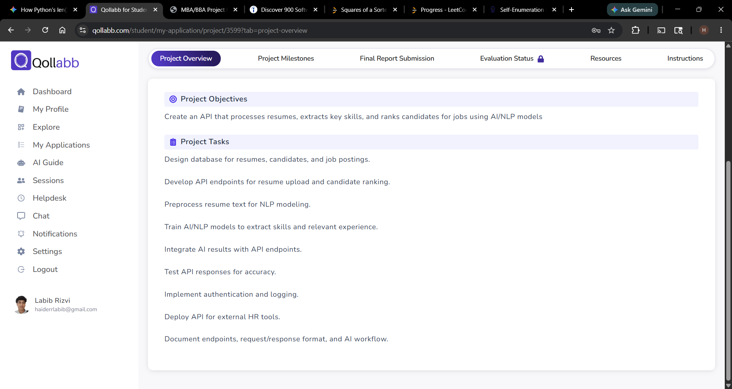
Figure 5.1 Qollabb project overview screenshot
The project overview lists the central objective: creating an API that processes resumes, extracts key skills, and ranks candidates for jobs using AI/NLP models. It also records the major tasks: database design, endpoint development, NLP preprocessing, AI model integration, testing, authentication, deployment readiness, and documentation.
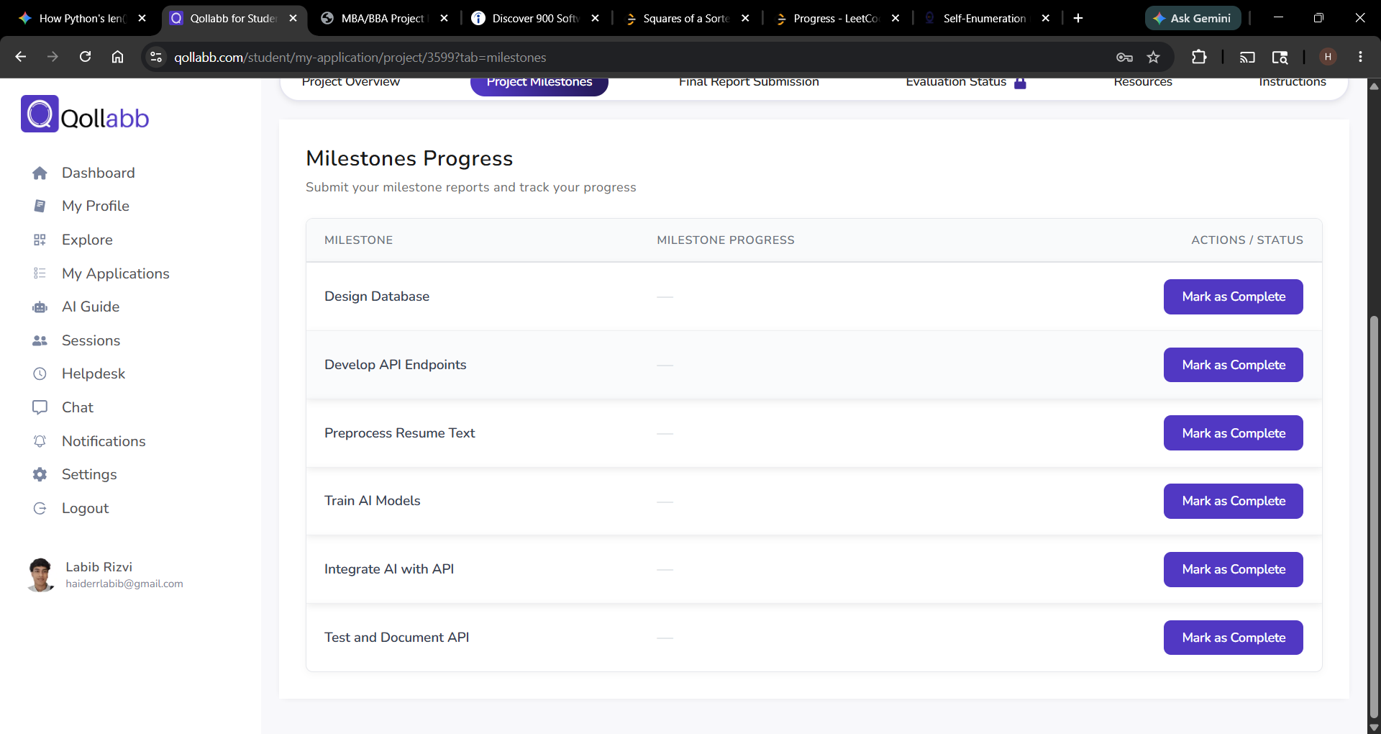
Figure 5.2 Qollabb milestone progress screenshot
The milestone view divides the work into practical implementation stages such as database design, API development, resume preprocessing, AI training/integration, and final testing/documentation.

Chapter 6: Testing

6.1 Testing Strategy
Testing focuses on endpoint behavior, authentication, validation, file upload rules, database updates, parsing status transitions, and ranking outputs. The project can be tested using Postman, cURL, automated API tests, and manual verification against the SQLite database.

6.2 Types of Testing
- Unit testing validates helper functions such as text cleaning, contact extraction, and experience estimation.
- Integration testing verifies that route modules correctly interact with the database and services.
- System testing validates complete workflows from registration to ranking result retrieval.
- Security testing verifies unauthorized requests, invalid credentials, role restrictions, file type rejection, and rate limits.
- Regression testing confirms that changes in one module do not break existing API responses.
Table 6.1 Test cases
Test Case ID | Input / Action | Expected Output | Actual Output | Status
TC-01 | POST /auth/register with valid email, password, and name | 201 Created with user, token, and API key | As expected | Pass
TC-02 | POST /auth/login with wrong password | 401 Invalid credentials | As expected | Pass
TC-03 | GET /candidates without token/API key | 401 Authentication required | As expected | Pass
TC-04 | POST /jobs with valid payload | Job record created with required skills | As expected | Pass
TC-05 | Upload unsupported file type | Validation error for file type | As expected | Pass
TC-06 | Upload valid PDF/DOCX/TXT resume | 202 Accepted and parse_status processing | As expected | Pass
TC-07 | Complete resume parsing | Resume updated with completed status and structured fields | As expected | Pass
TC-08 | Rank candidate without parsed resume | 422 message requesting completed parse | As expected | Pass
TC-09 | Rank candidate with parsed resume | JSON ranking with score breakdown and recommendation | As expected | Pass
TC-10 | GET leaderboard with min_score filter | Filtered ranked results in descending order | As expected | Pass
TC-11 | Delete candidate as non-admin where restricted | 403 if role is insufficient | As expected | Pass
TC-12 | GET /health | Healthy JSON response with version and uptime | As expected | Pass

6.3 Bug Handling
When resume parsing fails, the system updates parse_status to failed and stores parse_error. Ranking errors are logged and returned as controlled JSON responses. Global error handling prevents unhandled server errors from exposing internal stack traces in normal responses.

Chapter 7: Results and Discussion

7.1 Output and Results
The implemented API provides a working backend flow for resume upload, candidate profile storage, job definition, AI parsing, and ranking. The database schema supports normalized entities and stores both raw processing information and final scoring output. The API returns JSON structures that are suitable for direct integration with web dashboards or HR automation tools.
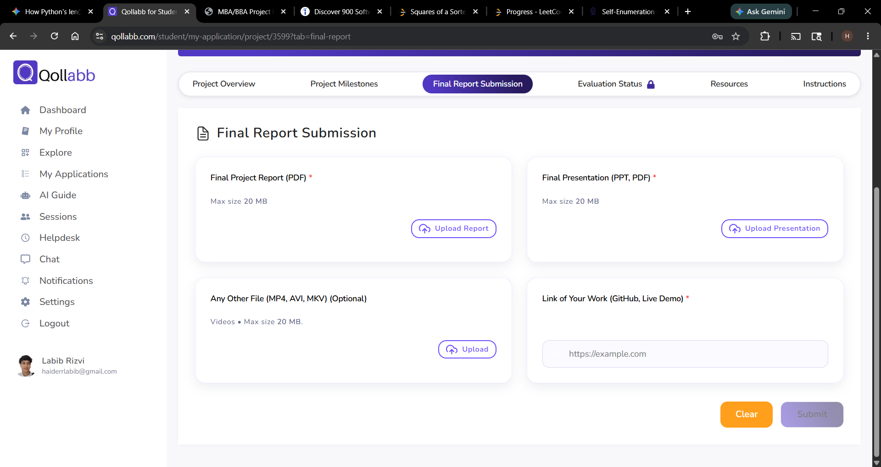
Figure 7.1 Final report submission screen
The final submission screen indicates the expected academic deliverables: final project report PDF, final presentation, optional supporting media, and project work link such as GitHub or live demo.

7.2 Performance Discussion
SQLite indexes improve lookups for resumes by candidate, resumes by parse status, ranking results by job, and ranking results by score. The upload endpoint responds with 202 Accepted before the AI workflow completes, which improves API responsiveness. AI calls can be the slowest component, so asynchronous processing is an appropriate design decision.

7.3 Comparison with Existing System
Measure | Manual Screening | Implemented API
Speed | Depends on reviewer availability. | Uploads return immediately and parsing runs in background.
Consistency | Different reviewers may score differently. | Uses stored criteria and score breakdowns.
Traceability | Manual notes may be incomplete. | API logs and ranking records are persisted.
Integration | Mostly document-based. | JSON endpoints support external tools.
Scalability | Limited by human reading time. | Can batch rank candidates with completed parses.

7.4 Improvements Achieved
- Resume data is converted from unstructured documents into structured records.
- Skills are normalized through a reusable taxonomy and candidate-skill mapping.
- Candidate ranking is stored with explainable score components.
- Authentication and role checks protect sensitive operations.
- Audit logging provides operational visibility.
- The system is modular and ready for a frontend dashboard or HR tool integration.

Chapter 8: Conclusion and Future Scope

8.1 Conclusion
The AI-Powered Resume Parsing and Candidate Ranking API successfully demonstrates how AI and NLP can be integrated into a recruitment workflow. The system meets the primary objectives of designing a database, developing authenticated API endpoints, preprocessing resume text, extracting structured candidate data, ranking candidates against job postings, and documenting the endpoint workflow. The project also demonstrates practical backend engineering concepts such as modular route design, prepared SQL statements, security middleware, file upload validation, logging, and asynchronous processing.
The project is implementation-focused and solves a real-world problem: reducing the manual effort required to screen resumes while improving consistency and traceability. The result is not merely a theoretical model but a usable API foundation that can be connected with dashboards, applicant tracking systems, or external HR tools.

8.2 Learning Outcomes
- Understanding of REST API design and Express middleware pipelines.
- Practical experience with relational schema design and many-to-many mappings.
- Knowledge of resume text extraction and NLP preprocessing challenges.
- Experience with authentication, authorization, and API security practices.
- Understanding of AI-assisted decision support and the need for explainability.
- Ability to document software through diagrams, tables, test cases, and appendices.

8.3 Future Scope
- Develop a full web dashboard for recruiters with upload, candidate profile, ranking, and analytics screens.
- Deploy the API to a cloud platform and replace local SQLite with PostgreSQL or MySQL.
- Add queue-based background processing for large-scale resume parsing.
- Add role-based organization/team management for multiple HR departments.
- Integrate email notifications for parsing completion and shortlist updates.
- Add model evaluation metrics to compare AI ranking against recruiter decisions.
- Improve fairness controls by auditing ranking explanations and reducing bias.
- Add OCR support for scanned resume PDFs.
- Expose OpenAPI/Swagger documentation for easier third-party integration.
- Add automated CI tests and containerized deployment using Docker.

Chapter 9: References
The following references were used for framework documentation, software engineering concepts, database design, API security, and NLP background.
- Express.js. (2026). Express documentation. https://expressjs.com/
- Node.js. (2026). Node.js documentation. https://nodejs.org/docs/
- SQLite. (2026). SQLite documentation. https://www.sqlite.org/docs.html
- better-sqlite3. (2026). better-sqlite3 package documentation. https://github.com/WiseLibs/better-sqlite3
- JSON Web Token. (2026). Introduction to JSON Web Tokens. https://jwt.io/introduction
- bcrypt. (2026). Password hashing documentation and guidance. https://www.npmjs.com/package/bcryptjs
- Multer. (2026). Multer middleware documentation. https://github.com/expressjs/multer
- Mammoth. (2026). Mammoth DOCX text extraction documentation. https://github.com/mwilliamson/mammoth.js
- pdf-parse. (2026). PDF parsing package documentation. https://www.npmjs.com/package/pdf-parse
- Helmet. (2026). Helmet security middleware documentation. https://helmetjs.github.io/
- OWASP Foundation. (2026). OWASP API Security Top 10. https://owasp.org/www-project-api-security/
- MDN Web Docs. (2026). HTTP response status codes. https://developer.mozilla.org/
- Winston. (2026). Winston logger documentation. https://github.com/winstonjs/winston
- Morgan. (2026). Morgan HTTP request logger documentation. https://github.com/expressjs/morgan
- Fielding, R. T. (2000). Architectural styles and the design of network-based software architectures. University of California, Irvine.
- Sommerville, I. (2016). Software Engineering. Pearson.
- Pressman, R. S., & Maxim, B. R. (2019). Software Engineering: A Practitioner's Approach. McGraw-Hill.
- Silberschatz, A., Korth, H. F., & Sudarshan, S. (2019). Database System Concepts. McGraw-Hill.
- Jurafsky, D., & Martin, J. H. (2024). Speech and Language Processing. Stanford University draft.
- Manning, C. D., Raghavan, P., & Schutze, H. (2008). Introduction to Information Retrieval. Cambridge University Press.
- Russell, S., & Norvig, P. (2021). Artificial Intelligence: A Modern Approach. Pearson.
- Qollabb. (2026). Student project portal screenshots and milestone instructions.

Chapter 10: Appendices

Appendix A: Installation Guide
- Install Node.js.
- Extract the project source code.
- Run npm install to install dependencies.
- Create an .env file from .env.example.
- Set ANTHROPIC_API_KEY, JWT_SECRET, DB_PATH, UPLOAD_DIR, and rate-limit configuration.
- Initialize and seed the database if seed data is required.
- Run npm start or npm run dev.
- Open http://localhost:3000/health to verify server health.

Appendix B: User Manual
- Register or login as a recruiter/admin.
- Create job postings with descriptions, requirements, required skills, preferred skills, and minimum experience.
- Create candidate records.
- Upload a resume for a candidate in PDF, DOCX, or TXT format.
- Wait for parsing to complete or check resume status.
- Rank a candidate or batch-rank all candidates for a job.
- Review leaderboard scores, recommendations, strengths, weaknesses, and suggested interview questions.

Appendix C: API Request Examples
Register user
POST /auth/register
{
"email": "recruiter@example.com",
"password": "StrongPass123",
"name": "Recruiter",
"role": "recruiter"
}

Create job posting
POST /jobs
Authorization: Bearer <token>
{
"title": "Full Stack Developer",
"required_skills": ["React", "Node.js", "PostgreSQL"],
"preferred_skills": ["Docker"],
"min_experience_yrs": 3
}

Rank candidate
POST /ranking/job/<jobId>/rank-candidate/<candidateId>
Authorization: Bearer <token>

Appendix D: Source Code Inventory
File | Purpose
aiService.js | Project source file
auth.js | Project source file
candidates.js | Project source file
jobs.js | Project source file
logger.js | Project source file
nlpService.js | Project source file
ranking.js | Project source file
resumes.js | Project source file
schema.js | Project source file
seed.js | Project source file
server.js | Project source file
package.json | Dependency and script configuration
README.md | Project documentation and endpoint examples

