Big Data Analytics: Project 2
Digital Advertising Budget Optimizer
Where should we spend the next Rs 1,000,000?
KPI analysis, a pandas vs MapReduce vs Spark comparison from 10,000 to 10,000,000 records, and a Marketing Budget Recommendation Engine
Student name: ______________________ Roll no.: ______________
Course / instructor: ______________________ Date: ______________
All data in this project is simulated. Results describe the simulator, not real campaigns.

Contents
1. Executive summary
2. Problem and objectives
3. Data and simulation design
4. KPIs and platform performance
5. Big Data simulation: pandas vs MapReduce vs Spark
6. Marketing Budget Recommendation Engine
7. Validation
8. Software engineering and testing
9. Limitations and ethics
10. Conclusions and future work
11. Appendices

1. Executive summary
A company advertises on Facebook, Instagram, Google, TikTok and YouTube and asks where the next Rs 1,000,000 should go. This project builds the full analytics chain to answer that question on simulated data: a seeded generator of advertising records, the standard KPIs (CTR, CPC, CPA, conversion rate, ROAS, revenue), three processing engines compared at four data sizes, and a recommendation engine that turns historical performance into a budget split.
- Recommendation: Google 50%, Facebook 25%, Instagram 11%, YouTube 8%, TikTok 6%. Google and Facebook gain share; Instagram, YouTube and TikTok lose share.
- Expected effect: the model expects Rs 4.07 million of monthly revenue from the recommended split against Rs 3.60 million from the current mix (+13.1%). Scored against the simulator's true response curves the gain is +13.0%.
- Engines: at 10,000,000 rows pandas took 8.4 s and the MapReduce simulation 9.6 s on a 2-core machine; both returned identical results at every size. Spark was written, with an equivalence test, but PySpark could not be installed in the development sandbox, so Spark was not run and no Spark timings are reported.
- Main caveat: the recommended shares depend strongly on the guardrails (Google ranges from 40% to 79% across reasonable settings). The direction of the advice is robust; the exact percentages are not. The result must be confirmed with a small live test before real spend.

2. Problem and objectives
Digital marketing teams split a fixed budget across platforms that differ in cost per impression, click-through, conversion and basket size. Intuition tends to chase the platform with the best average return, but returns shrink as spend on one platform grows, so the best split is not simply 'everything to the best ROAS'. Management's question is therefore a constrained optimisation problem on top of a data-engineering problem: the history can be large, and the tooling choice (pandas, MapReduce, Spark) matters as it grows.

Objectives
- Generate realistic, reproducible advertising records at 10 thousand, 100 thousand, 1 million and 10 million rows.
- Calculate CTR, CPC, CPA, conversion rate, ROAS, revenue and campaign performance correctly (ratios of sums, safe division).
- Run the same aggregation job in pandas, a MapReduce simulation and Spark, verify they agree, and compare time and memory as data grows.
- Build a recommendation engine that outputs a platform split of a budget, with uncertainty and validation, and be explicit about what it can and cannot claim.
- Deliver it as tested, documented software with an interactive Streamlit app, in the same structure as Project 1.

3. Data and simulation design

3.1 Schema
Column | Meaning
date | Day of the record (2024, 366 days)
campaign | One of 12 campaigns (Eid_Sale, Retargeting, Black_Friday, ...)
platform | Facebook, Instagram, Google, TikTok or YouTube
impressions, clicks, conversions | Integer counts with clicks <= impressions and conversions <= clicks
spend, revenue | Pakistani rupees (Rs)
age | Age band: 18-24, 25-34, 35-44, 45-54, 55+
gender | Female, Male, Other
city | Karachi, Lahore, Islamabad, Rawalpindi, Faisalabad, Multan, Peshawar, Quetta
device | Mobile, Desktop, Tablet

3.2 How the data is generated
No real campaign data is used. The generator (src/data_generation/simulator.py) is seeded and block-based, so the same seed always gives the same file and the first 10,000 rows of the 10,000,000-row file are exactly the 10,000-row file. Each record draws a platform, day, campaign and audience segment, then:
- Impressions are log-normal and scaled by that platform's daily intensity.
- Clicks are binomial in the impressions with a click-through rate set by platform, age band, gender and device.
- Conversions are binomial in the clicks with a conversion rate set by platform, campaign, device, city, month and age.
- Spend is impressions x the platform's CPM with auction noise; revenue is conversions x order value with city and noise effects.
Platform parameters (Rs) were chosen to be plausible in order of magnitude, not calibrated to any real account:
Platform | CPM (Rs) | Base CTR | Base conv. rate | Order value (Rs) | True elasticity
Facebook | 350 | 1.1% | 2.2% | 3,200 | 0.70
Instagram | 420 | 0.9% | 1.8% | 3,500 | 0.75
Google | 600 | 3.0% | 3.0% | 3,600 | 0.55
TikTok | 250 | 1.0% | 1.4% | 2,600 | 0.85
YouTube | 300 | 0.7% | 1.5% | 3,000 | 0.80

3.3 Built-in diminishing returns (ground truth)
On any day a platform's intensity m multiplies impressions (so spend) by m, while click-through and conversion rate are each scaled by m^(-GAMMA/2). Daily revenue therefore grows like spend^(1-GAMMA): the true elasticity of each platform is 1 - GAMMA (table above). This is the economic idea that makes the budget question interesting (Google's search demand saturates fastest, TikTok's slowest) and, because it is known, it lets the recommendation engine be checked against the truth in Section 7.
Honest framing. Because the simulator contains the saturation effect, finding it again shows the method works; it does not show that real platforms behave this way. On real data the same code would need real daily spend variation to identify the curves.

4. KPIs and platform performance
KPI | Formula | Note
CTR | clicks / impressions
CPC | spend / clicks | Rs per click
CPM | 1000 x spend / impressions | Rs per 1,000 impressions
CPA | spend / conversions | Rs per conversion
Conversion rate | conversions / clicks | Defined per click, not per impression
ROAS | revenue / spend | Rs of revenue per Rs of spend
Profit | revenue - spend | No product cost is modelled, so this is not margin

Ratios are always computed on summed totals, never as an average of row-level ratios, which would over-weight small rows. Division by zero returns an empty value instead of infinity. Both rules are covered by unit tests.

4.1 Platform results (1,000,000 simulated rows)
Platform | Spend (Rs M) | Revenue (Rs M) | CTR | CPC (Rs) | CPA (Rs) | Conv. rate | ROAS
Google | 877 | 6,355 | 3.03% | 19.8 | 502 | 3.94% | 7.25
Facebook | 486 | 1,301 | 1.09% | 32.2 | 1,219 | 2.64% | 2.68
TikTok | 352 | 639 | 1.01% | 24.7 | 1,466 | 1.69% | 1.81
Instagram | 605 | 955 | 0.89% | 47.3 | 2,268 | 2.08% | 1.58
YouTube | 435 | 485 | 0.64% | 46.9 | 2,760 | 1.70% | 1.12

Table: platform KPIs from the 1M-row dataset (Rs M = millions of rupees). The data represents about Rs 2.75 billion of simulated spend, which is rescaled for the recommendation.
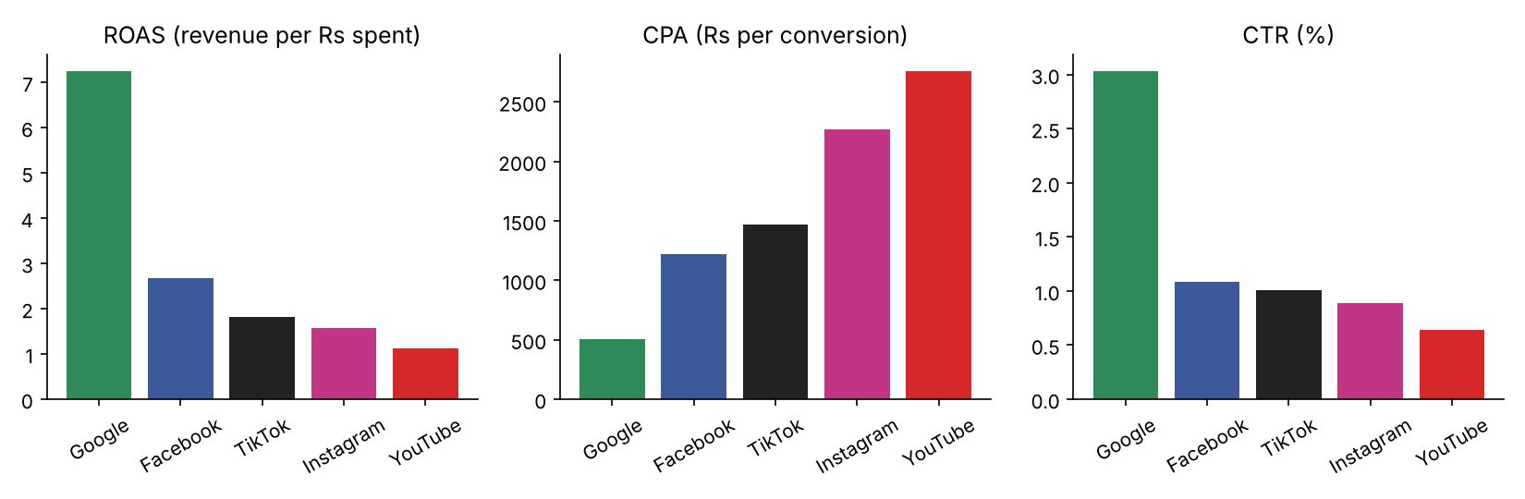
Figure 1: ROAS, CPA and CTR by platform.
Google earns the highest ROAS (7.25) and the lowest CPA (Rs 502) because search traffic has both a high click-through rate and a high conversion rate. YouTube is weakest (1.12). ROAS above 1 only means revenue exceeded ad spend; whether that is profitable depends on product margin, which is not in the data.

4.2 Campaign performance
Campaign | Spend (Rs M) | CTR | Conv. rate | CPA (Rs) | ROAS
Retargeting | 228 | 1.34% | 4.71% | 612 | 5.65
Loyalty_Rewards | 231 | 1.34% | 3.60% | 800 | 4.33
Black_Friday | 230 | 1.34% | 3.47% | 828 | 4.18
Eid_Sale | 231 | 1.33% | 3.17% | 909 | 3.81
Ramadan_Offers | 229 | 1.34% | 3.05% | 944 | 3.67
Clearance | 232 | 1.34% | 2.91% | 989 | 3.50
Independence_Day | 231 | 1.34% | 2.79% | 1,031 | 3.37
Winter_Launch | 227 | 1.34% | 2.63% | 1,092 | 3.18
Summer_Collection | 229 | 1.33% | 2.62% | 1,100 | 3.15
Back_To_School | 229 | 1.35% | 2.50% | 1,144 | 3.04
New_Arrivals | 232 | 1.35% | 2.50% | 1,147 | 3.03
Brand_Awareness | 228 | 1.33% | 1.24% | 2,321 | 1.50

Retargeting and Loyalty_Rewards (audiences who already know the brand) convert best; Brand_Awareness has the weakest ROAS, as expected for a campaign whose goal is reach rather than sales. CTR is almost identical across campaigns because the generator varies conversion, not click behaviour, by campaign.

5. Big Data simulation: pandas vs MapReduce vs Spark

5.1 Benchmark design
The job is identical in every engine: read the CSV, group by (date, platform, campaign) and sum impressions, clicks, spend, conversions and revenue, plus the row count. This produces a compact cube (about 22,000 groups) from which every platform, campaign and daily KPI can be rolled up. The datasets have 10,000, 100,000, 1,000,000 and 10,000,000 rows (the 10M file is about 860 MB).
- pandas: read_csv with the needed columns, then groupby. Single process, vectorised C code.
- MapReduce (simulation): the file is split into byte ranges aligned to line boundaries, mapper processes parse lines and emit (key, value) pairs with an in-mapper combiner, keys are routed to reducers with a stable hash, and reducer processes sum them. It reproduces the programming model on one machine with Python's multiprocessing; it is not Hadoop, and has no distributed file system or fault tolerance.
- Spark: a PySpark DataFrame version (read CSV, groupBy, agg). It is included and has an equivalence test, but pyspark could not be installed in the development sandbox (no package-index access), so it was not run.
Method: every run is a separate operating-system process (clean timings, per-engine memory), wall-clock time includes reading the file, the median of 3 runs is reported, and the harness verifies that every engine returns identical group counts, row counts and totals before a timing is accepted. Machine: 2 CPU cores, 7 GB RAM, Linux, Python 3.13.

5.2 Results
Records | pandas (s) | MapReduce (s) | MapReduce / pandas | pandas peak MB | MapReduce peak MB* | Spark
10,000 | 0.018 | 0.082 | 4.64x | 73 | 85 | not run
100,000 | 0.109 | 0.324 | 2.97x | 109 | 133 | not run
1,000,000 | 0.838 | 1.283 | 1.53x | 208 | 162 | not run
10,000,000 | 8.395 | 9.560 | 1.14x | 1,309 | 606 | not run

Table: median of 3 runs. *Peak memory of the largest single process; MapReduce's total across its worker processes is higher.
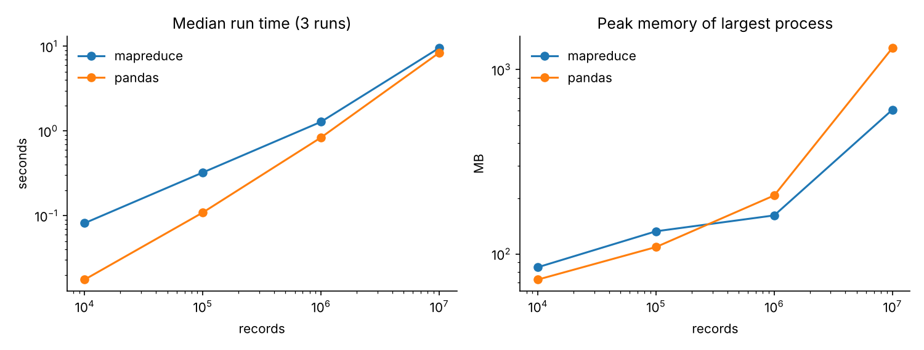
Figure 2: run time and peak memory against data size (log-log axes).

5.3 What the results show
- Single machine: pandas was faster at every size on this machine. The gap shrinks from 4.6x at 10,000 rows to 1.14x at 10,000,000 rows, because the MapReduce simulation pays a fixed cost for starting processes that is spread over more data, and two cores partly offset its slower pure-Python parsing.
- Scaling: going from 1M to 10M rows multiplied pandas time by 10.0x and MapReduce time by 7.5x: both scale roughly linearly in this range.
- Memory: at 10M rows pandas' process peaked at 1,309 MB because it loads the whole table, while the largest MapReduce process peaked at 606 MB because each mapper handles one split at a time. That streaming property, not raw speed, is why MapReduce-style engines keep working when data no longer fits in memory.
- Combiner experiment: on 1M rows the combiner matters: with it the job takes 1.3 s on 2 workers; without it every mapped pair has to be shuffled between processes and the job takes 5.9 s (4.5x slower). Two workers beat one with the combiner (1.7 s for one) but are slower without it (2.5 s for one), because shuffle cost grows with the volume that must be serialised.
MapReduce configuration (1M rows) | Median s (3 runs) | Min | Max
1 worker, combiner | 1.70 | 1.68 | 2.24
2 workers, combiner | 1.31 | 1.20 | 1.48
1 worker, no combiner | 2.53 | 2.47 | 2.66
2 workers, no combiner | 5.94 | 5.60 | 5.99

Spark. No Spark number is claimed. On a laptop-sized file the usual expectation is that Spark is slower than pandas (JVM start-up and scheduling overhead) and only pays off when the data exceeds one machine's memory or runs on a cluster; that is an expectation, to be replaced by a measurement with python run_benchmark.py --engines pandas mapreduce spark (see docs/SPARK_SETUP.md).
Conclusion for the comparison. For up to 10 million rows on one machine, pandas is the right tool: simplest and fastest. MapReduce and Spark are justified by data that outgrows memory or by cluster execution, which this single-machine test cannot show. It does show that the MapReduce model is correct (identical results) and how a combiner changes its cost.

6. Marketing Budget Recommendation Engine

6.1 Method
1. Response curves. For each platform, daily spend and revenue are fitted with revenue = a x spend^b by ordinary least squares on logarithms. b below 1 means diminishing returns: each extra rupee earns less than the last.
2. Rescaling. The simulated history covers billions of rupees, so it is rescaled by one common factor to a programme of Rs 1,000,000 per month. ROAS and b do not change under a common factor.
3. Optimisation. Maximise total predicted monthly revenue subject to spend adding up to the budget. For concave curves, repeatedly giving the next small increment to the platform with the highest marginal revenue is optimal (a unit test checks that marginal returns equalise).
4. Guardrails. Each platform gets at least 5% and at most 50% of the budget, and stays within 0.5x to 2x of its current share, because the curves are only reliable for spend levels that were actually observed.
5. Comparison and checks. The result is compared with the current mix, an equal split and a ROAS-proportional split, then tested by bootstrap, backtest, sensitivity and a check against the simulator's truth.

6.2 Recommended split of Rs 1,000,000
Platform | Current | Recommended | Budget (Rs) | Change (pts) | b | ROAS at rec. | Marginal ROAS | At bound
Google | 31.8% | 50.0% | 500,000 | +18.2 | 0.55 | 6.04 | 3.33 | max
Facebook | 17.6% | 24.7% | 247,346 | +7.1 | 0.71 | 2.46 | 1.74
Instagram | 22.0% | 11.0% | 109,832 | -11.0 | 0.74 | 1.92 | 1.43 | min
YouTube | 15.8% | 7.9% | 78,920 | -7.9 | 0.80 | 1.30 | 1.04 | min
TikTok | 12.8% | 6.4% | 63,902 | -6.4 | 0.85 | 2.03 | 1.72 | min

Recommended split (rounded): Google 50% Facebook 25% Instagram 11% YouTube 8% TikTok 6%
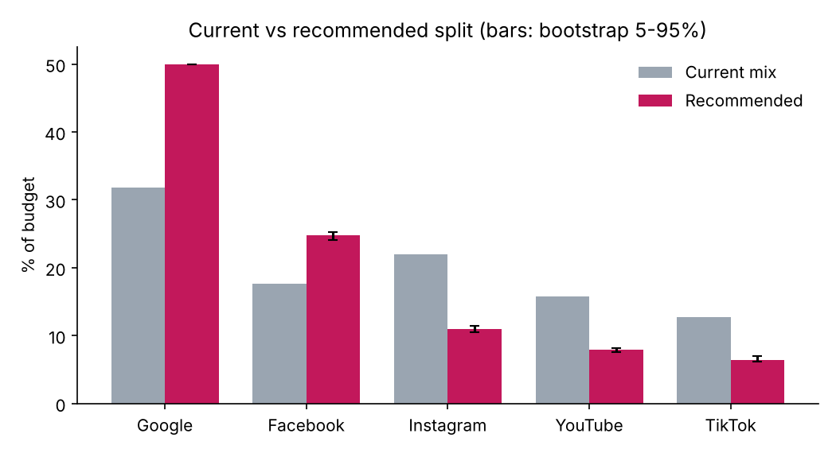
Figure 3: current and recommended shares; whiskers show the 5th to 95th percentile of 200 bootstrap re-fits.
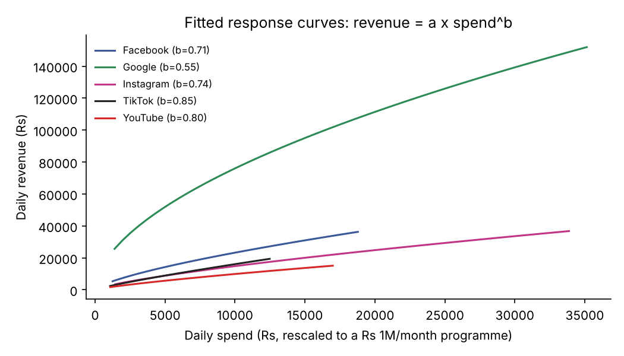
Figure 4: fitted response curves over the range of daily spend that was observed.
4 of the 5 platforms end at a guardrail: Google at the 50% cap, and Instagram, YouTube and TikTok at the 0.5x floor. Their marginal ROAS is not equal to the others, which means the model would move further if allowed. The only platform that settles at an interior optimum is Facebook, so the advice is partly driven by the guardrails, not only by the data (Section 7.3).

6.3 Comparison with simpler strategies
Strategy | Expected revenue (Rs M / month) | ROAS | Within guardrails
Current mix | 3.602 | 3.60 | yes
Equal split | 3.236 | 3.24 | yes
Proportional to ROAS | 4.069 | 4.07 | no
Optimised (recommended) | 4.075 | 4.07 | yes

The optimised split beats the current mix by 13.1% and the equal split by 25.9% under the fitted curves. A budget split proportional to ROAS scores almost the same (it breaks the guardrails, so it is not a fair rival): when curves are similar, ROAS-proportional is a decent rule of thumb, and the curve-based engine adds value mainly through the guardrails and by showing marginal returns.

7. Validation

7.1 Out-of-time backtest
Curves were fitted on the first 75% of days (274) and used to predict platform revenue on the last 92 days from their spend.
Platform | Out-of-sample R-squared (log) | Mean abs. % error
Facebook | 0.909 | 8.2%
Google | 0.841 | 8.2%
Instagram | 0.891 | 9.2%
TikTok | 0.930 | 7.9%
YouTube | 0.912 | 8.9%

The curves predict unseen days with about 8 to 9% average error. In simulated data this is a necessary check, not a guarantee for real data, where seasonality, creative changes and competitors move the curves.

7.2 Elasticity recovery against the simulator's truth
Platform | Fitted b | True b | Absolute error | Standard error
Facebook | 0.706 | 0.70 | 0.006 | 0.010
Instagram | 0.744 | 0.75 | 0.006 | 0.010
Google | 0.551 | 0.55 | 0.001 | 0.010
TikTok | 0.849 | 0.85 | 0.001 | 0.010
YouTube | 0.797 | 0.80 | 0.003 | 0.011

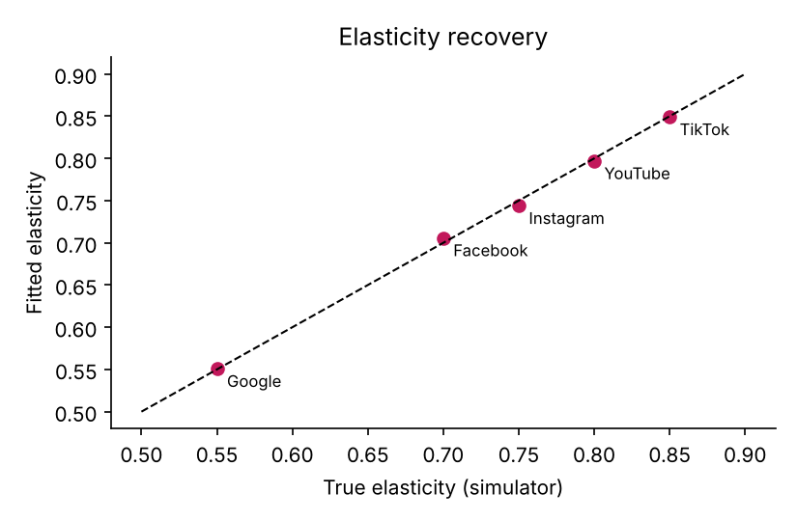
Figure 5: fitted vs true elasticity (dashed line = perfect recovery).
All five elasticities are recovered to within 0.006. Re-optimising with the true elasticities gives a nearly identical split; scored under the true curves the recommendation earns +13.0% against the current mix and the oracle allocation earns +13.0%, a capture ratio of 1.000. This verifies that the pipeline (fit, rescale, optimise) is implemented correctly. It is a test of the code against its own simulator, so it says little about how well the method would work on real campaigns.

7.3 Sensitivity to the guardrails
Setting | Google | Facebook | Instagram | YouTube | TikTok | Revenue (Rs M)
Default (max 50%, trust 0.5x-2x) | 50% | 25% | 11% | 8% | 6% | 4.07
No platform cap (max 100%) | 64% | 11% | 11% | 8% | 6% | 4.24
Tighter cap (max 40%) | 40% | 31% | 11% | 8% | 10% | 3.89
Narrow trust region 0.7x-1.4x | 45% | 20% | 15% | 11% | 9% | 3.94
Wide trust region 0.25x-4x, no cap | 79% | 6% | 5% | 5% | 5% | 4.40

This is the most important caution in the report. With no cap Google would take 64% (and 79% with a wide trust region), with a 40% cap only 40%. What is stable across every setting is the ordering of advice: more to Google and Facebook, less to Instagram, YouTube and TikTok. The exact percentages are decisions about risk (how far to move away from today's mix), and management should choose the guardrails, not the model.

7.4 Bootstrap and data-size stability
Resampling days with replacement 200 times and re-optimising gives very narrow share intervals (for example Facebook 24.0% to 25.2%). They are narrow partly because four platforms sit at guardrails, and because they only capture sampling noise in the fitted curves, not model misspecification. Using 10,000,000 rows instead of 1,000,000 changes no share by more than 0.3 percentage points.

8. Software engineering and testing
Part | Location | Purpose
Simulator | src/data_generation/ | Seeded, prefix-stable generator with built-in ground truth
KPIs | src/metrics/kpis.py | CTR, CPC, CPM, CPA, conversion rate, ROAS, profit; roll-ups on sums
Engines | src/engines/ | pandas, MapReduce simulation, Spark, process-isolated benchmark harness
Recommendation | src/recommendation/ | Curves, optimiser, bootstrap, backtest, ground-truth check, sensitivity
App | app.py, pages/ | Streamlit: simulation, KPI dashboard, benchmark, recommendation, reports
Scripts | run_benchmark.py, run_recommendation.py, make_report_assets.py | Reproduce every number and figure here

Tests (pytest): data invariants, determinism and prefix stability; KPI formulas and zero-division; MapReduce equals pandas in five configurations (workers, reducers, splits, with and without combiner); input splits cover the file exactly once; stable hashing; curve fitting recovers a known elasticity; allocation sums to the budget and respects bounds; marginal returns equalise at the optimum; infeasible constraints are rejected; the optimum beats every strategy that respects the same constraints; bootstrap and backtest behave sensibly.
Test status. 21 tests passed in the development environment. The 12 Streamlit page smoke tests and the Spark equivalence test are written but did not run there (Streamlit, Plotly and PySpark could not be installed without package-index access); they run automatically on a machine where those packages are installed, and the app pages were checked for syntax only. Run python -m pytest -q after installing the requirements.

9. Limitations and ethics
- Simulated data. Every finding describes the simulator. Real platforms have attribution overlap, creative fatigue, auction dynamics and seasonality that are not modelled.
- Guardrail dependence. The percentages move materially with the constraints (Section 7.3).
- Revenue is not profit. ROAS ignores product margin, returns and fixed costs. A platform with ROAS 1.3 can lose money.
- Causality. Response curves are fitted on observed spend variation; on real data, days with higher spend may differ in other ways, so a small live experiment (for example geo or time split tests) is needed before trusting the curves.
- Benchmark scope. Two cores, one machine, one job; Spark not measured; MapReduce is a simulation. The results do not predict cluster behaviour.
- Privacy. The data has audience segments but no personal identifiers; with real data, aggregate to segments and follow platform terms and local privacy rules.

10. Conclusions and future work
The project answers management's question with an auditable chain: simulated history, correct KPIs, verified engines and a recommendation that is compared, tested and honestly bounded. On the simulated history the advice is to shift budget towards Google and Facebook and away from Instagram, YouTube and TikTok (Google 50%, Facebook 25%, Instagram 11%, YouTube 8%, TikTok 6%), expected to raise monthly revenue by about 13% under the fitted model. For data of up to 10 million rows pandas is the practical engine; MapReduce and Spark matter when memory or a cluster is the constraint.

Future work
- Measure Spark (and Dask or DuckDB) on the same files and on a multi-core or cluster environment.
- Replace the single power-law curve with saturating curves per platform and campaign, and add margin so the objective is profit.
- Model seasonality and creative fatigue; add platform-overlap (attribution) effects.
- Fit the engine to real campaign exports and validate with a controlled live split test.
- Add an interval-aware recommendation that chooses guardrails by risk tolerance.

Appendix A. How to reproduce
pip install -r requirements.txt
python -m pytest -q
python run_benchmark.py --engines pandas mapreduce spark # generates data/ads_*.csv (about 1 GB) and writes outputs/
python run_recommendation.py data/ads_1000000.csv 1000000
python make_report_assets.py
streamlit run app.py

Appendix B. Reference notes
The assignment pointed to public GitHub marketing-analytics projects as starting points for KPI definitions (CTR, CVR, ROAS, CAC, budget reallocation). No code from them was used; the KPI definitions here are the standard industry definitions given in Section 4, and all code in this project was written for it. Method background: ordinary least squares on log-log data for constant-elasticity response curves; MapReduce programming model (map, combine, shuffle, reduce).

