

**Lab 5**

**Cinema Management System**

**October 1, 2025**

Submitted by:

Labiqa Salman CIIT/SP25-BCS-058/LHR

Section A

Submitted to:

Sir Muhammad Shahid Bhatti

Course name/Code:

CSC241

Object Oriented Programming

Department:

Computer Science

**Comsats University Islamabad, Lahore**

**Description:**

Cinema Management System shows the implementation of Object-Oriented Programming using Java. In this assignment, I have made a simple cinema management system that displays layout of multiple seats in multiple screens in multiple cinemas in multiples cities. A seat can be booked and cancelled in a specific screen in a specific cinema. There is also a detailed description of all the seats in each cinema. This system also counts and displays total number of seats, total available and occupied seats and total seats according to seat type (VIP, RECLINER etc.).

Following classes are used:

**Seat**: Represent a single seat with id, price, type and availability

**Screen**: Represent a 2D array of seat

**Cinema**: Manages multiple screens

**CityCinema**: Manages multiple cinemas in a city

**SeatDemo**: main for seat class

**CinemaDemo**: main that runs the program

**Output:**

1. **Displaying Layout of all cinemas in city:**

Following images displays all 3 cinemas in city Lahore.

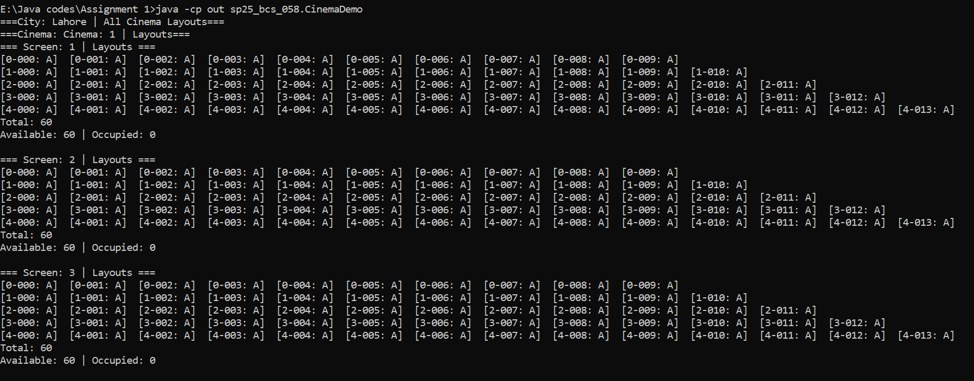

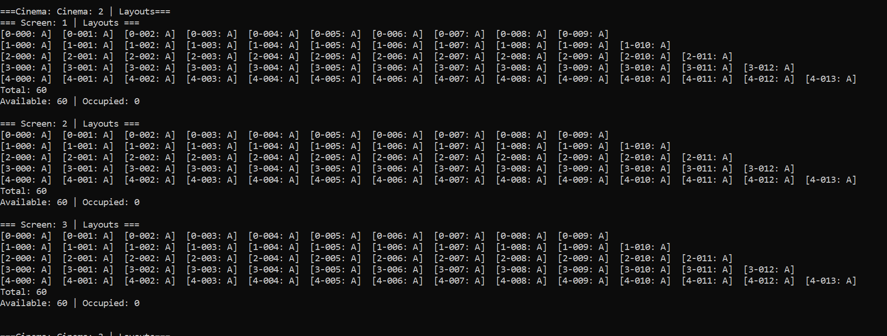

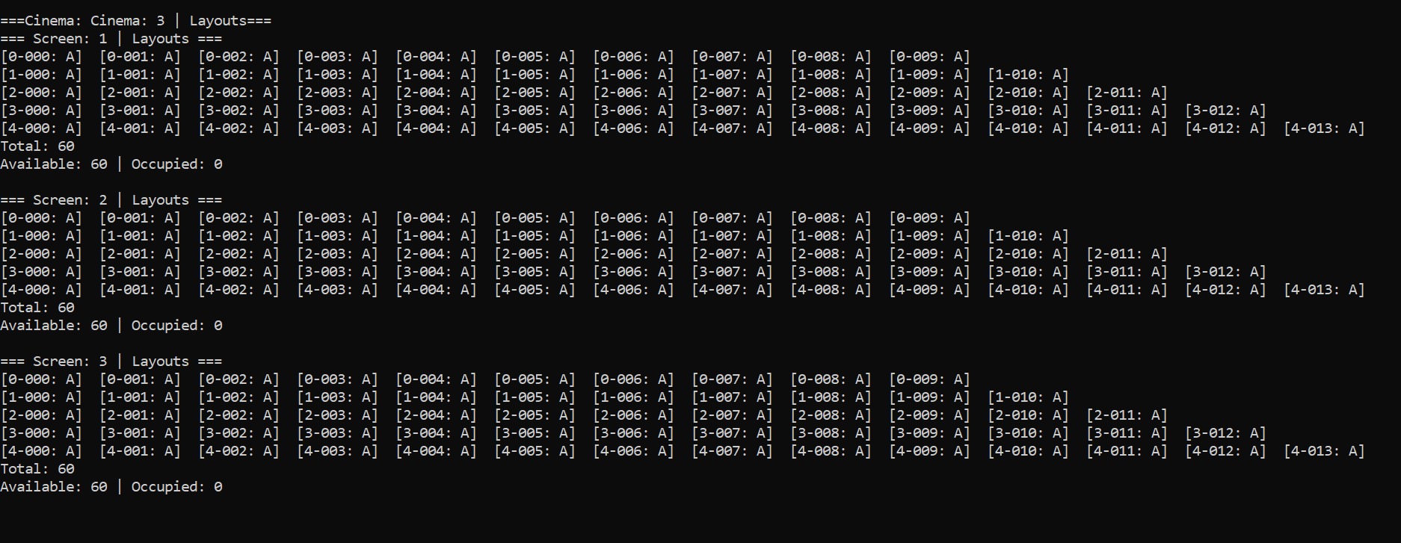

Similarly, the project is capable of printing all the cinemas for Karachi and Islamabad.

1. **Booking a seat in a specific cinema.**

Before booking:



After Booking:

The changes are encircled with blue pen.

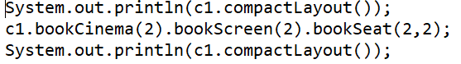

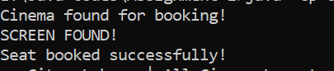

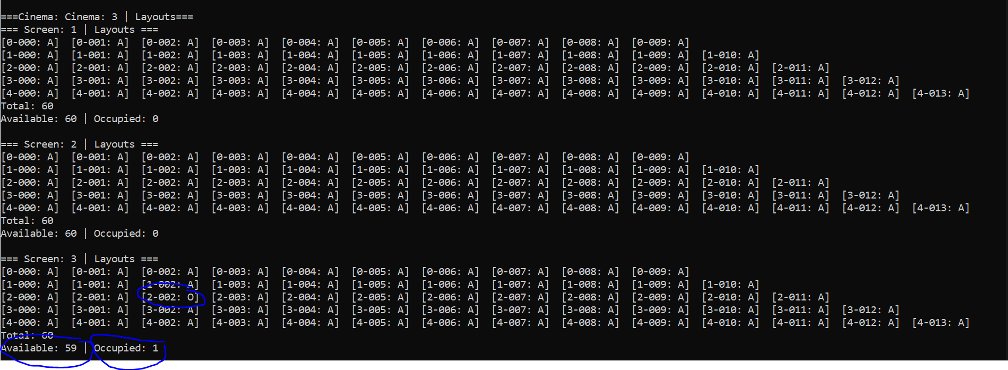

1. **Booking same seat again:**

Booking same seat again informs the user that seat is already booked.

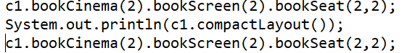

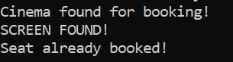

1. **Cancellation of seat:**

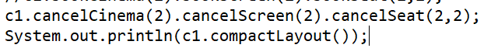

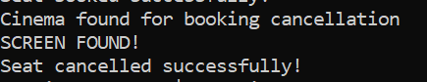



1. **Informs about number of total seats in all cinemas of a city:**



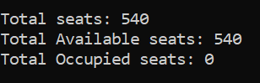

**Conclusion:**

This cinema management system performs basic management tasks and efficiently updates all the cinemas in a city. It majorly books, cancels, updates, displays, add and remove cinemas and screen.