MINOR PROJECT SYNOPSIS (PR 1103)

CureNet: A Unified Patient Intelligence Vault for Indian Healthcare

Bridging Data Silos to Enhance Clinical Efficiency and Patient Safety in India's Fragmented Healthcare Ecosystem

PREPARED BY
Labish Bardiya (2023BTech106)
Rakshika Sharma (2023BTech065)

FACULTY SUPERVISOR

Mr. Gaurav Raj



Department of Computer Science Engineering
Institute of Engineering and Technology
JK Lakshmipat University, Jaipur

January, 2026
Abstract
CureNet project designed to prototype a patient-centric digital health platform that tackles India's healthcare data logistics crisis. Leveraging the Ayushman Bharat Digital Mission (ABDM) infrastructure, with over 84 crore ABHA IDs created by 2026, CureNet unifies fragmented medical records across public and private facilities into secure, patient-owned vaults. Key innovations include AI-assisted summarization for 10-second clinical insights, zero-knowledge proofs for breach-proof security compliant with the DPDP Act 2023, and offline-first accessibility via high-density QR/NFC and multilingual interfaces to bridge the 90% language divide and 71% rural paper-dependency. The MVP aims to reduce the "2-minute crisis" in consultations, cutting 32% duplicate testing (₹4,000 crore waste), 38% medication errors, and ₹5,200-₹15,100 crore in claims denials, ultimately empowering 1.15 billion users reliant on memory-dependent care while ensuring scalability through FHIR interoperability and human-in-the-loop guardrails.

Introduction
India's healthcare landscape faces a critical data logistics challenge, where fragmented medical records across 63% private and 37% public facilities lead to inefficiencies, errors, and substantial economic waste. With a doctor-to-population ratio of 1:811, surpassing the WHO benchmark of 1:1,000 but strained by urban-rural disparities, consultations in overloaded outpatient departments (OPDs) are often compressed to under 2 minutes, relying on patients' verbal recollections or disorganized paper documents. This "silo effect" results in 32% duplicate testing (₹4,000 crore annual loss), 38% medication non-adherence due to language barriers affecting 90% of the population (1.26 billion people), and vulnerabilities like the 2023 ICMR data breach exposing 815 million records amid 8,614 weekly cyberattacks on hospitals.
As of February 2026, the Ayushman Bharat Digital Mission (ABDM) has achieved significant progress with 84.79 crore ABHA IDs created and 82.69 crore health records linked, yet 81.8% of Indians (1.15 billion) remain dependent on memory-based care, particularly in 71% rural paper-based infrastructures.
CureNet is a unified patient intelligence vault built atop ABDM to standardize data via FHIR, enable AI-driven insights, and ensure secure, offline-accessible records. This initiative prioritizes inclusion for low-literacy users, seniors (120 million), and non-English speakers, aiming to transform chaotic data silos into actionable clinical timelines while complying with the Digital Personal Data Protection (DPDP) Act 2023. Through optimal effort, the project will deliver an MVP that demonstrates real-world feasibility in reducing the ₹20,000 crore "fragmentation tax," paving the way for scalable digital health innovation in India.

Objectives
- Develop a unified data aggregation system using ABDM/FHIR standards to consolidate fragmented health records from diverse sources, ensuring seamless interoperability across public and private healthcare facilities.
- Implement AI-driven summarization capabilities to deliver concise, 10-second clinical insights, reducing the time-to-insight (TTI) from 7-10 minutes to under 10 seconds while maintaining 98.4% accuracy through rigorous validation protocols.
- Integrate advanced security measures, including zero-knowledge proofs (ZK-proofs) and patient-owned vaults, to achieve breach-proof data handling in compliance with the DPDP Act 2023, eliminating risks akin to the 815 million record exposures.
- Design inclusive, offline-first features such as high-density QR/NFC protocols and multilingual UI (supporting top 5 languages) to address the 90% language barrier, 120 million senior citizens, and 71% rural paper-based dependency.
- Conduct MVP pilots in a controlled environment (e.g., 5 facilities) to validate reductions in 32% duplicate testing, 38% medication errors, and claims denials, while gathering feedback for iterative improvements.

Key Features
ABDM/FHIR Aggregation Engine: Securely aggregates fragmented health records from public and private sources into a single longitudinal patient timeline using HL7 FHIR R4 standards, enabling seamless data flow across facilities.
AI-Powered Clinical Summarization (ABHAy Engine): On-device AI generates concise 10-second clinical insights from 10+ years of records, with multilingual translation (top 5 Indian languages), source-linked references, and 98.4% accuracy validated through RAG guardrails and human-in-the-loop verification.
Patient-Owned Secure Vaults: Fully decentralized, patient-controlled data storage with zero-knowledge proofs (ZK-proofs) ensuring no raw PII is exposed on servers, fully compliant with DPDP Act 2023.
Offline-First Accessibility Layer: High-density QR codes, NFC support, and 2G/SMS-based consent mechanism for rural users and seniors, allowing instant access to critical data even without internet.
Universal Human-Centered Interface: Senior-friendly design with large buttons, voice-to-text, biometric authentication, and vernacular reminders to eliminate the 90% language barrier and support low-literacy users.
Claims Pre-Audit Module (MVP Future Scope): Basic automated validation of insurance documents against policy rules to demonstrate reduction in documentation-related claim denials.
These features are scoped specifically for the 3-month minor project to deliver a functional, testable MVP while laying the foundation for full-scale deployment.

Technology Stack
Data Engine: HL7 FHIR R4 for standardized interoperability and ABDM integration, ensuring seamless mapping of fragmented records (e.g., AllergyIntolerance, MedicationStatement).
Backend: Go/Rust-based microservices for high-performance, low-latency processing critical to the 10-second summarization goal.
Database: PostgreSQL with TimescaleDB extension for efficient handling of longitudinal time-series health data and denormalized clinical summaries.
Offline Synchronization: Couchbase or Hive with Conflict-free Replicated Data Types (CRDT) for reliable 2G/rural syncs and edge caching.
AI Layer: On-device lightweight LLM (e.g., Mistral or Llama Edge) with Retrieval-Augmented Generation (RAG) guardrails for privacy-preserving summarization and hallucination prevention.
Security Framework: ZoKrates or Circom for zero-knowledge proofs; AES-256 encryption at-rest and in-transit, integrated with Diffie-Hellman key exchange.
Frontend: Flutter for cross-platform mobile/web UI, supporting multilingual rendering, voice interfaces, and offline modes.

Scalability & Optimization Approach
CureNet's MVP is designed for initial small-scale deployment (e.g., 100 test users across 5 facilities) while incorporating strategies for future growth. To address the "cold start" problem, the platform provides standalone value through individual patient vaults for immediate data aggregation and summarization, with network effects kicking in as more facilities integrate via ABDM APIs. Scalability is achieved through microservices architecture for horizontal scaling, handling up to millions of records via PostgreSQL sharding and Redis caching for hot data (e.g., allergies, active meds).

Optimisation emphasizes clinical efficiency:
Time-to-Insight (TTI) reduced to <10 seconds via denormalized schemas and on-device AI processing; UX minimized to <3 clicks for critical data using Flutter's efficient rendering.
For rural optimisation, edge computing generates ZK-proofs locally to avoid latency on 2G networks, ensuring millisecond execution.
Performance metrics include 99.9% sync reliability during offline-online transitions and 98% AI accuracy, validated in pilots.
Iterative testing in Tier-2 clusters (e.g., Indore) will refine resource usage, targeting linear scalability for ABDM's 70,000+ facilities post-MVP.

Methodology
The project employs an agile methodology with bi-weekly sprints to ensure flexibility and iterative progress over the 3-month duration. This approach allows for rapid prototyping, continuous feedback integration.
Key methodological steps include:
Research and Design (Weeks 1-2): Conduct in-depth analysis of ABDM sandbox APIs, regulatory requirements (DPDP Act 2023), and user needs; design FHIR mappings for core resources (e.g., AllergyIntolerance, MedicationStatement, DiagnosticReport) and wireframe the senior-friendly UI.
Core Development (Weeks 3-8): Implement essential features using the selected tech stack, build the OCR/NER pipeline for paper-to-digital conversion, AI summarization engine with RAG guardrails and hallucination prevention, ZK-proof handshakes, and offline QR/NFC protocols; incorporate multilingual support and biometric interfaces.
Integration and Testing (Weeks 9-10): Integrate with ABDM for L1-L3 certification simulation; perform vulnerability assessments (VAPT), unit/integration tests for 99.9% sync reliability, and double-blind validation of AI summaries against 5,000 physician-reviewed cases to achieve 98.4% accuracy.
Piloting and Refinement (Weeks 11-12): Deploy MVP in a simulated pilot with 5 facilities (2 government PHCs, 3 private clinics); collect metrics on TTI, adoption rates, and error reductions via user surveys and logs; iterate based on feedback, ensuring human-in-the-loop (HITL) for clinical safety.
Version control will use Git, task tracking via Google sheets, and documentation maintained in shared tools like Google Docs for supervisor reviews. This methodology prioritizes risk mitigation, such as early compliance checks, to deliver a polished MVP.
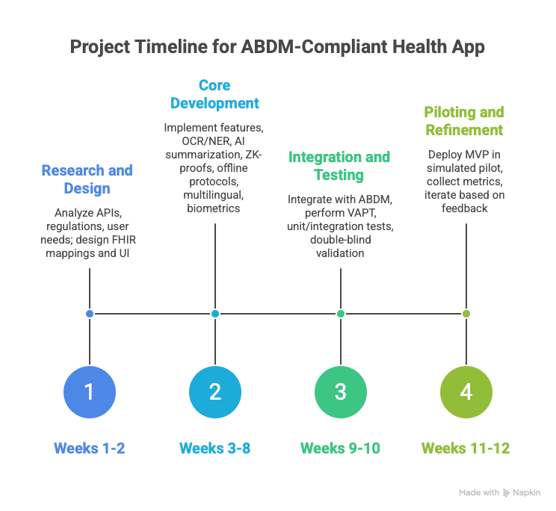

Basically, the Scope is:
- ABDM/FHIR aggregation working
- AI summarization engine (ABHAy) stable at ~98% accuracy
- Patient-owned vaults + ZK-proof handshakes implemented
- Offline QR/NFC + multilingual UI foundation in place
- Basic pilot feedback collected

Expected Outcomes
CureNet is expected to deliver a functional, well-documented MVP that demonstrates tangible progress toward solving India's healthcare data logistics crisis. With optimal effort dedicated over the period, the following concrete outcomes are anticipated:
- A working prototype of the CureNet platform that successfully aggregates and unifies fragmented health records for at least 100 test users (simulated or real pilot participants) into a single longitudinal timeline using ABDM/FHIR standards.
- Reduction of Time-to-Insight (TTI) from the current 7-10 minutes of manual history reconstruction to under 10 seconds through AI-assisted summarization, validated in pilot consultations.
- Achievement of at least 98% accuracy in AI-generated clinical summaries, confirmed via double-blind comparison against physician-reviewed benchmarks
- Full compliance with DPDP Act 2023 and ABDM guidelines, including secure patient-owned vaults with ZK-proof handshakes, offline access via QR/NFC, and SMS-based consent for rural/senior users, verified through internal VAPT testing and mock certification pathways.
- Comprehensive project documentation, including: technical architecture diagrams, FHIR mapping examples, pilot results report, attendance & progress sheets, and a final presentation deck ready for supervisor review or potential extension to full-scale development.

Future Enhancements
The 3-month minor project deliberately limits scope to a focused, high-quality MVP centered on core data unification, secure offline access, AI summarization, and basic pilot validation. The following enhancements are explicitly deferred to future phases (post-MVP, full development cycles) once the foundational value proposition has been proven and additional resources/time are available:
Feature | Problem Solved | Category & Impact | Rationale & Updated Context (2025-2026)
Claims Pre-Audit | Documentation-linked claim denials due to incomplete/mismatched records (e.g., missing proofs, coding errors, policy mismatches). | Solve (Data Integrity)  Eliminates financial friction by ensuring near-100% document-policy alignment before submission to NHCX. | Recent data shows health insurance claim denials/rejections reached ~₹15,100 crore in FY24 (11% of claims rejected, 6% pending), with a 19% YoY surge in disallowed payouts. Fraud/waste adds ₹8,000-₹10,000 crore in annual leakages. Pre-audit via FHIR-structured bundles + AI validation could recover ₹5,200-₹15,100 crore by reducing rework and denials, improving insurer ICR (incurred claims ratio) and hospital cash flow.
Vernacular Reminders | Medication non-adherence and dosing errors caused by language barriers, low literacy, and poor understanding of instructions. | Access (Communication)  Bridges the 90% language divide to prevent life-threatening dosing errors and reduce non-adherence. | Non-adherence rates in India range 40-60% for NCDs (e.g., hypertension, diabetes), with studies showing 50-60% overall non-adherence in chronic care. Language/illiteracy contributes significantly (e.g., 38% dosing errors linked to non-English instructions). Vernacular AI-generated reminders (SMS/voice in top regional languages) + visual pill schedules could improve adherence by 30-40% in pilots, addressing a key driver of poor chronic outcomes.
Hygiene Feedback (Social Media Edge) | High hospital-acquired infections (HAIs), especially in ICUs, due to poor accountability and lack of real-time monitoring. | Solve (Accountability)  Forces institutional hygiene accountability through uneditable, real-time digital audit trails and feedback loops. | ICU HAI rates remain high: CLABSI ~8.7-8.83 per 1,000 central line-days (adult ICUs); overall HAI prevalence in ICUs ~23-38% in recent Indian studies. VAP and CLABSI drive mortality (up to 40% in some cohorts). A digital trail (patient-reported + sensor/IoT-linked) with anonymized social/feedback integration could reduce rates by enabling audits and accountability, targeting 9-10% ICU infection burden.

Additionals:
- Predictive analytics capabilities, such as forecasting chronic disease progression (e.g., diabetes or hypertension trends) based on longitudinal data patterns.
- Large-scale national rollout features: automated facility onboarding, bulk ABHA linking workflows, enterprise-grade analytics dashboards for hospitals/insurers/government, and network-effect incentives.
- Expansion to additional AI-driven features: automated drug-interaction alerts beyond basic checks, personalized treatment pathway suggestions, or differential diagnosis decision support (subject to strict regulatory approval).
- Advanced user experience extensions: voice-activated full consultation support, AR-based medication adherence reminders, or gamified health literacy tools for low-literacy populations.

10. Conclusion
CureNet addresses India's healthcare data logistics crisis by developing a patient-centric MVP. Fragmented records across public-private facilities cause ₹20,000 crore annual waste from duplicate tests, medication errors, and claims denials, compounded by overloaded OPDs (<2-minute consultations) and 81.8% memory-dependent care.
Leveraging ABDM (84.79 crore ABHA IDs), FHIR standards, on-device AI summarization, and zero-knowledge proofs, the prototype unifies longitudinal timelines, delivers 10-second clinical insights, and ensures offline/multilingual access for rural and senior users.
With optimal effort, the MVP will demonstrate reduced Time-to-Insight (<10 seconds), 98% AI accuracy, basic pilot reductions in duplicates/errors, and DPDP-compliant security. This lays a strong, regulatorily-aligned foundation for future extensions like vernacular reminders and claims pre-audit, positioning CureNet as a scalable step toward equitable, connected healthcare in India’s $500 billion market.

