KETERAMPILAN KOMPUTER & PENGELOLAAN INFORMASI
SEKOLAH MENENGAH ANALIS KIMIA BOGOR
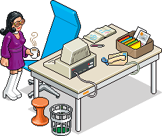


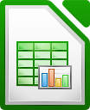

KELAS 11

Preface

“The illiterate of the 21st century will not be those who cannot read or write, but those who cannot learn, unlearn, and relearn.” ~ Alfin Toffler.
This Keterampilan Komputer & pengelolaan Informasi Book for 11th Grade SMAKBo Student isn't the first computer book written for the purpose of teaching computer skills for SMAKBo students, but this may be the first one to be written completely under GNU/Linux environment. A cost-effective computing OS environment started by Linus Torvalds & Richard Stallman. As the world is starting to leave the traditional x86 / Windows working environment, we feel that our future students should too, taste how it feel to learn the computing world in an Open Source way.
This Preface is written by the author at 3.20 AM, October 11th 2012 in the dead of the morning. Thinking he's Alan Wake. Or maybe even Stephen King. In the hopes that this book would be read, understood, and practiced by those who read it in their daily life in the best possible way.
Live long & Prosper! V(^_^)
Author,

About the Author

Mohamad Tachya Wiratanudatar is a Civil Servant at the Indonesia's Ministry of Industry working as a Computer Teacher at Sekolah Menengah Analisis Kimia Bogor since 2009. Aside teaching LibreOffice & GIMP to the 11th grade, he also manages the computer lab at his workplace. His passion includes everything computey, (is that a word?) films, and reading.

Meti Kurnia Sabarini is a Civil Servant at the Indonesia's Ministry of Industry working as a Computer Teacher at Sekolah Menengah Analisis Kimia Bogor since 2004. Her passion include reading and swimming. Aside teaching computer at school, she also teaches the English subject to SMAKBo's 12th grade students.

Who should read this book

This book is written with the sole purpose to teach simple data analysis & making charts using LibreOffice Calc, making simple presentation using LibreOffice Impress, basic image editing using GIMP, and basic HTML / CSS to 11th Grade SMAKBo Students. But not limited to students only.
As of the writing of this book, the software used are Ubuntu 12.04 LTS, LibreOffice 3.5 and GIMP 2.6. the HTML /CSS used in this book are based on W3C standards, HTML version 4.01 and CSS 2 with some CSS 3 featured.
This book is written completely using LibreOffice Writer version 3.5. The online / PDF version of this book is available for download at https://www.dropbox.com/sh/n58i3mifk9erbtu/pxMWxxcr3Z/Modul-KKPI-Kls-11.pdf for free. And links to exercise files to this book is available throughout the chapters.

Dedicated to my loving wife & kid.
“Hey look! I actually wrote something other than the stuff I usually copied & pasted from the Interweb!”

Table of Content
Preface i
About the Author ii
Who should read this book iii
Table of Content v
Chapter 1 : Simple Data Analysis 8
SORT 8
FILTER 10
Auto Filter 10
Standard Filter 10
Advanced Filter 12
Chapter 2 : Simple Data Analysis (continued) 13
Subtotal 13
Pivot Table 14
Conditional Formatting 15
Exercise 16
Chapter 3 : Chart 17
Pie Chart 17
Bar & Column Chart 17
Line Chart 17
Exercise 20
Chapter 4 : LibreOffice Impress 21
Workspace View 21
inserting an element to slides 22
Master Pages 23
Layouts 23
Table Design 23
Slide Transition 23
Adding a custom animation to an element. 24
Tips on creating a presentation using Impress 25
Chapter 6 : GIMP 27
Getting to know GIMP 27
Image File Types 29
Simple Photo Retouching 30
Getting to know Layers 32
Drawing with GIMP 33
Selection 35
Filters 37
Exercise 39
Chapter 7 : HTML & CSS 40
History of HTML & CSS 40
First HTML Page 40
HTML tags 42
CSS descriptor 42
Tables 43
Forms 44
Exercise 45
Chapter 8 : Bkchem & Chemical Calculator 46
Chemical Calculator 46
BKChem 47
Saving your work 48
Exercise 48
Bibliography 50

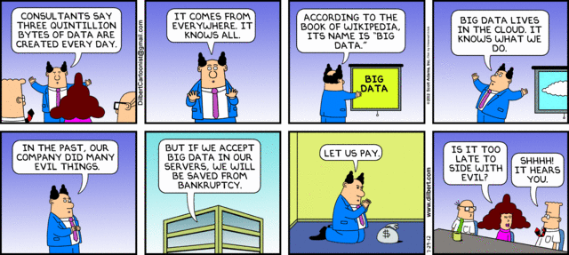

Chapter 1 : Simple Data Analysis

Data Analysis is the means to find order from raw data, to simplify information and make it easier to read data make decisions from it. Life would be easier if everybody's data were only two rows long and a few columns width. But in reality, more often we have to deal more than hundreds of rows and tens or more of columns to simplify, make charts and information of, and decisions based from it.
This first chapter will try to explain what it means to simplify any data we have in the shortest way possible through LibreOffice Calc's feature of Sort, Filter, and Conditional Formatting.

SORT
The Sort feature in LibreOffice Calc is used to, well, sorting out data. Be it ascending or descending. This feature can be found through the pull-down menu Data → Sort which will bring out this dialog box.
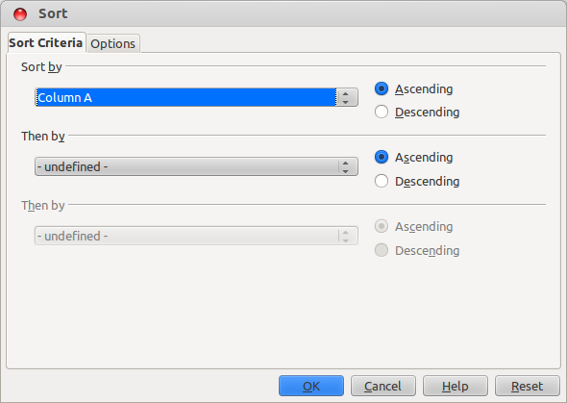
Where we will have a maximum of 3 levels of sort. (in MS Excel, there are more than 3 levels of sorting). A 'Sort by' indicates the first level of sorting, and the 'Then by' after it is the next level of sorting.
For example, say that we have several rows of data looked like this.
Then, we're going to sort it one level based on the column “Kota”, all you have to do is go Data → Sort and Sort by “Kota” ascendingly. It will look like this.
Now that's just a 1 level sort, a 2 level sort basicaly will arrange the data in the order of the first level, before rearranging the data again based on the second column that need to be sorted.
Let's try another example for 2 level sort. First open up the Sort dialog box. And input Sort by “Kota”, Then by “Dept”. The table should look like this.
The table looks just the same., But wait! There's a little bit difference. Yes, the data from Denpasar City is sorted by the Dept column alphabeticaly.
Now try to get the hang of it, find some larger amount of data & try to use sort by 3 levels on it, for example try to tinker with this data “DAFTAR KARYAWAN” below.
Some 3 levels sort should make that data much more readable, Try sorting based on column 'Kota', 'Dept', or 'Pendidikan'!
The Options tab in the Sort dialog box contains several options which most of the is not of use. However, there are few notable option which might come in handy at times. Namely the 'Case sensitive' option which detects data with capital letters and not, & the 'Copy sort results to' option where you can copy the sort result to another location or sheet since sorting feature changes the data you've been working on.

FILTER
The filter feature in Calc is used to hide rows of data that doesn't match the criteria given. For example if you have some hundreds of data and you want to filter out which one of these data comes from the City Bogor, after filtering out, the other data is not deleted, but hidden. And the data shown in the spreadsheet are the only one comes from the criteria.
But the filter technique isn't as easy as it seem. There are 3 kinds of filter in Calc, they are Auto Filter, Standard Filter, & Advanced Filter.

Auto Filter
Let's try out the first one on the table below.
Now lets try Auto Filter via the Data pull down menu. Data → Filter → Auto Filter. Don't forget to select the column header before you do this! The data should look like this.
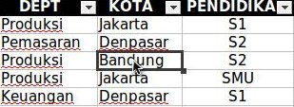
Auto Filter toggles a small button just beside the column headers, When you click the buttons there will be a menu showing which data you would like to filter.
Most of the time, Auto Filter is used to see top 10 data or if there are empty data inside a table. Or in most cases where there are many similar data.
The figure above shows the results of auto filtering data showing 'Produksi' in column 'DEPT'.

Standard Filter
Standard Filter is the most common used filter. With Standard Filter, you can put more than one category in a single filter operation, and your operator option could be AND or OR, unlike Auto Filter where the filter operator is always AND.
To start Standard Filter, go via menu Data → Filter → Standard Filter which will bring up a dialog box.
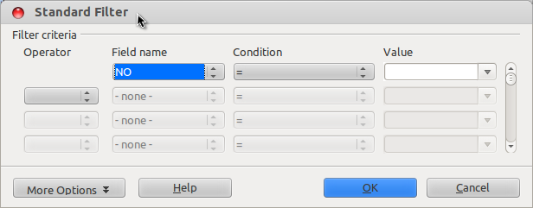
The Standard Filter provide several input needed which is Field name (which column you'd like to filter), Condition (the operator for the data value that is being filtered), and Value (the condition that the data should be). And if there is more than one criteria being filtered, the operator (the left most input) provides Boolean operators (AND and OR) for the filter criteria.
Let's try out an example for the same data we've been doing!

Now try out some filter on the data above, filter out Field name = 'Kota', Condition = '=' and Value = 'Jakarta'. This operation will hide any other data where the value in the 'Kota' Column isn't 'Jakarta'.
Now, add another criteria below this one with an AND operator. Filter out where 'Pendidikan' column is 'S1'.
Voila! We hide every other data and only shows where 'Kota' is 'Jakarta' and 'Pendidikan' is 'S1'!.
This is a two criteria filter with an AND Operator, The OR operator provides ways to see if either one of the criteria is valid, the filter operation will be executed, while the AND operator runs both the criteria for the data.
Try other condition operator such as =, <, >, largest, and contains and see the result for yourself, The operators should be self explanatory.

Advanced Filter
The advanced filter is a filter method using another criteria table. This filter method has a little bit more difficulty, but gives more criteria possibility.
First step of using this method is build your own criteria table on the same sheet, this figure below gives an idea how.
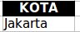

This small table is created, say, at cell I3:I4 just next to our data. This criteria table is going to be used to filter any data where its Kota is Jakarta.
Second step is via the menu bar, Data → Filter → Advanced Filter and you'll see something like this.
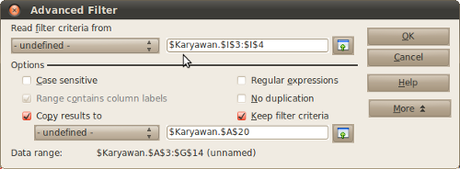
We're reading filter criteria from I3:I4 and apllies it to our data. Before going through the menu bar, make sure the data is blocked. From this dialog box, we can see there are other options such as copying our filter results to other sheet, remove duplications and regular expressions. For the use of regular expressions consult the LibreOffice help or using the DOS format of wildcards with added dots (.) in front of the regex is feasible.

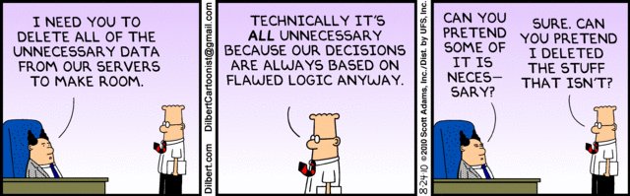

Chapter 2 : Simple Data Analysis (continued)
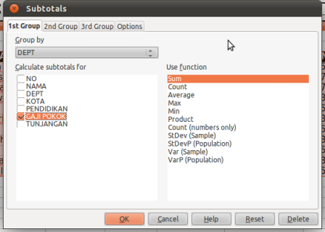
Chapter 2 of Data Analysis consists of several methods of grouping, instead of filtering or sorting data. These methods are

Subtotal
The use of subtotal is to group our data based on its fields and then calculating other fields from the same table.
Still using our old data, block our table first and go through Data → Subtotal and you'll see a dialog box.
The first option, Group by, let's you decide which field will be grouped. This option in MS Excel requires you to sort the data first, but in LibreOffice, the sort is auto.
Second option, is calculating another field and it's function. In this case, we are grouping our data based on DEPT, and we'll summarize the field GAJI POKOK, that way we'll know which DEPT has the most GAJI POKOK combined. Here's the result.
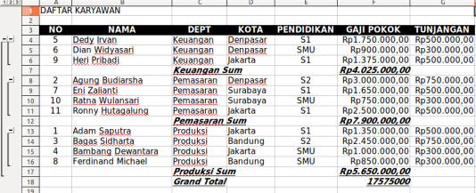

Pivot Table
Pivot Table is another way of grouping data. Only this time it's little bit automatic, you'd probably see something of similarity in MS Excel. Back in OpenOffice.org this used to be called Data Pilot, and the screenshot used here is from the early versions of LibreOffice.
First things first, after highlighting your data, go through Data → Pivot Table, the dialog box will ask if you'd like create a Pivot Table from your current selection or from a registered database in LibreOffice. For now let's choose the first option.
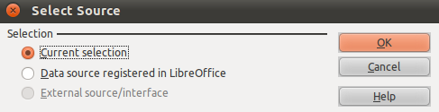
After clicking OK, a Pivot Table will appear on a new sheet, and you'll be given a dialog box.
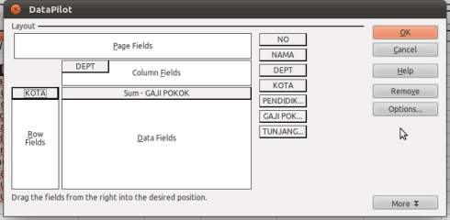
The Pivot Table dialog box may be confusing at first, but put it in a sort level way of perspective, it would be less confusing.
First level is the Pages, consider this a first level sort where you'll be sorting data based on fields, but what you need to focus first is the column and row fields, this are like the same level of sort or group in subtotals. Basically the field you drag to the row fields and column fields will be sorted an grouped by its respective field. In this example we'll ignore the Page Fields and group our KOTA field at the row and our DEPT at the column.
Third level is the Data Fields, pretty much like subtotal, this is where we calculate the field which were grouped at the row and column level. Just use Sum GAJI POKOK at this field for an example. Here's what you'll probably see as a result.
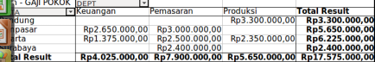

Conditional Formatting
The last method of analyzing data would be the conditional formatting. Although there are numerous type of Data analysis method out there, these are the simple ones you can probably use on a daily basis.
The Conditional Formatting method basically doesn't do anything to change your data. Be it grouping or changing your table. Conditional Formatting only formats the cell you highlighted and gives you easier view on your data. Here's a simple example.
First of all block only the field which you'd want to apply conditional formatting, in our example we will change the field GAJI POKOK to display yellow background when it's less than Rp. 1.000.000, so block that field first, and go through Format → Conditional Formatting
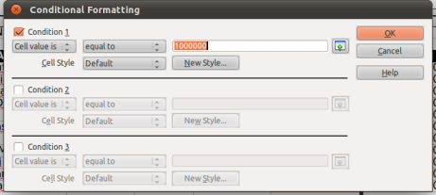
And then enter the first condition, that would be cell value is less than 1000000. And after that we create the cell style. Click on the New Style button and you'll go to the cell formatting dialog.
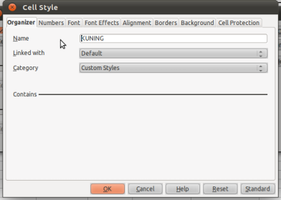
At the cell style dialog, gives this cell style a name, in this book example, the name is KUNING – from the background. And go to the Background tab and select the yellow colour.
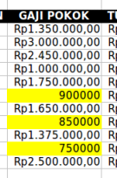
When you're done here, click OK, go back to the conditional formatting dialog and click OK there. You'll see some similar result.

Exercise
Now try this chapter's exercise using the figure below!
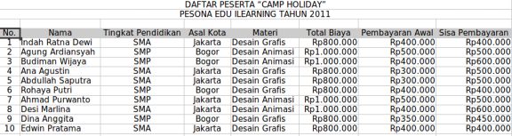
- Sort the table ascendingly based on the field Asal Kota and Nama
- Using standard filter, display the data where the criteria is Asal Kota from Jakarta and Sisa Pembayaran is equal to or more than Rp. 500.000
- Using advanced filter, display the students who took the class Desain Grafis
- Create a subtotal based on the field Materi and calculate the sum for each Total Biaya
- Create a Pivot Table to compare Total Biaya between the students from Jakarta and Bogor

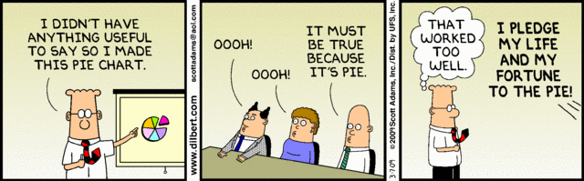

Chapter 3 : Chart
Charts in LibreOffice Calc is somewhat different than the ones most people use in their Microsoft product. Having that said, learning to create charts in LibreOffice -albeit slightly different, is really not that difficult.
Charts & Graphs are powerfull tools to present your data to your reader. There are many type of charts provided by LibreOffice but here, we will try to explain 3 most commonly used type. Which is :

Pie Chart
Pie charts is often the basic chart used to display a comparison of two or more data. But it has it quirks, often the Pie chart does not provide anyway to display timeline where the data is presented, therefore it is more often used to display percentage comparison.

Bar & Column Chart
Bar & Column Charts are pretty much the same thing, the only difference is column chart presents your data in vertical way while bar chart present it in a horizontal fashion. Being a chart that uses the Cartesian axis, both Bar & Column provide a way to present some timeline for data that has more than one instances.

Line Chart
Line Chart is also another chart that uses the XY axis. So reading this kind of chart is similar like that of the Column chart, but the line chart diplays it's data using a line (duh!).
For some sample exercise let's try to create a chart from the figure provided below.

First of all, highlight your data. Now these might seem simple, but when you get to the part where you need to display specific data on your charts, this could get tricky.
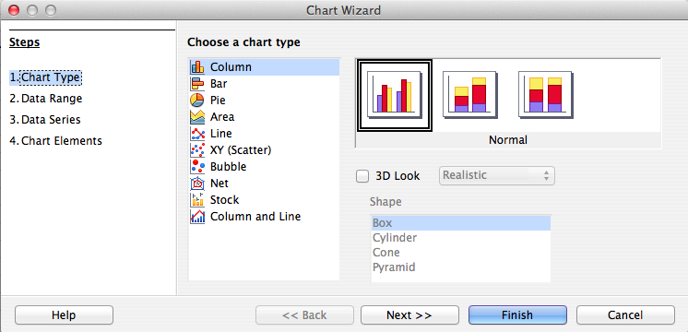
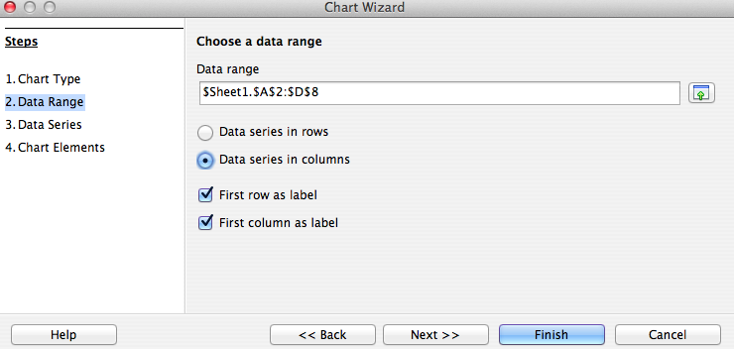
Finish blocking your data? Now display the Chart Wizard dialog box. This can be done via the toolbar or the menu bar through Insert → Chart. The first step of the Chart Wizard is to select a chart type, for the sake of simplicity, we will try the column chart first. Click OK and continue to step 2.
Selecting Data Range makes a big difference to how your chart look, reading data series in rows or in columns is what makes it so. If you set reading your data series in column, the X axis will read as data series and display your data from left to right, while reading in rows will make your X axis display its data from top to bottom. Try to switch between the two and understand and get the hang of it before going to step 3.
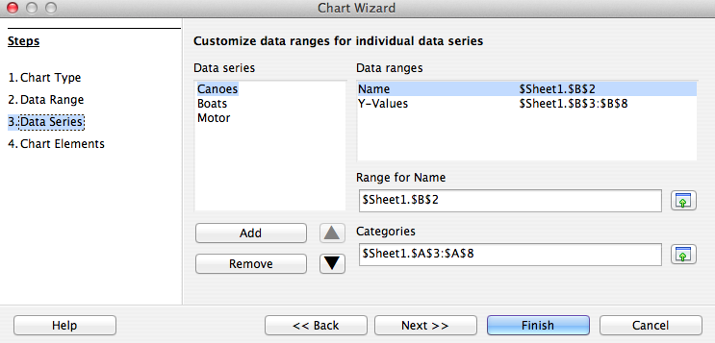
Editing the Data Series is used to edit the data (instead of the look) that shows on your chart. This is often used to improve data reading, for example you can take out the Motor Data Series and display only the comparison between the Canoes and Boats data.
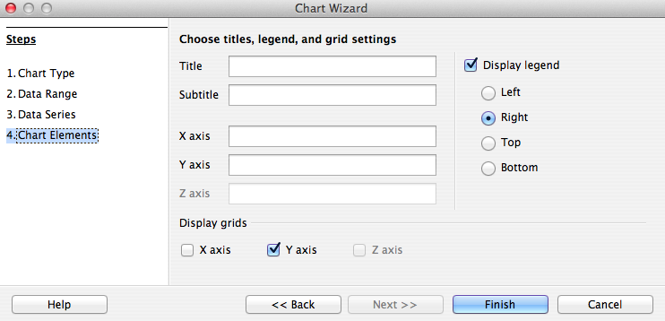
The last step, Chart Element is to edit the look and feel of your data. Here you can add chart titles, legends, and add some more names for the X and Y axis.
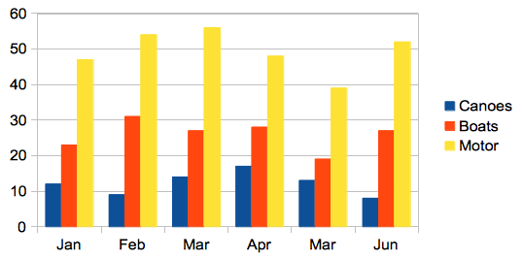
The steps of creating charts for Pie Chart, Bar, and Line is similar, try to master editing Data Range and Data Series because that is where usually the need for displaying specific data rises.

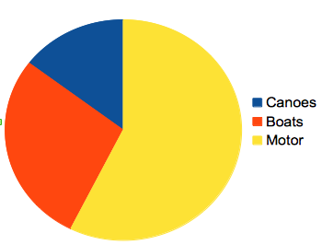
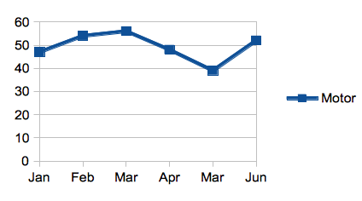

Exercise
- A figure is given below :
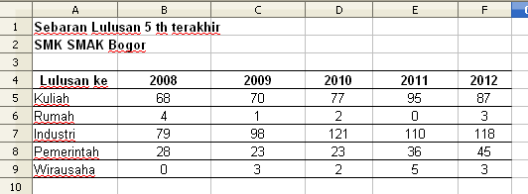
Using the table above, create two charts that shows where alumnus went after high school,
a. Column Chart Based on Category (Places as X axis and legend)
b. Pie Chart Based on Year (Year as X axis and legend)
- Another Table is given,
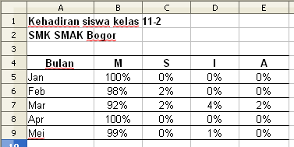
Using the table above, create two charts that shows students attendance,
- Column chart for January
- Line chart for January and May

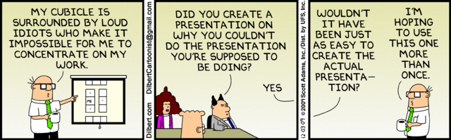

Chapter 4 : LibreOffice Impress
Impress is LibreOffice’s slide show (presentations) program. You can create slides that contain many different elements, including text, bulleted and numbered lists, tables, charts, clip art, and a wide range of graphic objects. Impress also includes a spelling checker, a thesaurus, prepackaged text styles, and attractive background styles.
(yes, I quoted that from the manual).
The use of slide-creation-and-presentation applications is – depends on who's statistics you've read – the second most used application in an Office Suite. Just behind spreadsheets apps. Impress is one of those, and by the time of this writing, can actually open a pptx file with 75%+ accuracy.
Other slide-creation application worth mentioning are slideshare (an online slide application), slide rocket (also online), and a part of the iWorks productivity suite, Apple Keynote. Which, of course only runs on Mac OS X.

Workspace View
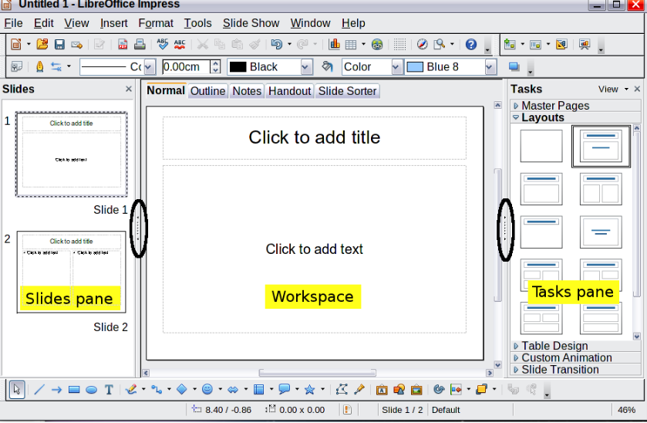
The Workspace view of Impress is also somewhat similar to the one in that other OS. There are Slides pane on the left side, and Task pane on the other. At the center, we have the Workspace, which consists of several other views like Normal, Outline, Notes, Handout, and Slide sorter.
And at the top, we have the usual menu bar. And Drawing bar at the bottom. Most menus can be accessed via the menu bar, and the toolbar is there most of the time for your shortcuts convenience.
The Slides pane on the left is where we navigate through slides most of the time. While the Task pane on the left consists of ;
- Master Pages, where the slide's designs resides. This is where we choose the slide's background and color themes.
- Layouts, where user chooses which layout is suitable for the slide. Be it a blank layout, text only, photo galleries, and so on.
- Table Design, obviously to choose from several available color theme for that table inside that slide. Should there be any.
- Custom animation, where most users spend their time on, is also pretty much like the one in that other OS. But rather lacking in the interesting animations factor.
- Slide transition, for choosing the animation and sound that shows when the slide show is playing.

inserting an element to slides
Adding an element, such as pictures, sounds, and videos, or tables and charts is pretty straightforward. The Insert menu bar is there at your disposal. While the chart, hyperlink and other toolbar is just a shortcut. The Drawing bar at the bottom gives you a little bit more variations for the elements you're taking into your presentation.
Try to give into the habit of using the Insert → …. menu bar, it is not a shortcut, of course. But it opens up more option when you are putting something into your slides.
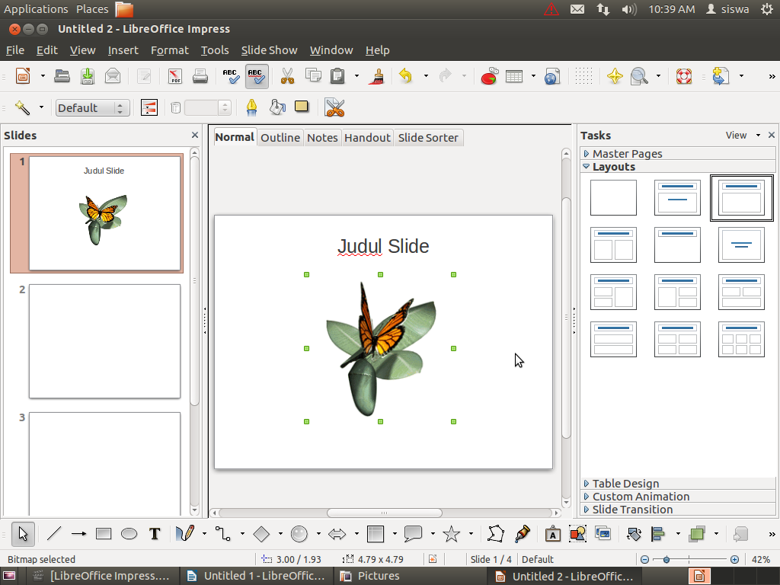

Master Pages
The Task pane first content is the Master Pages, where you will be given some choices for the background and themes for your slides. You can also set your own background picture. Just right click on the middle of the slide and go Slide → Set background picture for slide.
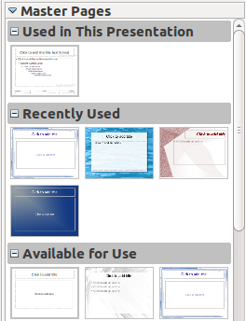

Layouts
The second content – choosing layouts, is easy. But choosing the correct layout for your presentation can be tricky. Would your audience need comparison charts? Does this slide need tables? Or just some photos will do. This often gets easier with practice.
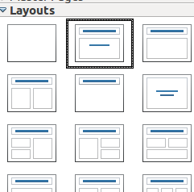

Table Design
Should be self explanatory, but most presenters copy tables from spreadsheets, Impress just makes it looks better.

Slide Transition
The Slide transition is most often overlooked. But building up your presentation and timing training can be time consuming.
Most of the time, the speed of the slide transition doesn't matter, but the slide timing with your speech often can make or break a slide. So choose wisely if you want the slide to move at your pace (On mouse click) or automatically after.
Also keep in mind that in Impress, the sound and music you played on the previous slide doesn't carry on to the next slide, you can only have one audio media playing at a times.

Adding a custom animation to an element.
While most of the other features of a presentation software is self explanatory, the custom animation usually deserves it's own section. This is also true for Impress, here's a simple step for custom animation.
First things first, you need to have an object on your slide before breathing some life into it. The available objects for custom animation includes pictures, texts, and custom drawing objects, and excludes sounds and videos.
For this example, try inserting a text object or a fontwork gallery.
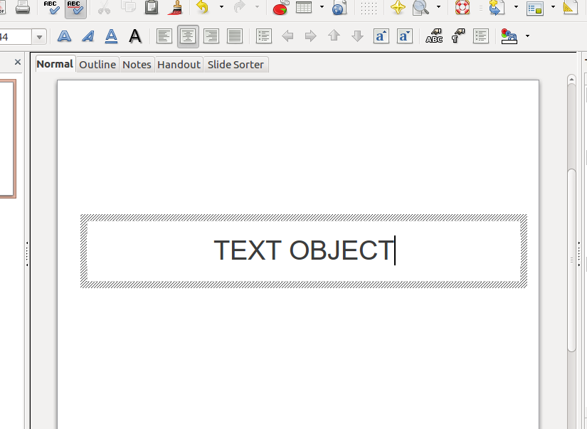
From there on, select your object and choose custom animation from the Task pane.
Click add and you will be given a myriad of custom animations to choose from, starting from entrance, emphasis, exit, to creating your own motion paths.
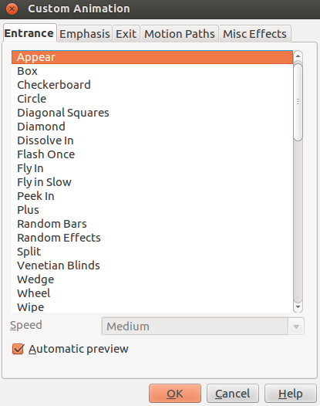
Some properties need mentioning are;
- Start, this differs from on click, with previous, and after previous. On click starts the animation when user click the mouse button. With previous starts the animation altogether with the previous object that were given an animation. While after previous waits for the last object animation to finish before starting.
- Effect, usually varies from which animation that were chosen; and
- Speed, chooses the speed of the animation.
This concludes the custom animation part.

Tips on creating a presentation using Impress
Impress is NOT Microsoft PowerPoint. Albeit you can open a pptx file here, the results won't be the same. Some things worth mentioning are;
- Gather the resources you have for the presentation in a single folder. Including pictures, sounds, videos, and fonts. This usually solves the “stuff not showing on slides” problems.
- Make your point short and clear! Nobody want's to go through a half an hour presentation as if they have to read an entire book. NO BODY.
- Don't use text color with too much contrast or less contrast from the background. This is usually comes with practice, but it's important not to hurt your audiences eyes.
- Sounds and music – unlike in Power point – doesn't go through slide transition. It stop when you change slide.
- Use pictures, and videos sparsingly. Remember it is YOU who is giving the presentation, not Impress. Going through an entire photo gallery without any explanation and you're better off giving your audience handouts instead of a presentation.

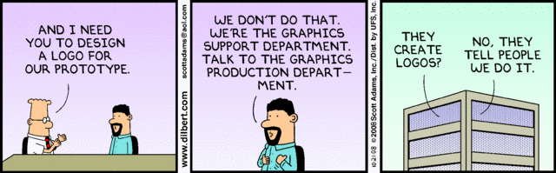

Chapter 6 : GIMP
GIMP (GNU Image Manipulation Program) is an image retouching and editing tool and is released under the GPLv3 license as free and open-source software. There are versions tailored for most operating systems including Microsoft Windows, Mac OS X and Linux.
GIMP has tools used for image retouching and editing, free-form drawing, resizing, cropping, photo-montages, converting between different image formats, and more specialised tasks. Animated images such as GIF and MPEG files can be created using an animation plugin.
(that one is from Wikipedia).
GIMP (original's name was the GIMP) first released version was 0.54 back in 1995 as a semester-long project by Spencer Kimball and Peter Mattis at the University of California, Berkeley.
By the time this is written, the stable version of GIMP is 2.8.4 under Linux platform.
There are other forked versions of GIMP, one notable is the GIMPShop, which aim to replicate Adobe Photoshop at some point.

Getting to know GIMP
GIMP user interface is, well, looks almost exactly like Adobe Photoshop. Or lots of other raster based application. Although somewhat different, users who have experience or came from a design orientation background should have no trouble using this software after a few weeks of frequent usage.

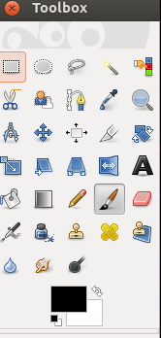
The Toolbox is the where your tools resides. Each tool is designed to do something to your images and layers. Some of these will be used a lot more than the others. And for most situations, there are shortcuts to most of these so you won't have to click on them all the time. Just below the toolbox there's a color “swatch”. These represent the current background and foreground of GIMP. Clicking on them opens up the color chooser.

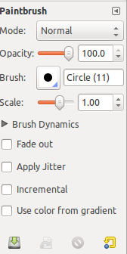
Just below the color swatch, lies the Tool Options. This dialog box changes everytime we choose a different tool. For example if we select the Paintbrush tool, the Tool Options provide options for brush type, scale, modes, and so on.
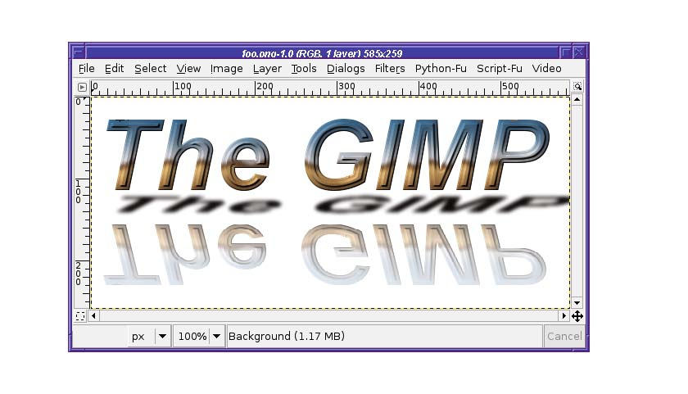
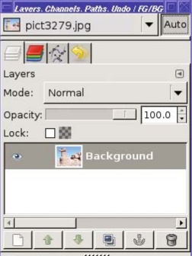
The Image Window is where your images appear. And also where we do the editing. The menu bar in MS Windows appears at the top. While in Unity Desktop, is integrated with the top
panel. The Image Window provide useful information from how much we are zooming on the image, image size, etc.
And the last window is the Layer dock, this window is actually called Dialog Docking, because it has several other function more than just managing existing layer. There's the history tab, the channel and also brush and patterns.

Image File Types
Before we actually dive in, there are several important concept we need to brief. That is “What file type should I save?”. By default when we start a new project with GIMP, it automagically saves a project using the XCF format, which is GIMP's default. But most of the other time, we don't want to start a new project, we just want to edit existing images. Here's a few image type you need to know.
- XCF, as mentioned above, this is GIMP's default file format. It's file size is quite large, but saves every layer you need to work with.
- PSD, the Industry's de facto standard. This is Adobe Photoshop's default format.
- JPG/JPEG, stood for Joint Picture Group or Joint Picture Expert Group is a common image file type used since late 90's but it has several limitations. It's a lossy file compression, meaning every time you save the file, there's always some color information missing.
- PNG, now a more popular on the web. PNG has slightly larger file size than JPG but it doesn't lose any color information when it's saved. Also PNG supports tranparency and partial transparency to make translucent images. So it's a common format we see in everyday web pages. PNG once stood for “PNG's not GIF” or “PNG's not JPEG”. But now, most convention calls it Portable Network Graphic.
- GIF, Graphic Interchange Format. Supports 8 bit color, transparency and animation. But it's saving algorithm makes it a bad choice for full color images.

Simple Photo Retouching
- Scaling
Scaling is a way to change your image resolution. Most Digital Cameras today can take pictures at high resolution up to 12 Megapixel. Albeit this method takes beautiful, crisp images. When you upload them to a website, the loading time for these images is frustrating. Scaling these images to a lower resolution could reduce loading time.
Vice versa, if you scale a low-res image to a higher resolution, the image quality will look really poor.
Scale tool can be accessed via the toolbox. Or from the menu. The menu → Tools → Scale provide a dialog box where you can manually choose the resolution, while the toolbox allow to resize images using the mouse. Also, if you want to keep the image ratio, use the chain in the dialog box. Similar method using the mouse is to use Shift+click while resizing your image.
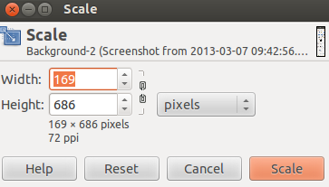
- Cropping
Cropping is an act to cut a part of an image to your liking/need. The tool GIMP provide is pretty straight forward. Select a part of the image you want to crop and press enter.

- Brightness & Contrast
Changing the image brightness and contrast is probably something we see on TV every other day. in GIMP, this dialog box can be accessed via menu Color → Brightness-Contrast.
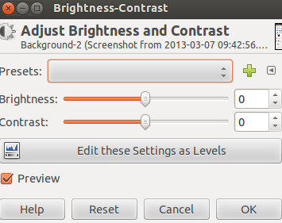
The Brightness and Contrast tool is particularly usefull for low light photography, and the color menu also provide some other usefull features such as changing color level, hue, and saturation.
- Rotating Images
Rotating Images is also usefull when we didn't hold the camera at the right angle. The Rotate Tool can be accessed from the toolbox (if you want to use the mouse) and from the menu there's the Tools → Transform Tool→ Rotate. You can also rotate images 90 degree quickly using the menu Image → Transform → 90 degree clock or counterclock wise. This also allow image flipping.
- Sharpening & Fixing Red Eyes
Sharpening or blurring images usually comes at the filtering chapters. But these filters are used so often it deserves a little preview.
To sharpen an image, we use the menu filter → enhance → sharpen, while blurring an image, we use the menu filter → blur. These filter is some of the most common filter people use. Blurring can also be accessed via the toolbox, while the filter blur method is used for the entire image, or selection.
The Fix Red Eye is also accessed from the enhance filter. But be sure to use the selection tool first. If you don't, the red colors in your image can be reduced to blue.

Getting to know Layers
Layer, be it in Photoshop or GIMP. Are your bread and butter in image editing. Most beginners tend to avoid using layers at first try. But using a multitude of layers for image editing can make things much easier.
Almost every project in GIMP consist of several images combined called layers. A layer may or may not be transparent. It can even be translucent!
For example, we have an image where we want to add some caption, just drop some text layer and your'e done!, or we want to change someone else's face into a celebrity, just crop some images and drop them as layer and you'll have a -terrible- composition of head-to-body picture!
To get the hang of it, let's try some exercise. Below, we have a couple of images we're going to join.


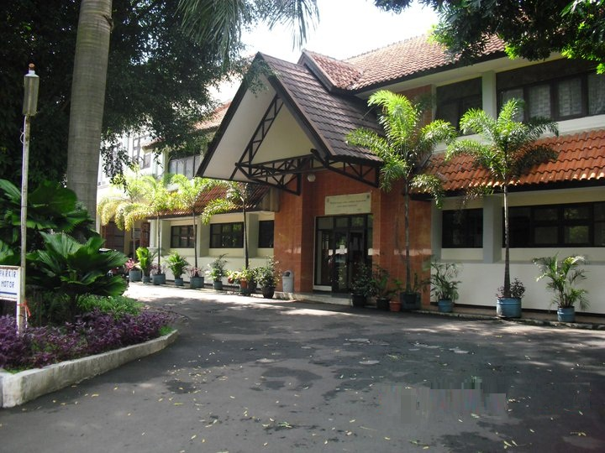

First up start a new project with a tranparent background. After that, open up the second image as layer and then the first. And you'll have something like this on the layer dock.
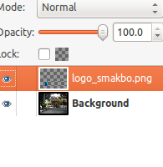
Here, you have two layer on top of each other. You can scale the image to your liking, you can also change the layer mode (more on this later). After that try adding a third layer, a text layer. And your final image should look something like this.
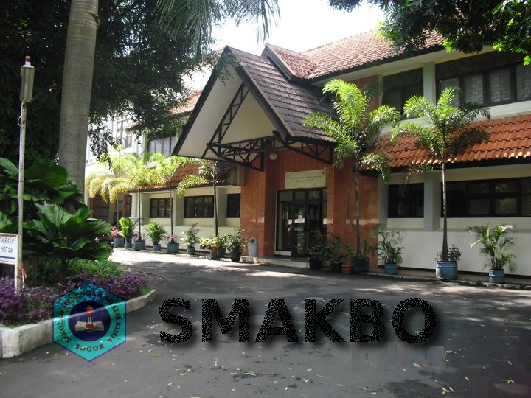
There are quite a few things on the layer dock that you should try familiarize with, namely
- Tabs. By default this consists of Layers, Channels, Paths, and Undo History.
- Layers List. This is where you see your layer previews, names, visibility toggles and layer linking.
- Layer Button. Performs usual layer tasks such as new layers, delete layers, and move layers up and down
- Layer Mode & Opacity. The popular layer modes are normal, multiply, and dissolve. The opacity slider dictates how much transparency the layer has. Now, layer modes are actually mathematical calculation between the active layer and the layer just below it. You can see what it does by selecting differebt layer modes and changing the opacity slider.

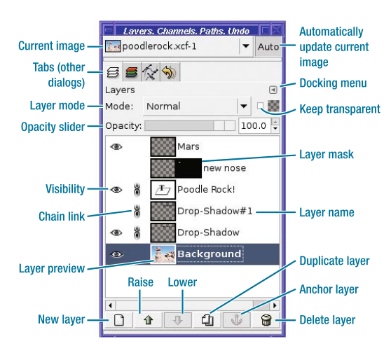
Drawing with GIMP
Raster based graphic apps such as GIMP is usually used to edit photos, but it does provide an array of drawing tools at your disposal. But before we dive in to some of the drawing tools available in GIMP, here's a few tips.
- Always use a new layer to draw new component. Why do this? Simply because when your image consist of several editabel components (in this case, layers), you'd be able to edit your images with ease in the future.
- Use a tranparent background, and use a new white layer to draw. You don't always have to draw on a white layer, but most people ends up wanting tranparency for their drawings.
With that out of the way, let's go through some of the basic drawing tools available.
- Pencil Tool. To draw some hard edge lines, this is the way to go.
- Paintbrush Tool. The main difference between this and the pencil tool is the antialiasing. You can draw fuzzy edges and smooth lines.
- Airbrush Tool. Always draws fuzzy edges. This one has some extra tool options that is rate and pressure. The longer you press the mouse, the more differences it makes on the canvas. Think of it as using a real airbrush.
- Ink Pen Tool. The most complex drawing tool available, this emulates an old fashioned fountain pen, and is best used with drawing tablets.
The multiple drawing mode :
- Normal. Is what normal does.
- Dissolve. Adds some random dots to your brush.
- Behind. Draws whatever behind the active layer.
- Color Erase. Erases the selected foreground color.
The Tool Options :
- Opacity : is self explanatory
- Mode : as explained above
- Scale : makes you brush bigger! - or smaller
- Fade out : makes the line fade out after somewhile drawing
- Jitter : makes some randomness on your brush, sometimes makes the drawing look natural.
- Incremental : works only when opacity is below 100%. it makes the brush grow darker as you draw.
- Use color from gradient : uses gradient color instead of the foreground color.

Selection
Selection is the second most used Tools for photo editing, just after Filters. You might have used the basic selection tools available in GIMP, the Rectangle and Ellipse selection tool.
The select tool is used to -*duh- select a part of your image. Here is some similar tool options for the basic select tool.
- Select Mode includes replace, add, substract and intersect.
- Feather Edges disables anti aliasing, so you can have a fuzzy selection a few pixel more instead of a hard-edged selection
- Rounded Corner gives a round corner for the rectangle selection
- Expand from center is to select part of your image from the center
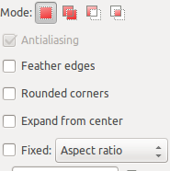
after a selection is done, users may do several other thing to selected parts such as applying filters, cutting and moving selection, grow, shrink, or give some fuzzy edges. But most of the time, the after task is done in the select menu.
Here's some of the sub-menu you'll find in the select menu.
- Select All / None. Is self explained.
- Invert. This one inverts your selection. Changes what you don't select into your selection.
- By Color. Select the color you choose from the image
- Feather. Gives a fuzzy selection so you won't have to deal with with hard-edged images.
- Shrink / Grow. Is to reduce or grow your selection by the number or pixel you choose.
The basic select tool works like a charm for simple images with few colors. But with a fuzzy image, you might want to look at some other advanced selection tool.
- Beezier Path Tool. Or Path Tool named after a French engineer who invented it, is a selection tool which allow users to give path points. This is particularly usefull when the image is complex.
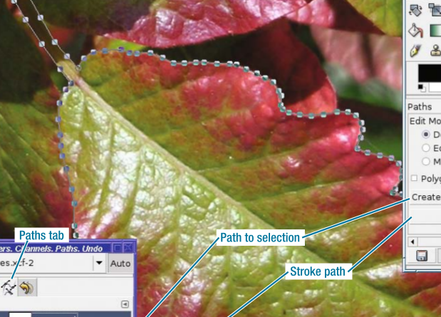
The Path Tool creates Path first. This Path can be saved as selection when needed.
- Intelligent Scissor Tool. Works just like Path tool, but it tries to follow similar foreground color.
- Foreground Select Tool. This select tool works by selecting similar foreground color with three steps.
  - Step one, after selecting the foreground select tool, select the area between the object you want to select and the background

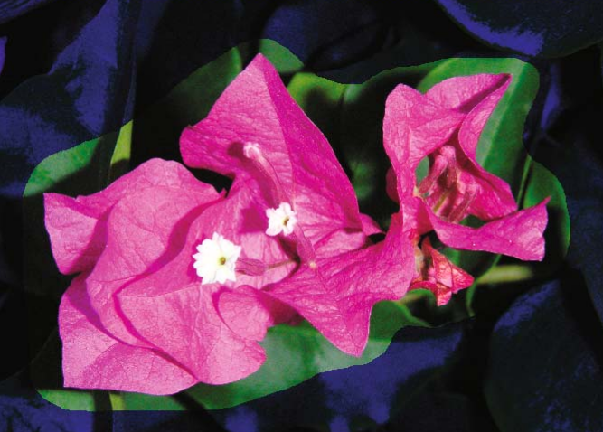
  - After that release the mouse button and the general area will be highlighted, second step is to draw along the object you want to extract, but be carefull not to touch the area you don't want.

  - When you finished, hit enter key and the object will be masked and turned into a selection.
Another technique to selecting images includes a quick mask. You can find quick mask in the left corner of the image window.
Here's a simple way to use quick mask;
- First, draw a rough selection of your image. And then activate quick mask.
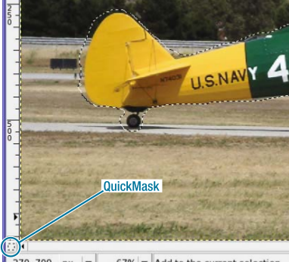
- After quick mask had been activated, the unselected area will turn into red. At this point, use the paintbrush and draw along the object to add selection precision.
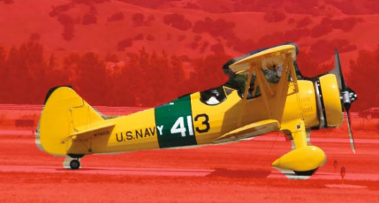
- Turn off Quick Mask and see result.

Filters
GIMP has tons of tools at your disposal. The easiest of them all is probably the Filters. This feature resides in the menu Filters and using them is a easy as applying one to your image.
Albeit it seems easy, the desired results often doesn't always reach the users needs. This is where practice comes in.
here, we'll discuss and try some of the most popular filters in GIMP, usually used for photo retouching.
- Blur
You probably have used the Blur Tool from the toolbox, the Blur Filter applies the same principle but to the entire image or selection. Some interesting options are the Gaussian Blur and Motion Blur. The Motion Blur spreads the image along a line (linear)
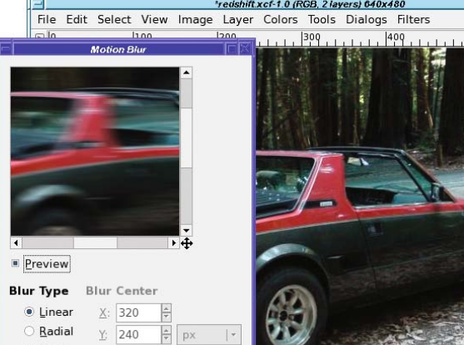
- Enhance
The Enhance Filters contains some usefull features mostly used to correct problems in images. Few of these worth mentioning are Sharpen, which is used to sharpen an image, and Antialias, to look for jagged edges and make them look smoother.
- Distorts
Is a filter dedicated to reshape your layer, as opposed to correcting it. It contains many types of filters, including Emboss.
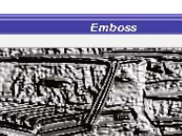
Iwarp, Swirl, & Ripple help reshape your layer to many forms, and filters like mosaic gives a glass effect to your image.
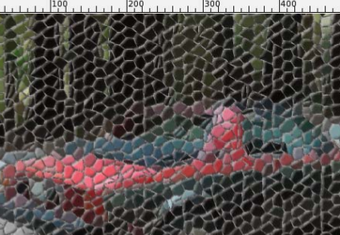
- Light & Shadow
Flares, Light, Sparkles & Supernova gives a light and flare effects to your images, and Shadows - like we have tried previously – gives a drop shadow to a layer. This is mostly used for text layers.

Last one in the Light & Shadows is also Lens & Glass Effects which gives the illusion of a translucent objects.
- Noise Filters
The Noise Filters gives a noise effect to an image or selection. This is opposed to correcting an image, but more often than not, giving a noise effect to a photo makes it better, and looks like the photo was taken by professionals.he

- Artistic Filters
The Artistic Filters gives an image the impression of being made out of an oil painting. There are tons of different filters inside this category to explore, but the most interesting is probably the GIMPressionist.
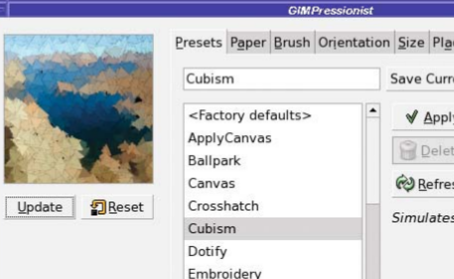

Exercise
The exercises for this chapter can be found at the writers Dropbox site at :
https://www.dropbox.com/sh/2mghlsusctz4o8n/67JvBdV0ro


Chapter 7 : HTML & CSS

History of HTML & CSS
HTML (Hypertext Markup Language) is a markup language created to diplay web pages and other information that can be displayed in a web browser.
HTML is written in the form of HTML Elements usually consisting of tags enclosed in angle brackets “< />” and most commonly comes in a pair. The first tag is the opening tag and then followed by a closing tag.
The Web Browsers job is to translate this tags and compose them to a readable web pages. HTML tags also allows images and objects to be embedded.
HTML was first proposed & prototyped by Tim Berners-Lee at CERN (European Organization for Nuclear Research) to use and share research documents. Berners-Lee specified and wrote HTML and its parser (a browser) in 1990.
The currently widely used version HTML is 4.1, while HTML 5 is beginning to spread all over the internet. Most of the modern web browsers available can now translate HTML 5.
CSS (Cascading Style Sheet) is a style sheet language used for describing looks and formatting of an element written in markup languages such as HTML. It is mostly used in adjacent to HTML markups.
CSS initial release was December 17th 1996, and developed by the World Wide Web Consortium. It is primarily designed to enable the separation of document content with document presentation.

First HTML Page
HTML is written in text editors, saved as text file with the .html extension, and translated by web browsers.
You can have any text editor you want. The Ubuntu's default text editor, Gedit, can handle Syntax Highlighting in HTML & CSS just fine. The more popular text editor in Linux would be Geany, and Bluefish. For most people using Microsoft Windows Platform, Notepad++ is widely used.
Now let's try to create our first html page. Save this page as latihan-1.html.
</html>
<head>
<title>Welcome to HTML</title>
<link rel="stylesheet" type="text/css" href="latihan-1.css" />
</head>
<body>
<p>
<h1>Document HTML yang Pertama</h1>
</p>
</body>
</html>
Now, after you saved it. And open it in a web browser. It would probably look like a normal HTML page, now let's try adding some CSS into it.
Next, open up another new file and write this down.
body {background:orange;
}
Now saved it as latihan-1.css and then fire up your browser. It would probably look something like this.
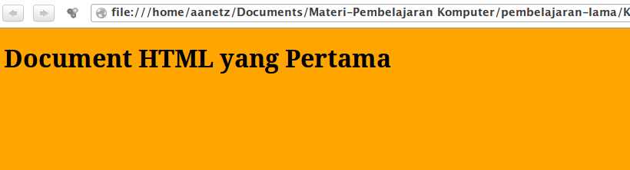
Okay, here's a brief explanation for the HTML page.
First of all, The <html> and it's closing tag </html> marks the document as a html page. Everything written between this tag is translated by a browser to a html page.
The second part is the <head> </head> tags. This is the head of the html element. Most of the time, programmers put CSS links here, more on this later. But take a look at the <title> tag. Everything written in this tag is displayed on the browsers windows title.
The third and largest is the <body> tags. This is where your pages are. Everything written here will be displayed as a web page, Note that I wrote <h1> tags meaning this is a Heading number 1. and everything in Heading 1 is written in large fonts. While the <p> tags marks it as a paragraph.
Now the CSS part. There are actually 3 kinds of way to insert a CSS to a html page, but we're just going to discuss just one, using the <link> tag.
Watch carefully at latihan-1.html line 3. this is where we insert the link to a CSS file named latihan-1.css. The <link> tag also has some other arguments like rel=”stylesheet” and type=”text/css” and href. Marking the linked file as text/css as a stylesheet.

HTML tags
Try Familiarize yourself with some of these HTML Tags as practice.
- <a> : hyperlink
- <br> : break return (serves as new line)
- <h1> to <h6> : marks a heading 1 to heading 6
- <p> : paragraph
- <form> : marks a form area to submit data
- <button> : a clickable button
- <img> : marks an image
- <table> : defines a table
- <ul> & <ol> : defines an ordered and an unordered list.
- <div> : marks a section in the document.

CSS descriptor
CSS as we have seen in the file latihan-1.css defines the presentation of the document. In this case we select the background of the document an changes it's color to orange.
What CSS is basically doing is to select an element, and then change it's appearance. For example, here's another CSS file
h1 {font-family:ubuntu;
}
h2 {color:white;
}
Now, if you add this to your last CSS file, It will select the heading 1 and heading 2 element and changes it's font family and font color.
Now for a bit of exercise, try adding some HTML elements and also these CSS descriptions to your files
#upperroman {list-style-type:upper-roman;}
#loweralpha {list-style-type:lower-alpha;}
#decimal {list-style-type:decimal;}
#lingkaran {list-style-type:circle;}
#kotak {list-style-type:square;}

Note that this CSS styles are for ordered & Unordered lists.

table,th,td { border:2px solid black;
border-collapse:collapse;
margin:2px;
padding:5px;
}
And these CSS stylesheets are for HTML elements <table>.

Tables
Tables in HTML is old school. Most designers moved to <div> tags for more flexibility. But still there's just no getting away completely from them. It's still a topic that spurs endless debate in internet message boards to this day. And another reason to learn how to use them. Here's an example of a table tags in HTML.
<table>
<tr>
<td></td>
<td></td>
<td></td>
</tr>
<tr>
<td></td>
<td></td>
<td></td>
</tr>
<tr>
<td></td>
<td></td>
<td></td>
</tr>
</table>
The code above creates a table by definition, and adds 3 rows and three columns. For if you haven't tested it, the additional tags are.
- <tr> stands for table row. This tags represents a row in a table in which you add some cell
- <td> this tags marks the smallest element in a table. Or if in a spreadsheet, you call them cells.
- There are a few additional tags in tables such as <th> or the new <thead> and also <tbody>.

Forms
Forms, during the early ages of the internet, is the only way to communicate between the client and the server. It is what separates static website and dynamic ones.
Although these days websites uses many kinds of user interactions, the form tags persists. It's still among the primary ways to send data to servers.
Now, the scope of HTML in this book doesn't cover server side scripting, but it's still important to know some of the basic tags used to create a form.
A form tags usually involves inputting some texts, some radio buttons, drop down lists, etc. and followed by a submit buttons.
<form>
First name: <input type="text" name="firstname"><br>
Last name: <input type="text" name="lastname">
</form>
The basic form to input names.

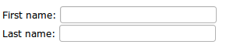
And also several other kinds of input form, such as radio buttons, and checkboxes
<form name="input" action="html_form_action.asp" method="get">
<input type="radio" name="sex" value="male">Male<br>
<input type="radio" name="sex" value="female">Female
<input type="checkbox" name="vehicle" value="Bike">I have a bike<br>
<input type="checkbox" name="vehicle" value="Car">I have a car
</form>
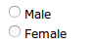
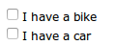
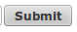

Exercise
The Exercises for this chapter is available at the writer's Dropbox Sites :
https://www.dropbox.com/sh/d5fgovff4xwcsk5/ofCN2sA-Zj

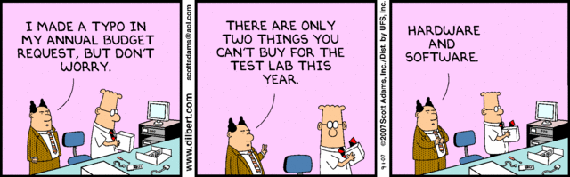

Chapter 8 : Bkchem & Chemical Calculator

The Ubuntu Software Center / Repository as of this writing, has literally over thousands of application available for free and download. While quite a number of them has some use for a would be chem analyst, there won't be enough time to cover every single one of them. So instead we will cover some of the most popular ones, being Kalzium, Chemical Calculator, & BKChem. Well, maybe not Kalzium as it's only a digitalized periodic table.
Note that the Chemical Calculator can be installed in Ubuntu using this command :
sudo apt-get install chemtool
and the calculator also comes with several handy tools like the chemtool and the periodic table viewer.

Chemical Calculator
This certain application is the easiest one yet. You will only have to input a certain chemical structure and then you'll get it's written formula, raw formula, molecular weight, Elements, and its mass.
For example we're entering H₂SO₄ here :
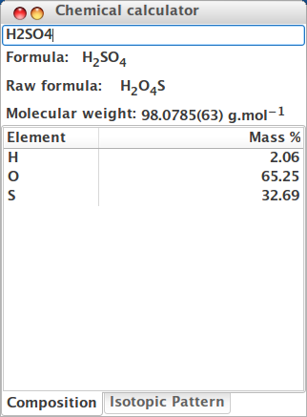
And that's it. This might come handy in the future, so make it a reference. There are tons of other scientific tools you can try at the Ubuntu Software Center.

BKChem
To install Bkchem in Ubuntu, simply search for it at the Ubuntu Software Center, or type this into the terminal.
Sudo apt-get install bkchem
after you're finished installing, fire it up and you'll see the workspace windows.
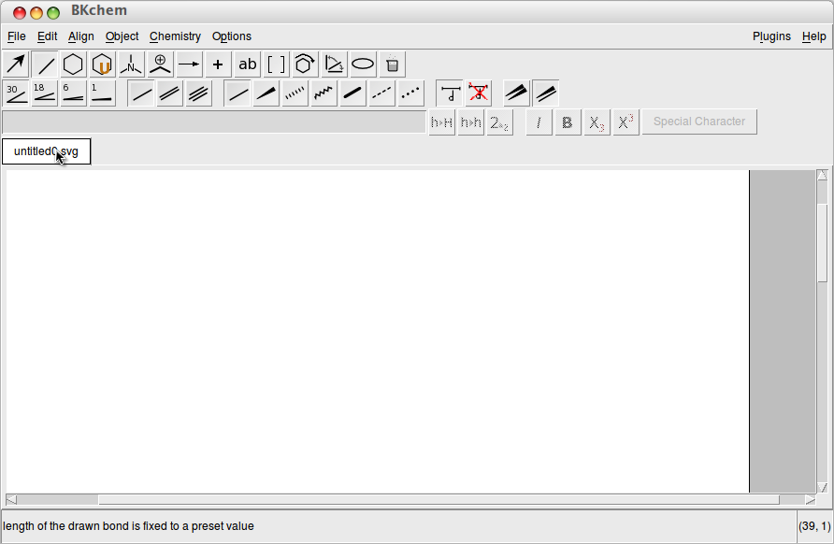
Drawing a chemical structure in BKChem is fairly easy due to an already premade templates.
Some key points we need to look at are these :
- Edit and Compound lines
The first 2 tool box represents drawing line compounds and editing them, make some notes that there are single, double lines, and so on. The edit tool makes it so that the object you draw can be moved, or edited.
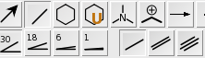
- Templates
The template tool & its options consist of premade templates such as benzene, cyclopentadiene, and other cyclohexane for easy drawing.
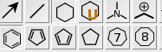
- Atom Mode
This is where you conjure your compound. To write some chem structure like CO, H, etc. simply click Atom Mode and then click at the end of the line you were drawing. You will go to text editing mode to input your chem molecules.
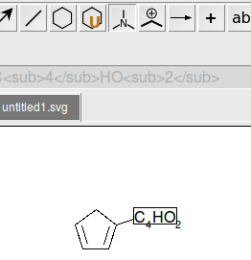
- Other menus and tools you need to try are Text tool, Rotate, and Transformation. The tools name are probably self explanatory.

Saving your work
BKChem by default saves your work in SVG format. (Scalable Vector Graphics). This format allows you to re edit your work in vector based design applications.
The steps below will guide you to use GIMP to convert your work to PNG format, which you will probably need later to insert your work to word processors.
- First things first save your work via the menu file → save. This automagically gives your file name a *.svg extension. But don't forget to choose your save folder! You might not remember them later.
- Second step fire up GIMP, and open your file. At first your image will seem huge, but there's a way to crop this, go to menu Image → Autocrop Image. Your image will be cropped to minimum size, taking less disk space. At this point you might want to resize your image to your need.

- Finally choose save as from the GIMP menu and give the filename a *.png extension. This will save your image in PNG format for later use.

Exercise
Let's try some of these simple drawing exercise and then turn them into PNG files!
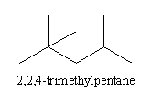

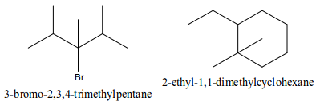
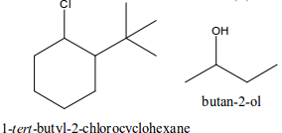
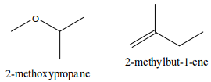
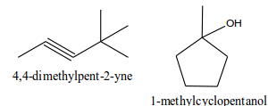

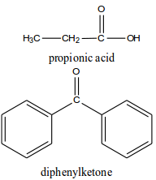
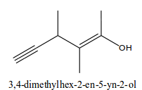

Bibliography
Refsnes Data, HTML Tutorial, www.w3schools.com : Refsnes Data, 1999-2013.
Peck, Akkana, Beginning GIMP From Novice to Professional Second Edition : aPress, 2008
The Document Foundation, Getting Started LibreOffice 3.5 : LibreOffice.org, 2010-2012

