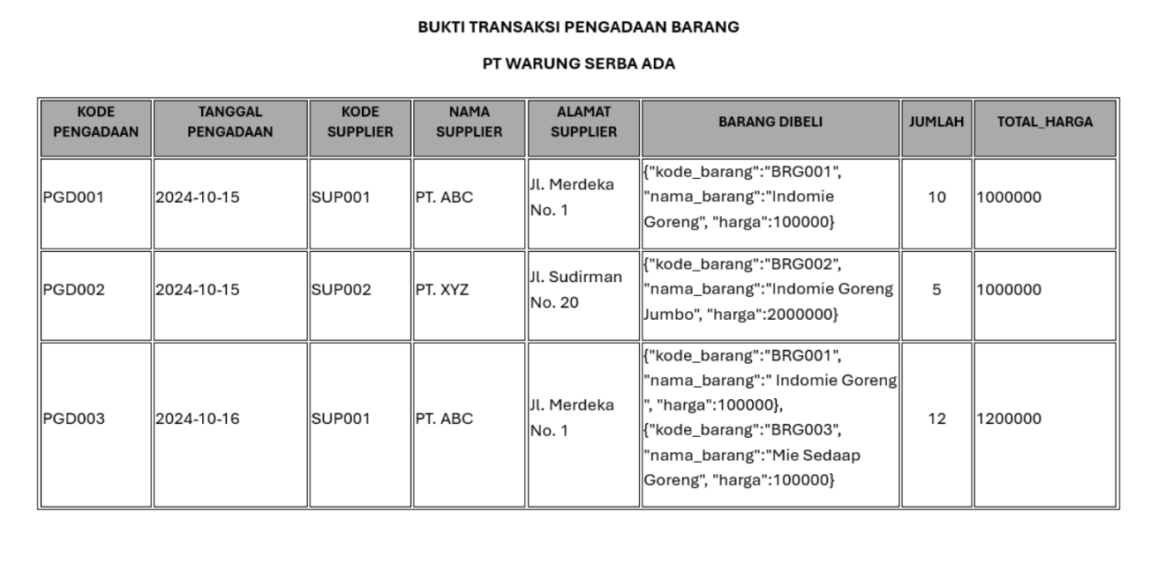

1. **First Normal Form (1NF)**

Membuat data bersifat Atomik

|  |  |  |  |  |  |  |  |  |  |
| --- | --- | --- | --- | --- | --- | --- | --- | --- | --- |
| **Kode Pengadaan** | **Tanggal Pengadaan** | **Kode Supplier** | **Nama Supplier** | **Alamat Supplier** | **Kode Barang** | **Nama Barang** | **Harga Satuan** | **Jumlah** | **Total Harga** |
| PGD001 | 2024-10-15 | SUP001 | PT.ABC | Jl. Merdeka No.1 | BRG001 | Indomie Goreng | 100000 | 10 | 1000000 |
| PGD002 | 2024-10-15 | SUP002 | PT.XYZ | Jl. Sudirman | BRG002 | Indomie Goreng Jumbo | 200000 | 5 | 1000000 |
| PGD003 | 2024-10-16 | SUP001 | PT.ABC | Jl. Merdeka No.1 | BRG001 | Indomie Goreng | 100000 | 6 | 600000 |
| PGD003 | 2024-10-16 | SUP001 | PT.ABC | Jl. Merdeka No.1 | BRG003 | Mie Sedaap | 100000 | 6 | 600000 |

1. **Second Normal Form (2NF)**

Untuk menghilangkan ketergantungan Transitif

Tabel 1 Tabel Barang

|  |  |  |
| --- | --- | --- |
| **Kode Barang** | **Nama Barang** | **Harga Satuan** |
| BRG001 | Indomie Goreng | 100000 |
| BRG002 | Indomie Goreng Jumbo | 200000 |
| BRG001 | Indomie Goreng | 100000 |
| BRG003 | Mie Sedaap | 100000 |

**Tabel 2 Tabel Supplier**

|  |  |  |
| --- | --- | --- |
| **Kode Supplier** | **Nama Supplier** | **Alamat Supplier** |
| SUP001 | PT.ABC | Jl. Merdeka No.1 |
| SUP002 | PT.XYZ | Jl. Sudirman |

**Tabel 3 Tabel Pengadaan**

|  |  |  |  |  |  |
| --- | --- | --- | --- | --- | --- |
| **Kode Pengadaan** | **Tanggal Pengadaan** | **Kode Supplier** | **Kode Barang** | **Jumlah** | **Total Harga** |
| PGD001 | 2024-10-15 | SUP001 | BRG001 | 10 | 1000000 |
| PGD002 | 2024-10-15 | SUP002 | BRG002 | 5 | 1000000 |
| PGD003 | 2024-10-16 | SUP001 | BRG001 | 6 | 600000 |
| PGD003 | 2024-10-16 | SUP001 | BRG003 | 6 | 600000 |

1. **Third Normal Form (3NF)**

Menghindari Redudansi Data

Tabel Detail Pengadaan

|  |  |  |  |
| --- | --- | --- | --- |
| **Kode Pengadaan** | **Kode Barang** | **Jumlah** | **Total Harga** |
| PGD001 | BRG001 | 10 | 1000000 |
| PGD002 | BRG002 | 5 | 1000000 |
| PGD003 | BRG001 | 6 | 600000 |
| PGD003 | BRG003 | 6 | 600000 |

Tabel pengadaan

|  |  |  |
| --- | --- | --- |
| **Kode Pengadaan** | **Tanggal Pengadaan** | **Kode Supplier** |
| PGD001 | 2024-10-15 | SUP001 |
| PGD002 | 2024-10-15 | SUP002 |
| PGD003 | 2024-10-16 | SUP001 |

Tabel 1 Tabel Barang

|  |  |  |
| --- | --- | --- |
| **Kode Barang** | **Nama Barang** | **Harga Satuan** |
| BRG001 | Indomie Goreng | 100000 |
| BRG002 | Indomie Goreng Jumbo | 200000 |
| BRG001 | Indomie Goreng | 100000 |
| BRG003 | Mie Sedaap | 100000 |

**Tabel 2 Tabel Supplier**

|  |  |  |
| --- | --- | --- |
| **Kode Supplier** | **Nama Supplier** | **Alamat Supplier** |
| SUP001 | PT.ABC | Jl. Merdeka No.1 |
| SUP002 | PT.XYZ | Jl. Sudirman |