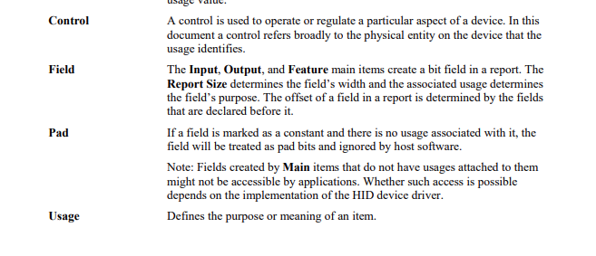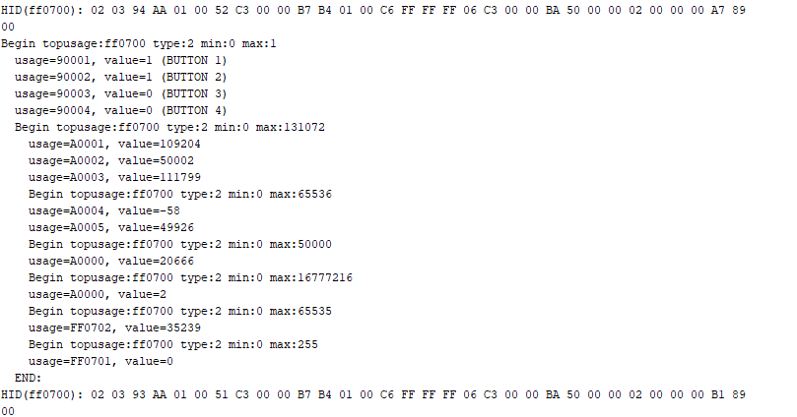

**Theta5**

**Theta6?**

**[NOT USED]**

**Time?[**

**-**

**Marker?**

**Theta0**

**Theta1**

**Theta2**

**Theta3**

**Theta4**

**Timer rolls over at 2^16 65k**

