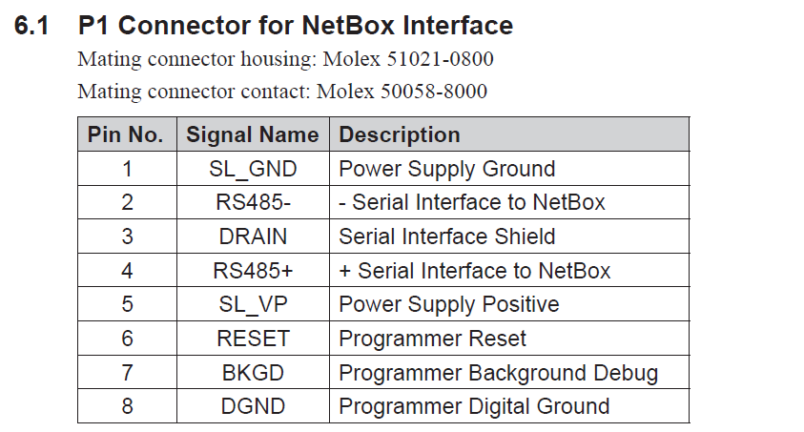

Reading holding registers (function 0x03) is the main way of getting non-streaming data from the ATI netCANoem board. Here is the excerpt from the Modbus guide on how to do this

