**Project Under Test: MonkeySim**

Ritika Maknoor

David Bickford

10 November 2016

**CS 1632 - DELIVERABLE 4: Performance Testing Using VisualVM**

**SUMMARY**

______________________________________________________________________

*Summary*

**SCREENSHOTS OF VISUALVM**

______________________________________________________________________

**BEFORE any refactoring:**

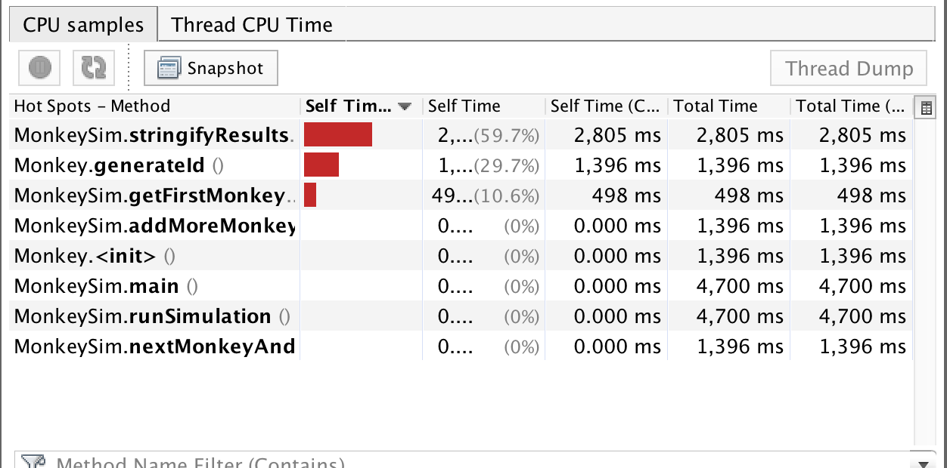

**AFTER refactoring stringifyResults()**

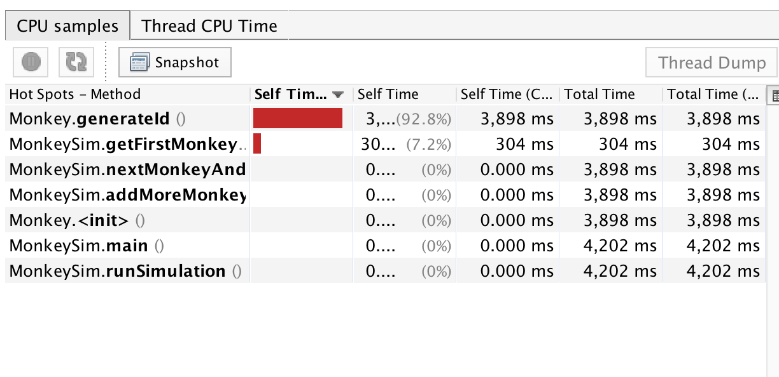

**AFTER refactoring generateID()**

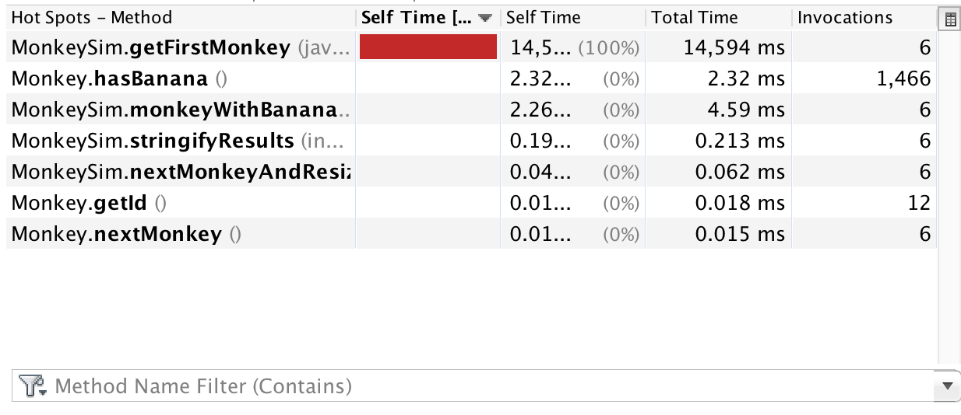

**AFTER refactoring getFirstMonkey()**

Was too fast to be able to run program and open profiler in time for a screenshot.

**INITIAL & FINAL TIMES**

______________________________________________________________________

**BEFORE any refactoring**

**Initial monkey: 23**

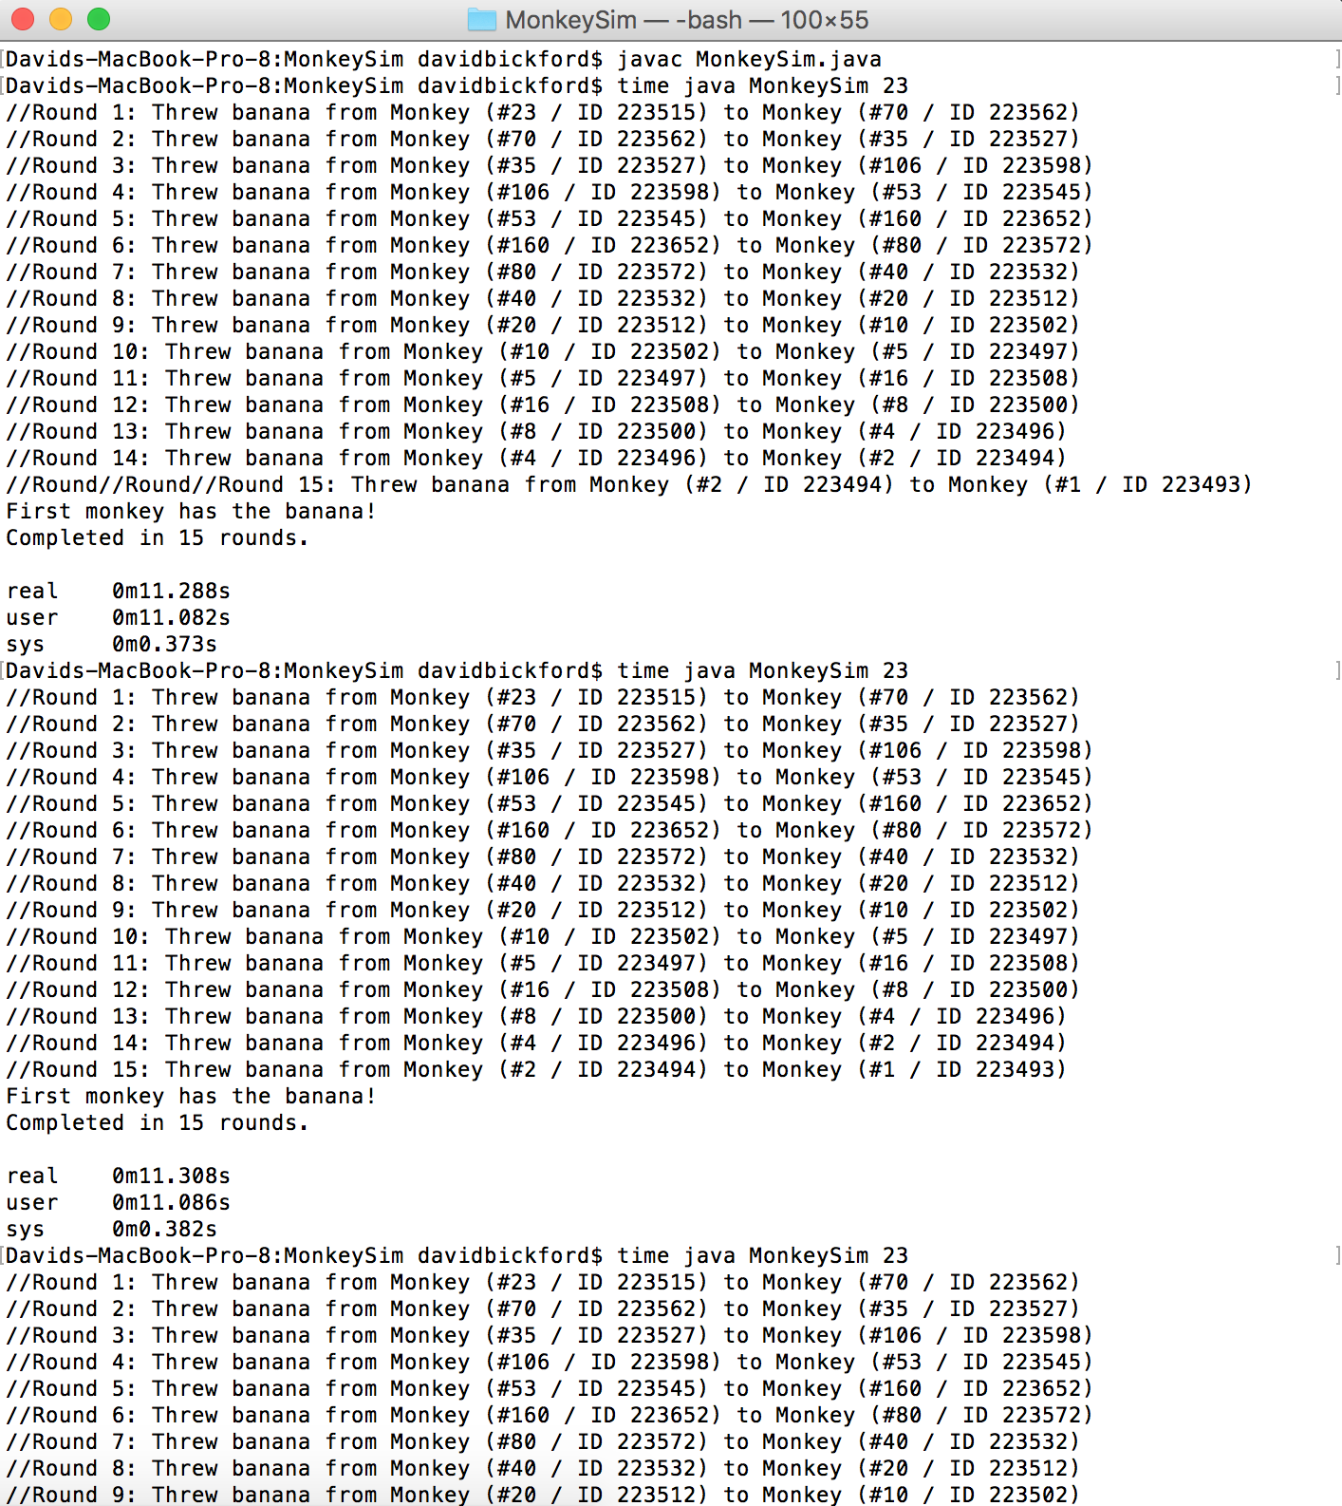

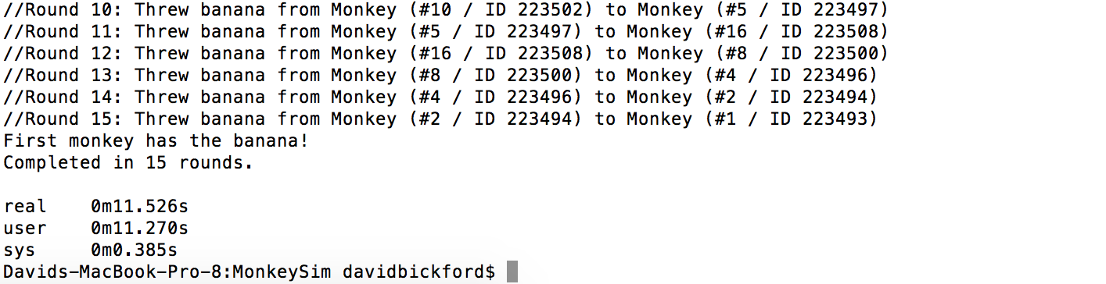

* Max amount of real time: 0m11.526s
* Mean time of real time: 0m11.374s

_________________________________

**AFTER refactoring stringifyResults()**

**Initial monkey: 23**

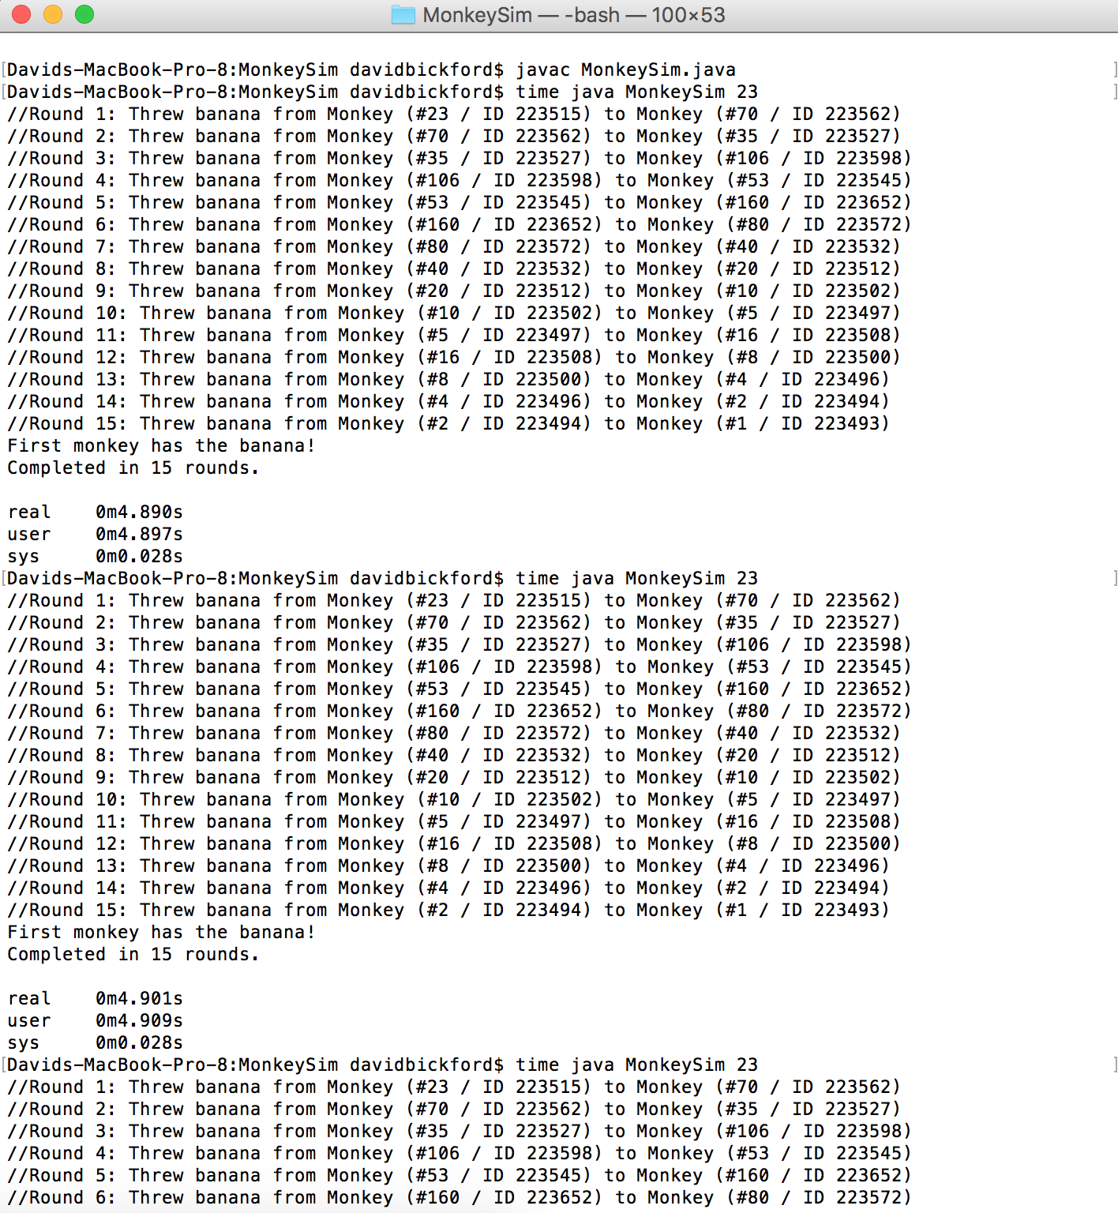

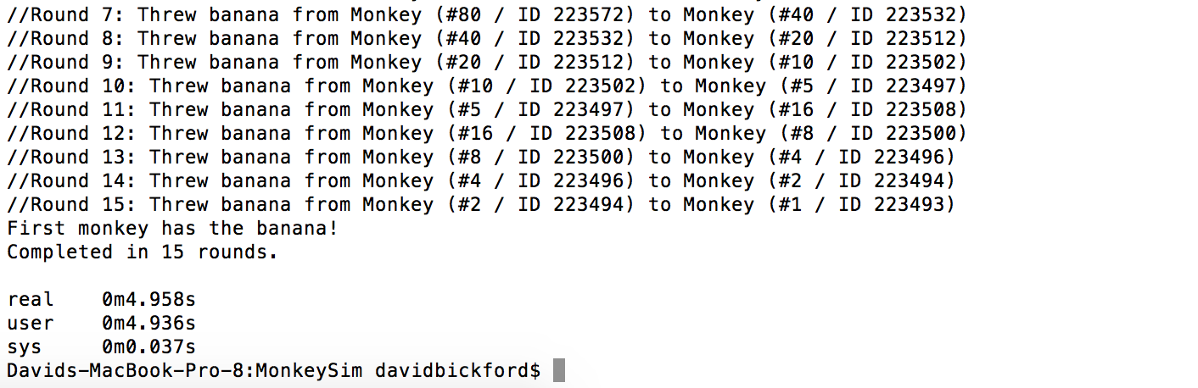

* Max amount of real time: 0m4.958s
* Mean time of real time: 0m4.916s

_________________________________

**AFTER refactoring getFirstMonkey()**

**Initial monkey: 4**

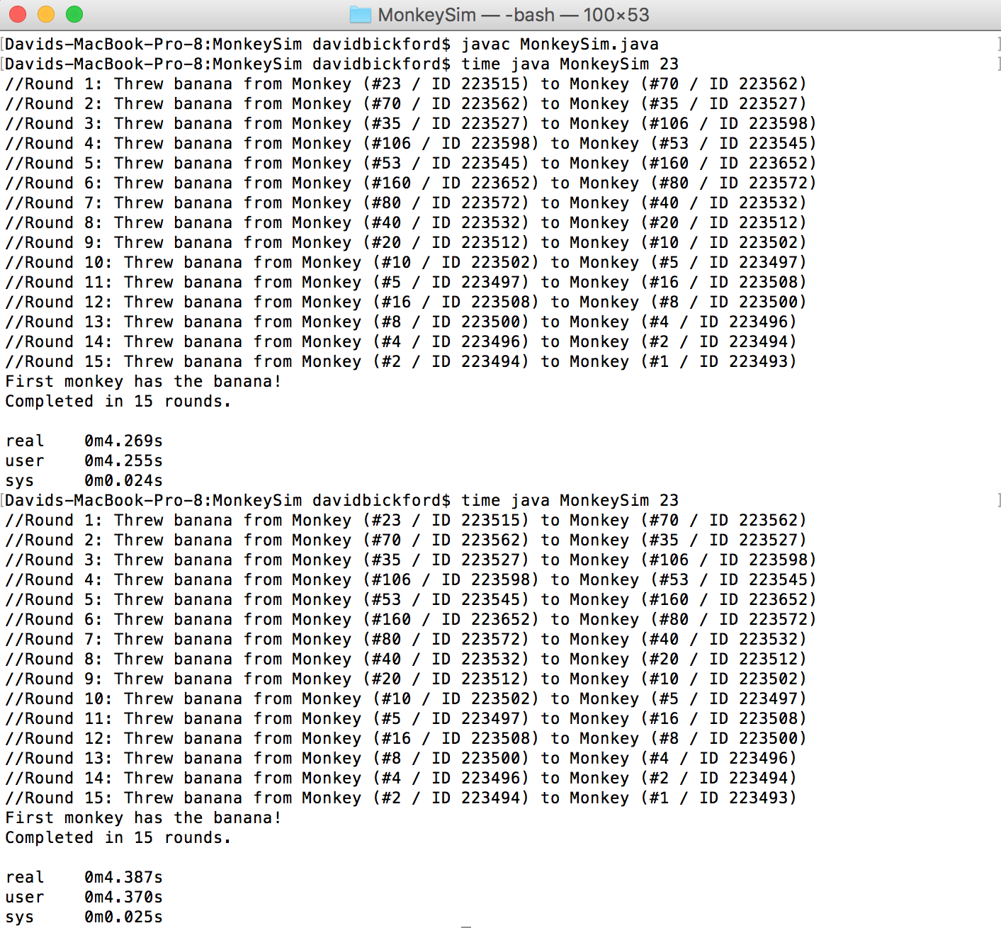

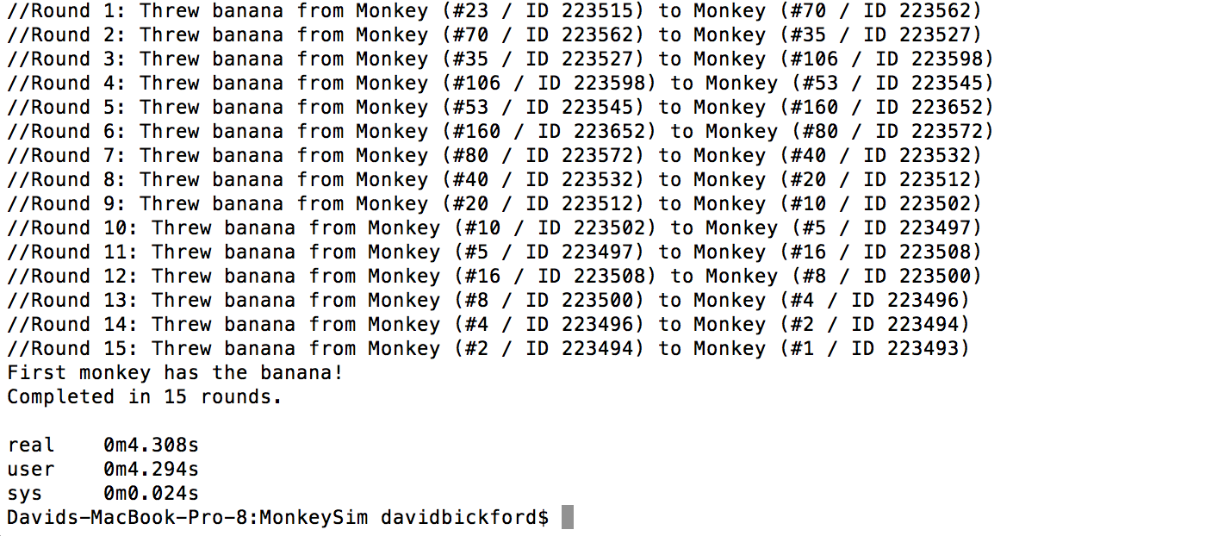

* Max amount of real time: 0m4.387s
* Mean time of real time: 0m4.321s

_________________________________

**AFTER refactoring generateID()**

**Initial monkey: 4**

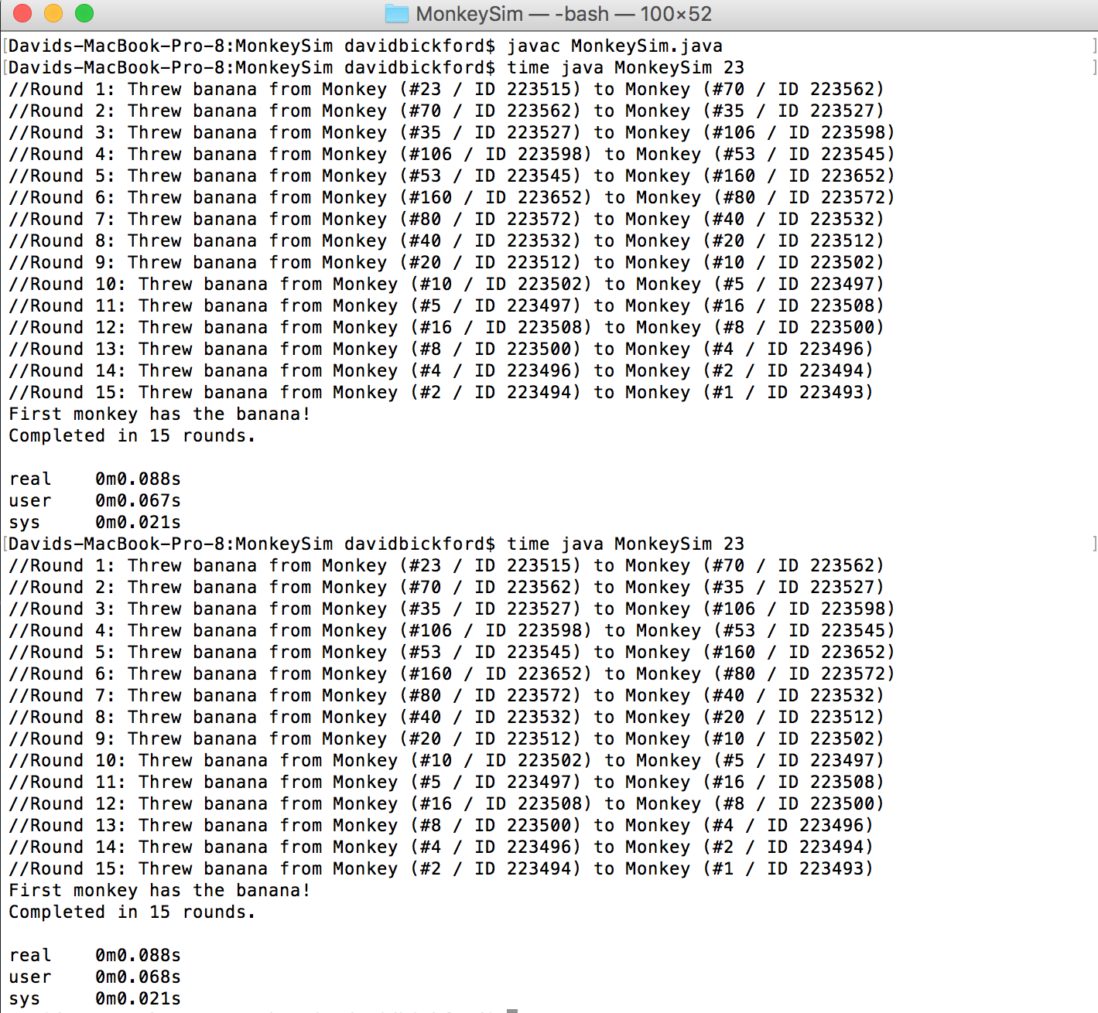

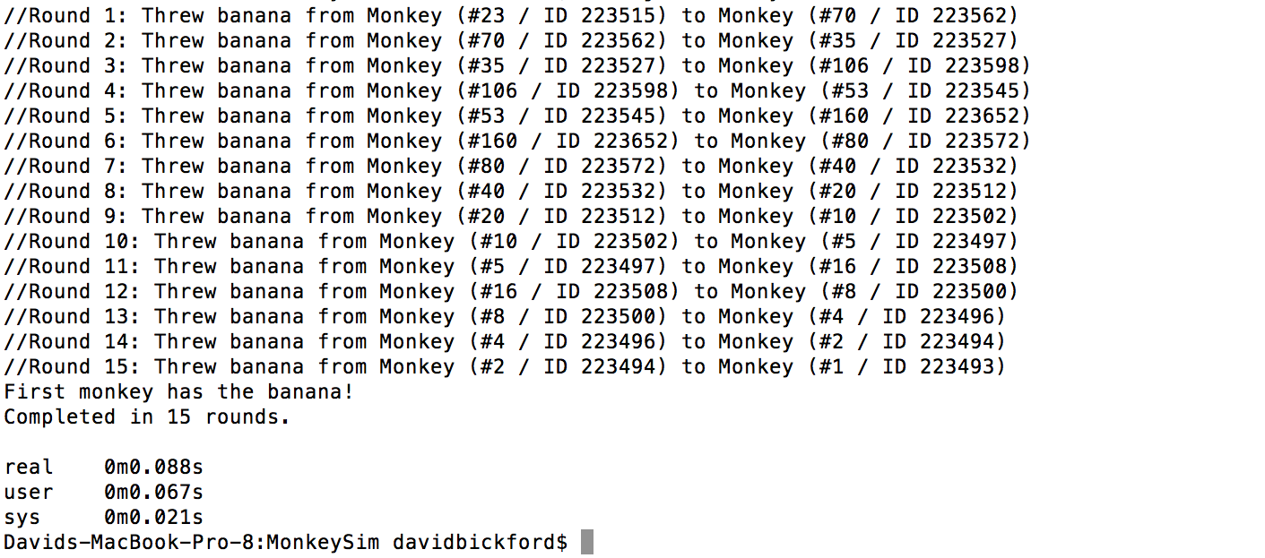

* Max amount of real time: 0m0.088s
* Mean time of real time: 0m0.088s

_________________________________