Development of a Smart Autonomous Guided Vehicle
Based Warehouse System with Integrated Robotic Arm
for Material Picking and Transfer
Figure Documentation Supplement
Sheikh Noorul A. Usmani (22AEB180)
Arbaz Rashid (22AEB485)
Under the guidance of
Prof. Mohammad Muzammil
Zakir Hussain College of Engineering & Technology
Aligarh Muslim University
2025–26

Chapter 3
System Design and Architecture
This chapter presents the complete design of the ATLAS Smart Warehouse AGV, beginning with the high-level architecture that decomposes the system into cooperating layers and progressing through the hardware-flow, ROS 2 communication, mission-pipeline, motion-control, order-management, state-machine and manipulator-pose representations. Each figure in this chapter captures a single, well-bounded design concern, and together they form the complete specification from which the implementation is derived.
3.1 Overall System Architecture of the ATLAS Smart Warehouse AGV
The overall system architecture defines the high-level decomposition of the ATLAS Smart Warehouse AGV into cooperating subsystems and the data flow that binds them together. It is presented at the start of the design chapter because every subsequent design decision—mechanical, electrical, and algorithmic—is constrained by the interfaces this architecture establishes. The diagram further makes explicit the boundary between simulation-only components and the components that survive the transition to physical hardware, which is central to the deployment strategy of the project.
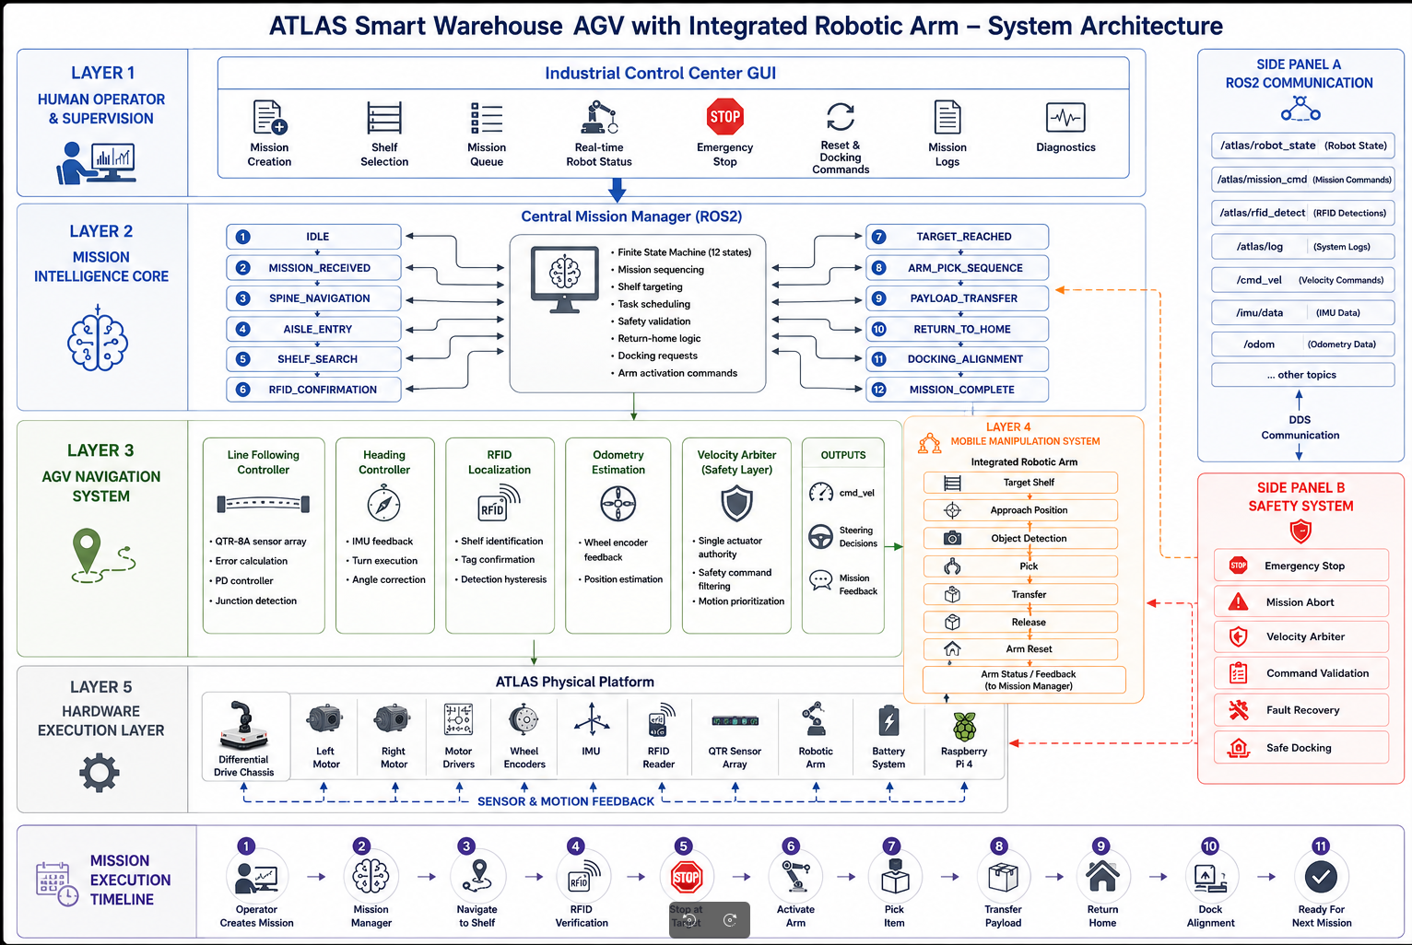
Figure 3.1: Overall System Architecture of the ATLAS Smart Warehouse AGV
As shown in Fig. 3.1, the system consists of five tightly coupled architectural layers stacked from the physics layer at the bottom to the human–machine interface at the top. The lowest layer is the physics and hardware layer, which in simulation is provided by Gazebo Classic 11 for the differential-drive AGV and by Gazebo Harmonic for the UR3 manipulator subsystem. This layer publishes ground-truth pose, wheel encoder ticks, IMU readings, line-array sensor states and RFID detections, and on the actuation side it consumes wheel velocity commands and joint trajectories. Sitting directly above it is the perception layer, which fuses these heterogeneous streams into compact mission-level abstractions such as the lateral tracking error from the line-following sensor array, the heading estimate produced by IMU complementary filtering and the junction-tag identity reported by the RFID reader. The control layer above perception is responsible for low-level closed-loop behaviour. It contains the line-following PD controller that converts lateral error into an angular-velocity correction, a dedicated turn controller that manages discrete heading changes at junctions, a per-wheel velocity PID loop and a velocity arbiter that enforces single-source command authority across manual, autonomous, safety and recovery sources. The planning layer is built around the twelve-state mission Finite State Machine, the priority-aware order queue, the AGV global path planner and the MoveIt 2-based motion planner of the UR3 arm. These elements transform high-level mission requests into discrete navigation goals and time-parameterised arm trajectories. All of the above communicate through a unified ROS 2 middleware backbone, drawn explicitly in the figure as the central spine connecting every block. ROS 2's Data Distribution Service transport, quality-of-service profiles and lifecycle node management provide deterministic, decoupled and discoverable communication between processes. The topmost layer is the operator-facing GUI and HMI block, which exposes mission start, pause, reset and emergency-stop controls and displays live telemetry such as battery voltage, current state and pending order count. The architectural decomposition shown here directly supports the project's stated 70% code-reuse target: only the perception driver nodes and the actuation interface nodes need to be replaced when migrating from Gazebo to physical hardware, while the control, planning, mission and HMI layers are carried across unchanged.

3.2 Hardware Architecture and Signal-Flow Diagram of the AGV
The hardware architecture diagram captures the electrical decomposition of the AGV platform, identifying every microcontroller, sensor, actuator and power stage as well as the directional signal flow between them. It complements the software architecture by anchoring each ROS 2 node to the physical port or bus from which its data originates. Documenting the hardware in this form is essential for reproducibility and for deriving the GPIO pin map and current budget that drive the physical build.
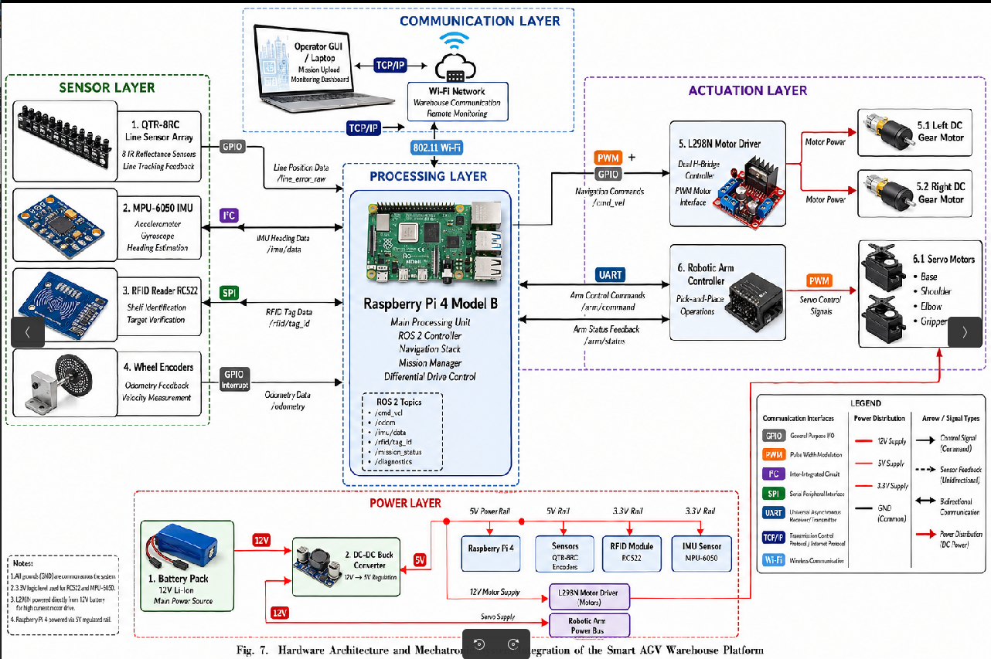
Figure 3.2: Hardware Architecture and Signal-Flow Diagram of the AGV
As shown in Fig. 3.2, the hardware architecture is organised around a Raspberry Pi 4 (4 GB) acting as the on-board ROS 2 host and a secondary low-level microcontroller, an ESP32 module, that handles real-time motor control and sensor sampling. The Raspberry Pi runs ROS 2 Humble together with the line-follower node, the velocity arbiter, the mission FSM and the GUI bridge, while the ESP32 publishes raw sensor frames over a USB-CDC link and consumes wheel velocity commands at 50 Hz. Mounted on the chassis is an eight-channel reflectance sensor array that feeds analogue line-position signals into the ESP32's ADC inputs, an MPU-6050 IMU communicating over I²C for heading estimation, and an RDM6300 125 kHz RFID reader on a UART bus that detects passive junction tags embedded in the warehouse floor. On the actuation side the ESP32 drives an L298N dual H-bridge motor driver, which delivers regulated power to two 12 V DC geared motors fitted with magnetic Hall encoders. The encoder signals close back into the ESP32's interrupt-capable GPIO pins and are used by the per-wheel velocity PID loop. A power distribution stage at the right side of the diagram shows a 12 V lithium-ion battery feeding a buck converter that produces a clean 5 V/3 A rail for the digital electronics, while the motor stage receives unregulated 12 V directly through a fuse and a manual emergency-stop switch. This separation between digital and motor power is critical for reducing brown-outs on the Raspberry Pi during high-current motor transients. The diagram also highlights the wireless interface: a Wi-Fi link from the Raspberry Pi connects the AGV to the supervisory laptop running the GUI and rviz2, while ROS 2 DDS discovery operates transparently across this link. Optional auxiliary peripherals—a buzzer for status indication and front and rear status LEDs—are wired to spare GPIOs and are toggled by the FSM in specific states such as ARM_PICK, EMERGENCY and DOCKED. This explicit bottom-up documentation of every signal path enables the simulation-to-hardware conversion table referenced later in the report and ensures that the physical build can be wired without ambiguity.

3.3 ROS 2 Node Communication and Topic Graph
Because the entire control stack is built on ROS 2, the runtime behaviour of the system is most clearly expressed as a directed graph of nodes connected by typed topics, services and actions. The communication diagram in this section gives a process-level view of that graph, listing every node executable deployed on the AGV and on the supervisory machine and showing how messages move between them. This view is the authoritative reference for all inter-process contracts in the project.
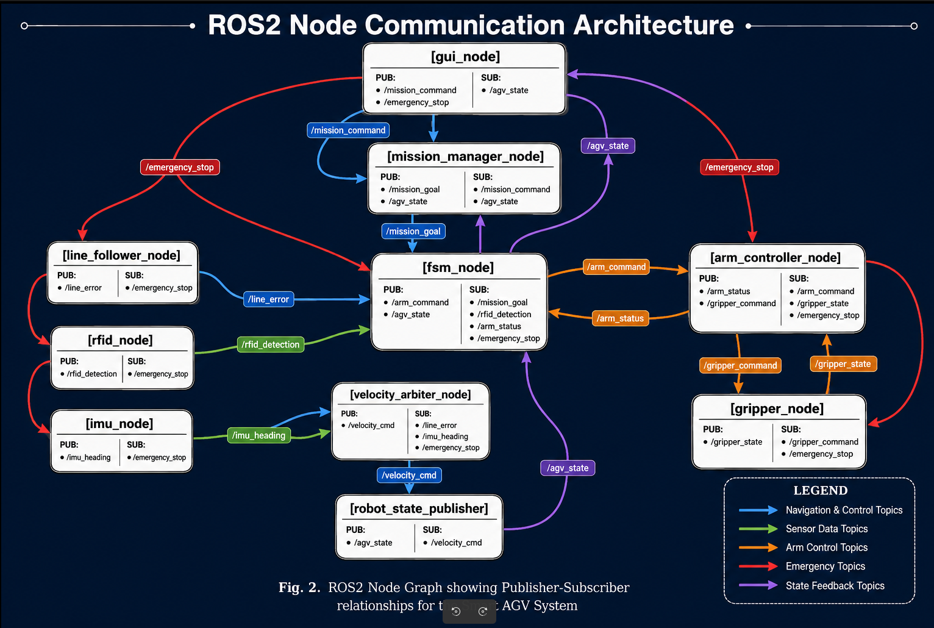
Figure 3.3: ROS 2 Node Communication and Topic Graph
As shown in Fig. 3.3, the system consists of approximately a dozen ROS 2 nodes distributed across the ATLAS packages and grouped into three logical clusters: sensing, control and mission. On the sensing side the line_sensor_node publishes a custom LineArray message at 50 Hz, the imu_node publishes sensor_msgs/Imu, the rfid_node publishes a JunctionTag message containing the 12-byte UID of the most recently detected tag, and the odometry_node fuses wheel-encoder ticks with IMU yaw to publish nav_msgs/Odometry on /odom and the associated /tf transforms. These messages flow into the line_follower_node (running the PD controller), the turn_controller_node and the junction_detector_node, which together produce candidate geometry_msgs/Twist commands on dedicated topics such as /cmd_vel/lf and /cmd_vel/turn. The velocity_arbiter_node subscribes to all candidate command topics and to a /safety/estop boolean from the safety_node; it then publishes a single /cmd_vel topic at 20 Hz to the differential-drive plugin. The arbiter enforces the priority order safety > teleop > navigation > line-follow, ensuring that an active emergency-stop or manual joystick command can always override autonomous behaviour. Above the control cluster sits the mission_fsm_node, which exposes a set of ROS 2 actions—StartMission, PauseMission and ResetMission—and a service to enqueue Order messages with priority. The FSM consumes the JunctionTag stream, the AGV pose and arm status, and produces high-level intent messages consumed by the planner and the GUI. On the manipulation side the diagram shows MoveIt 2's move_group node, the UR3 ros2_control hardware interface and the custom mtc_pickplace node that drives the pick-and-place pipeline using the MoveIt Task Constructor. These nodes communicate using FollowJointTrajectory action goals and the standard /joint_states topic. Finally the gui_bridge_node aggregates telemetry into a single AtlasStatus message that the PyQt5-based GUI on the operator laptop consumes. By making every connection in the graph explicit, the figure also documents the QoS profiles selected for each link—reliable + transient-local for mission state, best-effort for high-rate sensor streams—which is what permits the system to operate robustly over a wireless link.

3.4 End-to-End Material-Handling Mission Pipeline
The mission pipeline diagram complements the architecture and node graph by showing the temporal sequence of operations that the AGV and arm subsystems execute when fulfilling a single material-handling order. While the previous diagrams describe what exists, this diagram describes what happens, highlighting the hand-offs between perception, planning and manipulation. It is the conceptual backbone against which the state machine and the order manager are designed.
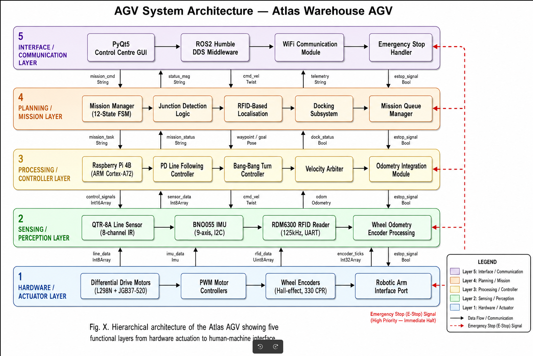
Figure 3.4: End-to-End Material-Handling Mission Pipeline
As shown in Fig. 3.4, the system consists of a left-to-right pipeline of stages that together implement a complete pick-up-transport-deliver cycle. The pipeline begins with order reception, in which a new request is pushed into the priority queue either by the operator GUI or by an external warehouse-management interface. The order is parsed into a structured tuple containing the source shelf identifier, the destination station, the priority level and the requested item descriptor. Once the queue head is selected, the AGV navigation stage is triggered: the global planner converts the source shelf coordinate into a sequence of waypoints aligned with the warehouse spine corridor, and the line-following PD controller keeps the chassis on the tape route while the junction detector counts and identifies RFID tags to anchor pose. When the AGV arrives at the source shelf and reaches a stable, low-velocity docking pose, the pipeline transitions to the arm pick stage. Here MoveIt 2 plans a collision-free trajectory from the home configuration to a pre-grasp pose, descends along an approach axis, closes the Robotiq 2F-85 gripper around the part and lifts to a transport-safe pose. The MoveIt Task Constructor decomposes this into modular sub-stages so that planner failures at any sub-stage can be retried without replanning the entire motion. After grasping succeeds and is confirmed by gripper-current feedback, the arm returns to a compact transport configuration that keeps the payload close to the chassis and lowers the centre of gravity. The pipeline then re-enters the navigation stage, but this time bound for the destination station. During transport the velocity arbiter caps the maximum AGV speed to a slower limit because the arm is loaded; this coupling between subsystem state and motion limits is one of the integration features that the diagram makes explicit. On arrival the arm place stage releases the part onto the destination shelf, and a delivery-confirmation message is published to the FSM, which removes the order from the queue and emits a success event to the GUI. Recovery and retry branches are drawn as dashed loops back to earlier stages, capturing failure modes such as line loss, missed junctions, grasp failure and timeout. The figure therefore serves not only as a workflow diagram but as a contract for the FSM transition table and for the recovery behaviours implemented in the velocity arbiter and the MoveIt pipeline.

3.5 AGV Line-Following PD Motion-Control Pipeline
Closed-loop line following is the mechanism by which the AGV translates a high-level navigation goal into wheel velocities, and a PD controller is used in preference to a full PID because the integral term is unnecessary for the near-zero steady-state error of a tape-following task. The motion-control pipeline diagram presented in this section exposes every transformation in the loop, from raw analogue line-array readings to per-wheel velocity setpoints. Understanding this pipeline is essential before discussing the gain tuning and tracking-accuracy results reported later.
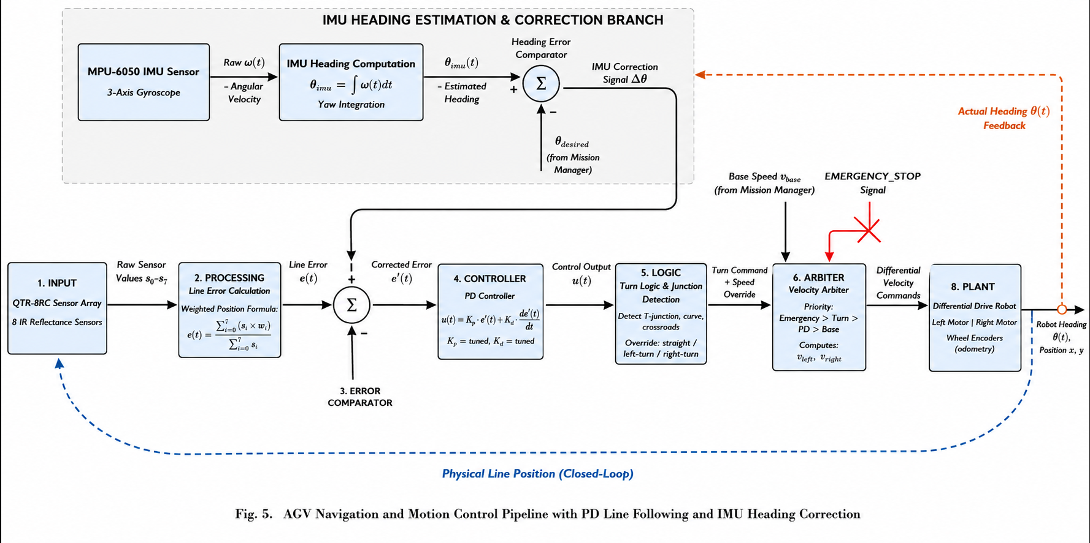
Figure 3.5: AGV Line-Following PD Motion-Control Pipeline
As shown in Fig. 3.5, the system consists of a cascade of signal-processing and control blocks that together form the line-following loop. The pipeline begins with the eight-channel reflectance sensor array mounted across the front of the chassis. The raw analogue signals are read by the ESP32's ADC, thresholded against a calibrated dark/light boundary, and converted into a weighted-average lateral position estimate by the line-position-estimator block. This produces a continuous error signal e(t) expressed in millimetres of lateral offset between the chassis centre and the centre of the tape. The error signal is passed to the PD-controller block, whose output is the angular velocity correction ω_corr = K_p · e(t) + K_d · de(t)/dt, with the derivative term implemented as a first-order backward difference filtered by a single-pole low-pass to suppress sensor noise. K_p and K_d are the two free parameters of the controller; the report selects them empirically to achieve sub-5 mm lateral tracking accuracy at the cruise velocity. The base linear velocity v_lin is supplied as a separate setpoint that the FSM adjusts based on whether the chassis is in straight, junction-approach or arm-loaded mode. The (v_lin, ω_corr) pair is then fed into the differential-drive inverse-kinematics block which computes the per-wheel angular velocities ω_L and ω_R given the wheel separation L and wheel radius r. Each wheel velocity setpoint enters its own dedicated motor-velocity PID loop running at 100 Hz on the ESP32. This inner loop closes around the encoder feedback, compensating for friction, motor non-linearity, payload-induced load torque and supply-voltage sag. Its output is a PWM duty cycle clamped to a safe range and applied to the L298N H-bridge driver. The diagram further shows two parallel branches that feed back into the loop: a heading estimate from the IMU complementary filter is used to detect when the chassis has drifted off-line for longer than a fail-safe timeout, in which case the line-recovery behaviour is triggered; and a junction-detector branch compares the sensor pattern with templates for T-junctions, cross-junctions and dead-ends and emits discrete events that the FSM consumes. The pipeline thus integrates continuous PD control with discrete event detection in a way that is simple to tune yet sufficient for the structured, tape-instrumented warehouse environment targeted by the project.

3.6 Priority-Based Order-Management Workflow
Real warehouse operations rarely involve a single order at a time, and even in a research demonstrator the AGV must be able to receive, queue, sequence and complete multiple requests with possibly different urgency. The priority-based order-management workflow diagram defines exactly how this queueing policy is implemented and how it interacts with the mission FSM. It is therefore a key part of the planning layer described earlier in the architecture.
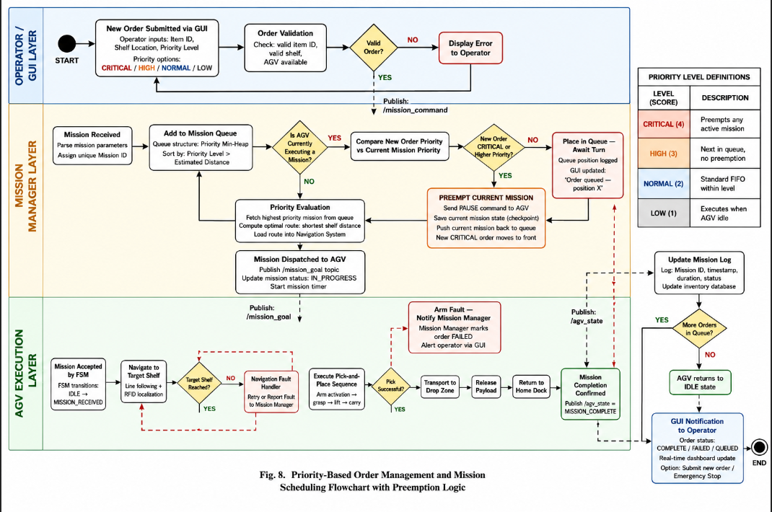
Figure 3.6: Priority-Based Order-Management Workflow
As shown in Fig. 3.6, the system consists of an order-input stage, a priority-queue data structure, a dispatcher and a feedback loop that closes around mission completion events. New orders enter the system from one of two sources: the operator-facing GUI, which constructs an Order message containing the source shelf, destination station, item descriptor and a priority integer drawn from the set {LOW, NORMAL, HIGH, EMERGENCY}; and an external warehouse-management interface that can publish orders programmatically through a ROS 2 service. Both sources are funnelled through an order-validation block that rejects requests with unknown shelf identifiers or with destinations that are occluded according to the latest navigation map. Validated orders are pushed into a binary-heap priority queue keyed on a composite key (priority_level, arrival_timestamp). The composite key is what guarantees the second-most important property of the queue—FIFO behaviour within a priority band—so that orders of equal priority are still served in the order they were received. A dedicated dispatcher routine pops the head of the queue whenever the FSM enters the IDLE or AWAITING_NEXT_ORDER state, and it forwards the popped tuple to the AGV path planner and the arm task selector. Because the dispatcher and the FSM are decoupled through ROS 2 topics rather than function calls, an EMERGENCY-priority order can be inserted at any time and will simply preempt the next idle event without destabilising the currently executing motion. The figure also illustrates the feedback path along which the FSM acknowledges the start of an order, reports intermediate progress through OrderStatus messages and finally publishes either an ORDER_COMPLETED or an ORDER_FAILED event. The order manager listens to these events and either removes the order from its bookkeeping store or returns it to the queue with an incremented retry counter. A maximum retry policy is enforced so that persistently failing orders are escalated to the operator instead of looping indefinitely. Beyond simple sequencing, the diagram captures one more important property: the queue is observable. Every operation on it emits a QueueDelta message that the GUI uses to render the order list in real time, giving the operator full visibility of what is pending, what is in progress and what has been completed. This combination of priority-aware dispatch, decoupled execution and live observability is what allows the AGV to behave predictably under realistic, multi-order operating conditions.

3.7 Twelve-State Mission Finite State Machine
The behaviour of the AGV across an entire mission is governed by a Finite State Machine (FSM) with twelve discrete states, designed so that every operationally meaningful situation—from idling on the dock to recovering from a lost line—corresponds to exactly one state. Encoding the mission lifecycle in this explicit form supports formal analysis, simplifies debugging and is what allows the velocity arbiter, the GUI and the order manager to reason about the AGV's current intent without ambiguity.
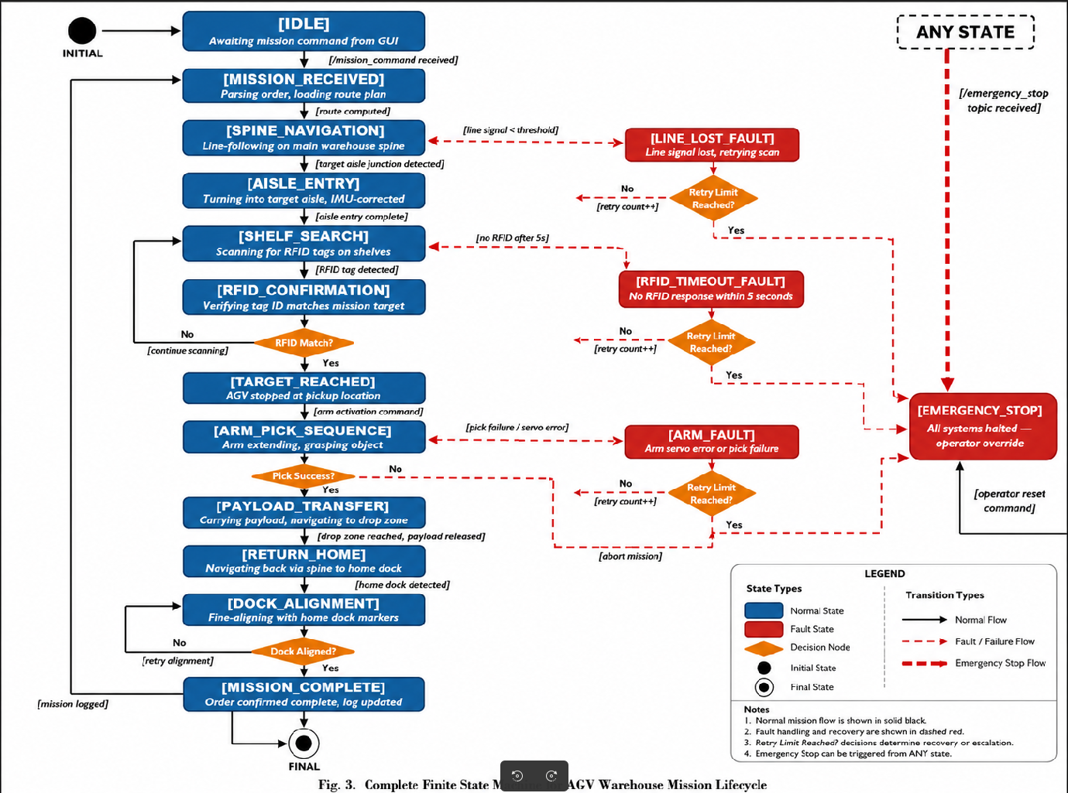
Figure 3.7: Twelve-State Mission Finite State Machine
As shown in Fig. 3.7, the system consists of twelve states, each represented by a labelled node, and a set of directed transitions, each annotated with the guard condition or event that triggers it. The IDLE state is the resting state in which the AGV is docked, motors are inhibited and the FSM is awaiting an order. From IDLE the FSM transitions to the FETCH_ORDER state as soon as the order manager publishes a non-empty queue head, copying the source and destination identifiers into local mission variables. The next state, NAVIGATE_TO_PICK, activates the line-following PD controller and the junction counter and is left only when the junction detector confirms arrival at the expected source-shelf RFID tag. On arrival the FSM enters DOCK_AT_PICK, where a low-speed precision-docking manoeuvre aligns the chassis with the shelf within a configurable tolerance. Successful docking advances the FSM to ARM_PICK, in which the MoveIt 2 pick-and-place pipeline is invoked through a ROS 2 action; the FSM blocks on the action result and inspects the gripper-current feedback to confirm a stable grasp. With a confirmed grasp the FSM transitions to NAVIGATE_TO_DROP, similar in structure to the pick navigation but with reduced maximum velocity because the arm is loaded. DOCK_AT_DROP and ARM_PLACE follow the same template as their pick counterparts and culminate in an ORDER_COMPLETED event being emitted to the order manager. Around the nominal happy-path states the diagram shows three exception states. EMERGENCY is a high-priority absorbing-style state entered whenever the safety node asserts the e-stop topic; it forces zero velocity, retracts the arm to a compact pose and waits for an explicit operator reset. LINE_LOST is entered when the line-array sensor reports an off-line condition for longer than a tunable timeout, and it executes a short reverse-and-search recovery before either re-entering navigation or escalating to EMERGENCY. ARM_FAULT is entered on MoveIt or hardware-interface errors and either retries the failed sub-stage or aborts the current order. The remaining state, RETURN_HOME, is invoked after the queue empties or after a reset and brings the chassis back to the dock. The transition table that accompanies the diagram in Appendix A enumerates every guard condition, event and side-effect, providing a single source of truth for all behavioural decisions made by the AGV over the course of an operating cycle.

3.8 UR3 Manipulator Pose Sequence for Pick-and-Place
Whereas the AGV navigation behaviour is captured by the FSM, the arm behaviour is captured by an explicit sequence of named end-effector poses that together implement a single pick-and-place cycle. The pose-stage diagram shown in this section visualises these poses in their kinematic order and annotates each one with the role it plays in the motion plan, providing the geometric intuition that the MoveIt Task Constructor encodes algorithmically.
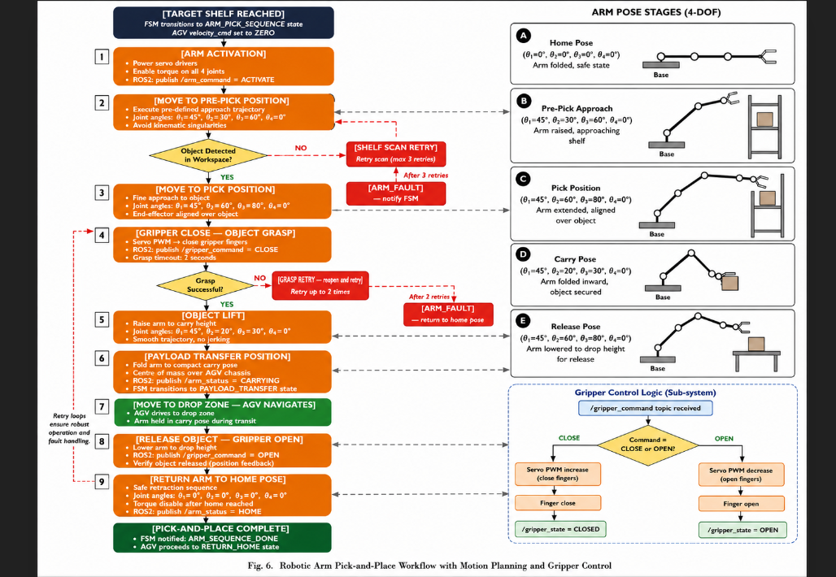
Figure 3.8: UR3 Manipulator Pose Sequence for Pick-and-Place
As shown in Fig. 3.8, the system consists of six labelled UR3 configurations rendered side by side in their natural temporal order: HOME, PRE_GRASP, GRASP, LIFT, TRANSPORT and PLACE. The HOME pose is a compact, kinematically central configuration with all joints near zero offset, chosen because it minimises the manipulator's footprint while the AGV is moving between stations. From HOME the arm extends to the PRE_GRASP pose, which is positioned a short approach distance directly above the target object; this intermediate pose decouples gross transport from fine alignment and allows MoveIt's Cartesian planner to compute a straight-line descent in the next stage. The GRASP pose places the gripper TCP exactly at the planned grasp frame, with its closing axis aligned to the principal inertia axis of the part. The Robotiq 2F-85 gripper is then commanded to close, and stable contact is confirmed by monitoring gripper current and finger position. The subsequent LIFT pose retracts the gripper vertically by a fixed clearance distance before any horizontal motion is permitted; this stage is critical because it prevents the part from catching on the shelf edge during retreat. The TRANSPORT pose moves the elbow inward and the wrist downward so that the payload is held close to the chassis centre, lowering the combined centre of gravity and reducing tip-over risk while the AGV accelerates toward the destination. Finally the PLACE stage mirrors the GRASP stage above the destination shelf: the arm executes an aligned approach, opens the gripper, retracts to a post-place clearance pose and returns to HOME, completing the cycle. The diagram makes explicit that each pose is parameterised: the approach offset, the grasp frame, the lift clearance and the transport joint vector are all configurable through the MoveIt Task Constructor's parameter interface, which means that the same sequence can be reused for parts of different geometry by changing only those numerical parameters. The figure also documents the planner that is selected for each transition; Cartesian interpolation is used between PRE_GRASP and GRASP and between LIFT and TRANSPORT, while OMPL's RRT-Connect handles HOME-to-PRE_GRASP and TRANSPORT-to-PLACE because those transitions span larger volumes of configuration space and need full collision-aware sampling. Together these design choices yield repeatable, collision-free pick-and-place cycles within the UR3's 500 mm reach radius.

Chapter 4
Implementation and Simulation Environment
This chapter describes how the design specified in Chapter 3 is realised in a fully working simulation environment, and how that environment relates to the physical hardware build. The figures in this chapter progress from the abstract two-dimensional warehouse layout through the navigation map, the three-dimensional Gazebo world, the AGV in operation and the UR3 arm in isolation, finishing with a photograph of the as-built AGV chassis to demonstrate the simulation-to-hardware portability claim of the project.
4.1 Two-Dimensional Warehouse Floor Layout
The simulation environment used to validate the ATLAS Smart Warehouse AGV begins from a top-view two-dimensional floor layout that fixes the position of every shelf, dispatch station, pickup station and tape route. This layout is the geometric specification from which both the Gazebo world file and the Nav2 occupancy map are derived. Reproducing it here makes the spatial assumptions of the entire simulation explicit.
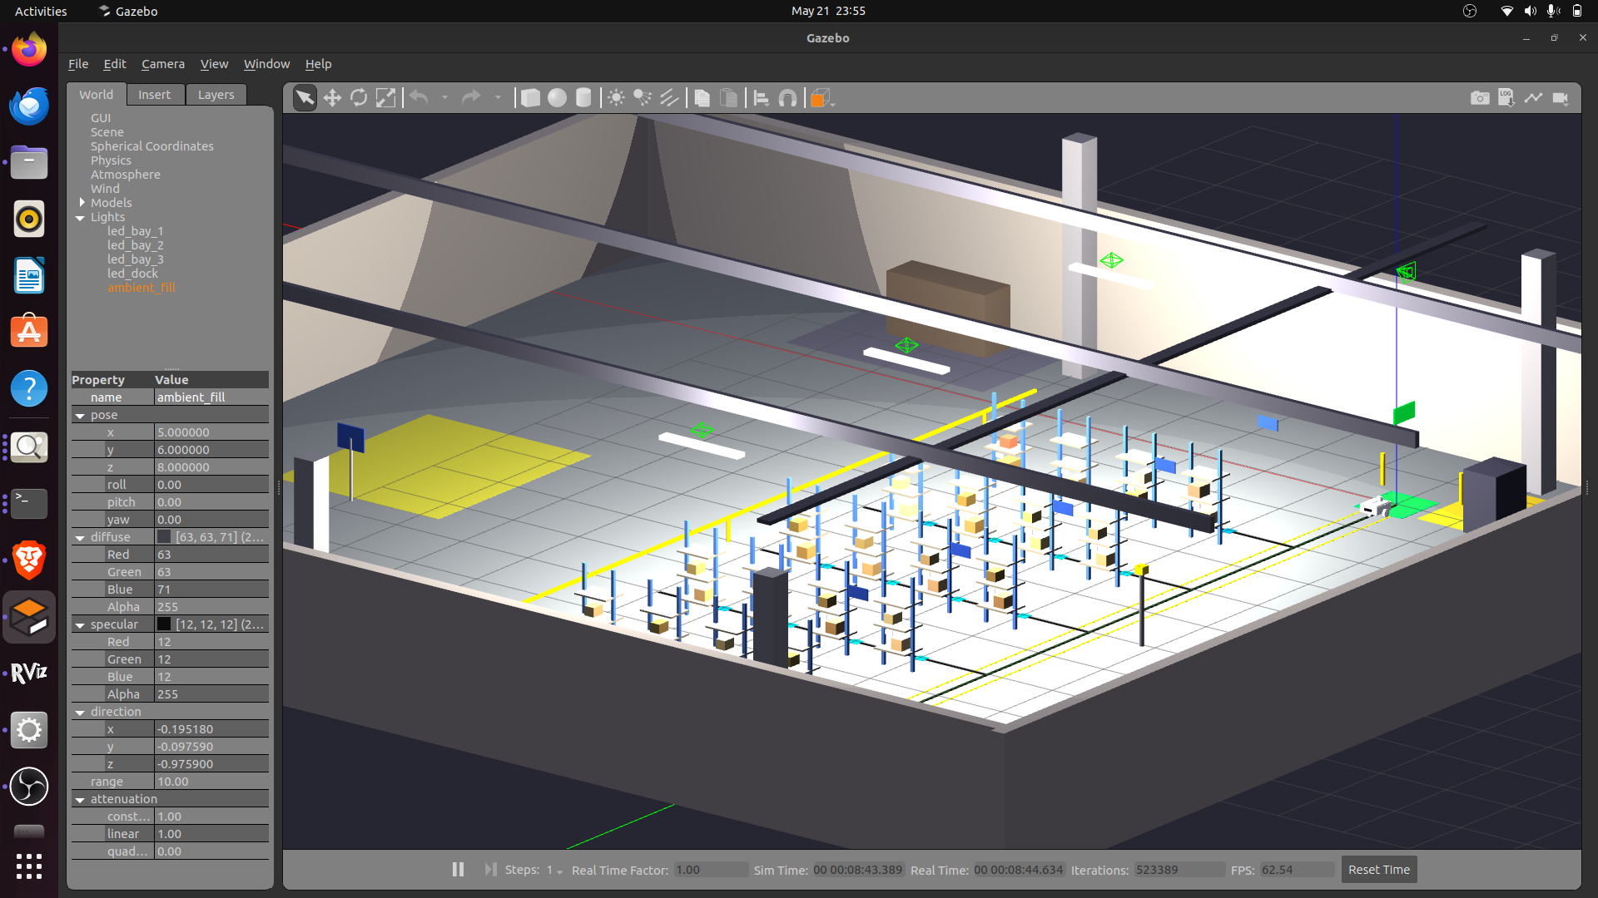
Figure 4.1: Two-Dimensional Warehouse Floor Layout
As shown in Fig. 4.1, the system consists of a rectangular warehouse footprint of fixed external dimensions, organised internally around a single longitudinal spine corridor with perpendicular shelf rows on either side. The spine corridor carries the primary tape route and is wide enough to allow the AGV to traverse it at full cruise speed without infringing the safety envelope of either shelf row. Each shelf row is composed of equally spaced storage units labelled S1 through Sn, and each storage unit is associated with a fixed world coordinate (x_s, y_s) that the order manager uses when dispatching pick orders. The dispatch station, where finished orders are placed for human collection, is drawn at one end of the corridor, while the docking and charging station occupies the opposite end. Embedded in the floor at the centre of every junction along the spine corridor and at every shelf entry is a circular RFID tag, drawn in the diagram as a small filled disc. These tags carry unique 12-byte identifiers that the AGV's RDM6300 reader detects as the chassis passes overhead. Because the tag positions are surveyed and stored in a YAML configuration file, every tag detection translates directly into a global pose anchor, dramatically simplifying odometry drift correction without requiring a full SLAM stack. The diagram also marks the line-following tape itself as a continuous high-contrast strip running along the centre of the spine corridor and branching into each shelf entry. Around the periphery of the warehouse the layout indicates fixed obstacles such as pillars and storage cabinets that the navigation map must inflate, and it also reserves a narrow human-only walkway separated from the AGV route. This separation reflects the design decision to keep human-AGV interaction zones spatially isolated, which in turn relaxes the perception requirements on the AGV (since unexpected pedestrians are unlikely on the tape route itself). The layout therefore captures the three categories of spatial information needed by the rest of the system: the tape topology used by the line follower, the discrete junction graph used by the FSM and the dispatcher, and the obstacle map used by the global planner. Every subsequent simulation figure can be interpreted as a particular rendering of this same floor specification, with progressively more visual detail layered on top.

4.2 Two-Dimensional Navigation and Occupancy Map
The two-dimensional occupancy map is the representation of the warehouse consumed by the navigation stack and by the AGV's global path planner. It is derived from the floor layout by rasterising every static obstacle into a fixed-resolution grid and inflating it according to the chassis footprint. Including this map alongside the layout makes it possible to relate planned paths back to the underlying physical geometry.
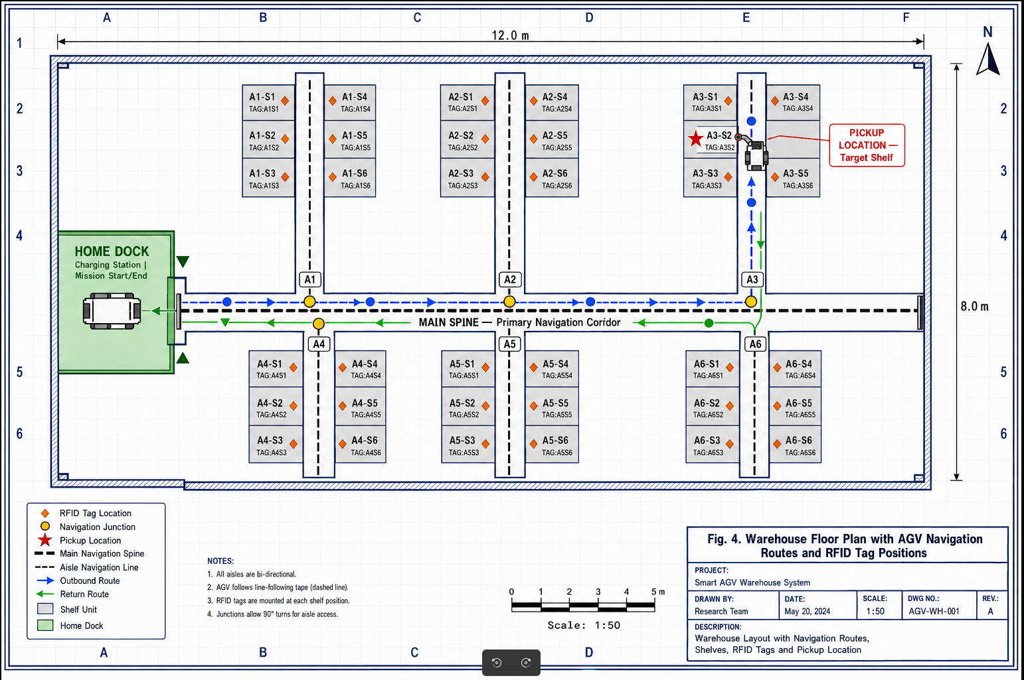
Figure 4.2: Two-Dimensional Navigation and Occupancy Map
As shown in Fig. 4.2, the system consists of a grid map at a chosen resolution of 0.05 m per cell, in which free cells are rendered light, occupied cells are rendered dark and inflation cells (cells inside the robot's safety radius around an obstacle) are rendered in an intermediate shade. The map covers the full extent of the warehouse layout, with the spine corridor appearing as a continuous wide free strip flanked by long lines of occupied cells corresponding to shelf walls. The dispatch and docking areas are visible as larger free regions at either end of the corridor, and the walls of the warehouse itself appear as the outermost occupied rectangle. The map also encodes the discrete junction graph implicitly through the geometry of the corridor: every place where a perpendicular shelf entry branches off from the spine corridor produces a recognisable T-shape in the free space. When the global planner overlays its computed path, drawn in the figure as a solid coloured polyline, the path visibly hugs the centre of the spine corridor exactly along the tape route, which is the desired behaviour because the tape coincides with the local minimum of the inflated cost field. This consistency is what allows the global planner and the line-following PD controller to operate as complementary rather than conflicting layers: the global planner produces high-level waypoints anchored to RFID tags, while the PD controller closes the local loop on the tape itself. Beyond its role for navigation, the occupancy map also drives several other components of the system. The MoveIt 2 planning scene receives a small extruded version of the same map as a static collision object, ensuring that the arm treats the warehouse walls as obstacles when it plans large reconfiguration motions. The GUI uses the map as the background layer onto which it overlays the live AGV pose, the order list and the active path. And the simulation harness uses the map to verify, before launching Gazebo, that every shelf coordinate referenced by the order generator falls inside the free space and is therefore reachable. The figure thus serves both as a debugging aid and as a contract that ties the higher-fidelity 3-D Gazebo world, the abstract geometric layout and the planning algorithms together into a single coherent spatial representation.

4.3 Three-Dimensional Gazebo Warehouse Environment
Once the layout and the navigation map are fixed, they are realised as a fully three-dimensional Gazebo world that hosts the rigid-body physics, lighting, sensor models and visual meshes used during simulation. The rendered Gazebo warehouse is what the perception stack actually sees and is therefore the reference environment for every figure that follows in this chapter. Documenting it explicitly is essential for reproducibility of the reported experiments.
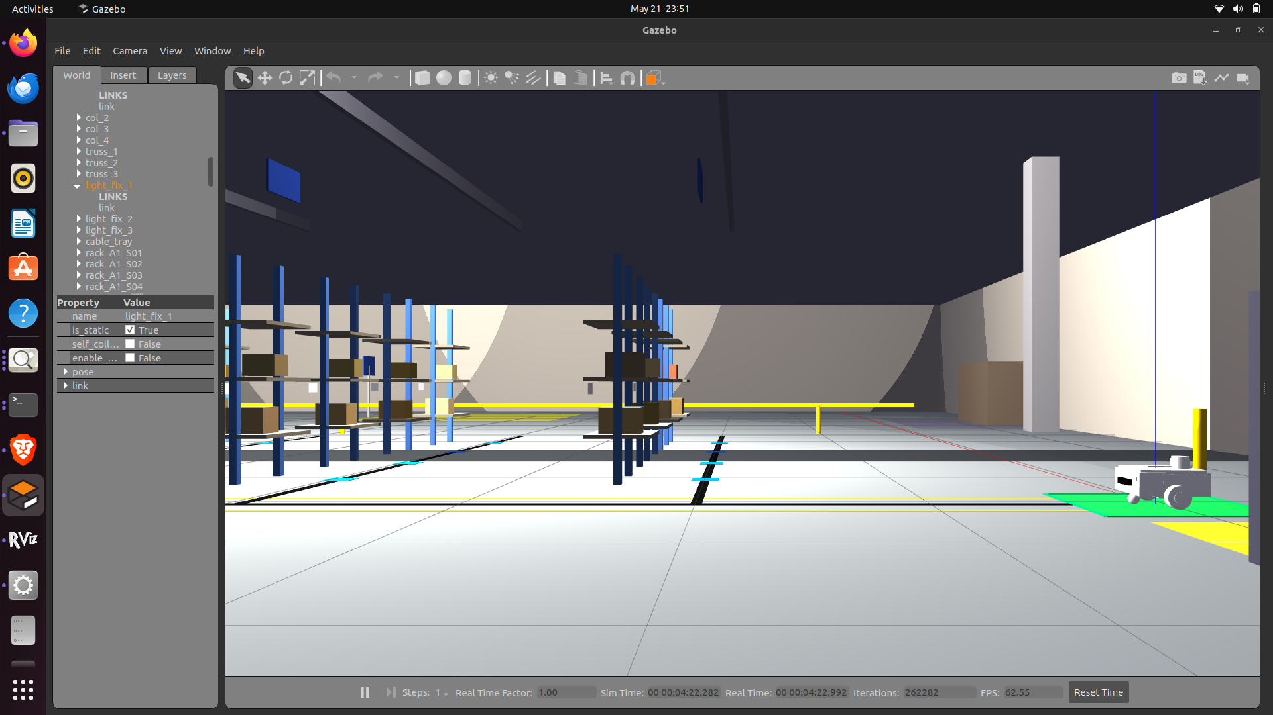
Figure 4.3: Three-Dimensional Gazebo Warehouse Environment
As shown in Fig. 4.3, the system consists of a Gazebo Classic 11 world file that instantiates the warehouse hull as a textured concrete-floor box with matte interior walls, populated by parametric shelf models arranged in two parallel rows along the spine corridor. Each shelf model is a multi-tier rigid body assembly of metal uprights and wooden trays, with collision geometry simplified to a stack of axis-aligned bounding boxes for computational efficiency while keeping the visual mesh photo-realistic. The tape route is rendered as a thin high-contrast strip texture-mapped onto the concrete floor, exactly along the centre of the spine corridor and into each shelf entry, providing the visual signal that the line-array sensor model samples. Lighting is provided by a directional sun-light approximating overhead industrial fixtures, plus point lights placed at regular intervals along the ceiling to ensure that the line-following sensor receives a usable contrast ratio everywhere on the tape. Several boxed parts of varying mass and dimension are pre-spawned on selected shelf trays so that the arm subsystem has realistic targets to grasp; their masses and friction coefficients are tuned to be reachable by the Robotiq 2F-85's gripping force without slip. Around the periphery the world includes static decorative obstacles—pallets, a forklift mesh, fire-extinguisher posts—whose collision boxes match the occupancy map's outermost obstacles so that perception, planning and physics are mutually consistent. The simulation also instantiates a number of Gazebo-specific plugins. The differential-drive plugin is attached to the AGV chassis and exposes the /cmd_vel topic that the velocity arbiter publishes on; corresponding ground-truth pose, IMU and wheel-encoder plugins expose the sensor topics consumed by the perception layer. A custom RFID plugin reads the surveyed tag positions from the same YAML file used by the layout and emits a JunctionTag message whenever the AGV's reader frame is within reading range of a tag. Time is advanced at real-time factor 1.0 on a moderately equipped laptop, though headless mode and step-mode are both supported for headless CI runs. By documenting the world contents to this level of detail, the figure makes the simulation environment a fully specified experimental platform rather than an opaque visual prop.

4.4 Top-Down Render of the Simulated Warehouse
A top-down rendering of the same Gazebo world provides a useful intermediate between the abstract two-dimensional layout and the immersive perspective view, because it preserves three-dimensional shading and lighting cues while exposing the global structure of the environment. This view is included so that the reader can verify visually that the simulated warehouse matches the specification given by the layout and the navigation map.
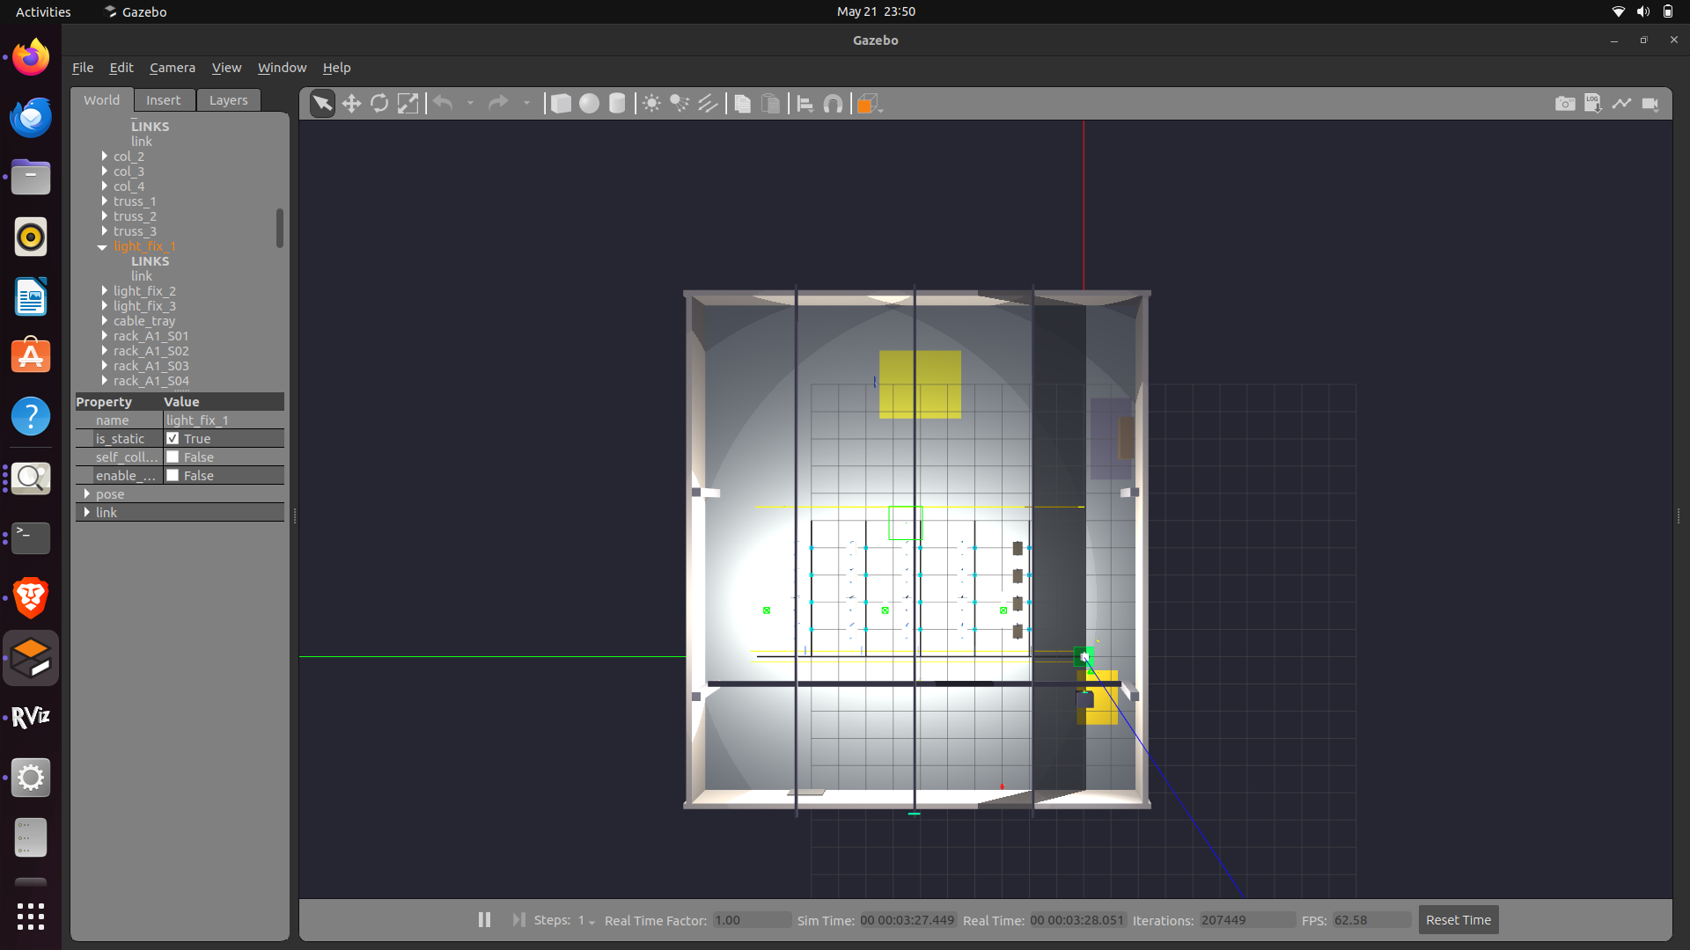
Figure 4.4: Top-Down Render of the Simulated Warehouse
As shown in Fig. 4.4, the system consists of an orthographic-style overhead camera that captures the entire warehouse footprint in a single frame, revealing the symmetry of the two shelf rows around the central spine corridor and the placement of the dispatch and docking areas at opposite ends. The continuity of the line-following tape is clearly visible from this perspective: it runs as a single uninterrupted strip down the corridor and branches cleanly into each shelf entry, confirming that the texture mapping in the world file is geometrically consistent with the layout drawing. The top-down render also exposes secondary structural details that are easy to overlook from a perspective camera. The aisles between successive shelves in each row are wide enough to accommodate small inspection robots but are deliberately narrower than the spine corridor so that the AGV's global planner has no incentive to enter them; this asymmetry encodes the operational discipline that the AGV traverses only the spine and the explicit shelf entries. The dispatch area at one end of the corridor is rendered as an open work surface adjacent to a workshop door, while the docking station at the opposite end shows a marked rectangular footprint that the precision-docking behaviour aligns with at the end of every mission. Sensor placement and lighting are equally informative from this view. Because the overhead lights are visible as bright spots evenly distributed along the corridor, it is easy to confirm that the line-array sensor will see uniform tape contrast throughout, eliminating one common source of line-loss events in tape-following systems. The shadows of the shelves on the floor demonstrate that the directional sun-light is configured to come from a consistent direction, which simplifies any future computer-vision extensions that may rely on shading cues. Finally, the top-down view is the natural reference frame for overlaying the global path produced by the planner, the live AGV pose and the priority-ordered list of pending orders; this is the exact composition used by the operator-facing GUI, which means that the visual model the operator works with is precisely the one shown in this figure. The top-down render therefore acts as the bridge between the abstract spatial representations introduced earlier and the immersive experiential views that follow.

4.5 ATLAS AGV Operating Inside the Simulated Warehouse
Showing the AGV inside the simulated warehouse confirms that the chassis model, sensor suite and motion behaviour integrate correctly with the world file and that the visual scale matches the layout specification. This perspective view also makes it possible to inspect tape contact, sensor footprint and chassis clearance, none of which are observable from the abstract maps alone.
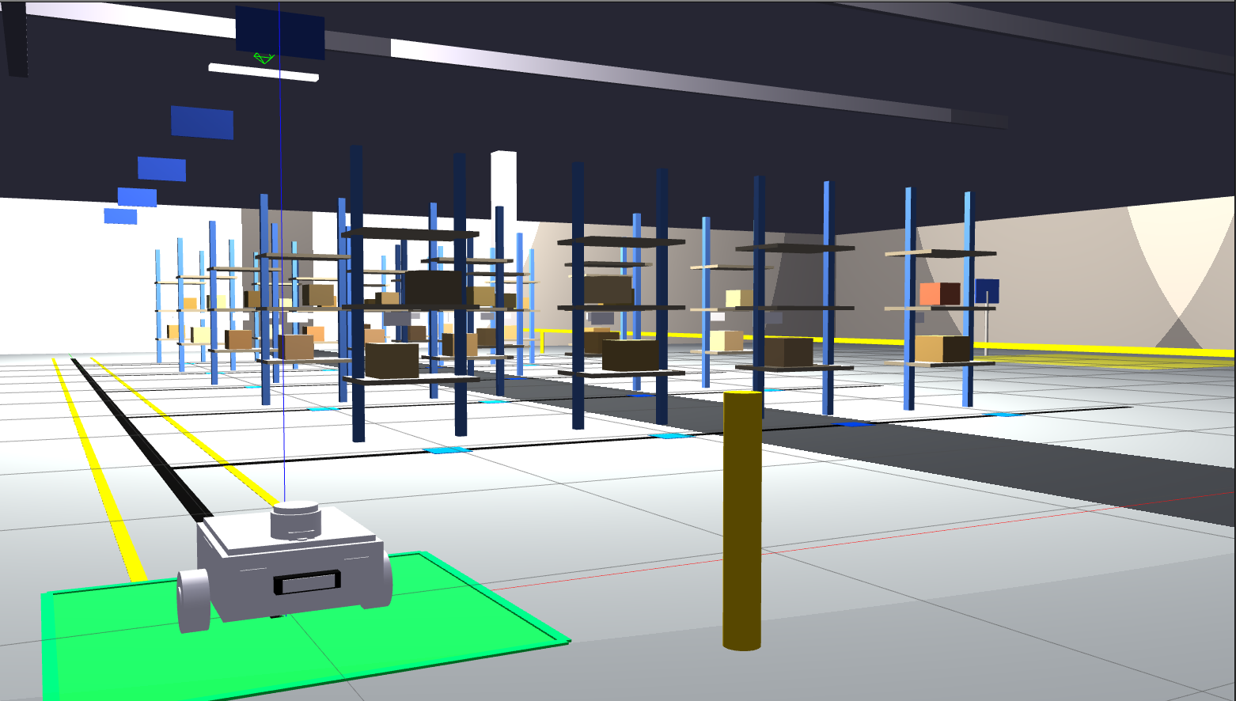
Figure 4.5: ATLAS AGV Operating Inside the Simulated Warehouse
As shown in Fig. 4.5, the system consists of the differential-drive AGV chassis instantiated in the spine corridor of the Gazebo warehouse, with its front line-array sensor straddling the high-contrast tape and its IMU and RFID reader mounted along the chassis centreline. The chassis URDF model carries every visual feature of the physical platform: the two rear-driven wheels with realistic radius and width, a free-rolling caster at the front, the protective fenders that house the line-array, the on-board electronics enclosure and the upper deck that supports the UR3 arm base. Because the URDF is reused unchanged on the physical platform, this view is also the visual reference for the real-world build. From this perspective the relationship between the AGV and the tape route is particularly clear. The line-array sensor is positioned a few centimetres ahead of the wheel axle so that lateral error is detected slightly before the chassis itself deviates, providing the look-ahead that the PD controller needs to remain stable at cruise speed. The chassis footprint sits well inside the spine-corridor free space, with margins on either side that the occupancy-map inflation step has reserved as a safety buffer. The colour and geometry of the wheels are identical to those used in the inverse-kinematics block, so the differential-drive plugin's response to /cmd_vel reflects the kinematic equations of the report rather than an arbitrary tuned model. The view further demonstrates the sensor coverage of the platform. The IMU is mounted near the geometric centre of the chassis, minimising centripetal coupling on the yaw measurement during tight turns, while the RFID reader frame is mounted on the underside near the tape line so that its reading field intercepts every junction tag as the chassis passes overhead. The computing enclosure on top of the deck represents the Raspberry Pi and ESP32 boards in the physical build and is sized to leave clearance for the UR3 arm's swept volume during transport. Watching the AGV move through this world during a mission also confirms the dynamic behaviour of the FSM: it can be observed entering and leaving each state at the correct geometric position, validating that the integration of perception, planning and control behaves as designed. The figure thereby ties together every concept introduced earlier in the chapter—mechanical, sensory, computational and behavioural—into a single observable scenario.

4.6 UR3 Robotic Arm with Robotiq Gripper in Simulation
The manipulation subsystem is built around a Universal Robots UR3 6-DOF collaborative arm equipped with a Robotiq 2F-85 two-finger gripper, both modelled in URDF and simulated under Gazebo Harmonic. Examining the simulated arm in isolation makes it possible to verify joint limits, link visuals, tool-frame placement and gripper geometry before they are coupled with the AGV chassis.
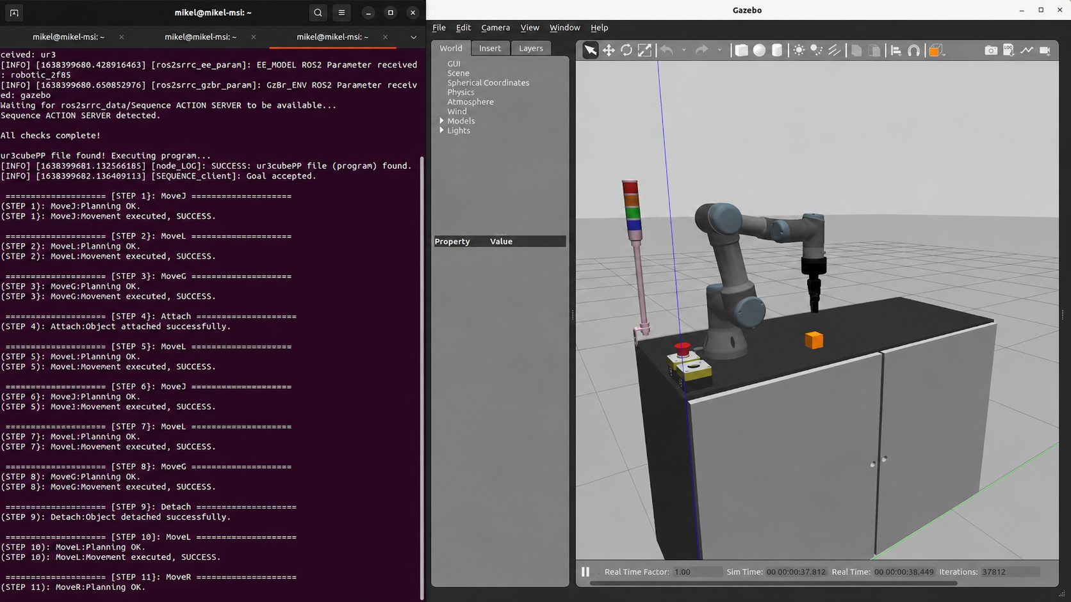
Figure 4.6: UR3 Robotic Arm with Robotiq Gripper in Simulation
As shown in Fig. 4.6, the system consists of the UR3 manipulator mounted on a fixed base plate, with the Robotiq 2F-85 gripper attached at the wrist flange and a tool-frame coordinate triad rendered at the end-effector for reference. The UR3 model uses the official Universal Robots URDF, modified only by the addition of the gripper end-effector and the project's tool-centre-point transform. The six revolute joints are visible at the shoulder pan, shoulder lift, elbow, wrist 1, wrist 2 and wrist 3 positions, and each joint is annotated in the URDF with its mechanical limit, maximum velocity and effort, taken from the manufacturer's datasheet. Kinematically the arm follows the modified Denavit–Hartenberg convention used by ROS Industrial; the four DH parameters per link (a, alpha, d, theta) are tabulated in the report and form the basis of every analytical and numerical inverse kinematics computation. MoveIt 2 is configured to use this DH model directly through the ur_description and ur_moveit_config packages, which means that the planning scene shown in the figure is not a custom approximation but the same kinematic representation used during deployment. The Robotiq 2F-85 gripper is added with a parallel-jaw URDF whose two finger joints are coupled by a mimic relationship so that a single command opens or closes both fingers symmetrically; this matches the behaviour of the physical gripper's controller. Several practical features of the model are visible in the rendered view. The base plate is sized to match the AGV's upper deck so that the arm can be transferred from the standalone test scene to the integrated AGV scene without any pose-frame edits. The visual meshes are detailed enough to support meaningful camera-based perception experiments in future work, while the collision meshes are simplified primitives that keep planning queries fast enough for interactive use. The wrist-mounted force-torque interface specified in the URDF makes it possible to extend the system later with force-controlled insertion behaviours without re-engineering the model. Finally, the tool-frame triad at the end-effector is placed exactly between the gripper fingers' contact surfaces, which is the convention assumed by the MoveIt Task Constructor when planning approach and retreat motions. The figure therefore documents not only the visual appearance of the arm but the dimensional and kinematic conventions on which all higher-level manipulation behaviour is built.

4.7 Physical ATLAS AGV Chassis (Real-World Build)
Although the bulk of validation is performed in simulation, the project also includes a physical realisation of the AGV chassis intended to demonstrate the simulation-to-hardware portability of the software stack. The background-removed photograph reproduced in this section captures that real chassis in isolation so that its mechanical layout can be compared side-by-side with the simulated URDF model presented earlier.
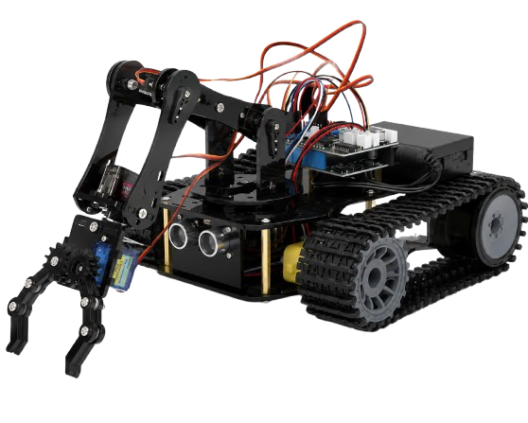
Figure 4.7: Physical ATLAS AGV Chassis (Real-World Build)
As shown in Fig. 4.7, the system consists of the as-built ATLAS chassis imaged with the surrounding workspace removed for clarity. The platform is a low, flat differential-drive robot whose external dimensions match the URDF model used in Gazebo, with the two rear-driven wheels visible at the back edge and the free caster at the front. Mounted on the upper deck are the Raspberry Pi 4 single-board computer and the ESP32 microcontroller, interconnected by a short USB-CDC cable that carries the high-rate sensor stream and the wheel-velocity command stream defined in the hardware architecture diagram. The L298N motor driver and the protective fuse-and-switch module sit between the battery pack and the motors, isolating motor transients from the digital electronics. Underneath the front of the chassis is the eight-channel reflectance line-array sensor, mounted exactly at the simulated stand-off height so that the calibrated dark/light threshold transfers directly between simulation and hardware. The MPU-6050 IMU is fastened to the centre of the deck, oriented with its X-axis pointing forward to match the URDF convention, and the RDM6300 RFID reader is positioned on the underside near the tape-following line so that its reading field intercepts the surveyed junction tags. Two status LEDs and a small piezo buzzer are wired to spare GPIOs of the ESP32; the FSM toggles them in distinguished states to give the operator a low-bandwidth view of the AGV's behaviour even without a network connection to the GUI. Because the chassis was specifically engineered to be a one-to-one physical realisation of the simulated URDF, the figure also serves as evidence for the project's headline portability claim. Each component visible in the photograph has a counterpart in the simulation: the differential-drive Gazebo plugin substitutes for the real motors and encoders, the Gazebo IMU plugin substitutes for the MPU-6050, the custom RFID Gazebo plugin substitutes for the RDM6300, and the simulated reflectance sensor substitutes for the line-array board. With the perception drivers and actuator interfaces being the only nodes that change between the two deployments, the bulk of the ROS 2 stack—line follower, velocity arbiter, FSM, order manager and GUI—runs unchanged. The photograph therefore closes the loop between the abstract architectural diagrams of Chapter 3, the simulation views earlier in this chapter and the real hardware on which future field experiments will be conducted.

