Supplementary Material

Supplementary Table S1. Token exclusion breakdown by corpus and criterion (criteria applied independently, not sequentially).
Corpus | Pre-filter tokens | Dropped: duration | Dropped: unvoiced | Dropped: sparse frames | Dropped: octave jump | Final
CSJ Monologue | 94,965 | 4,542 | 4,292 | 2,078 | 2,366 | 81,687
CSJ Dialogue | 29,137 | 1,826 | 4,602 | 825 | 326 | 21,558
Buckeye | 357,301 | 14,555 | 43,754 | 13,695 | 11,024 | 274,273

Supplementary Figure S1.
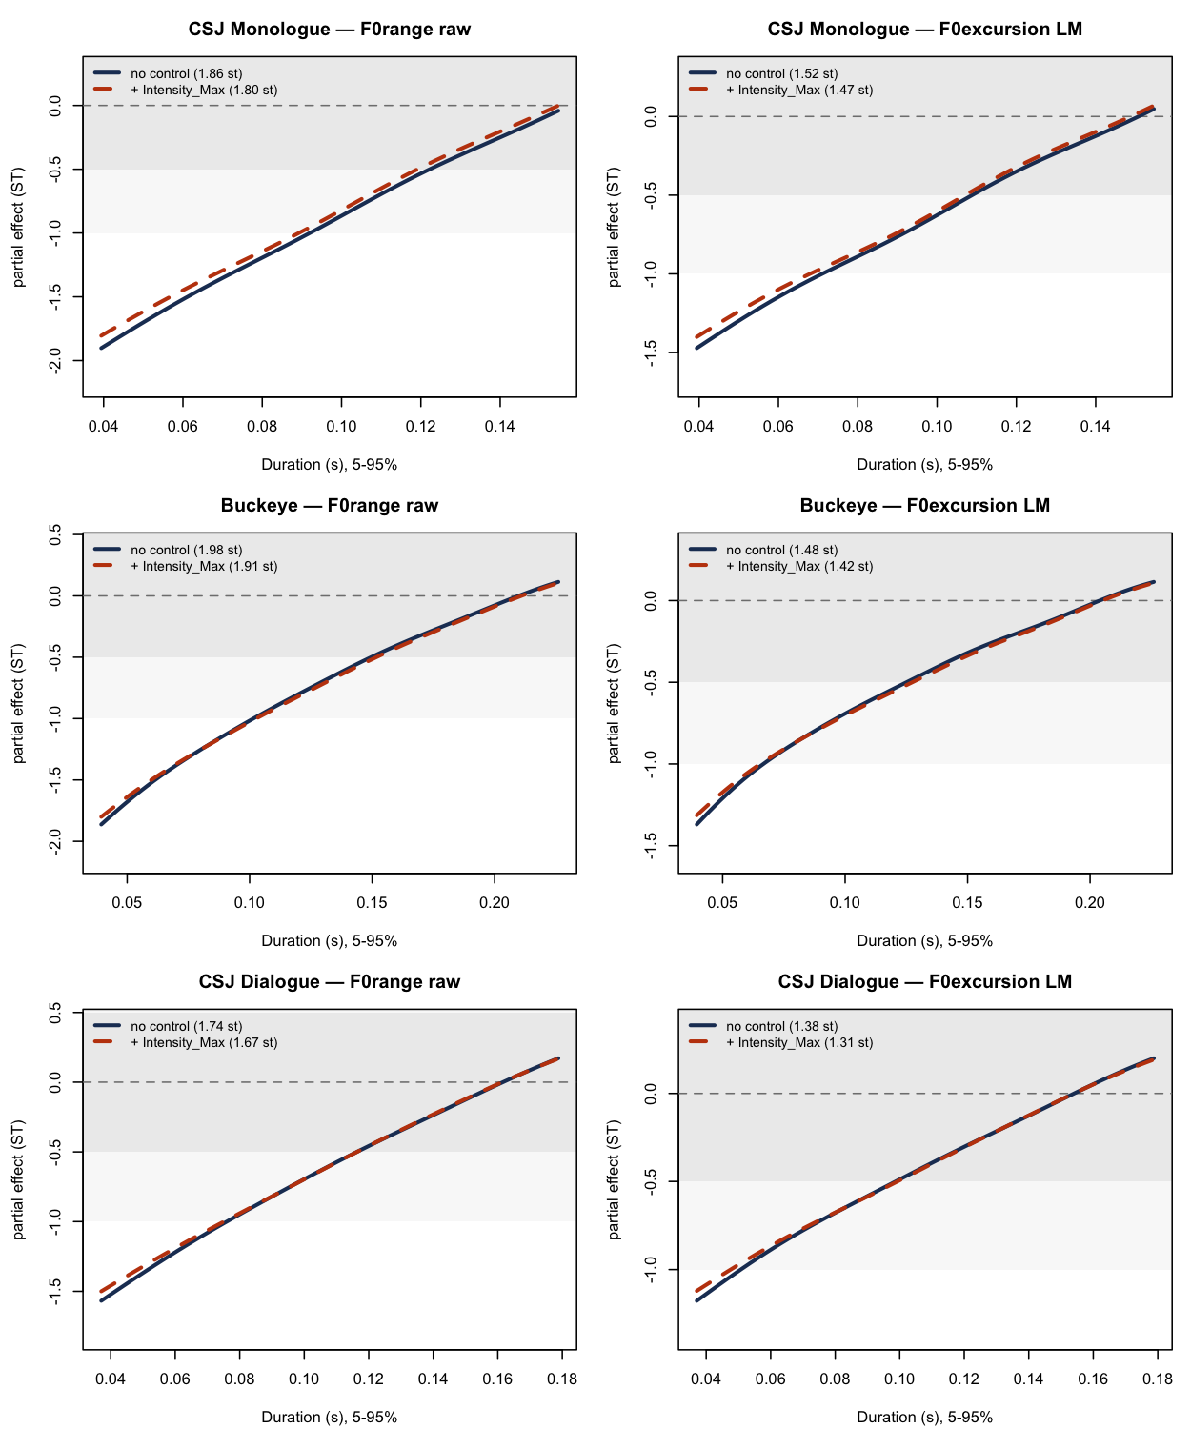
Supplementary Figure S1 (Fig_intensity_control.png). Duration effect on f₀ excursion before and after controlling for maximum intensity, for the raw excursion measure (left column) and the fixed-landmark excursion measure (right column), across three corpora (rows). Solid lines show the uncontrolled partial effect; dashed lines show the partial effect after adding a smooth term for maximum intensity. The near-complete overlap of the two curves in every panel indicates that controlling for intensity produces only a small (3–5%) change in the estimated effective range, consistent with the conclusion that the rate–excursion relationship is not attributable to a general loudness or vocal-effort confound (§3.5).

Supplementary Figure S2.
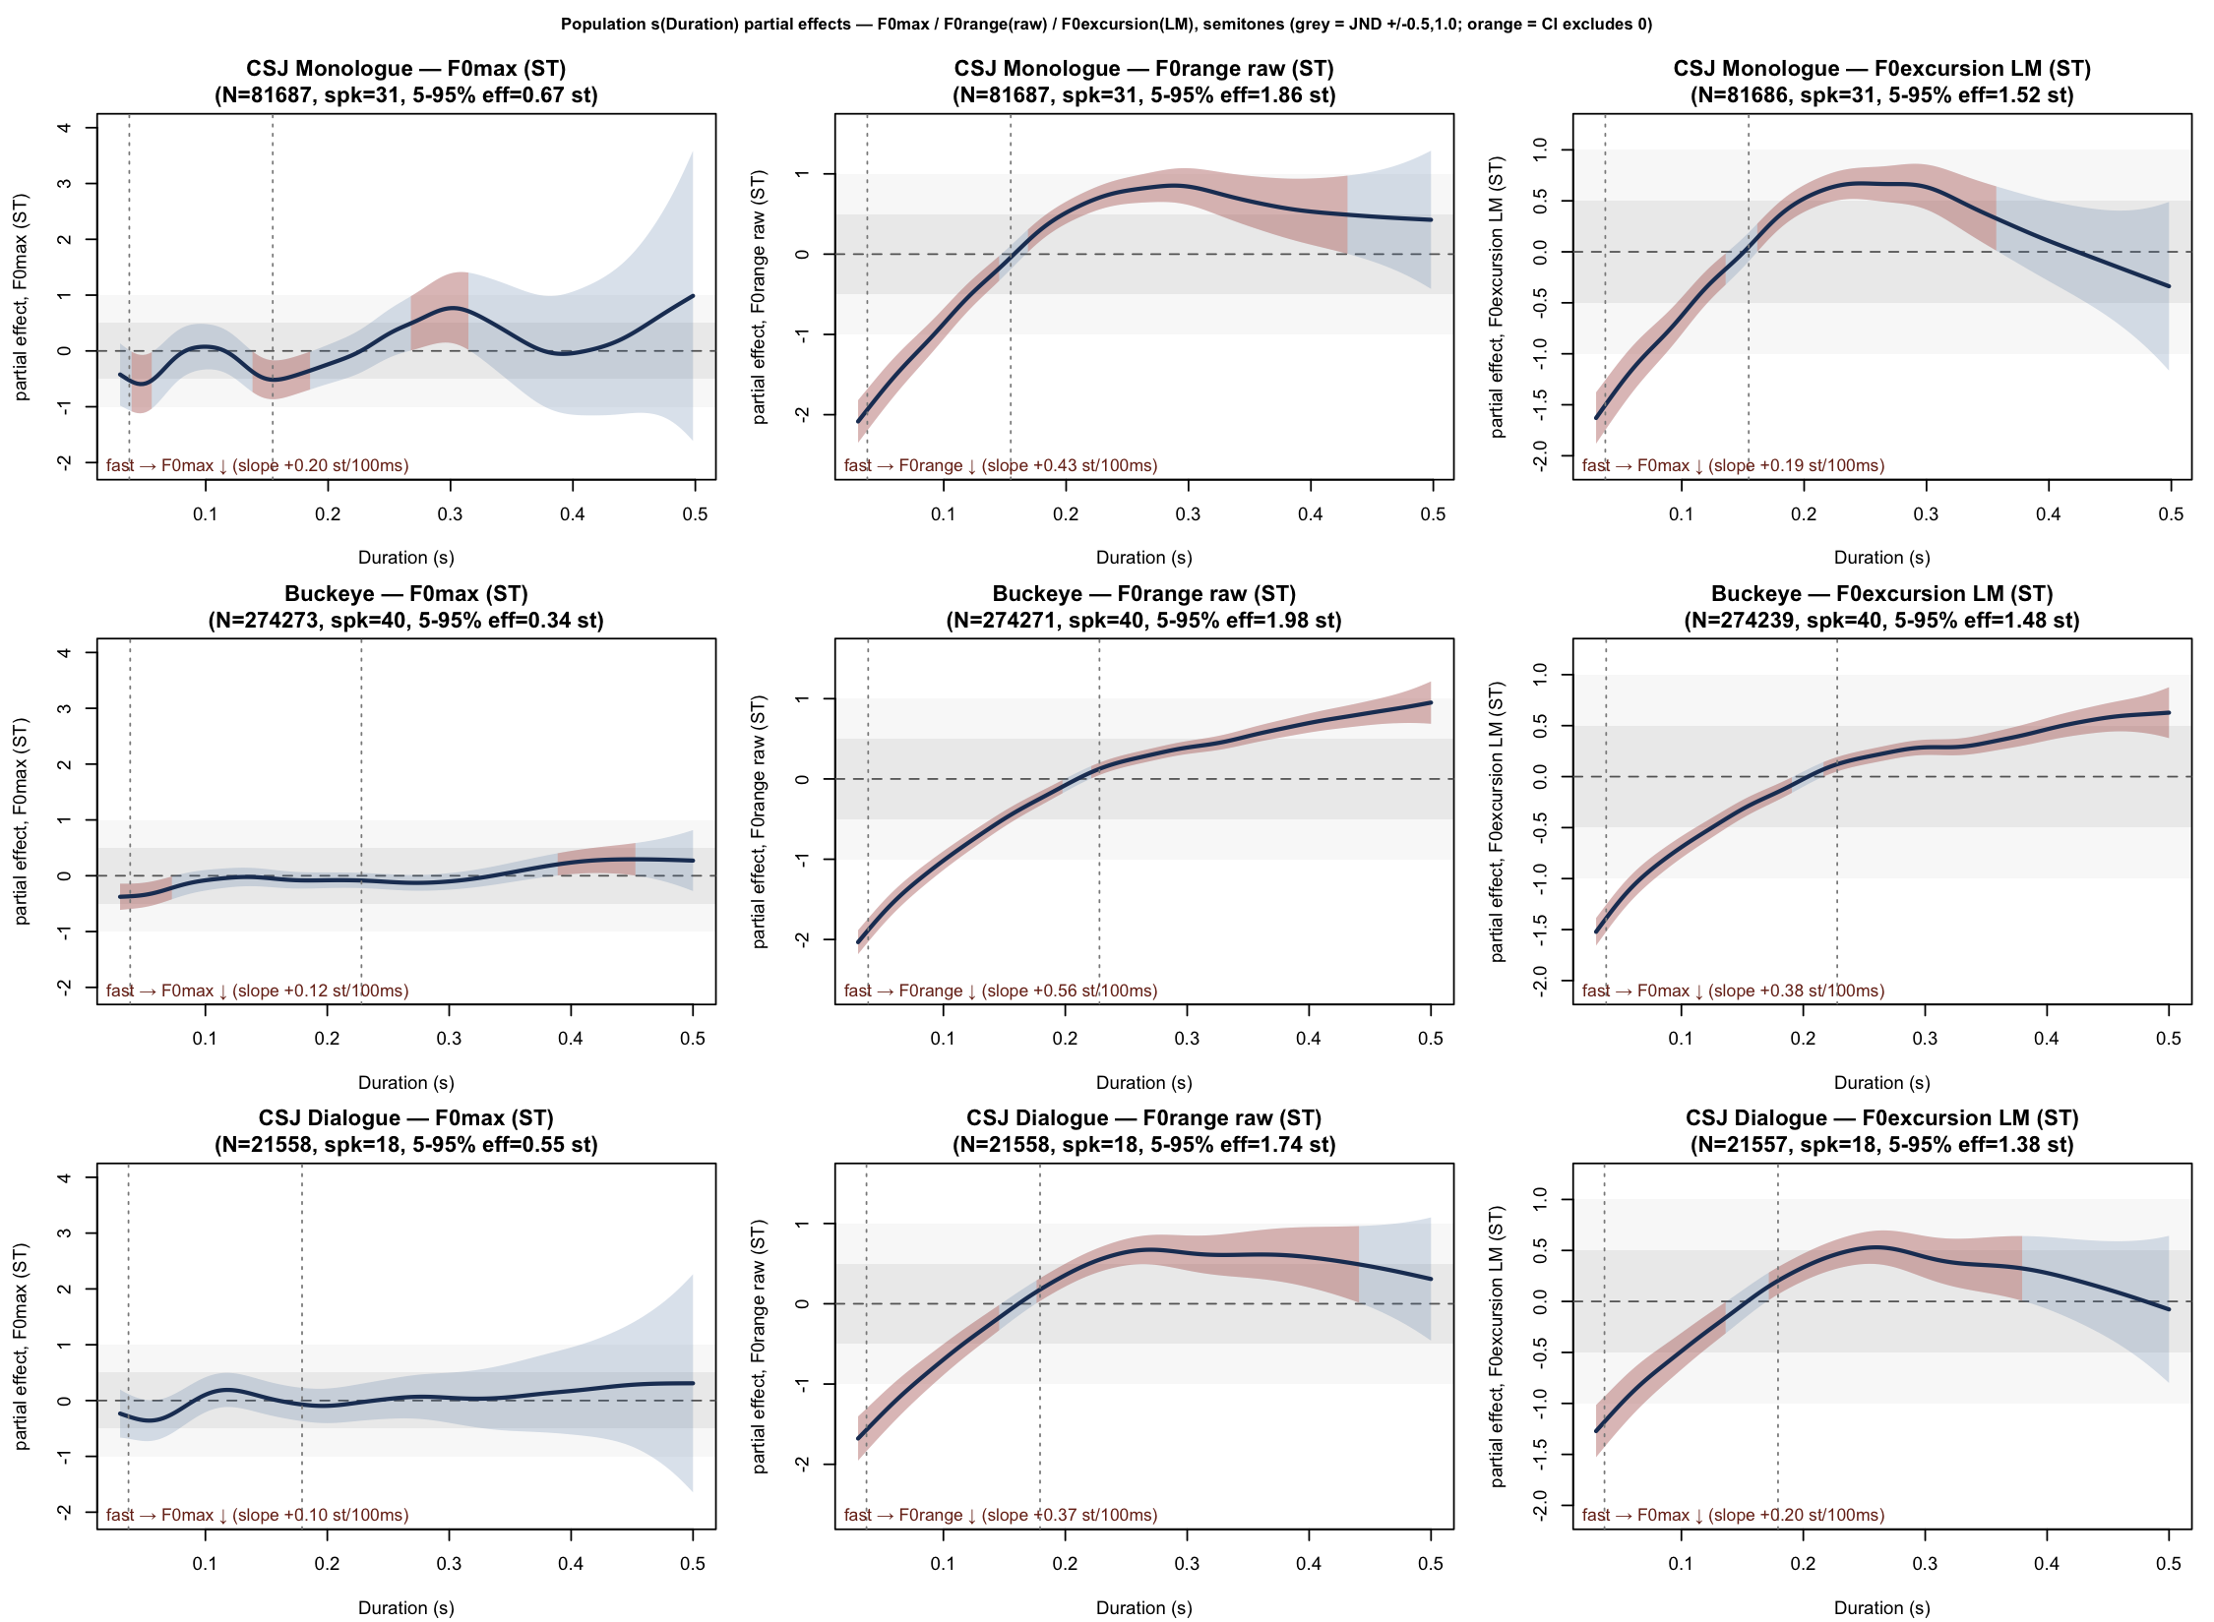
Supplementary Figure S2 (effect_size_partial.png). Detailed version of Figure 1’s 3×3 comparison (f₀ maximum / raw excursion / fixed-landmark excursion, by corpus), with pointwise confidence intervals shaded orange where they exclude zero. This highlights that the f₀-maximum partial effect (top row) is not merely small in magnitude but also non-monotonic and inconsistent in sign across corpora — in CSJ Monologue and CSJ Dialogue the pointwise-significant regions are brief, narrow, and do not form a consistent trend across the duration range, unlike the clearly monotonic and broadly significant excursion effects in the middle and bottom rows.

