## Queries

1. A simple display of all the data in Customers table, ordered by region.  
     
   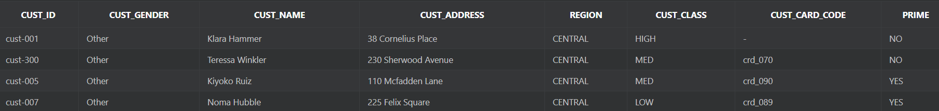
2. Creates a view that performs the following tasks:
   1. Returns Yes if the game is rated R based on the pegi system or No otherwise.
   2. Calculates the final discount by taking into consideration the max possible discount and the edition ordered by the client. The more expensive the edition, the higher the discount.
   3. Created a global shipping fee in case the product is not shipped locally.
   4. Adds an urgency fee based on the urgency of the order.
   5. It also includes Ord_id, Prod_id, and Warehouse_id to make future joins possible.

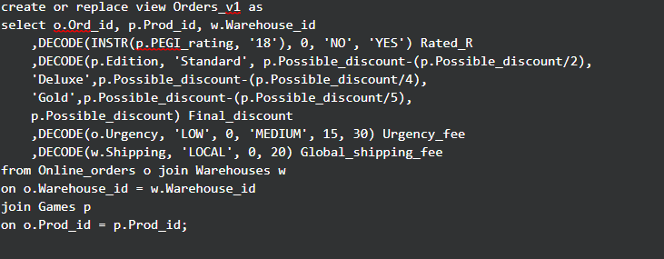  
  


1. View that calculates the total shipping cost.  
   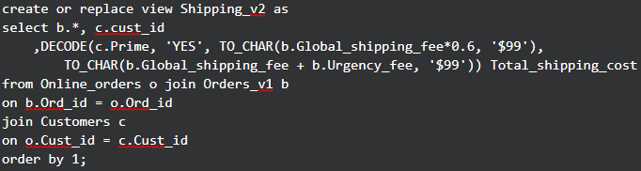  
     
   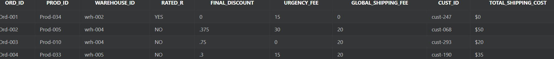
2. View that calculates the total cost of the order.  
   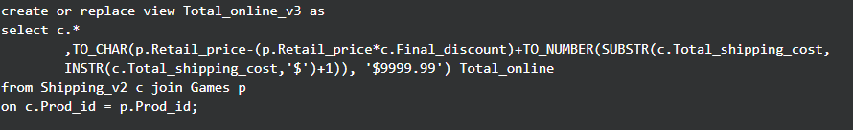  
     
   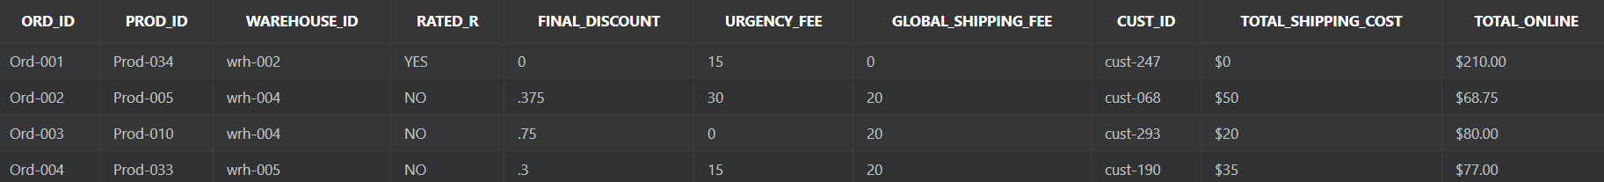
3. View for calculating class discounts.  
     
     
   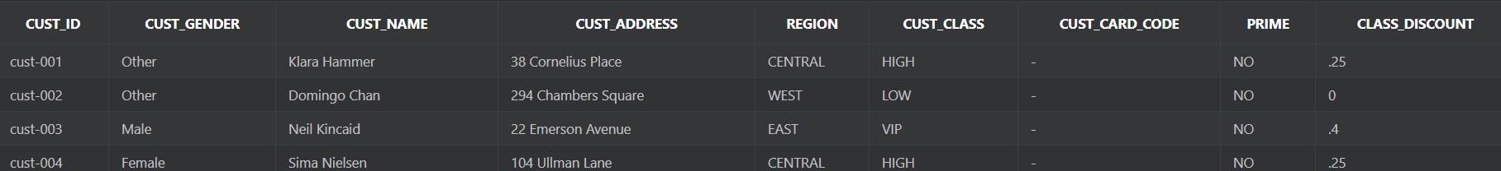
4. View for calculating the total cost of local sales.  
   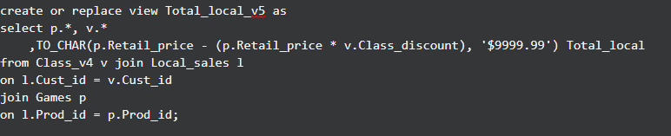  
     
     
   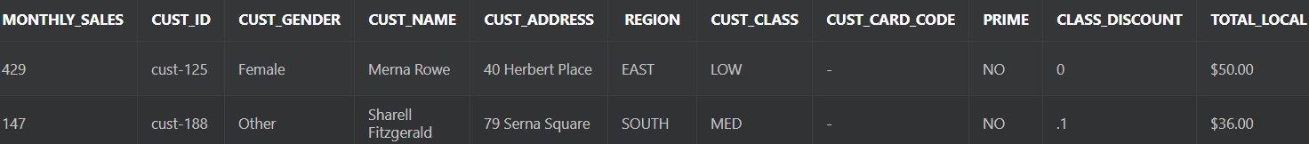
5. View that calculates the employee salary and the number of sales per employee.  
   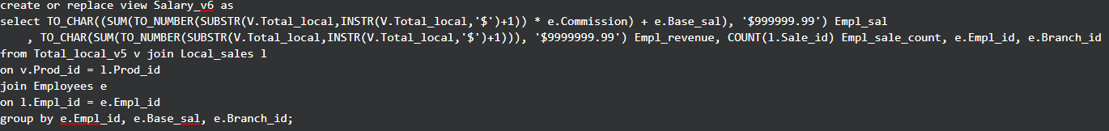  
     
   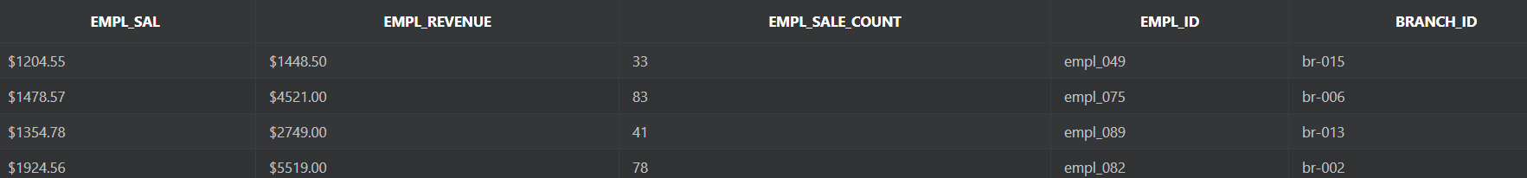
6. Views for calculating the branch revenue, losses and overall balance.  
   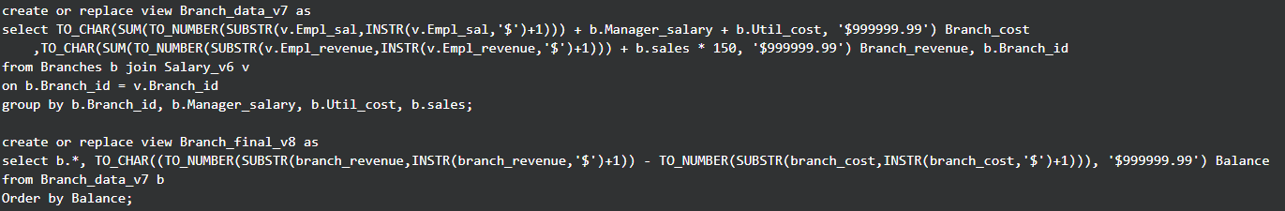  
     
   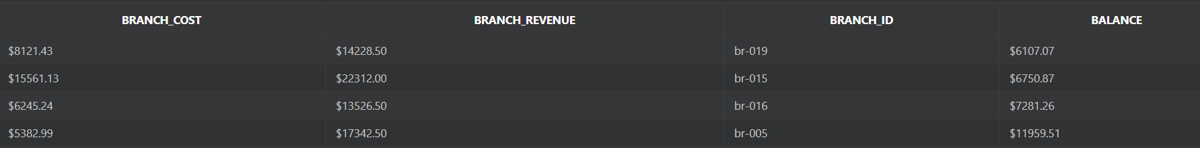
7. Bookkeeping info on the worst performing branch.  
   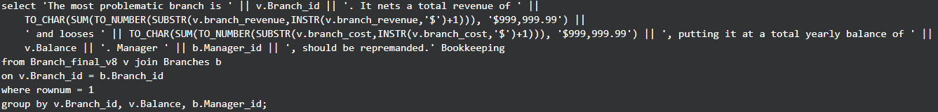  
     
   
8. A tabulation showing the clean revenue from local sales based on customer class.  
   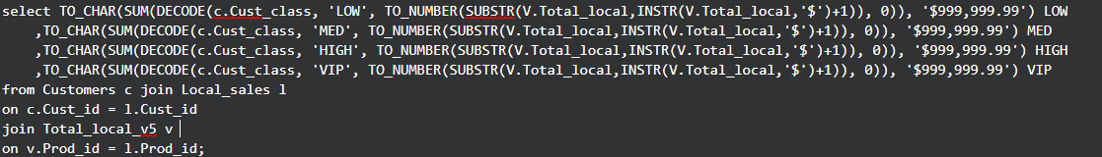  
     
   
9. A contest based on the card credit of the customers.  
   