**Rosa Bonheur**

(boe-NER) French Painter **1822 – 1899**

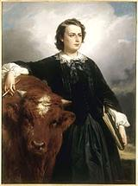

**77**

France

**Rosa Bonheur**, (Marie-Rosalie Bonheur), was known for having

skill in the realistic portrayal of animals

(an [animalière](http://en.wikipedia.org/wiki/Animali%C3%A8re)), a realist artist, and a sculptor.

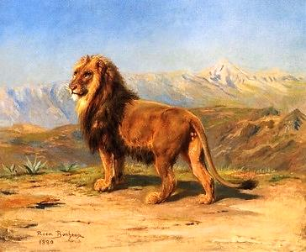 Rosa was the oldest child in a family of artists. Her father, Oscar-Raymond Bonheur, was a landscape and portrait painter and a

Saint-Simonian, a Christian-socialist sect that promoted the education of women alongside men and also

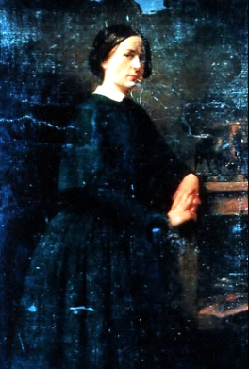prophesied the coming of a female messiah. Her mother Sophie was a piano teacher, but died when Rosa was eleven. Bonheur's younger siblings were Auguste Bonheur and Juliette Bonheur (animal painters) and animal [sculptor](http://en.wikipedia.org/wiki/Sculptor) Isidore Jules Bonheur.

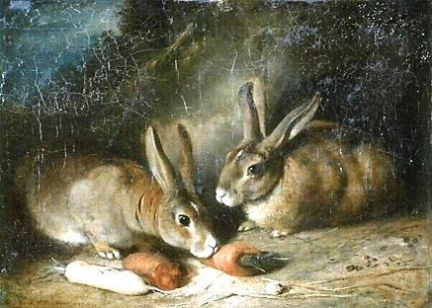 In 1828 **(6)** the Bonheurs moved to Paris. By family accounts, Rosa was

an unruly child and had a difficult

time learning to read. However

even before she could talk she

would sketch for hours. Her

mother taught her to read and write by having her

select and draw an animal for each alphabet letter.

To this practice in the company of her doting mother she

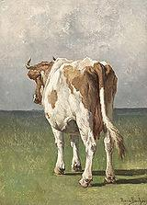 attributed her love of drawing animals.

Rosa was sent to school like her brothers, but was a a disruptive force and was expelled from numerous

schools. Finally, after trying to apprentice her to a

seamstress, her father agreed to educate her as a

painter himself. Rosa was **twelve**, too young to

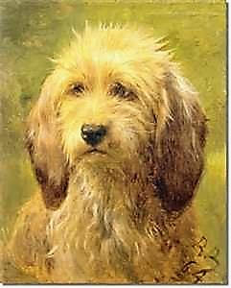 attend the École des Beaux-Arts,

which didn’t admit women

anyway. Following the art

school’s traditional method

Bonheur began copying

images from drawing books,

sketching plaster models, and

studying domesticated animals.

*Portrait of Rosa Bonheur,* E. Dubufe, 1857 **(27)**.

(Dubufe painted her arm on a table. Rosa repainted the portrait with her favorite young bull. When it sold,

Dubufe sent her half of the money he received.) *Lion in a Mountainous Landscape*.

Portrait of Rosa painted by her brother, Auguste. *Rabbits*. *Study of a Cow*.

*Brizo, A Shepherd’s Dog*. *Main Source of document: Wikipedia.*

*lab***EL***brass*.com

She began to copy paintings at the Louvre **(14)**. Among her favorite painters were Nicholas **Poussin** and Peter Paul **Rubens**. She also studied animal anatomy and osteology by visiting slaughterhouses and by performing dissections of animals.

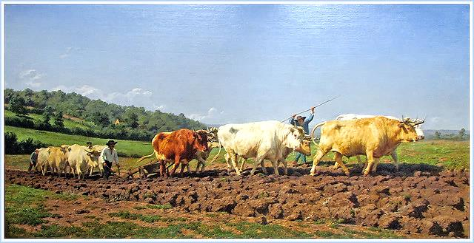 Receiving a French government commission led to her first great success, *Ploughing in the Nivernais*, 1849 **(27)**. Her most famous work was the monumental *Horse Fair*, completed in 1855 **(33)**.

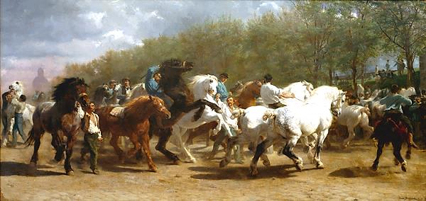

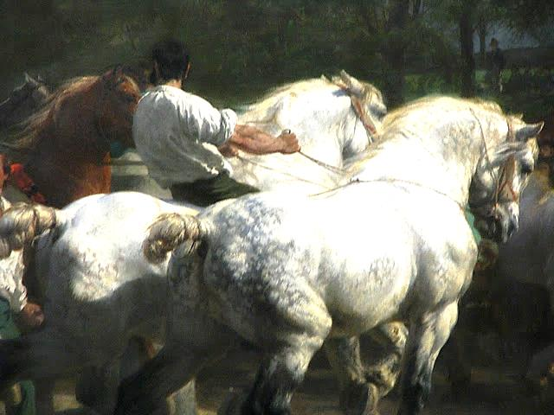

Its subject is the horse market held in Paris on the tree-lined boulevard near the Pitié-Salpêtrière Hospital, visible in the background on the left. It led to international fame.

That same year she travelled to Scotland, and met Queen Victoria, who admired her work.

*Plowing in the Nivernais*, 1849 **(27)**.

[*The Horse Fair*](http://en.wikipedia.org/wiki/The_Horse_Fair)(2), 1853-1855 **(31-33)**

measures eight feet high by sixteen feet wide.

The original hangs in the

Metropolitan Museum of Art in New York.

***2***

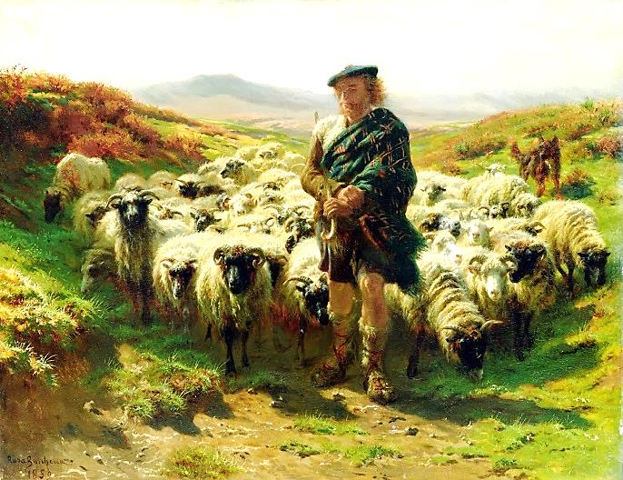 During these travels Bonheur completed sketches for later works including *Highland Shepherd,* 1859 **(37)** and *A Scottish Raid,* 1860 **(38)**. Although these pieces depicted a way of life in the Scottish highlands that had disappeared a century earlier, they had enormous appeal.

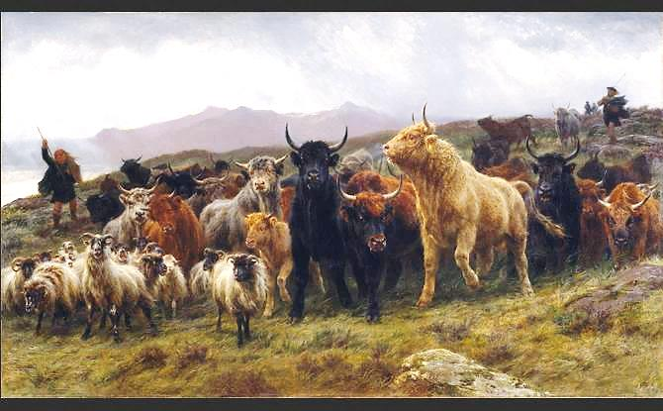

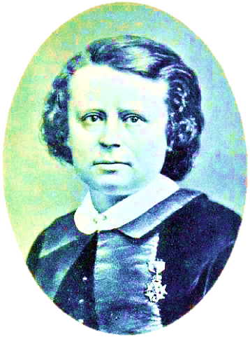

She was very popular in England, less so in France.

She was decorated with the French Legion of Honour by

Empress Eugénie (1865) **(43)** and promoted to Officer of

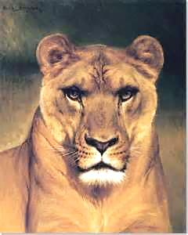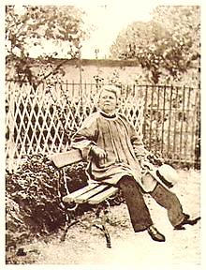 the order in

1894 **(72)**.

*Highland*

*Shepherd,*

1859 **(37).**

*A Scottish*

*Raid,* 1860 **(38)**.

***Photos:*** Bonheur,

1865 **(43)**, wearing the

Legion of Honour. Rosa Bonheur c.1880-90 **(58-68)**

in the garden of Château de By.

*Head of a Lioness*.

*lab***EL***brass*.com

***3***

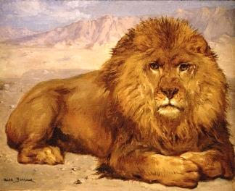 Rosa often dressed in trousers, had female

companions and smoked cigarettes. She claimed that her choice of attire was simply practical in her work with animals: "I was forced to recognize that the clothing of my sex was a constant bother. That is why I decided to solicit the authorization to wear men's clothing from the prefect of police. But the suit I wear is my work attire, nothing else. The epithets of imbeciles have never bothered me."

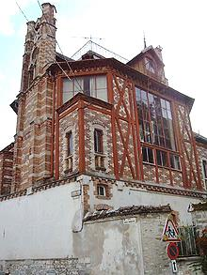 She was such a popular artist that she financially did

well and at age forty-two she was able to purchase a house in the country where she was able to keep her animals including gazelles, monkeys, elk, a yak, a boar, an eagle and, at various times, three pet lions.

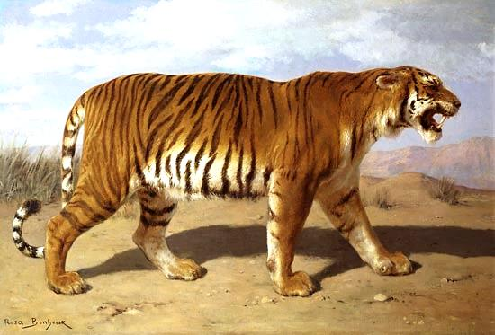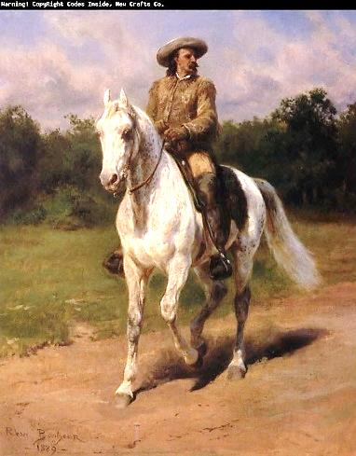

She died at the age of **77**.

Many of her paintings, (not previously shown publicly), were sold in Paris in 1900. *Monarchs of the Forest*, sold

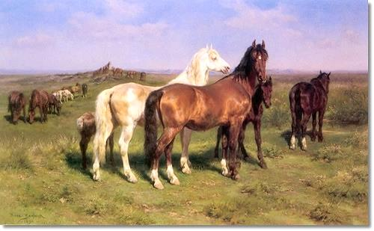 in 2008 for ~ $200,000.

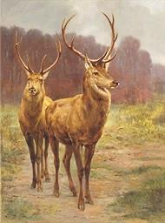

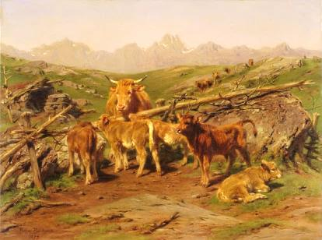

**Photo:**

Atelier in Château de

By, [Thomery](http://en.wikipedia.org/wiki/Thomery),

(museum

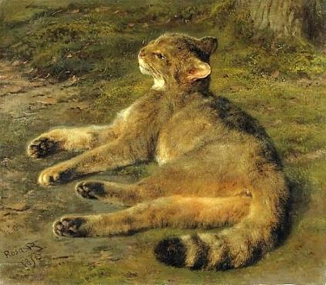now), where

she worked during her

last 40

years.

*Lion at Rest*, c. 1877-80 **(55-58)**. *Col. William F. Cody on His Horse,* 1889 **(67)**. *Stalking Tiger*. *Wild Horses on the Open Plains*, 1890 **(68)**. *Monarchs of the Forest*, 1879 **(57).** *Weaning the Calves*, 1879. *Wildcat*, 1850 **(28)**.

***4***

***4***