Please see the highlighted and the screenshots.

Requirements:
Use the Codio application you created and additional product features - add new order management feature.

Submission:
Provide your GitHub link,
https://github.com/labricot-lab/446_pro_07_20260419
live link and
https://labricot-lab.github.io/446_pro_07_20260419/
screenshots of your application running on Codio browser with a description of which feature you added and why.
Please see the screenshots below.
I have now added individual prices for each product, calculated the total price for each order, and implemented a toggle feature that allows users to view order details when clicked. I also adjusted the order timestamps to display in my local timezone (UTC-4).
The next step is to push the project to my GitHub repository and then deploy it on DigitalOcean. This is done to ensure the code is safely version-controlled, easily shareable, and ready for cloud deployment, where it can be tested and run in a real production-like environment.

Develop update / Implement order management and integrate additional cloud services features (DigitalOcean)
I created three .py files as follows:
1 orderdatabase.py
import sqlite3
conn = sqlite3.connect('database.db')
c = conn.cursor()
c.execute('''
CREATE TABLE IF NOT EXISTS orders (
id INTEGER PRIMARY KEY AUTOINCREMENT,
total_price REAL,
status TEXT,
created_at TIMESTAMP DEFAULT CURRENT_TIMESTAMP
)
''')
c.execute('''
CREATE TABLE IF NOT EXISTS order_items (
id INTEGER PRIMARY KEY AUTOINCREMENT,
order_id INTEGER,
product_name TEXT,
quantity INTEGER,
price REAL
)
''')
conn.commit()
conn.close()

2 saveorder.py
import sqlite3
def save_order(cart):
conn = sqlite3.connect('database.db')
c = conn.cursor()
total = sum(item['price'] * item['quantity'] for item in cart)
# Insert order
c.execute(
"INSERT INTO orders (total_price, status) VALUES (?, ?)",
(total, "Confirmed")
)
order_id = c.lastrowid
# Insert items
for item in cart:
c.execute(
"INSERT INTO order_items (order_id, product_name, quantity, price) VALUES (?, ?, ?, ?)",
(order_id, item['name'], item['quantity'], item['price'])
)
conn.commit()
conn.close()

3 orderapp.py
from flask import Flask, request, redirect, url_for, session
from saveorder import save_order
app = Flask(__name__)
app.secret_key = "secret_key_for_session"
# -------------------------
# HOME PAGE
# -------------------------
@app.route('/')
def home():
return """
<h1>Simple Shop</h1>
<p><a href="/add/Item 1/10.0">Add Item 1 ($ 10)</a></p>
<p><a href="/add/Item 2/20.0">Add Item 2 ($ 20)</a></p>
<a href="/cart">Go to Cart</a>
"""
# -------------------------
# ADD TO CART
# -------------------------
@app.route('/add/<name>/<float:price>')
def add_to_cart(name, price):
if 'cart' not in session:
session['cart'] = []
session['cart'].append({
"name": name,
"price": price,
"quantity": 1
})
session.modified = True
return redirect(url_for('home'))
# -------------------------
# VIEW CART
# -------------------------
@app.route('/cart')
def cart():
cart = session.get('cart', [])
total = sum(item['price'] * item['quantity'] for item in cart)
html = "<h1>Your Cart</h1>"
if not cart:
html += "<p>Your cart is empty.</p>"
else:
for item in cart:
html += f"<p>{item['name']} - ${item['price']} x {item['quantity']}</p>"
html += f"<h3>Total: ${total}</h3>"
html += """
<form action="/confirm_order" method="POST">
<button type="submit">Confirm Order</button>
</form>
"""
html += '<br><a href="/">Back to Home</a>'
return html
# -------------------------
# CONFIRM ORDER
# -------------------------
@app.route('/confirm_order', methods=['POST'])
def confirm_order():
cart = session.get('cart', [])
if cart:
save_order(cart)
session['cart'] = []
return """
<h2>Order placed successfully!</h2>
<a href="/">Return Home</a>
"""
# -------------------------
# RUN APP
# -------------------------
if __name__ == '__main__':
app.run(debug=True)
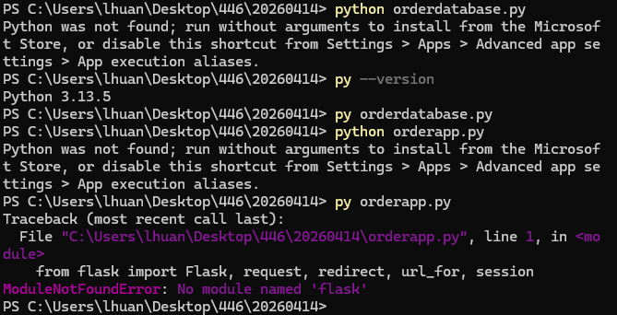
Therefore, I need to install Flask into the SAME Python version you're using (py).
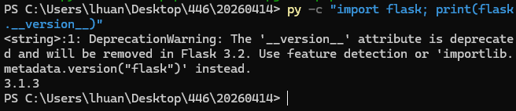
Then I need to run orderapp.py again.
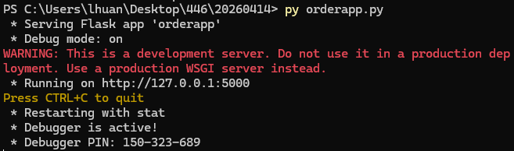

Then I opened the link:
http://127.0.0.1:5000/
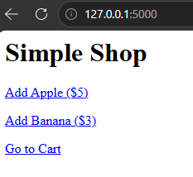
Add item 1 ($10)
Add item 2 ($ 20)
Go to cart

However, these .py related steps won’t go well with my node.js (server.js). Therefore, I decided to delete these .py files and stick to node.js (server.js)
I then updated my server.js and orders.html
1 server.js updated
// =====================
// iterating_20260414 - FINAL SERVER
// =====================

const express = require('express');
const sqlite3 = require('sqlite3').verbose();
const cors = require('cors');
const path = require('path');

const app = express();

// =====================
// MIDDLEWARE
// =====================
app.use(cors());
app.use(express.json());
app.use(express.static(__dirname));

// =====================
// DATABASE
// =====================
const db = new sqlite3.Database('./cart.db', (err) => {
if (err) {
console.error("DB error:", err.message);
} else {
console.log("Connected to SQLite database.");
}
});

// =====================
// TABLES (IMPORTANT)
// =====================

// Cart table
db.run(`
CREATE TABLE IF NOT EXISTS cart (
id INTEGER PRIMARY KEY AUTOINCREMENT,
item_id INTEGER
)
`);

// Orders table
db.run(`
CREATE TABLE IF NOT EXISTS orders (
id INTEGER PRIMARY KEY AUTOINCREMENT,
created_at DATETIME DEFAULT CURRENT_TIMESTAMP
)
`);

// Order items table
db.run(`
CREATE TABLE IF NOT EXISTS order_items (
id INTEGER PRIMARY KEY AUTOINCREMENT,
order_id INTEGER,
item_id INTEGER
)
`);

// =====================
// ADD TO CART
// =====================
app.post('/cart', (req, res) => {
const itemId = req.body.id;

console.log("🔥 Item added:", itemId);

db.run(
"INSERT INTO cart(item_id) VALUES(?)",
[itemId],
function (err) {
if (err) {
return res.status(500).json({ error: err.message });
}

db.all("SELECT * FROM cart", [], (err, rows) => {
if (err) {
return res.status(500).json({ error: err.message });
}

res.json({ cart: rows });
});
}
);
});

// =====================
// GET CART
// =====================
app.get('/cart', (req, res) => {
db.all("SELECT * FROM cart", [], (err, rows) => {
if (err) {
return res.status(500).json({ error: err.message });
}

res.json({ cart: rows });
});
});

// =====================
// CHECKOUT (ORDER MANAGEMENT CORE)
// =====================
app.post('/checkout', (req, res) => {

console.log("🛒 Checkout started");

// 1. Create new order
db.run("INSERT INTO orders DEFAULT VALUES", function (err) {
if (err) {
return res.status(500).json({ error: err.message });
}

const orderId = this.lastID;

// 2. Get cart items
db.all("SELECT * FROM cart", [], (err, items) => {
if (err) {
return res.status(500).json({ error: err.message });
}

// 3. Save items into order_items
items.forEach(item => {
db.run(
"INSERT INTO order_items (order_id, item_id) VALUES (?, ?)",
[orderId, item.item_id]
);
});

// 4. Clear cart AFTER saving
db.run("DELETE FROM cart");

// 5. Response
res.json({
message: "Order placed successfully",
orderId: orderId
});
});
});

});

// =====================
// ORDER HISTORY (IMPORTANT FOR YOUR PROJECT)
// =====================
app.get('/orders', (req, res) => {
db.all("SELECT * FROM orders ORDER BY id DESC", [], (err, orders) => {
if (err) {
return res.status(500).json({ error: err.message });
}

res.json({ orders });
});
});

// =====================
// GET ORDER DETAILS
// =====================
app.get('/orders/:id', (req, res) => {
const orderId = req.params.id;

db.all(
"SELECT * FROM order_items WHERE order_id = ?",
[orderId],
(err, items) => {
if (err) {
return res.status(500).json({ error: err.message });
}

res.json({
orderId,
items
});
}
);
});

// =====================
// HOME PAGE
// =====================
app.get('/', (req, res) => {
res.sendFile(path.join(__dirname, 'productList.html'));
});

// =====================
// START SERVER
// =====================
app.listen(3000, () => {
console.log("Server running on http://localhost:3000");
});

2 orders.html
// orders.html_cleaned_20260418

<!DOCTYPE html>
<html>
<head>
<title>Orders</title>
</head>
<body>

<h1>Order History</h1>

<div id="orders"></div>

<script>
// Get all orders from backend
fetch('/orders')
.then(res => res.json())
.then(data => {
const container = document.getElementById('orders');

data.orders.forEach(order => {
const div = document.createElement('div');

div.innerHTML = `
<hr>
<h3>Order #${order.id}</h3>
<p>Date: ${order.created_at}</p>
<button onclick="loadItems(${order.id})">
View Items
</button>
<div id="items-${order.id}"></div>
`;

container.appendChild(div);
});
});

// Load items for a specific order
function loadItems(orderId) {
fetch('/orders/' + orderId)
.then(res => res.json())
.then(data => {

let html = "<ul>";

data.items.forEach(item => {
html += `<li>Item ID: ${item.item_id}</li>`;
});

html += "</ul>";

document.getElementById('items-' + orderId).innerHTML = html;
});
}
</script>

</body>
</html>
Then I tested the full system end-to-end.
I started server.js first.
After I added items and clicked the checkout button, I opened the orders.html here.
http://localhost:3000/orders.html
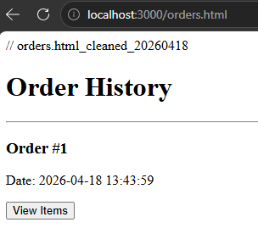
I then clicked View Items.
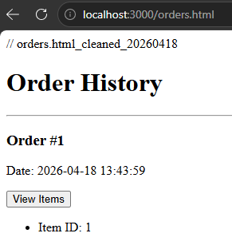
Then I updated my server.js here.
// =====================
// iterating_20260418 - FINAL SERVER
// =====================

const express = require('express');
const sqlite3 = require('sqlite3').verbose();
const cors = require('cors');
const path = require('path');

const app = express();

// =====================
// MIDDLEWARE
// =====================
app.use(cors());
app.use(express.json());
app.use(express.static(__dirname));

// =====================
// DATABASE
// =====================
const db = new sqlite3.Database('./cart.db', (err) => {
if (err) {
console.error("DB error:", err.message);
} else {
console.log("Connected to SQLite database.");
}
});

// =====================
// PRODUCT LIST (FIXED)
// =====================
const products = {
1: "Eagle bottle",
2: "Eagle Dart",
3: "Eagle T-shirt",
4: "Eagle Tie",
5: "Eagle Ring",
6: "Eagle Mug"
};

// =====================
// TABLES
// =====================
db.run(`
CREATE TABLE IF NOT EXISTS cart (
id INTEGER PRIMARY KEY AUTOINCREMENT,
item_id INTEGER
)
`);

db.run(`
CREATE TABLE IF NOT EXISTS orders (
id INTEGER PRIMARY KEY AUTOINCREMENT,
created_at DATETIME DEFAULT CURRENT_TIMESTAMP
)
`);

db.run(`
CREATE TABLE IF NOT EXISTS order_items (
id INTEGER PRIMARY KEY AUTOINCREMENT,
order_id INTEGER,
item_id INTEGER
)
`);

// =====================
// ADD TO CART
// =====================
app.post('/cart', (req, res) => {
const itemId = req.body.id;

db.run(
"INSERT INTO cart(item_id) VALUES(?)",
[itemId],
function (err) {
if (err) {
return res.status(500).json({ error: err.message });
}

db.all("SELECT * FROM cart", [], (err, rows) => {
if (err) {
return res.status(500).json({ error: err.message });
}

res.json({ cart: rows });
});
}
);
});

// =====================
// GET CART
// =====================
app.get('/cart', (req, res) => {
db.all("SELECT * FROM cart", [], (err, rows) => {
if (err) {
return res.status(500).json({ error: err.message });
}

res.json({ cart: rows });
});
});

// =====================
// CHECKOUT (ORDER CREATION)
// =====================
app.post('/checkout', (req, res) => {

db.run("INSERT INTO orders DEFAULT VALUES", function (err) {
if (err) {
return res.status(500).json({ error: err.message });
}

const orderId = this.lastID;

db.all("SELECT * FROM cart", [], (err, items) => {
if (err) {
return res.status(500).json({ error: err.message });
}

items.forEach(item => {
db.run(
"INSERT INTO order_items (order_id, item_id) VALUES (?, ?)",
[orderId, item.item_id]
);
});

db.run("DELETE FROM cart", () => {
res.json({
message: "Order placed successfully",
orderId: orderId
});
});
});
});

});

// =====================
// ORDER HISTORY
// =====================
app.get('/orders', (req, res) => {
db.all("SELECT * FROM orders ORDER BY id DESC", [], (err, orders) => {
if (err) {
return res.status(500).json({ error: err.message });
}

res.json({ orders });
});
});

// =====================
// ORDER DETAILS (FIXED WITH PRODUCT NAMES)
// =====================
app.get('/orders/:id', (req, res) => {
const orderId = req.params.id;

db.all(
"SELECT * FROM order_items WHERE order_id = ?",
[orderId],
(err, items) => {
if (err) {
return res.status(500).json({ error: err.message });
}

const formatted = items.map(item => ({
name: products[item.item_id] || "Unknown Item"
}));

res.json({
orderId,
items: formatted
});
}
);
});

// =====================
// HOME PAGE
// =====================
app.get('/', (req, res) => {
res.sendFile(path.join(__dirname, 'productList.html'));
});

// =====================
// START SERVER
// =====================
app.listen(3000, () => {
console.log("Server running on http://localhost:3000");
});
Several files updated here.
server.js
// =====================
// iterating_20260418 - FIXED SERVER (CLEAN VERSION)
// =====================

const express = require('express');
const sqlite3 = require('sqlite3').verbose();
const cors = require('cors');
const path = require('path');

const app = express();

// =====================
// DEBUG LOGGER
// =====================
app.use((req, res, next) => {
console.log(`➡️ ${req.method} ${req.url}`);
next();
});

// =====================
// MIDDLEWARE
// =====================
app.use(express.json());
app.use(cors());
app.use(express.static(__dirname));

// =====================
// DATABASE
// =====================
const db = new sqlite3.Database('./cart.db', (err) => {
if (err) {
console.error("DB error:", err.message);
} else {
console.log("Connected to SQLite database.");
}
});

// =====================
// PRODUCT LIST (FIXED STRUCTURE)
// =====================
const products = {
1: { name: "Eagle bottle", price: 10 },
2: { name: "Eagle Dart", price: 15 },
3: { name: "Eagle T-shirt", price: 20 },
4: { name: "Eagle Tie", price: 25 },
5: { name: "Eagle Ring", price: 30 },
6: { name: "Eagle Mug", price: 14 }
};

// =====================
// TABLES
// =====================
db.run(`
CREATE TABLE IF NOT EXISTS cart (
id INTEGER PRIMARY KEY AUTOINCREMENT,
item_id INTEGER
)
`);

db.run(`
CREATE TABLE IF NOT EXISTS orders (
id INTEGER PRIMARY KEY AUTOINCREMENT,
created_at DATETIME DEFAULT CURRENT_TIMESTAMP
)
`);

db.run(`
CREATE TABLE IF NOT EXISTS order_items (
id INTEGER PRIMARY KEY AUTOINCREMENT,
order_id INTEGER,
item_id INTEGER
)
`);

// =====================
// ADD TO CART
// =====================
app.post('/cart', (req, res) => {
const itemId = parseInt(req.body.id);

console.log("🛒 Add to cart:", itemId);

if (!itemId || !products[itemId]) {
return res.status(400).json({ error: "Invalid item id" });
}

db.run(
"INSERT INTO cart(item_id) VALUES(?)",
[itemId],
function (err) {
if (err) {
return res.status(500).json({ error: err.message });
}

db.all("SELECT * FROM cart", [], (err, rows) => {
if (err) {
return res.status(500).json({ error: err.message });
}

res.json({ cart: rows });
});
}
);
});

// =====================
// GET CART
// =====================
app.get('/cart', (req, res) => {
db.all("SELECT * FROM cart", [], (err, rows) => {
if (err) {
return res.status(500).json({ error: err.message });
}

const formatted = rows.map(r => ({
id: r.id,
item_id: r.item_id,
name: products[r.item_id]?.name || "Unknown",
price: products[r.item_id]?.price || 0
}));

res.json({ cart: formatted });
});
});

// =====================
// CHECKOUT
// =====================
app.post('/checkout', (req, res) => {

console.log("🛒 Checkout started");

db.serialize(() => {

db.run("INSERT INTO orders DEFAULT VALUES", function (err) {
if (err) {
return res.status(500).json({ error: err.message });
}

const orderId = this.lastID;

db.all("SELECT * FROM cart", [], (err, items) => {
if (err) {
return res.status(500).json({ error: err.message });
}

if (items.length === 0) {
return res.json({ message: "Cart is empty", orderId });
}

const stmt = db.prepare(
"INSERT INTO order_items (order_id, item_id) VALUES (?, ?)"
);

items.forEach(item => {
stmt.run(orderId, item.item_id);
});

stmt.finalize(() => {
db.run("DELETE FROM cart", () => {
res.json({
message: "Order placed successfully",
orderId
});
});
});

});
});

});

});

// =====================
// ORDERS LIST
// =====================
app.get('/orders', (req, res) => {
db.all("SELECT * FROM orders ORDER BY id DESC", [], (err, orders) => {
if (err) {
return res.status(500).json({ error: err.message });
}

res.json({ orders });
});
});

// =====================
// ORDER DETAILS (FIXED - MAIN BUG FIX)
// =====================
app.get('/orders/:id', (req, res) => {
const orderId = req.params.id;

db.all(
"SELECT * FROM order_items WHERE order_id = ?",
[orderId],
(err, items) => {
if (err) {
return res.status(500).json({ error: err.message });
}

const formatted = items.map(item => {
const product = products[Number(item.item_id)];

return {
name: product?.name || "Unknown Item",
price: product?.price || 0,
quantity: 1
};
});

res.json({
orderId,
items: formatted
});
}
);
});

// =====================
// HOME
// =====================
app.get('/', (req, res) => {
res.sendFile(path.join(__dirname, 'productList.html'));
});

// =====================
// START SERVER
// =====================
app.listen(3000, "0.0.0.0", () => {
console.log("Server running on http://localhost:3000");
});
productList.html
<!-- iterating_20260414 -->

<!DOCTYPE html>
<html lang="en">
<head>
<meta charset="UTF-8">
<meta name="viewport" content="width=device-width, initial-scale=1.0">
<title>Eagle Items</title>

<link href="https://fonts.googleapis.com/css2?family=Poppins:wght@300;400;600&display=swap" rel="stylesheet">

<!-- External CSS -->
<link rel="stylesheet" href="external.css">

<!-- Font Awesome for shopping cart icon -->
<link rel="stylesheet" href="https://cdnjs.cloudflare.com/ajax/libs/font-awesome/6.4.0/css/all.min.css">
</head>

<body class="Types">

<!-- ===========================
TITLE
=========================== -->
<div class="header">
Everything Birds - Items
</div>

<!-- ===========================
BOTTOM NAVIGATION
=========================== -->
<nav class="bottom-nav">
<a href="#" class="nav-link cart-link">
<i class="fas fa-shopping-cart"></i>
</a>

<a href="#" class="footer-icon">
© 2026 Copyleft favoriteproject
</a>
</nav>

<!-- ===========================
ITEM GRID
=========================== -->
<main class="item-container">

<section class="item">
<div class="item-image">
<img src="images/1eaglebottle.jpg" alt="Item 1">
</div>
<h2>Item 1: Eagle bottle $10</h2>
<p>Beautifully crafted eagle bottle.</p>
<button class="add-cart" data-id="1">Add to Cart</button>
</section>

<section class="item">
<div class="item-image">
<img src="images/2eagledart.jpg" alt="Item 2">
</div>
<h2>Item 2: Eagle Dart $15</h2>
<p>Cool eagle dart against your wall.</p>
<button class="add-cart" data-id="2">Add to Cart</button>
</section>

<section class="item">
<div class="item-image">
<img src="images/3eagletshirt.jpg" alt="Item 3">
</div>
<h2>Item 3: Eagle T-shirt $20</h2>
<p>High-quality T-shirt with eagle design.</p>
<button class="add-cart" data-id="3">Add to Cart</button>
</section>

<section class="item">
<div class="item-image">
<img src="images/4eagleties.jpg" alt="Item 4">
</div>
<h2>Item 4: Eagle Tie $35</h2>
<p>Eye-catching Ties featuring an eagle graphic.</p>
<button class="add-cart" data-id="4">Add to Cart</button>
</section>

<section class="item">
<div class="item-image">
<img src="images/5eaglering.jpg" alt="Item 5">
</div>
<h2>Item 5: Eagle Ring $40</h2>
<p>Rings with eagle-themed design.</p>
<button class="add-cart" data-id="5">Add to Cart</button>
</section>

<section class="item">
<div class="item-image">
<img src="images/6eaglemug.jpg" alt="Item 6">
</div>
<h2>Item 6: Eagle Mug $10</h2>
<p>Mugs with detailed eagle patterns.</p>
<button class="add-cart" data-id="6">Add to Cart</button>
</section>

<button onclick="checkout()">Checkout</button>

</main>

<p>&nbsp;</p>
<p>&nbsp;</p>

<script src="jsfile.js"></script>

<script>
function checkout() {

fetch('http://localhost:3000/checkout', {
method: 'POST'
})
.then(res => res.json())
.then(data => {

console.log("Order placed:", data);

// optional: show message
alert("Order placed successfully!");

// go to orders page AFTER checkout finishes
window.location.href = "orders.html";

})
.catch(err => {
console.error("Checkout failed:", err);
alert("Checkout failed. Check console.");
});

}
</script>

</body>
</html>

orders.html
<!DOCTYPE html>
<html>
<head>
<title>Orders</title>

<style>
.hidden {
display: none;
}

.order-box {
margin-bottom: 20px;
}
</style>
</head>

<body>

<h1>Order History</h1>

<button id="refreshBtn">🔄 Refresh Orders</button>

<p id="status"></p>

<div id="orders"></div>

<script>

/* =========================
STATUS DISPLAY
========================= */
function setStatus(msg) {
document.getElementById("status").innerText = msg;
}

/* =========================
LOAD ORDERS
========================= */
async function loadOrders() {
setStatus("Loading orders...");

const container = document.getElementById('orders');
container.innerHTML = "<p>Refreshing...</p>";

try {
const response = await fetch(
"http://localhost:3000/orders?nocache=" + Date.now(),
{
method: "GET",
cache: "no-store"
}
);

if (!response.ok) {
throw new Error("Server error: " + response.status);
}

const data = await response.json();

container.innerHTML = "";

if (!data.orders || data.orders.length === 0) {
container.innerHTML = "<p>No orders found.</p>";
setStatus("No orders in database.");
return;
}

data.orders.forEach(order => {
const div = document.createElement('div');
div.classList.add("order-box");

div.innerHTML = `
<hr>
<h3>Order #${order.id}</h3>
<p>Date: ${new Date(order.created_at + ' UTC').toLocaleString()}</p>

<button onclick="toggleItems(${order.id})">
View Items
</button>

<div id="items-${order.id}" class="hidden"></div>
`;

container.appendChild(div);
});

setStatus("Orders refreshed ✔");

} catch (err) {
console.error("FETCH ERROR:", err);

container.innerHTML = `
<p style="color:red;">
Cannot connect to server.<br>
Make sure backend is running on port 3000.
</p>
`;

setStatus("❌ Failed to load orders: " + err.message);
}
}

/* =========================
TOGGLE + LOAD ITEMS
========================= */
async function toggleItems(orderId) {

const container = document.getElementById('items-' + orderId);

// ✅ If already open → CLOSE
if (!container.classList.contains("hidden")) {
container.classList.add("hidden");
return;
}

// ✅ If already loaded → just OPEN (no fetch again)
if (container.dataset.loaded === "true") {
container.classList.remove("hidden");
return;
}

setStatus("Loading items for order #" + orderId);

try {
const response = await fetch(
`http://localhost:3000/orders/${orderId}?nocache=` + Date.now(),
{ cache: "no-store" }
);

if (!response.ok) {
throw new Error("Server error: " + response.status);
}

const data = await response.json();

container.innerHTML = "";

if (!data.items || data.items.length === 0) {
container.innerHTML = "<p>No items in this order.</p>";
container.classList.remove("hidden");
return;
}

let total = 0;
let html = "<ul>";

data.items.forEach(item => {

const price = item.price || 0;
const quantity = item.quantity || 1;
const subtotal = price * quantity;

total += subtotal;

html += `
<li>
${item.name} - $${price} × ${quantity}
= $${subtotal}
</li>
`;
});

html += "</ul>";

html += `<strong>Total: $${total}</strong>`;

container.innerHTML = html;

// ✅ mark as loaded
container.dataset.loaded = "true";

// ✅ show it
container.classList.remove("hidden");

setStatus("Items loaded ✔");

} catch (err) {
console.error("ITEM FETCH ERROR:", err);
setStatus("❌ Failed to load items: " + err.message);
}
}

/* =========================
EVENTS
========================= */
document.getElementById("refreshBtn").onclick = loadOrders;

/* =========================
INITIAL LOAD
========================= */
window.onload = loadOrders;

</script>

</body>
</html>

jsfile.js
document.addEventListener("DOMContentLoaded", () => {

const buttons = document.querySelectorAll('.add-cart');

buttons.forEach((btn, index) => {
btn.addEventListener('click', () => {

fetch('http://localhost:3000/cart', {
method: 'POST',
headers: {
'Content-Type': 'application/json'
},
body: JSON.stringify({ id: index + 1 })
})
.then(res => res.json())
.then(data => {
alert(`Added to cart! Total items: ${data.cart.length}`);
})
.catch(err => console.error("Cart error:", err));

});
});

});

I arrived at the order history here._20260418
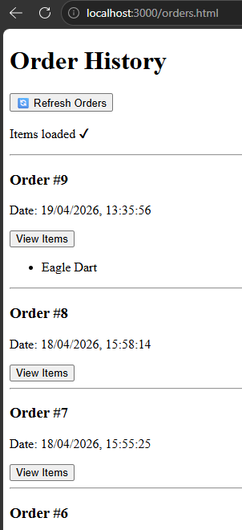
I will see if I can add one more step today to this shopping history._20260419
Before I add one more step to my shopping history, I need to ask a question. There is an undefined element in my server.js, is it okay to leave it like that undefined? Do I need to amend that?
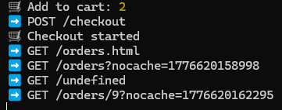
I now added each price for each item, total price for a whole order, a toggle that I can click to see the order details. I also change the order issue time to my time (UTC-4) Therefore, now I plan to push it first to my GitHub account and then run it on Digital Ocean.
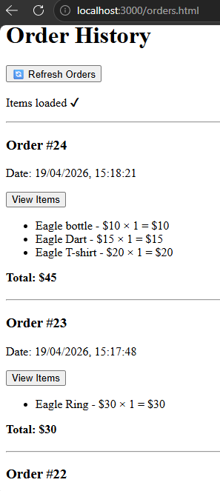
Now I’m first pushing it to my GitHub account and then trying to run it on Digital Ocean.

