


Sirius3

Developer Manual
INDUSTRIAL LASER·SCANNER CONTROL PLATFORM

Contents
01 The library and the machine job 7
1.1 Three packages and four main interfaces 7
1.2 Capabilities to build on 7
1.3 Supported SCANLAB controllers 8
1.4 Target platforms 9
1.5 System requirements 9
1.6 Dependencies and runtime files 9
1.7 Install the packages 10
1.8 Project settings before the first control 10
02 Sirius3 features and practical advantages 11
2.1 Scanner and laser integration 11
2.2 Process timing and extension options 11
2.3 Geometry and file workflows 11
2.4 Editing and dynamic data 11
2.5 Measurement and commissioning 11
03 A first WinForms workstation 12
3.1 Host entry point and form 12
3.2 Create and register RTC devices 12
3.3 Read the public demo configuration flow 14
3.4 DPI and application lifetime 14
04 Documents pages layers and pens 15
4.1 Organize work across four pages 16
4.2 Read the page and block trees 17
4.3 Create select then edit 17
05 Document actions and WinForms commands 19
5.1 Files selection and history 19
5.2 Hierarchy clipboard and processing order 20
5.3 PropertyGrid geometry and hatch edits 21
5.4 Geometry preparation and simulation 22
06 PropertyGrid as a working tool 24
6.1 Find commit and inspect 24
6.2 Keyboard focus changes the meaning 24
6.3 Read the complete SiriusEditorControl layout 25
6.4 Toolbar icons and their commands 25
6.5 Editor and TreeView shortcut reference 29
6.6 TreeView selection order and block reuse 29
6.7 Property editors 34
6.8 Alignment, Scale and Rotate editors 36
6.9 FontName and the font preview list 39
6.10 Create geometry interactively 41
6.11 Switch grip modes with Tab 44
6.12 Simulate the selected paths with F1 46
07 Entity interfaces and their UI 47
7.1 IEntity and typed cloning 48
7.2 IRenderable IRenderData and IHitTestable 48
7.3 ITransformable and coordinate spaces 49
7.4 IMarkerable and IHasChildren 50
7.5 IHatchable and IReversable 51
7.6 IClippable and ClipOptions 52
7.7 ISliceable 53
7.8 Edit entities with grips 53
08 Barcodes and text 56
8.1 Create basic entities 56
8.2 Text layout and fonts 56
8.3 Barcode dimensions and cells 59
09 TextConverter and dynamic text 60
9.1 Event Host event data 61
9.2 SimpleScript C# expression and script properties 62
9.3 File Consume a text queue 62
9.4 Offset Data for each placement 62
9.5 Link Reuse an already converted master 63
9.6 Edit the Script production data 64
9.7 Extend the Script context 65
10 Hatching clipping images and import 66
10.1 Hatching converts a valid region into paths 66
10.2 Clip geometry before placing the final job 67
10.3 Image size and bitmap lifetime 68
10.4 Import through the document 69
10.5 Mesh sections are contours not a finished process 69
10.6 HatchLine properties 70
10.7 HatchPolygon properties 71
10.8 Load an STL then slice and hatch 73
10.9 Clip real Gerber text and barcode paths 75
11 FontEditor — edit Sirius font files 78
11.1 Open and edit an existing Sirius font 78
11.2 Convert a Windows TTF into a Sirius font 79
11.3 Read ascent, descent and x-height 80
11.4 Add the font editor to your application 80
12 RTC fundamentals and laser timing 82
12.1 From C# calls to controller execution 82
12.2 10 µs microsteps and path resolution 83
12.3 Find the RTC connections 83
12.4 Read the laser timing diagrams 93
12.5 Adjust laser timing, then scanner settling 97
13 IRtc and the SCANLAB execution model 101
13.1 Control commands and list commands 101
13.2 Controller capabilities 103
13.3 Align a rotated scan head with the working coordinates 104
14 ILaser and output control 105
14.1 PropertyGrid settings to verify 106
14.2 Extend a laser adapter 106
14.3 LaserVirtual output methods 106
14.4 Implement a custom ILaser adapter 108
15 EntityPen and per-entity conditions 109
15.1 Laser values and their coupled calculations 109
15.2 Scanner speed and delay tuning 111
15.3 Raster exposure and Wobbel 112
15.4 Understand Wobbel paths and frequency limits 114
15.5 Using EntityPenWobbelForm 116
15.6 Customize EntityPen and EntityLayerPen processing 117
16 LayerPen and layer-wide control 119
16.1 ALC signal mode and limits 119
16.2 Speed, position and Defined Vector control 121
16.3 Sky Writing 122
16.4 Read variable delays on a graph 128
16.5 Process separate layers after external Stage moves 129
17 Marker execution and simulation 131
17.1 Choosing a marker 132
17.2 LayerFirst and OffsetFirst 133
17.3 Use simulation for the path question 134
17.4 Preview and ILaserGuideControl 135
18 ManualControl for manual device operation 136
19 LogControl for operation and fault diagnosis 137
20 IPowerMeter — acquire optical power 138
20.1 Device, units and acquisition 138
20.2 Use the editor’s Power tab 139
20.3 How IPowerMap uses the meter 139
21 IPowerMap and measured output 140
21.1 Frequency categories and interpolation 141
21.2 Read the map from target Y to input X 142
21.3 Choosing Linear or Pchip 142
21.4 PowerMapControl workflow 143
22 Measurement entities and result plots 147
22.1 Place Begin and End in EditorControl 147
22.2 Run the recipe and obtain the result 149
22.3 Read time and X/Y plots 149
23 2D scanner field calibration 152
23.1 Why the 2D field needs correction 152
23.2 Measure convert apply and verify 154
23.3 Verify KFactor, then refine the 2D grid progressively 155
23.4 Enter the measured positions correctly 156
24 3D scanner field calibration 157
24.1 Calibration order and measurement data 157
24.2 Prepare units and scale 158
24.3 Beam Tilt corrects beam incidence 158
24.4 XY Field corrects positions on the reference plane 158
24.5 Focus Z zero flattens the reference focus 159
24.6 ABC fits the focus actuator curve 159
24.7 Stretch corrects the lateral scale over Z 159
24.8 Calculate save apply and verify 160
24.9 Focus on a free-form surface from a point cloud 160
25 SiriusMultiEditorControl and WPF support 165
25.1 Register the sets before selecting one 165
25.2 Change a device set 166
25.3 Native WPF controls are supported 167
26 Digital inputs and outputs 170
26.1 Digital inputs and outputs 170
26.2 Name individual DIO bits 171
26.3 Poll, receive transitions and dispatch actions 171
27 Stepper control and indexed motion 172
27.1 Pulse generation and the external driver 172
27.2 Read and operate StepperControl 173
27.3 Connect the panel and sequence the document 174
28 SCANahead and advanced timing 175
28.1 SCANahead and SDC 175
28.2 Combine ALC with SCANahead 175
28.3 Combine the ALC base mode and extensions 176
28.4 Practical combinations for SCANahead and MoF 177
28.5 SCANahead settings on EntityPen 178
28.6 Tune automatic delays and pen parameters together 180
28.7 Auto Delays: timing and PropertyGrid visibility 182
29 MoF extension option 183
29.1 MoF and encoder coordinates 183
29.2 Build an ordered moving-part recipe 184
29.3 X Y mode with the linear MoF demo 186
29.4 Rotary mode with the public editor demo 187
30 syncAXIS extension option 188
30.1 Configuration and job ownership 188
30.2 Installation and first simulation 189
30.3 Edit XML with syncAXIS Configurator 191
30.4 Use the public setup and editor demos 194
30.5 Inspect results with syncAXIS Viewer 197
30.6 Layer motion with syncAXIS 200
30.7 Diagnose initialization and execution separately 201
30.8 Follow and Unfollow: manual positioning and return 202
30.9 Read Job Characteristic after execution or simulation 203
31 MultiBeam extension option 204
31.1 Optical layout and Router Gate roles 204
31.2 One source and two coordinated beam paths 205
31.3 AOM orders and beam paths 205
31.4 Operate MultiBeamRtcControl 206
31.5 Board numbering and signal connections 207
31.6 Token exchange during scanner jumps 208
31.7 Residual light and head power calibration 208
32 Remote communication 209
32.1 Remote protocols 209
32.2 RemoteControl: transport and MCP in one panel 210
32.3 Choose the transport and await startup 211
32.4 Command framing, authority and completion 211
33 Embedded MCP server 212
33.1 Embed MCP on the editor thread 212
33.2 Protocol endpoints and authorized scope 212
33.3 Connect ChatGPT and Claude over HTTP 213
33.4 Prompt examples 213
33.5 Ask the PDF manuals 214
34 Public demos as a source map 215
34.1 Start and editor integration 215
34.2 Entities and geometry preparation 215
34.3 Devices and processing 216
34.4 External data and host customization 218
34.5 Shared files and related references 219
35 EntityFactory creation catalog 220
35.1 Points, segments and planar primitives 220
35.2 Polylines, contours and parametric curves 220
35.3 Text, raster images and machine-readable codes 221
35.4 Meshes, surfaces and sampled grids 222
35.5 Containers and file-based objects 222
35.6 Ordered control and synchronization objects 223
35.7 Small verified recipes 225
36 Global configuration 226
36.1 Read the settings in the running UI 226
36.2 SpiralLab.Sirius3.Config logging and diagnostics 227
36.3 SpiralLab.Sirius3.Config paths and external tools 228
36.4 SpiralLab.Sirius3.Config geometry and measurement 229
36.5 SpiralLab.Sirius3.Config power mapping and compensation 230
36.6 SpiralLab.Sirius3.UI.Config documents and serialization 231
36.7 SpiralLab.Sirius3.UI.Config trees and editor policies 232
36.8 SpiralLab.Sirius3.UI.Config pens and wafer colors 233
36.9 SpiralLab.Sirius3.UI.Config selection camera and simulation 234
36.10 SpiralLab.Sirius3.UI.Config text and font sources 234
36.11 SpiralLab.Sirius3.UI.Config fixed width font metrics 235
36.12 SpiralLab.Sirius3.UI.Config image text rendering 236
36.13 SpiralLab.Sirius3.UI.Config file import 236
36.14 SpiralLab.Sirius3.UI.Config keyboard and grip increments 237
36.15 SpiralLab.Sirius3.UI.Config preview and device operations 238
36.16 SpiralLab.Sirius3.UI.Config ZPL rendering 239
36.17 SpiralLab.Sirius3.UI.Config Remote protocol text 239
36.18 Configuration recipes 240
37 Release history 242
37.1 v1.17.0 (2026.10.26) 242
37.2 v1.16.1 (2026.10.12) 242
37.3 v1.15.0 (2026.10.1) 242
37.4 Earlier releases 243

01 The library and the machine job
Sirius3 connects an editable document to a scanner and laser job. The laser produces light, the scan-head mirrors steer it, and the RTC controller turns paths into position commands and laser timing.
Start by creating an entity, assigning its pen conditions and inspecting its paths in simulation. After device preparation, Marker manages execution. Continue to 03 A first WinForms workstation for the first screen, 4.3 Create select then edit for document editing and 6.12 Simulate the selected paths with F1 for screen playback.
Jump moves to the next position without processing. Mark follows a processing path and controls the laser with the selected pen settings. Hatch fills a closed contour with processing paths. The screen shape supplies the geometry; the pen and marker turn it into a job. Screen simulation shows those paths without operating the equipment.
A Windows/.NET platform for precision laser processing that combines SCANLAB control, device integration, entity processing, OpenGL visualization, document editing, AI prompting through an embedded MCP server, simulation, and marking execution.

1.1 Three packages and four main interfaces
Component | Responsibility
SpiralLab.​Sirius3 | Scanner, laser, power meter, I/​O and device contracts.​
SpiralLab.​Sirius3.​UI | Documents, entities, geometry, WinForms controls, simulation, markers and embedded MCP.​
SpiralLab.​Sirius3.​Dependencies | Native/​vendor runtime files, correction data, fonts and samples copied to the application output.​
IRtc /​ ILaser | Build scanner commands and express the laser adapter’s output/​control model.​
IMarker /​ IPowerMap | Traverse and execute a document; convert requested optical output to a calibrated input command.​

1.2 Capabilities to build on
A document can contain vectors, TrueType and Sirius text, 1D/2D codes, raster images, groups, blocks and meshes. Prepare paths with hatching, clipping and slicing, then inspect the document and simulated laser paths in OpenGL. RTC features include correction, measurement, MoF, Sky Writing, SCANahead and ALC. syncAXIS also coordinates scanner and stage jobs. Check the controller, firmware, scan head and installed options to see which features your system supports.
The coordinate examples use the DVec2 and DVec3 aliases. Declare them in each source file and select the namespace with OPENTK3/OPENTK4 as shown below. See 1.4 Target platforms and 1.5 System requirements for the supported platforms and development environment.
#if OPENTK3
using DVec2 = OpenTK.Vector2d;
using DVec3 = OpenTK.Vector3d;
#elif OPENTK4
using DVec2 = OpenTK.Mathematics.Vector2d;
using DVec3 = OpenTK.Mathematics.Vector3d;
#endif

1.3 Supported SCANLAB controllers
The following factories create scanners for RTC4, RTC4e, RTC5, RTC6, RTC6e and RTC6-based syncAXIS systems. The Ethernet names indicate how the controller connects. Before initialization, select correction data, runtime, firmware and licensed options that match the actual system.
Controller | ScannerFactory | Control model and capability
RTC4 | CreateRtc4 | Local RTC4; 16-bit coordinates; no Sky Writing or ALC.​
RTC4e | CreateRtc4Ethernet | Ethernet RTC4; RTC4 capability boundary.​
RTC5 | CreateRtc5 | 20-bit coordinates; ALC; Sky Writing Modes 1–3.​
RTC6 | CreateRtc6 | 20-bit coordinates; ALC; Sky Writing Modes 1–4; SCANahead/​SDC with matching options.​
RTC6e | CreateRtc6Ethernet | Ethernet RTC6; RTC6 functions with connection-loss handling.​
syncAXIS | CreateRtc6SyncAxis | x64 SCANLAB/​ACS scanner–stage coordination; XML configuration and job execution.​

1.4 Target platforms
The Core, UI and Dependencies packages target .NET Framework 4.8.1, .NET 8, .NET 9 and .NET 10 for Windows. Use matching package versions within an application. The public demos target net481, net8.0-windows and net9.0-windows; they do not add a .NET 10 target. WinForms is the main integration used in this book; the UI package also supplies WPF controls.

1.5 System requirements
Use 64-bit Windows 10 or 11 and run the application as x64. The editor needs a GPU and driver supporting OpenGL 3.3. Install the SDK or targeting pack for the selected .NET target and use a compatible Visual Studio version. Visual Studio 2022 or later is the public-demo baseline; building .NET 10 additionally requires an IDE and SDK combination that supports .NET 10.
For physical devices, install the matching SCANLAB driver/runtime and the configured correction files. The README records the tested SDK baselines: RTC4 2023.11.02, RTC5 2024.09.27, RTC6 2026.8.17 / 1.25.1 and syncAXIS 1.8.2. These are repository baselines, not a promise that any newer vendor DLL can be substituted. Start with virtual devices when checking application integration.

1.6 Dependencies and runtime files
Add the package references to the application's csproj. NuGet resolves managed dependencies; the Dependencies package copies the native files and runtime data into the output folder.
Listing 1.1 PackageReference groups for the consumer project; the OpenTK branch follows TargetFramework.
<ItemGroup>
<PackageReference Include="SpiralLab.Sirius3" Version="1.*" />
<PackageReference Include="SpiralLab.Sirius3.UI" Version="1.*" />
<PackageReference Include="SpiralLab.Sirius3.Dependencies" Version="1.*" />
</ItemGroup>
<PropertyGroup Condition="'$(TargetFramework)' == 'net481'">
<DefineConstants>$(DefineConstants);OPENTK3</DefineConstants>
</PropertyGroup>
<PropertyGroup Condition="'$(TargetFramework)' != 'net481'">
<DefineConstants>$(DefineConstants);OPENTK4</DefineConstants>
</PropertyGroup>
<ItemGroup Condition="'$(TargetFramework)' == 'net481'">
<PackageReference Include="OpenTK" Version="3.3.3" />
</ItemGroup>
<ItemGroup Condition="'$(TargetFramework)' != 'net481'">
<PackageReference Include="OpenTK" Version="4.9.4" />
<PackageReference Include="OpenTK.Mathematics" Version="4.9.4" />
</ItemGroup>
The 1.* version range is the same as in the public demos. After restore, pin compatible published versions for the delivered application. Keep the generated folder structure, including x64 native files and required data. Copying only the two Sirius3 assemblies does not provide all required files.

1.7 Install the packages
Install the three packages into a Windows desktop project from NuGet Package Manager or the CLI below, then restore and build. Select the published release approved for your application and keep the package set aligned. The v1.17.0 book footer identifies the documented API; it does not assert that this version has already been published to every package feed.
Listing 1.2 NuGet CLI in the application project directory
dotnet add package SpiralLab.Sirius3.Dependencies
dotnet add package SpiralLab.Sirius3
dotnet add package SpiralLab.Sirius3.UI

1.8 Project settings before the first control
For a WinForms host, enable UseWindowsForms, set PlatformTarget to x64, and use ApplicationHighDpiMode=PerMonitorV2 for modern .NET startup. A net481 host additionally needs the app.config DPI opt-in and a Windows 10 compatibility manifest. DPI must be selected before any window/control is created. For new host forms use AutoScaleMode.Dpi and a (96, 96) design baseline.
Listing 1.3 A single-target WinForms project example
<Project Sdk="Microsoft.NET.Sdk">
<PropertyGroup>
<OutputType>WinExe</OutputType>
<TargetFramework>net9.0-windows</TargetFramework>
<UseWindowsForms>true</UseWindowsForms>
<PlatformTarget>x64</PlatformTarget>
<ApplicationHighDpiMode>PerMonitorV2</ApplicationHighDpiMode>
</PropertyGroup>
<!-- NuGet commands add PackageReference items here. -->
</Project>
After configuring the project, connect the devices in 3.2 Create and register RTC devices and implement cleanup in 3.4 DPI and application lifetime. A WPF host sets UseWPF=true and follows 25.3 Native WPF controls are supported for UI dispatch, DPI and lifetime differences.

02 Sirius3 features and practical advantages
Sirius3 connects document editing, geometry preparation and scanner/laser execution through C#. You can edit a recipe and turn it into a job for the selected devices. UI commands, application code and remote clients use the same document and actions. Your host application still manages the machine sequence, interlocks and device startup and cleanup.

2.1 Scanner and laser integration
SCANLAB RTC4/RTC4e/RTC5/RTC6/RTC6e and XL SCAN through syncAXIS share scanner and marker contracts. Laser adapters cover frequency, duty cycle, analog and digital power control, with integrations for AdvancedOptoWave, Coherent, IPG, JPT, Photonics Industries and Spectra Physics.

2.2 Process timing and extension options
Use layer pens to set variable jump and polygon delays, Sky Writing, and ALC or Pulse on Demand. With matching hardware, RTC6 also supports SCANahead automatic delays and Spot Distance Control. Extension options add encoder-compensated MoF and coordinated scanner/stage control through syncAXIS. They also provide MultiBeam with a shared source and Remote communication, including MCP.

2.3 Geometry and file workflows
Combine vectors, text, 1D and 2D barcodes, raster images and 3D meshes in one document. Multiple hatches keep winding and nested regions; clipping divides large areas, and mesh slicing creates cross-section contours. Import DXF/DWG, SVG, HPGL/PLT, Gerber/Excellon, G code/NGC, PDF and raster images, or STL, OBJ, PLY, STEP and 3MF. Mesh previews retain available colors and diffuse textures. The independent Font Editor edits CXF, LFF, FNT and DOT glyphs and converts installed TrueType fonts.

2.4 Editing and dynamic data
WinForms and WPF editors share four document pages, layers, entity and layer pens, groups, blocks and Undo/Redo. Show the same document in multiple OpenGL views, using one orthographic and five perspective cameras. AABB trees speed up picking. Script and text converters put production data into text and barcodes. Connect external applications through TCP/IP, serial, WebSocket, MQTT and MCP. Grid-based stitched images provide camera and inspection views.

2.5 Measurement and commissioning
Inspect trajectories and output signals as graphs, and calibrate the 2D/3D field and optical output. Power measurement can use Coherent PowerMax, Thorlabs OPM, Ophir StarLab and other supported devices. The interfaces support English, Korean, Simplified Chinese, Japanese and German. See 20 IPowerMeter — acquire optical power for acquisition and 21 IPowerMap and measured output for correcting output commands from measured values.

03 A first WinForms workstation
1. Install Core, UI and Dependencies together. Set the UI culture before initializing Core or creating Sirius controls.
2. Program.Main starts WinForms with the calls for the target framework: ApplicationConfiguration.Initialize for .NET 8/9/10, or EnableVisualStyles and SetCompatibleTextRenderingDefault for net481.
3. Program.Main runs MainForm. Put the following fields, constructor and methods inside that same Form class. It hosts SiriusEditorControl with Dock=Fill, creates devices in Shown and awaits cleanup in FormClosing.

3.1 Host entry point and form
Listing 3.1 Own Core lifetime around the WinForms message loop
[STAThread]
public static void Main()
{
#if NET8_0_OR_GREATER
ApplicationConfiguration.Initialize();
#else
Application.EnableVisualStyles();
Application.SetCompatibleTextRenderingDefault(false);
#endif
if (!Core.Initialize()) return;
try { using (var form = new MainForm()) Application.Run(form); }
finally { Core.Cleanup(); }
}
Listing 3.2 Host the editor and wire initialization and closing
private readonly SiriusEditorControl editor;
private IRtc rtc;
private ILaser laser;
private IMarker marker;
private IPowerMeter meter;
private bool closing, closeAllowed;

public MainForm()
{
AutoScaleDimensions = new SizeF(96, 96);
AutoScaleMode = AutoScaleMode.Dpi;
ClientSize = new Size(1400, 900);
editor = new SiriusEditorControl { Dock = DockStyle.Fill };
Controls.Add(editor);
Shown += (_, __) => InitializeDevices();
FormClosing += OnClosingAsync;
}

3.2 Create and register RTC devices
1. For practice without equipment, replace the scanner creation in the following RTC example with the CreateVirtual call below.
2. Keep the registration and cleanup sequence. Use the virtual scanner to learn document editing and screen simulation first.
3. Check that the scanner is virtual too. LaserVirtual connected to a physical RTC can control real output signals.
Listing 3.3 Replace only the scanner creation for virtual practice
rtc = ScannerFactory.CreateVirtual(0,
Math.Ceiling((1 << 20) / 100.0), LaserModes.Yag1,
RtcSignalLevels.ActiveHigh, RtcSignalLevels.ActiveHigh, correction);
Listing 3.4 Create an RTC6 a LaserVirtual adapter and an RTC marker
private void InitializeDevices()
{
try
{
string correction = Path.Combine(Config.CorrectionPath,
"cor_1to1.ct5");
rtc = ScannerFactory.CreateRtc6(0, Math.Ceiling((1 << 20) / 100.0),
LaserModes.Yag1, RtcSignalLevels.ActiveHigh,
RtcSignalLevels.ActiveHigh, correction);
if (!rtc.Initialize())
throw new InvalidOperationException("RTC initialization failed.");
laser = LaserFactory.CreateVirtual(0, 20, PowerControlMethods.Analog);
laser.Scanner = rtc;
if (!laser.Initialize())
throw new InvalidOperationException("Laser initialization failed.");
meter = null; // Register a physical meter when the application needs one.
marker = MarkerFactory.CreateRtc(rtc.Index);
editor.RegisterDevices(rtc, laser, meter,
null, null, null, null, null, marker);
}
catch
{
marker?.Dispose();
meter?.Dispose();
laser?.Dispose();
rtc?.Dispose();
throw;
}
}
1. Create the scanner with ScannerFactory.CreateRtc6 and prepare its runtime with Initialize. Create the laser adapter with LaserFactory.CreateVirtual and assign its Scanner before Initialize.
2. Create the RTC marker with MarkerFactory.CreateRtc(rtc.Index). Pass the devices to RegisterDevices; it connects the UI panels and calls Ready for the current document and view.
3. Pass null for an optional I/O port that you do not register. Follow 17 Marker execution and simulation to execute a document after device preparation.

3.3 Read the public demo configuration flow
Most editor demos use EditorHelper.CreateDevices in demos/helper.cs. The method reads config.ini or config_syncaxis.ini, selects scanner and laser factories, initializes the devices and returns a matching marker. The form then registers the returned instances. Before running a demo, check TYPE and the factory branch it selects. The example in beginner/Form1.cs explicitly creates a physical RTC6.

3.4 DPI and application lifetime
For modern .NET, use ApplicationHighDpiMode=PerMonitorV2 and call ApplicationConfiguration.Initialize before creating forms. For net481, keep PerMonitorV2 in the executable’s app.config and declare Windows 10 compatibility in its manifest. Use AutoScaleMode.Dpi with a 96 by 96 design baseline. The library does not choose the host process DPI mode.
Listing 3.5 Await device cleanup before releasing controls and documents
private async void OnClosingAsync(object sender, FormClosingEventArgs e)
{
if (closeAllowed) return;
e.Cancel = true;
if (closing) return;
closing = true;
await System.Threading.Tasks.Task.Yield();
var document = editor.Document;
try { await editor.DisposeDevices(); }
finally
{
try { editor.Dispose(); }
finally { document.Dispose(); }
closeAllowed = true;
Close();
}
}
Cancel the first close request and await DisposeDevices. Keep the document alive while disposing the control. Then dispose the document and allow the window to close. The application’s lifetime owner calls Core.Cleanup last. DisposeDevices stops registered MCP and remote services before releasing devices. The owner of a separate service must wait for that service itself. Keep this cleanup order even if a step fails.

04 Documents pages layers and pens
A document holds the working recipe: pages, entities, pens, selection and Undo/Redo history. SiriusEditorControl creates an initial document. Pass editor.Document to the examples below so the code edits the same document shown in the viewport, trees and PropertyGrid. The marker turns that document into device commands. Manage document data separately from the form layout.
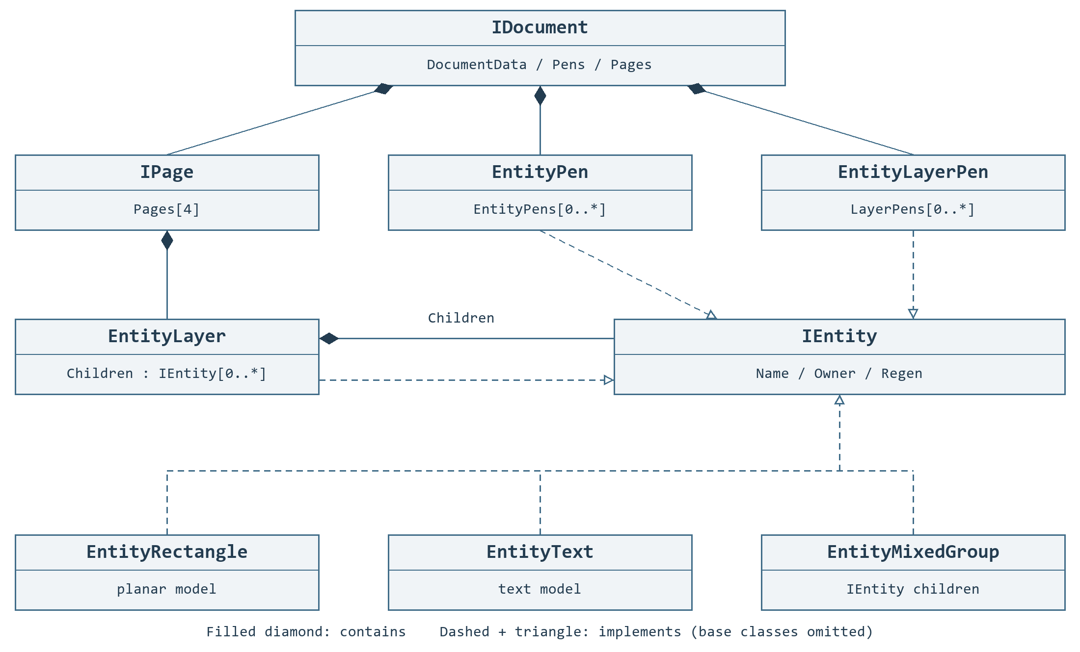
Figure 4.1 Document containment and process-pen references
Filled diamonds show containment. IDocument exposes pages and pen collections through its document data. Pages contain layers; layers contain entities or groups. EntityPen and EntityLayerPen are stored in separate collections and selected by PenColor. Geometry does not contain its pen. EntityLayer and both pen implementations also implement IEntity.
Level | Purpose and editing rule
IDocument | Use ActAdd, ActRemove, ActPropertyChanged and other Act methods for document edits and history.​
IPage | Four predefined pages; select the active page and its ActiveLayer before adding geometry.​
EntityLayer | Groups a processing stage; its PenColor selects an EntityLayerPen.​
EntityPen | An entity’s pen color selects laser output, speed, pulse and list settings.​
EntityLayerPen | A layer’s pen color selects control-state preparation such as ALC and Sky Writing.​
Group /​ BlockInsert | Groups own children; block instances reference a reusable block and add placement.​

4.1 Organize work across four pages
1. IPage is a workspace containing layers. A default document has Page1–Page4; each can hold different geometry.
2. Choose P1–P4 in the editor. In code, Document.Page is the page category and Document.ActivePage is the page object. Setting either to a page in Page1–Page4 keeps the other in sync.
3. Check the selected page's ActiveLayer before creating or importing entities. ActAdd adds its results to this active layer.
SpiralLab.Sirius3.UI.Config.MaxPages is a read-only property that returns 4. It is not a setting for changing the page count. The standard editor also provides four page trees. Pages uses indexes 0–3 in code.
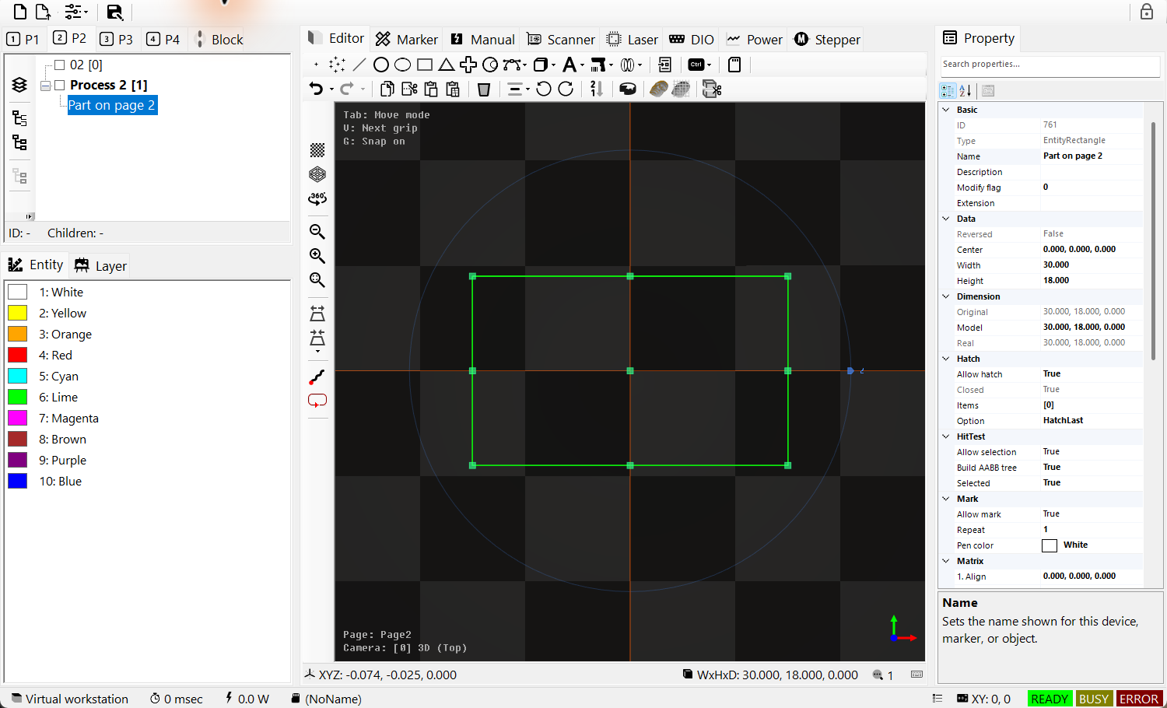
Figure 4.2 Activate P2 and inspect its layer and selected entity
Listing 4.1 Add a layer and rectangle on Page2
public static bool AddRectangleOnPage2(IDocument document)
{
if (document == null || document.DocumentData == null ||
document.DocumentData.Pages.Count < 2) return false;

document.Page = DocumentPages.Page2;
if (!document.ActAddLayer(DocumentPages.Page2, "Page2Layer"))
return false;

var rectangle = EntityFactory.CreateRectangle(DVec3.Zero, 30, 18);
if (!document.ActAdd(rectangle))
{
if (rectangle.Owner == null) rectangle.Dispose();
return false;
}
document.ActSelect(rectangle);
return document.ActRegen();
}
Use an existing document. Layer and rectangle additions create separate history entries. After an add failure, check whether the object belongs to the document and dispose only an unattached object. A final regeneration failure does not undo earlier successful additions.

4.2 Read the page and block trees
1. TreeViewPageControl shows the layers and entities of its assigned page. The P1–P4 tabs choose which page to edit.
2. Select a layer to make it that page’s ActiveLayer. New entities go into this layer. Select an entity to inspect it in the viewport and PropertyGrid.
3. TreeViewBlockControl shows the shared masters in DocumentData.Blocks. Continue to 6.6 TreeView selection order and block reuse for page-tree tools and ordering, and 6.6.1 Create a master and place it for creating a master and placing its instances.
Use 4.1 Organize work across four pages to select a page in code. Property assignment keeps the existing selection, whereas switching the editor’s P1–P4 tabs clears it. Call ActSelectClear when the application needs to clear selection. Block, Wafer and Substrate views keep the last active ordinary page. Pass the target DocumentPages explicitly to ActAddLayer.

4.3 Create select then edit
Listing 4.2 Add a rectangle to the active layer and select it
public static EntityRectangle Rectangle(IDocument document)
{
var rectangle = new EntityRectangle(DVec3.Zero, 30, 18);
rectangle.Name = "Plate outline";
rectangle.PenColor = SpiralLab.Sirius3.UI.Config.EntityPenColors[0];
if (!document.ActAdd(rectangle))
{
if (rectangle.Owner == null) rectangle.Dispose();
throw new InvalidOperationException("Cannot add rectangle.");
}
document.ActSelect(rectangle);
return rectangle;
}
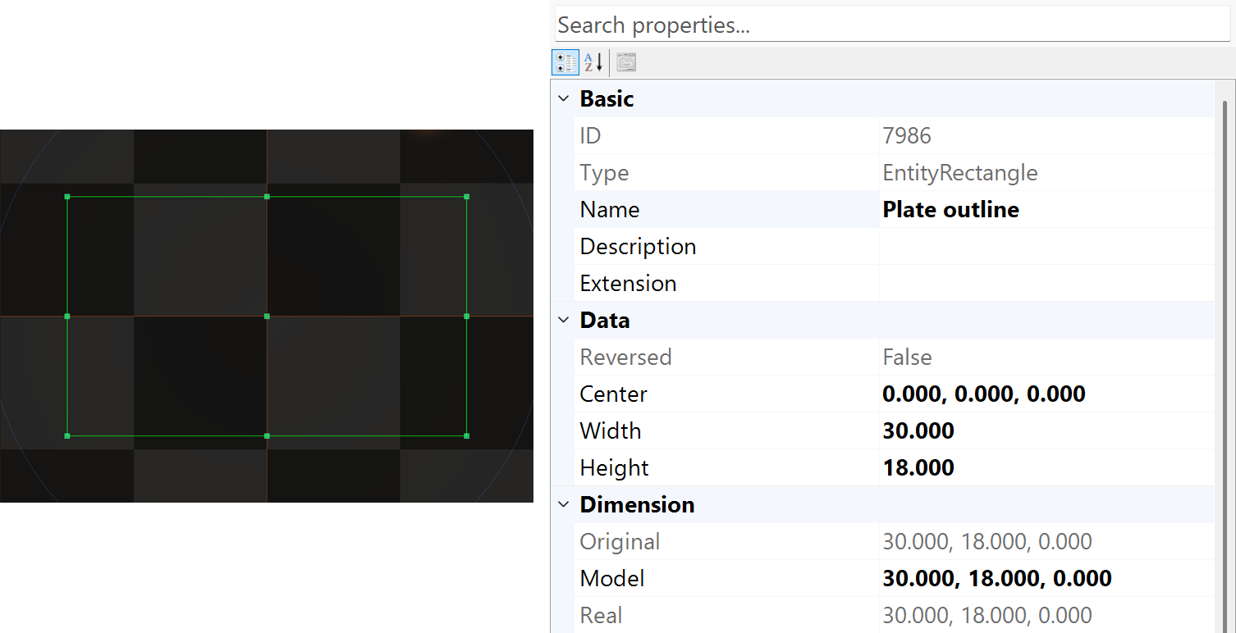
Figure 4.3 Selected 30 mm by 18 mm rectangle with its native dimensions
The example adds, selects and then edits an object. ActSelect makes the viewport and PropertyGrid follow it; confirm Name before using ActPropertyChanged. Do not change Children or Owner directly on live objects. See 05 Document actions and WinForms commands for the difference between history-aware edits and direct assignments.
Listing 4.3 Change a geometry property through document history
public static void Resize(IDocument document, EntityRectangle rectangle)
{
document.ActPropertyChanged(rectangle,
nameof(EntityRectangle.Width), 40.0);
}
Listing 4.4 Move and rotate through Undo and Redo
public static void MoveAndUndo(IDocument document, IEntity entity)
{
document.ActTranslate(new[] { entity }, new DVec3(10, 5, 0));
document.ActRotate(new[] { entity }, new DVec3(0, 0, 15));
document.ActUnDo();
document.ActReDo();
}
1. Create the model with a constructor or EntityFactory, then add it to the document with ActAdd.
2. Set the object's PenColor, then use the Entity pen tab to edit that color's EntityPen (power and speed). Use the layer's PenColor to choose its EntityLayerPen in the Layer pen tab. These pens are shared: editing one affects other objects or layers using the same color in that palette. RegisterDevices/Ready connects the document and devices.
3. Inspect the selected paths in screen simulation. Actual processing starts through the explicit marker Start workflow after the host is ready.

05 Document actions and WinForms commands
1. Use the document-changing IDocument.Act* methods for Undo/Redo in an external application. ActAdd, ActTranslate and ActPropertyChanged record accepted edits and update the editor.
2. Configure new objects directly before adding them. Use the appropriate Act method for later property or child-collection edits; direct changes do not automatically create history.
3. The Act prefix does not make every operation undoable. Selection, file lifetime, regeneration, simulation and point-cloud extraction serve different purposes.
For a custom edit, implement IUnReDo and pass it to ActExecute. The following examples connect the editor command, its result and document history.

5.1 Files selection and history
WinForms entry | Act family | Result and rule
New Open Save toolbar | ActNew /​ ActOpen /​ ActSave | Create/​reset, load or save the recipe.​ ActNew/​Open include flags choose page/​pen/​block sections.​ These are document lifecycle operations.​
Editor Import File | ActImport | Append supported content to the active layer with history.​ Importing .​sirius3 appends page contents, not source layers; out entity may be null.​
Viewport TreeView pen list | ActSelect /​ ActSelectClear | Synchronize selection; propertyName can focus a property.​ Selection is not a geometry edit.​
Mouse pick and area selection | ActHitTest | Use the matching view, page, modifiers and ray/​rectangle/​3D-range overload.​ For a known target, ActSelect is simpler.​
Undo Redo and history UI | ActUnDo /​ ActReDo /​ ActUnReDoClear | Traverse or clear stored edit history.​ Clearing history is not undoing its effects.​
Rebuild after mutation | ActRegen | Rebuild derived results.​ Check false; within a batch, true can mean queued work.​

Figure 5.1 ActAdd and ActSelect produce the same selected object inspected in PropertyGrid

5.2 Hierarchy clipboard and processing order
UI operation | Act family | Behavior and ownership
Create geometry or layer | ActAdd /​ ActAddLayer /​ ActInsert | Adopt detached entities into the active layer or an explicit owner.​ Insert uses a child index.​ Accepted additions belong to document/​history.​
Delete and collection edits | ActRemove /​ ActClearChildren /​ ActReplaceChildren | Use history-aware removal/​replacement.​ An out removed entity can still be retained by history; do not dispose it independently.​
Tree ordering controls | ActMove /​ ActMoveUp /​ ActMoveDown /​ ActMoveFirst | Reorder children, not XY coordinates.​ Hierarchy order can affect marking order.​ ActMove needs owner, range and destination.​
Mixed or uniform Group | ActMixedGroup /​ ActUniformGroup /​ ActUngroup | Group selected compatible children or restore their members.​ Keep resulting parent transforms and pen policy in view.​
Block toolbar | ActBlock | Create reusable block geometry from selected content; give the block a deliberate name.​
Copy Cut Paste and array paste | ActCopy /​ ActCut /​ ActPaste | Copy/​cut uses current selection.​ Paste can take one location or a locations array and returns the created entities.​

Listing 5.1 Group selected objects and move UI focus to the group
public static EntityMixedGroup GroupSelection(IDocument document)
{
if (!document.ActMixedGroup(document.Selected, out var group,
"Part group"))
throw new InvalidOperationException("Grouping failed.");
document.ActSelect(group);
return group;
}

5.3 PropertyGrid geometry and hatch edits
UI operation | Act family | How to apply it
Commit a property value | ActPropertyChanged | Use a property name and new value.​ The old/​new overload suits a UI editor that already assigned the value; pass the actual captured old value.​
Move Rotate Scale | ActTranslate /​ ActRotate /​ ActScale | Use mm, degree deltas and positive scale factors respectively.​ These edits participate in Undo/​Redo.​
Alignment toolbar | ActAlignTo | Choose a target point or AlignAnchors.​ An alignment command differs from the entity’s persistent AlignmentXY setting.​
Hatch collection editor | ActAddHatch /​ ActAddHatches /​ ActInsertHatch | Add hatch definitions to an IHatchable document object.​ Use direct AddHatch only while constructing detached geometry.​
Hatch Remove Move Apply | ActRemoveHatch /​ ActRemoveHatches /​ ActMoveHatches /​ ActReplaceHatches /​ ActHatchClear | Edit definition order or content through one document path.​ Do not dispose a hatch retained by history.​
Reverse path command | ActReverse | Requires IReversable.​ Reverses source direction; it does not repair invalid contours.​

Listing 5.2 Add a hatch to an object already owned by a document
public static bool AddLiveHatch(IDocument document, IEntity entity)
{
var hatch = HatchFactory.CreateLine(45, 0.25);
return document.ActAddHatch(entity, hatch);
}
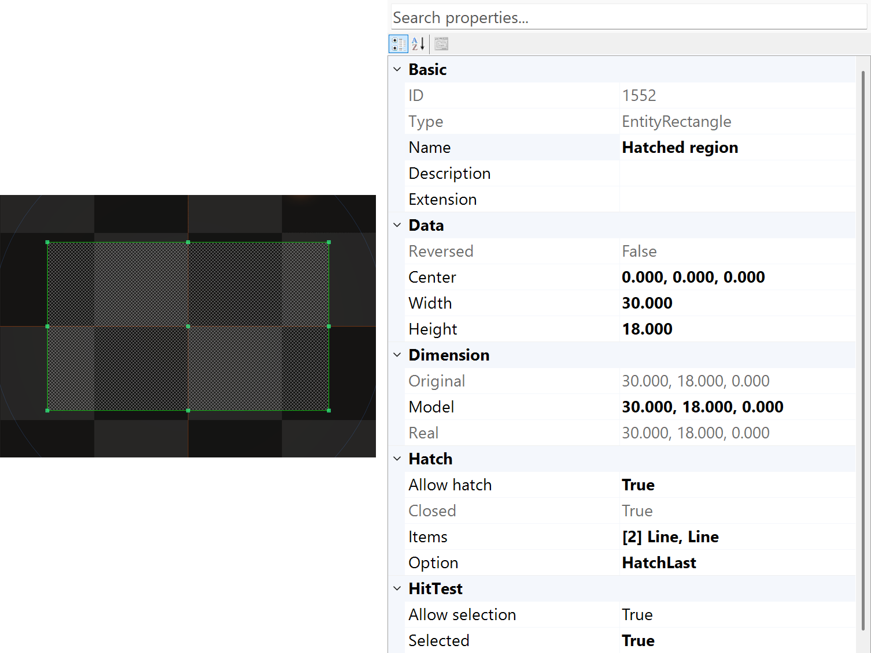
Figure 5.2 The Hatches collection is the UI counterpart of the hatch action family

5.4 Geometry preparation and simulation
1. ActPointCloud extracts surface vertices for the specified direction. ActGridCloud samples surface intersections on an XY grid at an interval in mm and returns normals too.
2. Choose coordinates and spacing for the calibration workflow. These methods return data; they do not insert document objects or apply correction files. Use ActAdd to add an object made from the result.
3. Use a regenerated triangle model and a current OpenGL 4.3 or newer context on the calling thread. The ordinary OpenGL 3.3 display requirement is insufficient for point-cloud extraction.
Call through the owning editor/render-context path. Task.Run does not create the required context. Check the bool result before using the returned points. See 24.9 Focus on a free-form surface from a point cloud for the illustrated flow from extraction to correction-file generation.
UI entry | Act family | Result and caution
Clipping | ActClip | Clip selected sources by world-space regions.​ isRemove removes sources that produce results.​ Choose Paths or ClosedRegions explicitly.​
Expand dialog | ActExpand | IHatchable offset distance is mm; positive expands, negative shrinks.​ The result is a mixed group.​
Mesh Slice command | ActSlice | Creates a cross-section at height z in mm. Collecting its contours into closed loops makes interior filling with hatching possible.
Point and grid cloud tools | ActPointCloud /​ ActGridCloud | Extracts surface vertices to form a point cloud that can be used for 3D scanner calibration.
Simulation control | ActSimulateStart /​ ActSimulateStop | Await display-only simulation for the selected scope and view.​ It is separate from Marker.​Start and physical output.​
Custom application command | ActExecute(IUnReDo) | Submit a custom history action.​ Define execute/​undo/​redo and resource retention together.​

Listing 5.3 Create and select a mesh section as a document action
public static EntityMixedGroup SliceMesh(IDocument document,
EntityMesh mesh, double z)
{
if (!document.ActSlice(mesh, z, out var section))
throw new InvalidOperationException("Slicing failed.");
document.ActSelect(section);
return section;
}
Invoke live-document actions on the owning editor/UI path. Do not wrap a live document mutation in Task.Run merely to hide a long operation. Prepare expensive source parsing separately, then apply the result through the owner. A false result can mean invalid state, unsupported input, failure or no change; inspect context and logs instead of assuming every false is a crash.

06 PropertyGrid as a working tool
Select the intended object in the viewport, TreeView or pen list, then confirm its Name and Type. PropertyGrid is a view of that object’s supported editable state. Multi-selection exposes common properties. A missing row may be filtered out, read-only or unsupported by the registered devices; it does not necessarily mean the underlying feature was removed.

6.1 Find commit and inspect
• Search by property name, category or description. Clear the search to restore the full list.
• Enter the value in the displayed unit, commit it and check the resulting value after clamping or time-base conversion.
• Use collection editors for vertices and hatches. Apply previews the pending change; acceptance commits it and cancellation restores it.
• Return focus to the viewport before using drawing shortcuts. Text boxes retain their text-editing keys.
Group | Principal members | Use and caution
Basic | Name, Description, ExtensionData | Name aids selection and conversion lookup.​ Keep external recipe identifiers explicit.​
Data | Center, Width, Height, Font, CapHeight | Native parameters define the object before transforms.​ Dimensions are mm, not screen pixels.​
Dimension and Matrix | OriginalDimension, ModelDimension, RealDimension | Distinguish source size, local scaled size and the result through all owners.​
Hatch | IsAllowHatch, Hatches, HatchMarkOption | A closed valid contour is required for filled regions.​ Small pitch increases processing length.​
Mark | IsAllowMark, Repeats, PenColor | These values affect machining.​ Display color or opacity is a separate concern.​
Render and HitTest | IsAllowRender, IsAllowHitTest, Alpha | Use separately to hide an object or make it non-selectable.​ Neither replaces mark permission.​
Device state | Ready, Busy, Error and supported properties | Read status before changing device settings.​ Busy-state edits are restricted.​

6.2 Keyboard focus changes the meaning
Keys are handled by the area that has focus. For example, Ctrl+F fits the viewport but opens property search in PropertyGrid. Click the intended area first and use the single shortcut reference in 6.5 Editor and TreeView shortcut reference.

UI.Config.KeyboardTransitXYCtrl, KeyboardTransitXYCtrlAlt and KeyboardTransitXYCtrlAltShift default to 1, 0.1 and 0.01 mm. The corresponding rotation steps default to 90, 10 and 1 degree. These are configurable settings, not permanent keyboard guarantees. The configured Marker Start shortcut can run physical equipment; it is distinct from display-only simulation.

6.3 Read the complete SiriusEditorControl layout
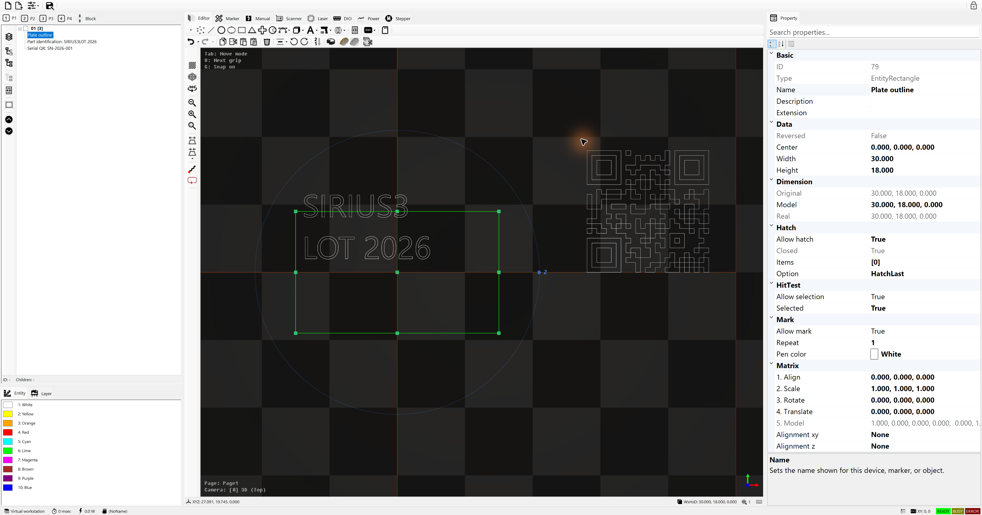
Figure 6.1 Complete WinForms SiriusEditorControl: file tools, hierarchy, pens, editor, device panels, properties and status
Position | Control and purpose
Top | New/​Open/​options/​Save manage the recipe.​ Lock changes edit availability.​ Open/​New options select the included pages, pens and blocks.​
Upper left | P1–P4 select the page.​ The tree shows layers, groups and child order; the Block tab manages reusable blocks.​
Lower left | Entity and Layer pen lists select process conditions by color.​ Selecting a pen populates PropertyGrid.​
Center | Editor contains creation/​edit toolbars and the GL viewport.​ Marker, Manual, Scanner, Laser, DIO, Power and Stepper tabs expose registered device functions.​
Right | PropertyGrid edits the selected entity, pen or device.​ Search filters rows; categorized/​alphabetical buttons change grouping; the lower area explains the selected row.​
Bottom | The viewport reports coordinates, dimensions and selection count.​ The outer status bar reports workstation, elapsed time, power, file and Ready/​Busy/​Error.​ These indicators do not replace machine interlocks.​

6.4 Toolbar icons and their commands
The tables show the actual icons in the control. A small triangle opens the related menu. Creation buttons start the supported interactive creation flow or insert an initial object; finish the gesture, select the result and edit its PropertyGrid. Disabled commands require a compatible selection, an editable document or an idle registered device. Device Preview can move the scanner and enable a guide beam; Simulation only draws the computed path.

Document tools
Icon | Command | API /​ scope
 | New document | ActNew
 | Open document | ActOpen
 | Choose pages, pens and blocks included by Open/​New | Document include flags
 | Save document | ActSave
 | Lock/​unlock editing | IsAllowEdit

Create objects
Icon | Command | API /​ scope
 | Create one point | EntityPoint
 | Create a point collection | EntityPoints
 | Create a straight line | EntityLine
 | Create circle/​arc geometry | EntityArc
 | Create an ellipse | EntityEllipse
 | Create a rectangle | EntityRectangle
 | Create a triangle | EntityTriangle
 | Create a cross | EntityCross
 | Create a trepan path | EntityTrepan
 | Open polyline, Bézier, Catmull-Rom, Hermite, B-spline and NURBS choices | IGrippable /​ curves
 | Open plane, cube, cylinder, cone, sphere, pyramid, torus, NURBS and grid-cloud choices | EntityMesh /​ ISliceable
 | Open vector, Sirius, image, circular text and ZPL choices | ITextConvertible
 | Open DataMatrix, QR, PDF417, Aztec and 1D code choices | Barcode entities
 | Open spiral, classic spiral and Lissajous choices | Parametric curves
 | Insert a reusable block instance | EntityBlockInsert
 | Open delay, jump, measurement, MoF, ramp, correction, I/​O and stepper job objects | Control entities /​ Marker
 | Import supported files, including PDF | ActImport

Edit selected objects
Icon | Command | API /​ scope
 | Undo; open edit history | ActUnDo
 | Redo; open redo history | ActReDo
 | Copy selection | ActCopy
 | Cut selection | ActCut
 | Paste at a location | ActPaste
 | Paste at an array of locations | ActPaste
 | Delete selection through history | ActRemove
 | Open left/​right/​top/​bottom/​center alignment choices | ActAlignTo
 | Rotate selection counterclockwise by 90° | ActRotate
 | Rotate selection clockwise by 90° | ActRotate
 | Reverse supported source paths | ActReverse /​ IReversable
 | Clip supported objects by regions | ActClip /​ IClippable
 | Extract sampled points from selection | ActPointCloud
 | Extract a grid cloud from selection | ActGridCloud
 | Create contours from a mesh section | ActSlice /​ ISliceable

View and preview tools
Icon | Command | API /​ scope
 | Change grid display mode | View grid
 | Change polygon rendering mode | Render mode
 | Toggle automatic camera rotation | View camera
 | Zoom out | ActiveCamera.​ZoomOut
 | Zoom in | ActiveCamera.​ZoomIn
 | Fit geometry in the viewport | ActiveCamera.​ZoomFit
 | Switch to orthographic 2D view | CameraOrtho
 | Choose a perspective 3D camera | CameraPerspective
 | Display the simulated path at normal speed | ActSimulateStart
 | Trace the selected entity bounds with the guide beam | Marker.​Preview /​ hardware

The eight buttons on the left of TreeViewPageControl are explained together in 6.6 TreeView selection order and block reuse, with their icons, APIs and selection conditions.

6.5 Editor and TreeView shortcut reference
Focus and keys | Result
Editor: Ctrl+A | Select the active layer.​
Editor /​ TreeView: Ctrl+C /​ X /​ V | Copy /​ cut /​ paste current selection.​
Editor /​ TreeView: Ctrl+Z /​ Y | Undo /​ redo accepted document edits.​
Editor: F /​ Ctrl+F | Fit the selection; with no selection, fit the active layer.​
PropertyGrid: Ctrl+F | Focus property search; text editing retains text shortcuts.​
Editor: Tab /​ Shift+Tab; V /​ Shift+V | Cycle available Move/​Vertex/​Size modes; cycle available grips.​
Editor: Insert /​ Delete | Add/​remove a vertex when the active grip supports topology editing; otherwise Delete can remove selected entities.​
Editor: G; Enter /​ Escape | Toggle grip snapping; accept /​ cancel an active interaction.​ Escape also stops simulation.​
Editor: arrows; Alt+arrows | Move the camera; turn the camera with Alt+Left/​Right.​
Editor: Ctrl+arrows /​ Ctrl+Alt+arrows /​ Ctrl+Alt+Shift+arrows | Translate selected geometry at the configured 1 /​ 0.​1 /​ 0.​01 mm step.​
Editor: Ctrl+] /​ [; add Alt; add Alt+Shift | Rotate counterclockwise /​ clockwise at the configured 90 /​ 10 /​ 1 degree step.​
Editor: Ctrl+H /​ Ctrl+Shift+H | Center selected geometry in XY /​ XYZ.​
Editor: R /​ Ctrl+R; M /​ Ctrl+M | Toggle rendering or marking for compatible selected entities.​ Both modified and unmodified forms toggle; they do not restore a fixed value.​
Editor: F1 /​ Ctrl+F1 /​ Ctrl+Alt+F1 | Fast /​ normal /​ slow display simulation.​
Editor: F2; F4 /​ F5 /​ F6 /​ F8 | Select script; device Preview /​ Start /​ Stop /​ Reset.​ These are configurable and may operate physical equipment.​
TreeView: arrows /​ Tab | Navigate and expand/​collapse nodes; move keyboard focus.​ These keys stay with the tree.​ Node-name editing retains text keys.​

6.6 TreeView selection order and block reuse
1. On P1–P4, select a layer in TreeViewPageControl as the insertion destination. Select an entity to inspect it in the viewport and PropertyGrid. For grouping, select objects at the same hierarchy depth.
2. The table lists the left-hand buttons from top to bottom. Grouping and ungrouping ask for confirmation; Block also asks for a name, and Expand opens settings.
3. Expand the resulting tree branch and check its children and order. Check the shape in the viewport and verify document changes with Undo/Redo.
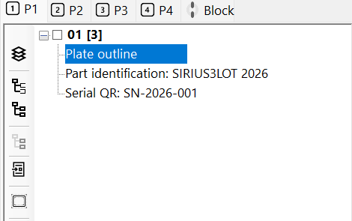
Figure 6.2 Page tree with the selected object
Table 6.1 Tree hierarchy tools
Icon | Button / tooltip / API | Action and conditions
 | Create Layer  ActAddLayer | Add a layer to the page displayed by this tree. No shape selection is required.
 | Convert as Mixed Group  ActMixedGroup | Group one or more allowed objects at the same depth. Different types and their individual text, hatch and pen settings can remain together.
 | Convert as Uniform Group  ActUniformGroup | For this button, select at least two objects at the same depth. EntityModelBase children need the same RenderMode; text, EntityControl and objects with hatches are excluded.
 | Un-Group  ActUngroup | Select one Mixed Group, Uniform Group or Gerber object. Release its children to the parent and apply the group transform to them. Unsupported transforms can fail.
 | Convert as Block  ActBlock | Select allowed geometry and enter a unique nonempty name. It becomes a reusable definition; no BlockInsert remains on the page. Use the following block-placement workflow.
 | Expand(or Shrink)  ActExpand | Select one closed IHatchable object. Set corner joint and distance (mm): positive expands, negative shrinks. A new Mixed Group is added; the source remains. This button offsets contours, not tree nodes.
 | Up  ActMoveUp | Move the selection one position earlier within each parent collection. Adjacent selected objects keep their order; objects already first do not move further.
 | Down  ActMoveDown | Move the selection one position later within each parent collection. Adjacent selected objects keep their order; objects already last do not move further.
Grouping may clear the selection; select the new group again to edit it. Up/Down changes stored order, not the parent or XY position.
Use the Entity and Layer pen tabs below the tree to edit the conditions in 15 EntityPen and per-entity conditions and 16 LayerPen and layer-wide control. Continue to 6.6.1 Create a master and place it to distinguish a shared master on the Block tab from its placements on P1–P4.
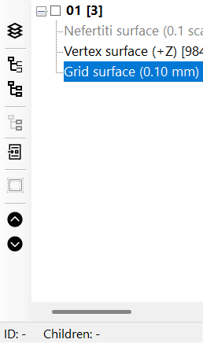
Figure 6.3 TreeView hierarchy toolbar, with its eight buttons in the table’s top-to-bottom order.

6.6.1 Create a master and place it
1. Select ordinary geometry on the working page. Use the page tree’s Block conversion button and enter a unique name. ActBlock moves the selected geometry into DocumentData.Blocks; it does not leave an insert on the page.
2. Inspect the master on the Block tab, return to P1–P4 and choose BlockInsert. Select the master and press OK to add an instance with its default transform. Select the new instance in the tree, then set its position with the Move grip or ModelTranslate (mm). OwnerBlockName refers to the shared master; each instance keeps its own translation, rotation and scale.
3. Place the master again and compare the instances. Instance grips change only that instance’s position, scale and Z rotation. Edit the master’s geometry on the Block tab and regenerate to update all its placements.
For code placement, call CreateBlockInsert(insertName, masterName, displacement), then ActAdd. Displacement is in mm and is added to the master coordinates. To edit source vertices, select the master geometry rather than an insertion.
ActBlock rejects duplicate or empty names, empty selections and unsupported layer, pen, Script, block/insert, wafer/substrate-family entities. Check its return value. Each Act* stage supports Undo/Redo; conversion and adding the placements below are separate history steps.
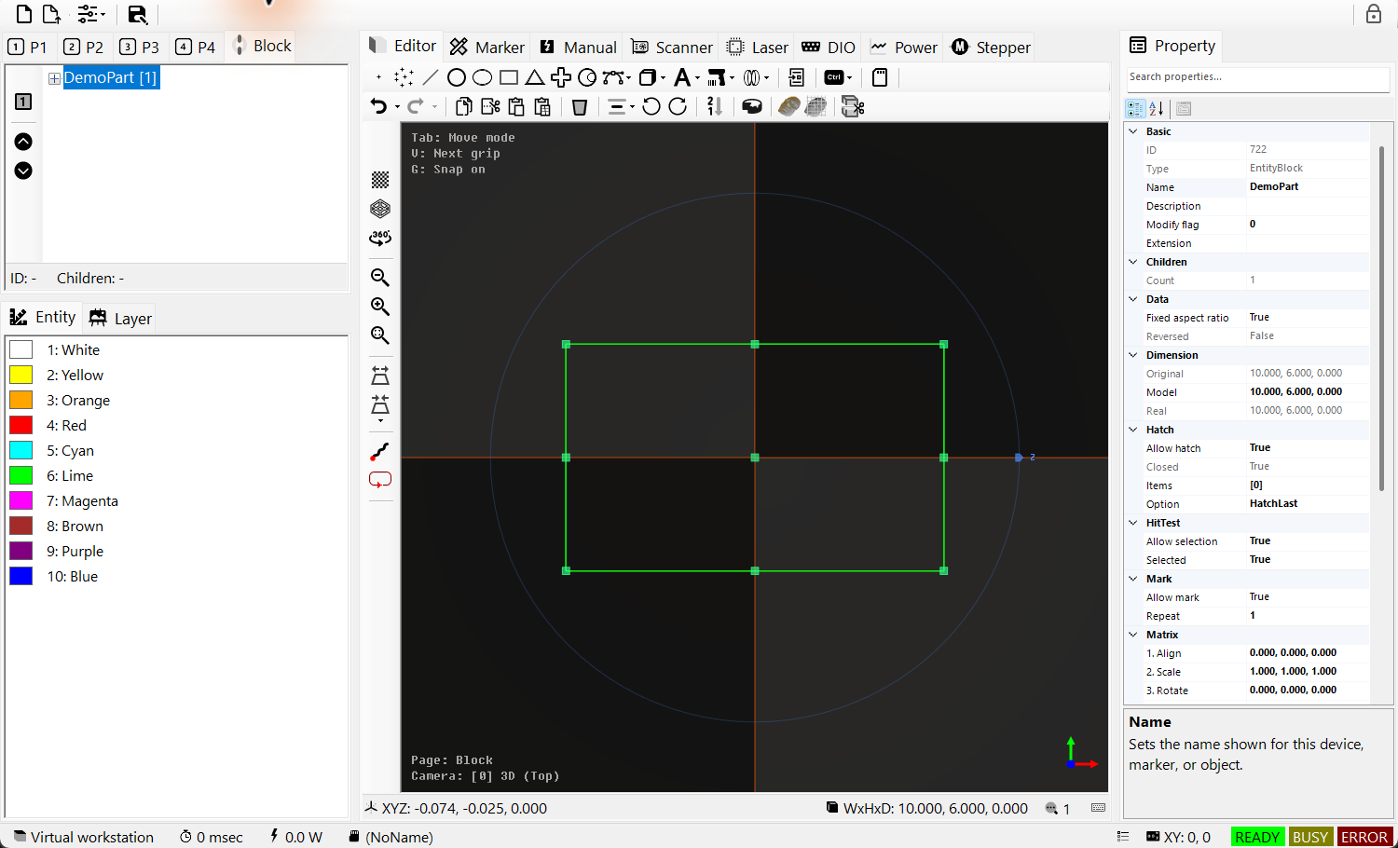
Figure 6.4 TreeViewBlockControl shows the DemoPart master. BlockInsert instances refer to this shared original.
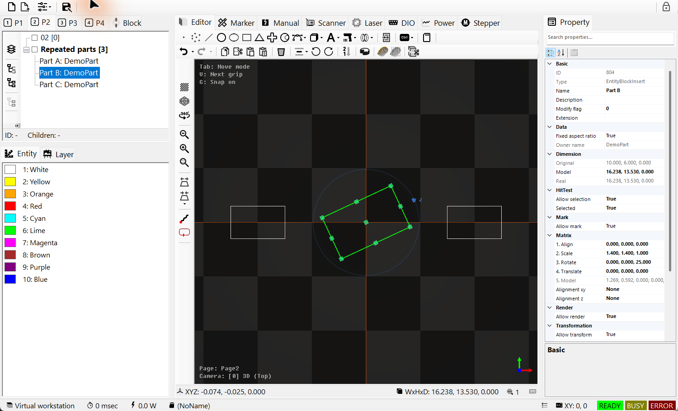
Figure 6.5 Three placements referencing one block master
Listing 6.1 Convert selected geometry and place three instances at 40 mm intervals
public static bool RepeatSelectedAsBlock(IDocument document)
{
if (document == null || document.ActivePage == null ||
document.ActivePage.ActiveLayer == null ||
document.Selected == null || document.Selected.Length == 0) return false;

if (!document.ActBlock(document.Selected, "RepeatedPart", out var master))
return false;

var instances = new IEntity[]
{
EntityFactory.CreateBlockInsert("PartA", master.Name, new DVec3(0, 0, 0)),
EntityFactory.CreateBlockInsert("PartB", master.Name, new DVec3(40, 0, 0)),
EntityFactory.CreateBlockInsert("PartC", master.Name, new DVec3(80, 0, 0))
};
if (!document.ActAdd(instances))
{
foreach (var instance in instances)
if (instance.Owner == null) instance.Dispose();
return false;
}
document.ActSelect(instances);
return document.ActRegen();
}
Call with ordinary geometry selected on the working page. An existing RepeatedPart name causes failure. After an add failure, check document membership and dispose only unattached new instances. The master remains in the document. Successful stages have separate Undo entries.

6.7 Property editors
Hatches on EntityRectangle, EntityText, EntityDataMatrix and EntityMixedGroup opens HatchEditor. Select Items in the Hatch category, then open the drop-down. Add a Line or Polygon pattern with +, select its row, and edit the lower PropertyGrid. Apply regenerates the preview; OK accepts the collection. Closing without acceptance restores the original collection. A pattern color selects its EntityPen, so verify its power and speed as well as the visible fill. Pattern angle, spacing and execution order are explained in 10.6 HatchLine properties and 10.7 HatchPolygon properties.
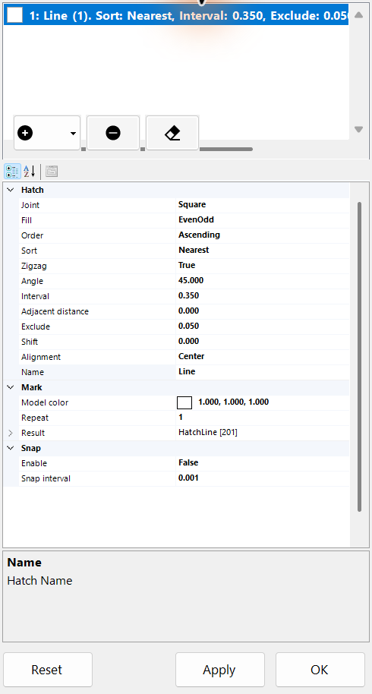
Figure 6.6 Hatches UITypeEditor with a line hatch

6.8 Alignment, Scale and Rotate editors
Select the object, then open AlignmentXY/AlignmentZ, ModelScale or ModelRotate in PropertyGrid. Use the value-cell arrow or F4. These editors are available on properties that declare the corresponding editor; IEntity alone does not provide them.
1. Choose the placement anchor first. MiddleCenter moves the centre of the original geometry to the local origin; Custom uses ModelAlign. This makes the point used for scaling and rotation easier to predict.
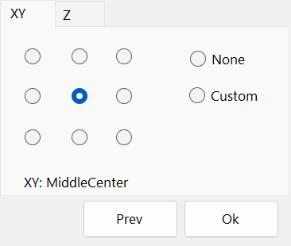
Figure 6.7 Alignment editor: choose the object's XY and Z anchors from its PropertyGrid.
2. Set size with Scale and angles with Rotate, then position with ModelTranslate. The model always applies Align → Scale → Z/Y/X rotation → Translate, regardless of the order in which you edit the properties. Parent transforms and marker offsets are applied afterward.
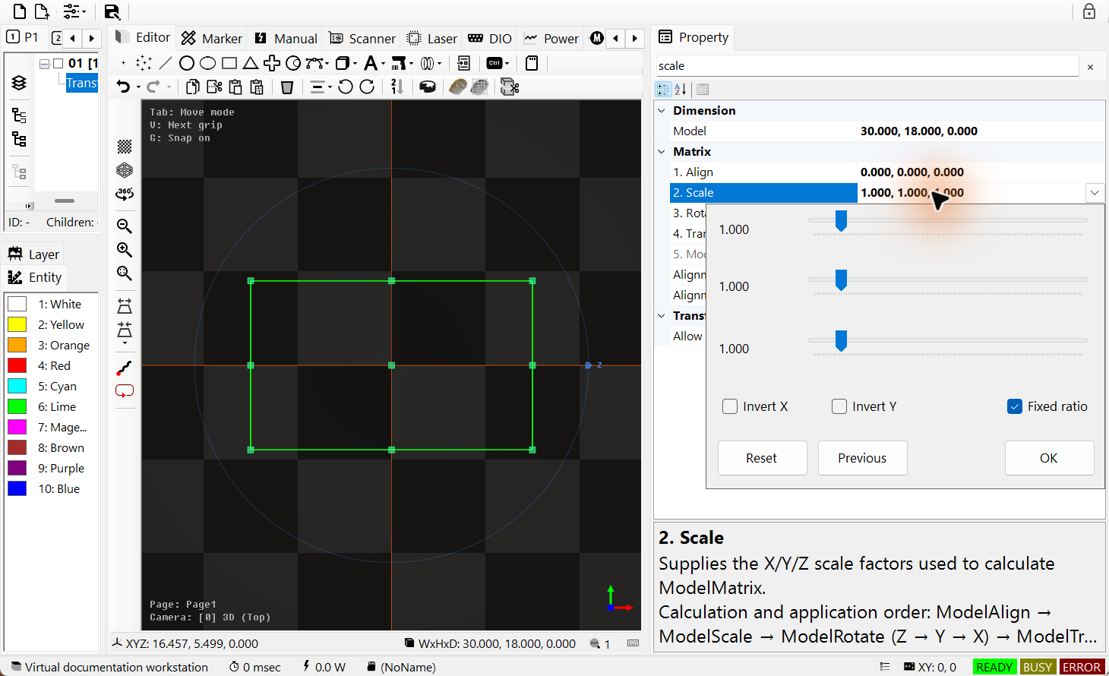
Figure 6.8 Scale editor with the rectangle selected
Scale changes the X/Y/Z size factors: 1 keeps the size, Fixed ratio links the axes, and Invert X/Y mirrors them. X and Y cannot be zero. Rotate sets X/Y/Z angles in degrees. Reset selects scale 1 or angle 0; Previous restores the opening values. OK accepts the preview as a document-history edit; closing without OK restores the original values.
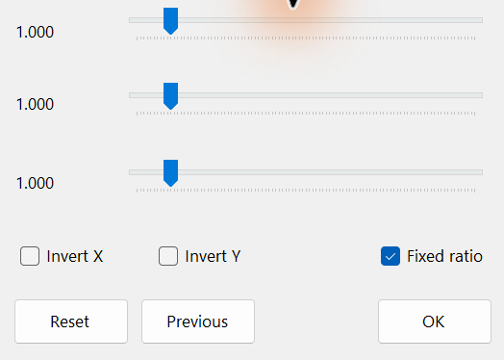
Figure 6.9 Scale editor with the rectangle selected
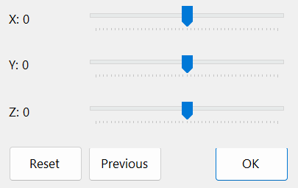
Figure 6.10 Rotate editor for X Y Z angles
3. Check the preview and accept with OK. In AlignmentForm, Prev restores both opening alignment values. Closing without OK cancels the preview; accepted edits support document Undo/Redo. A marker uses the resulting model transform when it generates the path, rather than replaying your editing clicks.
Listing 6.2 Set placement through document history
using SpiralLab.Sirius3.Document;
using SpiralLab.Sirius3.Entity;
using DVec3 = OpenTK.Vector3d;

public static bool SetPlacement(IDocument document, IEntity entity)
{
if (!(entity is ITransformable)) return false;
if (!document.ActPropertyChanged(entity,
nameof(ITransformable.AlignmentXY), AlignmentXYs.MiddleCenter))
return false;
if (!document.ActPropertyChanged(entity,
nameof(ITransformable.ModelScale), new DVec3(2, 2, 1)))
return false;
if (!document.ActPropertyChanged(entity,
nameof(ITransformable.ModelRotate), new DVec3(0, 0, 90)))
return false;
return document.ActPropertyChanged(entity,
nameof(ITransformable.ModelTranslate), new DVec3(10, 0, 0));
}
Use an existing document entity while the marker is idle. Each successful ActPropertyChanged creates a separate history entry; a later failure does not undo earlier changes.

6.9 FontName and the font preview list
1. Select a text object and open the SourceText editor in PropertyGrid.
2. Enter the original string. Ctrl+Enter inserts a line break. Configure the TextConverter that produces ConvertedText in 09 TextConverter and dynamic text.
3. Click OK to accept the text through document history. Closing without OK keeps the previous string. Then choose FontName from the preview list shown below.
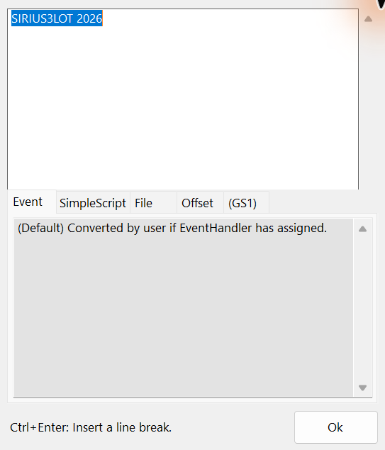
Figure 6.11 Multiline source text editor
EntityText.FontName uses FontNameEditor, a drop-down list of installed font families with sample glyphs. Select the text, search for font, open the Font value, and choose a family. FontStyle and FontCapitalHeight remain separate properties. The new family rebuilds the vector outlines, so recheck width, holes and hatching. This list is for installed TrueType/OpenType families; EntitySiriusText uses Sirius font files and the FontEditor workflow instead. See 8.2 Text layout and fonts to choose a text type and 11 FontEditor — edit Sirius font files to edit or convert Sirius font files.
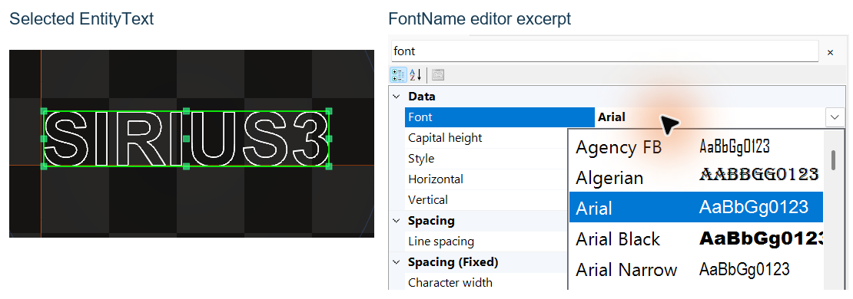
Figure 6.12 FontName list and selected vector text

6.10 Create geometry interactively
Select the active page/layer, then choose a creation icon in EditorControl. Click or drag in the canvas while reading its current step at the upper left. Only the completed result is added to the document; a preview is not yet an entity in the TreeView. Select the completed object to inspect its dimensions and other properties.
Tool | Input sequence | Completion / keys
Point / Points | Click / Drag | Point: one location. Points: successive locations; Enter finishes.
Line | Click / Drag | Start, then end; dragging from start to end also completes the line.
Rectangle / Ellipse / Triangle / Cross | Click / Drag | Center, then size. Shift constrains equal X/Y extent.
Arc / Circle | Click / Drag | Arc: center, start/radius, sweep. C switches arc/circle; Ctrl reverses the arc sweep.
Polyline2D / Polyline3D | Click / Drag | Click vertices; Enter finishes. Polyline2D: A switches line/arc; an arc segment also asks for bulge.
Splines | Click / Drag | Click control points, then Enter. The selected spline determines the required control-point count.
Trepan / Spiral / SpiralClassic / Lissajous | Click / Drag | Trepan: center, inner/outer radius. Spiral/Lissajous: center, diameter. SpiralClassic: center, start/end diameter.

Backspace returns to the preceding input step; Esc cancels the current creation. X/Y constrain supported input directions. An entity is inserted as one Undo action when creation finishes. A host OnCreateEntity handler that returns an entity replaces built-in creation for that command; return null to keep the built-in interaction.
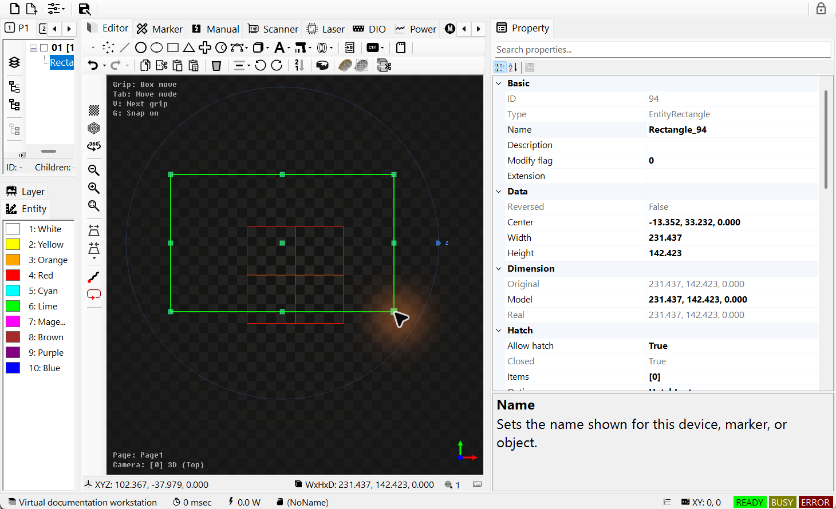
Figure 6.13 Rectangle created from center and size, with populated PropertyGrid
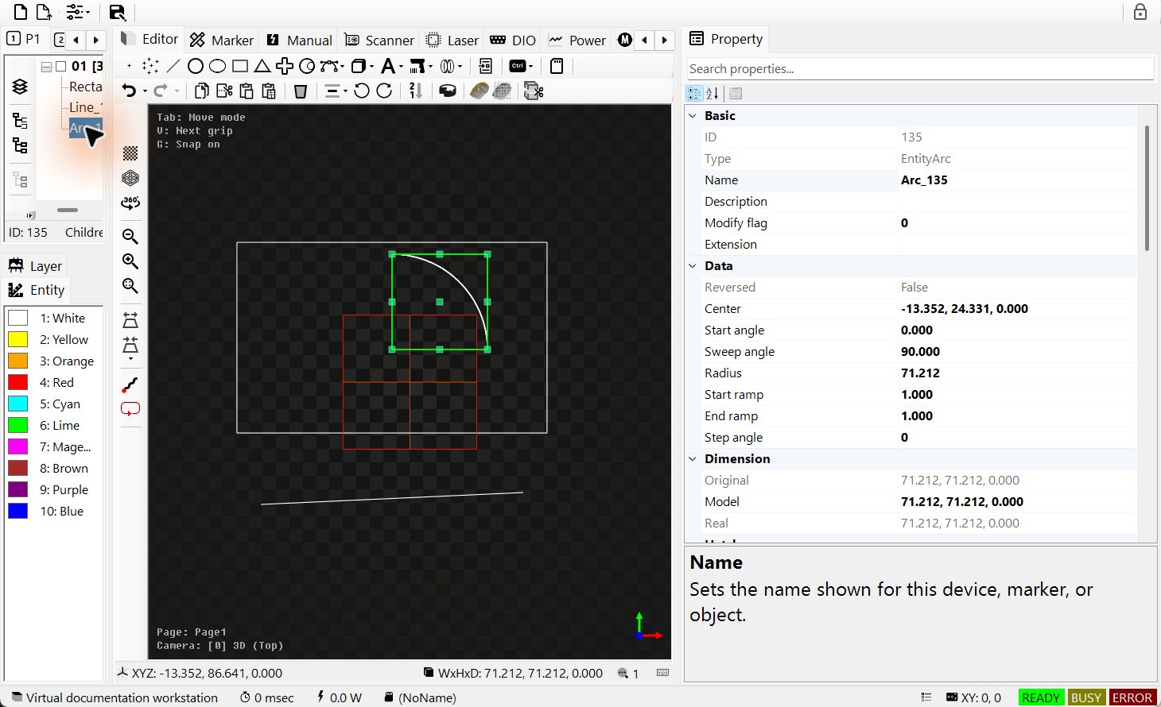
Figure 6.14 Arc created from center, radius and a 90° sweep
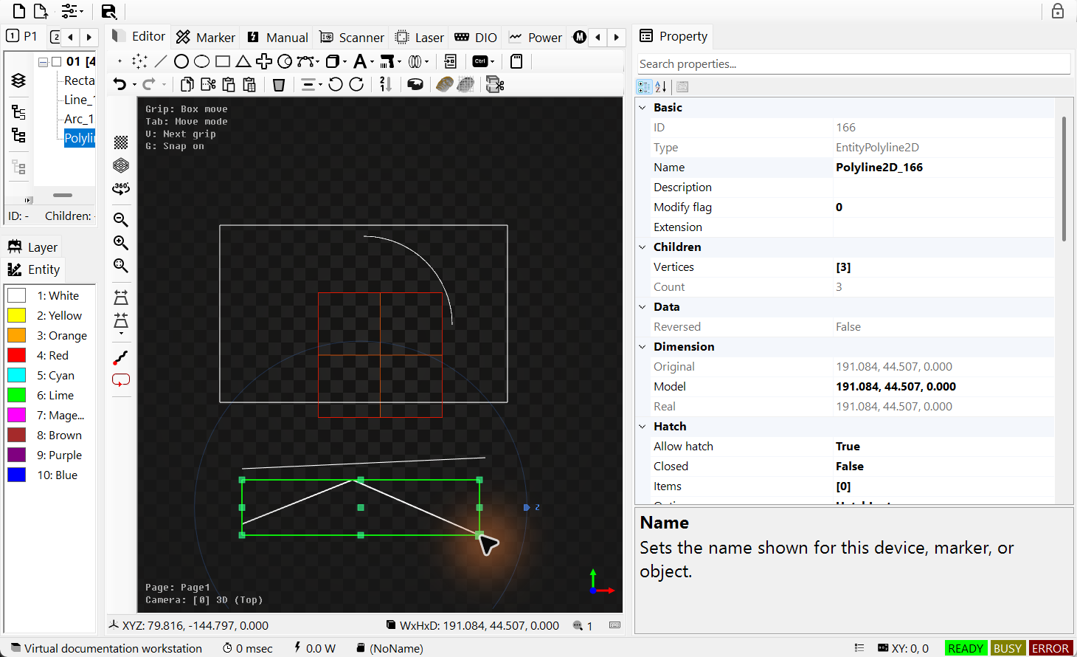
Figure 6.15 Three clicked vertices become one editable Polyline2D

6.11 Switch grip modes with Tab
Select one entity on the canvas, then choose the editing role from the three modes below. Check the current mode in the hint at the upper left.

6.11.1 The three grip roles selected with Tab
1. Move repositions the whole entity. Use its center/bounds position handles and supported rotation handles. A newly selected entity starts in this mode.
2. Vertex edits the shape itself. Depending on the entity, it shows line endpoints, curve controls, arc radius/start/sweep angles, or native rectangle width/height.
3. Size adjusts the overall size with bounds handles. Supported entities change native dimensions; other entities change ModelScale. A scale-reset handle appears when the model scale is not one.
The public enum member for Size remains GripEditMode.Scale for compatibility. Distinguish native dimension edits from model scaling in PropertyGrid. Entities supporting IsFixedAspectRatio follow that ratio setting.
For example, ordinary lines/arcs skip Size when they have no applicable size handles; meshes and BlockInsert offer no source Vertex editing. A BlockInsert instance exposes position, scale and Z rotation.

6.11.2 Check selection and focus before grip editing
1. Select one editable IGrippable entity and focus the canvas. Tab cycles Move→Vertex→Size; Shift+Tab reverses the order. Modes with no applicable handles are skipped.
2. Check the mode hint at the upper left, then drag a handle. V selects the next grip in the current mode; Shift+V selects the previous one. With multiple entities selected, first explicitly choose one source to edit.
3. Committing a drag that changed the entity creates one Undo/Redo entry. Esc or a mode change cancels an unfinished edit without history. Selecting a different entity returns to Move.
In TreeView, PropertyGrid and text input, Tab retains normal focus navigation. During creation it does not switch grip modes; use Enter to complete multi-point creation. Tab does not change grid spacing.
Editing, regenerating or applying Undo/Redo to the same entity preserves the current mode. Change the camera view to expose occluded non-rotation mesh grips before selecting them.
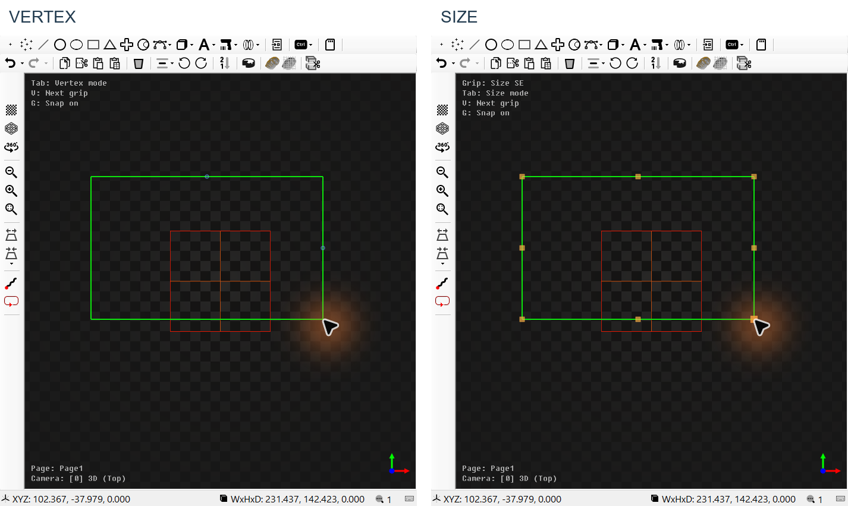
Figure 6.16 Vertex and Size modes for the same rectangle

6.12 Simulate the selected paths with F1
Select the geometry to inspect, then focus the EditorControl canvas and press F1. The default shortcuts are F1 = Fast, Ctrl+F1 = Normal and Ctrl+Alt+F1 = Slow. Selection is required: an empty selection does not automatically simulate the whole page. While simulation is active, the same shortcuts change its speed.
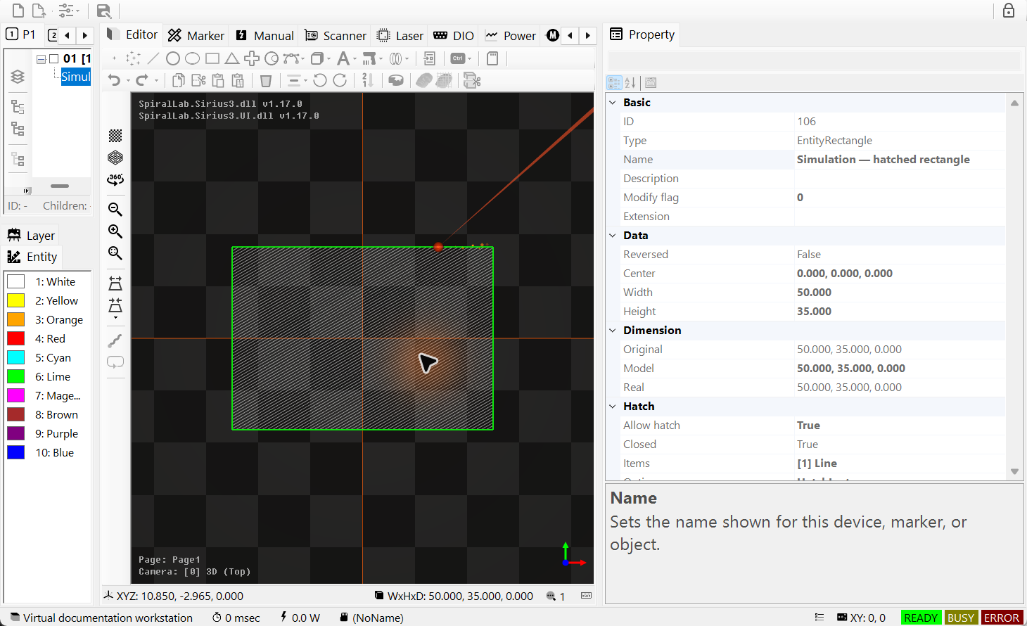
Figure 6.17 Ctrl+Alt+F1 simulates the selected hatched rectangle at slow speed
The animated marker follows generated mark/jump paths so you can inspect contour and hatch order. Press Esc in the canvas, or click the Simulation toolbar button again, to stop. The key can be customized through SpiralLab.Sirius3.UI.Config.KeyboardSimulationStart. This preview uses internal virtual devices; it does not measure actual laser output, hardware timing or production cycle time. Chapter 17 shows the equivalent ActSimulateStart/ActSimulateStop code.

07 Entity interfaces and their UI
Entity interfaces describe what an object can do. For example, an object that can be displayed does not necessarily support laser processing. Start with IEntity identity and lifetime, then check display, selection, transformation and marking capabilities individually. See 4.3 Create select then edit for document editing and 05 Document actions and WinForms commands for recording its history.
Contract | UI connection | Typical implementation
IEntity /​ IEntityCloneable<T> | Tree name, Basic properties, duplicate/​paste | EntityRectangle /​ EntityText
IRenderable /​ IRenderData | Viewport, render permission and display modes | EntityModelBase /​ EntityMesh
IHitTestable | Mouse pick and rectangle selection | EntityRectangle /​ EntityMesh
ITransformable | Matrix and Dimension groups, move/​rotate/​scale tools | EntityModelBase
IMarkerable | Mark permission, Repeats and PenColor | EntityRectangle /​ EntityPen
IHasChildren<T> | Layers, groups and block hierarchy in TreeView | EntityLayer /​ EntityMixedGroup
IHatchable /​ IReversable | Hatch editor and path-direction commands | EntityRectangle /​ EntityPolyline2D
IClippable /​ ISliceable | Clipping command and mesh slicing workflow | EntityRectangle /​ EntityMesh
ITextConvertible | Source text, converter and per-offset data | EntityText /​ EntityQRCode
IGrippable /​ IEntityGripEdit /​ IFixedAspectRatio | Move/​Vertex/​Size handles, preview, accept/​cancel | EntityModelBase and supported shapes

7.1 IEntity and typed cloning
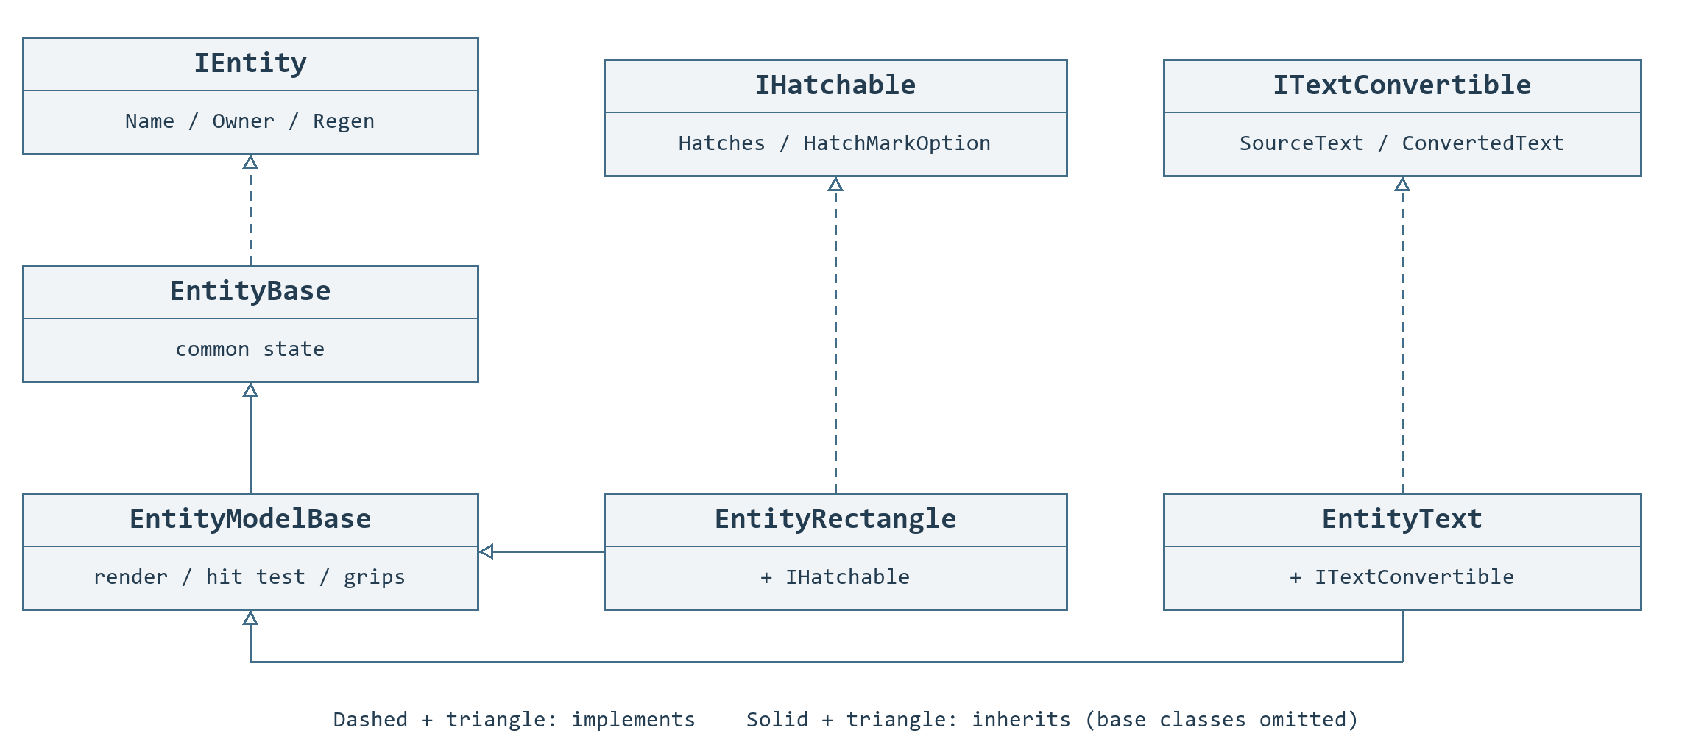
Figure 7.1 Entity contracts and model examples
EntityBase implements IEntity. EntityModelBase adds rendering, picking, grips and slicing through its base chain; EntityRectangle adds IHatchable and EntityText adds ITextConvertible. The diagram shows representative types, not every intermediate class or interface.
IEntity provides Id, Name, Description, IsSelected, Owner, ExtensionData, Tag, ModifyFlag and Regen. Owner identifies the parent; Node connects a TreeView item to the UI. Node is not a model identifier. Select through ActSelect so the document also updates its selection state. Setting IsSelected alone is insufficient. ExtensionData stores application text; Tag stores application state that is not saved.
IEntityCloneable<T>.CloneEntity returns a detached copy of type T with a new runtime identity. The older Clone method returns object. Regenerate the copy before reading generated geometry. Add it with ActAdd, or dispose it if adding fails. One instance must not belong to two owners.

7.2 IRenderable IRenderData and IHitTestable
IRenderable uses IsAllowRender and Render(view, camera, light) to control viewport drawing. View identifies the current or last drawing target; it does not identify an owning editor. IRenderData provides Vertices, Colors, Normals, Textures and Indices. Rebuild a custom entity’s generated data during regeneration, rather than rebuilding geometry on every Render call.
IHitTestable controls picking separately from drawing. IsAllowHitTest enables picking, and BoundBox gives its spatial bounds. HitTest takes RayInfo for a point pick or Frustum for an area selection. RayHitInfo returns the entity, position, distance and related index; FrustumHitInfo contains area-hit points. A visible entity can remain unselectable. Hiding its display does not disable laser marking.
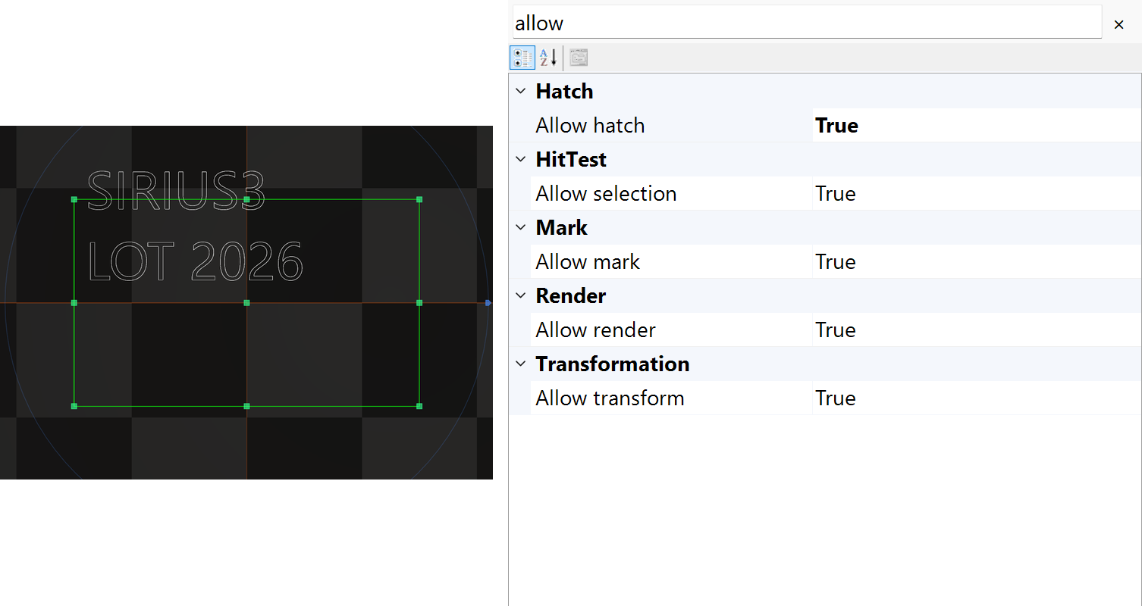
Figure 7.2 Independent render selection and marking permissions in PropertyGrid

7.3 ITransformable and coordinate spaces
ModelAlign selects the local reference, ModelScale changes size, ModelRotate turns the shape, and ModelTranslate positions it. Original means before these changes, Model means after the local transform, and Real includes parent transforms. Setting ModelDimension recalculates ModelScale for the requested size.
Setting | Unit or role | Use and caution
Center /​ Width /​ Height | Native geometry in mm | Edit the shape itself.​ It differs from model scaling.​
ModelScale | Per-axis factor | Negative values reflect geometry; zero collapses an axis.​
ModelRotate | Degrees about X/​Y/​Z | Check the local pivot and parent transforms.​
ModelTranslate | Local placement in mm | Do not repeat the same placement in marker Offsets.​
AlignmentXY /​ AlignmentZ | Original-bounds reference | Regeneration recalculates ModelAlign unless Custom retains manual values.​
RealDimension /​ RealMin /​ RealMax | Derived world result | Use to inspect placement, not as independent source geometry.​

$$p_{model} = p_{original} M$$
$$M = A S R_{z} R_{y} R_{x} T$$
$$p_{world} = p_{model} M_{parent} M_{grandparent} …$$
The formula uses row vectors, so matrices act from left to right. A is the alignment shift, S the scale, Rz/Ry/Rx the rotations, and T the position shift. Parent matrices follow. ModelRotate uses degrees; matrix creation converts them to radians.
For example, start at (1,0,0) with no alignment shift. Scale by (2,1,1), rotate Z by 90°, and translate by (10,0,0): the result is (10,2,0). Changing the order generally changes the result. Scale and rotation act about the local origin established by alignment. See 6.8 Alignment, Scale and Rotate editors to set the reference, scale and angles in the UI, and 17.2 LayerFirst and OffsetFirst for the subsequent repeated-placement transform.

7.4 IMarkerable and IHasChildren
IMarkerable provides IsAllowMark, Repeats, PenColor and Mark(IMarker). Mark adds the object’s path using the marker’s prepared settings; it does not start a machine by itself. Repeats belongs to the object being marked. PenColor selects its process pen. Built-in document lookup compares RGB components, so use a registered palette color rather than a merely similar-looking color.
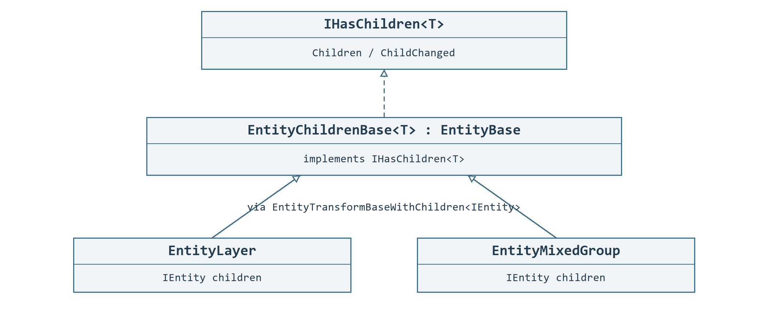
Figure 7.3 Containers implement IHasChildren
1. IHasChildren<T> describes a container of children. In IHasChildren<IEntity>, Children is the read-only list and ChildrenCount is its count. Groups, layers and Gerber objects are examples; TreeView displays children beneath their parent.
2. Choose Mixed Group for varied types or child hatches. Choose Uniform Group for compatible geometry to display efficiently. Uniform does not require the same class for every child.
3. Transform the group as a whole, or select a child in TreeView to edit its own settings. Use IDocument.Act* for grouping, ungrouping and ordering in an open document so Undo/Redo records the changes.
Table 7.1 Compare Mixed Group and Uniform Group
Comparison | EntityMixedGroup | EntityUniformGroup
Purpose | Retain individual behavior while treating different entities as one group. | Display many compatible shapes efficiently. Faster display does not guarantee shorter laser processing.
Allowed children | Different shapes, text and nested groups; no common RenderMode is required by Mixed Group. | The child list supplied at creation must be nonempty. EntityModelBase children must share RenderMode. ITextConvertible, EntityControl and IHatchable children with HatchCount > 0 are rejected.
Property effects | The group transform affects all children. IsAllowRender and IsAllowMark control the group without rewriting each child’s matching property. | The same group transform and enable controls apply. Children remain individually selectable in TreeView.
Process pen | Each child uses its own PenColor. Group PenColor does not replace child pens. | Each child uses its own PenColor, just as in Mixed Group.
Hatching | Child hatches can remain. Group hatching requires every child to be a closed IHatchable; grouping does not close open paths. | The group does not implement IHatchable and cannot accept children with existing hatches. Use Mixed Group when hatching is needed.
Marking order | Children are processed in stored order. Group Repeats repeats the child sequence; child repeats also apply. Group hatches follow HatchMarkOption. | The same group/child repeat relationship applies in stored order. Efficient display does not combine the group into one continuous laser path.
The page-tree Mixed conversion excludes layers, entity/layer pens, Script, wafer/substrate objects and their dies. Uniform conversion excludes layers and Script as well as the Uniform-specific types in the table. See the single table in 6.6 TreeView selection order and block reuse for the grouping icons and selection conditions.
Use collection methods to build a hierarchy before adding it to a document; they do not automatically create document history. Removing a child does not Dispose it, and ClearChildren disposes only when requested. ITextConvertible alone does not make an object a child container.

7.5 IHatchable and IReversable
IHatchable provides hatch permission, closed state, Hatches and HatchMarkOption. GetOriginalContours describes the fill region: which contours are open or closed and which nested contours form holes. Similar-looking polylines alone do not provide this information. HatchFirst, HatchLast and HatchOnly place hatch paths before, after or without the outline. IReversable exposes IsReversed and Reverse to change path direction. Reversing a path does not generally repair an invalid fill region.
Figure 7.4 Two hatch definitions on a selected closed rectangle
Listing 7.1 Add a 45 degree hatch at 0.25 mm pitch
public static bool AddHatch(IDocument document, IEntity entity)
{
if (!(entity is IHatchable hatchable) || !hatchable.IsClosed)
return false;
return document.ActAddHatch(entity,
HatchFactory.CreateLine(45, 0.25)); // angle: degrees; pitch: mm
}

7.6 IClippable and ClipOptions
IClippable.Clip creates new entities inside a world-space Frustum and leaves the source unchanged. You must adopt or dispose every result. Direct results already include ancestor transforms and retain world placement. Do not attach them again beneath the same transformed parent. Use ActClip to replace document objects with Undo/Redo support. Gerber, text and barcode examples are in 10.9.
Listing 7.2 Clip the selected closed region through the document
public static void ClipSelection(IDocument document)
{
var region = Frustum.Build(new OpenTK.Vector2d(-10, -6),
new OpenTK.Vector2d(10, 6));
var options = ClipOptions.Default;
options.Mode = ClipModes.ClosedRegions;
options.IncludeHatches = false;
if (!document.ActClip(document.Selected, new[] { region }, options))
throw new InvalidOperationException("Clip failed.");
}
Option | Initial value | Meaning
Mode | Paths | Clip paths; ClosedRegions reconstructs filled planar regions.​
IncludeHatches | true | Include existing active hatch paths as ordinary clipped paths.​
Fill /​ Winding | EvenOdd /​ OuterCounterClockwise | Interpret input fill and choose output contour direction separately.​
DecimalPrecision | 6 | Closed-region decimal grid; allowed range -8 to 8.​ Small detail below the grid can disappear.​
MergeTolerance | 1e-6 | Positive local tolerance for joining and coplanarity; match the geometry scale.​

7.7 ISliceable
Slice(z, out contours) returns XY contours at a height in millimetres. The built-in implementation applies the object’s ModelMatrix, without ancestor transforms. Closed outer contours run counterclockwise; holes run clockwise. Valid open paths remain open. IsPreviewSlice and SliceZ change the displayed cut preview, not whether Slice can run. Use ActSlice to create document-owned sections. The imported-STL and hatched-section example is in 10.8.
Listing 7.3 Create an XY section at a specified Z height
public static bool AddSection(IDocument document, ISliceable source, double z)
{
if (!source.Slice(z, out var contours)) return false;
var paths = contours.Select(c => (IEntity)new EntityPolyline2D(c));
var section = new EntityMixedGroup("Section", paths);
section.Translate(0, 0, z); // Contours contain XY coordinates only.
if (section.Regen() && document.ActAdd(section)) return true;
if (section.Owner == null) section.Dispose();
return false;
}

7.8 Edit entities with grips
1. GetGrips returns immutable EntityGrip descriptors in original local coordinates. Id identifies an editing role, not a permanent vertex number.
2. Open a session on the existing entity with BeginGripEdit and preview with TryPreview. Restore reverses the preview; Commit(document) accepts the edit.
3. Dispose the session after commit too. Disposing before commit restores the original state.
Listing 7.4 Preview and commit one grip edit
public static bool EditGrip(IDocument document, IGrippable entity,
string gripId, DVec3 originalLocalPoint)
{
using (IEntityGripEdit edit = entity.BeginGripEdit(gripId))
{
if (edit == null || !edit.TryPreview(originalLocalPoint))
return false;
return edit.Commit(document);
}
}
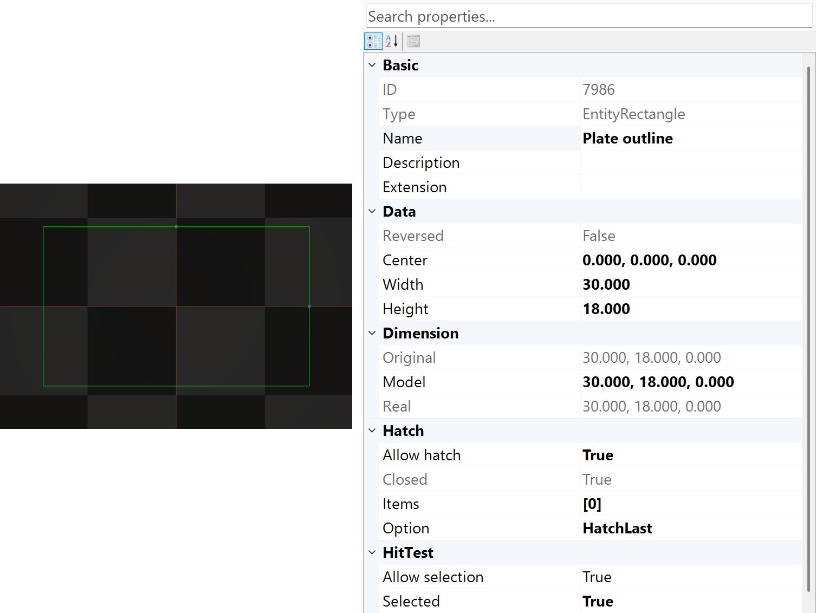
Figure 7.5 Vertex mode on the selected rectangle after pressing Tab in the viewport
IEntityGripEdit.Entity is the edited object, which the session does not own; Grip describes the starting handle. Check IsActive and HasChanges for progress and edits. EntityGripKind identifies position, dimension, control-point or angle roles; GripModifiers describes editing constraints.
IFixedAspectRatio.IsFixedAspectRatio controls the aspect ratio for size edits. Request GetGrips again after changing the original vertex layout. Follow 6.11 Switch grip modes with Tab for canvas mode switching and cancellation.
Listing 7.5 Request Size mode for the selected entity through the API
public static void ShowSizeGrips(IView view)
{
if (view is IViewInteractionHost interaction)
interaction.GripEditMode = GripEditMode.Scale;
}
Select the entity first and call on the view's UI thread. If Size is unavailable, the next applicable mode is selected. Changing modes cancels an unfinished edit without history; an unknown enum value throws ArgumentOutOfRangeException.

08 Barcodes and text

8.1 Create basic entities
Choose the active layer, add one object and check its dimensions. Point, line, arc, polyline, rectangle, spline, spiral and trepan share selection and placement controls, but store different shape data. A polyline can stay open. An arc’s sweep angle differs from model rotation. Edit the shape separately from its placement.
Interactive creation displays the current step in the viewport. For spiral and Lissajous tools, the centre and diameter define the XY footprint. SpiralClassic also uses start and end diameters. Finish as the tool allows, with Enter or the final click; Escape cancels. The finished object creates one document action.

8.2 Text layout and fonts
1. Choose the font source and path: Windows-font outlines, Sirius-font strokes/dots, or raster pixels. Use a circular variant for a circular baseline.
2. Set SourceText and FontName, then size and spacing. Circular text also uses Radius (mm), BaseAngle (degrees), Direction and arc alignment. Check the selected object’s actual size in the viewport.
3. Add with ActAdd, select the text and set its process pen. Changing lot numbers, files and expressions are covered in the TextConverter chapter. The text type determines how the resolved string becomes geometry or pixels.
Table 8.1 Choose among the five text types
Public type | Font and machining form | Layout / use / checks
EntityText | Installed Windows font family → vector outlines. | Straight or multiline labels; closed outlines can be hatched. Auto, Variable and Fixed spacing. CapHeight is a font reference height in mm, not a guaranteed visible capital height. It does not automatically extract a centerline.
EntitySiriusText | Files under Config.SiriusFontPath: CXF/LFF/FNT paths or DOT dots. | Straight or multiline stroke/dot text; Variable and Fixed spacing. FontName is a file name, not a Windows family. Closed paths may be hatched; open strokes and DOT are not closed fill regions. Straight DOT can use a generated bitmap for raster marking; otherwise it uses points.
EntityImageText | Installed Windows font family → raster bitmap. | Straight or multiline, filled or outline pixels; Auto, Variable and Fixed spacing. Use raster process settings, not vector hatching. CapHeightPixels is the font rasterization reference in px; Height and Width are physical mm. Width = 0 derives width; positive Width is independent of Height.
EntityCircularText | Installed Windows font family → vector outlines on a circle. | Circular labels; multiline uses concentric baselines. Auto, Variable and Fixed spacing. Radius must be positive; check each line radius and glyph overlap. BaseAngle is the arc-alignment reference, not ModelRotate.
EntityCircularSiriusText | The same Sirius font files → circular paths or points. | Circular stroke/dot text; multiline uses concentric baselines. Variable and Fixed spacing only. Radius must be positive and each resulting line radius valid. Circular DOT is marked as points, not with straight DOT bitmap marking.
Fixed keeps character-cell positions stable when equal-length text changes; it ignores WordSpacing and kerning. Use named enum values because numeric values differ between text types.
A glyph is the shape data for a character, so the font must contain every character you need. Sirius FontName resolves under SpiralLab.Sirius3.UI.Config.SiriusFontPath; FNT needs EO-font support.
CapHeight does not make every visible capital the same height. Windows font processing (GDI) uses ascent as its height reference; Sirius uses representative uppercase metrics. Equal CapHeight values can therefore produce different visible heights. See 11.3 Read ascent, descent and x-height for height references and BBox comparison.
The independent Font Editor edits font files, not document pages. Saving may regenerate objects using that font and is separate from document Undo/Redo. Converting an installed font creates outlines or DOT pixels; it does not automatically extract a single-line font.
Listing 8.1 Create Windows-font vector text with a millimeter cap height
public static EntityText Text(IDocument document)
{
var text = new EntityText("Segoe UI", FontStyle.Regular,
"SIRIUS3\nLOT 2026", 5);
text.Name = "Part identification";
if (!document.ActAdd(text))
{
if (text.Owner == null) text.Dispose();
throw new InvalidOperationException("Cannot add text.");
}
document.ActSelect(text);
return text;
}
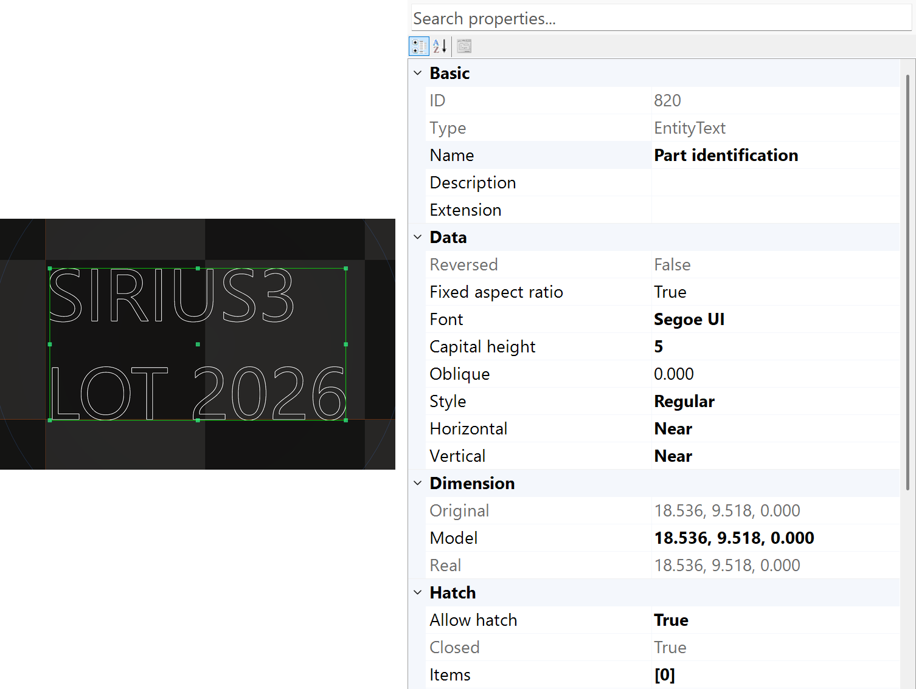
Figure 8.1 Vector text with font and cap-height properties
Member | Role | Use and caution
FontName /​ FontStyle | Installed Windows font and style | Deploy the same font and verify required glyphs.​
CapHeight | Font reference height in mm | Maps font ascent to the reference; visible uppercase height varies by font.​
SourceText /​ TextConverter | Input and dynamic conversion rule | Inspect conversion order and failures before marking serial data.​
LetterSpace /​ LetterSpacing | Spacing mode and extra gap in mm | Auto, Variable and Fixed use different spacing rules.​
TrackingFactor /​ TargetWidth | Cluster spacing and layout width | Tracking changes origins; it does not stretch each glyph.​ Distributed text does not compress.​
ModelScale /​ ModelRotate | Placement transform after layout | Do not use a transform to conceal a wrong font or wrong source units.​

8.3 Barcode dimensions and cells
Listing 8.2 Create an outline QR code at a specified physical size
public static EntityQRCode Qr(IDocument document)
{
var code = new EntityQRCode("SN-2026-001",
EntityBarcode2DBase.Barcode2DCells.Outline, 18, 18);
code.Name = "Serial QR";
if (!document.ActAdd(code))
{
if (code.Owner == null) code.Dispose();
throw new InvalidOperationException("Cannot add QR code.");
}
document.ActSelect(code);
return code;
}
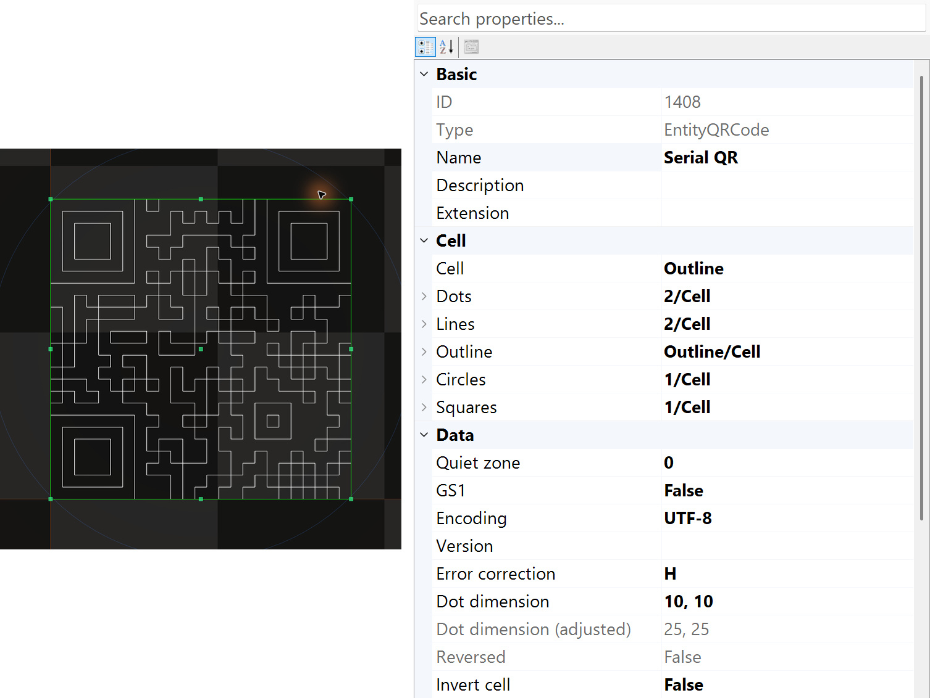
Figure 8.2 Selected QR code with cell mode and encoding properties
Width and Height specify the requested physical envelope. Cell mode chooses dots, lines or contours; it does not change the encoded matrix dimensions. Check quiet zone, encoding, error correction and the reader’s minimum module size. The picture shows raw outlines with quiet zone set to zero. Leave the required blank border on a production label.
DataMatrix can be square or rectangular. QR, PDF417, Aztec and 1D codes have their own shapes and reader requirements. Requesting a fixed aspect ratio does not prove that every module is square. When adding a hatch, check the combined fill region and its holes. Hatching each encoded cell as a separate closed region can leave seams.

09 TextConverter and dynamic text
1. Dynamic text replaces a document placeholder with production data such as a lot or serial number. ITextConvertible exposes source and result; TextConverter chooses the data source.
2. Select the text or barcode and enable IsAllowConvert. Choose a converter and supply its input data.
3. Verify the resolved value. The following sections explain the five converters and Script editing.
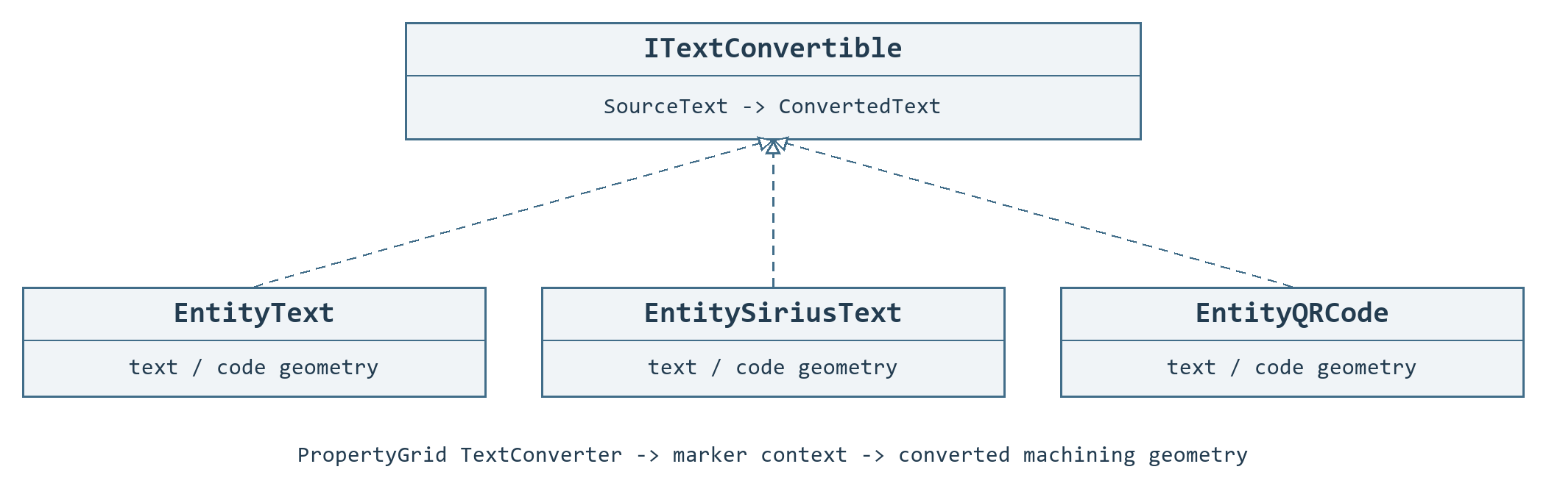
Figure 9.1 Text and code entities share conversion
IsAllowConvert enables conversion, and TextConverter chooses how SourceText becomes ConvertedText. File reads ExternalFile; Link reads LinkEntity; Offset reads ExtensionData for the marker’s current placement. A Link target must not also use Link. Do not set ConvertedText manually while conversion is enabled. A successful preview does not confirm a finished machining pass.
Figure 9.2 Text geometry selected for font and layout editing
Listing 9.1 Select conversion through document actions
public static bool UseOffsetText(IDocument document, IEntity entity)
{
if (!(entity is ITextConvertible)) return false;
if (!document.ActPropertyChanged(entity,
nameof(ITextConvertible.TextConverter), TextConverters.Offset))
return false;
return document.ActPropertyChanged(entity,
nameof(ITextConvertible.IsAllowConvert), true);
}
These examples configure detached objects, or objects whose affected markers are all idle. Use document property actions when edits need Undo/Redo. The marker performs conversion as part of its processing. The snippets only configure conversion; they do not start processing.

9.1 Event Host event data
The marker calls OnTextConvert and uses the returned string. The example resolves LOT-2026-001 regardless of SourceText. Keep one owned handler and synchronize external production data when markers run concurrently.
Listing 9.2 Host event data
public static void EventExample(IMarker marker, ITextConvertible text)
{
// Configure before processing. Unsubscribe when the host releases the marker.
text.IsAllowConvert = true;
text.TextConverter = TextConverters.Event;
marker.OnTextConvert += (m, entity) => "LOT-2026-001";
}

9.2 SimpleScript C# expression and script properties
SimpleScript evaluates SourceText using marker.ScriptInstance. With LotCode=LOT-01, the example returns LOT-01-5. ScriptInstance supplies production fields and serial/date helpers. An invalid or empty expression stops conversion. A returned serial value does not confirm successful processing.
Listing 9.3 C# expression and script properties
public static void ScriptExample(IMarker marker, ITextConvertible text)
{
// Reuse the marker's script context; do not replace a context owned elsewhere.
marker.ScriptInstance.LotCode = "LOT-01";
text.IsAllowConvert = true;
text.TextConverter = TextConverters.SimpleScript;
text.SourceText = "LotCode + \"-\" + (2 + 3).ToString()";
}

9.3 File Consume a text queue
Create a writable UTF-8 queue file with A001 and A002 on separate lines. Each conversion takes the next line: first A001, then A002. It removes the consumed lines from the top of the file. Test with a disposable copy. Empty data or a read/write failure stops the operation. Coordinate access with other writers.
1. The ordinary PropertyGrid preview reads the first line without deleting it.
2. Conversion for processing consumes the line before job completion. A later regeneration, transfer or processing failure does not restore it automatically.
3. Keep preview, data allocation and confirmed production results separate. Define the host retry policy before using the file as a production queue.
Listing 9.4 Consume a text queue
public static void FileExample(ITextConvertible text, string queueFile)
{
text.IsAllowConvert = true;
text.TextConverter = TextConverters.File;
text.ExternalFile = Path.GetFullPath(queueFile);
}

9.4 Offset Data for each placement
Assign the returned array to marker.Offsets while the marker is idle. PART becomes A001 at X=-10 mm and A002 at X=+10 mm. A plain ExtensionData string supplies the same value to all converted objects. For name/value pairs, use SpiralLab.Sirius3.UI.Config.RemoteSeparator; its default is |. JSON name/value data is also supported. See 17.2 LayerFirst and OffsetFirst for placement order and coordinate transforms.
Listing 9.5 Data for each placement
public static Offset[] OffsetExample(ITextConvertible text)
{
((IEntity)text).Name = "PART";
text.IsAllowConvert = true;
text.TextConverter = TextConverters.Offset;
return new[] {
new Offset(-10, 0) { ExtensionData = "PART|A001" },
new Offset(+10, 0) { ExtensionData = "PART|A002" }
};
}

9.4.1 OffsetControl and position data
1. Use the Marker offset table to place one design at several positions. Each row holds translation in mm, Z rotation in degrees, scale factors and Extension Data.
2. Add rows and enter the placement values. Reorder them with the arrow buttons or drag them. Create Array replaces all existing rows with a calculated array.
3. Enter each position's text in Extension Data and choose TextConverter=Offset on the relevant text or code object with IsAllowConvert enabled. The current row supplies the value during processing.
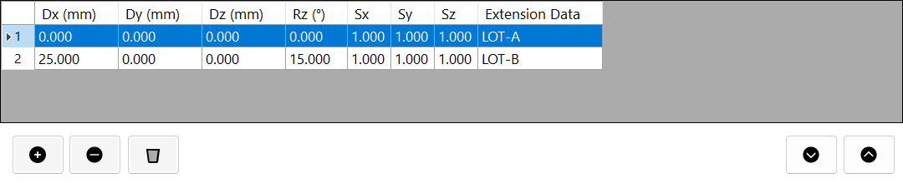
Figure 9.3 Offset table: placement values and Extension Data belong to the same processing row.
An empty resolved value stops processing. Name/value pairs and the separator are explained with TextConverter. The table cannot be edited while the Marker is busy; it edits Marker.Offsets rather than the document's Undo/Redo history.

9.5 Link Reuse an already converted master
Configure the master’s Event handler and process MASTER before its linked copy. If MASTER returns A001, the copy reads A001 from the master’s current ConvertedText. It does not convert the master again. The target must not use Link. Concurrent markers read the document’s latest value, not a separate value saved for each offset. See 6.6 TreeView selection order and block reuse to put MASTER before its linked copies in the tree order.
Listing 9.6 Reuse an already converted master
public static void LinkExample(ITextConvertible master, ITextConvertible copy)
{
((IEntity)master).Name = "MASTER";
master.IsAllowConvert = true;
master.TextConverter = TextConverters.Event;
copy.IsAllowConvert = true;
copy.TextConverter = TextConverters.Link;
copy.LinkEntity = "MASTER";
}

9.6 Edit the Script production data
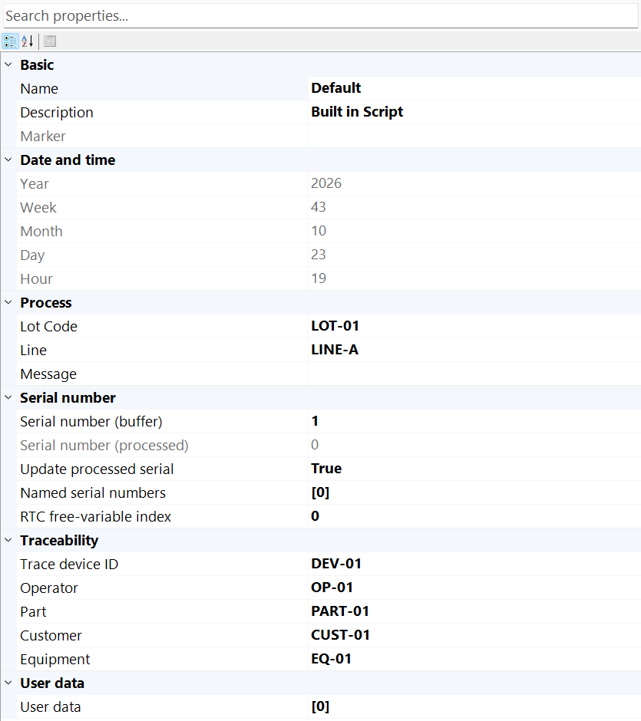
Figure 9.4 Script properties for production data and serials
Listing 9.7 Create and select a script context
public static void ConfigureScript(IMarker marker, IDocument document)
{
var script = ScriptFactory.Create();
script.LotCode = "LOT-01";
script.LineName = "LINE-A";
marker.ScriptInstance = script;
document.ActSelect(script); // Show editable context in PropertyGrid.
}
While the marker is idle, choose Script → Show in the editor or call document.ActSelect(marker.ScriptInstance). PropertyGrid now shows the Script instance rather than the selected geometry. Edit LotCode, LineName and the serial settings, then select the geometry again and choose SimpleScript. Script → Open/Save handles the supported serialized script settings; marker.ScriptFile or ScriptFactory.Create(path) loads a custom C# source/assembly. Keep these two operations distinct.
Listing 9.8 Evaluate the same expression used in SourceText
public static string PreviewScript(IScript script)
{
string expression =
"$\"{LotCode}-{LineName}-{Date(\"yyMMdd\")}-{SerialNo:D4}\"";
if (!ScriptEval.Evaluate(expression, script,
out string converted, out string reason))
throw new InvalidOperationException(reason);
return converted;
}
For example, SourceText can be $"{LotCode}-{LineName}-{Date("yyMMdd")}-{SerialNo:D4}". The C# listing escapes the string; in PropertyGrid enter the expression itself. Formatting a serial does not reserve it. SerialNo only reads the current counter. NextSerialNo("D4") advances it whenever evaluated, including preview and retry. The host must decide when to allocate, save and confirm production numbers for traceability.

9.7 Extend the Script context
Listing 9.9 Expose a custom editable property and a script method
public sealed class ProductionScript : Script
{
private string station = "S1";

[Category("Production")]
[DisplayName("Station")]
public string Station
{
get => station;
set { station = value; NotifyPropertyChanged(nameof(Station)); }
}

public string PartLabel() => LotCode + "-" + Station;
}
Listing 9.10 Assign and select the custom instance
public static void BindCustomScript(IMarker marker, IDocument document)
{
var script = new ProductionScript { LotCode = "LOT-01", Station = "S1" };
marker.ScriptInstance = script;
document.ActSelect(script);
}
The custom Station property appears under Production in PropertyGrid and sends change notifications. After assigning this Script instance, SourceText can use PartLabel() or $"{PartLabel()}-{SerialNo:D4}". The expression can access the concrete script type. Use separate mutable Script state for independently running markers. Loading the same file through ScriptFactory may return a cached shared instance.

10 Hatching clipping images and import
This chapter prepares source data as processing paths. Vectors describe lines, curves and contours; raster data describes pixels; a mesh describes a surface with triangles. Use hatching to fill closed regions, clipping to limit their extent, and slicing to obtain mesh cross-sections. Assign the resulting paths’ processing conditions in 15 EntityPen and per-entity conditions.

10.1 Hatching converts a valid region into paths
Listing 10.1 Cross-hatch one closed rectangle at a 0.25 mm interval
public static EntityRectangle Hatch(IDocument document)
{
var region = new EntityRectangle(DVec3.Zero, 30, 18);
region.Name = "Hatched region";
region.AddHatch(HatchFactory.CreateLine(45, 0.25));
region.AddHatch(HatchFactory.CreateLine(135, 0.25));
if (!document.ActAdd(region))
{
if (region.Owner == null) region.Dispose();
throw new InvalidOperationException("Cannot add hatch region.");
}
document.ActSelect(region);
return region;
}
Figure 10.1 The Hatch collection contains two independently editable line definitions
Angle uses degrees; Interval uses millimetres. A smaller interval adds path length and heat input. Two crossing hatches create two sets of paths. Check exclusion distance, zigzag direction, sort/order and whether the outline runs first, last or not at all. A hatch region must use valid closed fill contours.

10.2 Clip geometry before placing the final job
Paths trims machining paths; ClosedRegions computes planar fill regions. Both return independent entities. Included hatch paths become ordinary paths, not editable copies of the hatch settings. A clipped raster keeps its pixel pitch and makes outside pixels transparent. Check the resulting position and marking bounds.
Listing 10.2 Perform a closed-region clip with Undo and Redo support
public static void ClipSelection(IDocument document)
{
var region = Frustum.Build(new OpenTK.Vector2d(-10, -6),
new OpenTK.Vector2d(10, 6));
var options = ClipOptions.Default;
options.Mode = ClipModes.ClosedRegions;
options.IncludeHatches = false;
if (!document.ActClip(document.Selected, new[] { region }, options))
throw new InvalidOperationException("Clip failed.");
}

10.3 Image size and bitmap lifetime
Listing 10.3 Transfer a bitmap to an image entity with an 18 mm height
public static EntityImage Image(IDocument document, Bitmap bitmap)
{
var image = new EntityImage(bitmap, 18)
{
Name = "Grayscale sample"
};
if (!document.ActAdd(image))
{
if (image.Owner == null) image.Dispose();
throw new InvalidOperationException("Cannot add image.");
}
document.ActSelect(image);
return image;
}
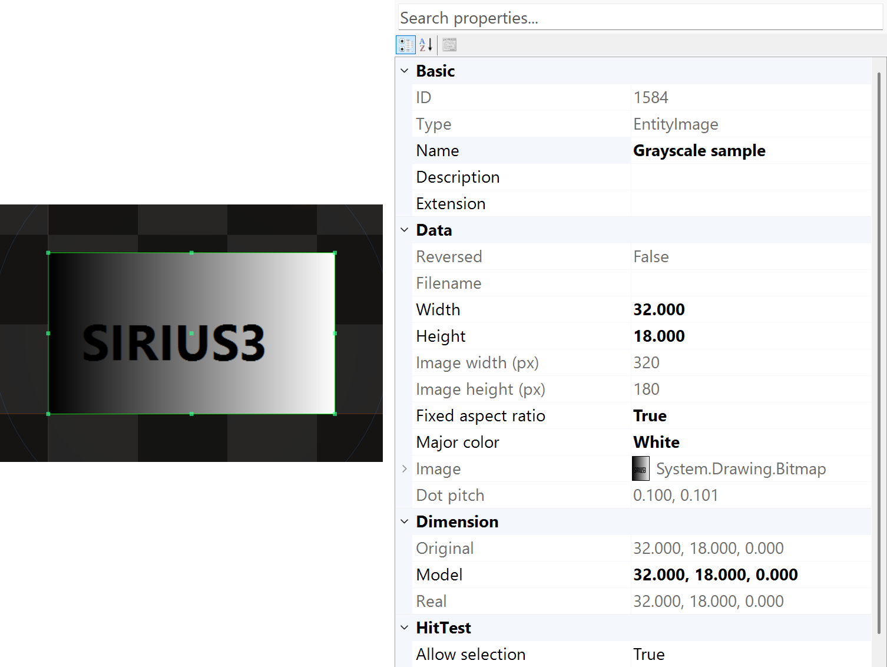
Figure 10.2 A grayscale image selected with physical dimensions and pixel information
EntityImage accepts a filename or Bitmap and a height in millimetres. Width=0 keeps the aspect ratio. Pixel dimensions describe the source sampling; DotPitch describes physical spacing in the image. After the EntityImage constructor successfully accepts a Bitmap, it owns that bitmap. Do not dispose it while the entity still uses it.
Property | Meaning | Check
Height /​ Width | Physical envelope in mm | Keep aspect ratio intentional; independent sizing uses explicit width.​
BitmapImage /​ MajorColor | Source image and pixel interpretation | Transparency, inversion and grayscale mode affect valid machining pixels.​
DotPitch | Physical X/​Y sample spacing | Match desired resolution and the pen’s raster timing.​
RasterMode /​ PixelTime /​ PixelPulses | EntityPen raster strategy and timing | JumpAndShoot and MicroVector are different execution modes.​

10.4 Import through the document
Listing 10.4 Import and select a file-backed entity
public static IEntity Import(IDocument document, string fileName)
{
if (!File.Exists(fileName))
throw new FileNotFoundException("Input file missing.", fileName);
if (!document.ActImport(fileName, out IEntity imported))
throw new InvalidOperationException("Import failed.");
document.ActSelect(imported);
return imported;
}
ActImport dispatches the supported format and creates the document edit. Vector paths include DXF/DWG, SVG, PLT/HPGL, Gerber/Excellon and G-code. Raster inputs and PDF become image-based content; meshes include STL, OBJ, PLY, STEP and 3MF. Large parsing/loading work belongs outside the UI/render thread; return the prepared result to the owning UI path.
G-code import retains source F/S/T and line metadata without applying those values as scanner or laser settings. Select the dialect before import and configure process pens explicitly. A 3MF import combines built mesh components and unit conversion; it does not import a slicer’s saved machining toolpath. A PDF entity can embed a rendered image while page changes still need the original PDF.
1. SVG screen fill differs from machining hatch paths. Automatic SVG hatching is off by default.
2. For interior processing paths, set SpiralLab.Sirius3.UI.Config.IsSvgImportHatchEnabled=true and choose SvgImportHatchInterval before a new ActImport or EntityFactory.CreateSVG call. The default interval is 0.1 mm.
3. These settings affect new imports, not existing or saved hatches. SVG text and image elements are unsupported; convert required text to vector outlines before import.

10.5 Mesh sections are contours not a finished process
Inspect mesh units and orientation, choose a Z plane, then create section contours. Keep valid open contours open; a non-manifold mesh may not define a closed hatch region. Review the section, assign pens and hatches, and check layer/order before marking. Display textures and mesh color are preview data, not laser-process parameters.

10.6 HatchLine properties
HatchLine intersects parallel bands with closed filled regions. The following values are constructor defaults; CreateLine replaces the supplied angle, pitch, clearance and zigzag values. Change a pattern attached to IHatchable, then call Regen or document.ActRegen. Open contours are excluded rather than implicitly closed.
Property | Initial value | Effect and use
Joint | Square | Corner treatment for the inward Exclude offset: Square, Miter, Round or Bevel. Miter preserves sharp intersections; Round rounds corners. Check narrow features after offsetting.
Fill | EvenOdd | EvenOdd uses nesting parity; NonZero uses signed winding. Positive/Negative retain only winding of that sign. Wrong contour directions can fill a hole or remove an island; choose the rule to match the source topology.
Order | Ascending | Ascending traverses low to high perpendicular band coordinates; Descending reverses that band order. Sort can subsequently reorder paths. This is not a command to reverse every segment.
Sort | Nearest | None keeps generation order. Nearest uses a nearby-path heuristic; Global considers a broader ordering at greater computation cost. Sorting changes travel order, not the filled region, and does not guarantee a mathematically shortest route.
IsZigZag | True | Alternates line direction between bands. False gives one-way passes. Compare jump time and direction-sensitive process quality.
Angle | 0° | Line direction in degrees. Pitch is measured perpendicular to this direction.
Interval | 0.05 mm | Nominal perpendicular pitch in mm; values below 0.001 become 0.001. Fit alignment can change the actual pitch to fit the region. Smaller pitch increases path count and exposure.
MinAdjacentDistance | 0 mm | Preferred minimum jump length in mm during optimization. Shorter connections receive a penalty. This does not space the hatch lines or delete short mark segments; None sorting does not apply this optimizer preference.
Exclude | 0.05 mm | Initial inward clearance in mm. Negative assignments are ignored. Excessive clearance removes narrow regions; zero permits intersections at the contour.
Shift | 0 mm | Periodic phase offset across the bands in mm. Shifts the parallel-line pattern perpendicular to its direction; does not translate the source entity.
Alignment | Center | None starts at the minimum projected boundary. Center centers the sequence while preserving pitch. Fit adjusts pitch to fit between the extrema. Compare edge coverage after changing this setting.
IsSnapToGrid | False | Snaps the first perpendicular coordinate to a global grid, then constrains it to the valid region. Useful for a consistent phase across separate objects.
SnapToGridInterval | 0.001 mm | Global snap step in mm; effective only with IsSnapToGrid and a positive value. Independent of the hatch pitch Interval.
Name | Line | Label in the pattern list; does not alter geometry.
ModelColor | EntityPenColors[0] | RGB model color, initially the first configured EntityPen color. The generated paths use that pen color; confirm that a matching EntityPen exists with the intended process settings.
HatchRepeats | 1 | Number of marking passes for this pattern. Does not create additional pattern definitions or set the contour repeat count.

10.7 HatchPolygon properties
HatchPolygon repeatedly offsets the closed region inward to form shells, using NonZero filling. Its Order refers to shell levels, unlike HatchLine band order. Narrow walls and small islands may vanish during offsetting, so inspect the innermost result.
Property | Initial value | Effect and use
Joint | Square | Corner treatment at every shell offset. Miter, Square, Round and Bevel produce different corner paths and can change which narrow features survive.
Order | Descending | Descending processes outer shells first; Ascending processes inner shells first. Sort can optimize paths within the generated grouping.
Sort | Nearest | None keeps generation order. Nearest uses a nearby-path heuristic; Global considers a broader ordering at greater computation cost. Sorting changes travel order, not the filled region, and does not guarantee a mathematically shortest route.
Interval | 0.1 mm | Inward shell spacing in mm, minimum 0.001. Does not automatically update MinArea. Choose overlap from the physical spot and process, not screen line width.
Exclude | 0 mm | Initial inward clearance in mm. At zero, one Interval-sized pre-inset is applied; the first shell therefore does not lie on the original contour. Negative assignments are ignored.
MinArea | 0.005 mm² | Minimum absolute area of an offset path in mm². Initially 0.005 from the constructor pitch 0.1; later Interval changes leave it unchanged. Too large removes small valid features. Zero still uses a small interval-dependent numerical threshold.
Name | Polygon | Label in the pattern list; does not alter geometry.
ModelColor | EntityPenColors[0] | RGB model color, initially the first configured EntityPen color. The generated paths use that pen color; confirm that a matching EntityPen exists with the intended process settings.
HatchRepeats | 1 | Number of marking passes for this pattern. Does not create additional pattern definitions or set the contour repeat count.

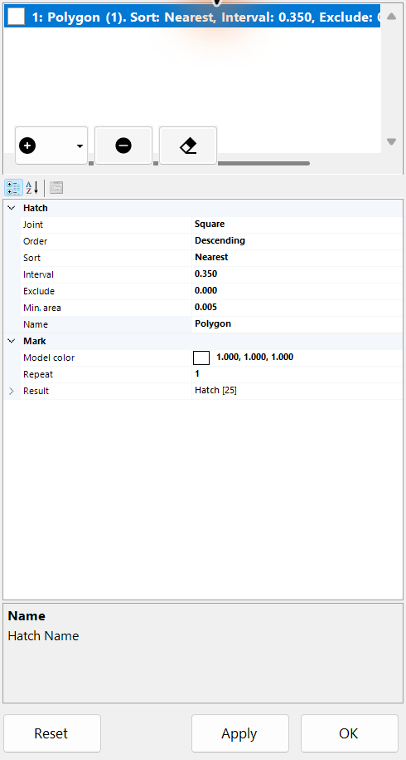
Figure 10.3 PropertyGrid of the Polygon hatch pattern

10.8 Load an STL then slice and hatch
Use the public demos/editor_slicer/Form1.cs workflow. Load sample/stl/20x20x15_mm_hollow_cube.stl, select EntityMesh and set SliceZ to 7.5 mm. The filename is only a label: this sample actually reports 20 × 20 × 20 mm bounds, which must be checked after import. IsPreviewSlice shows the portion at or below the plane; it does not create a section entity. ActSlice creates a new EntityMixedGroup, with its Z translation already set to 7.5 mm.
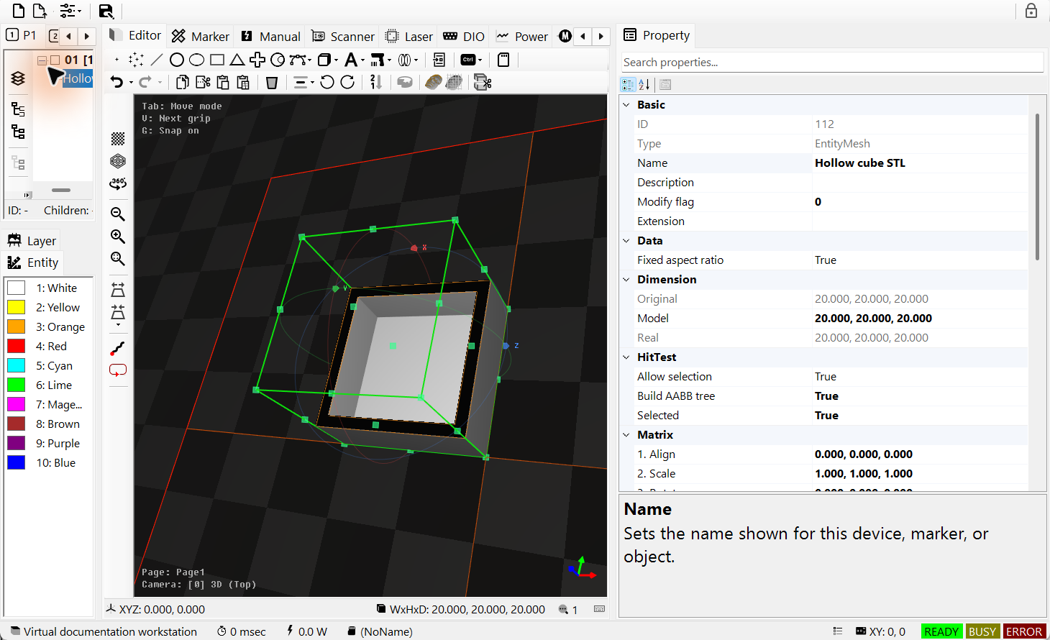
Figure 10.4 Imported STL with preview below Z 7.5 mm
The section contains two contours: the outer boundary and the inner hole. Add one 45° HatchLine with 0.35 mm pitch and 0.05 mm clearance to the group, then regenerate. The figure hides the source mesh only to expose the new section. The empty center confirms that the hole survived hatching. Inspect open or non-manifold output before assigning a machining pen; do not close it merely to force a fill.
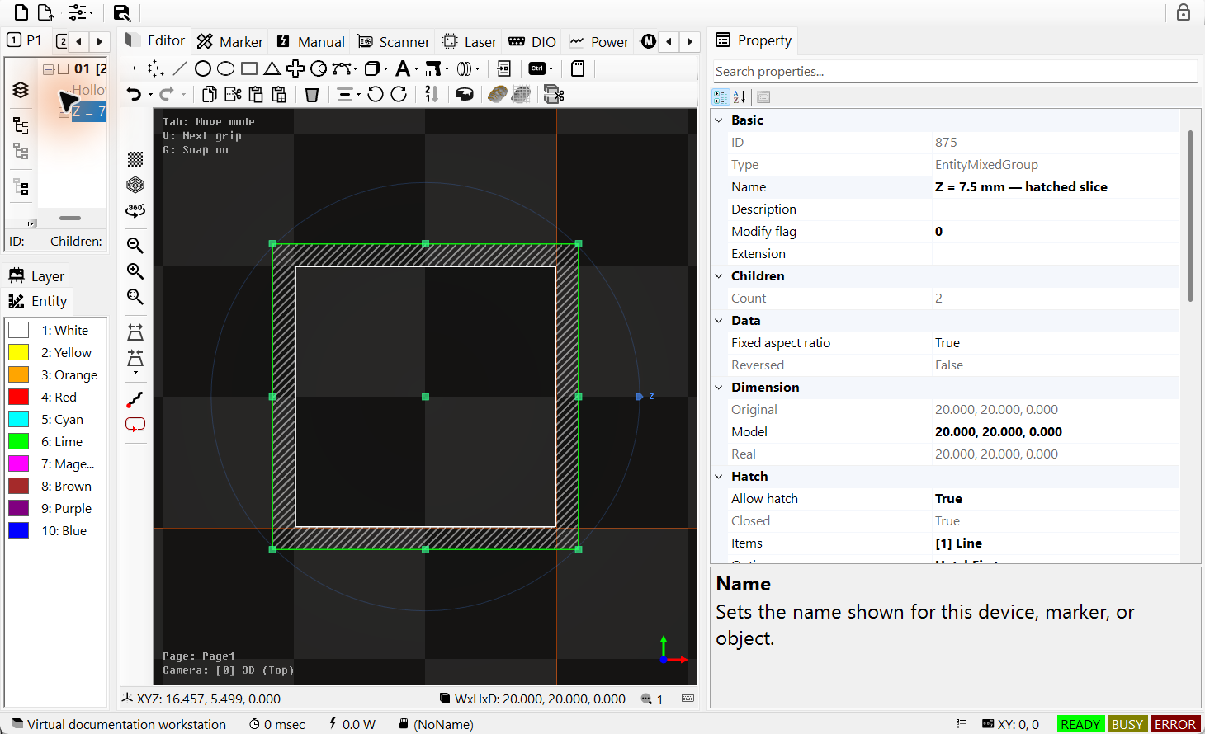
Figure 10.5 Selected slice group with two contours and a hatched wall
Listing 10.5 Create the section through IDocument and add its hatch
public static bool SliceAndHatch(IDocument document, string stlFile)
{
if (!EntityFactory.CreateMesh(stlFile, out var mesh)) return false;
if (!document.ActAdd(mesh)) { if (mesh.Owner == null) mesh.Dispose(); return false; }
const double z = 7.5; // mm
mesh.IsPreviewSlice = true;
mesh.SliceZ = z;
if (!document.ActSlice(mesh, z, out var section)) return false;
section.AddHatch(HatchFactory.CreateLine(45, 0.35, 0.05));
section.HatchMarkOption = HatchMarkOptions.HatchFirst;
mesh.IsAllowRender = false; // Show the section without the source mesh.
document.ActRegen();
document.ActSelect(section);
return true; // ActSlice already placed the section at Z = 7.5 mm.
}

10.9 Clip real Gerber text and barcode paths
The three captures use samples from the public editor_clip workflow: FINAL.TOP from sample/gerber, Arial Bold text SIRIUS, and a DataMatrix encoding CLIP123. Each view shows the unchanged source above and the clipped copy below. Cyan frames identify equal crop regions; the result is selected and PropertyGrid shows the generated group. Each source is first scaled to a maximum XY dimension of 30 mm for comparison.
The rectangle keeps the middle 63% of width and 72% of height. Frustum uses world millimetres. ActClip in Paths mode cuts the existing machining paths; lines may remain open at the crop boundary. ClosedRegions instead computes filled planar regions and their new boundaries. Text and barcode results are ordinary paths, so their original font or payload is no longer editable in the result. A cropped barcode is generally not readable as a code; use this example to understand path cropping, and preserve the original when a decodable symbol is required.
Listing 10.6 Crop the selected copy with document history
public static bool CropCopy(IDocument document, IEntity copy)
{
if (!(copy is ITransformable model)) return false;
if (!model.CalculateRealMinMax(out var min, out var max)) return false;
double cx = (min.X + max.X) * 0.5;
double cy = (min.Y + max.Y) * 0.5;
double w = (max.X - min.X) * 0.63;
double h = (max.Y - min.Y) * 0.72;
var region = Frustum.Build(new DVec2(cx - w / 2, cy - h / 2),
new DVec2(cx + w / 2, cy + h / 2));
var options = ClipOptions.Default;
options.Mode = ClipModes.Paths;
return document.ActClip(new[] { copy }, new[] { region }, options,
isRemove: true); // The document adopts results and records history.
}
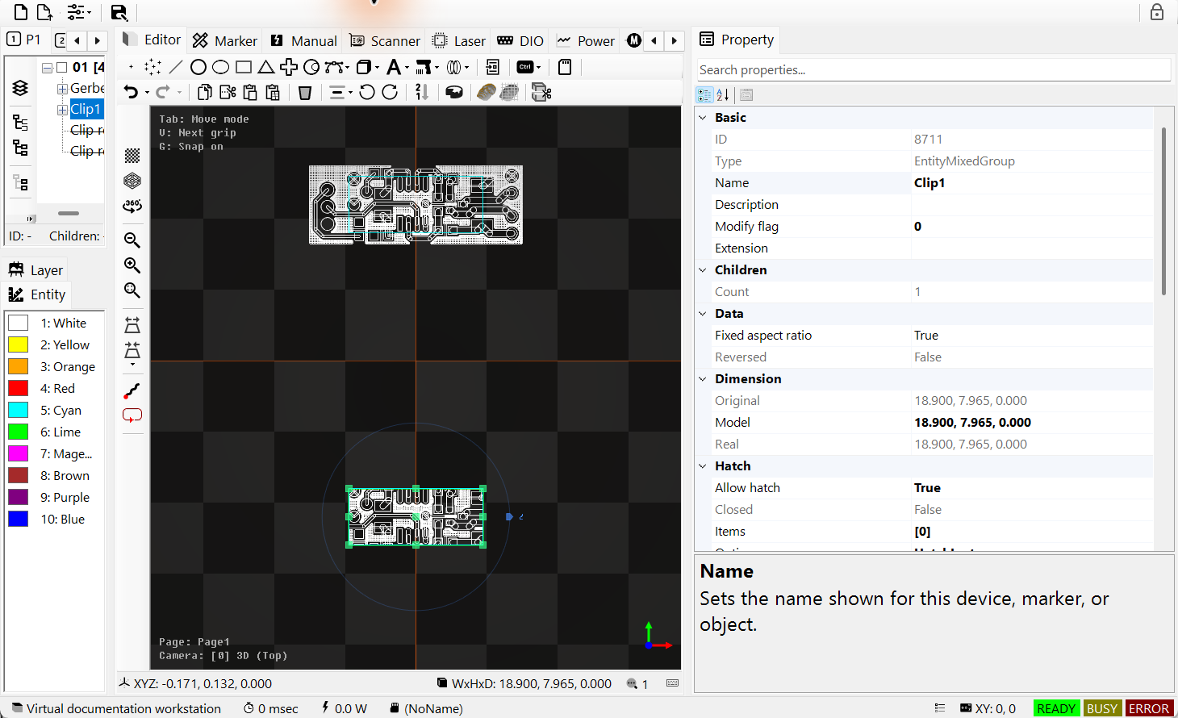
Figure 10.6 Gerber source and clipped copper paths
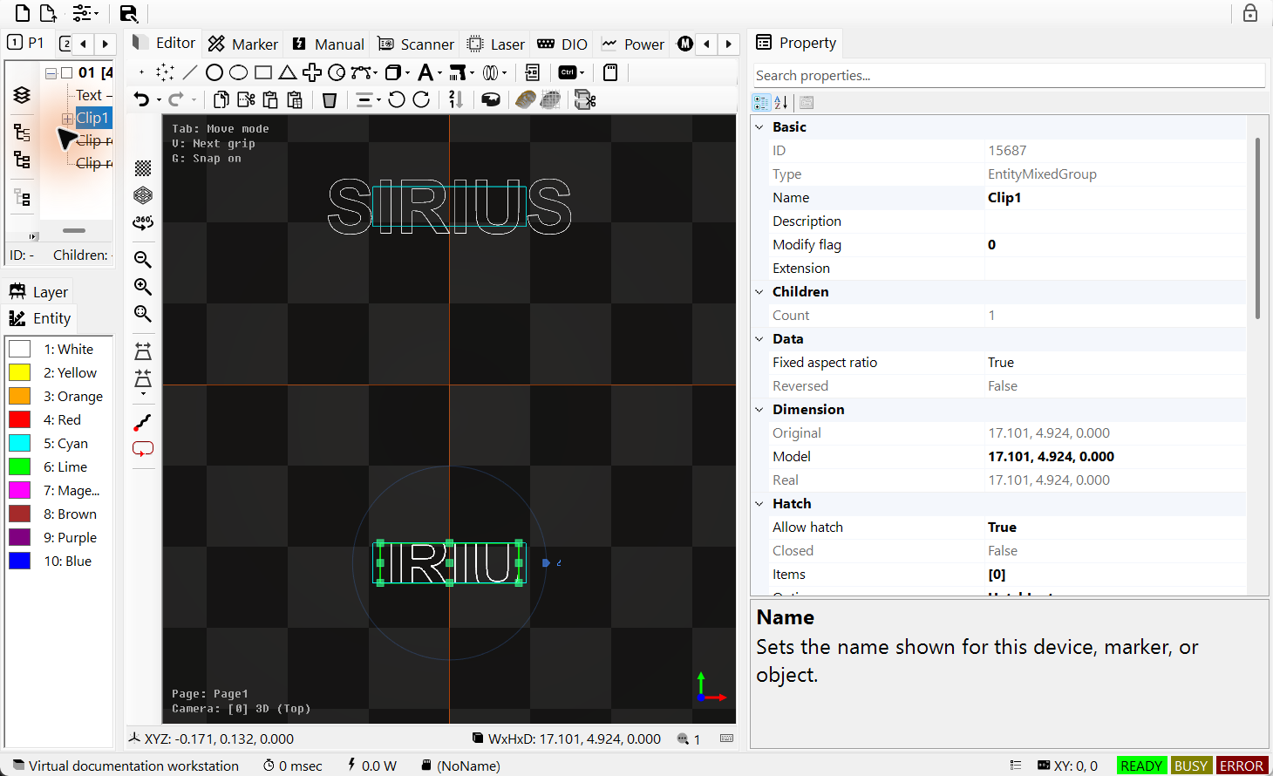
Figure 10.7 Text outlines before and after clipping
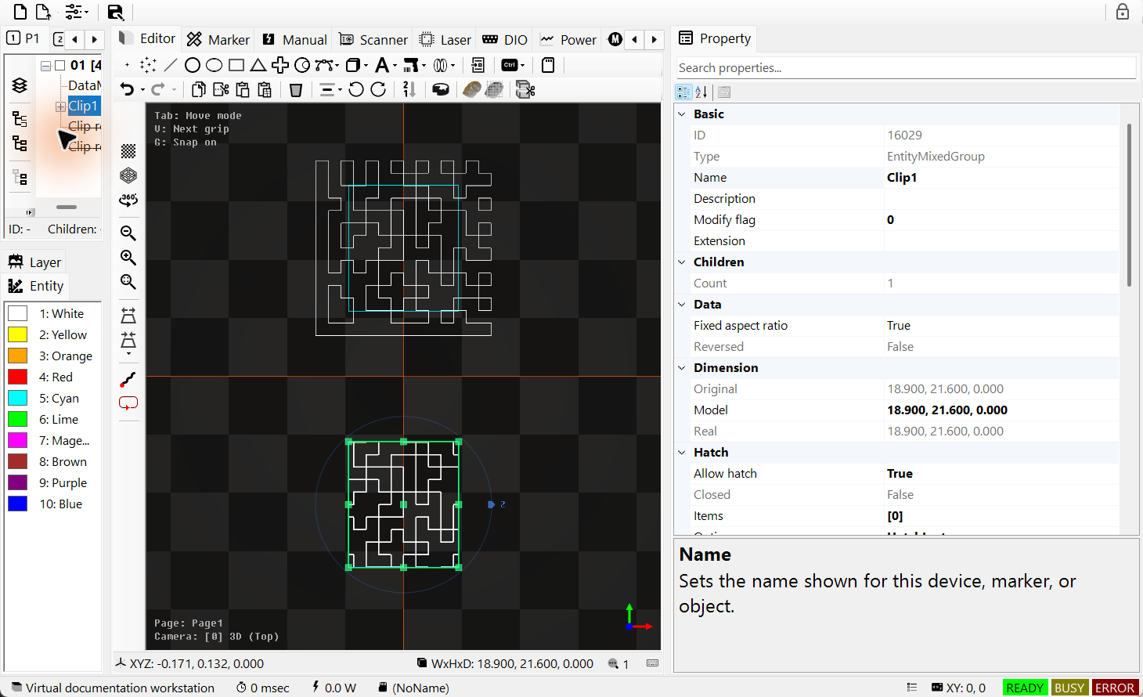
Figure 10.8 DataMatrix paths cropped to the region

11 FontEditor — edit Sirius font files

11.1 Open and edit an existing Sirius font
FontEditorControl edits the font files used by EntitySiriusText. Use the ready-made FontEditorForm or embed the control in WinForms. It needs no document, devices or OpenGL context. Choosing a Windows FontName for EntityText is a separate operation.
1. Open a copy of an existing CXF/LFF/DOT font, or an FNT font when EO support is enabled. Choose the character on the left. A single-line font already contains the strokes to follow; an outline font contains boundary paths. The extension alone does not prove which kind it contains.
2. Edit paths and vertices on the canvas. Use Tab for Move → Vertex → Size and the right table for processing order. Check the travel links between strokes, then use Text Preview to check a string.
3. Save the file and check the bool result of SaveFontAsync. Local Undo/Redo changes this font session. Saving updates live objects that use the same font file; document Undo/Redo does not restore that file.
Use Insert/Delete where supported; Esc cancels the current edit. Font Undo/Redo is separate from document Undo/Redo.
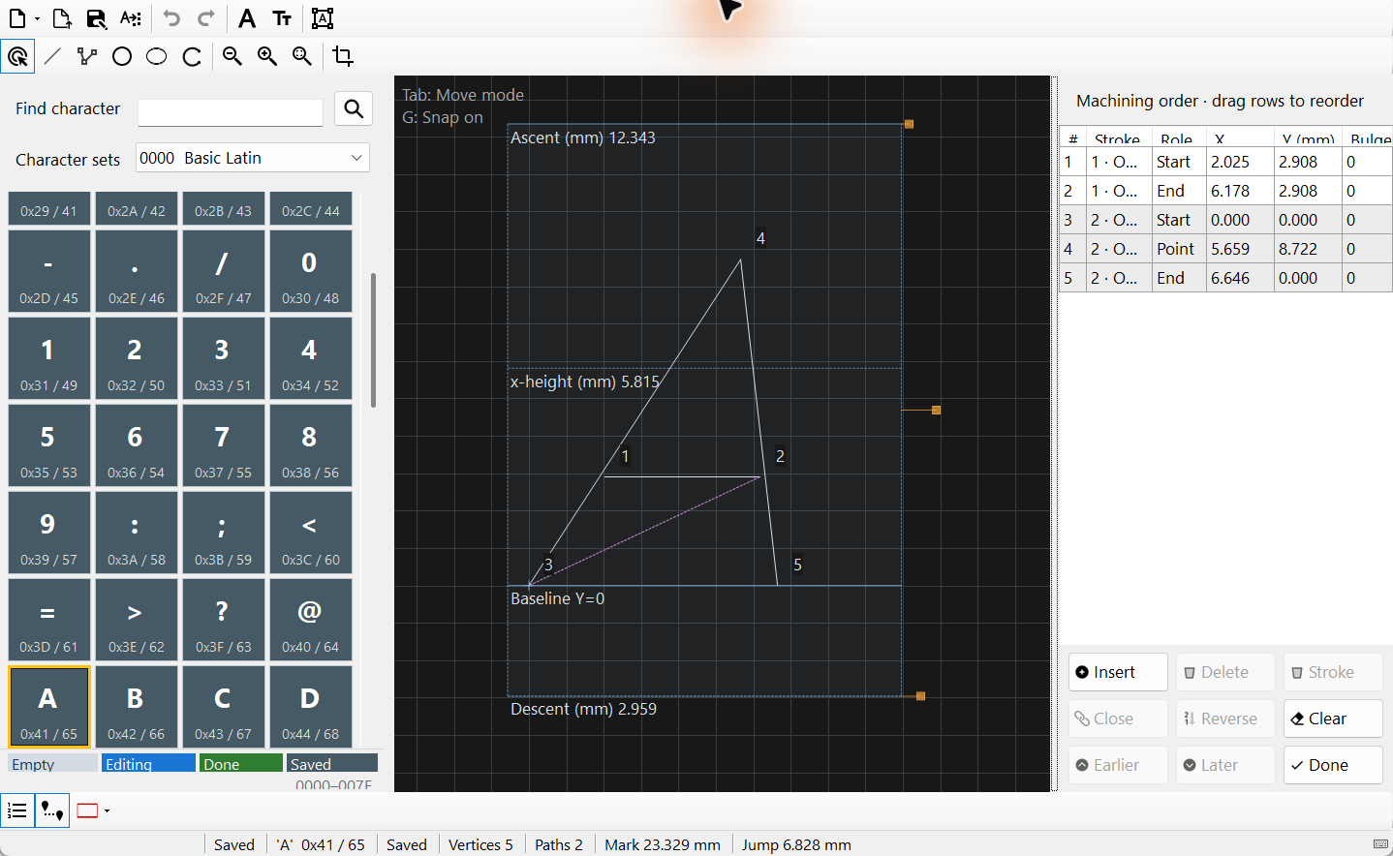
Figure 11.1 FontEditorForm with RomanS.cxf and the selected A glyph

11.2 Convert a Windows TTF into a Sirius font
1. Open Font Converter and select an installed TTF family, style and character blocks. Choose CXF/LFF for vector outlines, DOT for pixel cells, or FNT when EO support is enabled. Vector conversion keeps the TTF outline; it does not create a single-line centre path.
2. For vectors, set height and maximum curved-segment length in mm. For DOT, set integer raster height and binary weight. BBox width 0 means automatic; an explicit width must contain all selected glyphs.
3. Choose the output file and start conversion. The saved result opens in the editor. Check holes, curves, character coverage and physical size, then test a string in Text Preview before using the new font in EntitySiriusText.
The character list reflects the selected TTF’s supported BMP characters. EO binary is limited to U+00FF. Supplementary-character shaping is not provided. The supplied ttf2 utilities must be available in the deployed siriusfonts directory.
Vector curve error is calculated automatically as 0.01% of the requested height. FNT adds storage-grid rounding. Maximum segment length subdivides curves; it does not split original straight spans merely to meet that length.
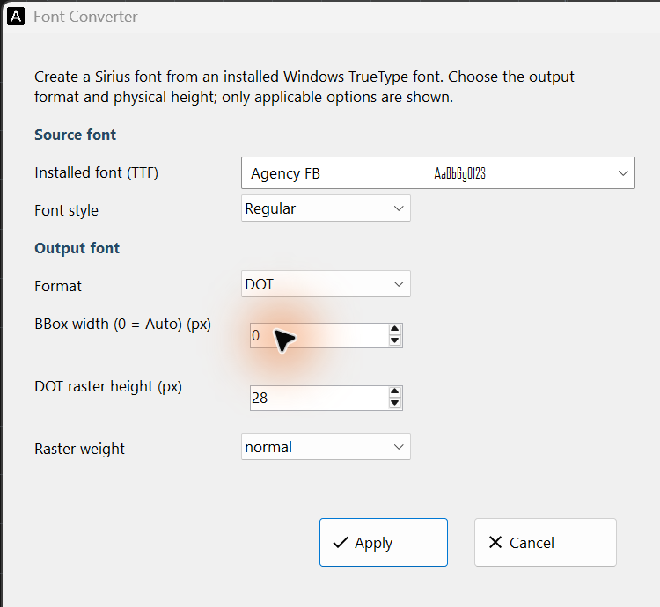
Figure 11.2 Font Converter settings: installed TTF, style and output format. This DOT example uses pixel height; CXF/LFF use vector dimensions in mm.

11.3 Read ascent, descent and x-height
1. Read the horizontal guides: baseline is Y=0, ascent is above it, descent is a positive distance below it, and x-height is the usual lowercase height. The shaded BBox is the allowed editing region, not another text baseline.
2. Open Metrics/Scale to edit font-wide guides or size. Keep ascent and descent inside the BBox, with x-height between 0 and ascent. On the main canvas, the ascent/descent grips move those guides; the BBox right-edge grip scales the whole font about (0,0).
3. Preview uppercase, lowercase and descenders, for example Agx. Confirm spacing and line placement before saving. Changing guide heights alone does not reshape the glyphs. If a smaller BBox excludes paths, the editor asks before clipping them.
Vector coordinates use mm. DOT can show integer pixels while retaining its physical pitch. Text Preview shows guide lines without their labels; use the main canvas to learn the line names.
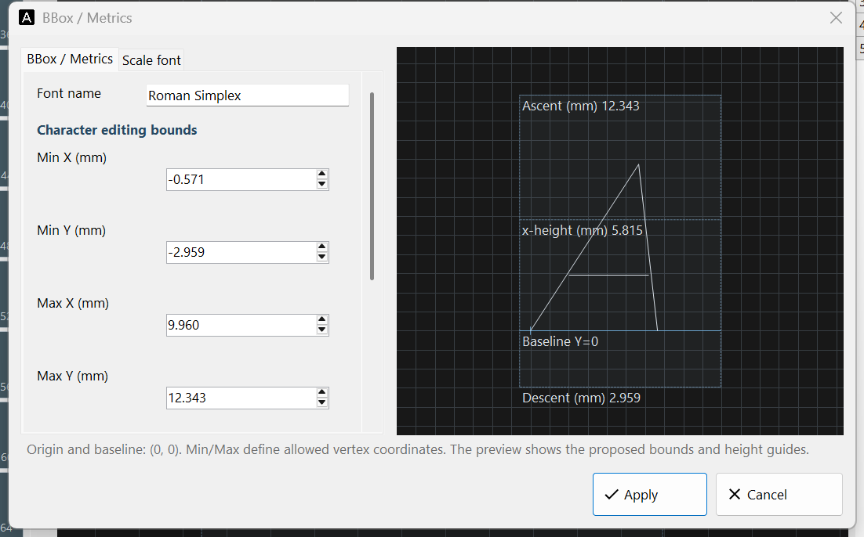
Figure 11.3 BBox / Metrics: set the editing bounds and check baseline, ascent, descent and x-height in the preview.

11.4 Add the font editor to your application
Listing 11.1 Open FontEditorForm on the UI thread
public static async Task OpenFontEditor(Form owner)
{
var form = new FontEditorForm(); // Owns FontEditorControl.
form.Show(owner); // Modeless; its close path checks unsaved edits.
string file = Path.Combine(SpiralLab.Sirius3.UI.Config.SiriusFontPath,
"RomanS.cxf");
if (!await form.Editor.OpenFontAsync(file)) form.Close();
}
Call OpenFontAsync and SaveFontAsync on the UI thread and check their bool results. FontEditorForm asks about unsaved changes when closing. An embedded FontEditorControl must finish ConfirmCloseAsync before disposal. Edit a writable copy and place it in SiriusFontPath when EntitySiriusText will use it.
Saving or converting refreshes live objects using that same font file. Document Undo/Redo does not undo font-file changes. Save As does not retarget objects that use the old filename.

12 RTC fundamentals and laser timing

12.1 From C# calls to controller execution
The PC describes a path and its processing conditions in C#. The RTC stores those commands and produces synchronized scanner and laser signals. IRtc exposes this controller: Ctl* changes or queries its current state, while List* writes a program for controller execution. A successful List* call confirms command acceptance, not completed motion or optical emission.
For an ordinary document job, initialize and register the devices as in 3.2 Create and register RTC devices, then let Marker own list generation and execution as in 17.1 Choosing a marker. Use direct lists for a custom controller sequence; 13.1 Control commands and list commands explains the required command order, Single/Auto behavior and storage limits. Do not mix the two list owners in one job.

12.2 10 µs microsteps and path resolution
For normal RTC6 jump, mark and arc commands, the board interpolates the path into Microsteps and sends a position update to the scan system every 10 µs (100 kHz). At constant speed, Δs = v × 10 µs: 500 mm/s gives 0.005 mm = 5 µm per step. The final step may be shorter to reach the endpoint. The PC does not have to send a new C# position command every 10 µs.
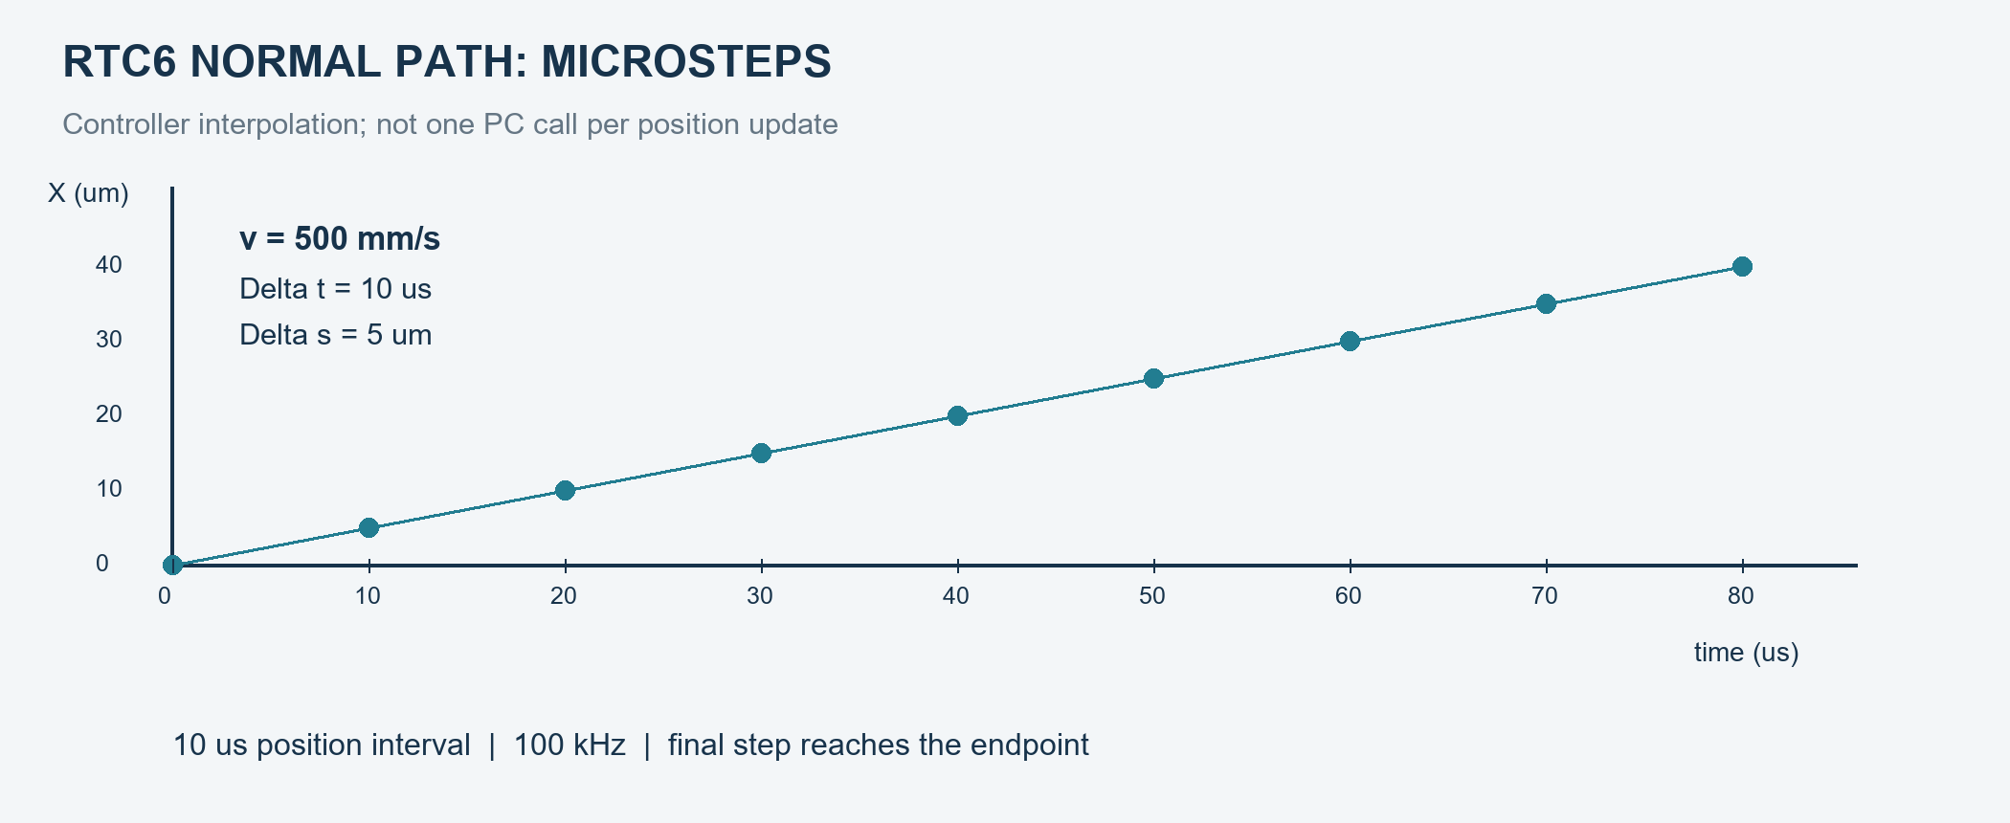
Figure 12.1 Normal path interpolation: 10 µs at 500 mm/s gives 5 µm per step
Use the vendor term Microstep for this interpolation. A micro_vector command is a separate direct-position instruction with its own timing contract. Also, 10 µs is not a universal duration for every list instruction, the optical pulse period, or the laser-edge resolution. RTC6 standard-mode scanner delays use 10 µs ticks, while laser-delay values use 1/64 µs ticks; Sirius3 pen properties expose microseconds and convert them internally. Position-command spacing is not guaranteed machining accuracy: correction, tracking error, dynamics and optics still matter.

12.3 Find the RTC connections
1. Start with the board model: RTC4 PCI, RTC5 PCI, RTC6 PCIe and RTC6 Ethernet have different layouts. The original drawings identify physical connectors; a connector being present does not enable its optional function.
2. Connect the scan head to SCANHEAD, the laser interface to LASER, encoder signals to MARKING ON THE FLY/MOF, and general I/O to the appropriate EXTENSION port. Use the table to distinguish these jobs before selecting a cable.
3. Check the connector at both cable ends, pin numbering, signal level and reference ground. The RTC6 Ethernet 16-pin LASER header is not the PCIe 15-pin D-SUB. A matching adapter maps the pins; a similar connector shape does not.
LASER1, LASER2 and LASERON reference GND2. Ordinary I/O and analog outputs reference GND. The DC/DC option can isolate GND2 from GND. DIN1 for external laser pulse synchronization is pin 13 on the PCIe/PCI 15-pin connector and pin 10 on the raw RTC6 Ethernet header. RTC4’s 9-pin LASER connector has no DIN1.

12.3.1 RTC6 PCIe
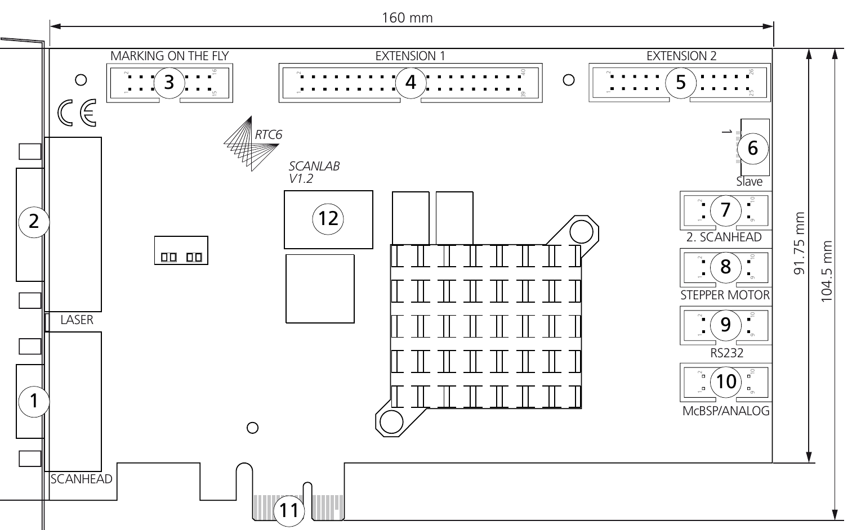
Figure 12.2 RTC6 PCIe board, upper side: original layout and connector labels.
Drawing label | Port | Connector | Purpose
1 | SCANHEAD | 9-pin D-SUB | Scan-head position interface; SL2-100, or XY2-100 through the matching converter.
2 | LASER | 15-pin D-SUB | Laser gate/pulse signals, auxiliary digital I/O and analog outputs; use the model-specific pin map.
3 | MARKING ON THE FLY | 16-pin | Encoder input for moving-workpiece compensation; not a motor drive output.
4 | EXTENSION 1 | 40-pin | 16-bit digital input and 16-bit digital output for peripheral control.
5 | EXTENSION 2 | 26-pin | 8-bit digital output; some pins depend on jumper configuration.
6 | Slave | 6-pin | Clock-cycle synchronization between compatible boards; connect Master to Slave with power off.
7 | 2. SCANHEAD | 10-pin | Second scan-head interface; matching controller option required.
8 | STEPPER MOTOR | 10-pin | Clock/direction/control signals for up to two external stepper drivers; not motor power.
9 | RS232 | 10-pin | RS-232 communication with an external device, such as a compatible laser interface.
10 | McBSP/ANALOG | 10-pin | McBSP data exchange and two analog inputs; RTC6 PCIe does not provide SPI mode here.
11 | PCIe-x-1 | PCIe x1 | Host PC bus interface. PCI and PCIe are different slot types.
12 | Serial label | — | Board identification label; not a connection port.
Lower side 1 | Master | 6-pin | Clock-cycle synchronization between compatible boards; connect Master to Slave with power off.
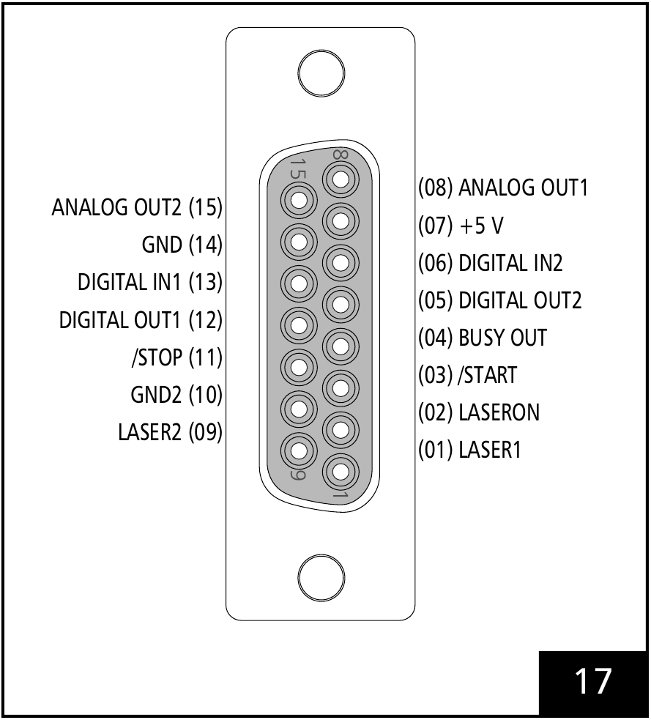
Figure 12.3 Original RTC6 PCIe 15-pin female LASER D-SUB and its pin assignments.

12.3.2 RTC6 Ethernet
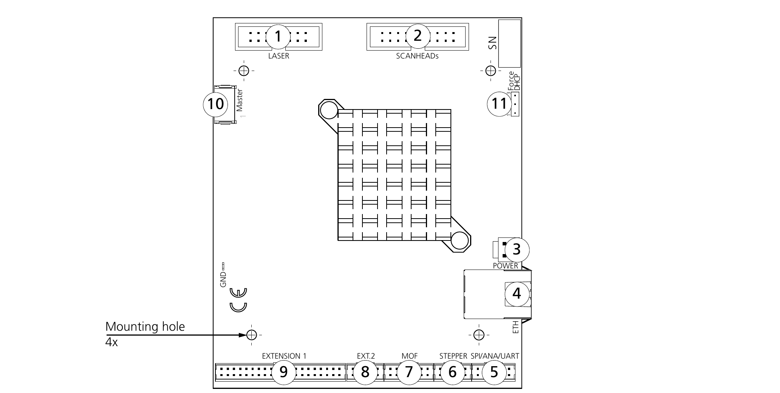
Figure 12.4 RTC6 Ethernet Board V1.2, upper side: its connector types and numbers differ from PCIe.
Drawing label | Port | Connector | Purpose
1 | LASER | 16-pin | Laser gate/pulse signals, auxiliary digital I/O and analog outputs; use the model-specific pin map.
2 | SCANHEADs | 20-pin | Scan-head position interface; SL2-100, or XY2-100 through the matching converter.
3 | POWER | 2-pin | External board power supply; use the specified supply and polarity.
4 | ETH | 8P8C RJ | Ethernet connection to the PC/network; separate from laser and scan-head signals.
5 | SPI/ANA/UART | 12-pin | McBSP, two analog inputs and RS-232 share this connector; the label alone does not imply SPI support.
6 | STEPPER | 10-pin | Clock/direction/control signals for up to two external stepper drivers; not motor power.
7 | MOF | 14-pin | Encoder input for moving-workpiece compensation; not a motor drive output.
8 | EXT. 2 | 10-pin | 8-bit digital output; some pins depend on jumper configuration.
9 | EXTENSION 1 | 40-pin | 16-bit digital input and 16-bit digital output for peripheral control.
10 | Master | 6-pin | Clock-cycle synchronization between compatible boards; connect Master to Slave with power off.
11 | Force DHCP | Jumper | Jumper field for whether to ignore a stored static IP address; not an I/O port.
Lower side 16 | Slave | 6-pin | Clock-cycle synchronization between compatible boards; connect Master to Slave with power off.
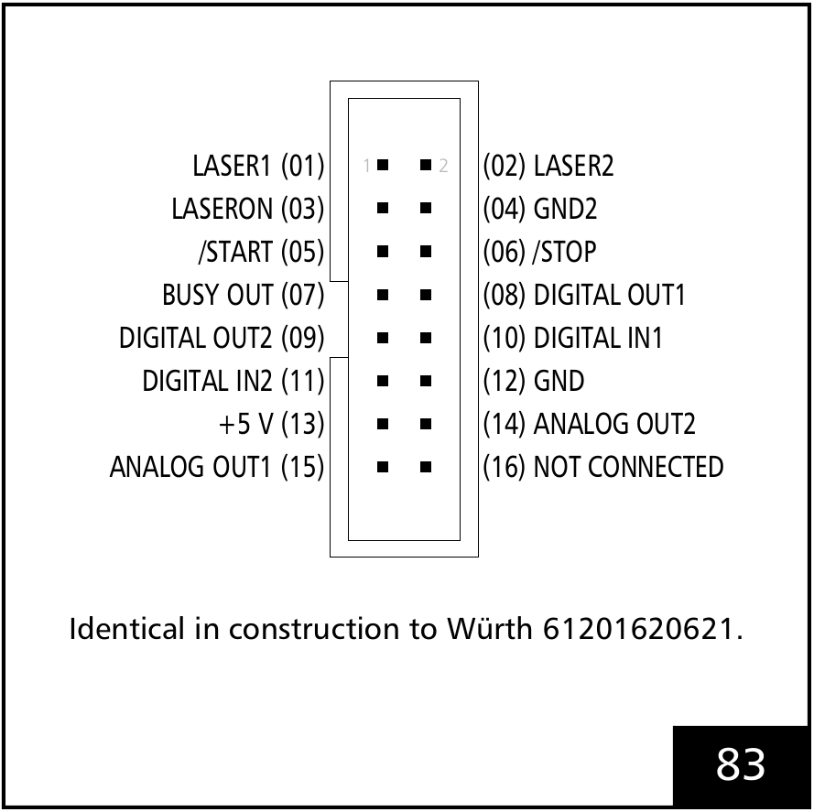
Figure 12.5 Original RTC6 Ethernet 16-pin LASER header; DIN1 is pin 10.

12.3.3 RTC5 PCI
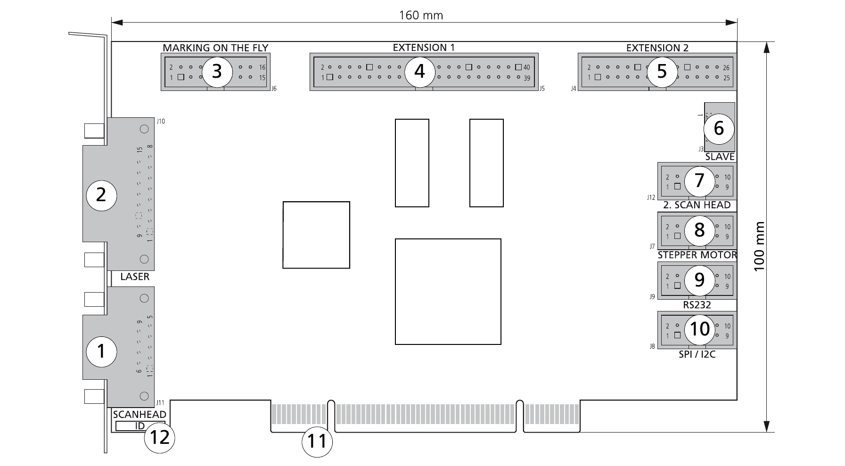
Figure 12.6 RTC5 PCI board: PCI host connector and SPI/I²C label, not RTC6 PCIe.
Drawing label | Port | Connector | Purpose
1 | SCAN HEAD | 9-pin D-SUB | Scan-head position interface; SL2-100, or XY2-100 through the matching converter.
2 | LASER | 15-pin D-SUB | Laser gate/pulse signals, auxiliary digital I/O and analog outputs; use the model-specific pin map.
3 | MARKING ON THE FLY | 16-pin | Encoder input for moving-workpiece compensation; not a motor drive output.
4 | EXTENSION 1 | 40-pin | 16-bit digital input and 16-bit digital output for peripheral control.
5 | EXTENSION 2 | 26-pin | 8-bit digital output; some pins depend on jumper configuration.
6 | Slave | 6-pin | Clock-cycle synchronization between compatible boards; connect Master to Slave with power off.
7 | 2. SCAN HEAD | 10-pin | Second scan-head interface; matching controller option required.
8 | STEPPER MOTOR | 10-pin | Clock/direction/control signals for up to two external stepper drivers; not motor power.
9 | RS232 | 10-pin | RS-232 communication with an external device, such as a compatible laser interface.
10 | SPI/I2C | 10-pin | RTC5 serial extension interface, labeled SPI/I²C; do not apply this label or pin map to RTC6 PCIe.
11 | PCI | PCI | Host PC bus interface. PCI and PCIe are different slot types.
12 | ID | — | Board identification label; not a connection port.
Lower side 1 | Master | 6-pin | Clock-cycle synchronization between compatible boards; connect Master to Slave with power off.
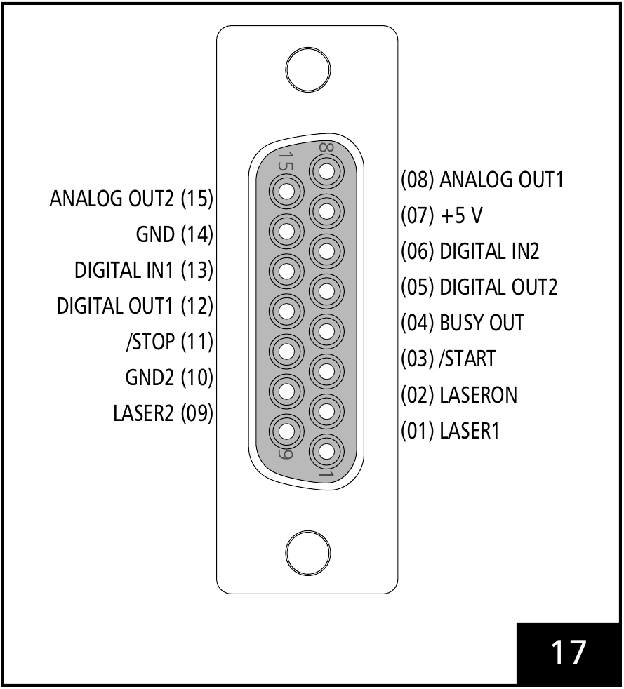
Figure 12.7 Original RTC5 PCI 15-pin female LASER D-SUB and pin assignments.

12.3.4 RTC4 PCI
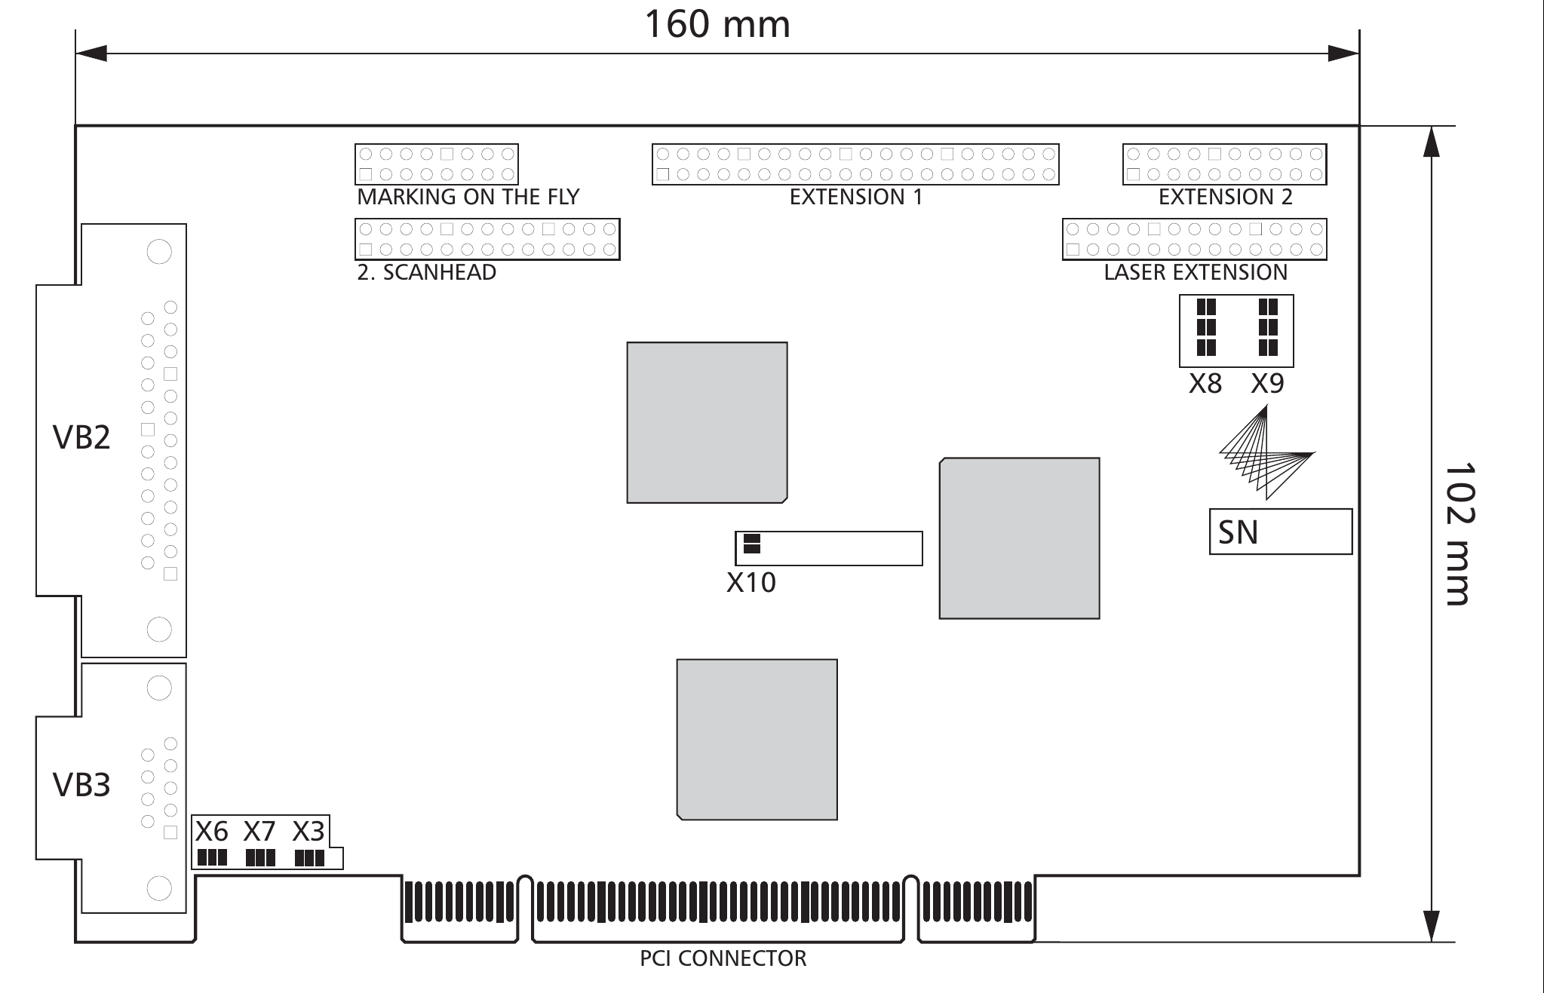
Figure 12.8 RTC4 standard PCI board: VB2 is the scan-head connector; VB3 is the 9-pin LASER connector.
Port and drawing label | Connector | Purpose
SCANHEAD  (VB2) | 25-pin D-SUB | Primary scan-head XY2-100 interface of the shown RTC4 standard board.
LASER  (VB3) | 9-pin D-SUB | Laser control and analog output; pins 2 and 4 depend on the board jumpers.
MARKING ON THE FLY | Optional | Encoder input for moving-workpiece compensation; not a motor drive output.
2. SCANHEAD | Optional | Second scan-head interface; matching controller option required.
EXTENSION 1 | Digital I/O | 16-bit digital input and 16-bit digital output for peripheral control.
EXTENSION 2 | Optional | Optional RTC4 I/O Extension Board connection; not the RTC6 EXTENSION 2 pin map.
LASER EXTENSION | 26-pin | 8-bit digital output; some pins depend on jumper configuration.
PCI  (PCI CONNECTOR) | PCI | Host PC bus interface. PCI and PCIe are different slot types.
Jumpers  (X6/X7/X3, X10, X8/X9) | — | Configuration jumpers, not external connection ports.
Serial label  (SN) | — | Board identification label; not a connection port.
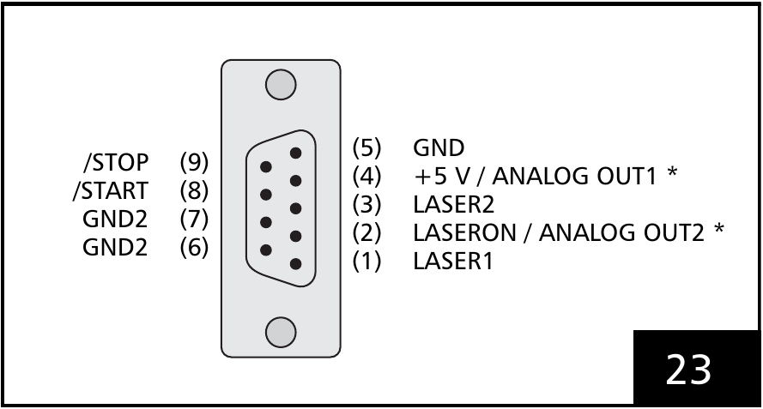
Figure 12.9 RTC4 9-pin female LASER connector: pins 2 and 4 depend on jumpers.
Signal | RTC5 PCI / RTC6 PCIe, 15-pin D-SUB | RTC6 Ethernet board header, 16-pin | RTC4 PCI, 9-pin D-SUB
LASER1 | 1 | 1 | 1
LASERON | 2 | 3 | 2*
LASER2 | 9 | 2 | 3
GND2 | 10 | 4 | 6, 7
/START | 3 | 5 | 8
/STOP | 11 | 6 | 9
BUSY OUT | 4 | 7 | —
DIGITAL OUT1 | 12 | 8 | —
DIGITAL OUT2 | 5 | 9 | —
DIGITAL IN1 (DIN1) | 13 | 10 | —
DIGITAL IN2 | 6 | 11 | —
GND | 14 | 12 | 5
+5 V | 7 | 13 | 4*
ANALOG OUT1 | 8 | 15 | 4*
ANALOG OUT2 | 15 | 14 | 2*
NOT CONNECTED | — | 16 | —
* RTC4 pins 2/4 depend on jumper selection: LASERON or ANALOG OUT2; ANALOG OUT1 or +5 V. The RTC6 15→9-pin laser adapter is a separate accessory with its own jumpers. The Ethernet 16→15-pin cable example maps header pins to the PCIe-style D-SUB; verify the actual cable.

12.4 Read the laser timing diagrams
1. LASERON defines the active gate. LASER1 and LASER2 change roles with LaserMode. The original diagrams show electrical control signals with active-HIGH polarity; they do not measure optical pulses or energy.
2. CO₂ alternates LASER1 and LASER2 by half a period. In YAG 1/2/3/5, LASER1 is Q-switch and LASER2 is FirstPulseKiller: the first Q-switch pulse starts after 0, the FPK length, 10 µs or the configured Q-switch delay, respectively. The combined YAG drawing makes this difference visible.
3. Mode4 keeps LASER1 standby pulses running and outputs FPK on LASER2 at activation. Mode6 also keeps standby pulses running, has no LASER2 output and defers gate switching during an active standby pulse until its end plus 5/64 µs. Select the source’s required interface and verify polarity, pulse completion and ground before use.
Mode | LASER1 / LASER2 | Active / standby behavior
Co2 (0) | Modulation 1 / 2 | Alternating modulation with 180° phase offset; standby pulses when idle.
Yag1 (1) | Q-switch / FPK | First Q-switch pulse starts with FPK; LASER1 standby pulses when idle.
Yag2 (2) | Q-switch / FPK | Preset Q-switch delay equals FPK length: first pulse starts at FPK end.
Yag3 (3) | Q-switch / FPK | Preset first-pulse delay is 10 µs from FPK start.
Mode4 (4) | Standby / FPK | LASER1 standby train continues in both states; LASERON gates processing; FPK on LASER2 when active.
Yag5 (5) | Q-switch / FPK | First-pulse delay is explicitly programmable with Q-switch delay; otherwise YAG timing.
Mode6 (6) | Standby / off | LASER1 remains continuous. If a standby pulse is active, LASERON switches 5/64 µs after its end. No LASER2 output.

FPK is an electrical request that the laser must interpret, not proof that excess optical energy was removed. Configure standby, pulse completion, polarity and gate behavior against the laser supplier’s interface. LaserModes.None is not a physical laser safety function. Pulse-picking mode has a separate RTC6 contract and is not covered by this 0–6 table.
Yag1/2/3 preset the Q-switch delay; a later Q-switch-delay setting can change it. In Yag2, changing FirstPulseKiller length also readjusts that delay automatically. Standby and active pulses need not have synchronized phases. RTC4 supports LaserMode 0–4; RTC5 and RTC6 support 0–6. LaserMode is separate from Sky Writing Mode.
FPK is a request signal: the laser must implement the response. Keep LaserModes.None, pulse picking, analog control and serial control under their existing separate contracts; these diagrams do not replace those settings.
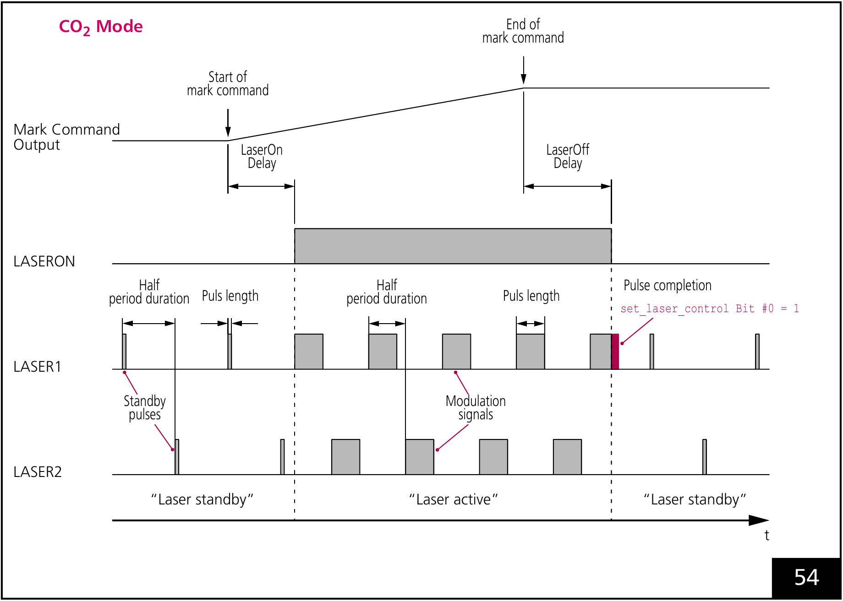
Figure 12.10 Original CO₂ timing: LASER1 and LASER2 are offset by half a period.
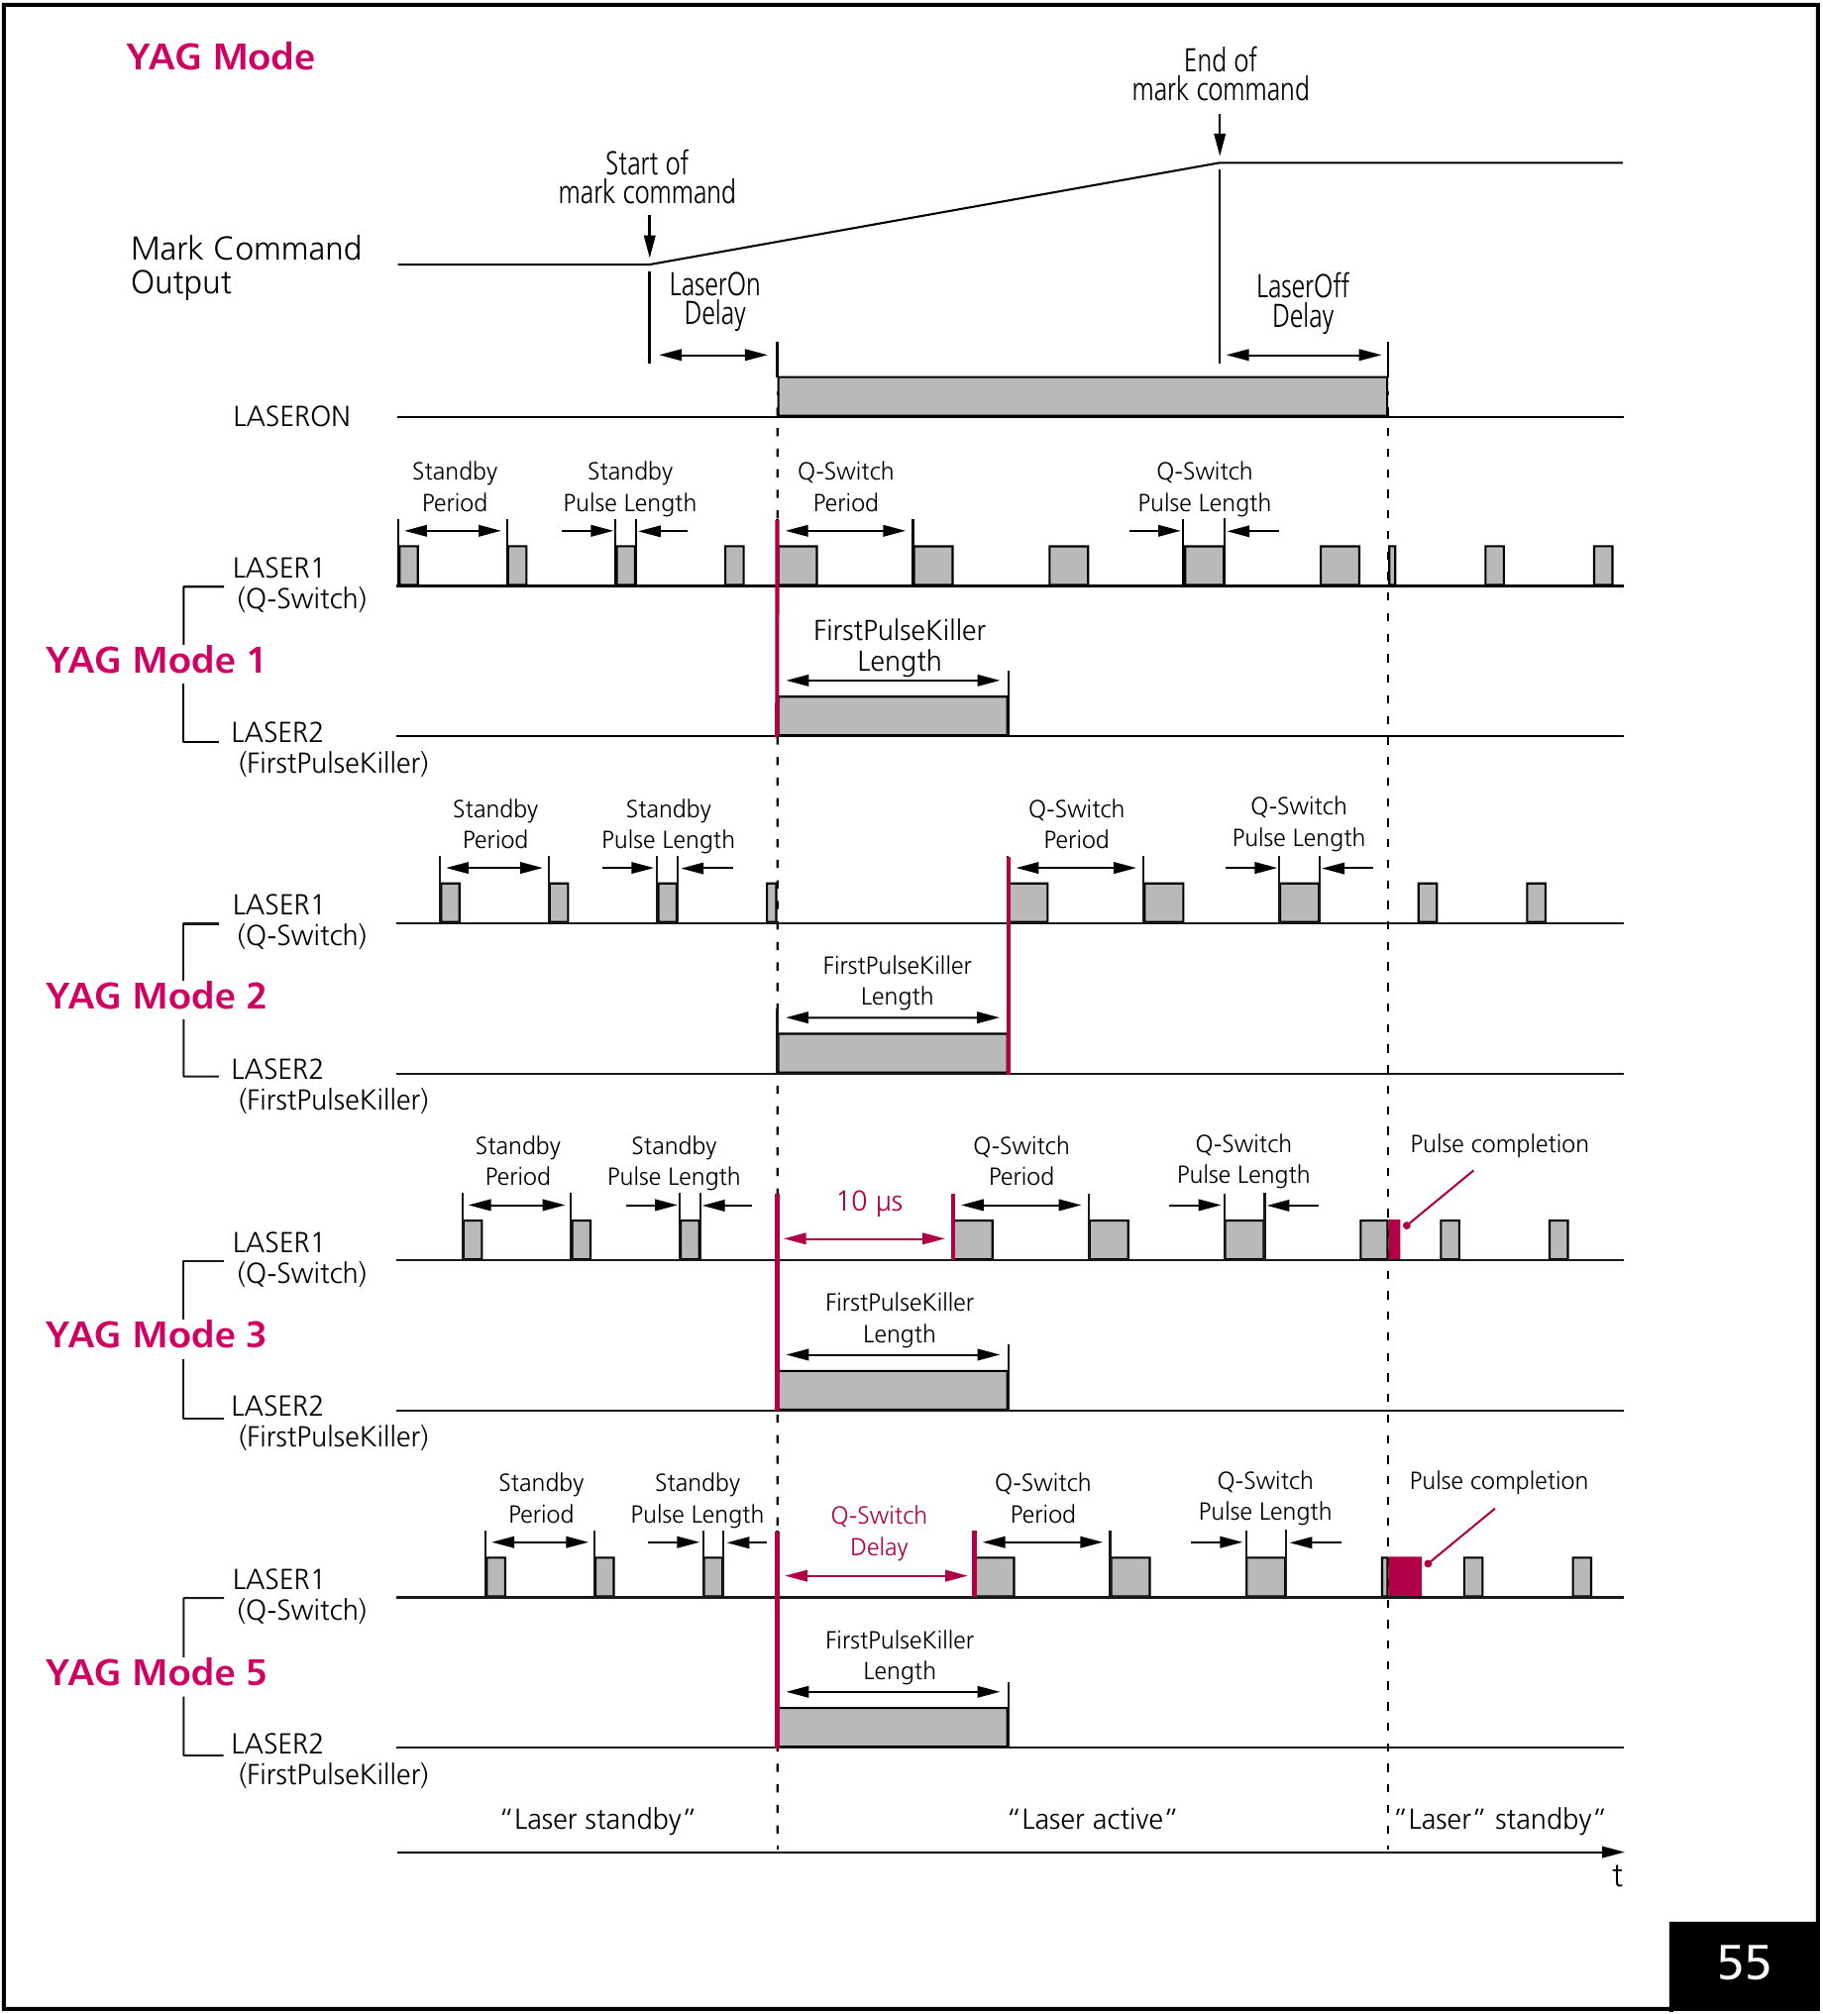
Figure 12.11 Original YAG 1/2/3/5 comparison: the first Q-switch pulse starts at different times.
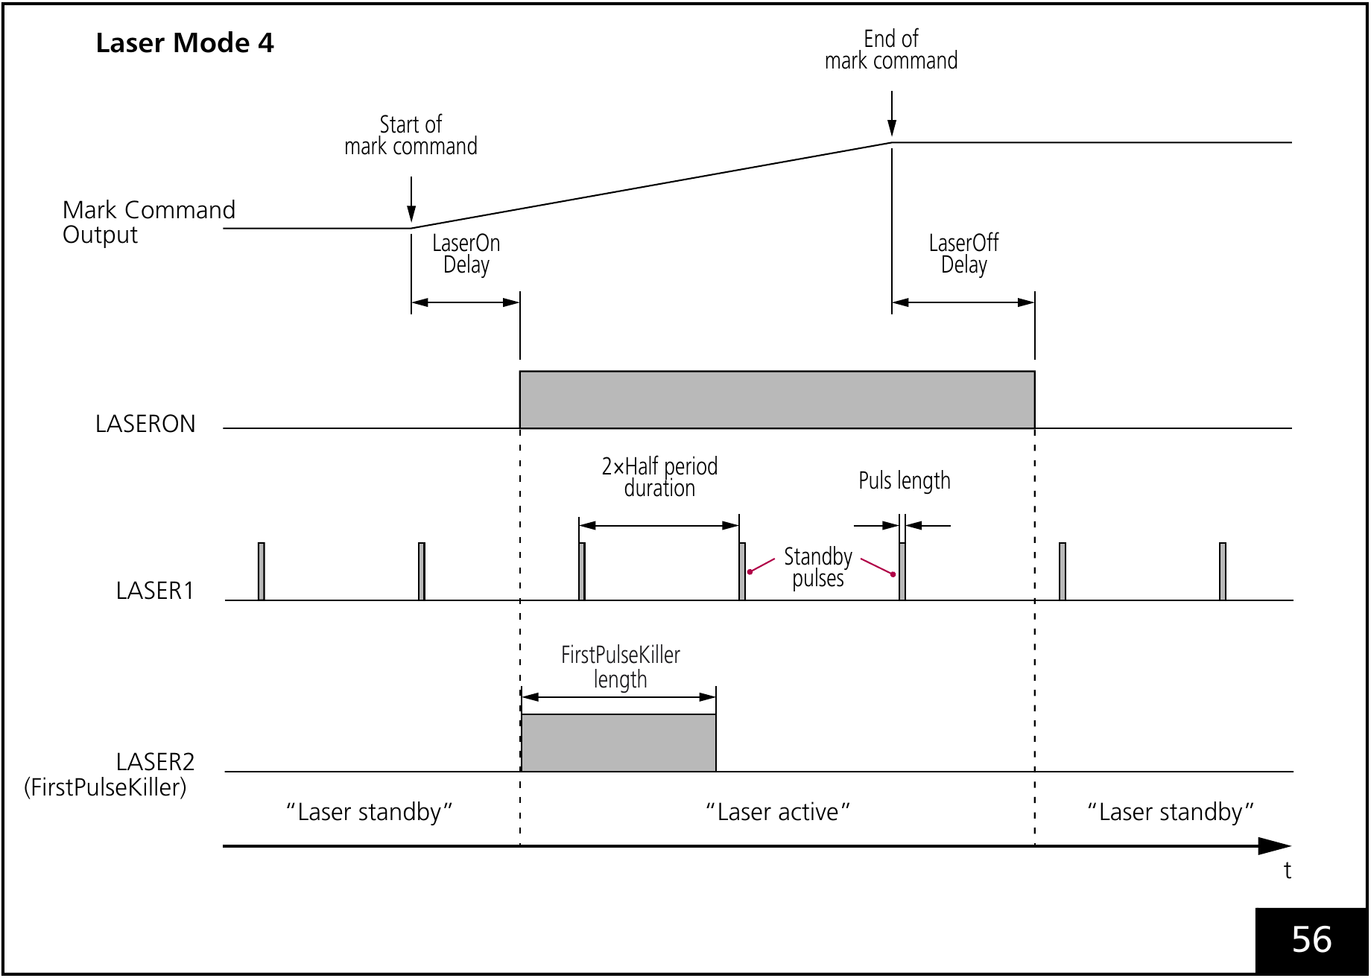
Figure 12.12 Original Mode4 timing: continuous standby pulses and a FirstPulseKiller signal.
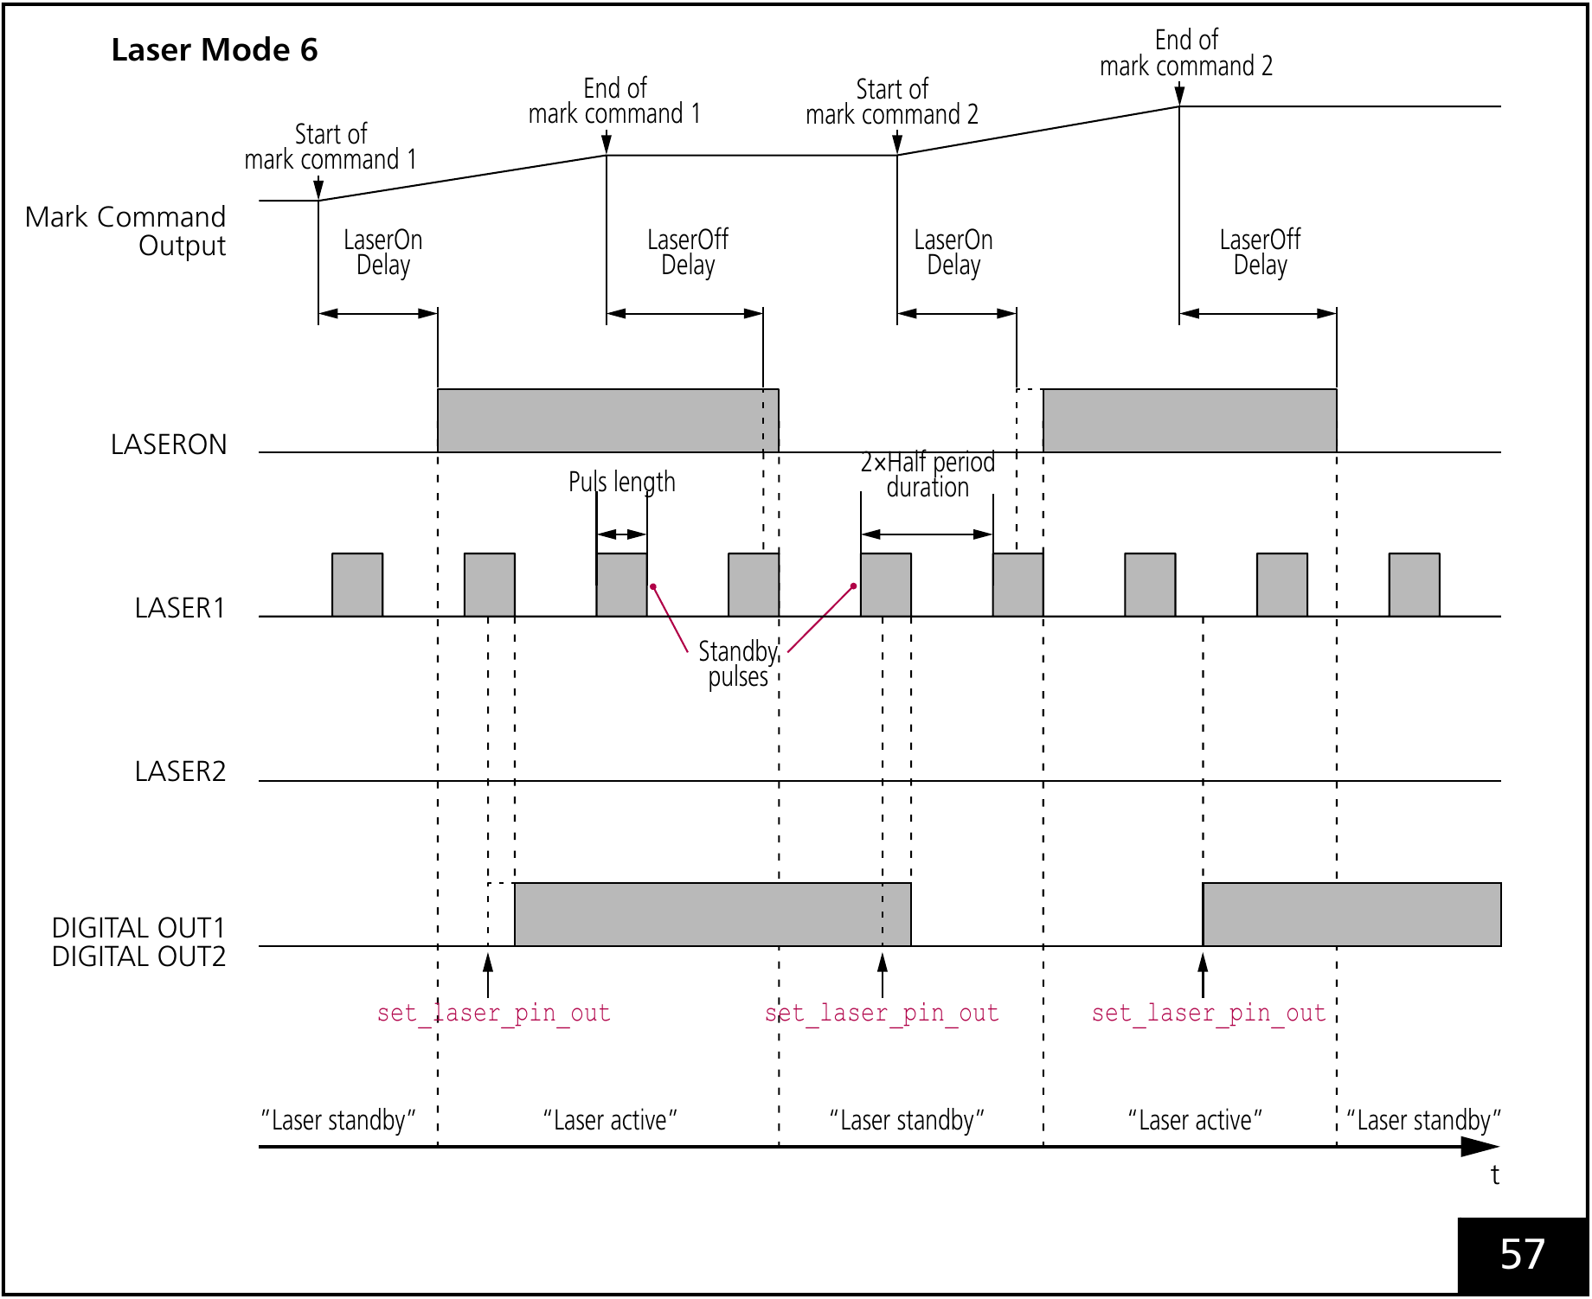
Figure 12.13 Original Mode6 timing: a standby pulse can defer LASERON and the shown digital-output changes.

12.5 Adjust laser timing, then scanner settling
Galvanometer mirrors cannot follow a discontinuous command instantly; acceleration, settling and tracking lag separate the commanded and physical spot positions. The laser also has an electrical-to-optical response. Scanner delays allow motion to settle or change direction; laser delays align emission with the useful part of that motion. Reducing every delay to zero can increase start/end burns, missing strokes and corner errors.
Setting | Purpose | Too short / too long
JumpDelay | After a laser-off jump | A short delay leaves the next start unstable; an excessive delay wastes cycle time.
MarkDelay | After the final mark vector | A short value can let the next jump start before the delayed laser-off; a long value reduces throughput.
PolygonDelay | Between consecutive mark vectors | Too short rounds corners; too long slows the corner and can concentrate heat. Laser behavior also depends on variable-delay EdgeLevel.
LaserOnDelay | Emission at contour start | Too short: start burn. Too long: missing start. Negative values can deliberately preheat and add scan time.
LaserOffDelay | Emission at contour end | Too short: missing end. Too long: end burn or an exposed following motion.

This sequence applies to ordinary delay handling. For SCANahead automatic delays, use the dedicated EntityPen, LayerPen and SCANahead explanations. Do not transfer ordinary delay values unchanged. Overlapping delays can alter the trajectory and duration, so also inspect short vectors and pen changes.
1. Keep the head tuning, field, jump/mark speeds, pulse settings and material fixed. Start with generous JumpDelay and MarkDelay so scanner settling does not mask the laser switching error. First adjust LaserOnDelay at the start and LaserOffDelay at the end.
2. Then reduce the scanner delays one at a time: JumpDelay for landing, MarkDelay before the next jump, and PolygonDelay between connected marks. In each original illustration, the upper result uses too little delay and the lower too much; the clock means longer processing time without a visible defect.
3. Check short and long jumps, several corner angles, field edges and the actual product, recording quality and cycle time. Positive laser delays normally do not add scan time; negative LaserOnDelay and automatic overlap corrections can add waits. SCANahead automatic delays use their separate procedure.
Recheck field edges and actual production objects after tuning.
The PolygonDelay burn-in example assumes the laser stays on between connected marks. Variable Polygon Delay can switch the laser at corners according to EdgeLevel. These drawings describe ordinary delay handling, not SCANahead Auto Delays.
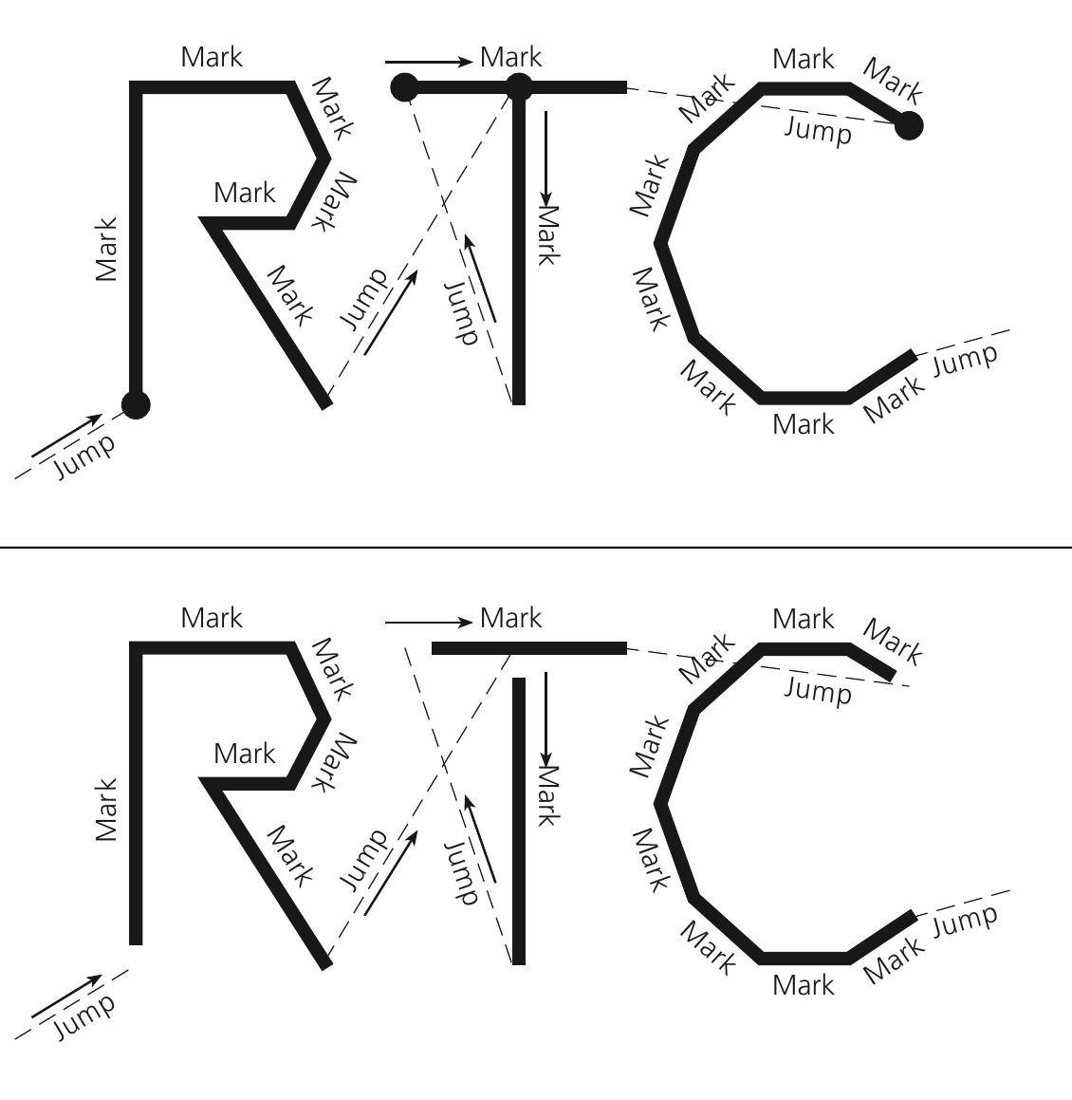
Figure 12.14 LaserOnDelay: above, too short burns the starts; below, too long leaves the starts incomplete.
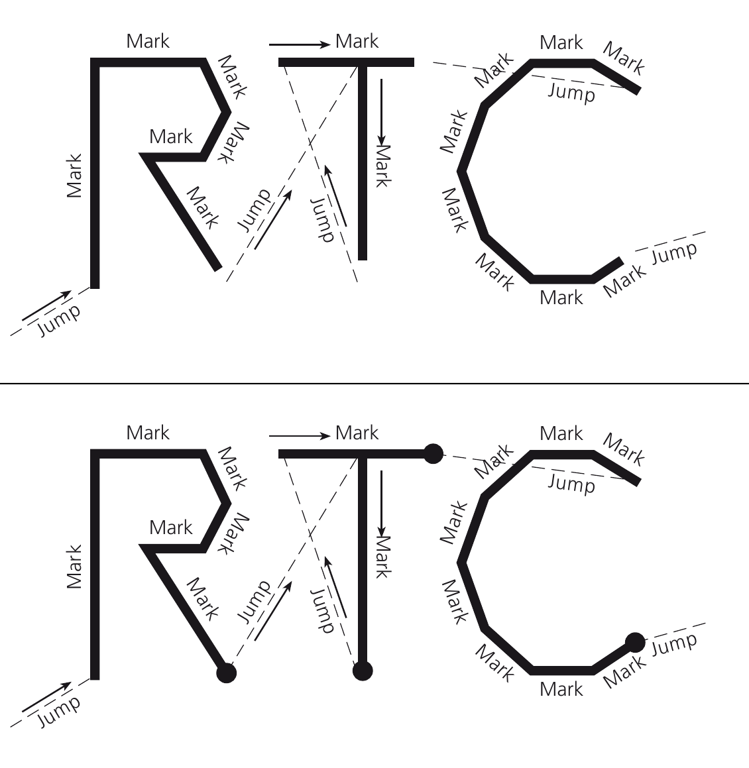
Figure 12.15 LaserOffDelay: above, too short leaves ends incomplete; below, too long burns the ends.
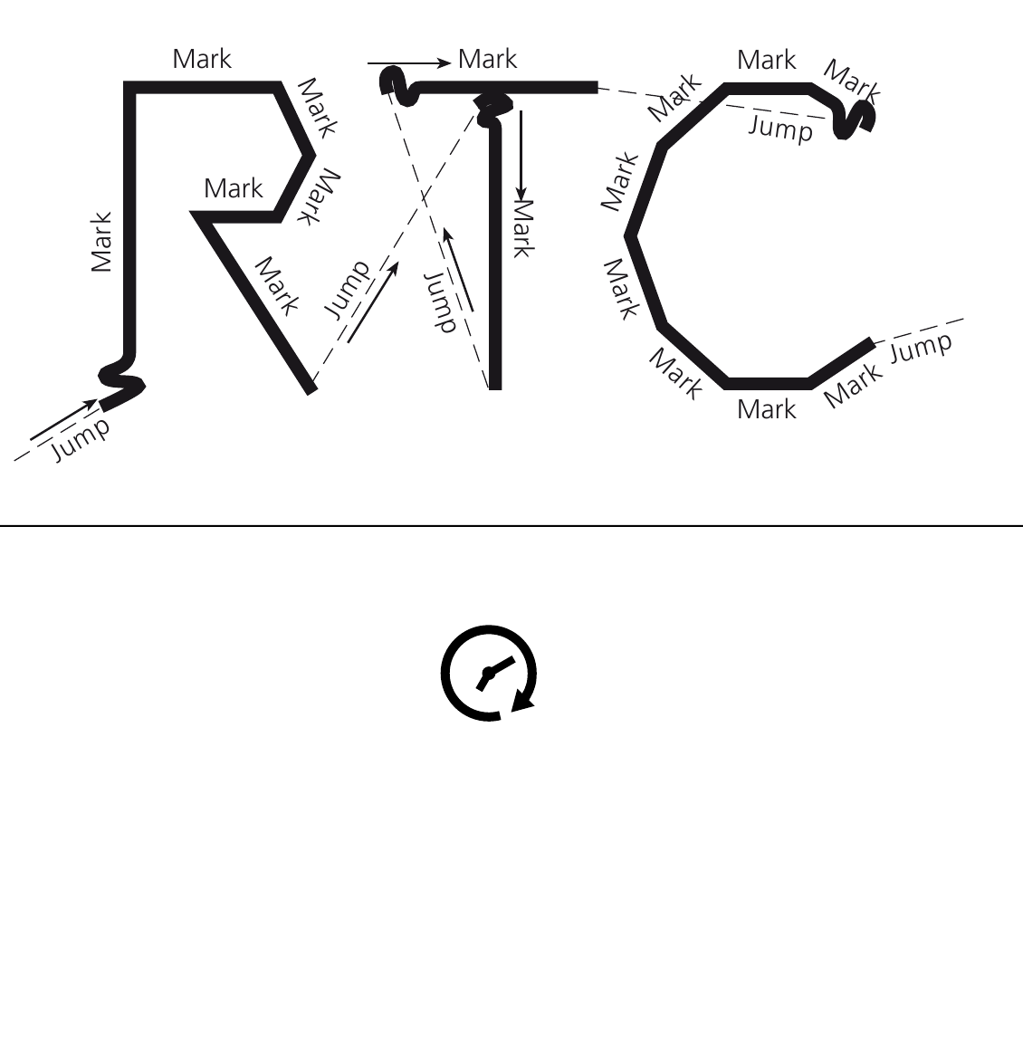
Figure 12.16 JumpDelay: above, too short causes oscillation/overshoot; below, too long only increases scan time.
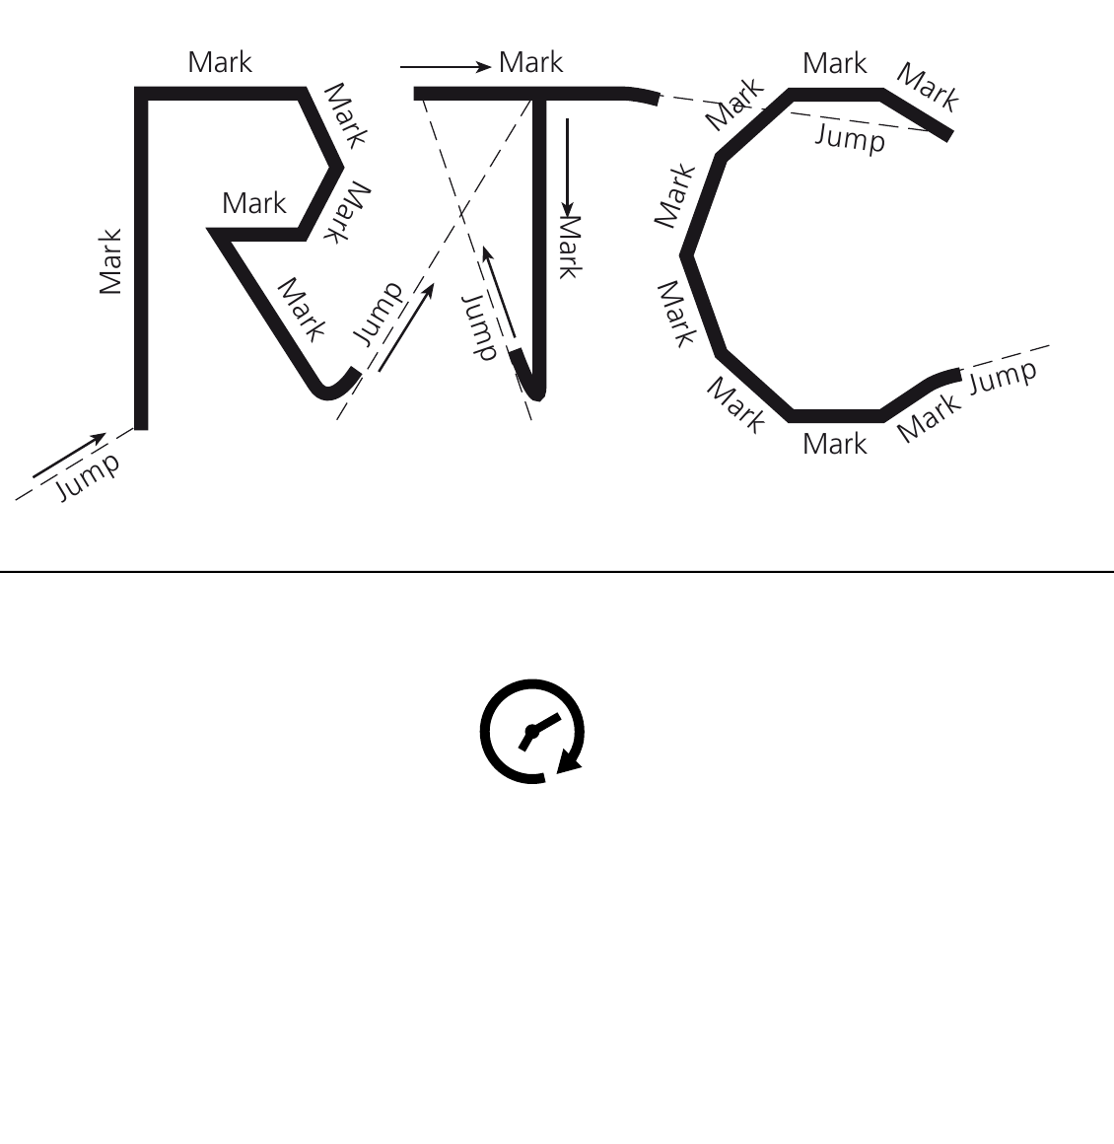
Figure 12.17 MarkDelay: above, too short pulls the end towards the next jump; below, too long only adds time.
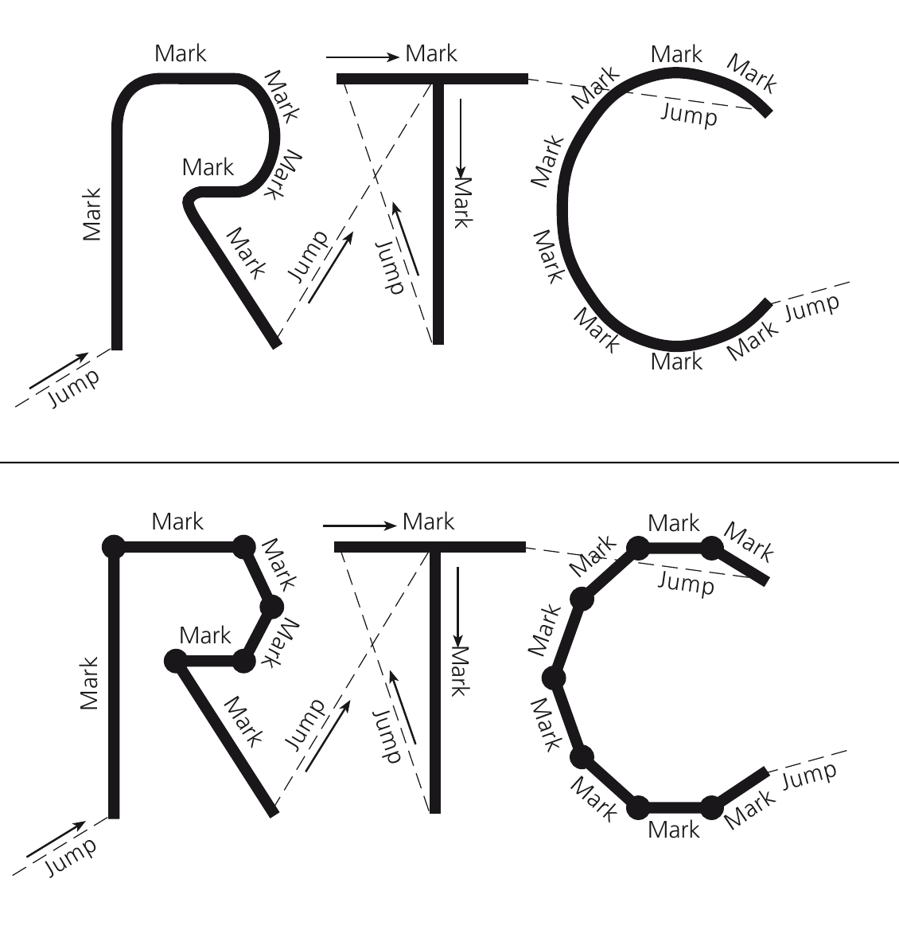
Figure 12.18 PolygonDelay: above, too short rounds corners; below, too long burns corners while the laser stays on.

13 IRtc and the SCANLAB execution model
IRtc combines a scanner’s geometry commands with RTC list execution, status, correction and timing. Build the high-level document workflow first. Use direct RTC lists when an application requires a bounded custom sequence and the controller-specific prerequisites are understood. Optional interfaces such as IRtcSkyWriting, IRtcMoF, IRtcSCANAhead and IRtcMeasurement describe capability, not automatic commissioning.
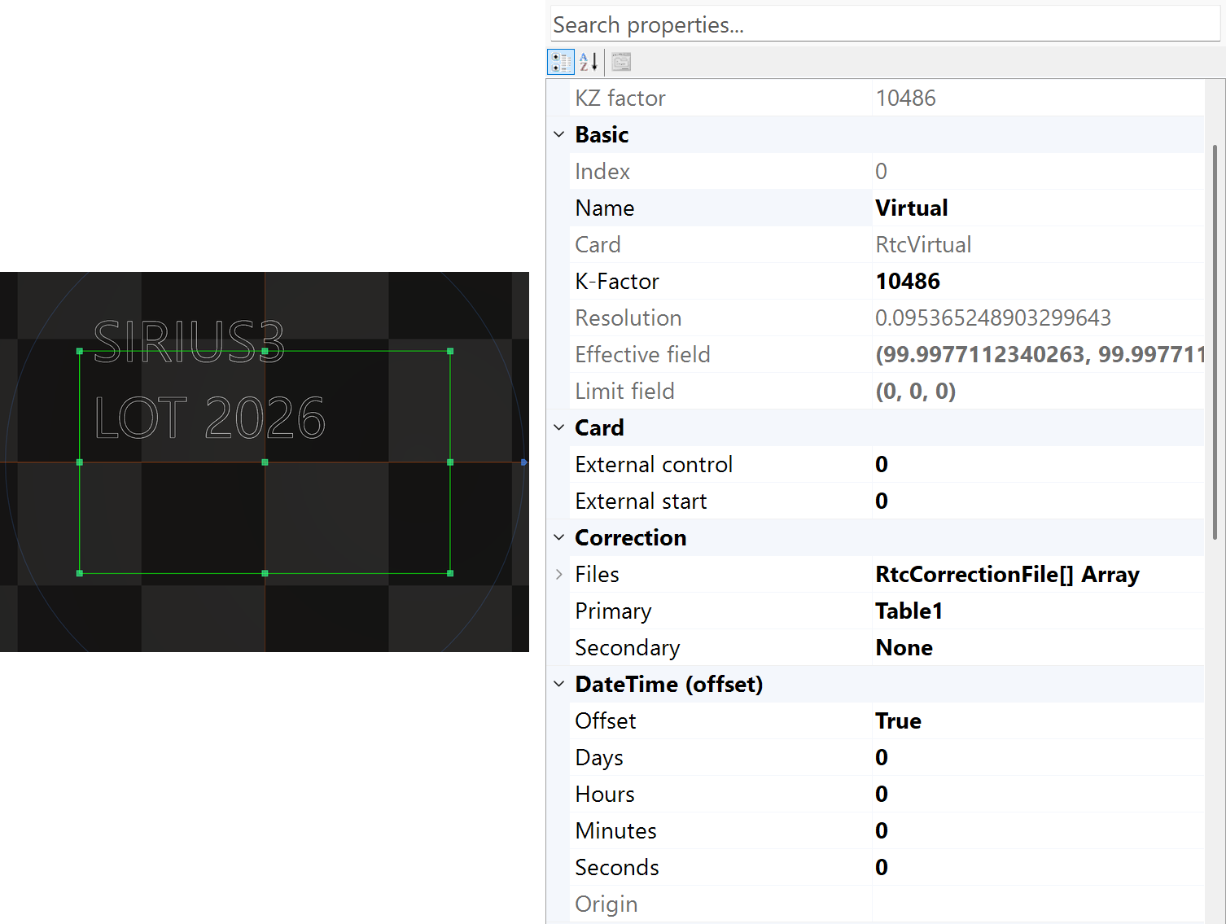
Figure 13.1 Selected virtual scanner and its coordinate and correction properties

13.1 Control commands and list commands
Stage | Action | Check
Initialize | Load the matching runtime and prepare the scanner.​ | Family, connection, driver, firmware and result.​
Ctl* | Read status or change immediate controller state.​ | Required idle/​busy state and command-specific restrictions.​
ListBegin → List* → ListEnd | Prepare and finalize the buffered job.​ | Every command result.​ Never execute a partially failed list.​
ListExecute | Submit the finalized list.​ | busyWait=false returns after submission, not completion.​
Completion /​ abort | Observe controller and application results.​ | Busy/​error/​completion, cancellation and safe recovery.​

Command family | When it acts | Examples
Control (Ctl*) | Requests a current-state change or reads status at the call. A move request still needs completion monitoring. | CtlMoveTo / CtlGetStatus
List (List*) | Records a command for RTC execution. Auto may start a completed buffer while later commands are still being written. | ListJumpTo / ListMarkTo
1. Create and initialize the devices, then load the matching correction file and set KFactor and timing. Keep the DLL, firmware and scan-head tuning compatible, with one process owning the board.
2. Use ListBegin → checked List* calls → ListEnd → ListExecute. A document Marker owns this sequence; do not open another list around or inside Marker processing. If generation fails, stop writing, abort the RTC and laser, and do not submit the incomplete remainder. Auto may already have executed earlier buffers.
3. ListExecute(false) returns after submission; confirm completion, abort and error status before changing controller settings. ListExecute(true) waits in the calling thread. Put low-level waiting work outside the UI thread.

13.1.1 Single and Auto: when the controller starts
1. Single records a finite job before ListExecute starts it. Use it when the whole generated command stream fits in the available List 1 memory.
2. Auto alternates two finite native lists. While the RTC executes one, the PC can prepare the other. Sirius3 can start a completed buffer during List* generation, before the final ListExecute. Longer total jobs are possible without enlarging the board memory.
3. Auto is the default for MarkerRtc and MarkerRtcFast. DoubleBufferMaxSize controls the switching threshold and defaults to 4000. This is not the total board capacity or a maximum entity count. Continuous output still depends on command generation, transfer and execution timing.

13.1.2 List storage capacity
Controller | Total native storage positions | List 1 allocation in Sirius3 Single | Auto: native List 1 + List 2 (default)
RTC4 / RTC4e | 8,000 | 8,000 | 4,000 + 4,000
RTC5 | 1,048,576 (2²⁰) | 917,504 (2²⁰ − 2¹⁷) | 8,000 + 8,000
RTC6 / RTC6e | 8,388,608 (2²³) | 8,257,536 (2²³ − 2¹⁷) | 8,000 + 8,000
RTC5/6 reserve 131,072 positions for List 3 in Single mode; native List 2 is empty. The table describes allocated storage, not a guaranteed number of C# calls, vertices or entities. Some commands occupy multiple positions, and setup/end commands also consume space. Check every result and retain headroom. Native memory partitioning changes the use of fixed board memory; it does not allocate unlimited memory.
Auto values show the native List 1 + List 2 allocation at the default threshold 4000. RTC5/6 assign 2 × DoubleBufferMaxSize to each native list; the remainder belongs to List 3. The defaults leave 1,032,576 positions on RTC5 and 8,372,608 on RTC6. This differs from Single’s fixed 131,072-position reservation. The RTC4/RTC4e row describes Sirius3 Rtc4/Rtc4Ethernet and their legacy 8,000-position model; verify the actual board revision and driver.

13.2 Controller capabilities
Feature | RTC4 family | RTC5 | RTC6 family
Scanner interface / positioning | XY2-100 / 16 bit | SL2-100 / 20 bit; Z control 16 bit | SL2-100 / 20 bit
Correction format | CTB | CT5 | CT5
Sky Writing | Unsupported | Modes 1–3 | Modes 1–4
Automatic Laser Control | Unsupported | Supported; mode/output limits | Supported; mode/output limits
SCANahead / Spot Distance Control | Unsupported | Unsupported | Matching options, head and firmware; SDC also needs a suitable laser
MoF | Controller option; limited public operations | Controller option; verify encoder configuration | Controller option; verify encoder configuration
Sirius3 IRtcStepper | Not exposed by Rtc4/Rtc4e | Exposed | Exposed
The table combines hardware generation and the implemented Sirius3 capability. An interface or connector alone does not enable a feature: verify the concrete scanner, installed controller options, firmware and required Sirius3 license. RTC4 PCIe hardware may offer step-motor control, but this does not make Rtc4/Rtc4e implement IRtcStepper. RTC Ethernet variants have their own connector and connection handling; do not reuse another board pin map. syncAXIS uses its separate configuration/job model.

13.3 Align a rotated scan head with the working coordinates
A head mounted at 90°, 180° or −90° does not require every document entity to be rotated. IRtc2ndHead.PrimaryHeadBaseOffset aligns the installed head with the desired working X/Y axes. Sirius3 combines it with PrimaryHeadUserOffset and applies the result through the RTC hardware matrix/offset.
Use entity ModelMatrix for object shape/placement (7.3 ITransformable and coordinate spaces), Marker Offsets for repeated job locations (17.2 LayerFirst and OffsetFirst), and 23.4 Enter the measured positions correctly when converting measured working positions back into scanner axes. These settings act at different stages; do not apply the same installation compensation twice.
Use a verified installation angle: the figure shows a +90° mounting convention compensated by −90°. Check axis direction and viewing convention rather than assuming the sign for every head. Start from Offset.Zero so scale is one, then set AngleZ explicitly. Offset(dx,dy,dz) takes Z translation as its third numeric argument; that overload does not specify a rotation angle.
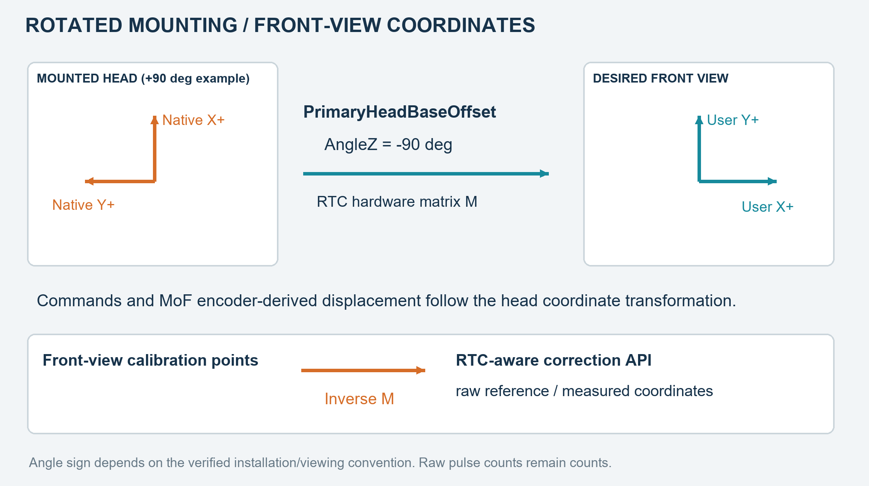
Figure 13.2 Mounting compensation, MoF displacement and inverse conversion for calibration
Listing 13.1 Set AngleZ explicitly during scanner setup
public static void SetMountingAngle(IRtc2ndHead head, double verifiedAngleZ)
{
var mounting = SpiralLab.Sirius3.Mathematics.Offset.Zero;
mounting.AngleZ = verifiedAngleZ; // Degrees; example: -90.
// Configure only during authorized, idle scanner setup.
head.PrimaryHeadBaseOffset = mounting;
}
The head transformation also affects the displacement contributed by external encoder inputs during MoF. Its rotation/axis orientation therefore has to agree with conveyor or Stage motion as well as the drawn geometry. Configure encoder counts/mm and signs for the physical connection. The raw encoder counter is still a count register; the matrix changes the resulting coordinate compensation, not the stored pulse count itself.

14 ILaser and output control
Prepare the scanner geometry and correction first. ILaser then connects the process power settings to the actual laser interface. It represents the source commands, state and startup/cleanup. Assign Scanner before initialization, then register the initialized adapter with the editor and marker. MaxPowerWatt is the configured source maximum. Available optical output also depends on frequency, pulse width and the source’s operating limits.
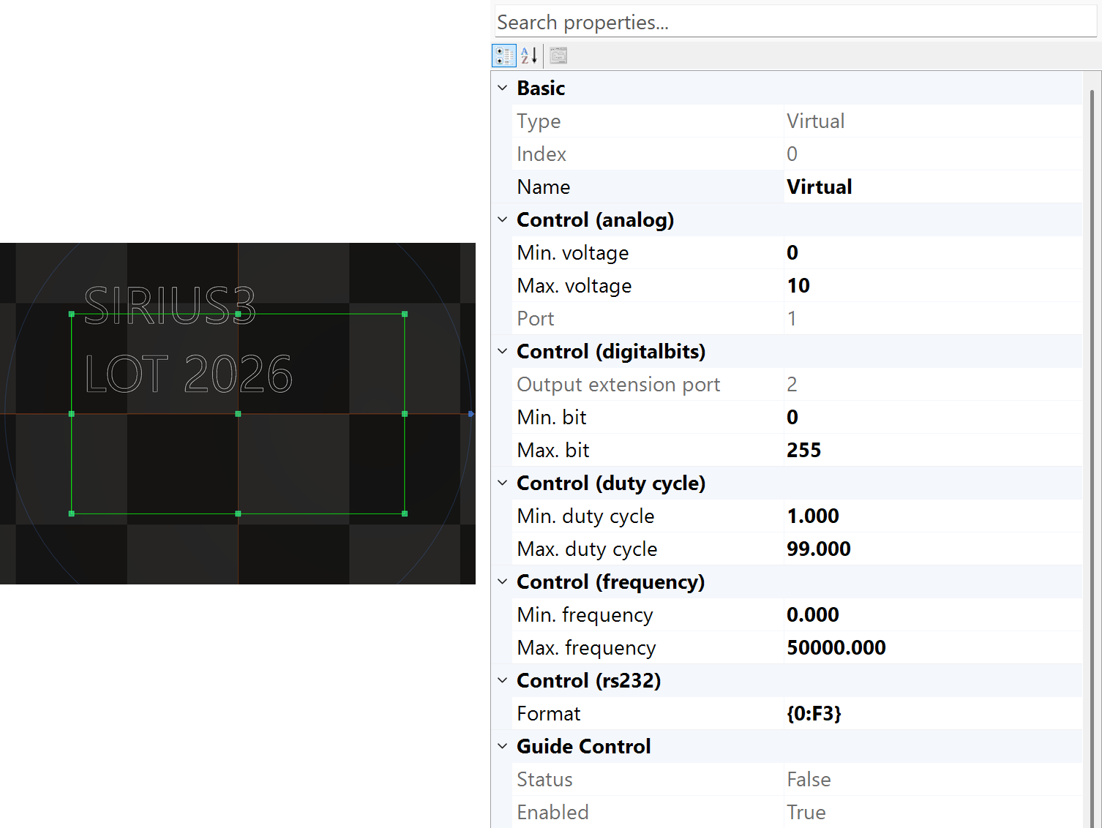
Figure 14.1 Selected virtual laser and its source-related properties
Capability | Purpose | Application rule
ILaser | Identity, state, initialization and lifetime | Bind the correct scanner and vendor/​runtime prerequisites.​
ILaserPowerControl | PowerMap, CtlPower and ListPower | Keep immediate control separate from buffered marking commands.​
PowerControlMethods | Analog, frequency, duty-cycle or digital command mapping | Select the method the laser input actually accepts; pulse settings may be derived by the adapter.​
Guide and vendor capabilities | Pointer and source-specific operations | Do not assume optional capability exists on every source.​

14.1 PropertyGrid settings to verify
Check the source Name/Index, maximum output, power-control method and Scanner assignment. Also check Ready/Busy/Error and the manufacturer’s pulse limits. Changing EntityPen.Power prepares a recipe setting. Manual output and source-control commands can affect the device immediately. Use virtual devices on the test workstation until the real interface and machine conditions have been deliberately commissioned.

14.2 Extend a laser adapter
demos/editor_laser_ui/laser_source.cs and LaserUIControl.cs show an adapter and its UI. LaserBase provides common state and notifications. A physical adapter must still implement communication, limits, failure reporting, abort and cleanup. Changing the panel alone does not implement laser control. Keep device communication out of rendering callbacks and avoid long-running UI event handlers.

14.3 LaserVirtual output methods
LaserVirtual is both a simulation aid and a configurable RTC output adapter. With RtcVirtual, it models output. With a physical RTC, its power methods can drive real pins or serial communication. Choose one of the separate configurations below. Assign Scanner, call Initialize, then register the adapter. Dispose any instances you do not use.
Listing 14.1 Factory alternatives for RTC-controlled output
public static ILaser[] CreateOutputAdapters()
{
return new ILaser[]
{
LaserFactory.CreateVirtual(0, 20, PowerControlMethods.Unknown),
LaserFactory.CreateVirtual(0, 20, PowerControlMethods.Custom),
LaserFactory.CreateVirtualAnalog(0, 20, 1, 0, 10),
LaserFactory.CreateVirtualFrequency(0, 20, 20000, 80000),
LaserFactory.CreateVirtualDutyCycle(0, 20, 1, 90),
LaserFactory.CreateVirtualDO16Bits(0, 20, 0, 65535),
LaserFactory.CreateVirtualDO8Bits(0, 20, 0, 255),
LaserFactory.CreateVirtualRS232(0, 20, "P={0:F1}\r")
};
}
1. LaserVirtual is an RTC output adapter and can control real outputs. Assign a compatible initialized RTC, valid channels and MaxPowerWatt > 0. Resolve target W through PowerMap only when a map and nonempty category are assigned; lookup failure returns false.
2. Let q = clamp(compensatedWatt / MaxPowerWatt, 0, 1). With no map, target 5 W and MaxPowerWatt=20 W give q=0.25. The table gives the electrical/protocol command, not independently measured optical watts.
Table 14.1 LaserVirtual output by PowerControlMethods
PowerControlMethods | Calculation / example at q=0.25 | Control / List
Frequency | f = MinFrequency + (MaxFrequency−MinFrequency)*q [Hz]. 20–80 kHz → 35 kHz. | CtlFrequency / ListFrequency; current RTC pulse width is retained.
DutyCycle | d = MinDutyCycle + (MaxDutyCycle−MinDutyCycle)*q [%]; width = 1000000/f*d/100 [µs]. 1–90%, f=50 kHz → 23.25%, 4.65 µs. | CtlFrequency / ListFrequency; current RTC frequency f is retained and must be positive.
Analog | V = MinVoltage + (MaxVoltage−MinVoltage)*q [V]. 0–10 V → 2.5 V. AnalogPortNo 1/2 selects ExtAO1/ExtAO2. | CtlWriteData; ListWriteData, or Rtc6.ListLaserPower for RTC6.
DigitalBits | b = DigitalBitMinValue + (DigitalBitMaxValue−DigitalBitMinValue)*q; truncate to uint. Port 1: ExtDO16; port 2: ExtDO8. | Control and non-RTC6 List use b. RTC6 List ignores min/max: truncate(65535*q) or truncate(255*q), giving 16383 or 63.
Rs232 | string.Format(Rs232StringFormat, 100*q). "P={0:F1}\r" → P=25.0 plus CR under a dot-decimal culture. | IRtcSerialComm required. Control reads/discards pending bytes, then CtlSerialWrite; List uses ListSerialWrite without that read.
Unknown | No power conversion/output in this branch. | No list wait; this does not disable every RTC laser signal.
Custom | No device-specific output in base LaserVirtual. | Implement the required CtlPower and ListPower behavior in a custom adapter.
3. CtlPower applies an immediate command and sleeps the calling thread for (int)PowerControlDelayTime milliseconds. ListPower queues the output and a list wait in milliseconds for Frequency, DutyCycle, Analog, DigitalBits and Rs232. It can omit the whole operation if the target differs from LastPowerWatt by less than 0.001 W and the category is unchanged. Validate both paths with the actual adapter and laser.
Configure laser mode, frequency, pulse limits and channel separately. If manual output and ALC share a channel, define which controls it and when. See 13.1 Control commands and list commands for command execution timing and 16.2 Speed, position and Defined Vector control for output control by speed or position.

14.4 Implement a custom ILaser adapter
CustomLaser derives from LaserBase and implements ILaserPowerControl directly. LaserBase already provides ILaser, shared state and notifications. The // ... comments mark protocol-specific initialization, reset, abort, immediate power, list recording and resource cleanup. Replace the placeholder false results with the actual operation results; set IsReady/IsError and update LastPowerWatt only on success. Apply PowerMap lookup where required. The complete hardware adapter and UI are in demos/editor_laser_ui/laser_source.cs and LaserUIControl.cs.
Listing 14.2 CustomLaser with protocol-specific implementation points
public sealed class CustomLaser : LaserBase, ILaserPowerControl
{
public IPowerMap PowerMap { get; set; }
public override LaserTypes LaserType => LaserTypes.UserDefined1;
public CustomLaser(int index, double maxWatts)
{
Index = index;
Name = "Custom laser";
MaxPowerWatt = maxWatts;
IsPowerControl = true;
PowerControlMethod = PowerControlMethods.Custom;
}
public override bool Initialize()
{
// ... Initialize hardware; update IsReady and IsError.
return false;
}
public override bool CtlAbort()
{
// ... Stop emission and abort pending commands.
return false;
}
public override bool CtlReset()
{
// ... Reset hardware; update IsReady and IsError.
return false;
}
public bool CtlPower(double targetWatt, string category = "")
{
// ... Validate/map power, send immediately, update LastPowerWatt.
return false;
}
public bool ListPower(double targetWatt, string category = "")
{
// ... Validate/map power; record a synchronized list command.
return false;
}
protected override void Dispose(bool disposing)
{
// ... Release owned resources once; keep cleanup idempotent.
base.Dispose(disposing);
}
}

15 EntityPen and per-entity conditions
Select an object, note its PenColor, then select the matching EntityPen in the pen list. Several entities can share one process condition. The marker writes the pen’s list settings when the active pen changes, then appends the entity’s path. Editing a pen therefore changes every object that uses that color.
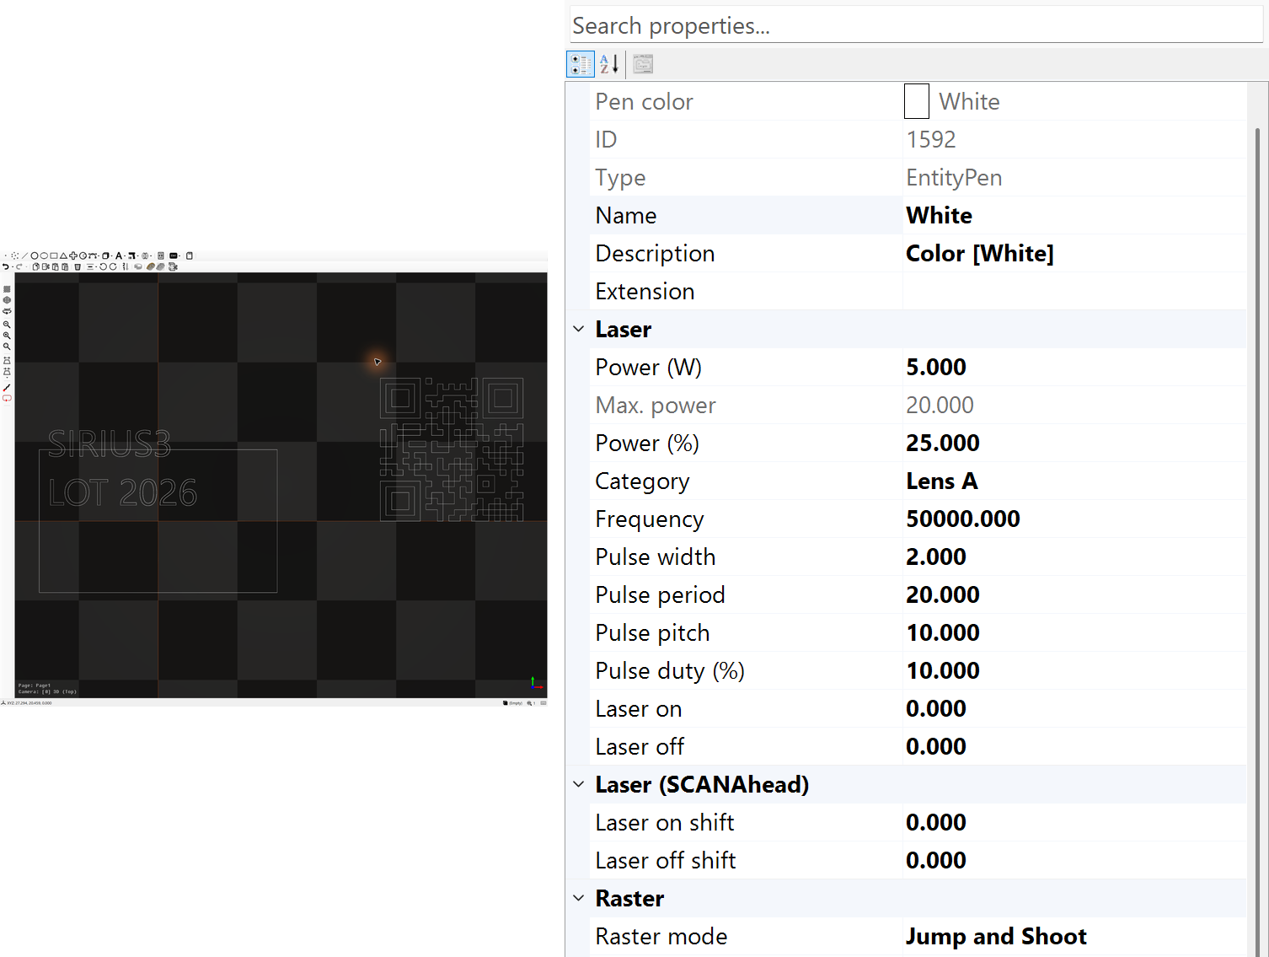
Figure 15.1 A 20 W virtual source with a 5 W pen command at 50 kHz
Listing 15.1 Find the entity pen and edit it through document history
public static void SetPen(IDocument document, IMarkerable entity)
{
if (!document.FindByEntityPenColor(entity.PenColor, out EntityPen pen))
throw new InvalidOperationException("Entity pen missing.");
document.ActPropertyChanged(pen, nameof(EntityPen.Power), 5.0);
document.ActPropertyChanged(pen, nameof(EntityPen.MarkSpeed), 500.0);
}

15.1 Laser values and their coupled calculations
The values in this section use Sirius3 processing units, rather than raw RTC arguments. Device initialization supplies the applicable limits and timing resolution; unsupported properties may be hidden. See 15 EntityPen and per-entity conditions for selecting the shared PenColor entry and 14.3 LaserVirtual output methods for converting power settings to output signals.
PulsePeriod is 1,000,000 divided by Frequency. PulsePitch is MarkSpeed multiplied by 1,000 and divided by Frequency. These steady-speed formulas describe pen values. With PowerControlMethods.Frequency, Power determines the output frequency and the current pulse width is retained. With PowerControlMethods.DutyCycle, Power determines pulse width and the current frequency is retained. In either mode, the normal pen routine does not apply the pen's Frequency or PulseWidth. Check the adapter's actual timing before using pitch or duty estimates. Acceleration, laser response, ALC and SCANahead can change energy deposition and actual point spacing on the material.
Property | Unit / value | Behavior and use
Power | W | Requested optical power passed to the laser output method; an enabled power map converts the target into the required input.
PowerMax | W | Maximum power used for the power editor and percentage conversion. It is a source rating, not a measured-power result.
PowerPercentage | % | Power / PowerMax × 100; editing the percentage updates Power.
PowerMapCategory | string | Selects the map curve for the current conditions, for example "50000" for 50 kHz. Match the category used during calibration.
Frequency | Hz | Pulse repetition frequency. Laser timing resolution can slightly change the represented value.
PulseWidth | µs | Electrical pulse width, not necessarily the optical pulse duration. Use the source-specific timing limits.
PulsePeriod | µs | 1,000,000 / Frequency. Editing the period updates frequency.
PulsePitch | µm | MarkSpeed × 1000 / Frequency. Editing pitch changes frequency for the current mark speed. It estimates constant-speed pulse spacing.
PulseDutyCycle | % | PulseWidth / PulsePeriod × 100. Editing duty changes pulse width; inspect the resulting timing values together.
PenColor | Color | Key used to find this shared pen; the PropertyGrid presents it as read-only.

Listing 15.2 A 50 kHz, 500 mm/s timing example
public static bool ConfigurePen(IDocument document, IEntity entity)
{
var markable = entity as IMarkerable;
if (markable == null ||
!document.FindByEntityPenColor(markable.PenColor, out var pen))
return false;
// At constant speed: period 20 us, pitch 10 um, duty 10%.
return document.ActPropertyChanged(pen, nameof(EntityPen.MarkSpeed), 500.0)
&& document.ActPropertyChanged(pen, nameof(EntityPen.Frequency), 50_000.0)
&& document.ActPropertyChanged(pen, nameof(EntityPen.PulseWidth), 2.0);
}

15.2 Scanner speed and delay tuning
Delays align mirror motion with laser switching. Tune laser switching delay and scanner settling time separately, checking starts, ends and corners at the intended speed. Follow the basic sequence in 12.5 Adjust laser timing, then scanner settling. A single Tracking Error value does not define the full delay setup.
Property | Unit / value | Behavior and use
JumpSpeed | mm/s | Laser-off travel speed; a faster command may need more settling time.
MarkSpeed | mm/s | Laser processing feed speed. Together with Frequency it determines nominal pulse pitch.
LaserOnDelay | µs | Shifts laser activation at the start. Too positive can shorten the start; negative values can preheat a stationary start and extend processing time.
LaserOffDelay | µs | Keeps emission timed to the physical end while mirrors lag the command. Too long can burn the end or expose the following travel.
ScannerJumpDelay | µs | Settling pause after a jump, before the next command. Reduce only after checking landing accuracy.
ScannerMarkDelay | µs | Pause after a marking sequence; allows the real spot to reach its final position before a subsequent jump.
ScannerPolygonDelay | µs | Transition delay between connected mark vectors. Too little rounds corners; too much can increase corner exposure.
IsHardJump | bool | Uses the supported RTC hard-jump path instead of the normal jump ramp. Tune ScannerJumpDelay for the resulting settling behavior.

SCANahead shifts, CornerScaleSCANa, EndScaleSCANa, AccScaleSCANa and SpotDistanceSCANa are explained with their interaction in chapter 28. MinMarkSpeed and ApproxBlendLimit belong to syncAXIS (chapter 30); they do not tune a conventional RTC6 path. Repeats on the pen objects is not the geometry-repeat setting; set repetition on the processing entity/layer.

15.3 Raster exposure and Wobbel
1. Connect the external laser synchronization output to DIGITAL IN1 (DIN1) on the RTC LASER PORT, not to an arbitrary extension I/O input.
Match the specified TTL levels, reference ground and rising or falling edge. PixelPulses and IsPixelPulsesExit do not generate a synchronization signal.
2. PixelPulses=0 uses timed exposure. Values from 1 to 65,535 count external edges; PixelTime limits the wait.
IsPixelPulsesExit=true advances immediately at the target count; false retains the full waiting interval. Missing synchronization cannot produce the requested count.
Example: five edges at 10 kHz span four 0.1 ms intervals. Allow time for the first edge and a margin too. These are electrical synchronization edges, not measured optical energy.
For image JumpAndShoot, the effective window is PixelTime × pixel weight. A smaller weight also reduces the time available for synchronization edges. Set pulse count and timing for this window, not only for the unweighted PixelTime.
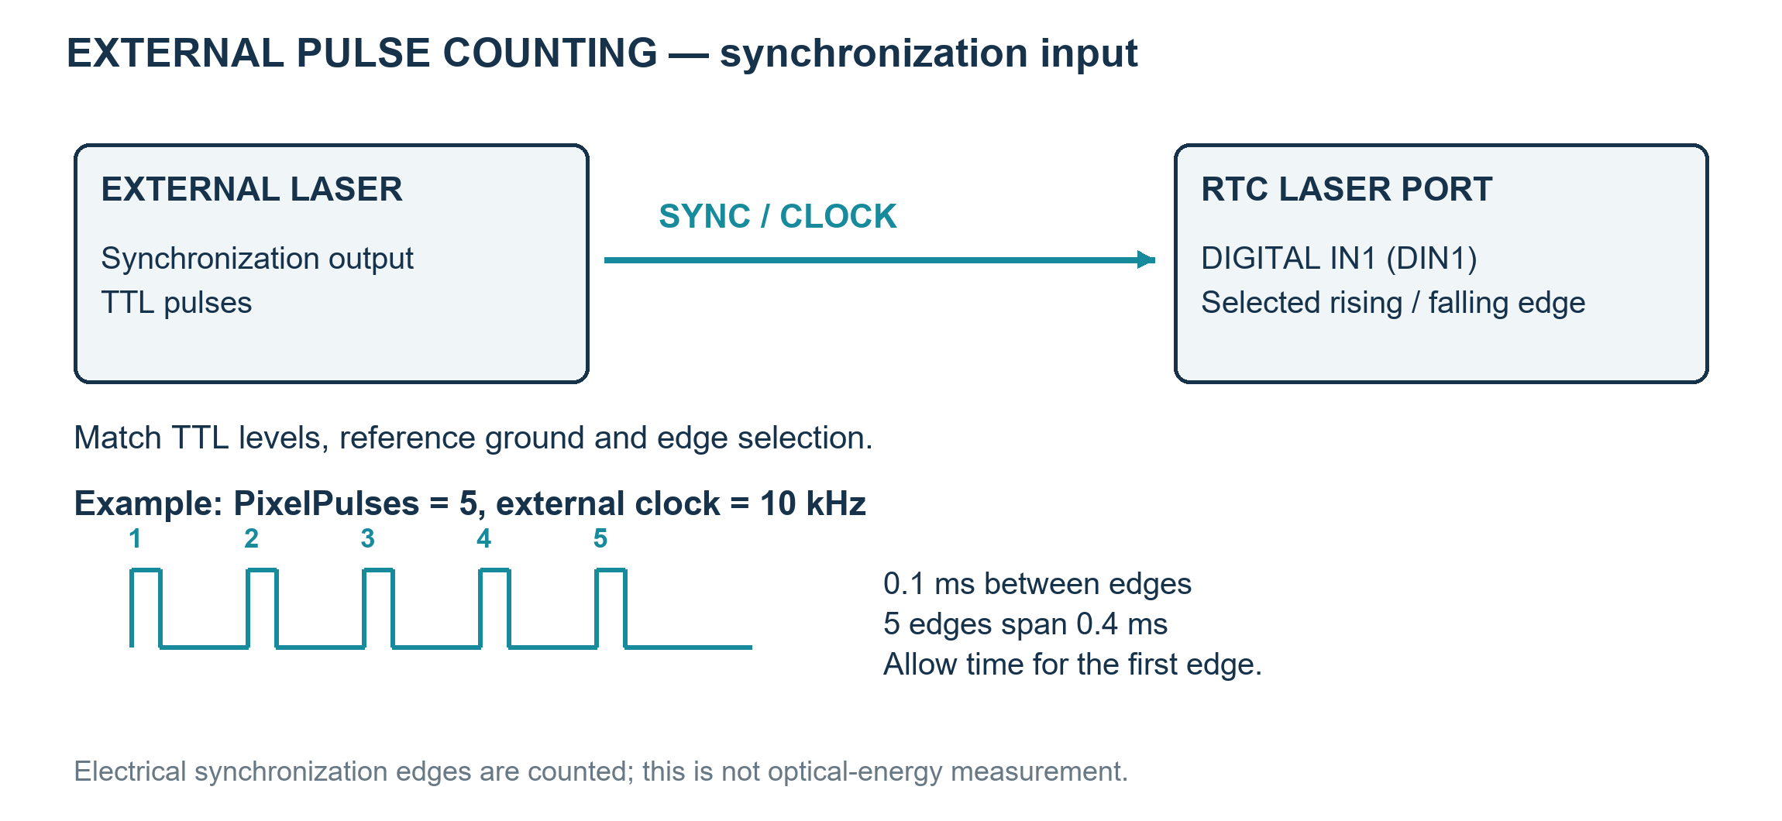
Figure 15.2 Wire the laser synchronization output to LASER PORT DIN1 before counting pulses
3. External counting is supported on RTC5 and later for points and JumpAndShoot raster processing. MicroVector does not use PixelPulses, and RTC6 rejects this operation with Auto Delays active. Check the raster mode and controller configuration.
Property | Unit / value | Behavior and use
RasterMode | enum | JumpAndShoot exposes discrete pixels; MicroVector scans pixels continuously. Select timing fields for the chosen mode.
PixelTime | µs | Exposure duration or external-pulse wait limit in JumpAndShoot; exposure time inside each MicroVector pixel period.
PixelPulses | count | 0: timed exposure. 1–65,535: counts edges from the external laser synchronization signal wired to LASER PORT DIGITAL IN1 (DIN1); PixelTime limits the wait.
IsPixelPulsesExit | bool | With PixelPulses > 0 and an external laser synchronization signal on LASER PORT DIN1: true ends the wait at the target count; false retains the full interval.
RasterDirection | enum | Chooses scan direction and therefore the axis and order used to traverse the image.
IsRasterZigZag | bool | Alternates scan direction between rows; check bidirectional registration before using it for processing.
PixelPeriod | µs | MicroVector period. Speed = pixel pitch (mm) × 1,000,000 / PixelPeriod (µs). Keep PixelTime within this period.
PixelChannel | enum | Selects the supported output channel for MicroVector pixel modulation; match wiring and laser configuration.

Property | Unit / value | Behavior and use
IsWobbelEnabled | bool | Enables an oscillating scanner path superimposed on the nominal vector.
WobbelShape | enum | Selects Ellipse, Parallel8 or Perpendicular8; the two widths describe the local vector axes.
WobbelFrequency | Hz | Oscillation frequency. The implemented RTC6 call rejects |frequency| > 1000 Hz; physical acceleration/response can impose a lower limit.
WobbelParallel | mm | Longitudinal extent along the nominal marking direction; check the resulting envelope against the field.
WobbelPerpendicular | mm | Transverse extent across the nominal marking direction; it changes the processed swath.

15.4 Understand Wobbel paths and frequency limits
Wobbel adds a periodic path to the nominal marking motion. WobbelParallel and WobbelPerpendicular are amplitudes along and across the local travel direction; equal values produce a circle. A circular radius r gives a geometric swath of about 2r before optical spot width. The nominal advance per cycle is MarkSpeed / |WobbelFrequency|. Ellipse, Parallel8 and Perpendicular8 choose different periodic shapes; curved nominal paths carry their local direction with them.
Apply wobble to processing vectors and arcs. Do not combine ordinary Wobbel with Sky Writing or Pixel Output Mode. Jumps and stationary point exposure do not trace the wobble figure. Put operations requiring these different modes in separately configured recipe sections.
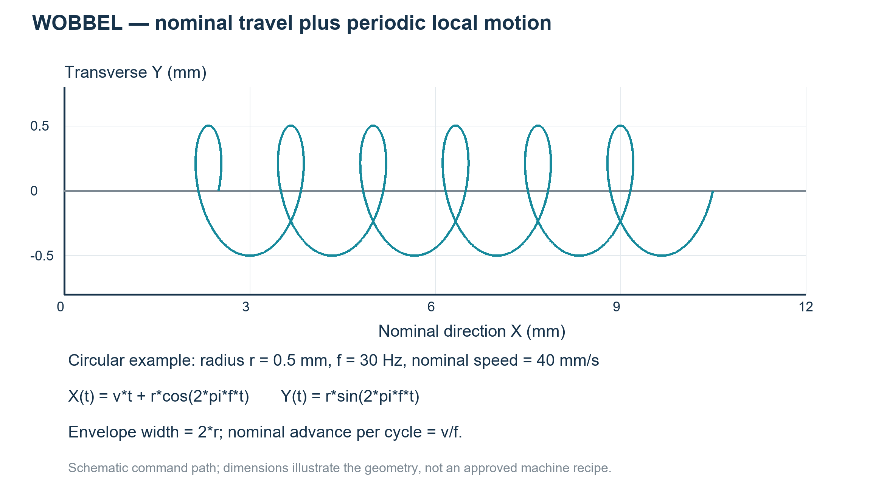
Figure 15.3 A circular Wobbel path superimposed on straight travel; schematic parameters
Do not raise frequency in isolation. For circular motion, Wobbel speed is 2πrf and acceleration is r(2πf)²: doubling frequency doubles speed and quadruples acceleration. Excessive frequency or amplitude can distort the commanded path, overheat the scanner/amplifier and permanently damage the system. The RTC6 implementation rejects |f| > 1000 Hz, but a value below 1000 Hz is not automatically suitable for the head. Permanent damage can occur even during a short test. Monitor the scan-head and control/amplifier temperature during evaluation.
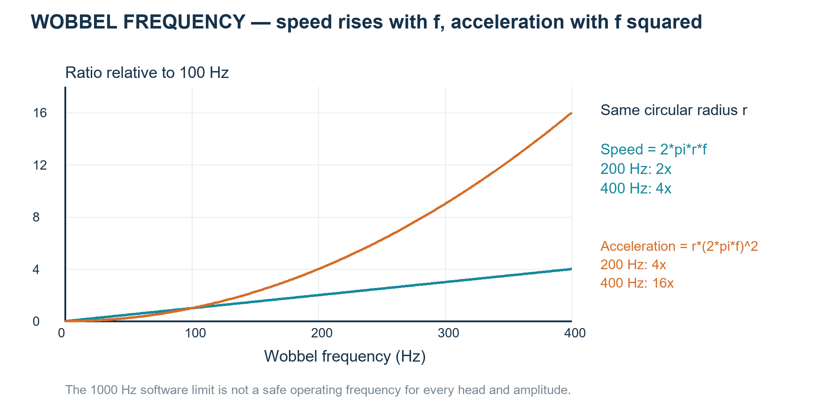
Figure 15.4 At fixed radius, frequency drives a quadratic increase in acceleration
1. Tracking Error is the time offset between commanded and actual mirror position at constant speed. Here it is measured in ms or µs, not as a distance error.
2. For a Tracking Error system, use fmax≈1/(10×T), with T in seconds. T=0.200 ms=0.000200 s gives fmax≈500 Hz and a wobble period of 2 ms.
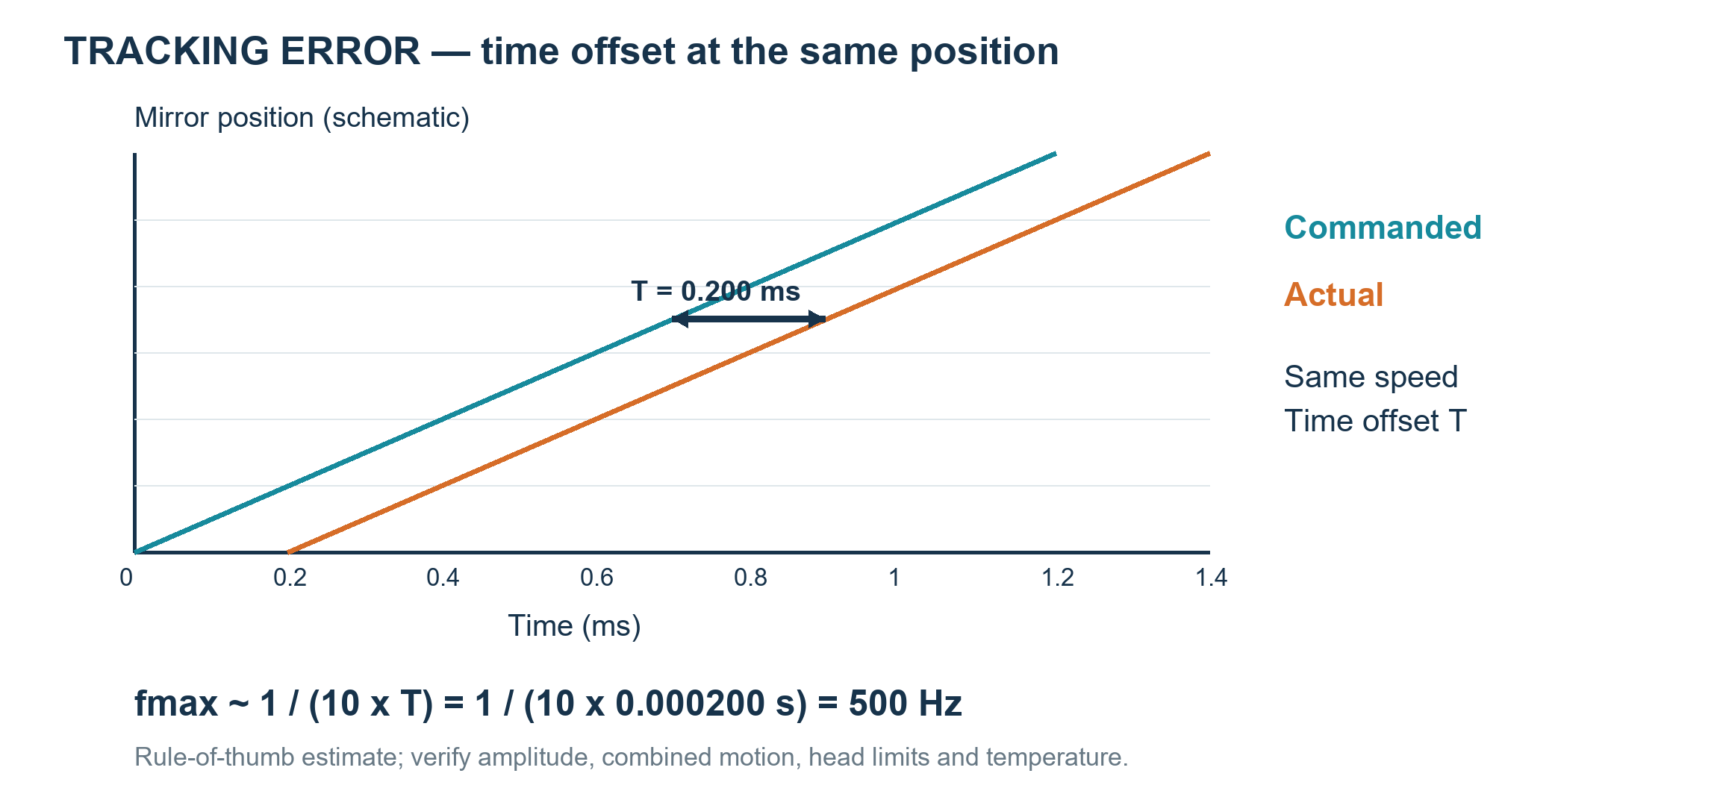
Figure 15.5 Tracking Error is a time offset; 0.200 ms gives an estimated 500 Hz
3. 500 Hz is an estimate, not an operating guarantee for every amplitude. Check circular-wobble speed 2πrf and acceleration r(2πf)² together with nominal travel, head limits and temperature.
With SCANahead, combined travel and wobble must remain within head speed and acceleration limits. Do not insert zero into the Tracking Error estimate.

15.5 Using EntityPenWobbelForm
1. Select the EntityPen and open the WobbelFrequency, WobbelParallel or WobbelPerpendicular editor. These properties open the grouped Wobbel settings.
2. Choose Enable and Shape, then set the size along and across the path in mm and the frequency in Hz. Compare the directions with the path diagram.
3. Press OK to accept the five values together. Closing without acceptance cancels the edit. The settings control wobbel during processing; the dialog itself does not execute a scan.
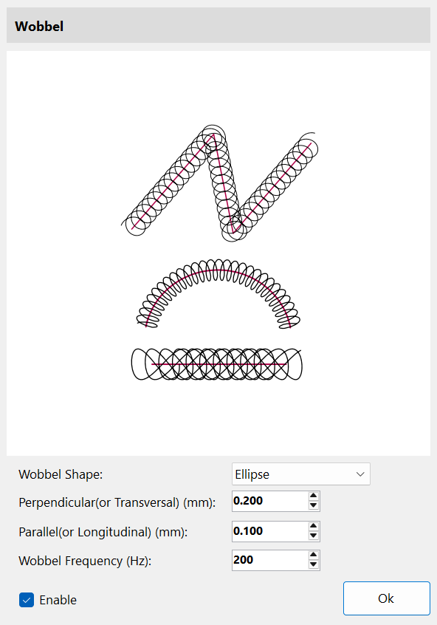
Figure 15.6 Wobbel editor: edit enablement, shape, two directional sizes and frequency together.
Use the Tracking Error estimate and the head's amplitude, speed and acceleration limits described earlier. The dialog's input range does not certify a safe physical operating range. Keep the documented SCANahead compatibility restrictions. See 28.6 Tune automatic delays and pen parameters together for the automatic-delay prerequisites.

15.6 Customize EntityPen and EntityLayerPen processing
1. Use OnMarkEntityPen to replace how power, speed and timing enter the list. Use OnMarkLayerPen to replace layer preparation, such as Sky Writing or variable delays. Registering either handler replaces that event’s complete default pen routine; there is no handled flag. Returning true reports success, not “continue with the default”.
2. Keep every setting needed by the job in a replacement handler and return false if preparation fails. For a small change that should retain the defaults, derive from the matching marker and override EntityPenEntityWork or LayerPenEntityWork, calling base. Register callbacks once and detach them only after the marker stops.
3. Use OnBeforeEntity/OnAfterEntity for work around entity command generation, not as pen replacements. OnAfterEntity means commands were generated, not that physical machining finished. MarkerRtc/MarkerSyncAxis provide layer completion at OnAfterLayer; MarkerRtcFast calls it during list generation and skips layer-pen preparation.
Pens belong to shared document palettes selected by PenColor. The callback receives that pen; changing it can affect several objects and does not create document Undo/Redo. Prepare intended document changes with ActPropertyChanged while idle; do not edit shared pens merely to customize one callback.
Pens already active by color may be reused, so pen callbacks are not guaranteed once per object or layer. Every registered bool handler is called and their results are combined; one false makes the result fail. Avoid duplicate registrations. Callbacks run on the marker worker; marshal UI updates.
Callback arguments are object references passed by value, not ref parameters. Editing the supplied entity or shared pen can affect the document, but assigning a different object to the handler’s local variable does not replace the caller’s object. There is no CancelEventArgs or ref cancel: a bool result reports success or failure. An event subscription with += is separate from a C# override.
Listing 15.3 Register complete pen replacement handlers
using System;
using SpiralLab.Sirius3.Entity;
using SpiralLab.Sirius3.Marker;

public static Action ReplacePenHandlers(IMarker marker,
Func<IMarker, EntityPen, bool> writeEntityPen,
Func<IMarker, EntityLayerPen, bool> prepareLayerPen)
{
if (writeEntityPen == null || prepareLayerPen == null)
throw new ArgumentNullException();
marker.OnMarkEntityPen += writeEntityPen;
marker.OnMarkLayerPen += prepareLayerPen;
return () => {
marker.OnMarkEntityPen -= writeEntityPen;
marker.OnMarkLayerPen -= prepareLayerPen;
};
}
The supplied functions must perform the complete required pen setup. Returning true alone sends no settings. Do not call pen.Mark from its own replacement handler: it would re-enter the same event. Invoke the returned detach action only after the marker stops.
Listing 15.4 Add checks while retaining default pen settings
using System;
using SpiralLab.Sirius3.Entity;
using SpiralLab.Sirius3.Laser;
using SpiralLab.Sirius3.Marker;
using SpiralLab.Sirius3.Scanner;

public sealed class CheckedMarkerRtc : MarkerRtc
{
private readonly Func<EntityPen, bool> checkPen;
private readonly Func<EntityLayerPen, bool> checkLayerPen;

public CheckedMarkerRtc(int index,
Func<EntityPen, bool> checkPen,
Func<EntityLayerPen, bool> checkLayerPen)
: base(index, "Checked RTC")
{
this.checkPen = checkPen ?? throw new ArgumentNullException(nameof(checkPen));
this.checkLayerPen = checkLayerPen
?? throw new ArgumentNullException(nameof(checkLayerPen));
}

protected override bool EntityPenEntityWork(EntityPen pen,
IScanner scanner, ILaser laser)
{
return checkPen(pen) && base.EntityPenEntityWork(pen, scanner, laser);
}

protected override bool LayerPenEntityWork(EntityLayerPen pen,
IScanner scanner, ILaser laser)
{
return checkLayerPen(pen)
&& base.LayerPenEntityWork(pen, scanner, laser);
}
}
The checks run before the base routine and must not modify shared pens. Returning false rejects preparation. Do not also register replacement pen events on this instance: those events bypass the default routines shown here.

16 LayerPen and layer-wide control
Use EntityPen for per-entity processing conditions and EntityLayerPen for layer-wide ALC, Sky Writing and delay policies. The layer pen prepares controller behavior before the list is written; EntityPen supplies conditions written with individual shapes.
Select the layer’s PenColor in the Layer pen tab to edit it. Use different pen colors for different policies, group shapes needing the same layer policy and set their order. See 15 EntityPen and per-entity conditions for entity pens and 17.2 LayerFirst and OffsetFirst for execution order.
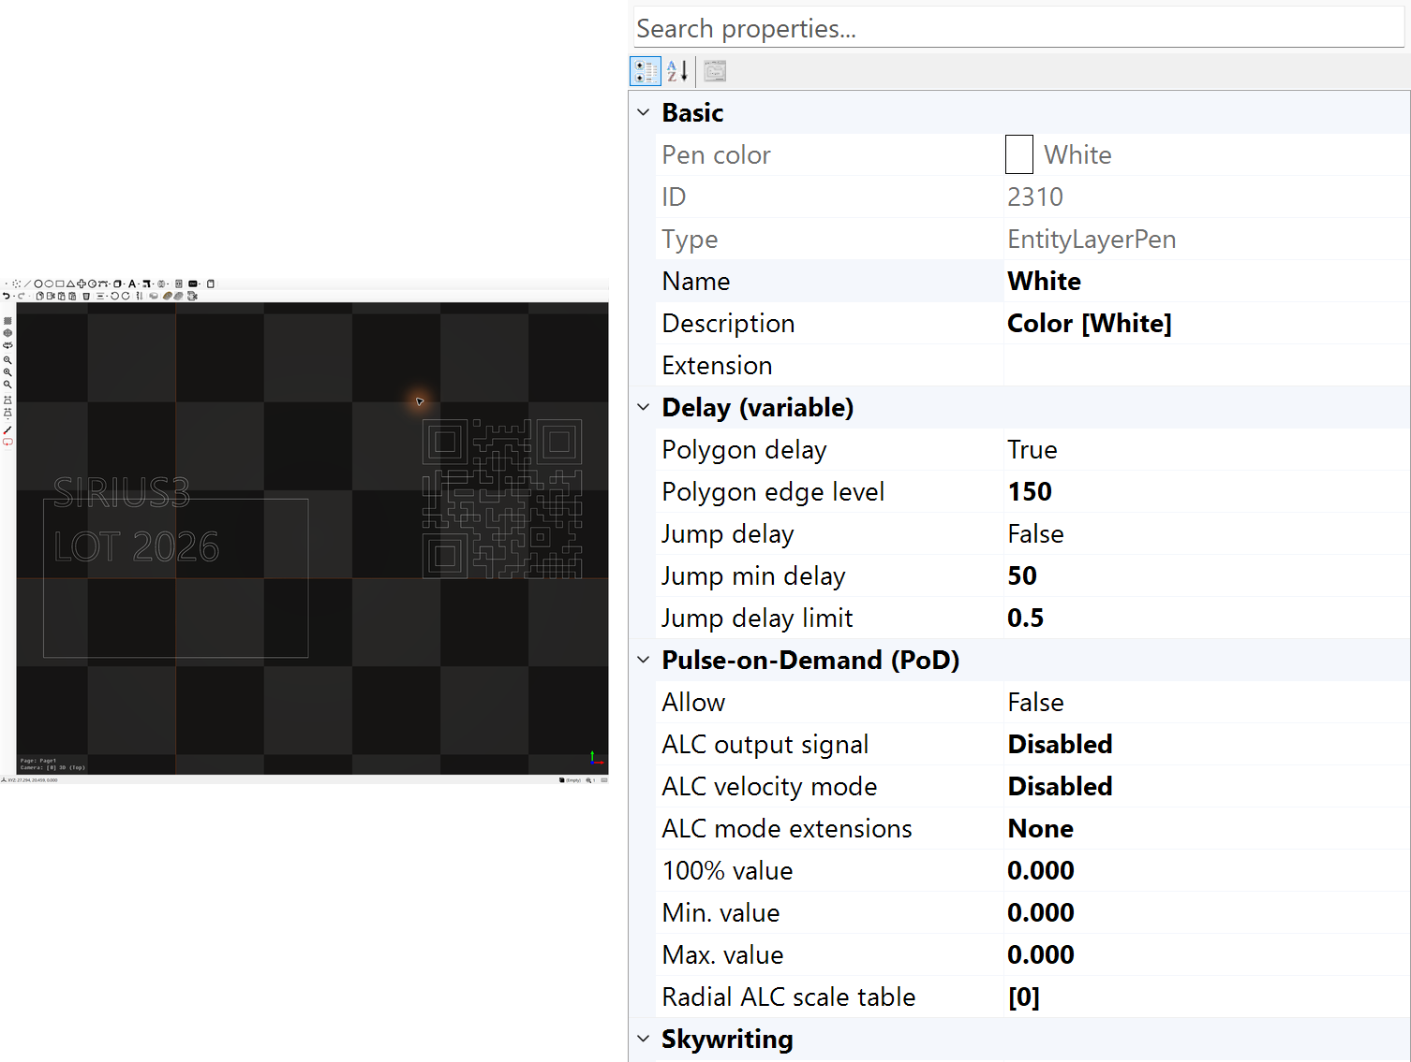
Figure 16.1 Variable-delay and ALC settings on the selected layer pen

16.1 ALC signal mode and limits
Automatic Laser Control changes a selected controller output according to velocity; it is separate from PowerMap’s measured W-to-input lookup (21.2 Read the map from target Y to input X).
EntityLayerPen selects AlcSignal, AlcMode, AlcModeExtensionBits, AlcPercentage100 and limits; EntityPen supplies per-path speed and output settings. Use MarkerRtc for this layer preparation. MarkerRtcFast skips it. Confirm the actual output, required scan-head feedback and installed options rather than enabling ALC from the RTC6 type alone.
Property | Unit / value | Behavior and use
IsALC / AlcSignal | bool / enum | Enables ALC and chooses its controlled output: frequency, pulse width or a supported digital/analog channel. Match the actual laser connection. MarkerRtc with an IRtcAutoLaserControl-capable RTC5/​RTC6 path; RTC4, syncAXIS and MarkerRtcFast do not apply this layer-pen setup.​ Analog V, digital bits, pulse width µs, frequency Hz or SDC each have different limits.​
AlcMode | enum | Chooses the base correction law. Disabled can still leave position-table correction active when IsALC and AlcSignal are configured. SetVelocity, ActualVelocity and EncoderSpeed need different feedback/​configuration.​
AlcModeExtension / AlcModeExtensionBits | flags | Additional mode bits, shown by the flag editor. Combine only documented modes for the selected controller; see the ALC/SCANahead recipes. Start with None; MoF, SCANahead and correction flags have separate prerequisites.​
AlcPercentage100 | signal unit | Output value corresponding to the correction’s 100% reference, not a universal 0–100 slider. Its unit follows AlcSignal.
AlcMinValue / AlcMaxValue | signal unit | Lower and upper output limits in the selected signal’s units; configure them as a coherent range with the reference value.
AlcByPositionTable | mm → factor | Radius from scanner origin in mm maps to a multiplier (0–4), with up to 50 valid points. The controller sorts/interpolates the table. Empty disables position correction.

The marker loads the position table before layer ALC and disables ALC/clears its table after the layer. Do not depend on state left by the previous layer. For radial compensation, check the field scale, supported radius range and controller-generation behavior. Position data in the example tables is not a calibration certificate.

16.2 Speed, position and Defined Vector control
These are three different ways to vary a control signal. EntityLayerPen configures speed-dependent ALC and its radial position table. Defined Vector is selected by EntityRampBegin/End around parameterized geometry; it is not another AutoLaserControlModes enum value. The figure uses analog volts to keep the distinction visible. A voltage ratio is not automatically the same optical-power ratio.
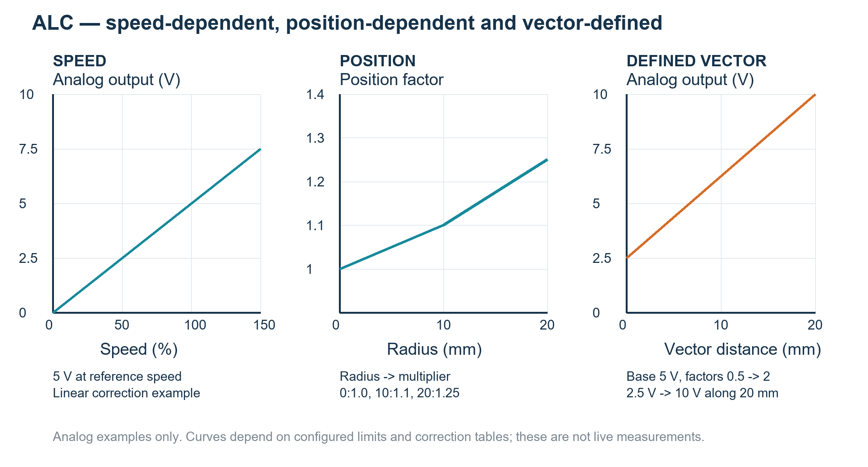
Figure 16.2 Three illustrative control relationships; analog values, not measured optical power
Speed dependence uses SetVelocity, ActualVelocity or EncoderSpeed. With a linear analog example, 100% reference speed corresponds to 5 V, so 50% speed produces 2.5 V before configured limits and other correction factors. ActualVelocity needs compatible feedback; a commanded speed alone does not describe acceleration through a corner. A nonlinearity table can change the relationship.
Position dependence uses AlcByPositionTable: radius 0, 10 and 20 mm can map to factors 1.00, 1.10 and 1.25. Between entries the factor is interpolated; a 5 V reference would become 5, 5.5 and 6.25 V in this analog illustration. This public pen table is radial, not an arbitrary X/Y compensation image. IsALC and a supported AlcSignal are required; AlcMode=Disabled isolates position correction from speed correction.
Defined Vector control is not supported on RTC4. Sky Writing does not apply to parameter vectors, and RTC6 vector-defined output control does not accept SpotDistance. Do not copy the analog voltage example directly to frequency control, which uses period values internally.
Listing 16.1 Configure speed or radial position correction
public static void ConfigureAlc(EntityLayerPen pen, bool positionOnly)
{
pen.IsALC = true;
pen.AlcSignal = AutoLaserControlSignals.Analog1;
pen.AlcModeExtension.Clear();
pen.AlcPercentage100 = 5; // Volts, not watts or percent.
pen.AlcMinValue = 0;
pen.AlcMaxValue = 10;
pen.AlcByPositionTable.Clear();
pen.AlcMode = positionOnly ? AutoLaserControlModes.Disabled
: AutoLaserControlModes.SetVelocity;
if (positionOnly) {
pen.AlcByPositionTable.Add(new KeyValuePair<double,double>(0,1));
pen.AlcByPositionTable.Add(new KeyValuePair<double,double>(10,1.1));
pen.AlcByPositionTable.Add(new KeyValuePair<double,double>(20,1.25));
}
}
Defined Vector specifies signal endpoints along a vector. The public demo starts Analog1 at 5 V, then uses an EntityLine with StartRampFactor=0.5 and EndRampFactor=2: the mark goes from 2.5 to 10 V over 20 mm. The jump can also be parameterized; laser-off travel does not imply an unchanged analog output. EntityRampEnd disables vector control rather than restoring the previous voltage automatically.
Listing 16.2 A document recipe for Defined Vector; construction only
public static bool AddDefinedVector(IDocument document)
{
if (!document.FindByLayerPenColor(
document.ActivePage.ActiveLayer.PenColor, out var layerPen))
return false;
layerPen.IsALC = false; // Isolate the ramp, as in the public demo.
layerPen.AlcSignal = AutoLaserControlSignals.Disabled;
layerPen.AlcMode = AutoLaserControlModes.Disabled;
layerPen.AlcByPositionTable.Clear();
var begin = EntityFactory.CreateRampBegin(
AutoLaserControlSignals.Analog1, 5); // Initial reference: 5 V.
if (!document.ActAdd(begin)) { if (begin.Owner == null) begin.Dispose(); return false; }
var line = EntityFactory.CreateLine(0, 0, 20, 0);
line.StartRampFactor = 0.5; // 2.5 V at start.
line.EndRampFactor = 2; // 10 V at end.
if (!document.ActAdd(line)) { if (line.Owner == null) line.Dispose(); return false; }
var end = EntityFactory.CreateRampEnd();
if (!document.ActAdd(end)) { if (end.Owner == null) end.Dispose(); return false; }
return true; // No physical job has been started.
}

16.3 Sky Writing
Sky Writing adds motion with the laser off before and after a marking segment. This lets the scanner cross the intended segment at steady marking speed. Run-in is the approach before marking; run-out is the extension after marking.
Select the layer’s EntityLayerPen, enable IsSkyWritingEnabled and choose SkyWritingMode. RTC4 does not support Sky Writing; RTC5 supports Modes 1–3 and RTC6 supports Modes 1–4 with matching software and firmware. Reserve field space for the added motion.
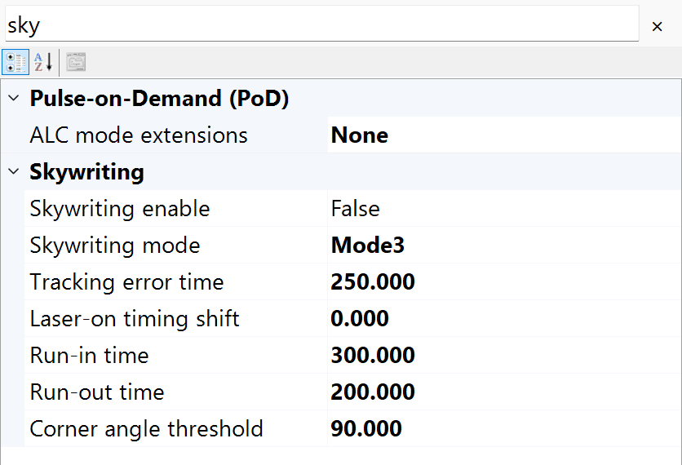
Figure 16.3 Filter layer-pen properties to inspect Sky Writing conditions
Property | Unit / value | Behavior and use
IsSkyWritingEnabled / SkyWritingMode | bool / enum | Selects run-in/run-out behavior: RTC4 unsupported; RTC5 modes 1–3; RTC6 modes 1–4 with matching firmware/software.
TimeLag | µs | Tracking-error compensation time for the scan head; it is not an arbitrary dwell at every vertex. Match measured scanner behavior rather than copying a sample number.​
LaserOnShift | µs | Fine timing adjustment for laser activation within Sky Writing; tune with the head tracking lag and material response.
Prev / Post | µs | Run-in and run-out durations. Their path extent grows with marking speed; reserve sufficient field space beyond the contour.
AngularLimit | ° | Corner threshold for the supported Sky Writing modes. Sirius3 converts degrees to the cosine expected by the RTC call. Used by Modes 3 and 4; it is not the model rotation angle.​

For conventional Sky Writing, TimeLag + LaserOnShift determines the laser-on delay and TimeLag the laser-off delay. Mode 1 uses twice the configured Prev/Post durations because of its return paths. With RTC6 SCANahead automatic delays active, TimeLag is used for activation but not timing, and Prev/Post have no timing effect; LaserOnShift remains effective. Stored conventional values apply again when automatic delays are disabled.
Grey marks added motion. In the original legend, m means marking speed, j means jump speed and × means an omitted jump. In Modes 3–4, Limit is a cosine value, while AngularLimit is entered in degrees: cos(φ) < Limit selects Sky Writing; cos(φ) ≥ Limit selects variable PolygonDelay.
For conventional Sky Writing, tune TimeLag and LaserOnShift instead of ordinary LaserOn/Off delays. Do not change MarkSpeed between a Sky Writing jump and its following Mark: the approach position was calculated using the previous speed.

16.3.1 Mode 1 Forerun and retrace
1. Before each Mark or Arc, the scanner moves back from the start and returns at marking speed. After marking, it travels beyond the end and returns. The added forerun and retrace motions keep the laser off.
2. Use this basic mode to examine the start and end of individual lines or arcs. Each segment receives its own motion, regardless of the preceding and following commands.
3. For conventional timing, the actual run-in and run-out durations are twice the configured Prev and Post values because of the return paths. Check the added motion when comparing processing times.

16.3.2 Mode 2 Jumps between extensions
1. Keep the run-in and run-out at marking speed. Jump from the previous run-out endpoint to the next run-in startpoint at JumpSpeed. Within a compatible sequence, this removes Mode 1’s separate forerun and retrace.
2. Consider this mode for repeated lines or hatch segments when Mode 1’s return paths add substantial time. Compare the complete path and processing time under the same marking conditions.
3. The shortened motion applies within a sequence of compatible Mark, Arc and Jump commands. An incompatible list command interrupts the sequence and adds Mode 1 motion at the interruption; it does not deactivate Mode 2.
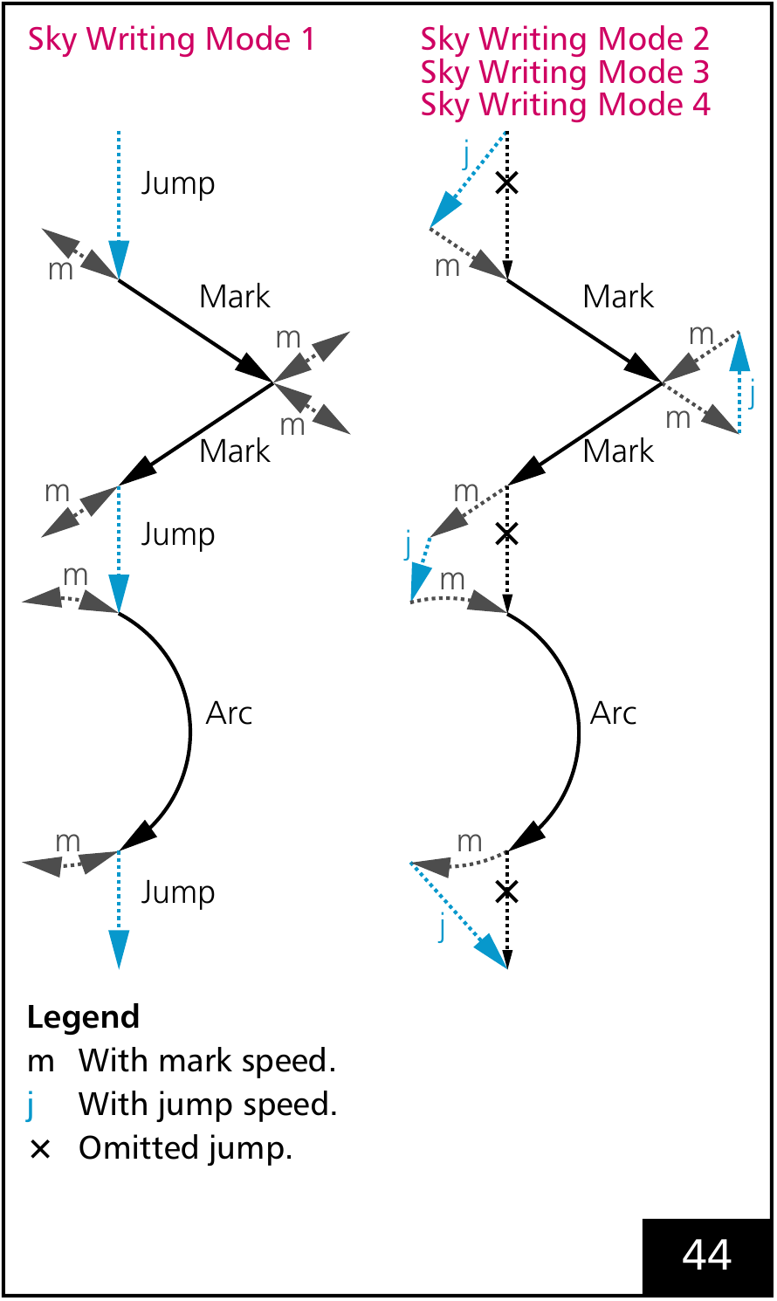
Figure 16.4 SCANLAB original illustration. Comparison of Mode 1 and Modes 2–4: forerun/retrace versus jumps between extended paths.

16.3.3 Mode 3 Select motion by direction change
1. Compare the directions of consecutive Mark or Arc commands. A change greater than AngularLimit uses Mode 2 motion; an equal or smaller change uses a variable polygon delay (PolygonDelay) instead of added Sky Writing motion.
2. Use the angle threshold to avoid repeated detours along finely segmented curves while retaining Sky Writing at sharper turns. Compare corner shape and processing time together.
3. Enter AngularLimit in degrees; Sirius3 converts it to a cosine. If the final Mark is shorter than the distance travelled at MarkSpeed during TimeLag, and Sky Writing was skipped, check the resulting endpoint precision.

16.3.4 Mode 4 Preserve the sequence across short commands
1. Mode 4 uses the same angle-dependent paths as Mode 3. Its additional function is to preserve the sequence when compatible Short List Commands occur between marking or jump commands; it does not introduce another path shape.
2. Use it on a supported RTC6 when short controller commands must occur between segments without triggering Mode 1 return motion. Short List Command is a controller-defined category, not an arbitrary callback or host operation.
3. A delayed short command also runs after the preceding Mark’s run-out; its usual delayed timing does not apply. Check for overruns with multiple short commands. Provide the following non-short command, or the controller may wait indefinitely.
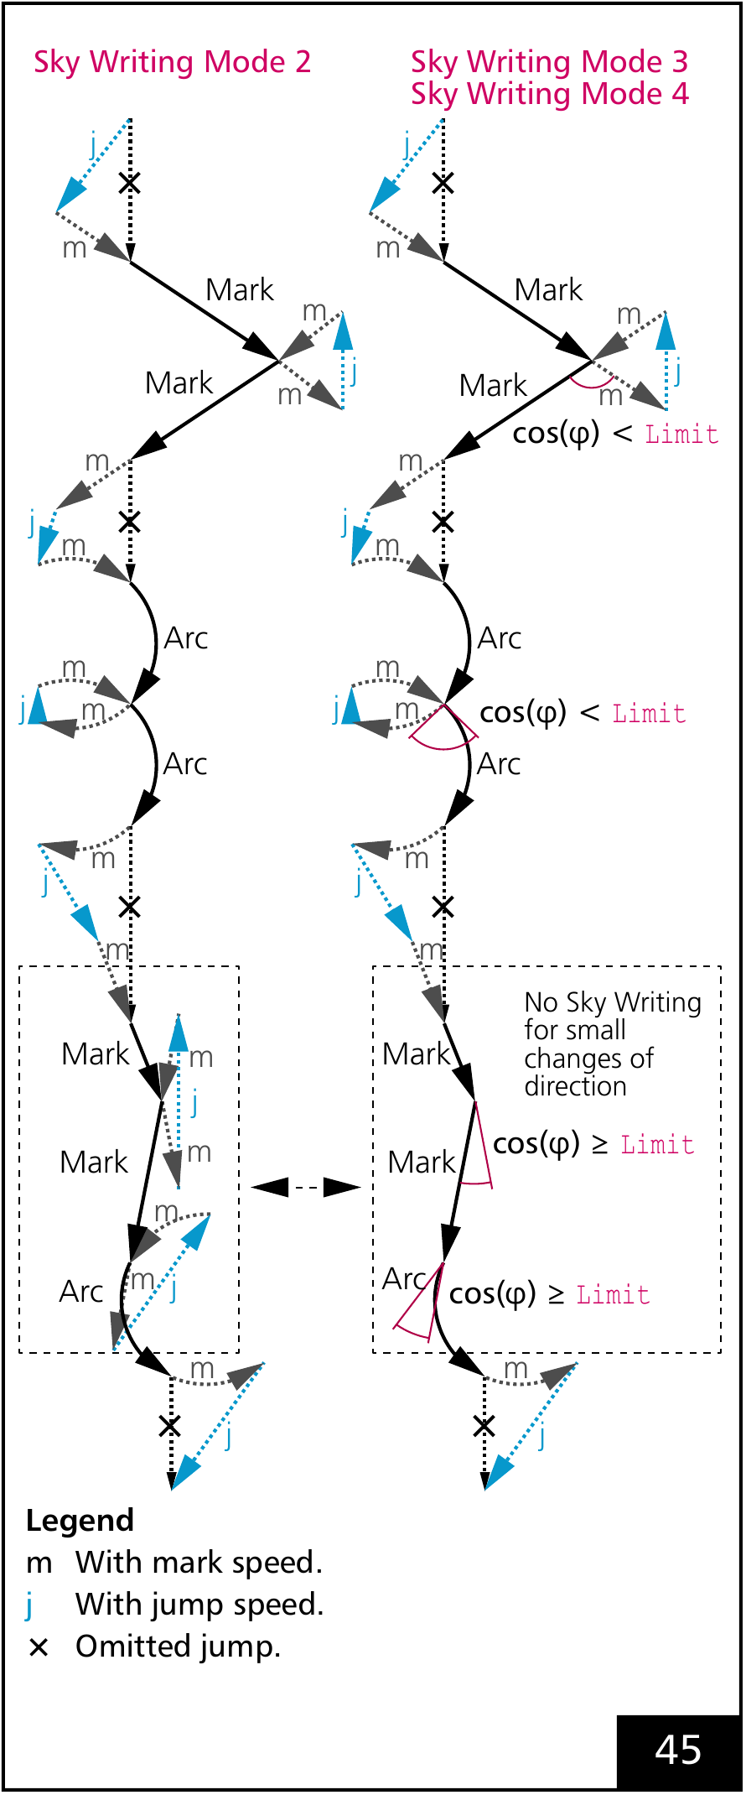
Figure 16.5 SCANLAB original illustration. Comparison of Mode 2 and Modes 3–4: direction changes determine whether added Sky Writing motion is used.

16.4 Read variable delays on a graph
1. A jump moves between processing paths with the laser off. A short jump usually needs less settling time than a long one.
2. Variable jump delay can shorten a job with many dense features or frequent jumps between nearby positions. Jumps at or above the length limit retain the full delay.
3. In the example below, 1,000 half-millimetre jumps at 125 instead of 200 µs save 75 ms of delay. Total job time also includes motion and other overhead.
Property | Unit / value | Behavior and use
IsVariableJumpDelay / VariableJumpDelayMin / VariableJumpDelayLimitLength | bool / µs / mm | Interpolates the jump delay up to the length limit, then uses EntityPen.ScannerJumpDelay. Keep the minimum no greater than the full delay; zero length limit disables this behavior.
IsVariablePolygonDelay / VariablePolygonDelayEdgeLevel | bool / µs | Adapts corner delays according to vector transitions. EdgeLevel is a time setting, not an angle in degrees. Tune together with ScannerPolygonDelay.
For conventional RTC delay handling, a zero-length jump has zero jump delay. For 0 < L < the configured length limit, delay increases linearly from VariableJumpDelayMin toward EntityPen.ScannerJumpDelay. At or beyond the limit, the full delay applies. The example uses 50 µs minimum, 200 µs full delay and a 1 mm limit: a 0.5 mm jump receives 125 µs. A zero limit disables variable jump delay.
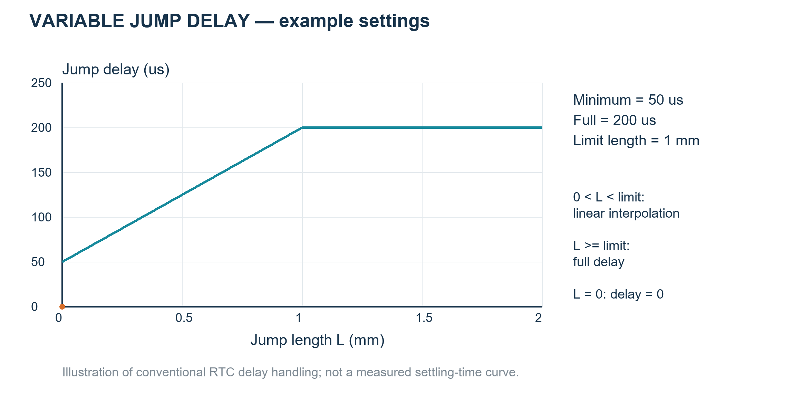
Figure 16.6 Jump length versus settling delay; example values, not measured scanner response
1. Variable polygon delay automatically calculates and adds delay according to the corner angle between consecutive Mark movements.
2. The angle is the change in travel direction: straight is 0°, a right-angle turn is 90°, and reversal is 180°. A larger turn needs more time for the mirror to change direction.
The default variable polygon law is D(φ) = ScannerPolygonDelay × (1 − cos φ). Here φ is the change in travel direction: straight continuation is 0°, a right turn is 90° and reversal is 180°. Thus a base 100 µs produces 0, 100 and 200 µs at those angles. A loaded custom table can change this law. Arc transitions use their tangents, not an arbitrary interior-angle label.
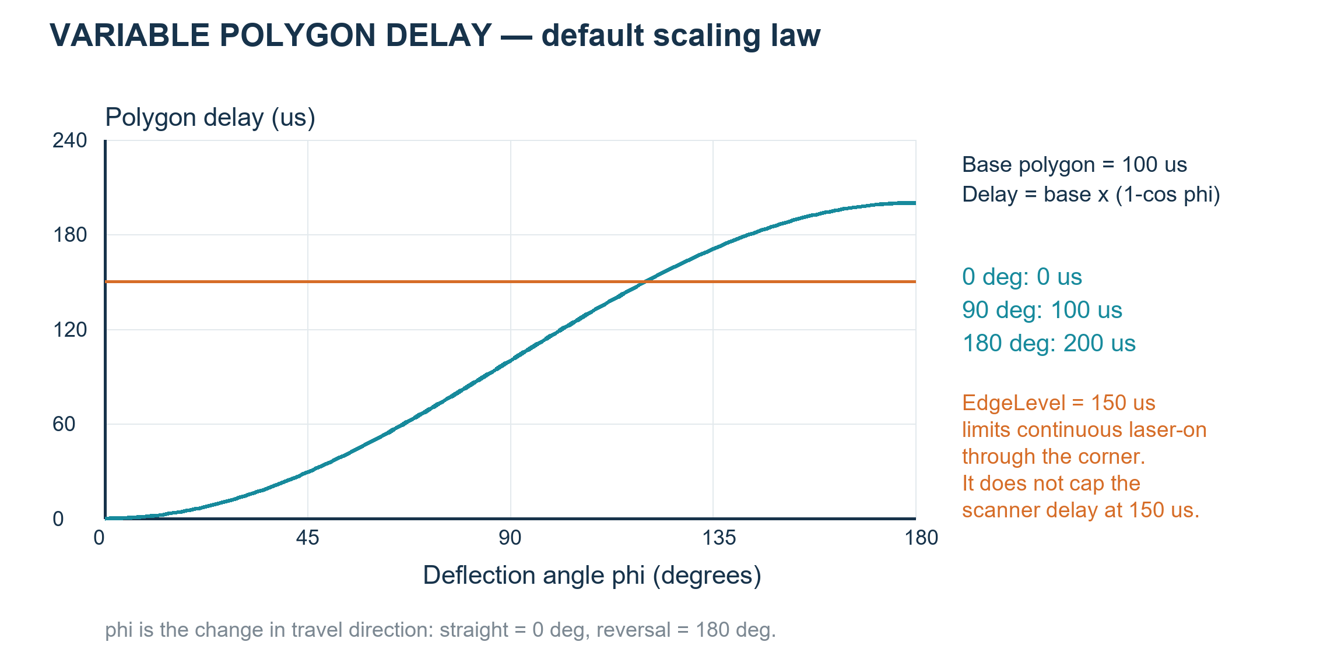
Figure 16.7 Default direction-dependent polygon delay and a separate EdgeLevel threshold
3. VariablePolygonDelayEdgeLevel is the threshold for keeping the laser on at a corner. If the corner delay exceeds it, the controller switches off according to the threshold and off timing, then begins the next processing sequence.
The setting controls energy accumulation at the corner; it does not cap the calculated scanner delay.

16.5 Process separate layers after external Stage moves
MarkerRtc and MarkerSyncAxis process each layer in a separate list. Before building it, they select EntityLayerPen by the layer PenColor. Reusing the same active pen color can skip reapplying its settings. Sharing a layer pen does not combine layer lists.
The order is OnBeforeLayer → layer pen → ListBegin → geometry → ListEnd → ListExecute(true) → OnAfterLayer. MarkerRtc starts the RTC list before the laser list; MarkerSyncAxis starts the laser list first, then ListBegin(MotionType). Both end the laser list first. The marker owns these calls; layer callbacks must not open or close another list.
Put each indexed region or Z level in its own layer. In OnBeforeLayer, move the external actuator and wait for in-position and settling with a timeout; return true only when ready. Return false on fault, timeout or cancellation. With MarkerRtc/MarkerSyncAxis, the layer finishes before OnAfterLayer and the next move. Callbacks run on a worker; dispatch screen updates to the UI thread.
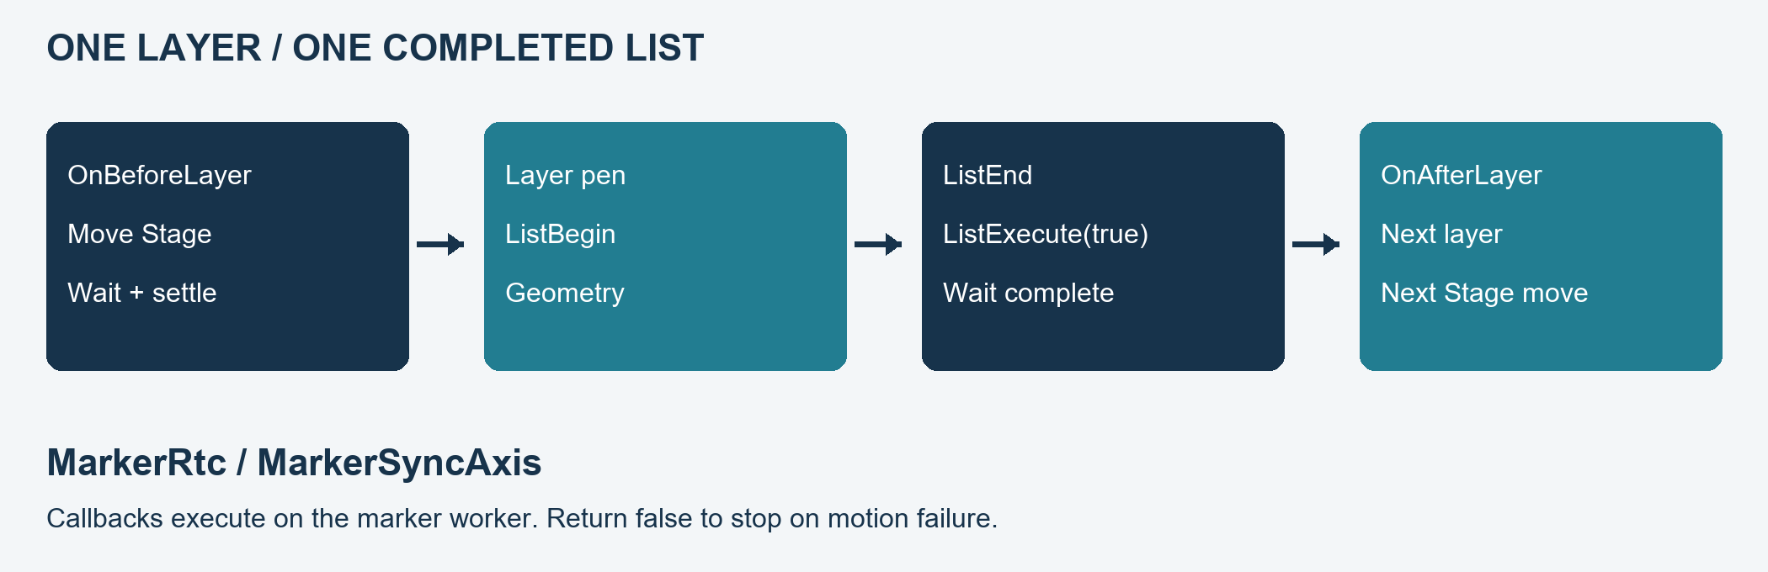
Figure 16.8 Process separate layers after external Stage moves
Listing 16.3 Bind host-owned motion to layer callbacks
public static Action BindLayerMotion(IMarker marker,
Func<EntityLayer, bool> moveAndWait, Action<string> report)
{
Func<IMarker, EntityLayer, bool> before = (m, layer) => {
try {
// The host moves its own actuator, waits for in-position
// and settling, and returns false on timeout/fault/cancel.
return moveAndWait(layer);
}
catch (Exception ex) { report(ex.Message); return false; }
};
Func<IMarker, EntityLayer, bool> after = (m, layer) => {
report(layer.Name + ": completed"); return true;
};
marker.OnBeforeLayer += before;
marker.OnAfterLayer += after;
return () => { // Detach only after the marker has stopped.
marker.OnBeforeLayer -= before;
marker.OnAfterLayer -= after;
};
}
LayerFirst repeats the layer callbacks and list for each offset/layer pair. OffsetFirst puts all offsets of one layer in its list, surrounded by one pair of layer callbacks. Choose this before using LayerIndex to select an external-axis position. This step-and-process workflow differs from coordinated syncAXIS StageAndScanner motion. Compare marker execution and offset/layer order in 17.1 Choosing a marker and 17.2 LayerFirst and OffsetFirst.

17 Marker execution and simulation
1. IMarker reads the selected document page in layer/entity order, applies its pens, and builds and executes the scanner and laser command lists.
2. Initialize the scanner and laser, then choose a matching marker. RegisterDevices binds the document, view, scanner, laser and optional power meter by calling Ready with those instances. Ready(document) in the example below only updates the document; it does not initialize or assign missing devices. Prepare repeated placements in Offsets while idle.
3. Await Start and check its result and OnEnded. Creating a marker or accepting a command does not establish completed machining; let the marker own its list sequence.
Listing 17.1 Regenerate prepare and await page execution on initialized devices
public static async System.Threading.Tasks.Task<bool> RunPage(
IDocument document, IMarker marker)
{
if (!document.ActRegen() || !marker.Ready(document))
return false;
return await marker.Start(document.Page);
}
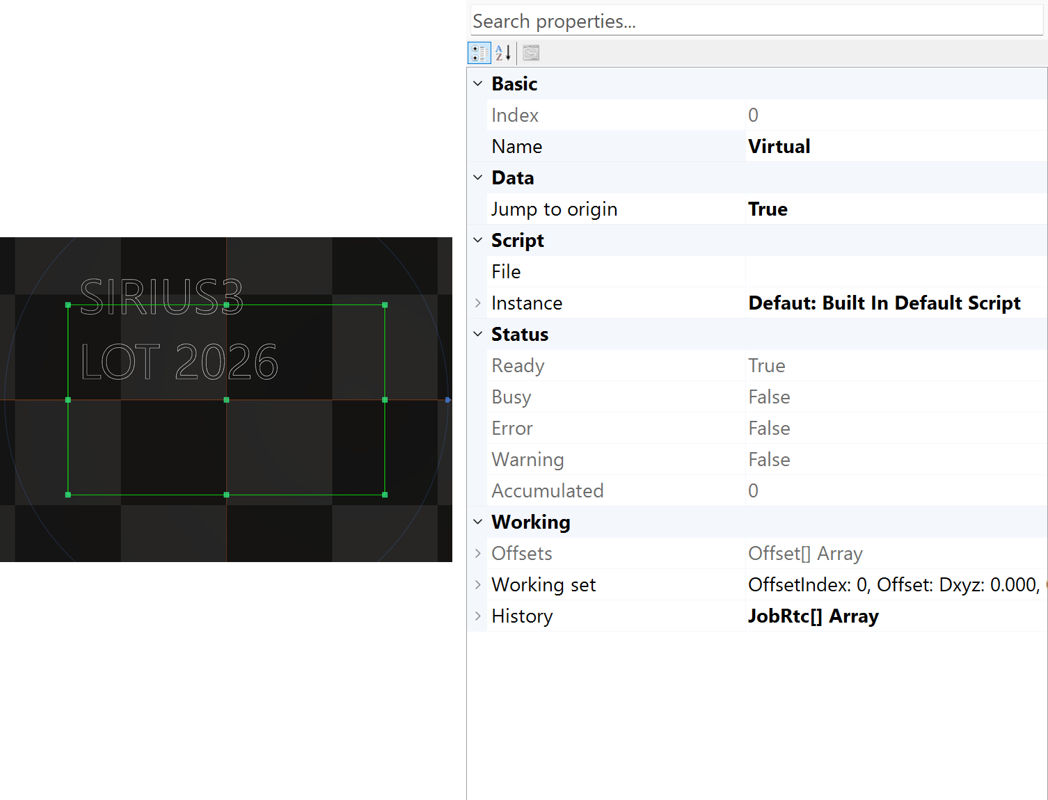
Figure 17.1 Marker selection and execution-related properties
Implementation | Use | Boundary
MarkerVirtual | Device-free host/​traversal development | Does not validate physical RTC timing or optical output.​
MarkerRtc | Ordinary RTC document processing | Supports its layer-level setup and layer/​offset list boundaries.​
MarkerRtcFast | One large RTC list; typically one large layer. | One ListBegin/ListEnd/execute for chosen layers and offsets. Omits MarkerRtc LayerPen ALC, Sky Writing and variable-delay preparation; no automatic speed gain.
MarkerSyncAxis | Coordinated scanner/​stage jobs | Uses the syncAXIS configuration/​job model.​

17.1 Choosing a marker

17.1.1 MarkerRtc
Use MarkerRtc for ordinary RTC4/5/6 jobs when each layer needs its own preparation and completion point. LayerFirst executes each layer at each offset; OffsetFirst executes all offsets of one layer together. This marker applies the layer pen before building that layer’s list.

17.1.2 MarkerRtcFast
1. MarkerRtcFast wraps the chosen layers and all Offsets in one ListBegin/ListEnd sequence, then completes the final ListExecute(true). One logical stream can span many alternating native buffers in Auto; it need not fit entirely in memory.
2. A single EntityLayer with one established controller configuration is a simple use case. A long MoF sequence can remain in the same logical stream. Multiple layers are accepted, but Fast does not prepare each EntityLayerPen, including layer ALC, Sky Writing and variable delays. Use MarkerRtc when that preparation is needed.
3. OnAfterLayer reports command-generation progress, not completed machining. Auto may already be executing earlier buffers. Fast lacks MarkerRtc external start and does not guarantee faster scanner motion. Use MarkerRtc for layer completion waits or external motion between layers.

17.1.3 MarkerSyncAxis
Use MarkerSyncAxis for a configured syncAXIS scanner/stage system with its required runtime and licenses. It builds jobs through IRtcSyncAxis. The layer’s EntityLayerPen.MotionType selects the motion mode. An ordinary RTC marker cannot replace this coordinated workflow.
demos/editor_marker provides MyMarkerRtc, MyMarkerRtcFast and MyMarkerSyncAxis examples based on MarkerBase. Form1.cs replaces the marker before RegisterDevices and Ready. Use these public examples to study traversal, list/job creation and callbacks. They disclose those demo implementations; MyMarkerRtcFast is included but is not the default choice.

17.2 LayerFirst and OffsetFirst
1. Choose the required part/layer order before Start. The names describe which work is completed first, not which loop is outermost.
2. Layer.Repeats repeats the child sequence inside the current layer/offset. Each entity then performs its own Repeats where supported. For one ordinary repeating entity, O×layer.Repeats×entity.Repeats gives its number of passes; the layer callbacks do not repeat for each layer pass.
3. These counts assume a successful job and enabled targets. A failure stops subsequent work. Fast and Auto may already have executed earlier commands; failure is not a rollback. External indexed moves requiring layer completion belong in MarkerRtc/MarkerSyncAxis, with a timeout and in-position check.
For two offsets O1/O2 and two layers L1/L2:
LayerFirst: O1L1 → O1L2 → O2L1 → O2L2
OffsetFirst: O1L1 → O2L1 → O1L2 → O2L2
Table 17.1 Offset and layer order, lists and completion callbacks
Marker / procedure | Nested order | List and layer callbacks
MarkerRtc / MarkerSyncAxis: LayerFirst | Offsets → layers → layer repeats → children | For O offsets and L enabled layers: O×L lists and O×L before/after-layer callback pairs. OnAfterLayer follows successful ListExecute(true).
MarkerRtc / MarkerSyncAxis: OffsetFirst | Layers → Offsets → layer repeats → children | L lists and L before/after-layer callback pairs; all offsets of one layer share that list. OnBeforeLayer runs before the first offset is assigned for that layer; do not treat WorkingSet.OffsetIndex there as the upcoming offset.
MarkerRtcFast | Offsets → layers → layer repeats → children | One logical list across all offsets/layers. O×L layer callback pairs occur during command generation; OnAfterLayer is not machining completion. EntityLayerPen preparation is skipped.
Before Start, check both the page and the target scope. Start(page) selects the page; the example passes document.Page. MarkerRtc.MarkTarget defaults to All: it processes every enabled entity on that page, even when only one is selected. Use Selected to restrict the scope. Layers and entities with IsAllowMark=false are skipped.
Offsets add placement, Z rotation, scale and per-location data without changing document geometry. Use Offset.Zero for no additional transform. For placement, use a parameterized constructor such as new Offset(dx,dy), which initializes unit scale. default(Offset) and parameterless new Offset() have zero scale.
Set offsets while the marker is idle. Do not apply the same placement through both entity transforms and Offsets. See 9.4.1 OffsetControl and position data for per-location text and the offset table, and 7.3 ITransformable and coordinate spaces for entity transforms.
1. Use the row-vector model transform defined in 7.3. Each Offset is applied after that transform.
$$M_{entity} = A S R_{z} R_{y} R_{x} T$$
$$O_{i} = S_{offset} R_{z}(θ_{i}) T_{offset}$$
$$p_{final} = p_{original} M_{entity} O_{i}$$
In the Offset equation, S_offset is the scale matrix from Offsets[i].Scale, θ_i is Offsets[i].AngleZ (degrees), and T_offset is the translation matrix from Offsets[i].Translate (mm).
The simple final-point formula assumes no transformed parents and an identity pre-existing RTC software stack; otherwise insert parent matrices from nearest to outermost before Oi, and the pre-existing software-stack matrix after Oi.
2. Oi applies Offset scale, Z rotation in degrees and translation. Each entry starts from the same source geometry; entries do not accumulate.
Pfinal here is the software-transformed command position before controller Wobbel, MoF and field correction, not an independently measured beam position.
3. Set Offsets while the marker is idle. The following example prepares two locations.
Listing 17.2 Prepare two processing locations while idle
public static void SetLocations(IMarker marker)
{
if (marker.IsBusy) throw new InvalidOperationException("Marker is busy.");
marker.Offsets = new[]
{
new SpiralLab.Sirius3.Mathematics.Offset(-15, 0),
new SpiralLab.Sirius3.Mathematics.Offset(+15, 0)
};
}

17.3 Use simulation for the path question
Listing 17.3 Simulate selected entities in an async UI handler
document.ActRegen();
await document.ActSimulateStart(view, document.Selected, marker,
IDocument.SimulationSpeeds.Normal);
Use simulation to inspect processing order, jumps and offsets on screen. It does not verify physical energy or timing. Preview, Start, Manual and power mapping are separate device operations. They can move the scanner or operate the guide beam or laser. See 6.12 Simulate the selected paths with F1 to start and stop playback with the keyboard or toolbar.

17.4 Preview and ILaserGuideControl
1. Preview takes each selected entity's axis-aligned XY bounds, applies marker Offsets, and traces that rectangle with the guide beam. It does not reproduce the complete hatch or machining path. MarkerSyncAxis uses ScannerOnly for Preview, so this operation does not verify coordinated stage motion.
2. Select at least one entity and use a ready marker whose laser implements ILaserGuideControl. Await Preview; Offsets, Config.MarkPreviewSpeed and Config.MarkPreviewRepeats in SpiralLab.Sirius3.UI control the outline traversal.
3. Check the result. Preview enables the guide beam, executes scanner commands and disables the guide beam afterward. It can operate physical devices, including when LaserVirtual is connected to a real RTC; use F1 simulation for screen-only playback.

18 ManualControl for manual device operation
ManualControl sends commands directly to the scanner and laser without starting a document job. RegisterDevices connects the panel to the editor’s scanner, laser and Marker. If you assign physical devices, the panel sends real commands. Learn the steps with virtual devices first.
1. Open the editor's Manual tab. Enter power in W, frequency in Hz and pulse width in µs, then press Set. If using a power map, check Category and Lookup.
2. For positioning, enter coordinates in mm and speed in mm/s, then press Move. Origin commands scanner coordinates (0,0[,0]); Jog opens the incremental positioning panel.
3. On/Off controls the laser gate. Auto Off sends Off after the specified number of seconds. Use the power-map preview button to inspect the requested power's mapping before sending a setting.
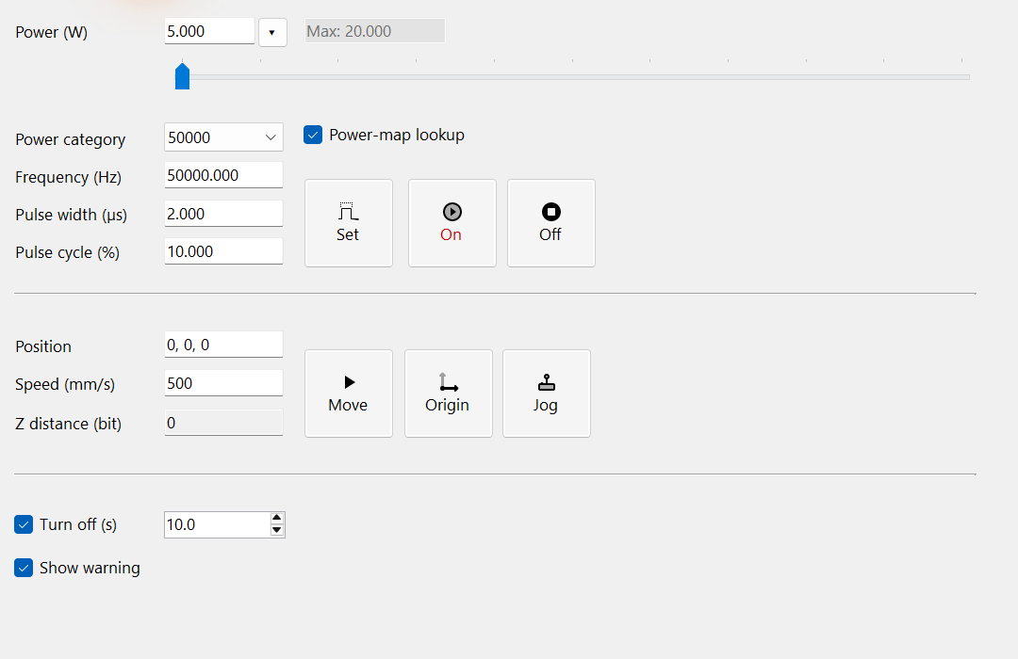
Figure 18.1 ManualControl with virtual devices: direct settings, positioning and laser-gate controls.
Releasing the power slider also sends frequency and power settings immediately. The power-map preview only displays the curve. Origin is not a stage homing operation. These device settings are separate from EntityPen and document Undo/Redo. Each relevant command needs compatible assigned devices and an idle controller.

19 LogControl for operation and fault diagnosis
LogControl shows library messages with their time, level and text. Use them to find why initialization, a document operation or a device command failed. The panel’s display filters decide what you see. The logger’s collection settings decide what it records; these are separate settings.
1. Open the log pane and read the time, level and message. Information, Warning, Error and Critical are shown by default; select Debug or Trace in Levels when needed.
2. Enter at least two characters to search message text. Search is case-insensitive and combines with the selected levels. Clear the search field to restore the filtered list.
3. Select rows and press Ctrl+C to copy them, or use Open Folder to inspect saved logs. Clear removes the current panel's list; it does not delete log files.
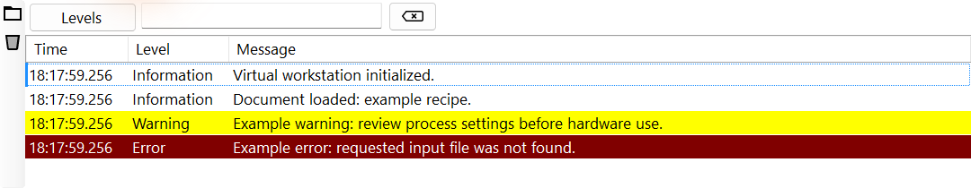
Figure 19.1 LogControl: narrow messages by level and search text, then copy the relevant rows.
Levels filters messages already received by the panel. It does not change the logger’s minimum recording level. A message shown on screen may therefore be missing from saved logs. Open Folder opens SpiralLab.Sirius3.Config.LogPath. An external ILogger may save messages differently.

20 IPowerMeter — acquire optical power
The requested power is a controller setting. A power meter measures the optical output reaching its sensor. Keep the measurement conditions stable and select the correct range. Use the measured samples to build a PowerMap. It then finds the input setting needed for the desired optical output.

20.1 Device, units and acquisition
IPowerMeter provides a common way to use optical measuring instruments. PowerMeterFactory creates virtual devices and supported implementations for vendors such as Ophir, Coherent, Thorlabs and Gentec. Install the chosen instrument’s runtime and initialize it, then assign and register it with the editor. MeasuredPower uses W; MeasuredEnergy uses J. Check MeasureUnits in OnMeasured so an energy sample is not used as a power sample.
CtlClear empties the sample buffer. CtlStart(category) starts sampling; CtlStop stops it. SamplingRateHz describes the rate of the instrument or its implementation, not RTC trajectory sampling. Use OnStarted, OnMeasured, OnStopped and OnCleared to update a trend or statistics. Handlers may run outside the UI thread. Queue the samples or dispatch screen updates, and detach handlers before disposing the device.
Listing 20.1 Acquire W samples and detach the handler reliably
public static void ObservePower(IPowerMeter meter,
Action<DateTime, double> acceptWatts, Action waitForSamples)
{
Action<IPowerMeter, DateTime, MeasureUnits, double> measured =
(source, timestamp, unit, value) => {
if (unit == MeasureUnits.Watt)
acceptWatts(timestamp, value);
};
meter.OnMeasured += measured;
bool started = false;
try {
meter.CtlClear();
started = meter.CtlStart("50000"); // Category: 50 kHz.
if (!started) throw new InvalidOperationException("Meter start failed");
waitForSamples(); // Run this acquisition routine off the UI thread.
}
finally {
if (started) meter.CtlStop();
meter.OnMeasured -= measured;
}
}

20.2 Use the editor’s Power tab
Open Power → Powermeter, start acquisition, observe the trend and the latest reading, then stop before disconnecting the instrument. The figure uses PowerMeterVirtual with LaserVirtual at zero requested output, so the displayed zero line is a virtual sample, not an optical measurement. A virtual meter linked to a virtual laser models its output and is useful for validating host/UI flow.
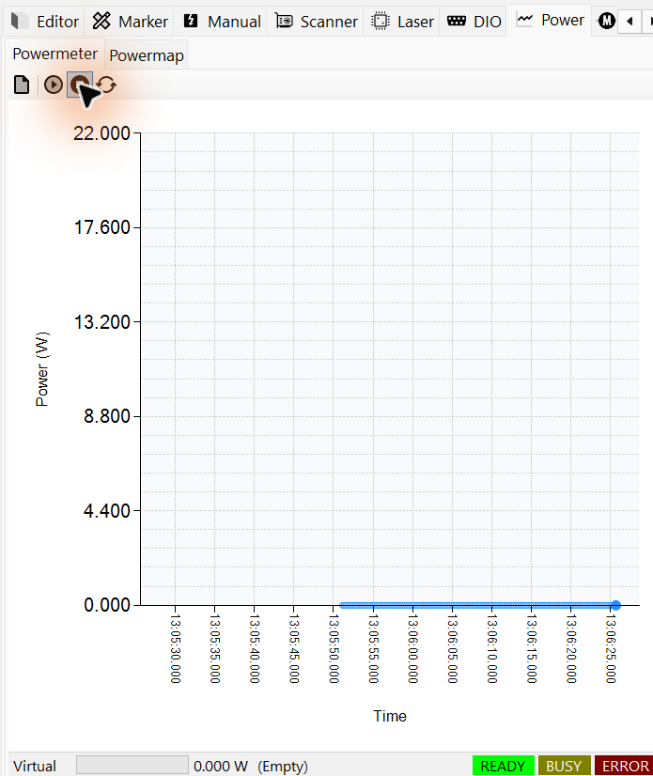
Figure 20.1 PowerMeterControl with virtual zero-output samples

20.3 How IPowerMap uses the meter
Use the meter to acquire optical output Y; use PowerMap.LookUp to find the input X needed for a requested Y. Online calibration reads IPowerMeter.MeasuredPower. The direction of this lookup is explained in 21.2 Read the map from target Y to input X; Mapping, Verify and Compensate are taught together in 21.4 PowerMapControl workflow.
LookUp uses stored measurement pairs and does not continuously sample the meter. Offline Update/LookUp therefore needs no live acquisition. Online mapping and verification use the host’s measurement procedure and may switch real laser output. Keep detector wavelength, range, saturation, beam routing and category conditions unchanged between acquisition and verification.

21 IPowerMap and measured output
1. IPowerMap records Y=f(X): commanded input X and measured optical output Y, both in watts. Independent categories retain measurements for different calibration conditions.
2. Store measured pairs with Update and enable IsLookUpEnable. For a requested output Y, LookUp returns the required input X; assign the map to ILaserPowerControl.PowerMap and use the matching category.
3. Check the Boolean result before using X. The built-in lookup requires at least two measurements and rejects targets outside the measured Y range. X is a watt-valued command; the laser adapter converts it to the configured output signal.
Listing 21.1 Create a sample calibration category without operating a laser
public static IPowerMap PowerMap()
{
IPowerMap map = new PowerMapDefault(0, "Bench calibration");
map.Update("50000", 0, 0);
map.Update("50000", 5, 3);
map.Update("50000", 10, 8);
map.Update("50000", 15, 12);
map.Update("50000", 20, 16);
map.IsLookUpEnable = true;
return map;
}
Listing 21.2 Resolve a requested output to a command value
public static double Compensate(IPowerMap map, double targetWatt)
{
if (!map.LookUp("50000", targetWatt,
out double commandWatt, out double left, out double right))
throw new InvalidOperationException("No calibration solution.");
return commandWatt;
}
The sample values explain the API; they are not measured calibration data. Update stores or replaces an X/Y measurement. Query reads a stored point. LookUp interpolates the input needed for the desired output. Check its Boolean result and returned interval. On failure, do not silently use the desired output itself as the input command.
Member or setting | Role | Use and caution
Categories | Independent measurement tables | Use an exact category key on the laser and EntityPen.​
IsLookUpEnable | Enable inverse compensation | Disabled bypasses compensation.​ A category name alone does not attach a map.​
Config.​PowerMapInterpolationMode | One global Linear or Pchip mode | Linear is the built-in default; categories do not have individual modes.​
LookUp | Requested Y → command X | Non-monotonic data can have several solutions.​ The built-in default chooses the smallest X.​
PowerMapPreHeatTimeMs /​ PowerMapHoldTimeMs | Mapping warm-up/​settling in milliseconds | Choose for the source and power-meter response.​
PowerMapInRangeThreshold | Acquisition/verification tolerance, % | Mapping compares raw input X with measured Y; Verify and Compensate compare target Y with the measurement.

Assign the map to ILaserPowerControl.PowerMap and enable lookup. Use the same category when generating power commands. The EntityPen Power dropdown previews the connected curve without emitting laser power. Mapping and verification are different: they can command real output. They require the correct meter, measuring range and optical arrangement.

21.1 Frequency categories and interpolation
The category key identifies one set of calibration conditions. In this example, "50000" denotes 50 kHz; use the exact same key in EntityPen.PowerMapCategory and Update/LookUp. Built-in online Mapping/Verify/Compensate interpret that key as frequency in Hz. Offline tables may use other keys, but LookUp does not set laser frequency. Verify the recipe’s output method and timing in 14.3 LaserVirtual output methods and 15.1 Laser values and their coupled calculations.

21.2 Read the map from target Y to input X
On the graph, move horizontally from target Y to the calibration curve, then vertically down to read the required input X. The following linear example uses the same measurement pairs as the code.
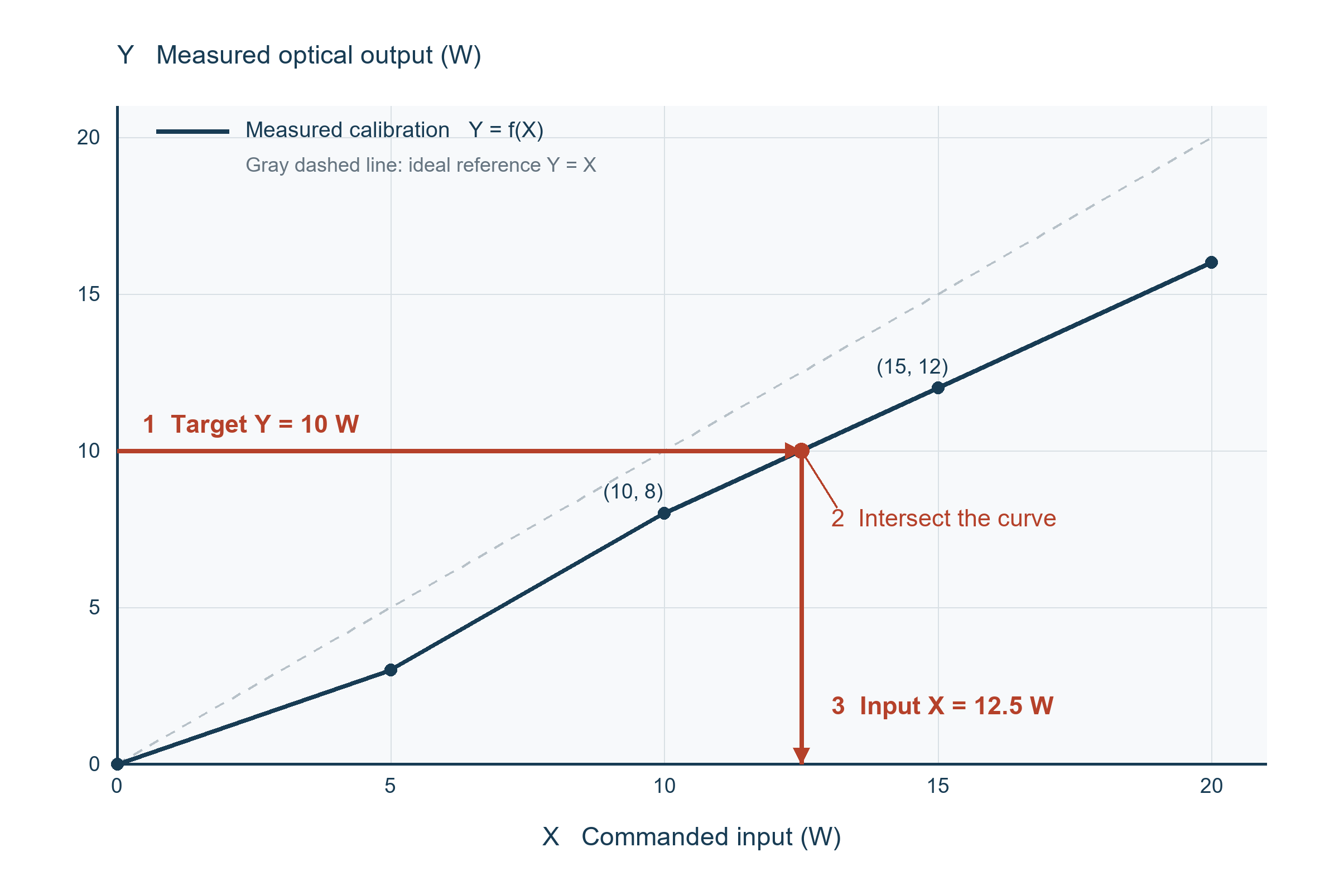
Figure 21.1 Inverse lookup from target 10 W to input 12.5 W
The plotted example uses linear interpolation in category "50000". Measurements (10, 8) and (15, 12) bracket target 10 W. The required input is 10 + (10 − 8) × (15 − 10) / (12 − 8) = 12.5 W; LookUp returns X = 12.5, left X = 10 and right X = 15. Sending X = 10 without correction would yield only Y = 8 in this example. These are illustrative measurements, not a laser specification.

21.3 Choosing Linear or Pchip
Linear joins adjacent measurements with straight segments and is the default. It provides a simple piecewise inverse for a measured calibration table.
Pchip draws shape-preserving cubic curves through the measurements. With only two points, it stays linear. The required input X can differ from the linear result. Pchip does not automatically remove noise, make the curve monotonic or remove multiple solutions. When several solutions exist, the built-in default chooses the smallest X. Check that this part of the curve is suitable for the laser.
Select the mode globally with SpiralLab.Sirius3.Config.PowerMapInterpolationMode. A .map file stores the original category/X/Y tables, not the interpolation mode. Re-verify useful target outputs after changing the mode or measurements.

21.4 PowerMapControl workflow
Mapping, Verify and Compensate can move the scanner and emit laser power. Run them while the ordinary marker is idle. They schedule background work: a true immediate return is not completion; check the corresponding Finished/Failed events and IsBusy/IsError.
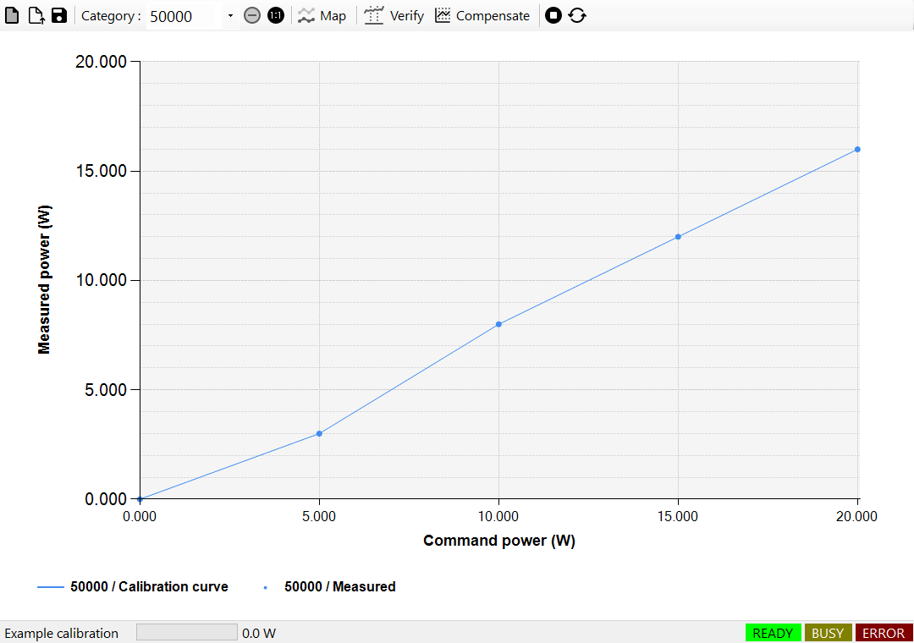
Figure 21.2 PowerMapControl with illustrative stored pairs; Map, Verify and Compensate perform different tasks.

21.4.1 Mapping
1. Mapping creates the calibration table. In PowerMapControl, select categories, input range and Steps; place and configure the power meter for the measurement location.
2. The procedure commands each uncompensated input X, waits for warm-up/settling, measures optical output Y and records the accepted pair. Steps is the number of intervals: 10 normally produces 11 samples including both ends.
3. Check completion and the measured points, then run Verify at the recipe's target outputs. A smooth graph alone does not establish optical accuracy.
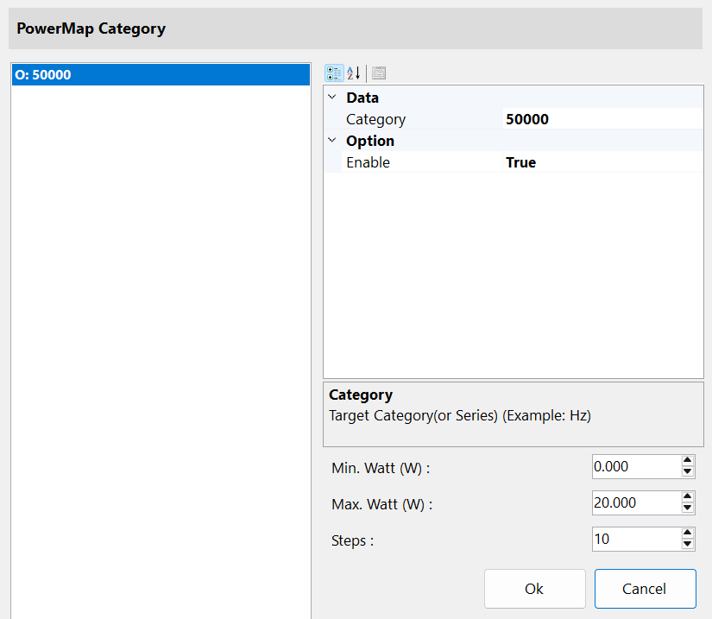
Figure 21.3 Mapping setup: select frequency categories, input range and intervals before acquisition.

21.4.2 Verify
1. Verify checks whether the existing map produces the required output. Select the category and target Y values actually used by the recipe.
2. The procedure applies the compensated input for each target Y, measures the output and compares its deviation with the configured percentage threshold. It does not change the calibration table.
3. Check the completion result and measured deviation. If output has drifted, investigate the conditions and use Compensate or repeat Mapping as appropriate.
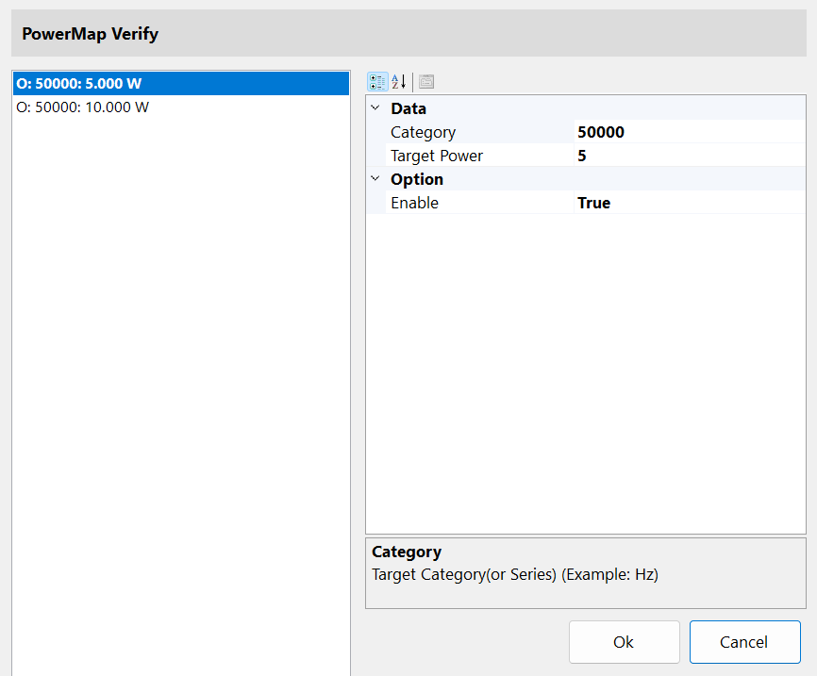
Figure 21.4 Verify setup: select enabled category and target-power pairs to measure without changing the table.

21.4.3 Compensate
1. Compensate adapts an existing map when measured output has drifted. Select the category and target output Y to check.
2. If deviation is within the permitted correction range, the procedure updates the measured Y at the current input X, inverts the revised map and retries. It does not multiply the entire curve by one common ratio.
3. Check completion, verify useful targets and save the accepted map. Excessive deviation or exhausted retries causes failure; compensation does not guarantee correction of every optical or laser fault.
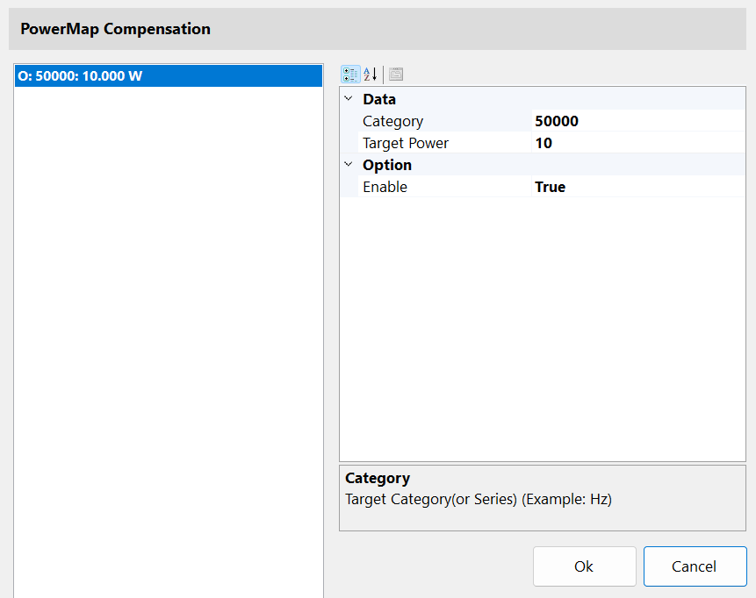
Figure 21.5 Compensate setup: select target powers for measured drift correction and re-verification.
Save the previous calibration before Mapping: each selected category is cleared before acquisition, and a failed run may leave partial data. Configure warm-up, settling and permitted deviation for the equipment. Mapping also checks PowerMapInRangeThreshold against raw X and measured Y; the default 5% can reject strongly nonlinear illustrative pairs.
Output drift means that measured Y has changed for a given input X. Compensate checks deviation from target Y using PowerMapInRangeThreshold and PowerMapOutOfRangeThreshold and limits retries with PowerMapCompensateRetryCounts. Confirm completion and verification before saving the revised map.
The public demos/editor_powermap/my_powermap.cs provides MyPowerMap : PowerMapBase with the complete Mapping, Verify and adaptive Compensate procedures. Form1.cs shows assignment of the scanner, laser and power meter, loading a .map and connecting it to ILaserPowerControl.PowerMap. Customize these acquisition procedures while preserving error/completion handling; the demo does not disclose the entire Core interpolation solver or commercial library.
PowerMapBase requires five abstract operations: CtlMapping, CtlVerify, CtlCompensate, CtlStop and CtlReset. Override LookUp when a different inverse model or branch selection is needed. Preserve abort, progress/completion events, device-state checks and laser-off cleanup. A custom LookUp defines its own behavior rather than automatically following the built-in global interpolation setting.

22 Measurement entities and result plots

22.1 Place Begin and End in EditorControl
Measurement is a document workflow: EntityMeasurementBegin → processing objects → EntityMeasurementEnd in one layer. In EditorControl, choose Measurement in the control-entity menu. It inserts Begin at index 0 of the active layer and appends End. Place the desired geometry between them and check the TreeView order. Do not add another pair when one is already present in that layer.
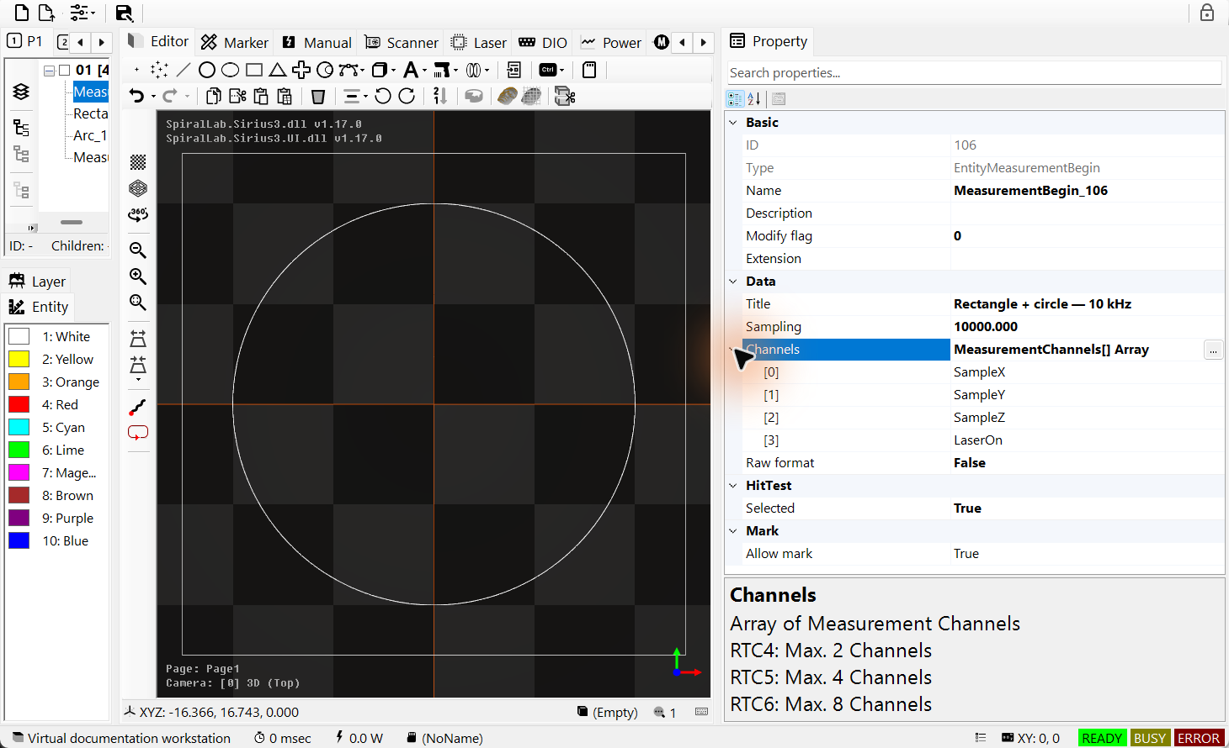
Figure 22.1 Selected EntityMeasurementBegin with sampling and expanded channel settings
Select Begin in the TreeView. Set SamplingFrequency in Hz, Channels and IsRawData. The standard non-RTC4 toolbar recipe starts at 10,000 Hz with SampleX, SampleY, SampleZ and LaserOn. RTC4 offers two channels, RTC5 four and RTC6 eight; choose supported channels. EntityMeasurementEnd closes the acquisition window. Keep both control entities enabled and in the same layer.
Listing 22.1 Build the same acquisition window through EntityFactory
public static bool AddMeasurement(IDocument document)
{
// Use an empty active layer. Insert only one Begin/End pair.
var begin = EntityFactory.CreateMeasurementBegin(10_000,
new[] { MeasurementChannels.SampleX,
MeasurementChannels.SampleY,
MeasurementChannels.SampleZ,
MeasurementChannels.LaserOn }, "Rectangle + circle");
begin.IsRawData = false;
if (!document.ActAdd(begin)) { if (begin.Owner == null) begin.Dispose(); return false; }
var rectangle = EntityFactory.CreateRectangle(DVec2.Zero, 50, 50);
if (!document.ActAdd(rectangle)) { if (rectangle.Owner == null) rectangle.Dispose(); return false; }
var circle = EntityFactory.CreateArc(DVec2.Zero, 20, 0, 360);
if (!document.ActAdd(circle)) { if (circle.Owner == null) circle.Dispose(); return false; }
var end = EntityFactory.CreateMeasurementEnd();
if (!document.ActAdd(end)) { if (end.Owner == null) end.Dispose(); return false; }
document.ActSelect(begin);
return true; // Recipe only; no physical job has been started.
}

22.2 Run the recipe and obtain the result
Use MarkerRtc on a commissioned RTC system. Set the marker’s IsMeasurementPlot=true to open the result plot after successful processing. When a layer completes, the marker saves the completed MeasurementSession and then plots queued results. Files go under SpiralLab.Sirius3.Config.MeasurementPath. Their names include the marker name, date/time and sequence number. The default folder is measurement under the application directory.
With IsRawData=false, the text file contains Time(s), channel names and converted sample values. Columns use whitespace, not commas. SampleX/Y/Z are commanded sample coordinates; they do not prove that the physical spot position was independently measured. Scanner feedback needs a compatible head and feedback configuration. LaserOn is a controller signal, not measured optical watts.

22.3 Read time and X/Y plots
TimeChart plots the saved channels against time in seconds. Use it to inspect motion segments and switching timing. PositionChart uses SampleX, SampleY and LaserOn to distinguish marked paths from jumps. For converted coordinate data, its X/Y axes use mm. Double-click to reset the native viewer’s axes. The helper below reopens a saved result without running a new job.
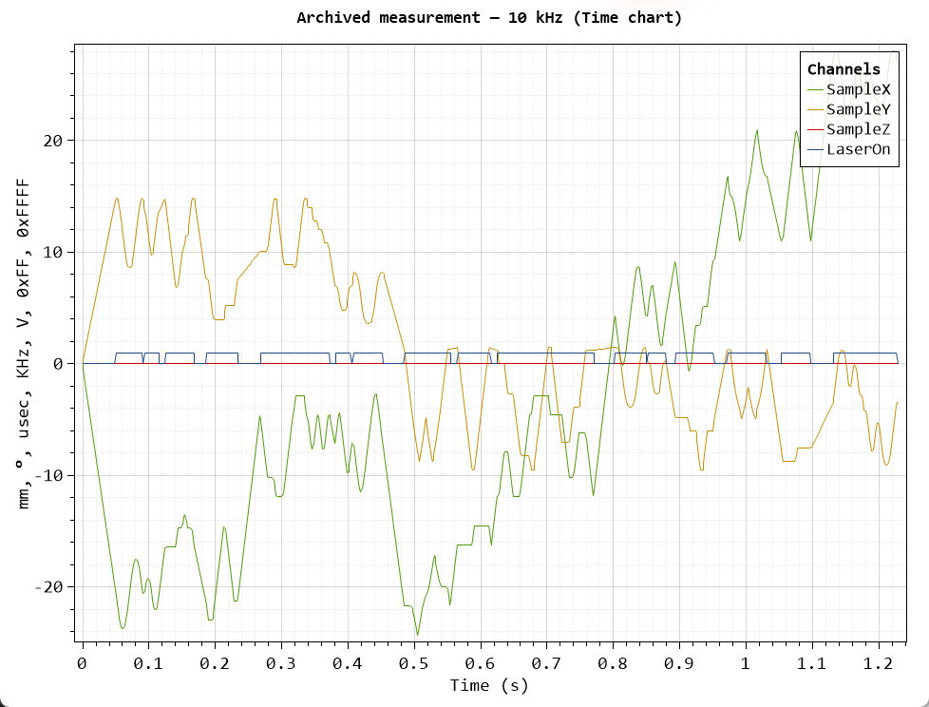
Figure 22.2 Time plot from an archived 10 kHz acquisition; a different job from the rectangle/circle recipe
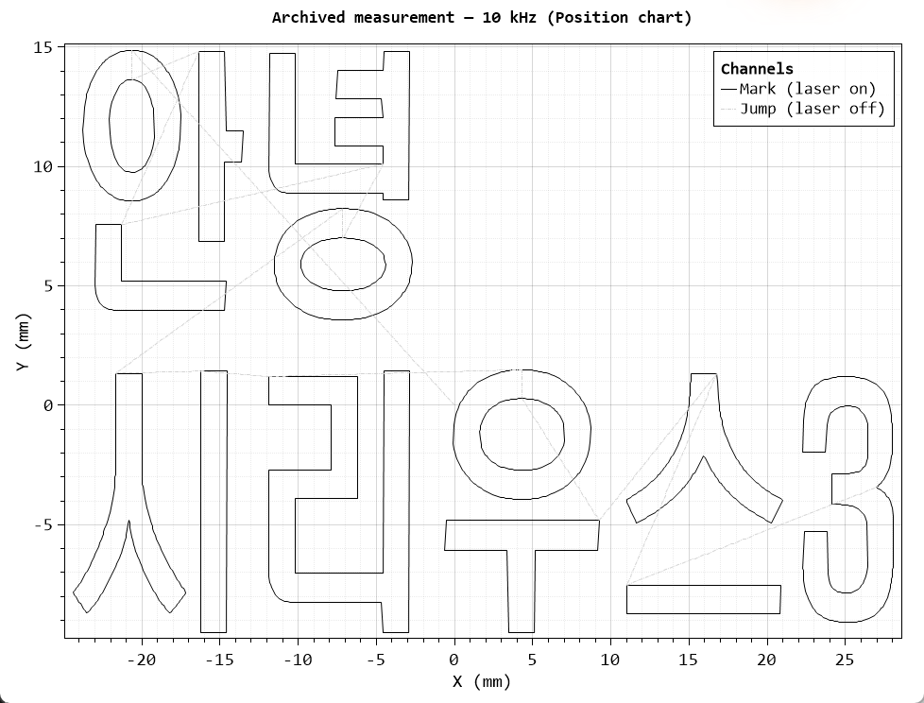
Figure 22.3 The same archived result as an X/Y path: mark and jump segments
Listing 22.2 Reopen an existing measurement file
public static bool PlotSavedMeasurement(string resultFile)
{
if (!File.Exists(resultFile)) return false;
// TimeChart accepts all saved channels.
bool time = RtcMeasurementHelper.Plot(resultFile,
PlotModes.TimeChart, "Saved measurement");
// PositionChart requires SampleX, SampleY and LaserOn.
bool path = RtcMeasurementHelper.Plot(resultFile,
PlotModes.PositionChart, "Saved measurement");
return time && path;
}
Use demos/editor_measurement_skywriting_wobbel/Form1.cs for the full recipe: identical geometry with different Sky Writing or Wobbel settings, followed by measurement plots. Compare results at the same frequency, channels and processing conditions. The Begin/End workflow is not the syncAXIS measurement-log workflow; use its Viewer chapter for syncAXIS.

23 2D scanner field calibration
Field calibration reduces the difference between commanded coordinates and measured work-plane positions. Establish coordinate directions first. In 3D, XY placement and focus must also agree at different heights; a correct screen model alone does not calibrate the optics.
Use the original correction that matches the lens and scan head, and preserve it so it can be restored. Save the corrected output separately. The public entry point is demos/editor_fieldcorrection_2d/Form1.cs.

23.1 Why the 2D field needs correction
1. Two spatially separated X/Y galvo mirrors steer the beam. For one mirror with a fixed incident beam, a mirror-rotation change φ produces a reflected-beam angle change θ=2φ. In the real two-axis system, both mirror angles and their spacing affect the field geometry.
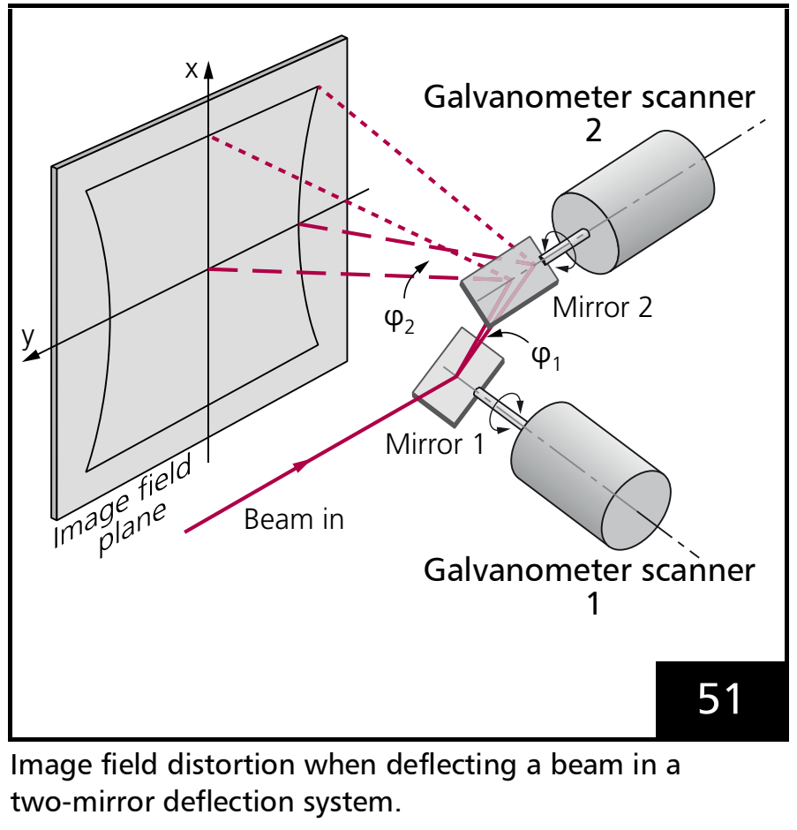
Figure 23.1 Separated X/Y galvo mirrors and beam deflection toward the work plane
2. An idealized single-axis model with an ordinary lens gives x=f·tan(θ): f is the focal length (mm), x is position (mm), and θ is the beam angle (rad). Only at small angles is tan(θ)≈θ. An F-theta lens optically targets x≈f·θ and a flat focal plane, but residual mirror, lens and assembly errors can still distort XY positions.
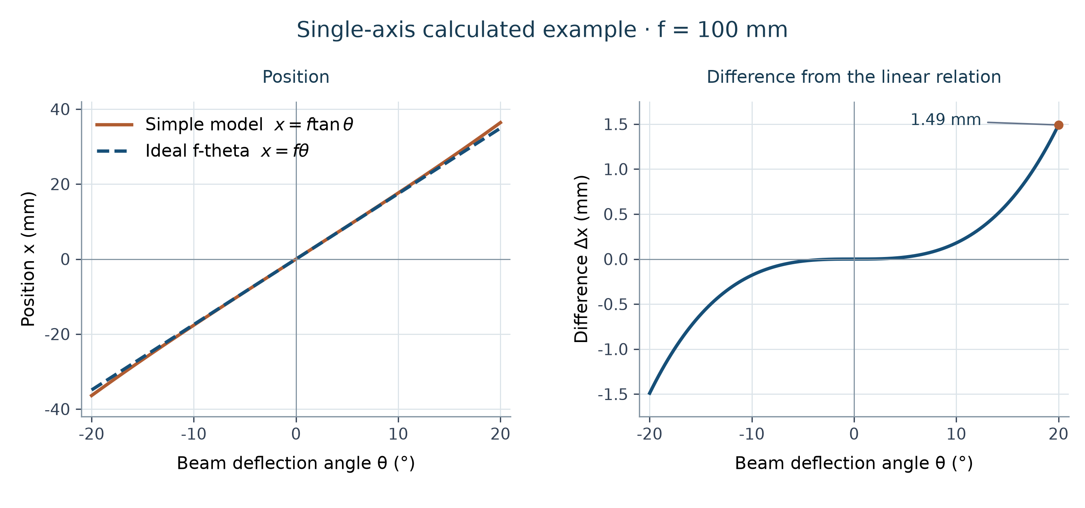
Figure 23.2 Calculated single-axis example: f=100 mm and beam angle θ from −20° to +20°. The curves compare x=f·tan(θ) with the ideal F-theta relation x=f·θ, using θ in radians in the calculation. This is an explanatory model, not measured correction data or the full two-mirror geometry.
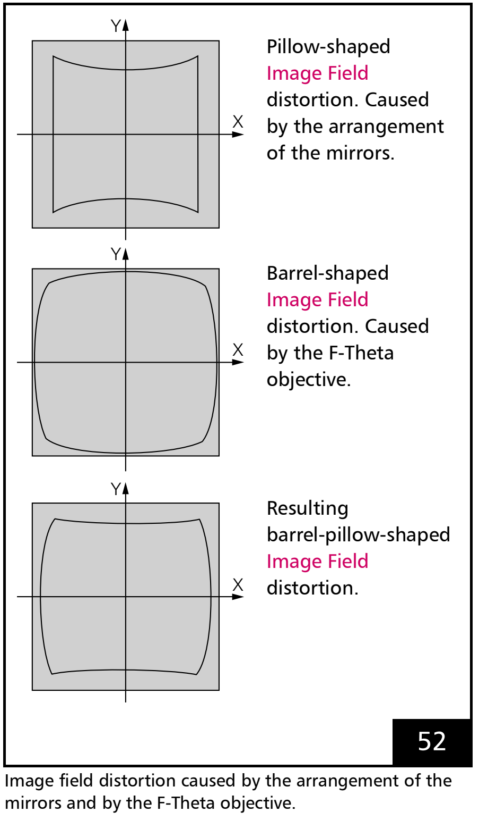
Figure 23.3 Mirror distortion, F-theta lens distortion and their combined effect
3. Establish KFactor, measure a grid using the matching source table, and calculate a separate correction table from the measured XY differences: CT5 for RTC5/6, or the matching CTB format for RTC4. Check success, load and select the file on the idle RTC, then verify independent points. A 2D table corrects XY positions; it does not remove defocus or solve every 3D error.

23.2 Measure convert apply and verify
Each measured-grid cell contains two lines in mm: ΔX = measured X − reference X and ΔY = measured Y − reference Y. Enter these deltas in the UI, not the absolute target coordinates. The API AddAbsolute(row, col, reference, measured) accepts absolute pairs and derives the same deltas. Grid indices in that API are zero-based. Values in the figure are illustrative deviations, not a calibration for a real lens.
1. Select a valid field and odd row/column counts within the source-format limit: 3–65 for .ctb, or 3–99 for other supported inputs. Set row and column pitch in mm and create a centered grid.
2. Mark the grid on the commissioned system, measure every point in a common XY frame and keep row/column correspondence.
3. Open Correction2DRtcForm, confirm source/target files and K-factor, then enter the measured XY deltas or import the measurement data.
4. Convert and inspect the result log. A changed input requires conversion again.
5. Only after successful conversion, apply the current result to correction table 1, verify its selection and measure a new independent pattern. Keep residual errors and the validated configuration with the result file.
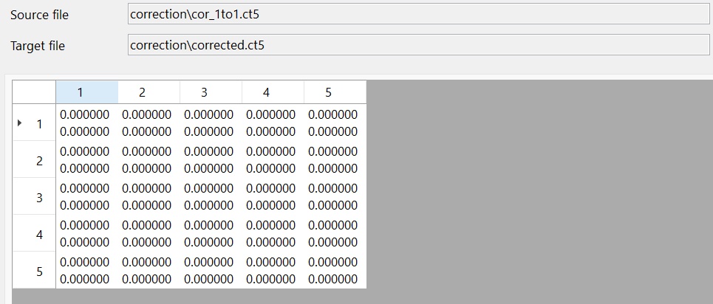
Figure 23.4 2D correction detail: source/target files and a 5×5 sample ΔX/ΔY table. Zero deviations are illustrative data from a virtual-scanner host.

23.3 Verify KFactor, then refine the 2D grid progressively
KFactor converts scanner coordinates in mm to controller bits (bits/mm). Establish it before fitting field distortion: use the matching head, lens and correction-file/Readme data, then verify a known span near the working reference.
Check mounting direction in 13.3 Align a rotated scan head with the working coordinates and the measurement frame in 23.4 Enter the measured positions correctly before adding grid density. KFactor establishes scale; a denser correction grid cannot repair wrong units, scale or orientation. The separate 3D scale preparation is explained in 24.2 Prepare units and scale.
Begin with a coarse grid, for example 3×3, to remove gross scale/orientation and broad field errors. Verify the result, use the accepted correction file as the next source, then increase the measurement density, for example 5×5 → 9×9 → a finer supported grid if needed. Keep the field extent explicit: more points over the same field mean smaller spacing. Recalculate row/column intervals consistently.
Verify each stage at independent positions, field edges and actual production shapes as well as the fitting points. Keep the previously accepted file and measurement conditions. Increase density only after the coarse result is stable; more points cannot compensate for poor measurement repeatability. Use the separate sequence in 24.1 Calibration order and measurement data for focus and scale at different heights.

23.3.1 CreateGridsForm and measurement points
1. Create a regular reference pattern before measuring XY positioning errors for 2D correction. Open Create Grids from the editor's creation commands.
2. Set rows, columns, both intervals in mm and the Point, Cross, Circle or Grid shape. Each count is 3–99; the span, (count−1)×interval, must fit within the field size.
3. Press OK to add the pattern to the document, then inspect its spacing and position. Measurement, correction-file conversion and application to the RTC are separate steps.
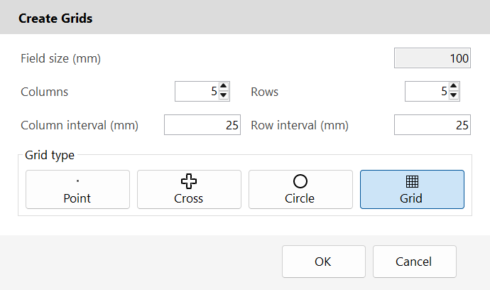
Figure 23.5 Create Grids: choose a measurable reference pattern and check the generated geometry before calibration.
Create Grids creates geometry; it does not run a marking job or calibrate the scanner. Use an odd grid such as 5×5 when continuing to the 2D correction dialog, whose measurement reset requires odd row and column counts.

23.4 Enter the measured positions correctly
1. A reference point is where the mark should be; a measured point is where it was found on the workpiece. Use millimetres and the same X/Y directions for both. For reference (10, 20) and measurement (10.12, 19.95), the error is ΔX=+0.12 and ΔY=−0.05 mm. Enter these two errors in the 2D measurement cell.
2. For API input, AddAbsolute takes the reference and measured positions; AddRelative takes the reference and the measured-minus-reference error. If the positions include the configured RTC head transform, call the overload with rtc (and the selected head for 2D). It reverses that hardware head transform once before storage; it does not also reverse the entity's ModelMatrix or marker Offsets. Without rtc, supply positions already expressed in the scanner's raw axes.
3. Check the bool result and one known point before filling the grid. Do not invert data twice or mix the two coordinate conventions. Grid row/column identifies the point; a measured error must not select another cell. In 2D, automatic grid remapping supports 90° axis rotations and reflections; clear recorded data before changing grid orientation or dimensions.
Example of undoing a head translation: if the current head transform adds +100 mm in X, working coordinates (110, 20) and (110.12, 19.95) become raw coordinates (10, 20) and (10.12, 19.95) inside the RTC-aware overload. The same +0.12/−0.05 mm error remains. “Working coordinates” means physical positions in mm, not mouse pixels.
The same position-versus-error distinction applies to RTC-aware 3D/CalibrationLibrary overloads. Their own contracts still apply: RtcCorrection3D uses the primary head and configured lower/upper reference Z planes. Focus-search A/Zout bit values are not XY measurements in mm.
Listing 23.1 Let the RTC-aware 2D overload perform the inverse transform
public static bool AddFrontViewPoint(IRtcCorrection2D correction,
IRtc rtc, int row, int col, DVec2 reference, DVec2 measured)
{
// Grid and source/target correction files are already configured.
// This overload performs the inverse head-matrix conversion.
return correction.AddAbsolute(row, col, reference, measured,
rtc, ScannerHeads.Primary);
}

24 3D scanner field calibration
3D calibration extends XY correction to beam tilt, focus and volume scale. Use an IRtc3D-capable scanner, the matching dynamic-focus hardware and licensed SCANLAB CalibrationLibrary runtime. Correction3DRtcForm is opened with an initialized marker. See demos/editor_fieldcorrection_3d and editor_fieldcorrection_3d_pointscloud for the interactive and point-cloud workflows.

24.1 Calibration order and measurement data
Use a valid 3D source correction file and its matching Readme. The optical geometry and focus-unit setup must already be meaningful. CalibrationLibrary orders file improvements as follows: CTB to CT5 conversion if needed; plane, cylinder or cone adaptation if needed; scale; Beam Tilt; XY; Focus Z=0; finally ABC and/or Stretch. Steps may be omitted when unnecessary, but earlier corrections must not be moved after later ones. The current Sirius3 dialog exposes the five measurement tabs from Beam Tilt through Stretch; preprocessing is not an extra tab in this dialog.
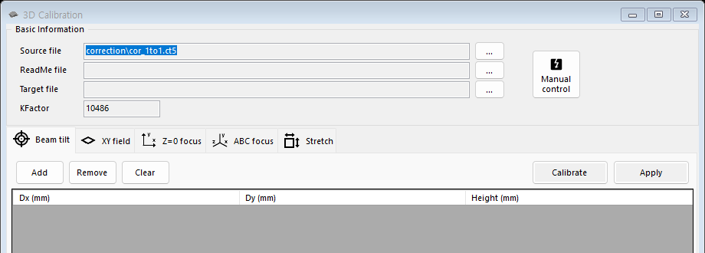
Figure 24.1 3D correction stages and measurement inputs

24.2 Prepare units and scale
IRtc.KFactor is the scanner coordinate conversion in bits/mm. Determine it from a known field dimension and keep it consistent with the correction file. The vendor Scale Calibration improves the table from a measured scale error; changing KFactor alone is not a substitute for distortion correction. Preserve the original table and Readme parameters, including the lens and Z range. A 2D table cannot serve as the source for Beam Tilt 3D calibration. See 23.3 Verify KFactor, then refine the 2D grid progressively to establish KFactor and 23.4 Enter the measured positions correctly for measurement coordinate conventions.

24.3 Beam Tilt corrects beam incidence
Measure the XY displacement of the reference beam between two parallel measuring planes separated by known Height H in mm. Enter DeltaX, DeltaY and H in the Beam Tilt tab. The measurement-data function derives the zero-galvanometer-angle offsets, then recalculates the 3D table. It corrects the height-dependent lateral shift caused by beam incidence; it is not a user rotation of the drawing. Keep the same reference position and displacement sign convention on both planes.

24.4 XY Field corrects positions on the reference plane
On the reference plane, measure a distributed XY grid with the current table. Enter target X/Y and measured X/Y pairs in mm, keeping row correspondence and axis signs. XyCalibration converts the targets using KFactor and fits the corrected field mapping. It corrects lateral placement, scale and field distortion sampled by the grid; it does not determine the best focus or ABC polynomial. Include the field edges and validate with points not used for fitting.

24.5 Focus Z zero flattens the reference focus
At several XY positions on physical Z=0, find the focus-unit output that gives the best focus. Record target XY in mm and the best A/Zout bit value, not the physical height in mm. The UI temporarily uses (A,0,0) for the focus search and restores the saved ABC state when leaving the step. FocusCalibrationAtZ0 readjusts the table from these samples so the reference plane focuses across the field. Begin with a valid initial focus model; the result is a plane correction, not a measured volume model.

24.6 ABC fits the focus actuator curve
1. The focus actuator uses zout = A + B·l + C·l². The focal-length value l comes from the optical correction model; it is not physical Z in mm. A is the offset, B the linear term and C the curvature. None is an X/Y/Z coordinate offset.
2. Measure at least three distinct focal-length / best-focus output pairs across the intended range. FocusCalibrationCoeffABC accepts 3–255 pairs. Both measurement arrays use 16-bit values for CTB or 20-bit values for CT5; the integrated UI converts the current RTC bit basis for the selected file.
3. Separate coefficient and measurement bases. CalibrationLibrary returns and IRtc3D.CoeffABC use 16-bit-compatible coefficients. On RTC6, CtlLoadZTable and CtlCorrectionReadABC/CtlCorrectionWriteABC use the 20-bit basis. Convert 16→20 bits with A×16, B unchanged and C÷16; never scale all three equally.
The integrated UI obtains l from the current optical model at each measured XYZ position.
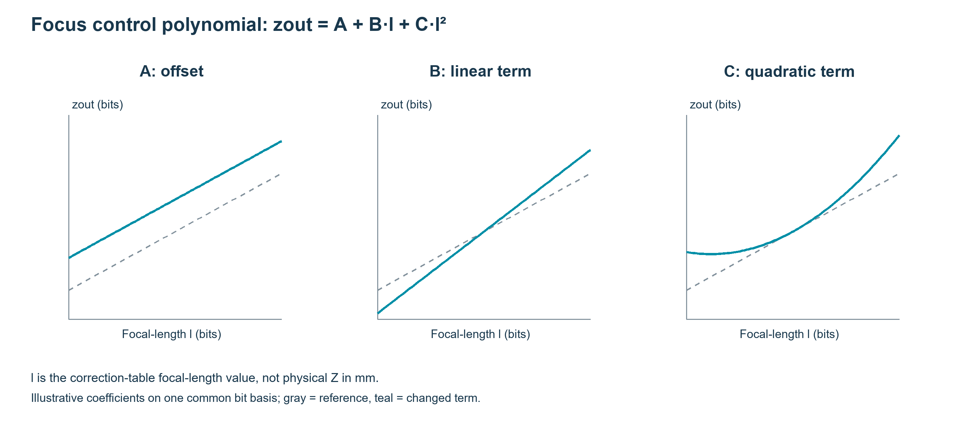
Figure 24.2 A shifts offset, B changes slope and C changes curvature.

24.7 Stretch corrects the lateral scale over Z
At several nonzero heights, compare target XYZ with measured XY, all in mm. StretchCalibration estimates the X/Y stretch factors that correct residual height-dependent lateral scale. It does not replace the ABC focus-actuator fit or prove that the spot is in focus. The vendor sequence permits ABC and Stretch in either order after Focus Z=0, and either may be omitted when not needed. Recheck both XY size and best focus at the center, edges and multiple Z planes after either operation.

24.8 Calculate save apply and verify
For each stage, keep the raw measurement rows and write to a new target correction file. Calibrate calculates a file; it does not automatically make it the RTC table. Check the returned error and the generated file, then use Apply while marker and RTC are idle. Apply loads/selects the target and makes it the next source, preserving the improvement chain. If an earlier stage changes, remeasure or repeat the affected later stages. CalibrationLibrary activation and matching native runtime are required.

24.9 Focus on a free-form surface from a point cloud
PointsCloudCalibration calculates a separate correction file from surface XYZ points in mm and an existing 3D optical correction. It interpolates the surface height while later RTC commands keep the same top-view XY coordinates. An STL cloud describes CAD geometry, not an optical measurement.
The STL importer keeps the file’s coordinate values without inferring physical units. Check a known dimension first. Prepare a 3D correction and matching README for the optics and dynamic-focus unit, plus an activated, compatible CalibrationLibrary. Copies of D3_2982.ct5 and D3_2982_ct5_ReadMe.txt are sample settings, not calibration data for every machine.
Extraction requires an OpenGL 4.3 or newer context current on the calling thread. For calibration, select one EntityPoints, use a ready, idle marker and an idle RTC, select the source correction table and stop document simulation.
This capture host uses a 0.10 mm grid interval to show surface height clearly. The default SpiralLab.Sirius3.UI.Config.GridCloudInterval remains 0.5 mm; ActGridCloud takes the desired interval explicitly. Finer spacing increases extraction and calibration work and does not itself prove greater accuracy.
1. Import sample/stl/Nefertiti_face.stl. Scale all axes to 0.1, centre XY and place the minimum Z at 0. The resulting bounds are X ±5.237954, Y ±2.264995 and Z 0–2.996162 mm. Check that they fit the source correction’s field and Z range.
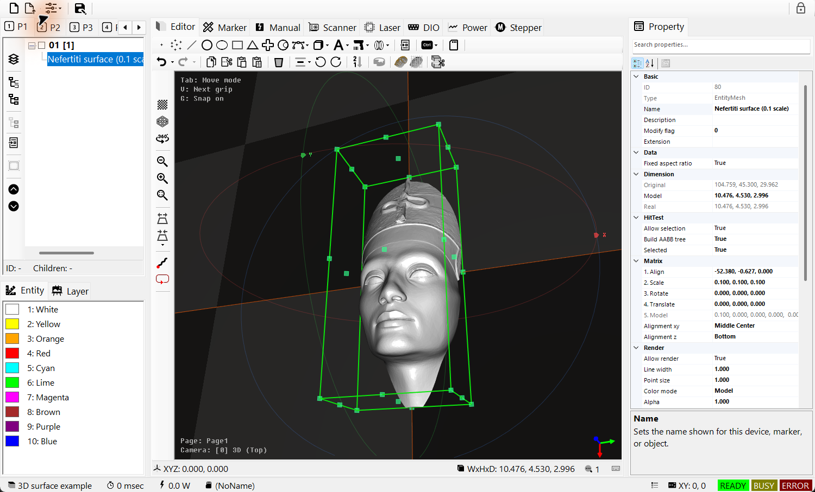
Figure 24.3 Imported Nefertiti mesh, scaled to 0.1 and centred in XY with minimum Z = 0. Check the transformed bounds in mm.
2. Select the mesh and use Extract PointsCloud: Each Vertex or Per Grids, as compared below. In this run, +Z vertex extraction returns 98,469 points; 0.10 mm grid extraction returns 3,104 points with normals. For the following calibration, select the grid EntityPoints. Set Allow render to false on the mesh and previous cloud to hide only their display, keep the cloud in place, and check its count and height from the same oblique view.
Table 24.1 Two ways to extract surface points
API | Sampling | Returned data / this run
ActPointCloud (Each Vertex) | Uses existing transformed mesh vertices. A normal-direction check selects candidates, then rays along dir reject occluded vertices. Density follows the mesh, not a uniform XY interval. | List<DVec3> and rayOriginOffset. Here dir = +Z, 98,469 points and offset (0, 0, 0.001) mm. The ray-start offset is removed from returned points; it is not a cloud displacement.
ActGridCloud (Per Grids) | Samples a regular XY grid from above along −Z. At each ray, the first intersected surface supplies the topmost point. Rays missing the mesh add no point. | DVec3[] vertices and DVec3[] normals. At 0.10 mm this run returns 3,104 corresponding points and normals. This evenly spaced XY sample is used for the following calibration.
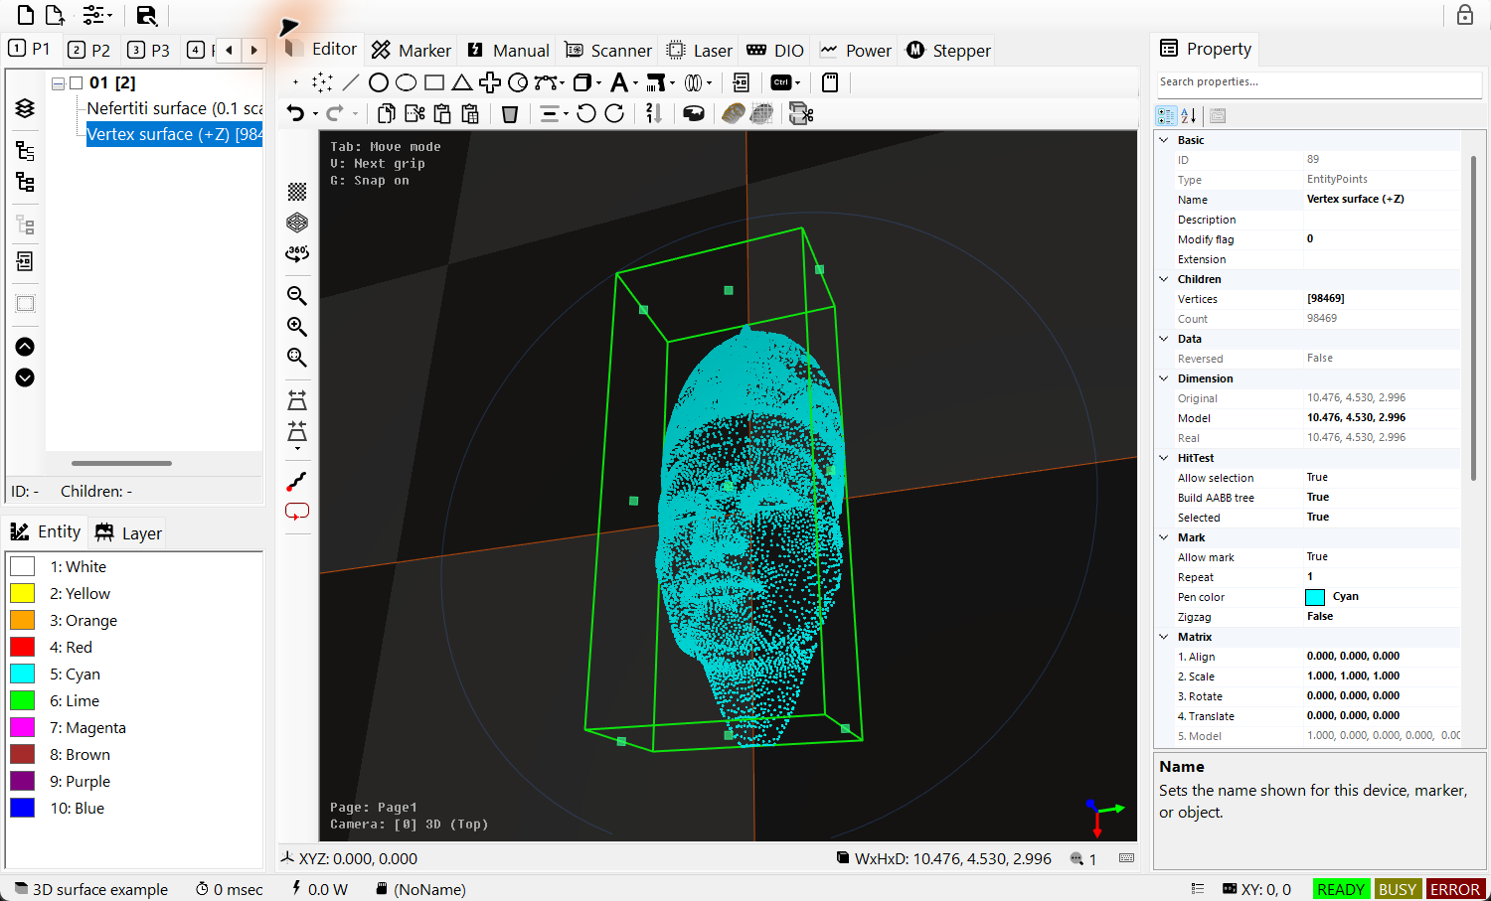
Figure 24.4 +Z vertex extraction: 98,469 points. Select the resulting EntityPoints and check its count in PropertyGrid from the same oblique view.
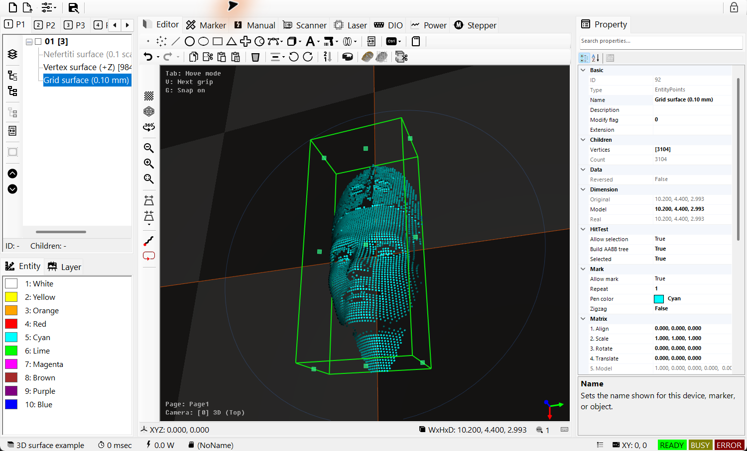
Figure 24.5 0.10 mm XY grid extraction: 3,104 surface points with normals. The selected grid cloud is the input for the following calibration; other displays are hidden.
3. Right-click the view and choose Scanner field correction → Point cloud. Confirm the selected 3,104 points to calculate a separate file from the current 3D correction and matching README. Check calculation success before confirming loading and selection on the idle RTC. Verify the physical result independently.
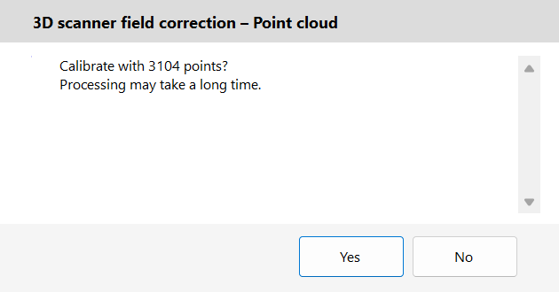
Figure 24.6 Confirm calculation with the selected 3,104 grid points. This is the confirmation dialog before calculation, not the generated-file result.
In this run, the 3,104 grid points produced a new CT5 separate from the source. Native coefficient and Stretch queries both returned NO_ERROR, and selection of the new file was checked on a virtual RTC. Physical focus was not measured.
Both APIs extract data only. The editor adds an EntityPoints through a document action. In code, construct EntityPoints and use ActAdd to record its addition in Undo/Redo. Keep it at the intended physical coordinates; moving it aside also changes the transformed calibration input.
Dense points and the shared oblique view help inspect surface height. They are a display aid, not a measured scanner result. Hide only unwanted displays instead of translating the cloud for comparison.
STL extraction does not replace Beam Tilt, XY, Focus Z=0, ABC or Stretch optical measurements. Establish the base correction in the preceding workflow. Point XYZ uses mm; focus-calibration bit values are separate. Preserve the source and keep the generated file with its matching README.
File creation, native file queries and selection on a virtual RTC verify software processing only. Physical focus and surface quality still require measurement. Document Undo can undo adding EntityPoints; it cannot undo writing a CT5 or changing RTC correction selection.

25 SiriusMultiEditorControl and WPF support
SiriusMultiEditorControl lets several device sets share one document and one view. It supports up to four indexed sets, each with a scanner, laser, marker, power meter and optional I/O and remote services. The selector changes the set displayed by the device panels. Use separate SiriusEditorControl instances when each scanner or station needs its own document and recipe.
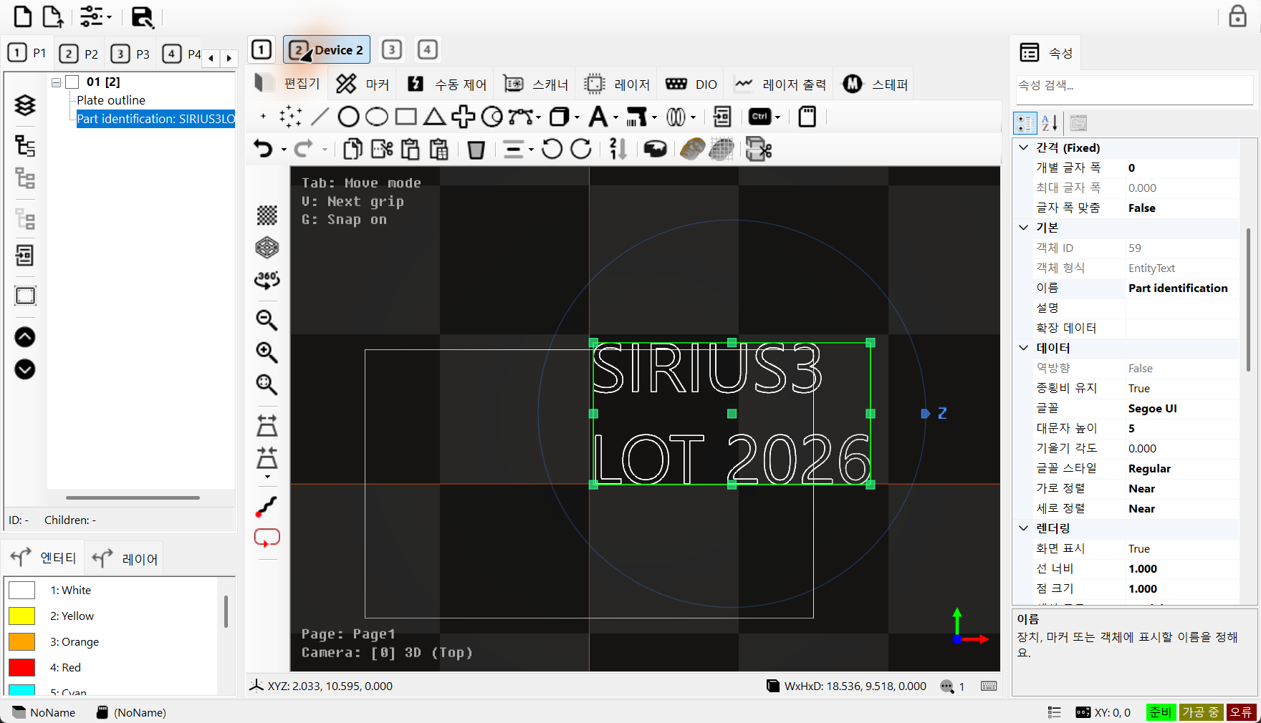
Figure 25.1 WinForms: Device 1 and Device 2 share the document; the selector sits above the editor tabs

25.1 Register the sets before selecting one
First set MaxDeviceCounts to 1–4. Initialize each device set, then register it with RegisterDevices using a zero-based index. This call connects the marker to the shared document and view through Ready. After registration, explicitly call SwitchDevices(0). CurrentDeviceIndex is read-only. Use SwitchDevices to change the selection. UI labels Device 1 and Device 2 correspond to API indexes 0 and 1.
Listing 25.1 Create RTC6 and LaserVirtual device sets
internal sealed class DeviceSet
{
internal IRtc Rtc;
internal ILaser Laser;
internal IPowerMeter Meter;
internal IMarker Marker;

internal static DeviceSet Create(int index)
{
var set = new DeviceSet();
try
{
var correction = Path.Combine(Config.CorrectionPath, "cor_1to1.ct5");
set.Rtc = ScannerFactory.CreateRtc6(index,
Math.Ceiling((1 << 20) / 100.0), LaserModes.Yag1,
RtcSignalLevels.ActiveHigh, RtcSignalLevels.ActiveHigh, correction);
if (!set.Rtc.Initialize()) throw new InvalidOperationException("RTC
initialization failed.");
set.Laser = LaserFactory.CreateVirtual(index, 20, PowerControlMethods.Analog);
set.Laser.Scanner = set.Rtc;
if (!set.Laser.Initialize()) throw new InvalidOperationException("Laser
initialization failed.");
set.Meter = null; // Optional physical power meter.
set.Marker = MarkerFactory.CreateRtc(set.Rtc.Index);
return set;
}
catch
{
set.Marker?.Dispose(); set.Meter?.Dispose();
set.Laser?.Dispose(); set.Rtc?.Dispose();
throw;
}
}
}
Listing 25.2 Register two device sets on one WinForms control
private void InitializeDevices()
{
editor.MaxDeviceCounts = 2;
for (int index = 0; index < editor.MaxDeviceCounts; index++)
{
var set = DeviceSet.Create(index);
editor.RegisterDevices(index, set.Rtc, set.Laser, set.Meter,
null, null, null, null, null, set.Marker);
}
if (!editor.SwitchDevices(0))
throw new InvalidOperationException("Device set selection failed.");
// Both device sets use this one document.
editor.Document.ActRegen();
editor.View.ActiveCamera.ZoomFit(editor.View,
new[] { editor.Document.ActivePage.ActiveLayer });
editor.View.DoRender();
}

25.2 Change a device set
Before switching, check that every marker is idle and stop display simulation. Process device switches and external start requests one at a time on the owning UI thread. A switch updates Scanner, Laser, Marker, PowerMeter and the registered port/remote panels. Use OnBeforeChangeDevice and OnAfterChangeDevice to save and restore station-specific UI state. The document and pen definitions remain shared. WinForms switching alone does not interlock every busy state.
Listing 25.3 Check all markers before switching to another device set
private bool SelectDevice(int index)
{
if (index < 0 || index >= editor.MaxDeviceCounts) return false;
if (editor.Markers.Any(marker => marker?.IsBusy == true)) return false;
editor.Document.ActSimulateStop();
return editor.SwitchDevices(index);
}
Inspect registered sets through Scanners, Lasers and Markers; Scanner, Laser and Marker identify the active set. Pair each device with its matching marker and settings, and do not switch devices during a job.
On closing, await DisposeDevices once, then follow 3.4 DPI and application lifetime to release the control, host-managed document and Core. See 25.3 Native WPF controls are supported for WPF lifetime differences.

25.3 Native WPF controls are supported
SpiralLab.Sirius3.UI.WPF.SiriusEditorControl provides one editor. The following native WPF screen shows its document tree, drawing view and PropertyGrid.
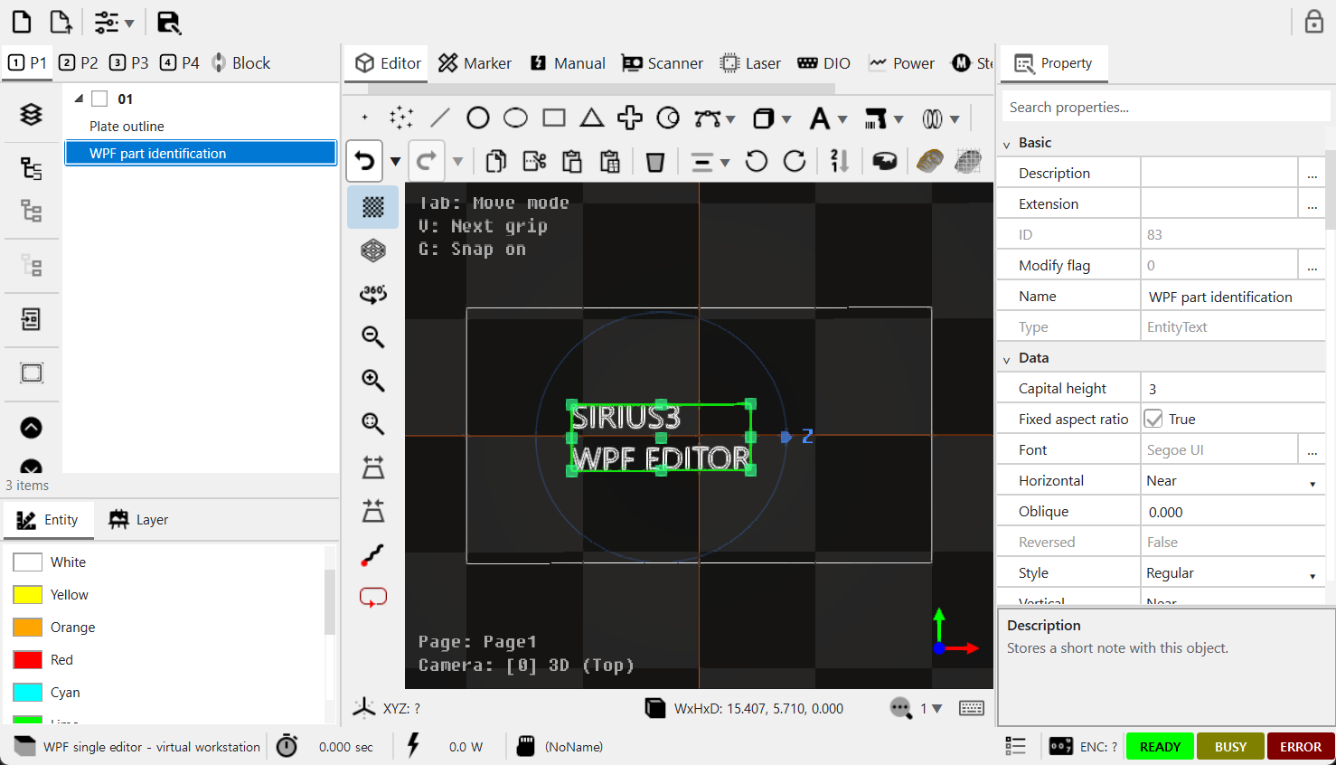
Figure 25.2 Single WPF.SiriusEditorControl with the text entity selected and its properties visible at right.
The Release UI package includes SpiralLab.Sirius3.UI.WPF.SiriusEditorControl and SiriusMultiEditorControl. The following capture is the running native WPF control, with its own WPF tree, toolbar and PropertyGrid. Choose the framework-specific namespace; a WindowsFormsHost wrapper is not required for these controls. The multi-control uses the same indexed registration model and shared document.
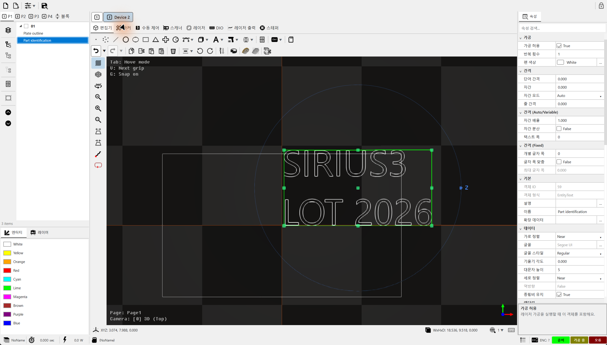
Figure 25.3 Native WPF multi-editor with the selected object and populated PropertyGrid
Listing 25.4 Initialize WPF device sets once from Loaded
private void OnLoaded(object sender, RoutedEventArgs e)
{
if (initialized) return;
initialized = true;
editor.MaxDeviceCounts = 2;
for (int index = 0; index < editor.MaxDeviceCounts; index++)
{
var set = DeviceSet.Create(index);
editor.RegisterDevices(index, set.Rtc, set.Laser, set.Meter,
null, null, null, null, null, set.Marker);
}
if (!editor.SwitchDevices(0))
throw new InvalidOperationException("Device set selection failed.");
Recipes.Rectangle(editor.Document);
Recipes.Text(editor.Document);
editor.Document.ActRegen();
editor.View.ActiveCamera.ZoomFit(editor.View,
new[] { editor.Document.ActivePage.ActiveLayer });
editor.View.DoRender();
}
Here editor is a WPF SiriusMultiEditorControl field; DeviceSet is the helper defined above. Initialize Core before constructing the window. Guard initialization because Loaded can occur repeatedly. Make document and control changes through the WPF Dispatcher. Unloaded only pauses display work. It neither transfers nor disposes the assigned document and devices.
Listing 25.5 Keep the WPF event loop alive until cleanup completes
private async void OnClosing(object sender, CancelEventArgs e)
{
if (closeAllowed) return;
e.Cancel = true;
if (closing) return;
closing = true;
await Task.Yield();
var document = editor.Document;
try { await editor.DisposeDevices(); }
finally
{
try { editor.Dispose(); }
finally { document.Dispose(); }
}
closeAllowed = true;
Close();
}

26 Digital inputs and outputs
Digital inputs read external electrical states; digital outputs send electrical signals to other devices. Match the channels, bits, active levels and wiring before using panel names. The example polls inputs and reports changes to the host. See 12.3 Find the RTC connections for RTC connectors and wiring, and 09 TextConverter and dynamic text for production-text conversion.

26.1 Digital inputs and outputs
IDInput and IDOutput identify the registered port and expose the adapter’s I/O behavior. Match RTC extension and laser-port channels to the wiring map. Read status and use events for host state updates; schedule UI updates on the owning UI thread. A host event callback is not a deterministic hardware trigger.
Item | Role | Use and caution
Port and channel | Index /​ device-specific port | Check physical mapping and active-high/​active-low interpretation.​
Input state | Read sensor/​controller state | Validate stale data, disconnection and the expected transition.​
Output state | Command a connected output | Can actuate equipment.​ Keep write ownership in the machine sequence.​
External start | Start from a configured external condition | Use the intended marker/​controller path; a UI click and an external trigger are different paths.​

26.2 Name individual DIO bits
editor_dio sets IDInput.ChannelNames and IDOutput.ChannelNames before calling RegisterDevices. Use the jagged ChannelNames[channel][bit] array, with 16 bit names per channel, and match the device's actual channel count. Names such as StartRequest, DoorClosed and Ready make the DIO panel easier to read. Renaming a bit does not change its wiring, number or active level.

26.3 Poll, receive transitions and dispatch actions
Call IDInput.Update periodically to read inputs. The device compares each new channel value with its previous value and raises OnChanged(input, bitNo, edge) for every changed bit. High and Low identify the electrical level after the change. With several channels, the notification number is channel × 1000 + bit. Channel 1 bit 3 is therefore 1003, not 19. The event runs on the thread that detected the change.
The demo updates inputs every 100 ms and passes requests to the host. Check the current recipe and marker readiness before accepting a start request. If a signal must remain asserted, also handle its transition to Low. Configure output names in the same way. IDOutput has no input OnChanged event, so handle output writes separately from refreshed readback.
Listing 26.1 Named inputs with an event handler and UI polling timer
public static Action MonitorInput(Form form, IDInput input,
Action<int, SignalEdges> consume)
{
// One 16-bit channel; assign before RegisterDevices.
input.ChannelNames = new[] { new[] {
"StartRequest", "StopRequest", "ResetRequest", "DoorClosed",
"D04", "D05", "D06", "D07", "D08", "D09", "D10", "D11",
"D12", "D13", "D14", "RecipeReady" } };
Action<IDInput, int, SignalEdges> changed = (source, no, edge) => {
if (form.IsDisposed || !form.IsHandleCreated) return;
form.BeginInvoke(new Action(() => {
if (!form.IsDisposed) consume(no, edge);
}));
};
input.OnChanged += changed;
var poll = new System.Windows.Forms.Timer { Interval = 100 };
poll.Tick += (s, e) => input.Update();
poll.Start();
return () => { // Invoke on UI thread before DisposeDevices().
poll.Stop(); poll.Dispose(); input.OnChanged -= changed;
};
}

27 Stepper control and indexed motion

27.1 Pulse generation and the external driver
IRtcStepper controls two RTC stepper channels with ENABLE, DIRECTION and CLOCK. It supplies pulse counts and rates; the motor windings need a driver. Set StepperScaleUnits and StepperScaleFactors for each axis. Use pulses/mm for linear axes and pulses/revolution for Degree axes, including microstepping and transmission ratio. The demo's 4,000 pulses/mm is an example. Set the value for the actual motor.
The RTC stepper interface does not generate acceleration or deceleration trajectories. Use the external driver's ramp/smoothing function or a separate motion controller for that profile. Initial velocity 1/2 means coarse/fine homing speed, not acceleration and deceleration. Abrupt pulse-rate or direction changes can cause shock or step loss. Match the driver's input mode, limits and smoothing settings, then wait for actual settling before laser processing.

27.2 Read and operate StepperControl
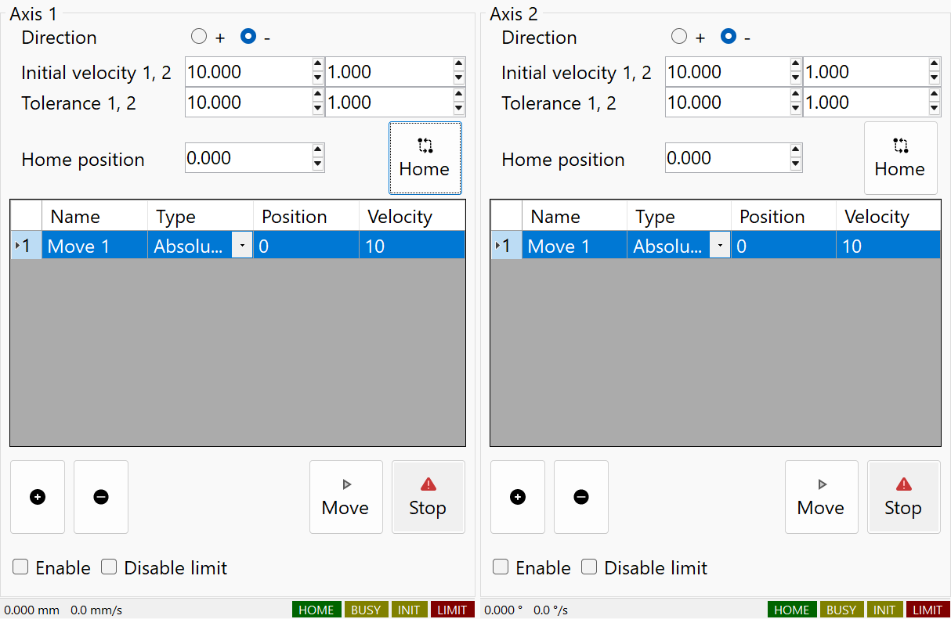
Figure 27.1 Native StepperControl with virtual RTC: separate axis settings, move lists and status
UI group | Role | Use and caution
Direction / Home | Reference search | Select direction, coarse/fine speeds and tolerances, then the assigned home position. Home performs a reference run; confirm switch wiring and travel first.
Add / Remove / drag | Move list | Add named Absolute/Relative targets and velocities, remove the selected row or drag rows to reorder. Up to 20 entries per axis; the list is not an automatically executed program.
Move / Stop | Selected-row action | Move confirms and runs the selected row. Stop stops that axis; an aborted target must be issued again. RTC completion is not an independent in-position sensor.
Enable / Disable limit | Output and switch handling | Enable changes the driver-enable signal. Disable limit ignores the limit input during positioning; it does not remove mechanical travel limits or homing switch use.
HOME / BUSY / INIT / LIMIT | Status strip | Read position and velocity with switch/busy/reference status. The captured devices are virtual; no real motor was moved.

27.3 Connect the panel and sequence the document
Register the scanner with RegisterDevices; the editor also connects StepperCtrl. For a standalone StepperControl, assign Stepper directly. editor_steppermotor/Form1.cs shows units/scales, OnStepperInitialized subscription and reference/move commands. Send status updates to the UI thread and detach events before disposing the device. If the stage must settle before processing, order the document as EntityStepperMove → EntityStepperWait → geometry.
Listing 27.1 Bind user units without starting a motor
public static void BindStepper(
SpiralLab.Sirius3.UI.WinForms.StepperControl panel, IRtcStepper rtc)
{
rtc.StepperScaleUnits = new[] {
StepperUnits.MilliMeter, StepperUnits.Degree };
rtc.StepperScaleFactors = new[] { 4000.0, 36000.0 };
// Axis 1: pulses/mm. Axis 2: pulses/revolution, not pulses/degree.
// Values are examples. Configure the external driver's ramp separately.
panel.Stepper = rtc; // No enable, homing or movement command.
}
Stepper motion can continue separately from the RTC marking list. Finishing, pausing or stopping the scanner list does not guarantee an axis stop. Include an explicit stepper stop/abort procedure in host shutdown and machine operation. After pulse completion, the driver or mechanism may still need extra settling time. The external ramp does not appear as a new RTC acceleration parameter.

28 SCANahead and advanced timing
Use this chapter after understanding Jump, Mark, the ordinary delays and the two pen types. SCANahead plans motion using the dynamics of a compatible scan head. Automatic delays align laser timing with that motion; ALC changes an output signal with speed or position, and SDC controls spot spacing. These features have different tasks and must be configured with their own prerequisites. Start with ordinary timing in 12.5 Adjust laser timing, then scanner settling, speed/position output control in 16.2 Speed, position and Defined Vector control, and moving-workpiece tracking in 29.1 MoF and encoder coordinates.

28.1 SCANahead and SDC
SCANahead uses a compatible RTC6/scan-head system to plan scanner motion and automatic delays. Enabling it changes which conventional delay settings remain meaningful. Spot Distance Control uses a supported external laser trigger to control spacing during acceleration/deceleration; the layer and entity pen must agree on ALC mode, SCANahead extensions and SpotDistanceSCANa.
Use editor_scanahead for automatic-delay behavior and editor_scanahead_sdc for spacing control. Start from the actual controller/scan-head option and its configured preview time. A PropertyGrid row being visible is not proof that the installed option or connected laser supports the requested behavior.

28.2 Combine ALC with SCANahead
Combination | Required settings and role
Conventional ALC | Choose a supported signal and SetVelocity or the supported feedback mode.​ Set its 100% value and min/​max in signal units.​
ALC + SCANahead | For compatible RTC6/​head feedback, use ActualVelocity and the SCANAhead extension.​ Commission preview/​dynamic settings and automatic delays before validating the signal.​
Spot Distance Control | Select SpotDistance + ActualVelocity + SCANAhead, enable IsActivateAutoDelays and set EntityPen.​SpotDistanceSCANa.​ AlcPercentage100 and min/​max are unused in this mode.​

Configure while all participating markers are idle, select the layer pen by the layer PenColor, and check that the registered scanner exposes the required capabilities. Keep ALC signal allocation consistent with LaserVirtual.PowerControlMethod. Verify pulse spacing, signal timing and output on the commissioned system. See demos/editor_automatic_laser_control and demos/editor_scanahead.

28.3 Combine the ALC base mode and extensions
Choose one base input with AutoLaserControlModes. AutoLaserControlModeExtensions adds correction flags to that input; it does not select another base mode. Set AlcMode, Clear AlcModeExtension, then Add only the flags needed. Configure IsALC and AlcSignal on LayerPen, and each path's SpotDistanceSCANa on EntityPen. Use MarkerRtc to apply the layer setup before marking.
Base mode | Value | Meaning and prerequisite
Disabled | 0 | Disables speed-based correction. A separately loaded position-based correction may remain active; this is not a universal laser-output stop.
SetVelocity | 1 | Commanded mark speed; no actual acceleration/deceleration feedback. Use without the ActualVelocity extension flags.
ActualVelocity | 2 | Feedback velocity from the first iDRIVE head with a selected correction table. This is the base for SCANAhead and the extension flags.
EncoderSpeed | 5 | Encoder-only speed control, using CtlAlcEncoderSpeed for its reference. Intended for a moving workpiece and stationary optics; do not enable a concurrent MoF session for this standalone mode.

Extension bit | Value | Effect and condition
EncoderSpeedAddition | 4 | Adds linear XY encoder velocity vectorially to scanner velocity, using fly scaling. Use with ActualVelocity and a commissioned XY MoF setup. Not for Rotary, set_fly_x_pos or set_fly_y_pos.
SCANAhead | 16 | SCANahead velocity processing using preview timing. Requires an active compatible SCANahead system on RTC6; setting the flag does not install or activate missing hardware options.
InverseSpeedCorrection | 32 | Converts angle-synchronous speed to image-field speed through the assigned correction table. Use when field-dependent speed correction is required and the table is valid.
BackwardTransformation | 64 | Undoes first-head controller coordinate transforms for velocity evaluation. Configure ALC before those transforms. Sirius3 normally applies model transforms upstream through MatrixStack, so ordinary entity rotation alone does not require this bit.
SkyWritingSDC | 128 | Keeps spot-distance continuity across Sky Writing interruptions in a polyline. Combine with ActualVelocity + SCANAhead and a commissioned Sky Writing configuration. This does not switch on the laser during the laser-off motion.

28.4 Practical combinations for SCANahead and MoF
Purpose | Base plus extensions | Combined mode
iDRIVE speed correction | ActualVelocity | 2
SCANahead SDC | ActualVelocity + SCANAhead | 18
SDC with Sky Writing continuity | ActualVelocity + SCANAhead + SkyWritingSDC | 146
SDC with image-field speed correction | ActualVelocity + SCANAhead + InverseSpeedCorrection | 50
Linear XY MoF plus SCANahead | ActualVelocity + EncoderSpeedAddition + SCANAhead | 22

For SpotDistance, select ActualVelocity + SCANAhead (18). Do not use bare ActualVelocity, SetVelocity or EncoderSpeed. Set the spacing in EntityPen.SpotDistanceSCANa; 0.01 mm is an example. ALC percentage and min/max limits do not set this spacing. The laser must accept the required trigger timing. At 1000 mm/s and 0.01 mm spacing, the nominal demand is 100 kHz. Check actual pulse capability and acceleration behavior on the commissioned system.
The example follows demos/editor_scanahead_sdc/Form1.cs and editor_automatic_laser_control/Form1.cs. It configures an idle RTC6 and the white recipe pens without executing a job. Adding SkyWritingSDC does not by itself enable Sky Writing; retain its separate LayerPen settings.
Listing 28.1 SCANahead SDC
public static bool ConfigureScanAheadSdc(Rtc6 rtc, IDocument document,
bool keepDistanceThroughSkyWriting)
{
// Initial setup; use document.ActPropertyChanged for undoable edits.
if (rtc.IsBusy || !rtc.IsSCANAhead) return false;
rtc.IsActivateAutoDelays = true;
if (!rtc.IsActivateAutoDelays) return false;
if (!document.FindByLayerPenColor(Color.White, out var layerPen)
|| !document.FindByEntityPenColor(Color.White, out var entityPen))
return false;
layerPen.IsALC = true;
layerPen.AlcByPositionTable.Clear();
layerPen.AlcSignal = AutoLaserControlSignals.SpotDistance;
layerPen.AlcMode = AutoLaserControlModes.ActualVelocity;
layerPen.AlcModeExtension.Clear();
layerPen.AlcModeExtension.Add(AutoLaserControlModeExtensions.Bit.SCANAhead);
if (keepDistanceThroughSkyWriting)
layerPen.AlcModeExtension.Add(
AutoLaserControlModeExtensions.Bit.SkyWritingSDC);
entityPen.SpotDistanceSCANa = 0.01; // mm; configure Sky Writing separately.
return true; // Configuration only; no marking job is submitted.
}

28.5 SCANahead settings on EntityPen
When SCANahead automatic delays are active, the three EntityPen scales affect different parts of processing. CornerScaleSCANa and EndScaleSCANa affect scanner positioning and calculated scanner delays. AccScaleSCANa controls the emission window during acceleration and deceleration. Do not treat all three as acceleration-limit multipliers. Their range is 0–100 and constructor value is 100. Select the matching pen color and edit EntityPen under Scanner (SCANa). Laser shifts are under Laser (SCANa).
Property | Unit | Effect and adjustment
CornerScaleSCANa | % | Mark-to-mark corner precision. 100 retains sharp corners; lower values shorten transition time by accepting rounding. This changes contour fidelity, not laser pulse energy. Inspect small corners at the intended marking speed.
EndScaleSCANa | % | Mark-to-jump and jump-to-mark endpoint precision. 100 preserves straight starts/ends; lower values trade endpoint fidelity for faster transitions. Remains effective during genuine Sky Writing.
AccScaleSCANa | % | Percentage of acceleration/deceleration time during which emission is permitted. 100 permits the entire interval; smaller values leave part unmarked and can shorten the marked line. Does not change scanner trajectory or Amax. ALC/SDC operates within this emission window.
LaserOnShiftSCANa | µs | Temporal offset added to automatically calculated laser switching. Positive delays the event; negative advances it. Start at zero for a new timing comparison and measure actual line endpoints before applying a device-specific correction.
LaserOffShiftSCANa | µs | Temporal offset added to automatically calculated laser switching. Positive delays the event; negative advances it. Start at zero for a new timing comparison and measure actual line endpoints before applying a device-specific correction.
SpotDistanceSCANa | mm | Geometric travel between pulses, not optical spot diameter. Set with the LayerPen SDC combination from 28.4. Zero suppresses SDC for that pen; maximum accepted spacing depends on MaxSpotDistance and the scanner configuration. SDC requires a PoD-compatible external trigger and does not itself guarantee equal optical pulse energy.

AccScale=50 allows emission for 50% of each acceleration/deceleration time. It does not mean 50% of the distance. In the manual's constant-acceleration model, the unmarked distance for each leg is (1 − AccScale/100)² × 100%. A value of 50 leaves 25% of each leg unmarked; 0 leaves the whole leg unmarked and 100 leaves none. Apply this ratio to each acceleration leg, not the whole programmed line. Use Sky Writing when constant-speed marking must cover the full commanded length.
1. Select the EntityPen and open a SCANahead line-property editor, for example LaserOnShiftSCANa. One editor groups both laser shifts and all three scales.
2. Set On/Off Shift in µs, Corner/End Scale for trajectory accuracy and Acc Scale for the laser-emission share of acceleration/deceleration time. Use the two illustrated tabs to distinguish their effects.
3. Press OK to accept the five values together; closing without acceptance leaves them unchanged. The confirmed pen settings take effect when its processing commands are generated.
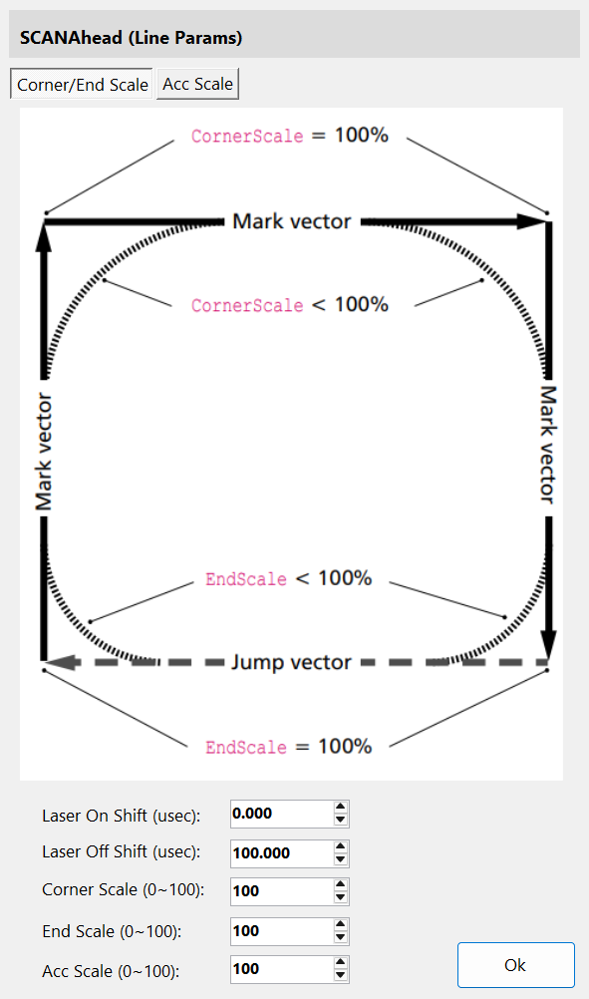
Figure 28.1 SCANahead line editor: compare Corner/End Scale with Acc Scale on its two illustrated tabs.
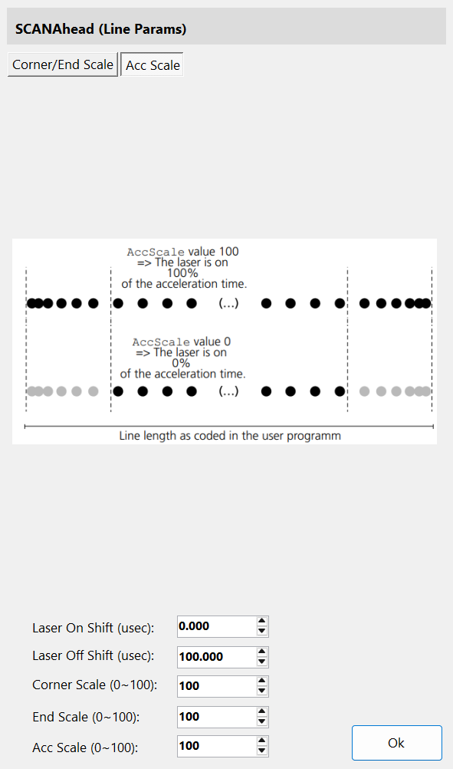
Figure 28.2 SCANahead line editor: compare Corner/End Scale with Acc Scale on its two illustrated tabs.
The matching RTC6 SCANahead option, compatible head and enabled AutoDelays are prerequisites. Opening this editor does not enable them. Acc Scale is a time percentage, not a distance percentage; retain the Sky Writing interaction described earlier.

28.6 Tune automatic delays and pen parameters together
On the initialized head, check RTC6.IsSCANAhead, then enable IsActivateAutoDelays. The RTC uses the compatible system's preview time and dynamic limits. While enabled, automatic calculation replaces conventional scanner and laser delays. ScannerJumpDelay and LaserOnDelay therefore do not provide the equivalent fine adjustment. Use the three scales to tune contour and emission behavior. Use LaserOnShiftSCANa and LaserOffShiftSCANa for timing offsets. Preview time defines how far ahead the path is planned; it is not conventional tracking error.
During actual Sky Writing motion, EndScale applies; CornerScale and AccScale do not. CornerScale matters again when Mode 3 skips Sky Writing because of the angle threshold. Automatic delays calculate run-in, run-out and timing automatically. Nprev/Npost and the timing component of TrackingErrorTime therefore do not give their conventional tuning effect. Dynamic limits still apply with SCANahead. For a small arc, v²/r must stay below the available image-field acceleration limit. Reduce speed to suit the radius and field dynamics.
Listing 28.2 Prepare a neutral SCANahead pen through document actions
public static bool SetScanAheadPen(IDocument document)
{
if (!document.FindByEntityPenColor(Color.White, out var pen)) return false;
// Configure the idle RTC6 and LayerPen as in the SCANahead example first.
document.ActPropertyChanged(pen, nameof(EntityPen.CornerScaleSCANa), 100u);
document.ActPropertyChanged(pen, nameof(EntityPen.EndScaleSCANa), 100u);
document.ActPropertyChanged(pen, nameof(EntityPen.AccScaleSCANa), 100u);
document.ActPropertyChanged(pen, nameof(EntityPen.LaserOnShiftSCANa), 0.0);
document.ActPropertyChanged(pen, nameof(EntityPen.LaserOffShiftSCANa), 0.0);
document.ActPropertyChanged(pen, nameof(EntityPen.SpotDistanceSCANa), 0.01);
return true; // Start from these values, then compare one parameter at a time.
}

28.7 Auto Delays: timing and PropertyGrid visibility
SCANahead anticipates the path using PreviewTime and the matched head dynamics. With IsActivateAutoDelays=true, the RTC6 calculates speed-dependent scanner and laser delays and applies them dynamically during execution. This includes acceleration time and the preview offset; it does not eliminate physical settling or laser response. Valid SCANahead tuning and a compatible system are prerequisites.
In Sirius3, this UI switch requires both rtc.IsSCANAhead and IRtcSCANAhead.IsActivateAutoDelays. The pen PropertyGrid then hides the conventional delay fields below and shows the SCANahead alternatives. The stored values are retained, not reset to zero. Disable Auto Delays and the conventional fields reappear and take effect again.
Object / fields | Auto Delays ON | Adjustment
EntityPen: ScannerJumpDelay, ScannerMarkDelay, ScannerPolygonDelay | Hidden; conventional timing bypassed. | Use CornerScaleSCANa / EndScaleSCANa; AccScaleSCANa sets the emission window (28.5).
EntityPen: LaserOnDelay, LaserOffDelay | Hidden; conventional timing bypassed. | Fine-tune LaserOnShiftSCANa / LaserOffShiftSCANa in µs.
EntityLayerPen: variable jump / polygon delay | Hidden; conventional timing bypassed. | Use CornerScaleSCANa / EndScaleSCANa; AccScaleSCANa sets the emission window (28.5).
EntityLayerPen: TimeLag, Prev, Post | Hidden; conventional timing bypassed. | Automatic Sky Writing timing; LaserOnShift remains effective (Sky Writing).

Auto Delays OFF does not turn off the scan head’s SCANahead servo control. Manual delays must then account for speed-dependent acceleration and PreviewTime. Configure the mode while idle and rebuild the job before execution. ALC/SDC remains a separate setup (28.3–28.4).

29 MoF extension option
The corresponding Sirius3 option can be evaluated for 30 minutes even when that option is not licensed. Required controllers, vendor runtimes, hardware and vendor licenses must still be available. Commercial operation requires the appropriate Sirius3 license.

29.1 MoF and encoder coordinates
Marking on the Fly follows workpiece movement measured by external encoders by adding that travel to the scanner coordinates. It does not command the conveyor or stage. First establish channel, counts/mm or counts/revolution, direction and XY/Rotary mode; then define the trigger, reset and offset sequence. The head orientation in 13.3 Align a rotated scan head with the working coordinates must agree with the motion. A stationary screen drawing does not verify physical scale or trigger timing: monitor encoder state, tracking range, overflow and job completion.
Workflow | Public demo | What to inspect
XY MoF | editor_​mof_​xy | Encoder X/​Y configuration and moving-part compensation.​
Triggered MoF | editor_​mof_​trigger | Trigger acceptance, sequence boundaries and per-part data.​
MoF with offsets | editor_​mof_​offsets | Location transforms and data for each offset.​
Raster and interrupt | editor_​mof_​xy_​raster /​ editor_​mof_​interrupt | Raster timing or host intervention at the documented boundary.​

1. TrackingErrorX and TrackingErrorY compensate scanner timing lag in linear encoder-based MoF; they are not encoder scale factors or XY position errors. A 0.200 ms lag at 1,000 mm/s corresponds to about 0.200 mm of travel, illustrating the timing effect rather than guaranteed accuracy. Section 15.4 Understand Wobbel paths and frequency limits uses Tracking Error to estimate Wobbel frequency; that estimate does not configure these MoF properties.
2. Sirius3 exposes both values in µs and converts them to controller increments of 10 µs: 200 µs becomes native value 20. Zero disables the correction; use zero for Rotary. Encoder readback still reports raw counts, not these compensated values.
3. Use sufficiently fine encoder resolution and configure while idle. RTC4 is unsupported; the correction does not apply to McBSP position input. RTC6 rejects this command with SCANahead active. Verify the result under the actual speed profile before using the recipe in production.
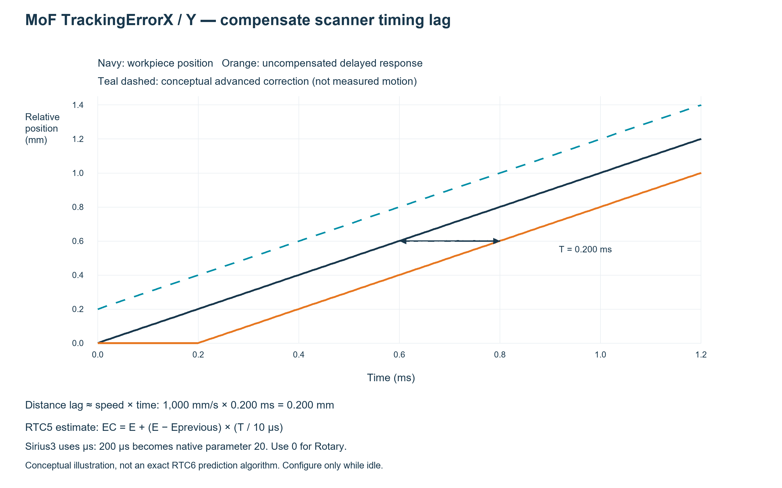
Figure 29.1 MoF timing lag and the first-order RTC5 encoder estimate.

29.2 Build an ordered moving-part recipe
A typical sequence is MoF Begin → encoder wait or trigger boundary → geometry → MoF End. First configure encoder scale/direction and the supported XY or rotary mode in the scanner. A wait position is not a screen coordinate: its relationship to the workpiece depends on encoder origin, sign and the chosen transform policy. Keep every Begin/End pair and the abort path complete.
Listing 29.1 Construct a MoF recipe without starting hardware
internal static bool AddFlySection(IDocument document)
{
// Recipe construction only; configure the encoder separately.
var group = EntityFactory.CreateMixedGroup("Fly section", new IEntity[] {
EntityFactory.CreateMoFBegin(RtcMoFModes.XY, true),
EntityFactory.CreateMoFWait(RtcEncoders.EncX,
RtcEncoderWaitConditions.Over, 0),
EntityFactory.CreateRectangle(DVec3.Zero, 10, 5),
EntityFactory.CreateMoFEnd(DVec2.Zero)
});
if (!document.ActAdd(group))
{
if (group.Owner == null) group.Dispose();
return false;
}
document.ActSelect(group);
return document.ActRegen();
}
In the editor, inspect the ordered control objects in TreeView and select each one to edit its PropertyGrid. The scanner panel exposes encoder-related state supported by the adapter. Subscribe to IRtcMoF encoder-signal and virtual-image-field events as in the public demo. Test sign, travel range, missed triggers and stop behavior with commissioned hardware; path simulation alone cannot validate encoder tracking.
Public demo /​ entry | Inspect and customize
demos/​editor_​mof_​xy/​Form1.​cs | Encoder errors, overflow events and Begin/​Wait/​End entity creation.​
demos/​editor_​mof_​trigger; editor_​mof_​offsets | Trigger acceptance and per-location data.​
demos/​editor_​mof_​xy_​raster; editor_​mof_​interrupt | Raster timing and explicit host-interrupt boundaries.​

The following linear and rotary recipes apply this encoder-to-coordinate relationship. Use 29.3 X Y mode with the linear MoF demo for counts/mm and 29.4 Rotary mode with the public editor demo for counts/revolution.
Keep the start/reset origin, sign, tracking range and overflow handling consistent with the installed system; MoF End does not stop its motor.

29.3 X Y mode with the linear MoF demo
demos/editor_mof_xy/Form1.cs orders the document as Begin → encoder waits → geometry → End. XY mode uses EncX and EncY. EncXCountsPerMm and EncYCountsPerMm convert accumulated external counts into travel in mm. While MoF is active, that accumulated travel changes the scanner coordinates. The X-only conveyor example sets EncYCountsPerMm=0 and assumes the Y encoder count remains unchanged; this zero does not disable the Y input. At 2000 counts/mm, +20000 counts mean +10 mm. Check the sign against actual encoder wiring and head orientation, and confirm that the unused Y count stays fixed.
Begin with reset=true sets the relative encoder origin at that command. The demo waits for positive travel and places geometry at negative X so the moving feature enters the field. Wait specifies distance, not speed or delay. End(DVec2.Zero) ends compensation and jumps the scanner to (0,0). It does not stop the conveyor. editor_mof_trigger shows external start conditions; editor_mof_offsets shows registration offsets. editor_mof_xy_raster uses the same command order for raster work.
Listing 29.2 Build an X-only XY MoF recipe without executing it
public static bool AddXyFlyRecipe(IDocument document, IRtcMoF mof)
{
mof.EncXCountsPerMm = 2000; // Example measured encoder scale.
mof.EncYCountsPerMm = 0; // Assumes the Y encoder count remains unchanged.
var recipe = EntityFactory.CreateMixedGroup("XY MoF", new IEntity[] {
EntityFactory.CreateMoFBegin(RtcMoFModes.XY, true),
EntityFactory.CreateMoFWait(RtcEncoders.EncX,
RtcEncoderWaitConditions.Over, 10), // mm from reset origin
EntityFactory.CreateLine(-10, 5, -10, -5),
EntityFactory.CreateMoFEnd(DVec2.Zero)
});
if (document.ActAdd(recipe)) return true;
if (recipe.Owner == null) recipe.Dispose();
return false;
}

29.4 Rotary mode with the public editor demo
The public demos/editor_ui provides Rotary Begin/End, Rotary Wait, encoder reset and a status display in degrees. There is no separate editor_mof_rotary project. Use editor_ui for interaction and adapt editor_mof_xy's ordered recipe as below. Rotary uses EncX for angle feedback. Set EncCountsPerRevolution instead of the XY counts/mm scales. At 36000 counts/revolution, 9000 counts mean 90°. RotateCenter is the rotation center in scanner mm coordinates, not an angle or radius.
Add Begin(Rotary), an angular Wait, the geometry and End in that order. The code waits for 90° then processes geometry located away from the rotation center. Enter measured counts per revolution including quadrature evaluation and transmission ratio. Check wrap, sign and center using a low-speed commissioned setup. Simulated rotary speed is specified in °/s and is only a test input; it is not a command to rotate a motor.
Listing 29.3 Build a Rotary recipe with an angular wait
public static bool AddRotaryFlyRecipe(IDocument document, IRtcMoF mof)
{
mof.EncCountsPerRevolution = 36000; // Example measured counts/revolution.
var begin = EntityFactory.CreateMoFBegin(RtcMoFModes.Rotary, true);
begin.RotateCenter = DVec2.Zero; // Scanner XY coordinates in mm.
var recipe = EntityFactory.CreateMixedGroup("Rotary MoF", new IEntity[] {
begin,
EntityFactory.CreateMoFWait(RtcEncoderWaitConditions.Over, 90),
EntityFactory.CreateRectangle(new DVec2(10, 0), 4, 2),
EntityFactory.CreateMoFEnd(DVec2.Zero)
});
if (document.ActAdd(recipe)) return true;
if (recipe.Owner == null) recipe.Dispose();
return false;
}

30 syncAXIS extension option
The corresponding Sirius3 option can be evaluated for 30 minutes even when that option is not licensed. Required controllers, vendor runtimes, hardware and vendor licenses must still be available. Commercial operation requires the appropriate Sirius3 license.
syncAXIS coordinates scanner and stage motion through the matching SCANLAB/ACS system. Use its dedicated scanner and MarkerSyncAxis; ordinary RTC markers do not prepare syncAXIS jobs.

30.1 Configuration and job ownership
The public host selects config_syncaxis.ini, then the shared device helper creates the configured scanner, laser and matching marker. Point the syncAXIS XML BaseDirectoryPath to the deployed working directory. Match axes, dynamics, correction and operating mode to the installed SCANLAB/ACS system. Use the matching vendor simulation workflow before enabling real motion; software evaluation does not supply a vendor option or hardware.
Listing 30.1 Bind already initialized syncAXIS devices to the editor
internal static void BindSyncAxis(SiriusEditorControl editor,
Rtc6SyncAxis rtc, ILaser laser, IPowerMeter meter)
{
// Inputs are initialized by the host's commissioned configuration.
var marker = MarkerFactory.CreateSyncAxis(rtc.Index);
if (!marker.Initialize())
{
marker.Dispose();
throw new InvalidOperationException("Marker initialization failed.");
}
editor.RegisterDevices(rtc, laser, meter,
null, null, null, null, null, marker);
// RegisterDevices prepares Ready for this document and view.
}
LayerPen.MotionType and BandWidth affect the configured scanner/stage strategy; inspect them in PropertyGrid with the actual registered syncAXIS scanner. A document offset places geometry in the job coordinate system. It is not a standalone stage command. Before Start, check job validity, axis readiness, travel limits and the stop/recovery path. Keep job submission, completion and vendor diagnostics distinct.
Public demo /​ entry | Inspect and customize
demos/​editor_​syncaxis/​Form1.​cs | config_​syncaxis.​ini → CreateDevices → RegisterDevices → Ready.​
demos/​console_​syncaxis_​setup | System setup and configuration entry points.​

30.2 Installation and first simulation
Prepare an x64 application with the matching syncAXIS runtime, RTC6 program files and SCANLAB license dongle. Use the supported Dependencies package payload and vendor installation instructions. Keep syncAXIS, RTC6 DLLs and program files as a compatible set; replacing an RTC DLL with an arbitrary newer copy is not an upgrade procedure.
Step | Action and acceptance criterion
1 XML | Copy the vendor configuration for the actual machine into the deployed syncaxis folder. Keep syncAXIS_1_8.xsd available for editing. Templates are reference material; never operate hardware with an unchanged template.
2 Paths | Set BaseDirectoryPath to an absolute deployment path. Check ProgramFileDirectory, correction files and writable log/simulation folders. XML paths and the C# Config paths must point to the same deployed files.
3 Machine | Verify RTC6 serial/connector mapping, ACS controller address, scan field, stage travel, correction, axis alignment and dynamics. Select monitoring and violation response for the commissioned machine.
4 Simulation | Before Initialize, set SimulationMode=true, BinaryOutput=false and DisableFileOutput=false. Ensure the SCANLAB dongle is recognized. Simulation uses no RTC/stage hardware, but still requires the vendor dongle.
5 Verify | Run the simulation demo, wait for job completion and open its output in Viewer. Inspect scanner, stage and combined motion, field limits, velocity, acceleration and jerk. Hardware commissioning is a separate controlled procedure.

The Sirius3 option evaluation lasts 30 minutes within the shared process deadline. It does not grant a SCANLAB license or remove the dongle requirement. LaserVirtual alone does not make a physical RTC configuration a simulation.

30.2.1 Connect the INI file to the XML
editor_syncaxis reads config_syncaxis.ini through EditorHelper. TYPE=SyncAxis selects CreateRtc6SyncAxis and CONFIG_XML is resolved relative to Config.SyncAxisPath. The helper initializes the scanner, laser and MarkerSyncAxis; RegisterDevices attaches them to the editor and calls marker.Ready for its Document and View.
[RTC0]
TYPE=SyncAxis
CONFIG_XML=syncAXISConfig.xml
[LASER0]
TYPE=Virtual
POWERCONTROL=Unknown
MAXPOWER=10
DEFAULT_POWER=1
The default XML location is <application>/syncaxis/syncAXISConfig.xml; the INI sits beside the application. The console setup demo opens the XML directly and does not use this INI selection. XML SimOutputFileDirectory and Config.SyncAxisSimulateFilePath must agree; setting one does not update the other.

30.2.2 Configure and validate simulation
Begin with a machine-specific syncAXISConfig.xml, not an unchanged template. In Configurator check the RTC serial number and scan-head/stage connectors, ACS address and StageAxisX/Y assignment, CT5 paths, usable scanner field and stage travel, speed/acceleration/jerk, MonitoringLevel and DynamicViolationReaction. Set BaseDirectoryPath and writable log/simulation paths for the deployed application. Retain the matching syncAXIS_1_8.xsd. A schema-valid file can still describe unsafe physical limits or produce trajectories outside them; it is not a replacement for trajectory inspection or machine safeguards.
Before the first Initialize, save SimulationMode=true in XML. The vendor simulation initialization checks the dongle, XML and configuration structure, but does not test real stage communication. Simulate the actual intended job and inspect scanner/stage position, speed, acceleration, jerk and flagged segments in Viewer. Combined-motion tests need the combined operation mode as well as simulation mode; the two settings are independent. A successful initialization or ListExecute submission alone does not establish that the complete job finished without violations.

30.2.3 Prepare hardware operation and tune timing
The vendor hardware sequence first verifies laser output, then manual reference movements of stage and head, then the already simulated test marking. These steps can emit radiation and move axes; perform them only on a commissioned, guarded machine. A manual reference run proves basic component communication and axis assignment, not trajectory decomposition or SL2-100/EtherCAT synchronization. Re-simulate after changing the pattern, dynamics or correction data before the first hardware use of that configuration.
Optimize in this order: laser switching offsets; scanner field calibration; separate static scanner and stage accuracy; system timing; combined-motion accuracy. Repeat laser-delay tuning after changing field correction. In the demo’s F8 grid, X varies LaserSwitchOffsetTime and Y varies LaserPreTriggerTime in µs; choose the cell by measured marking quality. F10 compares line alignment in both travel directions after static calibration. A field calibration cannot compensate a time offset. Finally compare ScannerOnly, StageOnly and StageAndScanner at the intended speed and travel, watching for scanner saturation during stage reversal.

30.3 Edit XML with syncAXIS Configurator
Open a working copy with Open. The left navigation contains General, RTC, Scan Device, Laser, IO, Trajectory, Stage and Motion Decomposition. Show XML exposes the corresponding XML; Optional Defaults shows optional default entries. Save As writes the working copy and does not initialize a controller.
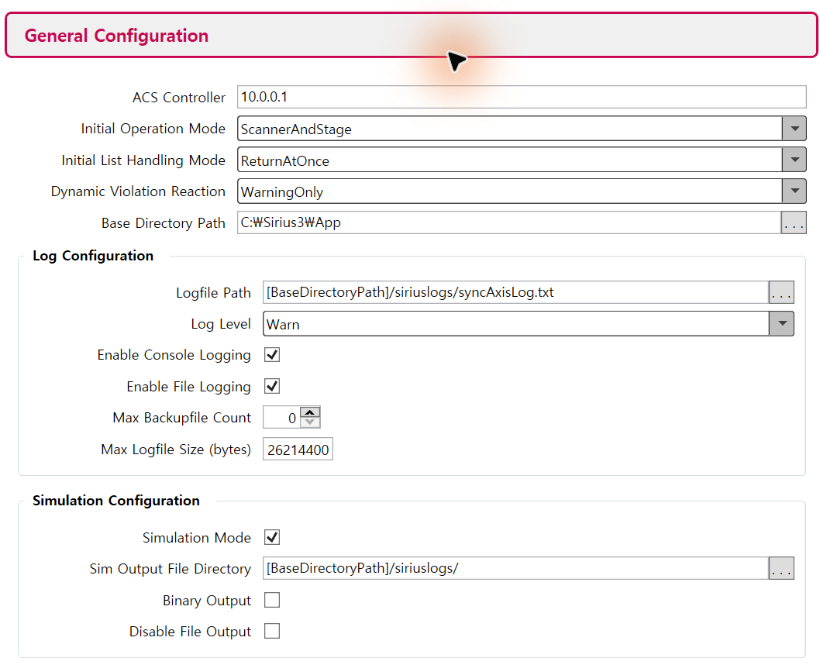
Figure 30.1 General Configuration detail from Configurator 1.8.2.1. Values shown are illustrative, not machine settings.
ACS Controller sets the motion-controller address. Operation Mode selects the available scanner/stage system; List Handling controls how native job submission returns. Base Directory anchors [BaseDirectoryPath] paths. Enable Simulation before runtime initialization, select a writable output directory and enable file output for Viewer. WarningOnly reports violations; it is not an interlock.

30.3.1 Scan device and RTC mapping
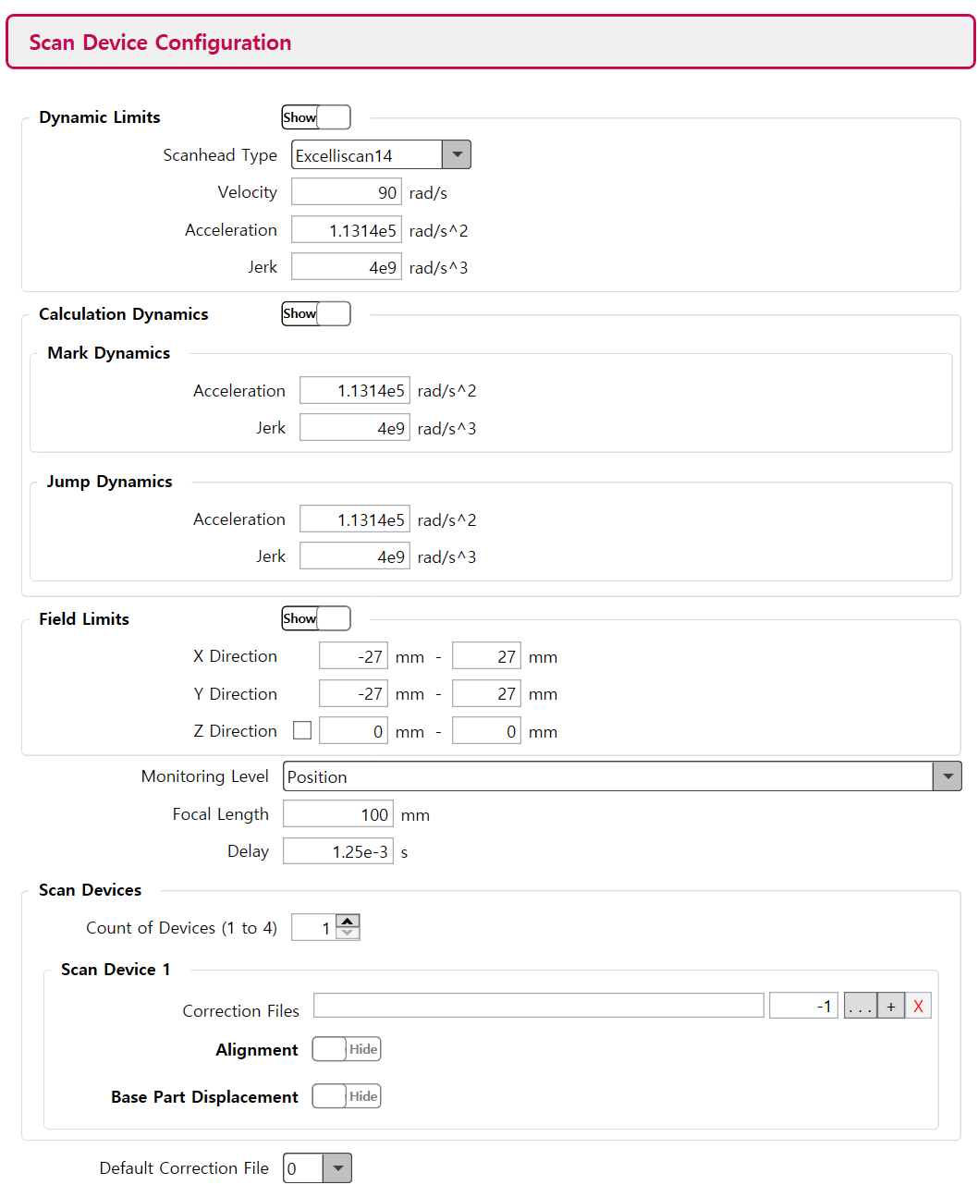
Figure 30.2 Scan Device Configuration detail showing angular dynamics and field limits.
Dynamic Limits bound angular velocity, acceleration and jerk in rad/s, rad/s² and rad/s³. Calculation Dynamics sets planning values for mark/jump motion. Field Limits use mm; Focal Length uses mm and Delay uses seconds. Monitoring Level chooses which limits are monitored. Do not copy stage units into scanner fields.
In RTC Configuration, match board identification, serial numbers and Head A/Head B assignments to the actual wiring. In Scan Device Configuration, select the correct ct5 files, calibration factors and alignment. A valid XML schema does not verify correction accuracy, physical travel or wiring.

30.3.2 Stage and motion decomposition
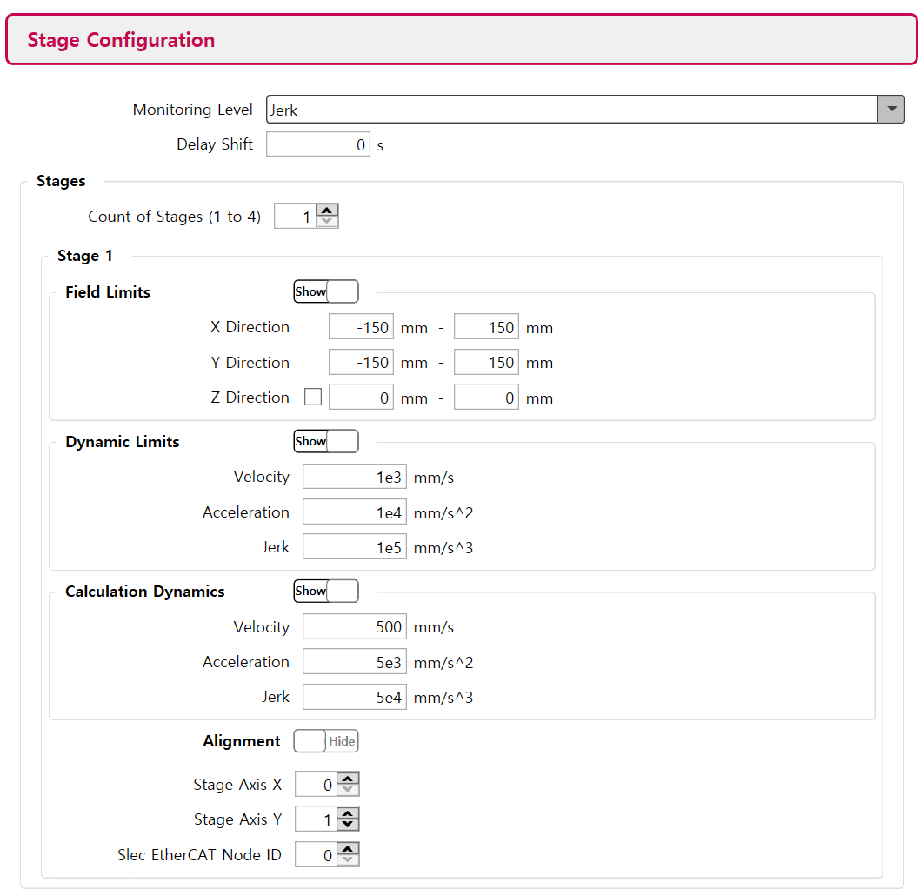
Figure 30.3 Stage Configuration detail with travel, dynamics and axis mapping.
Stage Field Limits are in mm; velocity, acceleration and jerk use mm/s, mm/s² and mm/s³. StageAxisX/Y and the EtherCAT node identify the actual stage axes. Check alignment and delay against the commissioned controller. Motion Decomposition FilterBandwidth is in Hz and changes scanner/stage motion allocation; review the resulting dynamics after any change.

30.4 Use the public setup and editor demos
Start with demos/console_syncaxis_setup/Program.cs for controller setup and job diagnostics. It directly creates Rtc6SyncAxis from the XML. demos/editor_syncaxis/Form1.cs adds the WinForms document workflow and uses demos/config_syncaxis.ini plus demos/helper.cs. Both projects are NuGet consumers and target net481, net8.0-windows and net9.0-windows; run the syncAXIS application as x64.
Key | Console demo behavior
J / S | Enable simulation while idle / inspect busy, error and native diagnostic status.
F1–F3 | Square: ScannerOnly / StageOnly / StageAndScanner.
F4–F6 | Circle with the same three motion allocations.
C / V | Inspect job characteristic / open the latest simulation in Viewer after completion.
Escape / Q | Abort / exit. Application abort is not a safety-rated emergency stop.

Confirm SimulationMode=true in the XML before starting the console demo; pressing J later cannot protect initialization. H switches to hardware, O commands origin motion, and F7–F10 are commissioning/calibration patterns. Use those commands only in the separately authorized machine procedure. In the editor, CreateDevices must succeed before RegisterDevices; on shutdown await DisposeDevices, release the owned document and call Core.Cleanup.
In console_syncaxis_setup, prepare the output-folder syncaxis/syncAXISConfig.xml before startup. S checks idle and error status. In simulation, compare F1/F2/F3 rectangles or F4/F5/F6 circles. After completion, C shows Job characteristics and V opens the generated simulation result. The 40 mm rectangle and 20 mm circle radius are sample dimensions; match them to the configured field and travel.
Keys | Purpose | What to compare or observe
S / C | Status and diagnostics | S prints busy/error and internal messages; C prints job characteristics after generation.
F1–F6 | Compare motion allocation | F1/F4 scanner only; F2/F5 stage only; F3/F6 combined. Each key builds and submits a job.
F7 | Scanner calibration pattern | DrawScannerCalibration uses ScannerOnly. Measure the grid before calculating a new field correction.
F8 | Laser delay grid | DrawOptimizeLaserDelay varies switch offset and pretrigger. The best cell is a measured process result.
F9 | Static calibration comparison | DrawCheckCalibration runs StageOnly and ScannerOnly patterns to compare their placement.
F10 | System timing comparison | DrawCheckSystemDelay uses StageAndScanner and opposite travel directions. Check collinearity after static calibration.
J / H / O / F / U | Mode and origin controls | J selects simulation after initialization; H selects hardware. O moves scanner and stage to origin; F/U changes Follow/Unfollow. These are operational controls, not a prerequisite-free preview.
Esc / R | Stop and recovery | Escape calls CtlAbort. R calls CtlReset; after abort it can reinitialize from ConfigXMLFile. Record errors and recheck the XML mode before recovery.

editor_syncaxis uses the INI initialization flow already described above. After device creation, RegisterDevices connects the editor and calls Ready; the demo calls Ready again afterward. Create shapes in the active layer and choose LayerPen.MotionType and BandWidth. Run the new recipe in XML simulation mode, wait for completion and inspect Viewer results before preparing hardware use of the same recipe.

30.4.1 Initialize the prepared simulation XML without submitting a job
Listing 30.2 Initialize the prepared simulation XML without submitting a job
using System;
using System.IO;
using SpiralLab.Sirius3;
using SpiralLab.Sirius3.Scanner;

public static class SyncAxisSetup
{
// XML must already have SimulationMode=true.
public static bool CheckSimulation()
{
string xml = Path.Combine(
AppDomain.CurrentDomain.BaseDirectory,
"syncaxis", "syncAXISConfig.xml");
if (!Environment.Is64BitProcess || !File.Exists(xml))
return false;
if (!Core.Initialize())
return false;
try
{
using (var rtc = ScannerFactory.CreateRtc6SyncAxis(0, xml))
return rtc.Initialize() && rtc.IsSimulationMode;
}
finally
{
Core.Cleanup();
}
}
}
This host-level example must run before opening another Sirius3 process. The XML must already contain SimulationMode=true; the runtime setter is not a substitute for that initial setting. The using block releases the controller, including a failed initialization, and finally balances Core.Initialize. Do not use this short-lived scope for an editor-owned device.

30.5 Inspect results with syncAXIS Viewer
After a simulation completes, open the generated text file with File > Open, the console V command or SyncAxisViewerHelper.Plot. SimulationFileName may be empty before a valid job exists. The following captures use an archived simulation in Viewer 1.8.2.1; they demonstrate analysis, not a newly executed hardware test.
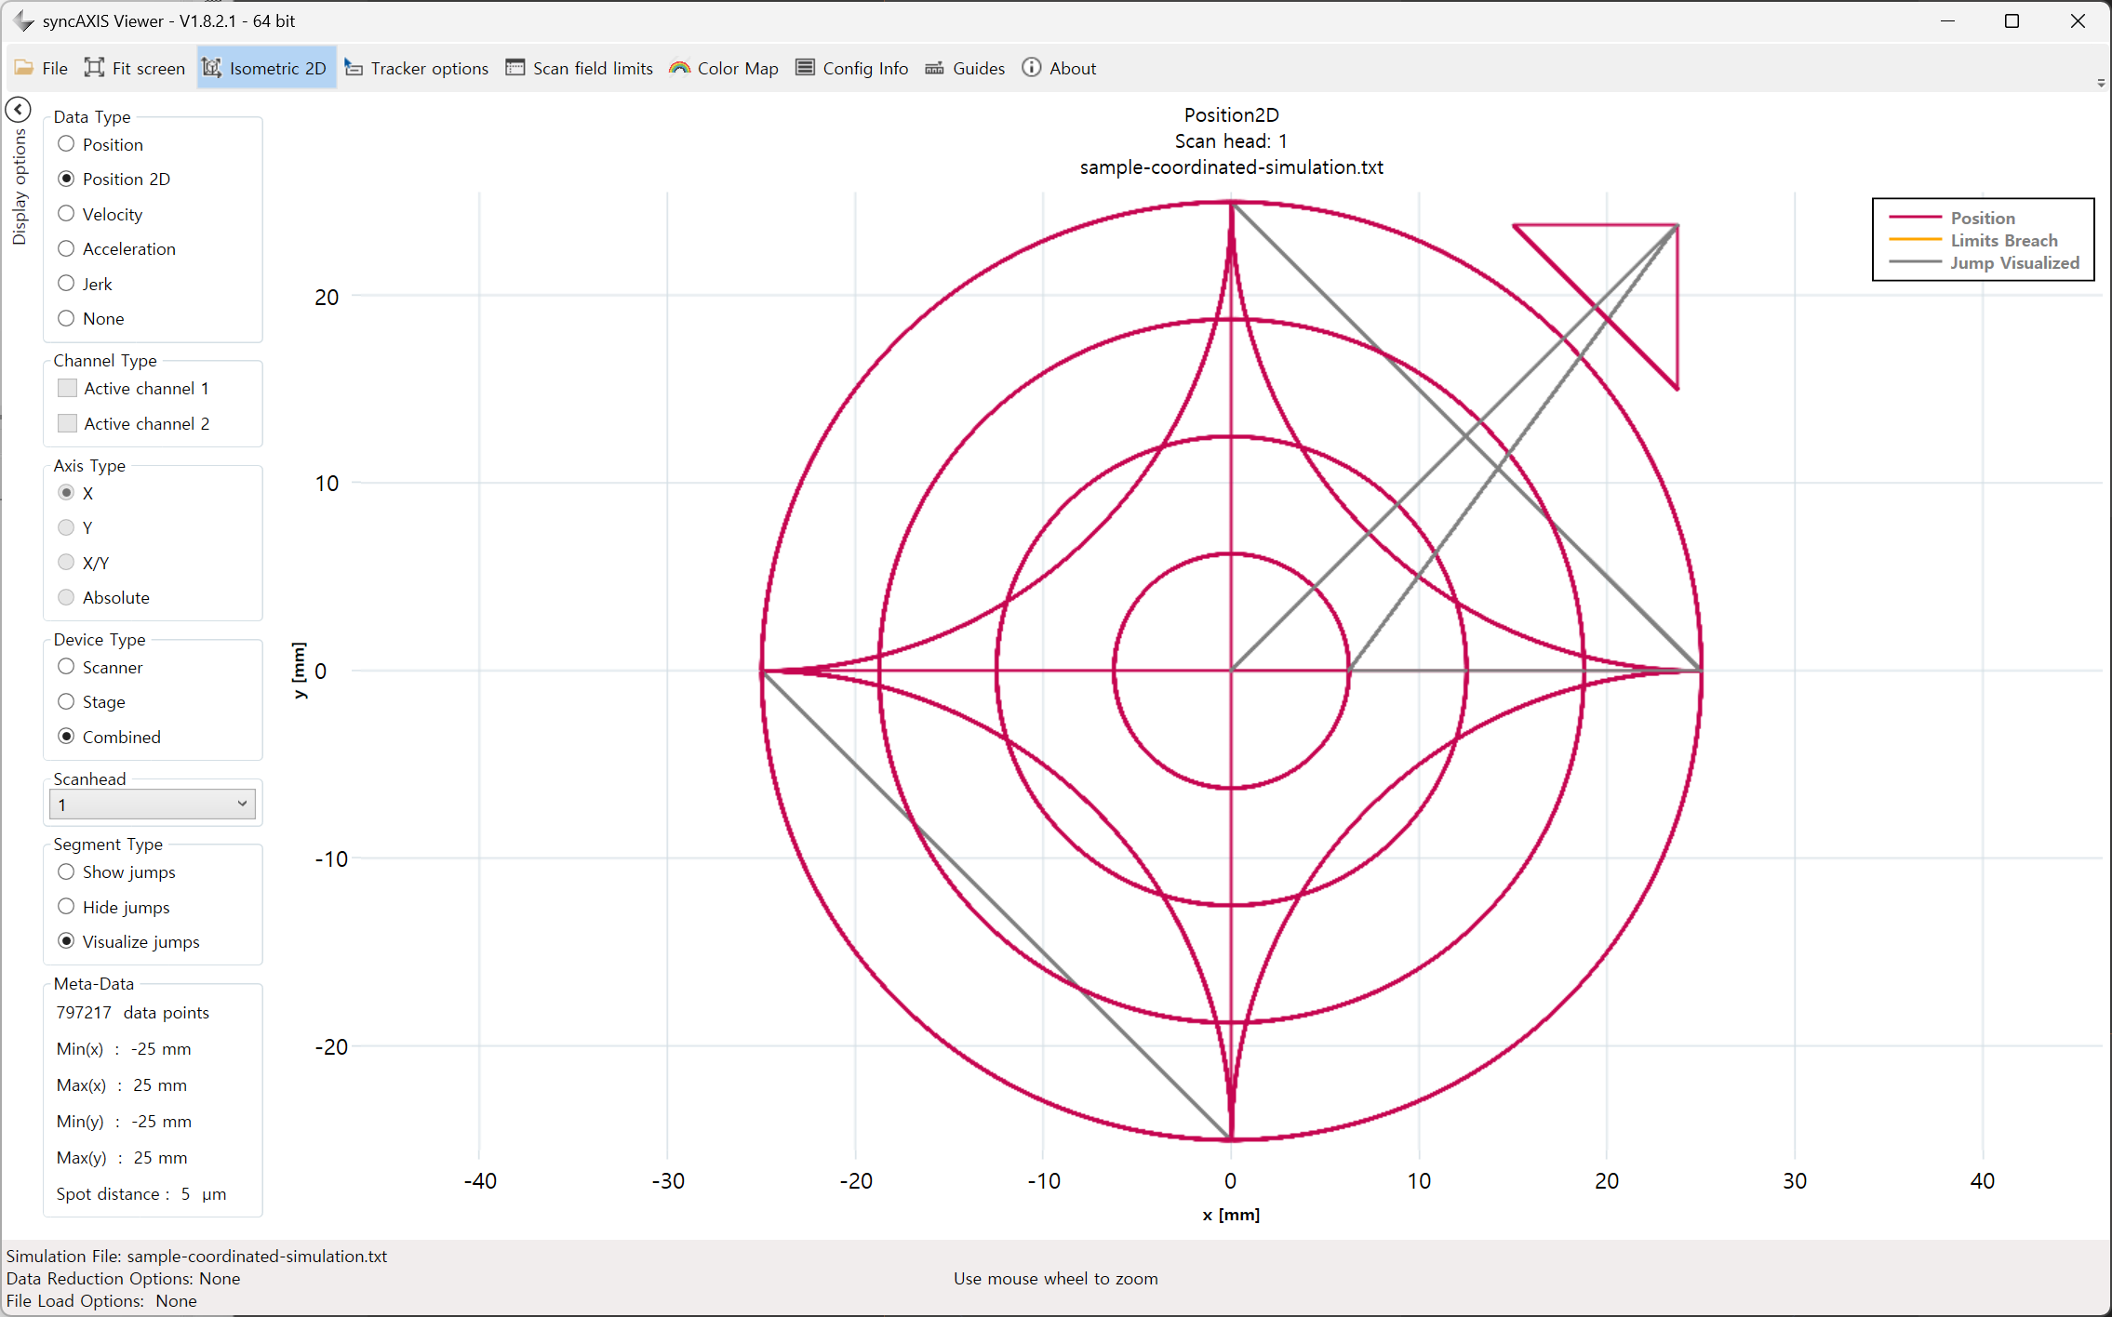
Figure 30.4 Combined Position 2D. Magenta is the path; gray visualizes jumps. Axes are in mm.
Compare Scanner, Stage and Combined for the same job. Combined shows the resulting trajectory; scanner and stage views reveal the motion allocation. Availability depends on the recorded data. Position 2D displays X/Y geometry; the time plots use Axis Type X, Y, X/Y or Absolute. Fit screen resets framing, the mouse wheel zooms, and Guides compares coordinates.

30.5.1 Load options and measurement units
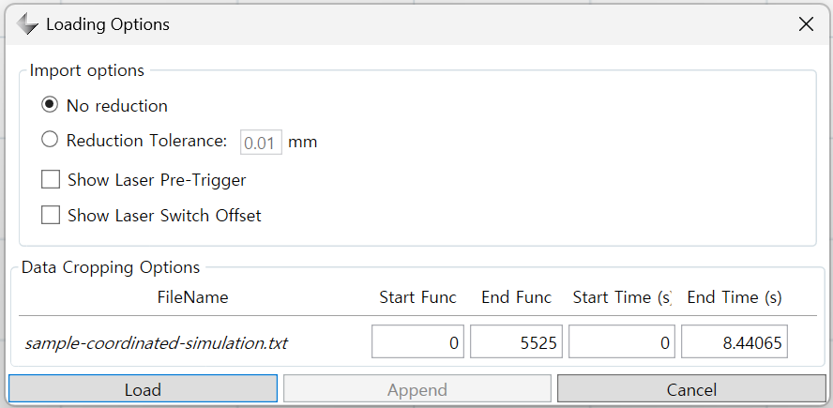
Figure 30.5 Loading Options detail. Reduction Tolerance is a display-data tolerance in mm.
No reduction keeps all loaded points. Reduction Tolerance simplifies the display using the selected tolerance in mm. It does not change the machining document or rerun path planning. Check full data or Accurate limits when analyzing limits; a reduced plot is not a complete numeric check. Crop by function number or time to inspect a short interval. Show Laser Pre-Trigger and Show Laser Switch Offset display additional timing information.
Data Type | Units and reading
Position / Position 2D | mm against time in s / X–Y in mm.
Velocity / Acceleration / Jerk | m/s, m/s², m/s³ against time in s. Viewer units differ from stage XML mm-based dynamics.
Scanhead / Segment Type | Select a recorded head; Show, Hide or Visualize jumps distinguishes travel from marking.

30.5.2 Read dynamics and limit warnings
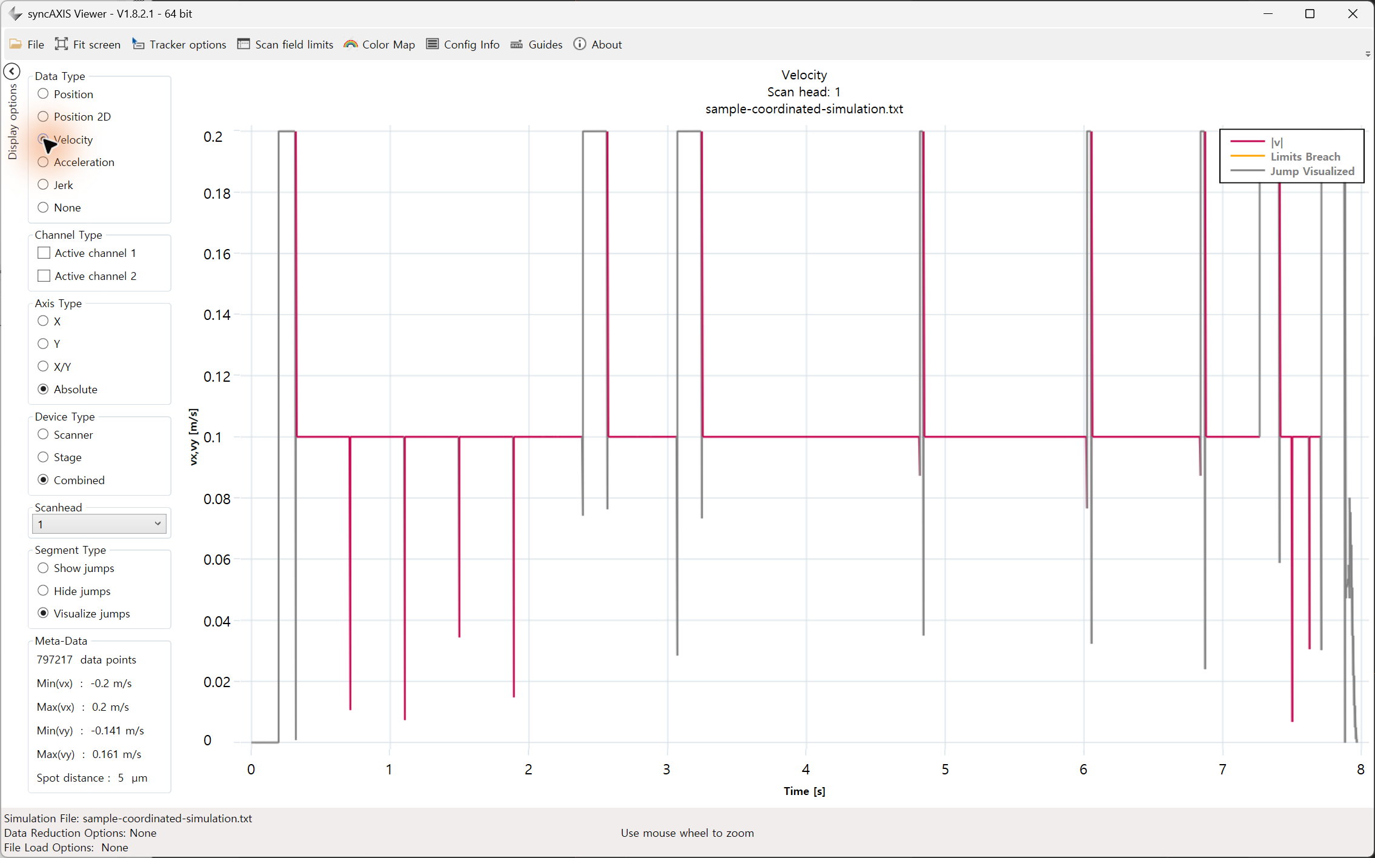
Figure 30.6 Combined absolute velocity against time. Marking is about 0.1 m/s; gray segments are jumps.
Orange Limits Breached indicates a detected field or dynamic-limit violation. Check the status details and affected device/axis. Compare the result with its configuration using Scan field limits and Config Info. If the correction file is missing, Viewer may report CorrectionFileNotFound and use default 54 × 54 mm limits. That view does not validate the real scan field. No orange warning does not certify calibration or machine safety.

30.5.3 Open an existing simulation result after job completion
Listing 30.3 Open an existing simulation result after job completion
using System.IO;
using SpiralLab.Sirius3.Scanner.Rtc.SyncAxis;

public static class SyncAxisResults
{
// Call after the simulation job has completed.
public static bool TryOpen(Rtc6SyncAxis rtc)
{
string file = rtc.SimulationFileName;
return !string.IsNullOrEmpty(file)
&& File.Exists(file)
&& SyncAxisViewerHelper.Plot(file);
}
}
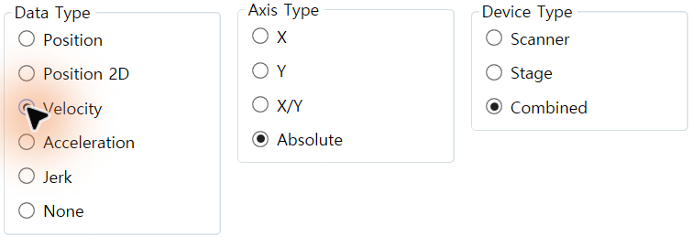
Figure 30.7 Viewer controls in the velocity view, shown as three native-pixel detail crops: Data Type, Axis Type and Device Type.
Plot returns true when the launch request has been scheduled, not when Viewer has finished loading. Check the log if launch fails. For paths containing spaces, use Viewer File > Open if the launcher does not open the file. Viewer reads simulation output; it does not command scanner or stage motion.

30.6 Layer motion with syncAXIS
EntityLayerPen.MotionType selects the syncAXIS motion decomposition mode and BandWidth controls its bandwidth. They belong to MarkerSyncAxis with a validated XML scanner and stage configuration. Select layer motion only after checking stage travel and scanner field/dynamics; these settings do not configure a conventional MarkerRtc job.
For syncAXIS, EntityLayerPen.MotionType selects ScannerOnly, StageOnly or StageAndScanner. BandWidth (Hz) configures the motion split for StageAndScanner. EntityPen.MinMarkSpeed (mm/s) and ApproxBlendLimit (mm) emit their corresponding syncAXIS list settings when greater than zero. A zero value does not send a reset command for these two settings. Use the configured stage dynamics and the installation workflow when choosing them.

30.7 Diagnose initialization and execution separately
Check the native return code, error queue and log. Native 0 confirms that call, not later job completion; Sirius3 exposes bool, LastError and internal messages. Save the failing command and full error before reset. For initialization check dongle, paths, schema, device assignment and runtime versions; for motion check simulated violation segments, dynamic limits and ACS diagnostics. Serious states may require corrected configuration and reinitialization, not repeated Reset.

30.8 Follow and Unfollow: manual positioning and return
Unfollow enters the vendor's Manual Positioning mode and temporarily gives the stage to external or manual control. The syncAXIS instance, RTC access, queued jobs and ongoing trajectory calculations remain in place. Jobs cannot start in this mode. Follow takes back stage control and returns to normal job execution. These names do not simply mean that the stage follows the scanner path. They are separate from ScannerOnly/StageOnly/StageAndScanner and simulation/hardware selection.
Finish or explicitly stop the current execution before calling CtlMotionMode(MotionModes.Unfollow). Complete the authorized manual/external move and confirm position and settling. Then call CtlMotionMode(MotionModes.Follow) and check its bool result. If a queued job requires an absolute start position, return to control can fail with InvalidPosition after manual movement. Resolve that start position before resuming. ListBegin(MotionType) also requests Follow internally, but the host must still coordinate the end of external control.

30.9 Read Job Characteristic after execution or simulation
When the job finishes, the syncAXIS completion callback fills JobSyncAxis.Characteristic and publishes the updated job through OnJob. Simulation uses the same result flow. Open the finished Job in the scanner's JobHistory/PropertyGrid or read it in the host's OnJob handler. A successful ListExecute(false) request or early OnJob event does not mean the characteristics are final. Wait for completion, and send event-driven display updates to the UI thread.
Result group | Available data | Use
Characteristic.Scanner | XY position ranges; laser-on ranges; maximum velocity/acceleration | Check scanner field use and dynamic demand.
Characteristic.Stage | XY position ranges; laser-on ranges; maximum velocity/acceleration/jerk | Compare travel and dynamics with the active stage.
MarkSpeedMinMax / InsertedSkywritings | Laser-on speed range; inserted transition count | Find speed reduction or difficult contour joins.
MotionMicroSteps / ExecutionTimeRtcOnly | 10 µs step count; step count / 100,000 seconds | Compare calculated controller time with host elapsed time.

The job also exposes UtilizedScanner and UtilizedStage1/2 percentages against configured limits, plus host execution time and result/state. Characteristics describe the calculated/executed trajectory, not independent physical metrology. Simulation cannot prove actual stage following error, optical output or surface quality. Query failures are logged and completion can still be reported; do not interpret a zero/default diagnostic field as proof that the machine stayed within limits.
Listing 30.4 Read characteristics only from a finished syncAXIS job
public static string DescribeFinishedJob(JobSyncAxis job)
{
// Invoke for the finished JobSyncAxis received through OnJob.
if (job == null || job.ExecStatus != ExecutionStatus.Finished)
return "Job is not finished.";
var c = job.Characteristic;
return $"Job {job.ID}: {job.ExecutionTimeRtcOnly:F4} s; " +
$"mark speed {c.MarkSpeedMinMax.Min:F3}.." +
$"{c.MarkSpeedMinMax.Max:F3} mm/s; " +
$"steps {c.MotionMicroSteps:F0}; " +
$"inserted transitions {c.InsertedSkywritings:F0}";
}

31 MultiBeam extension option
The corresponding Sirius3 option can be evaluated for 30 minutes even when that option is not licensed. Required controllers, vendor runtimes, hardware and vendor licenses must still be available. Commercial operation requires the appropriate Sirius3 license.

31.1 Optical layout and Router Gate roles
One laser source feeds two scan heads through two AOMs. AOM 1 is the upstream Router; AOM 2 is the downstream Gate for Head 1. The straight 0th-order chain is Laser → AOM 1 → AOM 2 → Beam Dump. With Head 1 on the left and Head 2 on the right, the folded 1st-order routes cross: AOM 2 feeds Head 1 and AOM 1 feeds Head 2. The crossing is not an optical junction; fold mirrors and distances are omitted.
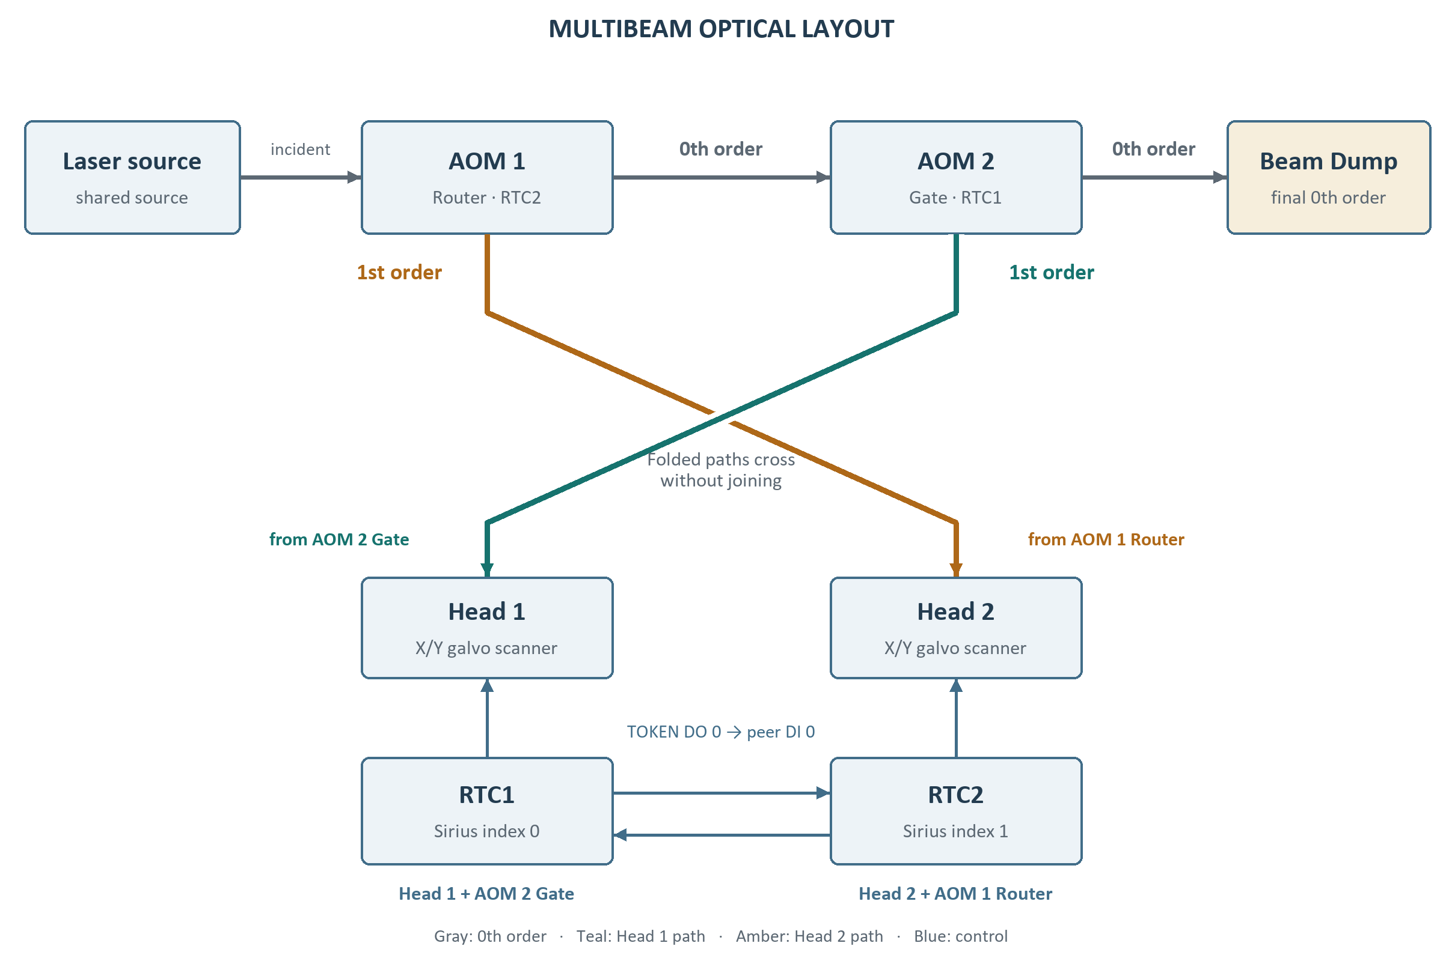
Figure 31.1 Router Gate layout and crossed 1st-order routes
RTC1 and RTC2 in the design are one-based board labels. In the public pair-0 demo they correspond to Sirius index/MultiBeamIndex 0 and 1. RTC1 (index 0) controls Head 1 and AOM 2 Gate; RTC2 (index 1) controls Head 2 and AOM 1 Router. Keep this mapping when reading the wiring and C# examples. One final Beam Dump absorbs unused 0th-order light.

31.2 One source and two coordinated beam paths
The public arrangement uses one laser source, two AOMs and two scan heads/controllers. Each editor has its document and marker, while the laser is shared. Pair index and head side identify the coordinated pair. The configured token and AOM I/O wiring determine beam ownership. A second editor alone does not establish a MultiBeam optical system.
Listing 31.1 Prepare a configured pair after all participating markers are idle
internal static bool PreparePair(int pairIndex,
RtcMultiBeamHelper.MultiBeamModes mode, IMarker[] markers)
{
if (markers.Any(marker => marker?.IsBusy == true)) return false;
if (!RtcMultiBeamHelper.SetMode(pairIndex, mode,
RtcMultiBeamHelper.MultiBeamPreperSides.Head1))
return false;
return RtcMultiBeamHelper.ReadyMode(pairIndex);
}
Follow the public UI order: verify pins, choose None/Head1/Head2/Both and the preparation side, then select Ready. Confirm IsReady before starting the intended markers. Both coordinates access to the shared source through the paired control path. Change modes only when idle. Manage the shared laser centrally so closing one editor does not invalidate the other. Stopping and fault recovery must handle both sides.
Public demo /​ entry | Inspect and customize
demos/​editor_​multibeam/​Form1.​cs | Shared laser, two device paths, pin labels and mode/​Ready/​Start buttons.​
demos/​editor_​multibeam2 | Alternative MultiBeam host arrangement and per-head setup.​

31.3 AOM orders and beam paths
OFF selects the 0th-order state; ON selects the 1st-order processing state. For Head 2, keep AOM 2 OFF so residual 0th-order light from AOM 1 reaches the dump rather than Head 1. Both alternates source ownership and does not select the ON/ON combination. The implementation controls 0th and 1st order, with no 2nd-order selection. Actual transmission and diffraction efficiencies depend on the installed optics.
AOM 1 Router | AOM 2 Gate | Target and beam path
OFF / 0th | OFF / 0th | Dump: AOM 1 (0th) → AOM 2 (0th) → Beam Dump
OFF / 0th | ON / 1st | Head 1: AOM 1 (0th) → AOM 2 (1st) → Head 1; RTC1 / index 0
ON / 1st | OFF / 0th | Head 2: AOM 1 (1st) → Head 2; RTC2 / index 1. Residual 0th light passes AOM 2 to Beam Dump.
ON / 1st | ON / 1st | Do not use: Head 2 is open and residual light can also enter Head 1. Both uses token exchange instead.

31.4 Operate MultiBeamRtcControl
Choose the pair index and the None, Head 1, Head 2 or Both mode. Preferred head controls the initial token in Both mode; the heads acquire the shared source in turn. Check pins verifies the configured interboard handshake. Ready prepares the selected mode, Start executes registered markers, Stop requests stopping and Reset resets their state. Mode changes are disabled while busy. This capture is an unconnected control preview; no pins or outputs were operated.
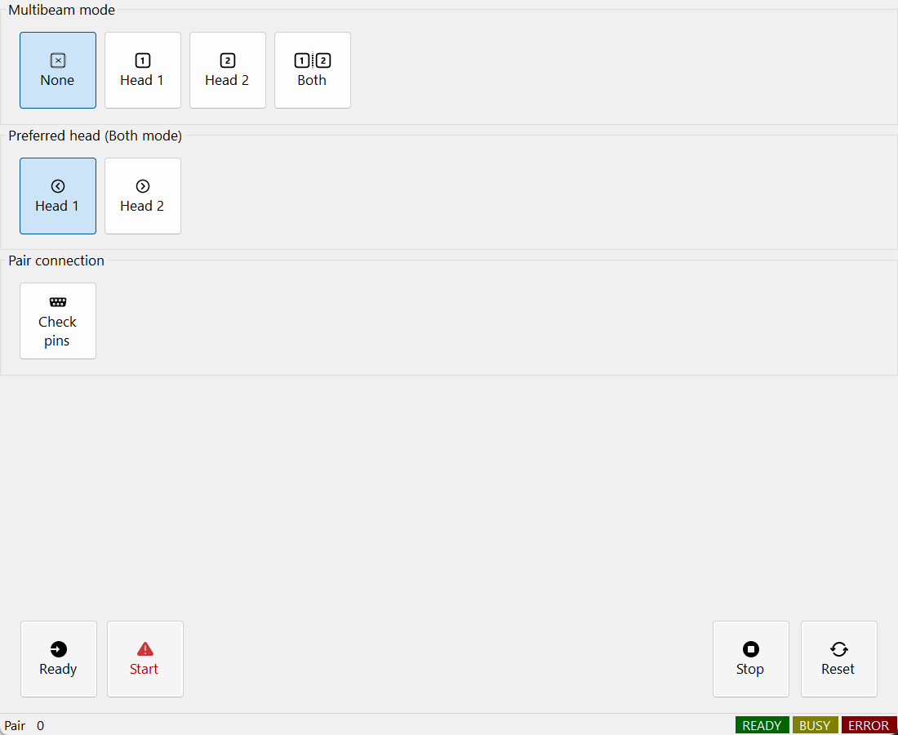
Figure 31.2 AOM pair control and status

31.5 Board numbering and signal connections
The following map uses the design labels RTC1/RTC2 with the public demo indices 0/1. Cross-connect each token DO to the peer DI. Connect each AOM driver to the controller of its processing head, even though the optical AOM numbers are crossed. Signal bit numbers are not connector pin numbers.
Source | Destination | Role
RTC1 / index 0 · DO 0 | RTC2 / index 1 · DI 0 | Token ownership to peer
RTC2 / index 1 · DO 0 | RTC1 / index 0 · DI 0 | Token ownership to peer
RTC1 / index 0 · DO 1 / AO 1 | AOM 2 Gate · D.IN / MOD | Head 1 Gate enable and RF modulation
RTC2 / index 1 · DO 1 / AO 1 | AOM 1 Router · D.IN / MOD | Head 2 Router enable and RF modulation
RTC1 LASERON / RTC2 LASERON | XOR A / B → Laser Trigger | Same signal type into each XOR input
RTC / driver / logic GND | GND | Logic reference; not an XOR data input

The demo config_multibeam.ini sets TOKEN_BIT=0 (mask 0x0001), AOM_BIT=1 (mask 0x0002) and AOM_CHANNEL=ExtAO1. OFF/ON uses 0/10 V; AOM_HOLD_MSEC is 0.01 ms. Match the driver's input range and settling time to the actual equipment. AOM0OrderVoltage and AOM1stOrderVoltage are in volts; AOMHoldMsec is in milliseconds.
The design sends both LASERON signals through XOR to the laser trigger. To combine LASER1 pulses as well, use a separate XOR for LASER1. Do not mix LASER1 and LASERON. XOR is High for inputs 01/10 and Low for 00/11. This truth table cannot suppress every overlap of asynchronous pulse trains. It does not replace token exclusion, shutters or the equipment interlock.

31.6 Token exchange during scanner jumps
In Both mode, one head may scan to its next position while the peer uses the shared source. The ordinary vector ListJumpTo path performs the following exchange in the RTC list, reducing source idle time during jumps. The benefit depends on the two jobs and their timing.
1. Close the current AOM path with ListAOM(false). Before a later jump, release the token DO and observe the release guard.
2. Jump the scanner to the next position. The peer can continue processing while this head moves.
3. Wait in the list until the peer token DI is LOW, then set the local token DO HIGH. Preferred head determines initial priority.
4. Open the AOM with ListAOM(true), wait AOMHoldMsec and restore the entity pen power before marking. ListEnd closes the AOM and releases the token in Both mode.
CheckPins verifies configured DIO wiring; it does not validate the optical path. SetMode changes the selected mode and invalidates readiness; call ReadyMode again while both sides are idle. Continuous raster pixels may retain the token within a segment, so the vector jump description is not a per-pixel switching rule. Handle stop or faults for both markers and the shared laser.

31.7 Residual light and head power calibration
Head 1 combines AOM 1 transmission and AOM 2 diffraction; Head 2 uses AOM 1 diffraction. Their losses can therefore differ. In the design example, 83% versus 85% efficiency gives a target output ratio of 83/85 ≈ 0.9765, about 2.35% less power for the higher-output path. These are example efficiencies, not guaranteed Sirius3 performance.
Measure both heads at the work plane under the same laser settings, then adjust the appropriate AOM RF modulation until the measured powers match. Head 1 uses AOM 2 on RTC1/index 0; Head 2 uses AOM 1 on RTC2/index 1. Store the measured voltage in AOM1stOrderVoltage or the corresponding AOM_1_ODR_V INI entry, and prepare the mode again before processing. Recheck the intended frequency, pulse width and operating power range.
The 0.9765 ratio describes optical power. Do not multiply voltage or a raw DAC code by it directly. RF drive and diffraction efficiency are not generally linear. Public voltage properties use volts, not the design example's 0–4095 DAC counts. Keep AOM0OrderVoltage at the commissioned OFF value; do not use it for arbitrary power trimming.

32 Remote communication
Remote communication lets a host or production system exchange commands and status with the registered marker. First choose a transport, then define command framing and control mode, and finally distinguish acceptance from job completion. Socket, Serial, WebSocket and MQTT use the same Remote option as the MCP server described in the following chapter.
The corresponding Sirius3 option can be evaluated for 30 minutes even when that option is not licensed. Required controllers, vendor runtimes, hardware and vendor licenses must still be available. Commercial operation requires the appropriate Sirius3 license.

32.1 Remote protocols
The Remote option covers socket, serial, WebSocket and MQTT communication as well as embedded MCP. Connect one remote target to the intended editor/marker and define local/remote ownership. Validate target identity, input format and operation state before applying requests. Await remote shutdown before disposing the bound editor or devices.

32.2 RemoteControl: transport and MCP in one panel
The left pane displays the assigned IRemote and controls its Start/Stop and Local/Remote mode. The right pane displays the assigned IMCPServer and separately starts/stops MCP. The public interface spelling is IMCPServer; MCPServer is its implementation. Assigning either instance makes the editor’s Remote tab available. The screenshot uses RemoteVirtual and a stopped MCP server: it demonstrates configuration, not an external connection.
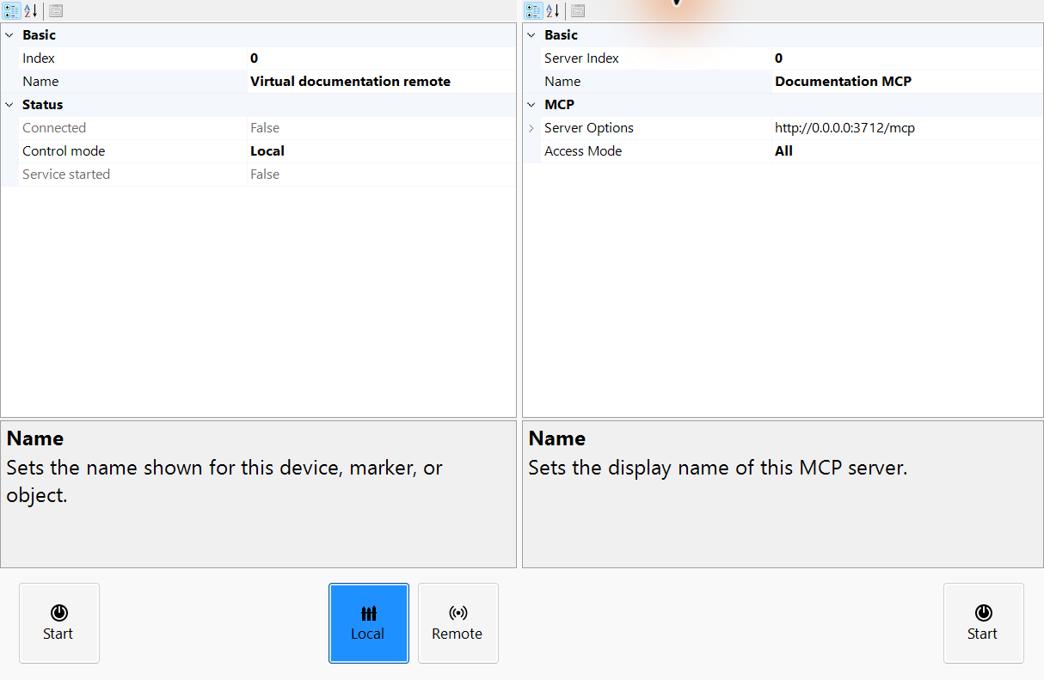
Figure 32.1 RemoteControl with transport properties, local mode and a separately configured MCP endpoint

32.3 Choose the transport and await startup
Transport / factory | Configuration | Workflow
CreateTcpServer | Listen port | Socket client sends framed commands and reads responses/status.
CreateSerial | COM / baud | Match port and serial framing with the peer.
CreateWebSocket | Listener prefix | Use the demo HTML client and its matching URL; HTTP prefix registration can be required.
CreateMqtt | Broker / topics | Subscribe to command topic and publish responses on the configured topic.

Create the transport for the initialized Marker. Register custom handlers, assign editor.Remote, then await Start(). Check IsStarted, IsConnected and OnConnected/OnDisconnected separately. Listening differs from having a connected peer; command acceptance differs from finished marking. Public editor_remote and demos/helper.cs show config*.ini selection. editor_remote_mcp/MainForm.cs and MCPDemoHelper.cs show MCP hosting.
Listing 32.1 Start a TCP endpoint and attach it to editor cleanup
public static async Task<IRemote> StartTcp(
SpiralLab.Sirius3.UI.WinForms.SiriusEditorControl editor, int port)
{
var remote = RemoteFactory.CreateTcpServer(0, "TCP endpoint",
editor.Marker, port); // Marker must already be ready.
remote.RegisterCommandHandler("ping", async (r, tokens) => {
await r.Send(SpiralLab.Sirius3.UI.Config.RemoteOk +
SpiralLab.Sirius3.UI.Config.RemoteTerminator);
return true;
});
editor.Remote = remote;
try {
if (!await remote.Start())
throw new InvalidOperationException("Remote start failed.");
return remote; // Await editor.DisposeDevices() on host shutdown.
}
catch {
editor.Remote = null;
await remote.DisposeAsync();
throw;
}
}

32.4 Command framing, authority and completion
Build text commands using SpiralLab.Sirius3.UI.Config.RemoteSeparator and RemoteTerminator. Do not assume a comma separator. Built-in examples include status, controlmode and select with entity names. Use the marker command family for start/stop. The immediate OK reply to start confirms acceptance; completion is reported separately. Local/Remote is the legacy transport's control mode. It does not set the MCP server's access policy or authentication.
RegisterCommandHandler runs before built-in commands and can override them. Check state and permissions, dispatch document edits to the editor UI, and await DisposeDevices before releasing the editor, document and Core. The next chapter introduces MCP.

33 Embedded MCP server
MCP gives an AI client a structured set of tools for the existing editor. The server connects to one editor and exposes supported document, entity and registered-device operations. Begin with a read-only document query, then create and select a simple shape, change one pen property and inspect the display-only simulation. Choose access scope, authentication and file roots before accepting requests.

33.1 Embed MCP on the editor thread
Listing 33.1 Create and register one MCP server for one initialized editor
public static async System.Threading.Tasks.Task AttachMcp(
SpiralLab.Sirius3.UI.WinForms.SiriusEditorControl editor)
{
var options = new SpiralLab.Sirius3.MCP.MCPServerOptions();
options.ApplyEnvironment();
var server = SpiralLab.Sirius3.MCP.MCPFactory.CreateServer(
0, "Editor MCP", editor, options);
server.AccessMode = SpiralLab.Sirius3.MCP.MCPAccessMode.All;
try
{
if (!await server.Start())
throw new InvalidOperationException("MCP start failed.");
editor.MCPServer = server;
}
catch
{
await server.DisposeAsync();
throw;
}
}
Create the server after device registration on the editor’s UI thread. The factory binds one editor; Start is explicit. The All access mode permits the supported document/entity and registered-device scope. Choose the intended access mode, configure endpoint/authentication/file roots and keep credentials in the host’s configuration rather than source code. Give multiple editors distinct endpoints.
Assign MCPServer to show the server on the editor's Remote page and include it in DisposeDevices cleanup. The host still manages the editor itself. Canceling a request can remove queued work, but cannot stop a job that already started. Read the current state and explicitly stop the job when needed. See demos/editor_remote_mcp for the complete hosting and configuration flow.

33.2 Protocol endpoints and authorized scope
Choose a protocol for the client and assign the intended editor/marker. Configure endpoint and authentication before listening. MCP is included in the Remote option and exposes registered editors, document/entity actions, simulation and supported registered-device operations. An AI client acts through the same host-owned state; it does not remove application permissions or machine interlocks. Executable C# evaluation and loading script assemblies are outside MCP operations.
Check service state and endpoint on the Remote page. Test a read-only query before changing the document. In v1.17.0, the default file policy permits paths accessible to the host process. Set AllowedFileRoots explicitly to restrict that range. Wait for service shutdown before releasing controls and devices. Canceling a request is not an emergency stop for a running job.
Public demo /​ entry | Inspect and customize
demos/​editor_​remote/​Form1.​cs | Protocol factory, target marker, request handling and async teardown.​
demos/editor_remote_mcp/MainForm.cs; config*.ini | One authenticated MCP service per editor, configuration and cleanup.​

33.3 Connect ChatGPT and Claude over HTTP
Start the embedded server after registering initialized devices. Read the exact endpoint and authentication settings from the host; use the complete MCP path, not just the port. The examples below use http://127.0.0.1:8080/mcp as a placeholder. The AI model accesses tools through its MCP client; model selection alone does not create a connection.
For a local Claude Code client run: claude mcp add --transport http sirius3 http://127.0.0.1:8080/mcp . Add the configured authentication header with --header when required. Run claude mcp get sirius3 or /mcp to inspect the connection, then request a read-only document query before creating geometry. A local desktop client can reach loopback; a cloud-hosted connector cannot use the user computer’s 127.0.0.1.
For ChatGPT, open Plugins, add a custom MCP server and supply a reachable HTTPS URL with the MCP path and supported authentication. Install/select the plugin in a new chat and confirm tool discovery with a document query. A cloud connection needs a controlled HTTPS gateway or a supported secure tunnel to the local HTTP server; pasting its loopback URL is insufficient. Keep the local listener, gateway authentication and client authentication consistent. Follow the current client documentation because account availability and menus can differ.
Client setup: OpenAI MCP quickstart · OpenAI MCP servers · Claude Code MCP

33.4 Prompt examples
1. Summarize the active page, layers and selected entity properties without modifying the document.
2. Create a 20 by 10 mm rectangle in the active layer, add a 0.1 mm line hatch and select it. Show the resulting dimensions.
3. Import sample.svg into the active layer, report unsupported content and show a display only path simulation. Do not start physical marking.
4. Explain SCANahead automatic delays for RTC6 in simple terms, including prerequisites, affected delays and units.
5. Compare MotionType and motion-decomposition bandwidth in syncAXIS, explaining their effects and required runtime.

33.5 Ask the PDF manuals
Place the API guide and allowlisted SCANLAB PDFs under DocumentationRoot. MCP searches and reads their extracted text. In the question, specify controller generation, prerequisites and units, and ask for the principle. Missing PDFs or image-only scans limit the answer. Arbitrary PDFs are not registered automatically, and MCP does not render page images.

34 Public demos as a source map
Choose a demo by the behavior to change, then read Program.cs, the owning form and its device setup. Shared helper.cs reads configuration, but individual forms may choose a factory explicitly. Build and inspect the resolved NuGet versions before running a demo. Source controls in editor_ui keep namespace Demos and remain NuGet consumers.
All paths below are relative to the public sirius3 repository. The table covers the WinForms and console projects; the core APIs, behavior and customization seams are explained in the related feature chapters. Start with editor_ui/editor_entity for document UI, editor_pen for process conditions, and the dedicated hardware-feature demo for the capability you need.
Read doc/WinForms.md for host integration; doc/EntityUserManual.md, doc/PenUserManual.md and doc/LayerPenUserManual.md for object and process settings; doc/MarkerUserManual.md and doc/OffsetUserManual.md for execution; doc/PowermapUserManual.md for compensation. The paired Korean guides use the .koKR.md suffix. Controller commissioning also requires the matching SCANLAB vendor manuals.

34.1 Start and editor integration
demos folder | Entry and extension files | What to learn
beginner | Program.​cs, Form1.​cs | Explicit factory initialization and a first editor.​ Inspect the physical RTC6 selection.​ API: ScannerFactory, LaserFactory, MarkerFactory
console_​document | Program.​cs | Create and process documents without an editor host.​ API: DocumentFactory.​CreateDefault, IDocument, IMarker
editor_​ui | Program.​cs, Form1.​cs, Form2.​cs, SiriusEditorControl.​cs, SiriusMultiEditorControl.​cs, EditorControlSupport.​cs | Editable composite control source in namespace Demos.​ API: SiriusEditorControl, SiriusMultiEditorControl, DisposeDevices

34.2 Entities and geometry preparation
demos folder | Entry and extension files | What to learn
editor_​barcode | Program.​cs, Form1.​cs | Code formats, cell geometry, hatching and dimensions.​ API: EntityQRCode, EntityDataMatrix, EntityBarcode1D
editor_​barcode_​textconvert | Program.​cs, Form1.​cs | Dynamic barcode/​text conversion and per-offset values.​ API: ITextConvertible, TextConverters
editor_​clip | Program.​cs, Form1.​cs, ClipSamples.​cs | Path/​region clipping and independent result ownership.​ API: IClippable, ClipOptions, IDocument.​ActClip
editor_​entity | Program.​cs, Form1.​cs, Form1.​WinForms.​cs | Built-in entity families and editable parameters.​ API: EntityFactory, IRenderable, IMarkerable
editor_​entity_​custom | Program.​cs, Form1.​cs, myentity.​cs, myentity2.​cs, myentity3.​cs | Custom entity source and capability implementation.​ API: EntityBase, EntityModelBase, IGrippable
editor_​hatch | Program.​cs, Form1.​cs | Hatch algorithms, fill topology and path order.​ API: IHatchable, HatchFactory.​CreateLine, HatchFactory.​CreatePolygon
editor_​hatch_​clip | Program.​cs, Form1.​cs | Clipping combined with hatch geometry.​ API: IHatchable, IClippable, IDocument.​ActClip
editor_​slicer | Program.​cs, Form1.​cs | Mesh section contours and sliced documents.​ API: ISliceable, EntityMesh, IDocument.​ActSlice
editor_​stitchedimage | Program.​cs, Form1.​cs, mycamera.​cs | Camera source and stitched-image visualization.​ API: EntityStitchedImage
editor_​zpl | Program.​cs, Form1.​cs | ZPL label rendering as image geometry.​ API: EntityImageZPL

34.3 Devices and processing
demos folder | Entry and extension files | What to learn
console_​syncaxis_​setup | Program.​cs | Configure the syncAXIS system entry flow.​ API: IRtcSyncAxis, ScannerFactory.​CreateRtc6SyncAxis
editor_​automatic_​laser_​control | Program.​cs, Form1.​cs | Layer-level ALC signals and speed/​output relationships.​ API: IRtcAutoLaserControl, EntityLayerPen, EntityPen
editor_​fieldcorrection_​2d | Program.​cs, Form1.​cs | 2D correction workflow and calibration data.​ API: IRtc, CorrectionFiles, KFactor
editor_​fieldcorrection_​3d | Program.​cs, Form1.​cs | 3D correction through CalibrationLibrary.​ API: IRtc3D, CalibrationLibrary
editor_​fieldcorrection_​3d_​pointscloud | Program.​cs, Form1.​cs | Point-cloud based 3D correction inputs.​ API: EntityMesh, EntityPoints, IRtc3D
editor_​laser_​ui | Program.​cs, Form1.​cs, laser_​source.​cs, LaserUIControl.​cs | Custom LaserBase-family adapter and WinForms device panel.​ API: LaserBase, ILaserPowerControl, LaserUIControl
editor_​marker | Program.​cs, Form1.​cs, markerrtc.​cs, markerrtcfast.​cs, markersyncaxis.​cs | Custom RTC, fast and syncAXIS marker implementations.​ API: MarkerRtc, MarkerRtcFast, MarkerSyncAxis
editor_​mof_​interrupt | Program.​cs, Form1.​cs | Host interruption during a MoF sequence.​ API: IRtcMoF, IMarker, Offset
editor_​mof_​offsets | Program.​cs, Form1.​cs | MoF positions and per-location data.​ API: IRtcMoF, IMarker, Offset
editor_​mof_​trigger | Program.​cs, Form1.​cs | Triggered moving-workpiece processing.​ API: IRtcMoF, IMarker, Offset
editor_​mof_​xy | Program.​cs, Form1.​cs | XY encoder tracking and moving coordinates.​ API: IRtcMoF, IMarker, Offset
editor_​mof_​xy_​raster | Program.​cs, Form1.​cs | Raster execution in an XY MoF workflow.​ API: IRtcMoF, IMarker, Offset
editor_​multibeam | Program.​cs, Form1.​cs | MultiBeam controller/​beam setup.​ API: ILaser, IMarker
editor_​multibeam2 | Program.​cs, Form1.​cs | A second MultiBeam integration arrangement.​ API: ILaser, IMarker
editor_​offset | Program.​cs, Form1.​cs | Offset placement and transformed processing locations.​ API: IMarker.​Offsets, Offset
editor_​pen | Program.​cs, Form1.​cs | Per-entity and per-layer processing pens.​ API: EntityLayerPen, EntityPen, IRtc2ndHead
editor_​pen_​multiple | Program.​cs, Form1.​cs | Pen conditions across multiple device systems.​ API: EntityLayerPen, EntityPen
editor_​powermap | Program.​cs, Form1.​cs, my_​powermap.​cs | Custom map source, measurement and compensation.​ API: IPowerMap, PowerMapBase
editor_​scanahead | Program.​cs, Form1.​cs | SCANahead options and automatic delays.​ API: EntityLayerPen, EntityPen
editor_​scanahead_​sdc | Program.​cs, Form1.​cs | SCANahead Spot Distance Control prerequisites.​ API: EntityLayerPen, EntityPen
editor_​syncaxis | Program.​cs, Form1.​cs | Coordinated scanner/​stage jobs and motion types.​ API: IRtcSyncAxis, MarkerSyncAxis

34.4 External data and host customization
demos folder | Entry and extension files | What to learn
editor_​dio | Program.​cs, Form1.​cs | Registered digital ports and external state handling.​ API: IDInput, IDOutput, RegisterDevices
editor_​document | Program.​cs, Form1.​cs | Document actions, hierarchy, save/​load and editing.​ API: IDocument, DocumentFactory.​CreateDefault
editor_​hardjump | Program.​cs, Form1.​cs | Hard Jump capability and motion conditions.​ API: EntityFactory.​CreateMeasurementBegin, EntityFactory.​CreateMeasurementEnd, EntityFactory.​CreateText
editor_​interrupt | Program.​cs, Form1.​cs | RTC list interruption and host-side handling.​ API: EntityArc, IRtcInterrupt
editor_​measurement_​skywriting_​wobbel | Program.​cs, Form1.​cs | Measurement channels with Sky Writing and Wobbel.​ API: IRtcMeasurement, IRtcSkyWriting
editor_​multiple | Program.​cs, Form1.​cs | Two independent editor/​document/​device systems.​ API: SiriusEditorControl, RegisterDevices
editor_​multiple2 | Program.​cs, Form1.​cs | Indexed device sets and multi-editor selection.​ API: SiriusMultiEditorControl, RegisterDevices
editor_​points_​sync_​pulses_​count | Program.​cs, Form1.​cs | Point processing with synchronized pulse counts.​ API: EntityModelBase, EntityPen, EntityPoints
editor_​remote | Program.​cs, Form1.​cs | Remote protocol ownership and marker integration.​ API: EditorHelper.​CreateRemote, SiriusEditorControl.​Remote, IMarker
editor_​remote_​mcp | Program.​cs, MainForm.​cs, MCPDemoHelper.​cs | One authenticated MCP server per editor and async cleanup.​ API: MCPFactory.​CreateServer
editor_​script | Program.​cs, Form1.​cs | Script context, serial data and conversion hooks.​ API: IScript, ITextConvertible
editor_​steppermotor | Program.​cs, Form1.​cs | Controller stepper-motor integration.​ API: IRtcStepper
editor_​viewer | Program.​cs, Form1.​cs | Multiple views of one document and view lifetime.​ API: ViewerControl, IView

34.5 Shared files and related references
demos/helper.cs connects config*.ini to factory initialization. demos/nativemethods.cs supplies demo configuration helpers. demos/Directory.Build.targets and shared Framework config/manifest files configure host DPI. Native WPF counterparts are in wpf_editor_entity, wpf_editor_multiple, wpf_editor_multiple2 and wpf_editor_ui. The SiriusMultiEditorControl and WPF support chapter explains the native WPF multi-control and its integration flow.
Need | Public source
WinForms multi-control integration | demos/​editor_​multiple2/​Form1.​cs
Customize the WinForms control | demos/​editor_​ui/​SiriusMultiEditorControl.​cs
WPF single and independent editors | demos/​wpf_​editor_​entity/​MainWindow.​xaml.​cs; demos/​wpf_​editor_​multiple/​MainWindow.​xaml.​cs
WPF multi-control integration | demos/​wpf_​editor_​multiple2/​MainWindow.​xaml.​cs
Customize WPF controls | demos/​wpf_​editor_​ui; doc/​WPF.​md

35 EntityFactory creation catalog
EntityFactory is in SpiralLab.Sirius3.Entity. Its public creation surface contains 85 method names and 125 overloads in this edition. The tables enumerate every Create* name once; XY/XYZ and scalar/vector overloads are grouped. A factory creates a detached model object. It does not add it to a document, select it or execute a machine job.
Constructors validate their own inputs and may throw. File factories with bool/out require checking both success and the result. Until ActAdd or another owning document action accepts an object, the caller must dispose it. For one-step import with Undo/Redo prefer IDocument.ActImport. Geometry dimensions are mm unless noted; angle values are degrees. Curve knots and weights have their own definitions.

35.1 Points, segments and planar primitives
Method | Result | Purpose and principal arguments
CreatePoint | EntityPoint | One XY/​XYZ point in mm.​
CreatePoints | EntityPoints | A collection of independent XY/​XYZ points.​
CreateLine | EntityLine | One segment from start to end, mm.​
CreateLines | EntityLines | Independent vertex pairs: 0–1, 2–3, …; not a connected polyline.​
CreateArc | EntityArc | Center/​radius in mm, start/​sweep in degrees; 360° makes a full circle.​
CreateEllipse | EntityEllipse | Ellipse from center and semi-major/​semi-minor radii, mm.​
CreateRectangle | EntityRectangle | Center, width and height, mm.​
CreateTriangle | EntityTriangle | Base center, base length and height, mm.​
CreateCross | EntityCross | Center, width, height and arm thickness, mm.​
CreateTrepan | EntityTrepan | Center, inner/​outer diameters in mm and revolution count.​

35.2 Polylines, contours and parametric curves
Method | Result | Purpose and principal arguments
CreatePolyline2D | EntityPolyline2D | Vertex2D collection with optional closure; preserves 2D segment data.​
CreatePolyline3D | EntityPolyline3D | XYZ vertices in mm and optional closure.​
CreateContour | EntityContour | Ordered connected segments are adopted; a Contour input is copied into independent straight segments.​
CreateBezierSpline | EntityBezierSpline | XY/​XYZ Bézier control points; check supported degree and control-point count.​
CreateCatmullRomSpline | EntityCatmullRomSpline | Control points and explicit isClosed.​
CreateHermiteSpline | EntityHermiteSpline | Control points, corresponding tangents and isClosed.​
CreateBSpline | EntityBSpline | Control points, knot vector, degree and isClosed.​
CreateNURBSpline | EntityNURBSpline | B-spline definition plus one weight per control point.​
CreateSpiral | EntitySpiral | Center, diameter, depth in mm; turns, type and closure.​
CreateSpiralClassic | EntitySpiralClassic | Start/​end diameters and height in mm, revolutions and closure.​
CreateLissajous | EntityLissajous | Center, diameter/​depth, turns, Lissajous type and direction.​

35.3 Text, raster images and machine-readable codes
Method | Result | Purpose and principal arguments
CreateText | EntityText | Windows font, FontStyle, source text and reference height in mm.​
CreateSiriusText | EntitySiriusText | Sirius font file, spacing mode, source text and reference height in mm.​
CreateCircularText | EntityCircularText | Windows vector text on a circular baseline: direction, radius mm, start angle degrees.​
CreateCircularSiriusText | EntityCircularSiriusText | Circular Sirius glyph layout with font/​spacing/​direction; line breaks are ignored.​
CreateImage | EntityImage | File or Bitmap; physical height/​width in mm.​ Width 0 derives aspect ratio; the entity owns an accepted Bitmap.​
CreatePDFImage | EntityImagePDF | One-based PDF page; physical size mm and 36–600 DPI (default 150).​ Raster page, not editable PDF vectors.​
CreateImageText | EntityImageText | Rasterized Windows text; capPixels and outlinePixels are pixels, height/​width are mm.​
CreateImageZPL | EntityImageZPL | ZPL label raster from text, size mm and dots/​mm; verify the configured renderer/​service.​
CreateDataMatrix | EntityDataMatrix | DataMatrix text, cell geometry and requested width/​height in mm.​
CreateQRCode | EntityQRCode | QR text, cell geometry and requested dimensions in mm.​
CreatePDF417 | EntityPDF417 | PDF417 code geometry; unrelated to PDF page import.​
CreateAztec | EntityAztec | Aztec text, cell geometry and requested dimensions.​
CreateBarcode | EntityBarcode1D | 1D text, Barcode1DFormats and physical size.​
CreateBarcodeV2 | EntityBarcode1D_​v2 | Second 1D family with explicit cell and format choices.​

35.4 Meshes, surfaces and sampled grids
Method | Result | Purpose and principal arguments
CreateCube | EntityCube | Center and width/​height/​depth, mm.​
CreateCylinder | EntityCylinder | Start, radius and depth in mm; circumferential segments default to 24.​
CreateCone | EntityCone | Reference/​end radii and +Z length; optional reference center.​ End radius 0 gives an apex.​
CreateSphere | EntitySphere | Center and radius in mm; segment count controls sampling.​
CreatePlane | EntityPlane | Rectangular triangle mesh in XY or perpendicular to a supplied nonzero normal.​
CreatePyramid | EntityPyramid | Rectangular-base center, X/​Y base size and positive Z height, mm.​
CreateTorus | EntityTorus | Ring around local Z; major radius to tube centerline, minor tube radius, mm.​
CreateNURBS3D | EntityNURBSSurface | Row-major control points/​weights, U/​V knots/​degrees and sample counts.​ U advances across columns.​
CreateGridCloud | EntityGrids | Rows×columns, XY interval, Z depths and Z range in mm.​ Not the extraction command ActGridCloud.​

35.5 Containers and file-based objects
Method | Result | Purpose and principal arguments
CreateLayer | EntityLayer | A named processing layer.​ Add it with a document layer action.​
CreateBlock | EntityBlock | Reusable master geometry owning the supplied detached children.​
CreateBlockInsert | EntityBlockInsert | Instance name, master block name and XYZ translation in mm; the master must exist in document Blocks.​
CreateMixedGroup | EntityMixedGroup | Owns mixed child types, including control objects.​
CreateUniformGroup | EntityUniformGroup | Compatible common render mode; no text converters, control entities or active hatches.​
CreateSVG | bool; out EntityMixedGroup | SVG vector import (actual EntitySvg); check true/​out.​ 96 px/​in conversion and Y reflection; unsupported SVG features are rejected or omitted by the importer.​
CreateMesh | bool; out EntityMesh | STL, PLY, OBJ, STP/​STEP or 3MF; check load result and physical units.​
CreateDxf | bool; out EntityMixedGroup | DXF drawing import; verify source units and supported entities.​
CreateHPGL | bool; out EntityMixedGroup | HPGL/​PLT vector paths.​
CreateGerber | bool; out EntityGerber | One Gerber/​Excellon source with an explicit model color.​
CreateGerbers | bool; out EntityGerber[] | Directory/​filter batch.​ Check every resulting file; for controlled imports prefer explicit absolute paths with CreateGerber.​

35.6 Ordered control and synchronization objects
Method | Result | Purpose and principal arguments
CreateDelay | EntityDelay | Delay, ms.​
CreateJumpTo | EntityJump | Jump target XYZ, mm.​
CreateMeasurementBegin | EntityMeasurementBegin | Measurement sample frequency in Hz and channels; pair with End.​
CreateMeasurementEnd | EntityMeasurementEnd | Close the measurement section.​
CreateMoFBegin | EntityMoFBegin | Begin XY/​rotary MoF and choose encoder reset.​
CreateMoFWait | EntityMoFWait | Encoder/​condition/​position in mm, or rotary angle in degrees.​
CreateMoFWaitRange | EntityMoFWaitRange | Wait for an XY rectangle in mm.​
CreateMoFEnd | EntityMoFEnd | End MoF and jump to the requested XY position.​
CreateMoFExtBegin | EntityMoFExtBegin | Begin extended MoF with encoder-reset selection.​
CreateMoFExtWait1D | EntityMoFExtWait1D | Condition, position (mm/​degree), keep-Fly and laser-off options.​
CreateMoFExtWait2D | EntityMoFExtWait2D | Condition and X/​Y ranges in mm, keep-Fly and laser-off options.​
CreateMoFExtPark | EntityMoFExtPark | Park object; verify Position and IsKeepFlyActive after creation.​
CreateMoFExtParkReturn | EntityMoFExtParkReturn | Return from the extended MoF park state.​
CreateMoFExtEnd | EntityMoFExtEnd | End extended MoF.​
CreateZDefocus | EntityZDefocus | Dynamic-focus displacement in mm; verify optics and sign.​
CreateZDelta | EntityZDelta | Relative Z change in mm, within the installed Z device range.​
CreateSelectCorrectionTable | EntitySelectCorrectionTable | Primary and secondary head correction-table choices.​
CreateRampBegin | EntityRampBegin | Ramp signal and initial value; units follow the selected signal.​
CreateRampEnd | EntityRampEnd | Close a ramp section.​
CreatePoD | EntityPoD | ALC 100% reference and minimum/​maximum values.​
CreateWriteData | EntityWriteData | Channel output: analog V or digital value according to channel.​
CreateWriteDataExt16 | EntityWriteDataExt16 | Set one output bit 0–15 on or off.​
CreateWriteDataExt16Cond | EntityWriteDataExt16Cond | Low/​high input masks, output mask and output level.​
CreateWaitDataExt16Cond | EntityWaitDataExt16Cond | Wait for the specified low/​high input masks.​
CreateWaitDataExt16EdgeCond | EntityWaitDataExt16EdgeCond | Wait on input bit 0–15 and selected edge.​
CreateFreeVariable | EntityVariable | Controller free-variable number 0–7 and value.​
CreateUserEvent | EntityUserEvent | Host event payload in ExtensionData.​
CreateBreakPoint | EntityBreakPoint | Interrupt wait ID or entity-derived ID; handle resume/​abort in the host.​
CreateStepperMove | EntityStepperMove | Axis, move type, position mm/​degree and velocity mm/​s or degree/​s.​
CreateStepperWait | EntityStepperWait | Combined axes and settling delay in ms.​

The CreateMoFExtPark implementation in this edition returns the default park object. Do not assume its position/keep-Fly arguments have been applied: explicitly configure and verify Position and IsKeepFlyActive, or use the matching entity constructor. For all control objects, confirm controller support, paired Begin/End order and wait/abort handling before execution.

35.7 Small verified recipes
Listing 35.1 Create a rectangle and adopt it through document actions
internal static bool AddRectangle(IDocument document)
{
var entity = EntityFactory.CreateRectangle(DVec3.Zero, 30, 18);
entity.Name = "Plate outline";
if (!document.ActAdd(entity))
{
if (entity.Owner == null) entity.Dispose();
return false;
}
document.ActSelect(entity);
return document.ActRegen();
}
Listing 35.2 Create vector text with an explicit font/style/reference height
internal static bool AddText(IDocument document)
{
var entity = EntityFactory.CreateText(
"Segoe UI", FontStyle.Regular, "SIRIUS3", 5);
entity.Translate(0, 12, 0);
if (!document.ActAdd(entity))
{
if (entity.Owner == null) entity.Dispose();
return false;
}
document.ActSelect(entity);
return document.ActRegen();
}
Listing 35.3 Load detached SVG vectors and release them if adoption fails
internal static bool AddSvg(IDocument document, string path)
{
if (!EntityFactory.CreateSVG(path, out var vectors) || vectors == null)
return false;
if (!document.ActAdd(vectors))
{
if (vectors.Owner == null) vectors.Dispose();
return false;
}
document.ActSelect(vectors);
return document.ActRegen();
}

36 Global configuration
SpiralLab.Sirius3.Config and SpiralLab.Sirius3.UI.Config are process-wide static settings. Set paths before Core.Initialize and UI policies before creating documents and controls. They do not form independent profiles and do not participate in document Undo/Redo. The following defaults precede host changes; assigning a path does not install a runtime or create a device.

36.1 Read the settings in the running UI
1. Open About, then press Config. The Core and UI tabs show the current process-wide settings of SpiralLab.Sirius3.Config and SpiralLab.Sirius3.UI.Config.
2. Select a property to read its value and description. Match it to this chapter's reference table for the default, unit and effective timing. Configure paths and logging before Core.Initialize in the application.
3. Editing a writable value changes the shared static setting. Creating another Config instance does not create independent settings. Values read during initialization or control creation must be configured before that step.
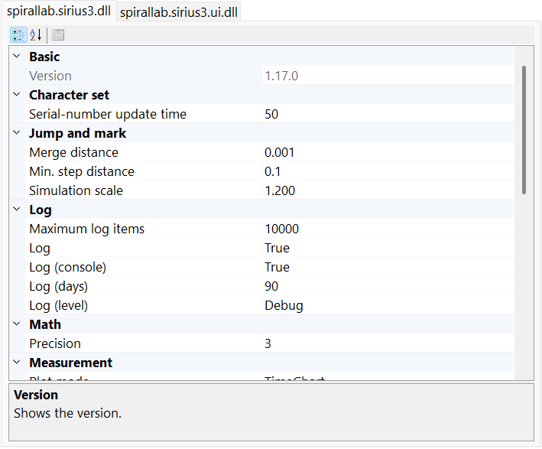
Figure 36.1 About → Config: inspect Core and UI settings, then match the property to its reference entry.
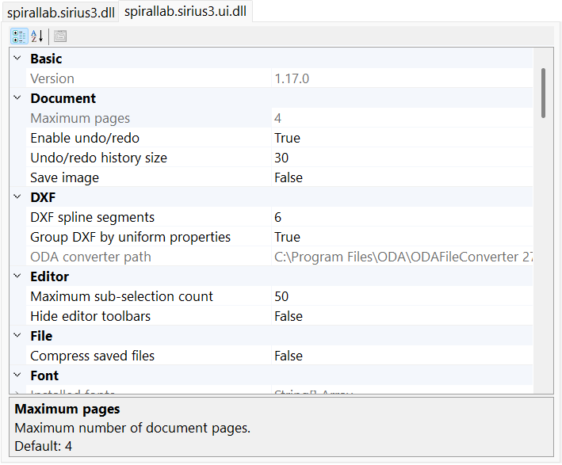
Figure 36.2 About → Config: inspect Core and UI settings, then match the property to its reference entry.
This screen does not automatically save values to config.ini or restore them after restart. Config settings are separate from device INI sections, EntityPen and document Undo/Redo. WPFTheme is intentionally absent from the WinForms view; use the appropriate WPF setting surface.

36.2 SpiralLab.Sirius3.Config logging and diagnostics
Core.Initialize arguments set MinimumLogLevel and LogMaxArchiveDays. Set logging paths and IsLogToConsole before initialization; changing them afterward does not rebuild the active logger. A caller-supplied ILogger owns its own logging policy.
Property | Default | Role and effect
Assembly​Version | loaded assembly | Loaded assembly version, formatted as major.minor.build; diagnostic value, not a selectable version.
Max​Log​Items | 10_​000 | Maximum messages shown in the WinForms log control.
Is​Log​Enable | true | Compatibility switch; the current built-in logger does not read it. Configure the logging level through Core.Initialize.
Is​Log​To​Console | true | Enables the built-in console target when logging is initialized; file logging is separate.
Log​Max​Archive​Days | 90 | Retention days for the built-in logger. Core.Initialize overwrites this value with its maxLogArchiveDays argument.
Minimum​Log​Level | null → "Debug" | Null before initialization; Core.Initialize supplies the level. The public API exposes a getter only.

36.3 SpiralLab.Sirius3.Config paths and external tools
Derived executable paths are initialized separately. Changing CorrectionPath does not recompute CorreXionProProgramPath, StretchCorreXion5ProgramPath or CorrectionFileCoverterProgramPath. SyncAxisViewerProgramPath is based directly on BaseDirectory. Set related paths explicitly and deploy the matching tools.
Property | Default | Role and effect
Log​Path | Base​Directory\​siriuslogs | Base directory for log files. Used for runtime output or the corresponding file dialog; provision the folder and access rights.
Measurement​Path | Base​Directory\​measurement | Base directory for measurement output. Used for runtime output or the corresponding file dialog; provision the folder and access rights.
Correction​Path | Base​Directory\​correction | Base directory for scanner correction files. Used for runtime output or the corresponding file dialog; provision the folder and access rights.
Corre​Xion​Pro​Program​Path | Correction​Path\​Corre​Xion​Pro.​exe | Full path passed when launching CorreXionPro.exe. Requires a separately deployed, compatible tool; assigning a path does not install it.
Stretch​Corre​Xion5​Program​Path | Correction​Path\​stretchcorre​Xion5.​exe | Full path passed when launching stretchcorreXion5.exe. Requires a separately deployed, compatible tool; assigning a path does not install it.
Correction​File​Coverter​Program​Path | Correction​Path\​Correction​File​Converter.​exe | Full path passed when launching CorrectionFileConverter.exe. Requires a separately deployed, compatible tool; assigning a path does not install it.
Power​Map​Path | Base​Directory\​powermap | Base directory for power-map files. Used for runtime output or the corresponding file dialog; provision the folder and access rights.
Sync​Axis​Path | Base​Directory\​syncaxis | Base directory for syncAXIS runtime files. Used for runtime output or the corresponding file dialog; provision the folder and access rights.
Sync​Axis​Viewer​Program​Path | Base​Directory\​syncaxis\​Tools\​sync​AXIS_​Viewer\​sync​AXIS_​Viewer.​exe | Full path passed when launching syncAXIS_Viewer.exe. Requires a separately deployed, compatible tool; assigning a path does not install it.
Sync​Axis​Simulate​File​Path | Base​Directory\​siriuslogs | Base directory for syncAXIS simulation output. Used for runtime output or the corresponding file dialog; provision the folder and access rights.
Recipe​Path | Base​Directory\​recipe | Base directory for native recipe files. Used for runtime output or the corresponding file dialog; provision the folder and access rights.
Script​Path | Base​Directory\​script | Base directory for script files. Used for runtime output or the corresponding file dialog; provision the folder and access rights.

36.4 SpiralLab.Sirius3.Config geometry and measurement
Property | Default | Role and effect
Decimal​Precision | 3 | Decimal places used by numeric displays and formatters. It does not define RTC position resolution or machining accuracy.
Merge​Distance | 0.​001 | Distance tolerance for collapsing redundant scanner moves. Larger tolerances can remove intended very short motion; distinct from import endpoint joining.
Min​Step​Distance | 0.​1 | Step length used by curve/path subdivision. Smaller values increase generated points and list size; regenerate affected geometry before using it.
Virtual​Jump​And​Mark​Acc​Scale | 1.​2 | Acceleration model factor used by the virtual scanner. Changes simulated timing, not the physical controller acceleration.
Character​Set​Max​Serial​No​Update​Time | 50 | Sets how often the RTC character-set maximum serial number is checked. Related: polling runs only while SerialMaxNo is greater than 0. Caution: the value must be greater than 0. Unit: msec
Measurement​Plot​Mode | Time​Chart | Selects the diagnostic plot layout for measurement results. It changes visualization rather than acquired samples.
Measurement​Laser​On​Factor | 1 | Scales converted LASER ON measurement-channel values. Related: applies only to MeasurementChannels.LaserOn after raw conversion. Unit: factor

36.5 SpiralLab.Sirius3.Config power mapping and compensation
Property | Default | Role and effect
Power​Map​Interpolation​Mode | Linear | Selects Linear or shape-preserving Pchip interpolation for power compensation and WinForms/WPF charts. Changing this value rebuilds calibration curves; Linear is the compatibility default.
Power​Map​Pre​Heat​Time​Ms | 10 * 1000 | Sets the wait before the first power reading after the laser turns on. Procedure: the first point uses this value; later points use PowerMapHoldTimeMs. Related: mapping, verification, and compensation. Unit: msec Range: 1000–50100 msec
Power​Map​Hold​Time​Ms | 5 * 1000 | Sets the stabilization wait used after preheating is complete. Procedure: laser on → wait → measure → laser off. Related: PowerMapPreHeatTimeMs is used for the first point. Unit: msec Range: 1000–50100 msec
Power​Map​In​Range​Threshold | 5.​0 | Sets the allowed difference between target and measured power. Procedure: verification or compensation succeeds when the absolute difference is within this percentage. Related: PowerMapOutOfRangeThreshold and PowerMapCompensateRetryCounts. Unit: % Range: 0–20 % Mapping also uses this percentage to check the deviation between raw input X and measured Y before storing a point.
Power​Map​Out​Of​Range​Threshold | 20.​0 | Sets the difference at which automatic compensation stops as out of range. Caution: a difference beyond this value is not adaptively retried. Related: PowerMapInRangeThreshold and PowerMapCompensateRetryCounts. Unit: % Range: 0–50 %
Power​Map​Compensate​Retry​Counts | 2 | Sets the maximum adaptive updates attempted when power is outside the in-range threshold but not beyond the out-of-range threshold. Related: PowerMapInRangeThreshold and PowerMapOutOfRangeThreshold. Range: 0–5

36.6 SpiralLab.Sirius3.UI.Config documents and serialization
Set history policy before document creation. A smaller UnReDoSize is enforced as new actions enter the history; 0 removes the cap. Compression affects subsequent saves, not the live document geometry. Public getters with internal setters can still expose mutable collections.
Property | Default | Role and effect
Max​Pages | 4 | Maximum number of document pages.
Is​Un​Re​Do​Enable | true | Enables document undo and redo. Related: UnReDoSize limits the retained history. Caution: disabling it prevents new user edits from being recorded for undo.
Un​Re​Do​Size | 30 | Sets the maximum number of undo and redo actions retained. Related: used only while IsUnReDoEnable is on. Caution: 0 is unlimited and can increase memory use.
Is​File​Save​With​Image | false | Release editor saves do not use this compatibility property to write a snapshot sidecar. Use the public view snapshot workflow explicitly.
Assembly​Version | loaded assembly | Loaded assembly version, formatted as major.minor.build; diagnostic value, not a selectable version.
Is​Compressed​File​Format | true (Release); false (Debug) | Uses the compressed file format when saving.
Json​External​Convertes | empty list | Public getter exposes a mutable, initially empty converter list; add trusted custom JSON converters before document loading. The list setter is internal.

36.7 SpiralLab.Sirius3.UI.Config trees and editor policies
Property | Default | Role and effect
Max​Degree​Of​Parallelism | max(1, floor(Processor​Count × 0.​5)) | Positive worker limit for supported parallel geometry, hatching and parsing operations. Lower it when sharing CPU with machine supervision; no UI thread limit is implied.
Max​Tree​Node​Items | 10_​000 | Child count above which expanding a WinForms tree asks for confirmation. It is not a document entity limit.
Treeview​Font​Size | 8.​25 pt | Positive finite point size for WinForms trees. Set on the UI thread; existing trees refresh and apply their own DPI scale.
Treeview​Node​Default​Font | Segoe UI, 8.​25 pt, Regular | Borrowed Regular style template. Each tree owns sized copies; do not dispose the shared template.
Treeview​Node​Bold​Font | Segoe UI, 8.​25 pt, Bold | Borrowed Bold style template. Each tree owns sized copies; do not dispose the shared template.
Treeview​Node​Strike​Out​Font | Segoe UI, 8.​25 pt, Strikeout | Borrowed Strikeout style template. Each tree owns sized copies; do not dispose the shared template.
Treeview​Node​Bold​And​Strike​Out​Font | Segoe UI, 8.​25 pt, Bold | Strikeout | Borrowed Bold | Strikeout style template. Each tree owns sized copies; do not dispose the shared template.
Max​Sub​Selection​Items | 50 | Maximum number of entities that can be sub-selected.
Is​Hide​Editor​Tool​Bars | false | Hides the editor toolbars while editing is allowed.
WPFTheme | Material | Sirius3 WPF uses the Material theme only. Fixed value: Material

36.8 SpiralLab.Sirius3.UI.Config pens and wafer colors
Set pen palettes before new-document pen collections are built. Existing pens keep their parameters. LayerPenColors returns the EntityPenColors array. Controller-resolution conversion depends on the assigned scanner; it is not a universal precision setting.
Property | Default | Role and effect
Entity​Pen​Colors | White, Yellow, Orange, Red, Cyan, Lime, Magenta, Brown, Purple, Blue | Colors available for entity pens and marking assignments.
Layer​Pen​Colors | Entity​Pen​Colors | Colors used for layer pens.
Is​Convert​To​Controller​Resolution | false | Converts pen values to controller-dependent low-level values.
Wafer​Die​Color | Orange.​To​Vector3() | RGB display color for the wafer die; components are normalized 0–1. This does not select a marking pen.
Wafer​Outline​Color | new DVec3(0.​99, 0.​5, 0.​1) | RGB display color for the wafer outline; components are normalized 0–1. This does not select a marking pen.
Wafer​Edge​Color | new DVec3(0.​95, 0.​15, 0.​1f) | RGB display color for the wafer edge; components are normalized 0–1. This does not select a marking pen.

36.9 SpiralLab.Sirius3.UI.Config selection camera and simulation
Property | Default | Role and effect
Selected​Line​Width | 2 | Line width used to emphasize selected geometry; affects display only, not machining width.
Drag​Mouse​Pixel | 5 | Logical 96-DPI pixels for the mouse drag threshold. The view applies DPI scaling; not millimeters.
Ray​Hit​Test​Pixel​Size | 4 | Logical 96-DPI pixels for the ray picking tolerance. The view applies DPI scaling; not millimeters.
Frustum​Hit​Test​Pixel​Size | 1 | Logical 96-DPI pixels for the selection rectangle expansion. The view applies DPI scaling; not millimeters.
Simulation​Marker​Pixel​Size | 15 px; min 3 | Target-marker diameter for simulation and vertex preview (pixels).
Simulation​Beam​Pixel​Width | 20 px; min 3 | Laser-beam source diameter in simulation (pixels).
Simulation​Debris​Enabled | true | Shows short-lived debris particles around the laser simulation target.
Simulation​Debris​Max​Particles | 16; range 1–128 | Maximum number of debris particles rendered at once.
Simulation​Debris​Spread​Pixel​Radius | 10 px; min 1 | Approximate debris spread radius on screen (pixels).
Simulation​Debris​Lifetime​Milliseconds | 1500 ms; range 100–10000 | Average time for debris particles to fade out (ms).
Camera​Zoom​Fit​Steps | 30 | Number of interpolation steps for ZoomFit camera transitions. More steps produce a longer smooth transition; not a geometry tolerance.

36.10 SpiralLab.Sirius3.UI.Config text and font sources
Font defaults are sampled when entities are created or font data is loaded. Keep required files in SiriusFontPath. Changing a path/sample does not edit existing FontName values or guarantee cached glyph regeneration; reload the font or recreate/regenerate the affected text through the supported workflow.
Property | Default | Role and effect
Sirius​Font​Path | Base​Directory\​siriusfonts | Folder containing Sirius font files (.cxf, .lff, .fnt, .dot).
Installed​Font​Names | system-dependent | Installed system font names, cached at first access. There is no public refresh method or public setter.
Font​Default | "Segoe UI" | Default font used to create text entities.
Sirius​Font​Default | "romans2.​cxf" | Default font used to create Sirius-text entities.
Sirius​Font​Capital​Sample | "@567890​ABHWMZQ0()" | Sets the Sirius Text sample used to derive capital height and Fixed character width. Configure it before loading the Sirius font.

36.11 SpiralLab.Sirius3.UI.Config fixed width font metrics
Each string is a measurement sample for its writing system, not machining text. Metrics influence Fixed cell width and fallback line height in the text families. Keep representative wide, tall and descending glyphs; test actual installed fonts before changing a sample.
Property | Default | Role and effect
Fixed​Text​Hangul​Fallback​Sample | "대한민국스파이럴랩옳닳흙깊" | Hangul sample used to derive Fixed character width and fallback line metrics.
Fixed​Text​Chinese​Fallback​Sample | "中文汉字國語測試永高低上下左右鼎鬱龘" | Chinese Han-character sample used to derive Fixed character width and fallback line metrics.
Fixed​Text​Japanese​Fallback​Sample | "あいうえおがぎぐげござじずぜぞぱぴぷぺぽゃゅょっアイウエオガギグゲゴパピプペポ日本語漢字" | Japanese Kana and Kanji sample used to derive Fixed character width and fallback line metrics.
Fixed​Text​Latin​Fallback​Sample | "HMQXWgyjpq" | Latin sample used to derive Fixed character width and fallback line metrics.
Fixed​Text​Cyrillic​Fallback​Sample | "ШЖФфрудцщ" | Cyrillic sample used to derive Fixed character width and fallback line metrics.
Fixed​Text​Arabic​Fallback​Sample | "ملا ينجحقخق" | Arabic sample used to derive Fixed character width and fallback line metrics.
Fixed​Text​Devanagari​Fallback​Sample | "कृगुहृक्षज्ञ" | Devanagari sample used to derive Fixed character width and fallback line metrics.
Fixed​Text​Bengali​Fallback​Sample | "কৃগুক্ষজ্ঞ" | Bengali sample used to derive Fixed character width and fallback line metrics.
Fixed​Text​Greek​Fallback​Sample | "ΗΜΩβγμρφψξ" | Greek sample used to derive Fixed character width and fallback line metrics.
Fixed​Text​Hebrew​Fallback​Sample | "אבגךםןףץ" | Hebrew sample used to derive Fixed character width and fallback line metrics.
Fixed​Text​Thai​Fallback​Sample | "ญฐฎฏฤฟฬ" | Thai sample used to derive Fixed character width and fallback line metrics.
Fixed​Text​Tamil​Fallback​Sample | "ழளறஞ" | Tamil sample used to derive Fixed character width and fallback line metrics.
Fixed​Text​Telugu​Fallback​Sample | "ళక్షజ్ఞ" | Telugu sample used to derive Fixed character width and fallback line metrics.

36.12 SpiralLab.Sirius3.UI.Config image text rendering
Rasterization colors and smoothing can alter pixel weights used for marking. Rebuild the affected image text and verify its MajorColor and machining preview. ImageTextFillBrush initially borrows Brushes.White; do not dispose shared system brushes.
Property | Default | Role and effect
Image​Text​Clear​Color | Black | Background color used to create image-text entities.
Image​Text​Fill​Brush | White | Fill brush used to create image-text entities.
Image​Text​Pen​Color | White | Pen color used to create image-text entities.
Image​Text​Rendering​Hint | Single​Bit​Per​Pixel | Text rendering hint used for image-text entities.
Image​Text​Smoothing​Mode | None | Smoothing mode used for image-text entities.
Image​Text​Pixel​Offset​Mode | High​Quality | Pixel-offset mode used for image-text entities.

36.13 SpiralLab.Sirius3.UI.Config file import
Import settings are sampled for a new import and do not rewrite existing geometry. ImportMergeDistance is an endpoint-joining tolerance; Core MergeDistance governs scanner command merging. G-code F/S/T values remain source metadata and do not program laser power or live motion.
Property | Default | Role and effect
Import​Merge​Distance | 0.​001 (source units or mm) | Maximum endpoint distance used to join DXF, DWG, HPGL, and PLT paths. DXF/DWG use source units; HPGL/PLT use millimeters.
Is​Import​Color​Preserved | false | Keeps source colors for DXF, DWG, Gerber, and SVG. When off, each color is replaced by the nearest entity-pen color.
GCode​Import​Dialect | Auto | Selects source parsing rules. Auto detects Marlin headers and otherwise uses CNC. Laser retains M3/M4 paths with positive S.
Is​GCode​Skip​Optional​Blocks | false | Skips source blocks beginning with '/'. Default: False.
GCode​Import​Helix​Tolerance | 0.​001 | Sets the maximum helical-arc chord error in mm. Range: 0.000001-10 mm. Default: 0.001 mm.
Is​Svg​Import​Hatch​Enabled | false | Adds a line hatch when importing SVG, using SvgImportHatchInterval. Existing documents are unaffected. Default: False.
Svg​Import​Hatch​Interval | 0.​1 | Sets the SVG import line-hatch interval in mm when automatic hatching is enabled. Boundary exclusion is half the interval. Minimum: 0.001 mm. Default: 0.1 mm.
Dxf​Spline​To​Polygonal​Counts | 6 | Compatibility value without a current built-in consumer. Assigning it does not change the shipped importer or jog dialog; custom hosts may read it explicitly.
Is​Dxf​With​Uniform​Group | true | Creates or parses DXF entities in uniform-property subgroups.
ODAConverter​Path | detected path or null | Path to the Open Design Alliance file converter.
Grid​Cloud​Interval | 0.​5 | Interval used to create a mesh grid cloud.
Is​Gerber​Precombine​Polygons | false | Precombines Gerber polygons before entities are created.
Is​Gerber​Tessellation | false | Tessellates outlined areas while importing Gerber.
Is​Gerber​With​Uniform​Group | true | Creates or parses Gerber entities in uniform-property subgroups.

36.14 SpiralLab.Sirius3.UI.Config keyboard and grip increments
Editor focus and TreeView focus route arrow keys differently; see the shortcut chapter. Use positive finite movement and angle increments. Grip constraints use these steps in the editor; MCP coordinates remain explicit local coordinates. Marker Preview/Start/Stop/Reset operate the registered marker; Preview can produce real device motion.
Property | Default | Role and effect
Keyboard​Help​Message | localized generated text | Localized keyboard help derived from current shortcut settings; read-only and generated for display.
Keyboard​Transit​XYCtrl | 1 | Grid spacing for CTRL + arrow keys and movement/size grips in both editors. Unit: mm
Keyboard​Transit​XYCtrl​Alt | 0.​1 | Grid spacing for CTRL + ALT + arrow keys and movement/size grips in both editors. Unit: mm
Keyboard​Transit​XYCtrl​Alt​Shift | 0.​01 | Grid spacing for CTRL + ALT + SHIFT + arrow keys and movement/size grips in both editors. Unit: mm
Keyboard​Rotate​Ctrl | 90 | Angular grid spacing for CTRL + [ or ] and rotation grips in both editors. Unit: degree
Keyboard​Rotate​Ctrl​Alt | 10 | Angular grid spacing for CTRL + ALT + [ or ] and rotation grips in both editors. Unit: degree
Keyboard​Rotate​Ctrl​Alt​Shift | 1 | Angular grid spacing for CTRL + ALT + SHIFT + [ or ] and rotation grips in both editors. Unit: degree
Keyboard​Simulation​Start | F1 | Shortcut used to start simulation.
Keyboard​Show​Script | F2 | Shortcut used to show the script window.
Keyboard​Marker​Preview | F4 | Shortcut used to preview marking.
Keyboard​Marker​Start | F5 | Shortcut used to start marking the current page.
Is​Show​Message​Box​When​Marker​Start | true | Shows a confirmation message before marking starts.
Keyboard​Marker​Stop | F6 | Shortcut used to stop marking.
Keyboard​Marker​Reset | F8 | Shortcut used to reset the marker.

36.15 SpiralLab.Sirius3.UI.Config preview and device operations
Property | Default | Role and effect
Mark​Preview​Repeats | 50 | Number of repeats used for mark preview.
Mark​Preview​Speed | 1000 | Speed used for mark preview (mm/s).
Is​Mark​Arcs​Into​Lines | true | Chooses how EntityArc is written to the scanner list. Procedure: True uses ListMarkTo line segments; False uses ListArcTo. Caution: use False only with a compatible 3D scanner arc implementation.
Mo​FExt​Mc​BSPFrequency | 8_​000_​000 | McBSP frequency used by the MoF extension (Hz).
Stepper​Reference​Run​Time​Out | 30 | Timeout for a stepper reference run (seconds).
Scanner​Jog​Distance | 5 | Compatibility value without a current built-in consumer. Assigning it does not change the shipped importer or jog dialog; custom hosts may read it explicitly.

36.16 SpiralLab.Sirius3.UI.Config ZPL rendering
BinaryKits renders locally. Labelary sends ZPL to the configured HTTP service and requires network access; choose it deliberately for the data involved. Font substitutions affect raster output. Re-render affected EntityImageZPL objects after configuration changes.
Property | Default | Role and effect
ZPLService | Binary​Kits | Service used to render ZPL.
ZPLBinary​Kits​Default​Font | "Arial Narrow;Arial;Helvetica" | BinaryKits font mapping for font identifier 0.
ZPLBinary​Kits​Fonts | 21 keys; case-insensitive | Mutable, case-insensitive dictionary with 21 font identifiers. K/1 and KOREAN/SIMSUN aliases use ordered CJK candidates; A–H and P–V use monospace candidates. First installed candidate wins.
ZPLLabelary​APIURIFormat | "http:/​/​api.​labelary.​com/​v1/​printers/​{0}dpmm/​labels/​{1}x{2}/​{3}/​" | URI format used for the Labelary ZPL web service.

36.17 SpiralLab.Sirius3.UI.Config Remote protocol text
These strings belong to the legacy Remote text protocol, not MCP JSON-RPC. Keep host and client delimiters/replies aligned. Ready/NotReady/Busy/Error are event text for protocols that publish them; setting a string does not change device readiness.
Property | Default | Role and effect
Remote​Separator | "|" | Field separator used by remote communication.
Remote​Terminator | ";" | Message terminator used by remote communication.
Remote​Ok | "OK" | Success response used by remote communication.
Remote​NG | "NG" | Failure response used by remote communication.
Remote​Ready | "Ready" | Ready response used by remote communication.
Remote​Not​Ready | "Not​Ready" | Not-ready response used by remote communication.
Remote​Busy | "Busy" | Busy event text used by remote communication.
Remote​Error | "Error" | Error event text used by remote communication.

36.18 Configuration recipes
Listing 36.1 Core paths before initialization
using System;
using System.IO;
using SiriusConfig = SpiralLab.Sirius3.Config;

public static class CorePaths
{
// Call before Core.Initialize("Information", 30).
public static void Configure()
{
string root = AppDomain.CurrentDomain.BaseDirectory;
SiriusConfig.LogPath = Path.Combine(root, "siriuslogs");
SiriusConfig.CorrectionPath = Path.Combine(root, "correction");
SiriusConfig.CorreXionProProgramPath = Path.Combine(
SiriusConfig.CorrectionPath, "CorreXionPro.exe");
SiriusConfig.PowerMapPath = Path.Combine(root, "powermap");
}
}
Listing 36.2 UI policies before document creation
using System;
using EditorConfig = SpiralLab.Sirius3.UI.Config;

public static class UiDefaults
{
// Call after Core.Initialize, before creating documents/controls.
public static void Configure()
{
EditorConfig.UnReDoSize = 100;
EditorConfig.MaxDegreeOfParallelism = Math.Max(
1, Environment.ProcessorCount / 2);
EditorConfig.ImportMergeDistance = 0.001;
EditorConfig.IsImportColorPreserved = false;
EditorConfig.KeyboardTransitXYCtrlAlt = 0.1;
}
}
Listing 36.3 Power map policy without executing a job
using SpiralLab.Sirius3.PowerMap;
using SiriusConfig = SpiralLab.Sirius3.Config;

public static class PowerMapDefaults
{
// Change only while every affected marker is idle.
public static void Configure()
{
SiriusConfig.PowerMapInterpolationMode = PowerMapCurveModes.Pchip;
SiriusConfig.PowerMapPreHeatTimeMs = 10_000;
SiriusConfig.PowerMapHoldTimeMs = 5_000;
SiriusConfig.PowerMapInRangeThreshold = 5.0;
SiriusConfig.PowerMapOutOfRangeThreshold = 20.0;
}
}

37 Release history
Recent changes are reproduced from the matching public HISTORY file. The earlier-version index gives the first recorded change for each release; consult the complete HISTORY file for all details. Dates and release labels follow that language’s source.
HISTORY.md

37.1 v1.17.0 (2026.10.26)
• added) IGrippable
• Interactive entity creation and editing of vertices, position, size and rotation
• Snapped movement using CTRL, Alt and Shift key combinations
• added) FontEditorControl
• Create and edit font files for EntitySiriusText
• added) EntityImagePDF
• Support for importing .PDF files - 'IDocument.ActImport'
• fixed) EntityMixedGroup, EntityUniformGroup, EntityGerber
• Improved rendering performance when editing child entities in composite entities
• fixed) MCPServerOptions.AllowedFileRoots
• MCP file access allows all paths accessible to the host process by default

37.2 v1.16.1 (2026.10.12)
• updated) Updated the SCANLAB RTC6 dependency to Software Package 1.25.1
• added) Support for importing .3MF files : 'IDocument.ActImport'
• added) Support for importing .SVG files : 'IDocument.ActImport'
• added) IPowerMap supports selecting existing linear interpolation or new nonlinear curve interpolation (PCHIP) : 'Config.PowerMapInterpolationMode'
• added) IClippable supports splitting large-area data into rectangular regions (clipping) : 'IDocument.ActClip'
• fixed) Corrected ListWriteMaskExtDO16If to pass the masks in the correct order

37.3 v1.15.0 (2026.10.1)
• added) WinForms HiDPI support
• fixed) Asynchronous resource disposal support for IRemote and IMCPServer
• added) Texture rendering support for 3D meshes

37.4 Earlier releases
Version and date | First recorded change
v1.14.5 (2026.9.24) | added) MCP (Model Context Protocol) support
v1.13.0 (2026.8.31) | updated) Updated the SCANLAB RTC6 dependency to Software Package 1.25.0, selected firmware automatically for the board revision during initialization, and exposed RtcRevision values 0 for Revision 1 and 1 for Revision 2
v1.12.2 (2026.8.18) | added) Added the EntityCircularSiriusText entity
v1.12.1 (2026.8.16) | added) EntitySiriusText.IsAutoKerning now supports automatic kerning of adjacent glyphs from cached font outlines in Variable character-spacing mode
v1.11.14 (2026.8.7) | fixed) OpenTK 3 and 4 now read and restore polygon modes safely for their context type, preventing Release-mode memory access failures, disappearing bound boxes, and an incorrect OpenTK 3 debug assertion
v1.11.11 (2026.8.5) | fixed) RTC6 now reads status and analog I/O through the correct controller API, detects Ethernet connection errors correctly, and shuts down without racing its status timers
v1.11.10 (2026.8.1) | fixed) Barcodes now stay within the requested size, and their machining paths, supplemental codes, hatching, and dot-cell simulation line up correctly
v1.11.0 (2026.7.27) | added) Added the EntityStitchedImage object
v1.10.14 (2026.7.10) | added) TextConverters.Link
v1.10.11 (2026.7.1) | refactoring) Text
v1.10.10 (2026.6.22) | added: Support for fixing the full width of text objects
v1.9.0 (2026.6.1) | added) Support for importing G-code
v1.8.6 (2026.5.14) | fixed) Hatch
v1.8.5 (2026.5.8) | added) Undo and Redo support
v1.8.1 (2026.4.22) | added) Remote
v1.7.1 (2026.4.16) | updated) RTC6 v1.24.0 package
v1.6.1 (2026.4.9) | added) ViewerControl
v1.5.4 (2026.4.2) | Fixed) Hotfix
v1.5.3 (2026.3.31) | fixed) IDocument
v1.5.2 (2026.3.27) | added) Stepper motor control support
v1.4.1 (2026.3.10) | added) documentation provided via web server
v1.4.0 (2026.3.3) | added) .NET 9.0-Windows, .NET 10.0-Windows development environments
v1.3.2 (2026.2.20) | fixed) Support for Extended Mode in Automatic Laser Control
v1.3.1 (2026.2.9) | added) IRtcSCANAhead interface
v1.3.0 (2026.2.5) | added) EntityPolyline2D and EntityPolyline3D
v1.2.7 (2026.1.26) | added) Added Variable Delays to EntityLayerPen
v1.2.6 (2026.1.20) | added) Ellipse entity
v1.2.5 (2026.1.15) | added) ClipHelper to intersect
v1.2.4 (2026.1.7) | added) shortcuts
v1.0.1 (2025.12.22) | added) .chm documentation files
v0.9.3 (2025.12.5) | added) zoom to fit
v0.9.2 (2025.11.25) | added) convert to block and block insert at menu
v0.9.1 (2025.11.18) | added) include 'gnuplot' program at Spirallab.Sirius3.Dependencies package
v0.8.2 (2025.11.11) | fixed) fail to parse HPGL format
v0.8.0 (2025.11.7) | Developer preview version
v0.1 (2025.03.06) | Initial release

For net481, DVec3 means OpenTK.Vector3d; modern Windows targets use OpenTK.Mathematics.Vector3d. Keep the package and vector branch consistent rather than mixing the two assemblies.
The four library target frameworks and the three public-demo target frameworks serve different build baselines. Installing a newer SDK alone does not add support for that target to an older IDE. Keep the net481 application configuration and manifest alongside its EXE.
The example uses a commissioned RTC6, LaserFactory.CreateVirtual with Analog power control and MarkerFactory.CreateRtc. Set the board index, K-factor (bits/mm), correction path, laser mode, polarity, power range and analog channel/voltage limits to the installation. LaserVirtual connected to a real RTC can drive real outputs. Creation and initialization do not start marking.
WPF uses device-independent units (1/96 inch) and its own layout system; do not apply WinForms AutoScaleMode or ApplicationHighDpiMode to a WPF Window. Configure DPI awareness in the executable host before creating windows. Construct and access Sirius3 WPF controls on the Dispatcher thread. Unloaded pauses drawing/timers but does not dispose the control or assigned devices. In Window.Closing cancel the first request, await editor.DisposeDevices(), dispose the control and then its document, allow closure and call Core.Cleanup() from the application lifetime owner. See doc/WPF.md and demos/wpf_editor_ui.
An entity Id is a runtime identity and is not a durable recipe key. Name is a display/lookup name and need not be globally unique. Use validated application data when a stable external recipe identifier is required.
Undo retains state and sometimes removed resources so it can restore the edit exactly. Neither an out parameter nor absence from the visible tree transfers disposal ownership to the application.
Regeneration failure is a real operation failure. Check ActRegen/Regen results and do not mark stale generated geometry after a failed rebuild.
Do not transform a world pointer directly into a grip value by guesswork. The session expects original local coordinates; the normal editor performs the camera/parent/model conversion for pointer input.
Font-file ownership, path deployment and converter tools are separate from the document’s text entity. A document containing a font reference still needs the appropriate font asset on the destination system.
The diagnostic capture also shows Result. This read-only diagnostic row is hidden in Release; it is not a process setting.
FontEditorControl is included in the UI package for Debug and Release. FontEditorForm owns its Editor control. Do not dispose it while an asynchronous open/save operation is still running. Metric changes can affect the whole font, so verify text layout and a copy of the machining recipe after saving.
The UI may quantize entered timing to the registered controller’s time base when IsConvertToControllerResolution is enabled. The displayed post-edit value, controller capability and measured waveform matter more than the originally typed decimal.
Use these callbacks with MarkerRtc or MarkerSyncAxis. MarkerRtcFast is intended for one layer and one large RTC list buffer and is not an interchangeable choice for per-layer motion barriers. An async-void callback or a callback that only starts a move does not wait for completion. The host motion function must include bounded completion/fault/cancellation handling and the machine’s required interlock logic.
Translate.Z is a coordinate displacement for the supported processing path. It is not an implicit request to move a physical Z stage. Host sequence, stage readiness and focus positioning remain explicit.
PCHIP preserves the measured curve’s local shape. It does not establish which branch is physically suitable when a laser has hysteresis or foldback. Re-measure before changing the interpolation mode used by a commissioned recipe.
The figures are native viewer captures of an archived MarkerRtc acquisition, not a fresh hardware test. RtcVirtual can display and prepare the control entities but does not return a captured measurement buffer. Finite hardware buffers and sampling frequency limit recording duration; MarkerRtc.MaxMeasurementTime is an estimate for the current session, not a substitute for checking channel/board limits. Raw data should not be interpreted using converted-coordinate axis labels.
Polling reports observed state transitions, not every electrical pulse. A 100 ms interval can miss shorter pulses; debounce and pulse capture belong to the chosen hardware/host design. Stop the timer and detach handlers before device disposal. A display label such as DoorClosed does not implement a safety interlock.
The 30-minute period starts when the library enters evaluation mode, including time spent in its notice dialog. It is shared by the process, not a new period per option. On expiry the process terminates; save recipes and finish evaluation in advance.
The 30-minute period starts when the library enters evaluation mode, including time spent in its notice dialog. It is shared by the process, not a new period per option. On expiry the process terminates; save recipes and finish evaluation in advance.
The 30-minute period starts when the library enters evaluation mode, including time spent in its notice dialog. It is shared by the process, not a new period per option. On expiry the process terminates; save recipes and finish evaluation in advance.
The 30-minute period starts when the library enters evaluation mode, including time spent in its notice dialog. It is shared by the process, not a new period per option. On expiry the process terminates; save recipes and finish evaluation in advance.
BaseDirectory is the application runtime folder, not the C# project folder or the current working directory. Its value depends on the host. Use absolute paths built with Path.Combine when deploying a custom application.

