Firebase Options :

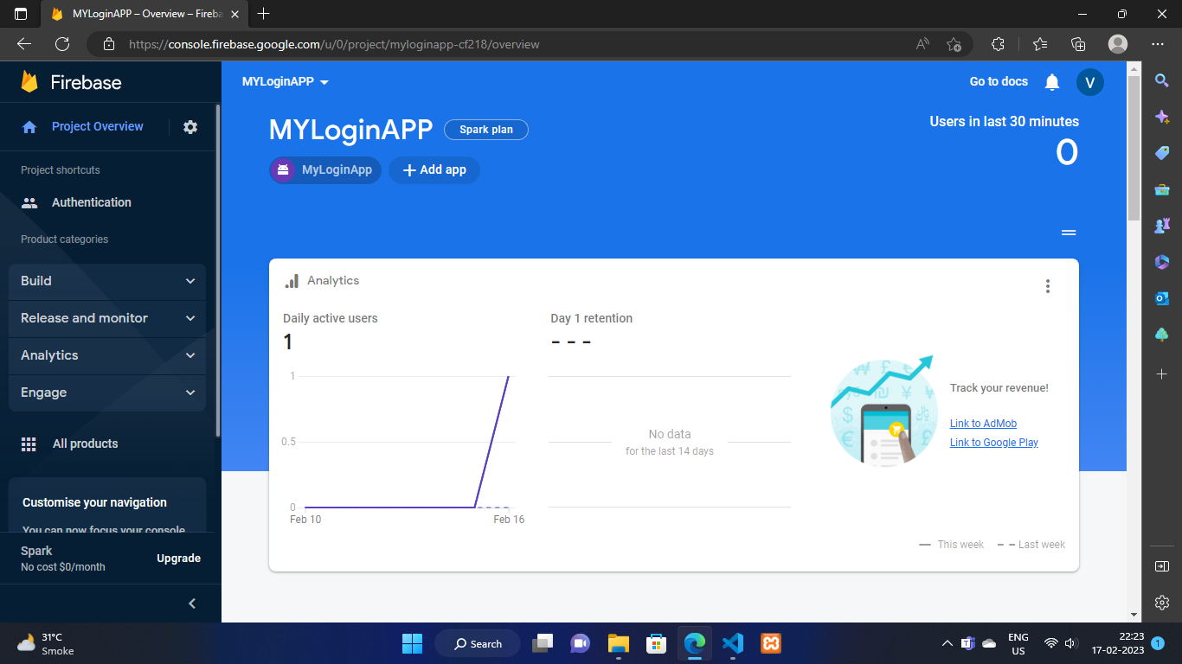

1. Go to firebase dashboard and click on android logo you will see a widget as shown below

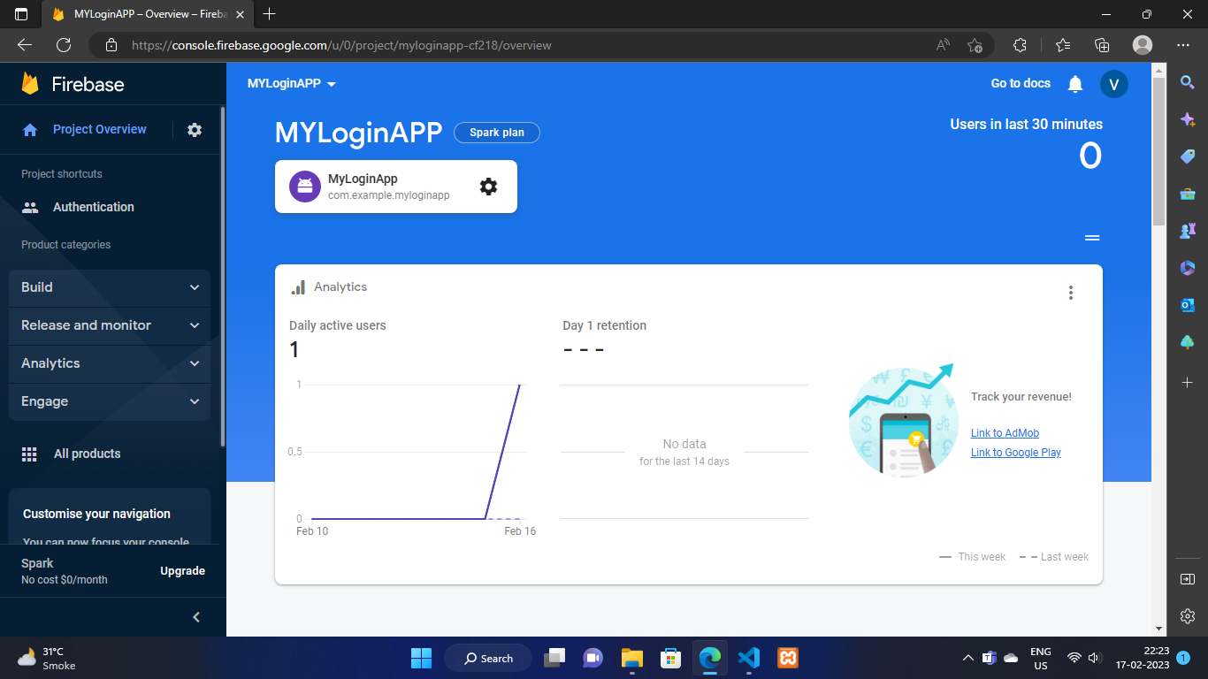

1. Now click on settings icon

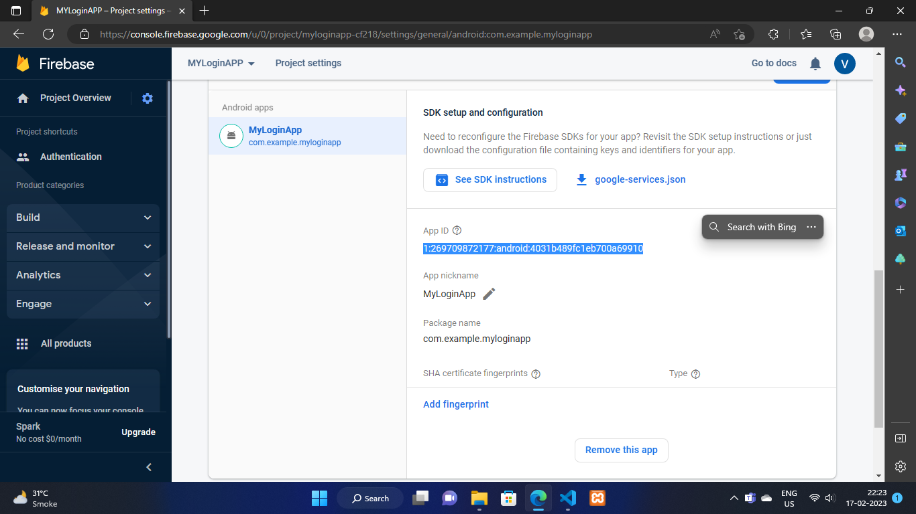

1. Scroll down and locate highlighted part it will be our app id

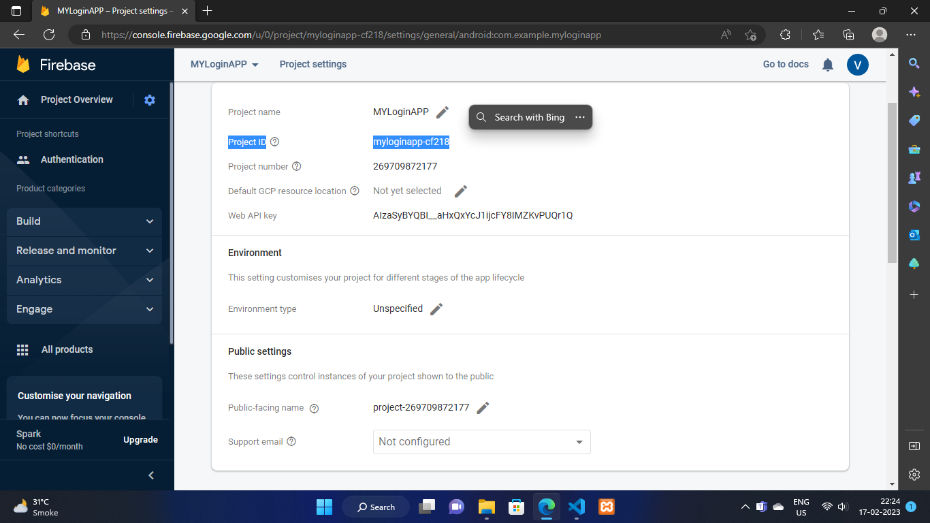

D. The thing highlighted above is our project id

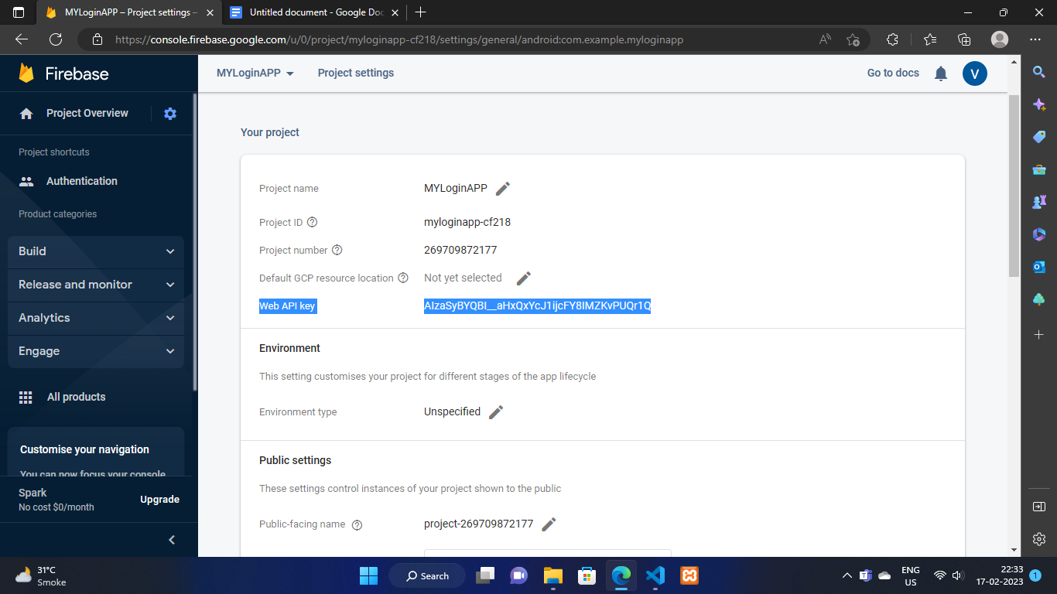

E. The highlighted part is our apikey

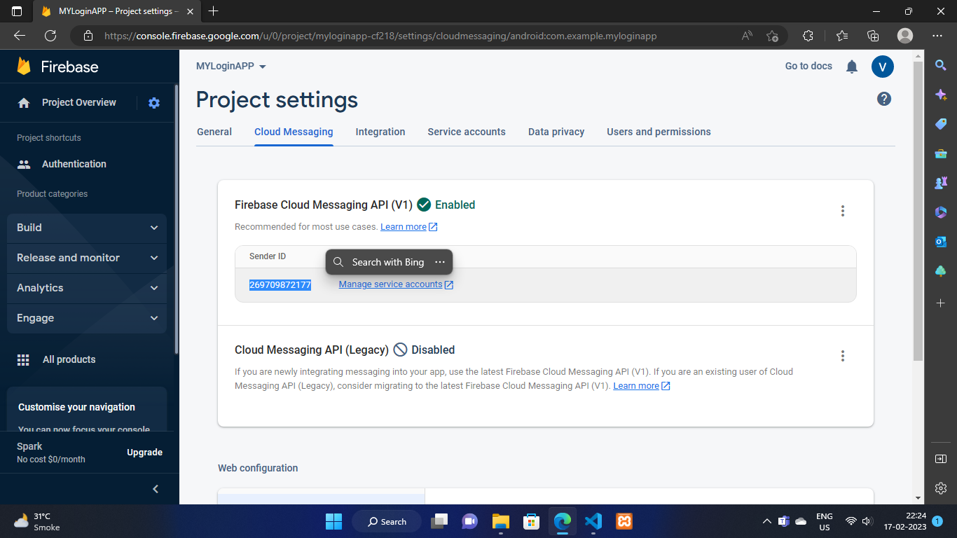

F. Click on Cloud Messaging under Project settings you will see this page and you will get the messangingSenderID as shown in highlighted part

Now Put All These Things In Flutter App As Shown Below :

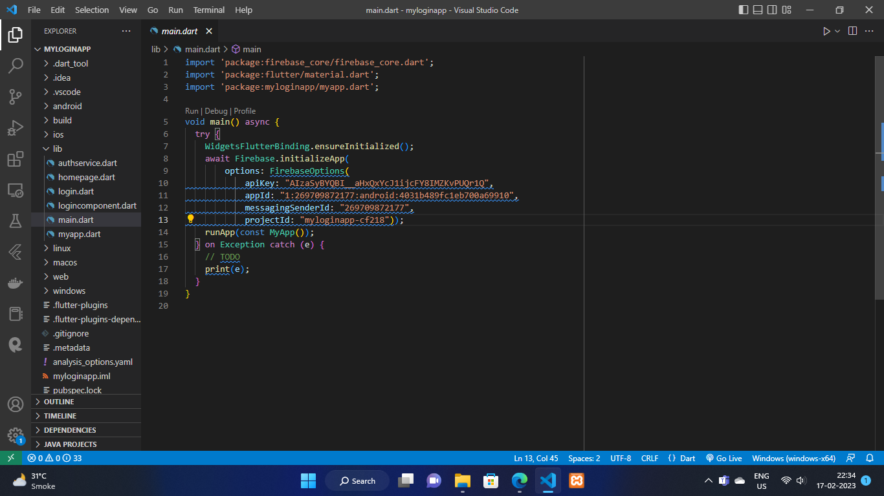

NOW TYPE THE CODE AND YOU ARE READY TO GO .