Task:
Ansible

ubuntu@ip-172-31-19-21:~$ sudo su
root@ip-172-31-19-21:/home/ubuntu# su - devops
devops@ip-172-31-19-21:~$ ssh-keygen
devops@ip-172-31-19-21:~$ ls -a
devops@ip-172-31-19-21:~$ cd .ssh
devops@ip-172-31-19-21:~/.ssh$ ssh-copy-id devops@172.31.16.169
password:devops
devops@ip-172-31-19-21:~/.ssh$ ssh-copy-id devops@172.31.21.142
devops@ip-172-31-19-21:~/.ssh$ ansible all -a"touch file1"
devops@ip-172-31-19-21:~/.ssh$ ansible all -a"ls"
devops@ip-172-31-19-21:~/.ssh$ ls
deep.yml file.yml firstfile.yml id_ed25519 id_ed25519.pub known_hosts known_hosts.old
devops@ip-172-31-19-21:~/.ssh$ ansible-playbook firstfile.yml

script1:deep.yml

hosts: all
become: true
tasks:
name: Install apache
ansible.builtin.package:
name: apache2
state: present
name: Touch a file, using symbolic modes to set the permissions (equivalent to 0644)
ansible.builtin.file:
path: /home/devops/akshat.txt
state:
touch
Bode: u-rw,g-r,o-r
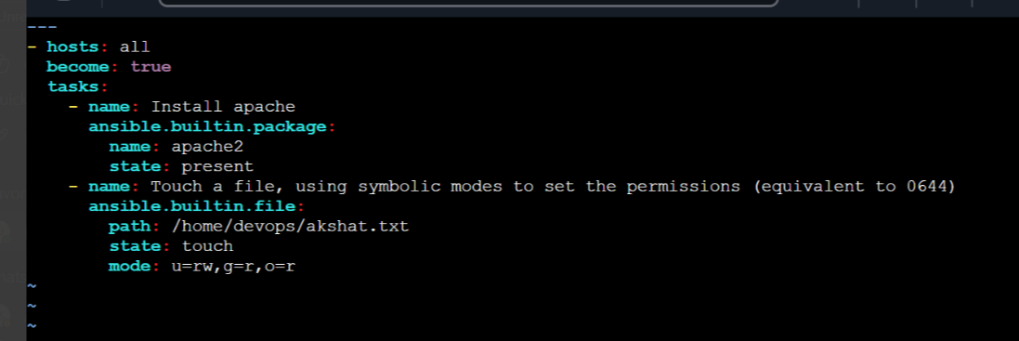

Script2:firstfile.yml

hosts:
all
become:
true
tasks:
name: Update apt cache
ansible.builtin.apt:
update_cache: yes
name: Install apache ansible.builtin.apt:
name: apache2
state: present
name: Create file with permissions
ansible.builtin.file:
path: /home/devops/newfile.txt
state: touch
mode: u=rw,g=r,o=r
