JADAVPUR LOVE BIRDS (JLB / JUD)
System Architecture Specification & Technical Reference Blueprint
Version 2.4.1 — Campus Fleet Production Edition
Target Ecosystem | Jadavpur University (29 Departments, Engineering, Arts & Sciences)
Architecture Model | Zero-Knowledge P2P WebRTC Mesh + Asynchronous GitHub Cryptographic Relay
Identity Verification | Library Card Hash + FIDO2/WebAuthn Admin Gate Station
Code Base & Updates | React 18 / TypeScript / Vite / Capacitor Android / GitHub OTA Fleet Stream

1. Executive Summary & Core Architectural Tenets
Jadavpur Love Birds (JLB / JUD) is a hyper-localized, privacy-first matchmaking and communication network designed specifically for the student body of Jadavpur University. Unlike conventional commercial dating platforms that aggregate student data, ingest chat transcripts into central cloud databases, and monitor location telemetry, JLB is engineered under a strict Zero-Knowledge and Zero-Retention operational standard.
The foundational pillars of the architecture comprise:
1. Zero Server Chat Storage: Student conversations, media transmissions, view-once photos, and typing interactions never hit a central application server database. Live interactions occur peer-to-peer over direct WebRTC DataChannels.
2. Asynchronous Cryptographic Offline Relay: In the event of network disconnection or offline peers, messages are encrypted using AES-GCM-256 keyed to the shared match secret and buffered in a private GitHub backend repository under one-way SHA-256 recipient hashes. Upon delivery, the recipient immediately wipes the file from the remote buffer.
3. Campus Identity Gate & Admin Passkeys: Verification is pinned to official Jadavpur University Library Card Hashes and 29 validated academic departments. Administrative authority is anchored by hardware biometric FIDO2/WebAuthn passkeys (YubiKey, Windows Hello, smartphone biometric keys) rather than leakable passwords.
4. Autonomous Fleet Over-The-Air (OTA) Updates: Mobile Android clients hot-patch their codebase directly from the official GitHub JUD repository, enabling instant feature deployments and security updates without wiping local IndexedDB chat vaults.
📌 SECURITY GUARANTEE: All private conversations reside strictly within client-side encrypted IndexedDB (Dexie) storage. No telemetry, third-party analytics, or server logging exist within the communication pipeline.

2. Global System Architecture & Component Topology
The system architecture is structured across five cooperative, decoupled tiers: Client Frontends (Android WebView / Vite React), Discovery & Signaling (Supabase PostgreSQL), Real-time P2P Mesh (WebRTC), Encrypted Asynchronous Buffer (GitHub Backend), and the Administrative Gate Station.

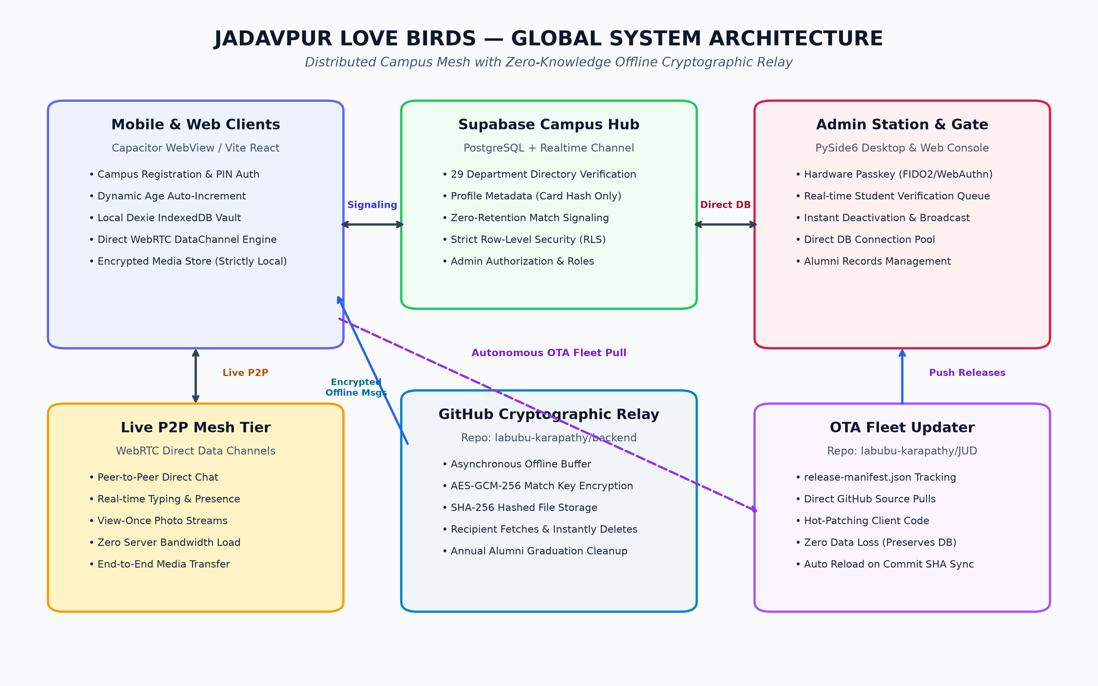
Figure 1: Global Multi-Tier System Topology of Jadavpur Love Birds
2.1 Detailed Subsystem Breakdown
Subsystem Tier | Primary Technologies | Core Operational Responsibilities
Mobile Client | React 18, TypeScript, Tailwind CSS, Capacitor, Dexie.js (IndexedDB) | UI rendering, local AES encryption, client-side photo compression, dynamic age calculation, and WebRTC mesh peer management.
Signaling & Metadata | Supabase PostgreSQL, Supabase Realtime Channels, Row Level Security | Broadcast discovery feed, match handshake exchange, library card hash validation, department classification, and abuse counters.
Real-time P2P Mesh | WebRTC (RTCDataChannel), STUN/TURN traversal fallback | Zero-latency direct browser-to-browser data exchange for unlimited concurrent active chats with zero server load.
Encrypted Offline Relay | GitHub REST API, AES-GCM-256, SHA-256, Obfuscated Token Gateway | Temporary asynchronous mailbox buffering for offline peers. Automatic ephemeral file deletion upon client receipt.
Admin Control Station | Python PySide6 Desktop GUI, Local WebAuthn Server (Port 8089), PostgreSQL Pool | Direct campus gatekeeping, FIDO2 passkey verification, student profile approvals/bans, KPI telemetry, and emergency broadcast dispatch.

3. Campus Identity, Verification & Onboarding Architecture
Registration on JLB is strictly restricted to bona fide Jadavpur University students. To balance total privacy with campus safety, the platform utilizes an obfuscated identity model based on Library Card Hashes and academic departments.

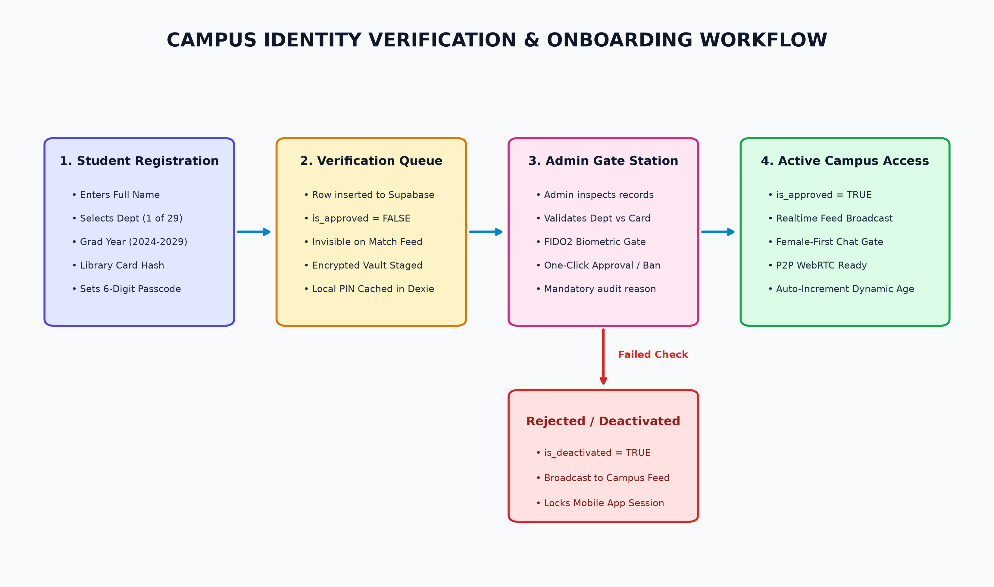
Figure 2: End-to-End Campus Student Onboarding and Admin Gate Workflow
3.1 Dynamic Age Auto-Increment Engine
Student age is not stored as a static integer. Instead, the platform computes dynamic age continuously using the formula:
CurrentAge = BaseAge + (CurrentCalendarYear - RegistrationYear)
This ensures that as semesters and years progress, student profile ages increment automatically without requiring manual profile re-editing or server-side cron triggers.
3.2 Female-First Initiation & Anti-Harassment Safeguards
In alignment with modern privacy protocols, female students retain unilateral control over match initiation. Once a match is confirmed, the male participant cannot transmit text or media messages until the female participant initiates the conversation (`has_female_initiated = true`). Furthermore, media sharing (camera photos, audio clips) requires explicit unilateral authorization (`media_allowed = true`).
4. Dual-Engine Messaging Architecture: WebRTC P2P vs. GitHub Relay
The messaging subsystem dynamically chooses between real-time direct peer routing and secure asynchronous store-and-forward buffering.

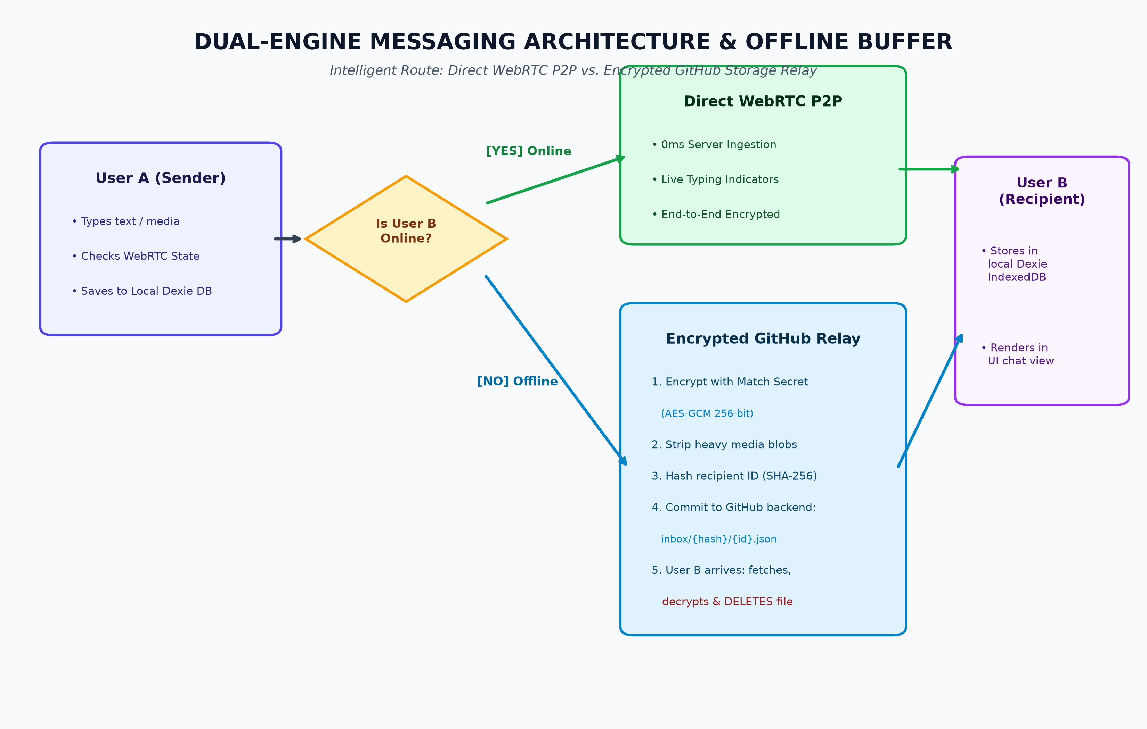
Figure 3: Dual-Engine Real-Time P2P WebRTC vs. Encrypted GitHub Storage Relay
4.1 Direct WebRTC Mesh Protocol
When both peers are active, communication flows through direct WebRTC DataChannels. Advantages include:
• Unlimited Active Chats: No concurrency limit or cloud bandwidth costs.
• Real-Time Interactivity: Instant typing indicators, delivery receipts, and live read status.
• Zero Ephemeral Footprint: Packets transfer memory-to-memory; no intermediary records exist on the public internet.
4.2 Asynchronous Offline Cryptographic Relay
When the intended recipient is disconnected, the client initiates the GitHub Cryptographic Relay protocol:
1. Key Derivation: An AES-GCM-256 key is derived from the pairwise match identifier: K = SHA256('jlb_match_aes_' || matchId).
2. Media Stripping: Large media blobs (images/videos) are retained exclusively in the sender's local IndexedDB to eliminate remote data leakage. Only encrypted text and metadata are transmitted.
3. Recipient Anonymization: The recipient's ID is hashed using SHA-256. The file is uploaded to the private repository `labubu-karapathy/backend` at path `inbox/{sha256(recipient_id)}/{msg_id}.json`.
4. Autonomous Drain & Purge: When the recipient logs in, their client queries their personal hash folder, decrypts all payloads into local Dexie IndexedDB, and issues atomic DELETE requests to GitHub, leaving zero residual trace.
5. Alumni Graduation Auto-Cleanup: All encrypted backups are stamped with minimum graduation years. Once graduates leave the university, expired chat histories are automatically dropped.
5. Autonomous Fleet Over-The-Air (OTA) Updates
To eliminate manual APK reinstalls and app store bottlenecks, JLB features a built-in Continuous Deployment / OTA engine tied to the official GitHub repository (`labubu-karapathy/JUD`).

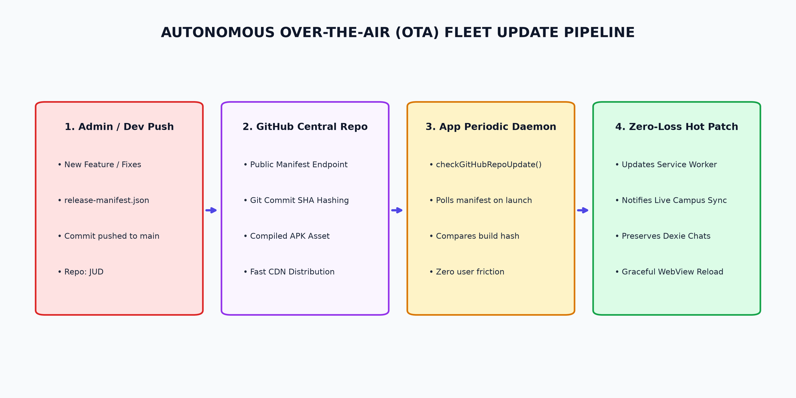
Figure 4: Autonomous Campus Fleet OTA Auto-Update & Hot-Patch Pipeline
The OTA cycle operates as follows:
1. The administrator commits verified updates and an updated `release-manifest.json` (or code build) to the `main` branch of `labubu-karapathy/JUD`.
2. Student mobile applications periodically run `checkGitHubRepoUpdate()` in the background upon launch or navigation.
3. The client compares the remote build hash against `localStorage.getItem('jlb_local_build_hash')`.
4. If a newer build hash or git commit SHA is detected, the client pulls the delta, triggers service worker refresh, displays a live sync toast to the student, and seamlessly reloads the WebView.
5. Crucially, the local IndexedDB database (`JUDAppLocalDB`) is completely preserved across updates, ensuring zero loss of chat logs or stored keys.
6. Administrative Station & Hardware Passkey Security
Campus management is enforced via a dedicated Python PySide6 desktop workstation (`admin_desktop`). The station connects directly to Supabase PostgreSQL using an SSL-encrypted persistent connection pool, bypassing public client API constraints.
• Hardware Passkey Gate: Access requires biometric authentication via FIDO2 / WebAuthn. A local HTTP authentication daemon (`auth_server.py`) operates on port 8089 to conduct cryptographic handshakes with physical YubiKeys, Windows Hello, or registered smartphone Bluetooth keys.
• Real-Time Queue & Instant Deactivation: Administrators can verify library card hashes against official university roll records, approve accounts, or immediately trigger campus-wide account deactivations with mandatory audit explanations.
• Broadcast Announcements: Administrators can publish signed system bulletins and security announcements to the `public.global_announcements` feed, which slides out in the student app via the campus drawer.
7. Database Schema & Security Policies (RLS)
The Supabase PostgreSQL database enforces strict Row Level Security (RLS) across all entities:
Table Name | Key Columns & Types | Row Level Security (RLS) Enforcement
public.profiles | id (UUID), full_name, department, grad_year, insta_handle, library_card_hash, is_approved, is_deactivated | Readable across campus only if approved and active. Insertable during registration; updatable by authenticated owner.
public.admin_passkeys | id (UUID), username, credential_id (TEXT UNIQUE), public_key, counter, device_label | Protected admin credential table. Restricted to admin station FIDO2 verification routines.
public.matches | id (UUID), female_id, male_id, has_female_initiated (BOOL), media_allowed (BOOL), matched_at | Accessible only by the two matched participants. Initiation & media permissions mutable solely by female participant.
public.chat_requests | id (UUID), sender_id, receiver_id, status ('pending'|'accepted'|'rejected') | Female-first gate. Visible only to involved parties. Status transitions restricted to receiver.
public.blocks | id (UUID), blocker_id, blocked_id, created_at | Bidirectional invisibility. Automatically triggers atomic block counter increments.
public.reports | id (UUID), reporter_id, reported_id, reason (TEXT), created_at | Abuse flagging repository. Automatically updates student report counters for admin triage.
public.global_announcements | id (UUID), content (TEXT), type ('admin_broadcast'|'system'), created_at | Campus-wide public read access. Insertable only by verified administrative console.

8. Cryptographic Specifications & Performance Metrics
The table below summarizes the operational cryptographic primitives and performance SLAs achieved by the JLB campus architecture:
Domain / Subsystem | Cryptographic Primitive / Standard | Operational Benchmark / SLA
P2P Mesh Communication | DTLS 1.3 / SRTP / WebRTC DataChannel (SCTP) | < 25ms round-trip latency on campus Wi-Fi / 5G mesh
Offline Storage Encryption | AES-GCM (256-bit key length, 96-bit unique IV per message) | Sub-millisecond encryption/decryption in browser Web Crypto API
Identity & Mailbox Obfuscation | SHA-256 (Canonical Pairwise Hash & Recipient Hashes) | Irreversible directory hashing preventing third-party discovery
Admin Authentication | FIDO2 / WebAuthn (Passkeys, ECDSA P-256 / Ed25519) | Hardware-attested phishing-resistant biometric login
Local Client Persistence | IndexedDB (Dexie.js) with client storage partitioning | Instant offline access; complete zero-data-loss across app OTA updates

— End of Architectural Specification Document —

