|  |  |  |
| --- | --- | --- |
|  | Vertical Farming | Traditional Farming |
| Land Use | Small space friendly, vertical farming | Large areas of farmland, horizontal farming |
| Water Use | Fewer water resources are used | Water use can vary, but generally, is higher |
| Energy Use | Often high energy use (but renewable) | Moderate energy use (if well managed) |
| GHG Emissions | Relatively low GHG emissions (with the right strategies) | Relatively high GHG emissions |
| Pollution and Ecosystem | Minimal pollution and ecosystem degradation | Most farming damages the environment |
| Supply Chains | Decentralized food production system | Centralized food production system |

**Vertical Farming**

**Good, but**

**Energy Consumption**

**High**

Solution?

**Partnership**

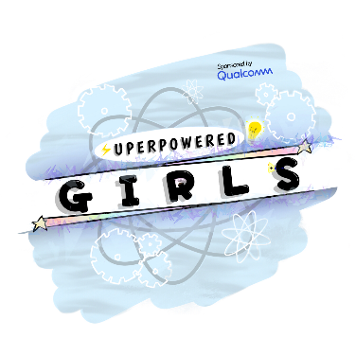

**Photosynthesis cycle**

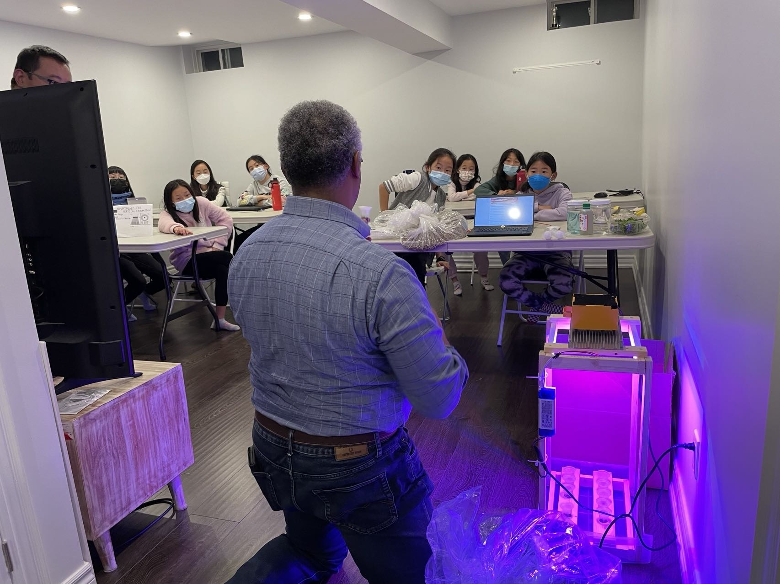

**Partnership**

**Energy GHG**

**Consumption Emissions**

Inspired by

Exploration

**Carbon Capture in Vertical Farming**

Underlying program of EV3-G

