**MTG Events**

**Requirements and Design**

***Levi Carpenter***

***05/14/2021***

## Project Name: MTG Events

## Project Overview:

The purpose of this website is to grant anyone interested in Magic: the Gathering a platform to create, find, and share upcoming events for the game. The potential users are Magic: the Gathering players, people interested in learning about Magic: the Gathering, and anyone else interested in the website. The website will include: a home page, a login page, a signup page, a “Connections” page to display all upcoming events, a “Connection” page to list individual event details and allow users to RSVP to the event, a “Saved Connections” page to display all of the events the user RSVP’d to, a “New Connections” page to allow new events to be added, a “Contact” page to inform users on how to contact the site owner, and an “About” page to briefly describe the purpose of the website. These pages, as a complete site, will allow users to connect with other supporters of the game and manage logistics about upcoming events.

## Site Map:

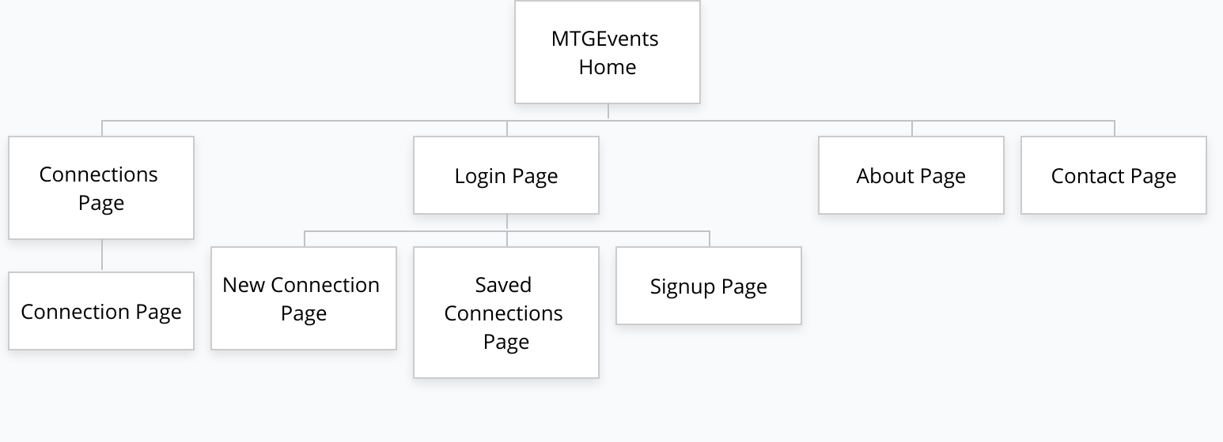

## Page Design:

* **Header**
  + Purpose: Bring consistency to the website and allow easy access to home page, login page, signup page, “New Connection” page, “Saved Connections” page, and signout.
  + Users: All users
  + Content:
    - Hyperlinks
      * Website logo
        + Links to home page
      * “Start a New Connection”
        + Links to “New Connection” page
      * “Login”
        + Links to login page
      * “Signup”
        + Links to signup page
      * “My Connections”
        + Links to “Saved Connections” page
      * “Signout”
        + Logs out user and redirects to home page
    - No data entry.
    - No validations.
* **Footer**
  + Purpose: Bring consistency to the website and allow easy access to the “About” and “Contact” pages
  + Users: All users
  + Content:
    - Hyperlinks
      * “About”
        + Links to about page
      * “Contact”
        + Links to contact page
    - No data entry.
    - No validations.
* **Navigation Bar**
  + Purpose: Allow easy access to “Connections” and “Saved Connections” pages
  + Users: All users
  + Content:
    - Hyperlinks
      * “Connections”
        + Links to the “Connections” page
      * Hyperlink with user’s name
        + Only visible when a user is logged in
        + Links to the “Saved Connections” page
    - No data entry.
    - No validations.
* **Home Page**
  + Purpose: Welcome users to the website and directs them to the “Connections” page
  + Users: All users
  + Content:
    - Textual Information
      * The page consists of a welcome header, a short website description, and a note to click on the connections link to find events.
    - No data entry or validations.
* **Login**
  + Purpose: Allow users to login and see previously saved connections
  + Users: Any user wanting to save their connections
  + Content:
    - Data Entry
      * Text entry box for email
      * Text entry box for password
    - Button
      * “Login”
        + Validation to ensure data in email field is an email
        + Validation to ensure password matches given email address.
        + On successful validation, user is redirected to saved connections page.
        + On error with validation, user is prompted with the errors in red.
* **Signup**
  + Purpose: Allow users to create an account so they can save and revisit saved connections
  + Users: Any user wanting to save their connections
  + Content:
    - Data Entry
      * Text entry box for first name
      * Text entry box for last name
      * Text entry box for email
      * Text entry box for line1
      * Text entry box for line2
      * Text entry box for city
      * Text entry box for state
      * Text entry box for zip
      * Text entry box for country
      * Text entry box for password
      * Text entry box for password confirmation
    - Button
      * “Sign Up”
        + Validates all required entry boxes are filled and contains appropriate data.
        + On successful validation, user is redirected to saved connections page.
        + On error with validation, user is prompted with the errors in red.
    - Validate that user is logged in before rendering the page. If the user is not logged in, they will be redirected to the login page.
* **Connections**
  + Purpose: Allows users to see all upcoming tournaments
  + Users: Any users interested in attending an event
  + Content:
    - Textual Information
      * Lists of hyperlinks for individual connections, sorted by topic
    - Hyperlinks
      * All hyperlinks redirect users to the “connection” page, which dynamically renders the page for each connection.
    - No data entry
    - No validations
* **Connection**
  + Purpose: Allows users to view a specific connection’s details and RSVP to that connection.
  + Users: Any user interested in a specific connection or looking to RSVP to an event.
  + Content:
    - Textual Information
      * Details for the connection, such as name, host, date, time, location, and description.
    - Buttons
      * All buttons redirect the user to the saved connections page.
      * “Yes”
        + RSVP yes to the current connection
      * “No”
        + RSVP no to the current connection
      * “Maybe”
        + RSVP maybe to the current connection
    - No data entry
    - RSVP buttons validate that the user is logged in before saving the connection and redirects the user to the login page if not.
* **Saved Connections**
  + Purpose: Allows users to view saved and user-created connections, update and delete RSVPs to another user’s connection, and edit and delete user-created connections.
  + Users: Any user who has saved or created a connection.
  + Content:
    - Textual Information
      * A table that displays the name, topic, and RSVP of saved connections along with an update and delete button for each of the connections.
    - Buttons
      * “Delete”
        + For saved connections hosted by another user:

Deletes the connection from the user’s saved connection list and removes the RSVP

* + - * + For saved connections created by the user:

Deletes the connection for all users

* + - * “Update”
        + For saved connections hosted by another user:

Redirects user to the connection’s detail page so the user can update their RSVP

* + - * + For saved connections created by the user:

Redirects the user to the new connection page and populated the form with the connection’s information so the event details can be updated.

* + - No data entry
    - Validate that user is logged in before rendering the page. If the user is not logged in, they will be redirected to the login page.
* **New Connection**
  + Purpose: Allows users to create new connections that can be viewed and RSVP’d to by other users.
  + Users: Any user who wants to share an upcoming MTG event.
  + Content:
    - Data Entry
      * Text entry box for topic
      * Text entry box for name
      * TextArea box for Details
      * Text entry box for location
      * Text entry box for date
    - Button
      * “Create Connection”
        + Validates all entry boxes are filled and contains appropriate data.
    - Validate that user is logged in before rendering the page. If the user is not logged in, they will be redirected to the login page.
* **Contact**
  + Purpose: Informs user how to contact site owner.
  + User: Any user interested in meeting or contacting site owner
  + Content:
    - Textual Information
      * UNCC address
      * Site owner’s email address
    - No data entry.
    - No validations.
    - No actions
* **About**
  + Purpose: Briefly describes the purpose of the website
  + User: Any new users who do not understand the purpose of the website.
  + Content:
    - Textual Information
      * Short description of the website’s purpose.
    - No data entry
    - No validations
    - No actions

## Database Design

**ER Diagram:**

**Schema Descriptions:**

* **Connection**
  + name: String
  + host: String
  + hostId: String
  + topic: String
  + details: String
  + date: Date
  + location: String
* **User**
  + fName: String
  + lName: String
  + email: String
  + address: addressSchema
* **Address**
  + line1: String
  + line2: String
  + city: String
  + state: String
  + zip: Number
  + country: String
* **UserConnection**
  + connection: connectionSchema
  + rsvp: String
* **UserProfile**
  + userId: String
  + userConnections: [userConnectionSchema]