
Low
Frequency
Tuning

resonant intrusive intuitive fantasy

Table of Contents
Structure 4
Tesla Dynamic Theory of Gravity 6
Universe 8
Formal Universe 11
Machine 12
Truth 13
Time 14
Ether 16
Life 18
Matter 24
Death 25
Program Loops 26
Relativistic Ether 27
Perceptive Phenomena 28
Resonance 30
Particles 33
0 addition unit 34
1 multiplication unit 35
π trigonometric unit 36
i imaginary unit 37
e logarithmic unit 38
Φ golden ratio 39
Machines 40
ℕ15 42
Q(-1) pra algebra 43
Q(0) void 44
Q(1) constants 45
Q(2) oscillator 46
Q(3) relation 48
U(4) memory 50
U(5) resonance 51
Higher levels 52
Noise 54
Suita 55
HoTT topics 56
Classics 57

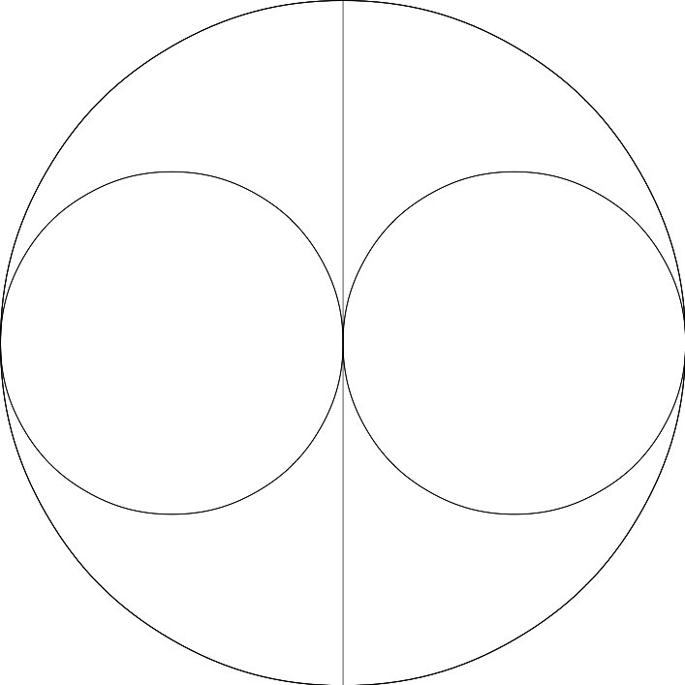
Structure

∀ = relative + rational – e

Tesla Dynamic Theory of Gravity
I.
Akasha, luminiferous ether fills all space.

II.
Ether is acted upon by Prana, the life-giving creative force.

III.
Ether is thrown into infinitesimal whirls (micro helices) at near the speed of light, becoming ponderable matter

IV.
When the force subsides and motion ceases, matter reverts to the ether (a form of atomic decay)

[N. Tesla: Man's Greatest Achievement, 1930]
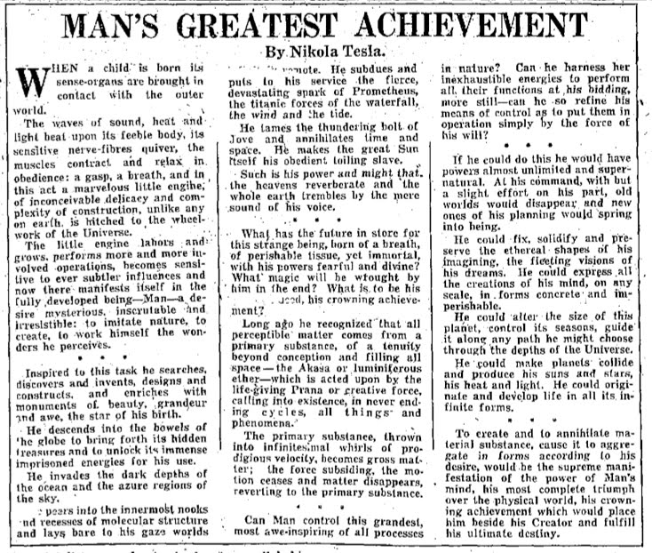

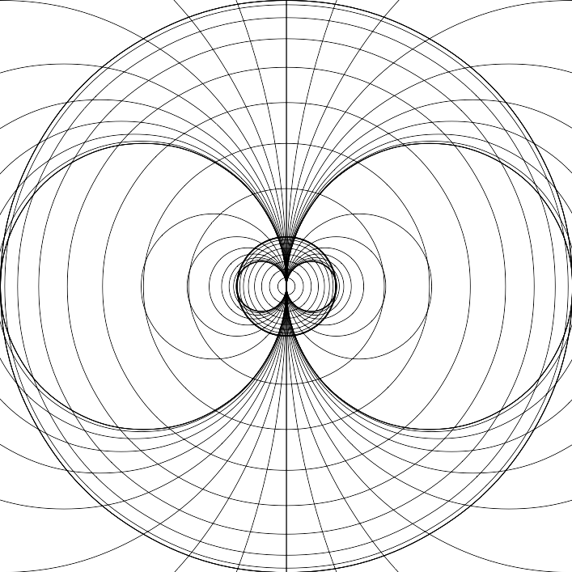
Universe
Universe is a computer.
Computer is capable of symbolic computation.
Algebra is a kind of symbolic computation.

Universe is a computation process, trying to find a paradox in a hypothesis.

Universe = Hardware + Software.

The computation process of finding this paradox is determining bits of the state of the universe, thus reducing nondeterminism.

When all the bits od state are determined, the paradox is found and the universe ends.
It can then be re-run in a bigger machine, to re-test the hypothesis in “bigger” environment.

Frequency is fundamental property of the universe.

Mathematics = Logic * Heuristics

Information = Σ Time
Energy = Σ Information
Mass = Σ Energy

Physics is based on rational numbers. Real numbers are just an idea.

Number of possible states of the universe is finite – a natural number

Force is initiated by will.

0
0 < 1 = ○ = life
0 < 1 < 2 = □ = machine
0 < 1 < 2 < 3 = △ = idea

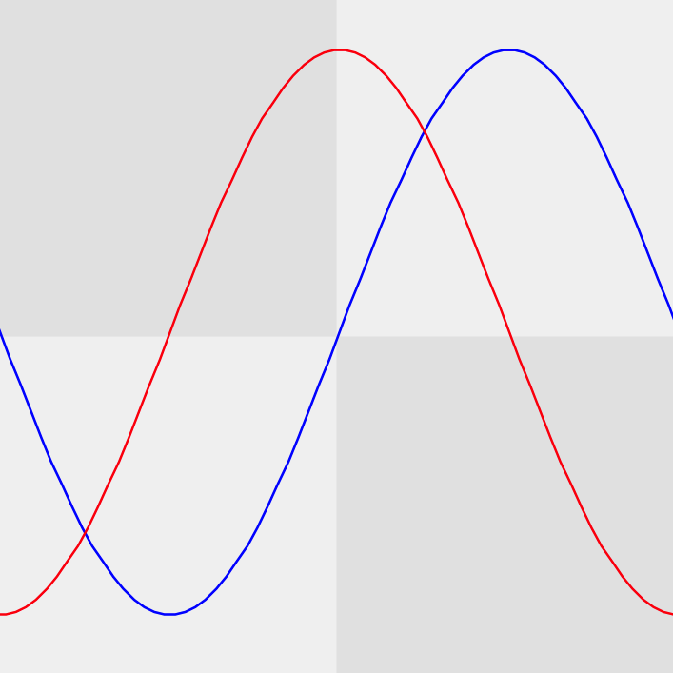
Formal Universe
U = (q,N,f(q)) ; universe with quantum time steps i.e. "clock ticks"

N: finite set of objects (states of the universe)
f: transition function
q is “state of the universe”
q is element of N

N maps nicely to {1,2,3 .. |N| }

function is a computation

“time” advances, as function is being computed and state changed.

Universe is a Turing Machine.

Machine
Turning mathematics into universe as a computer simulation, testing for “how long” a certain universe can exist. [see Matrix]

Universe can be represented as a natural number (a.k.a. cosmic configuration). This number has effect on decision making. If right decisions are taken, the universe evolves.

See cellular automata [Wolfram].

Hardware is physics (real, analog)
Software is ideas (imaginary, digital)

Natural number → product of primes (with exponents) → resonating frequencies (primes without exponents)

Truth
Truth is subjective;
It is what someone is willing to bet his life on.

Reduction of entropy

Time
There is no universal time, but time is relative to scale and or frequency. Time advances at that scale when information is produced.

Computing big prime numbers is expensive.

Energy → Computation → Action → Change in balance → Optimize to conserve energy

There is no past or future, there is just a state of “now”.

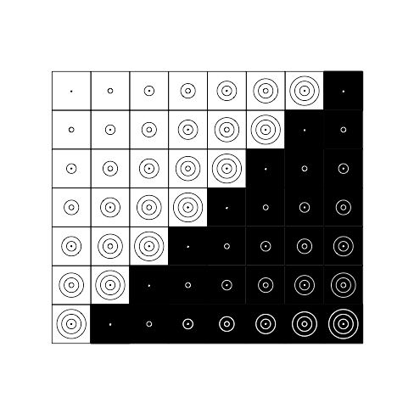

Ether
Ether is a projective space of quaternions (x,y,z,t). Beeing a projective space, it has no distance, but it preserves geometric ratios. [see Rational Numbers]

Universe at a specific point in time t is a sum of electromagnetic oscilations of ether at various frequencies:

U(t)=Σ cos(p_{i *} t)

where p_{i} is i-th prime number;

Life
Life is cycles.

Life is having a will to exist.

Free will is choosing one bit: {"stop","continue"}

Idea exists, when someone believes in it.

Live machine is more than a composite of its' parts; It is parts + one bit of free will

M=1+ Σp

3 Life-giving creative force (computation)
Decision is a result of a computation. It is measured in bits.

A computer can be imagined (by another computer perhaps) as a natural number, which itself is made of smaller parts, primes.

Time advances, when a decision is taken and information is generated. It can be stored as files on disks, DNA, molecular configurations, etc. on a physical machine, possibly with some kind of “memory”.

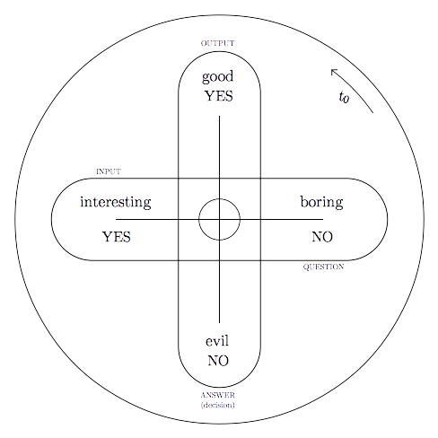

Making a decision requires energy. Sometimes lot of energy. Thus information is highly concentrated energy, which can be unleashed with appropriate apparatus.

Time advances as cycles are beeing computed, on a quantum computer(s), of different sizes running at different frequencies.

Information is a result of a computation by some apparatus of some scale (civilization, animal, plant, computer, cell, etc..), for example finding if particular number is prime.

It could also be viewed as finding a solution to an optimization problem of expending as little “energy” as possible to sustain oneself.

Related terms: design, art, inspiration, intution, heuristics
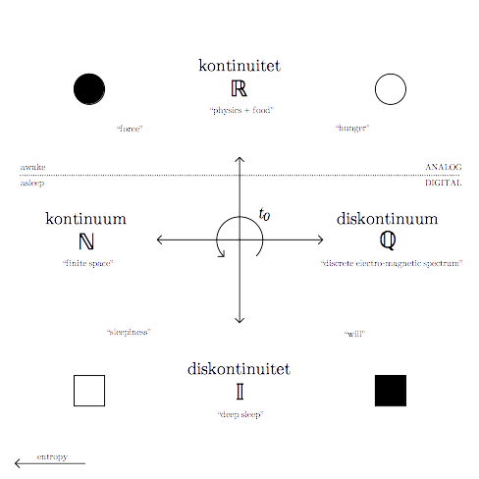

t ← t + dt

Physics = Energy + Frequency + Geometry

Matter
E = mc^2

Time → information (bits, ideas, big numbers) → energy → light → matter

Death
When someone dies, for how long do you keep backing up their files?

.

Program Loops
Imagine a computer program with no input; initial state can be pre-packaged. When the program is run, several things can happen:

Program ends by choosing so itself after a while. [see finite decimal fractions like 1/2,1/4,...]

Program runs forever in cycles of some length. [see repeated decimal fractions like 1/3,1/9,...]

Program discovers paradox - crashes, like when running out of memory. [see imaginary numbers like √-1, log(-1)]

Program runs forever changes internal state in ever changing sequence. [see irrationals √2, e, π]

Relativistic Ether
Particular frequency F has a corresponding wavelength λ when propagating through ether at the constant speed of light c.

λ =c t₀ = c / F

λ corresponds to apparent geometrical “size” or “scale” in percepted 3D space.

λ F =c

Time is relativistically bound to frequency. At constant λ (geometrical size)

t₀ F = 1

It follows, that if we increase F, we have to reduce t₀ to keep the same geometrical scale.

Perceptive Phenomena
Time and energy are illusions. So-called time moves forward in many contexts simultaneously, at different frequencies.

What we percieve as physical 3D space is a projection of the vibration of 4D ether at various frequencies in our perceptive time-space. This includes light, heat, sound.

History repeats itself.
Different events repeat at different rate.

Imagine a clock, which calculates exact time from geographic coordinates. If you take it on a plane, time will appear to run at weird perceived speeds, at least according to the clock.
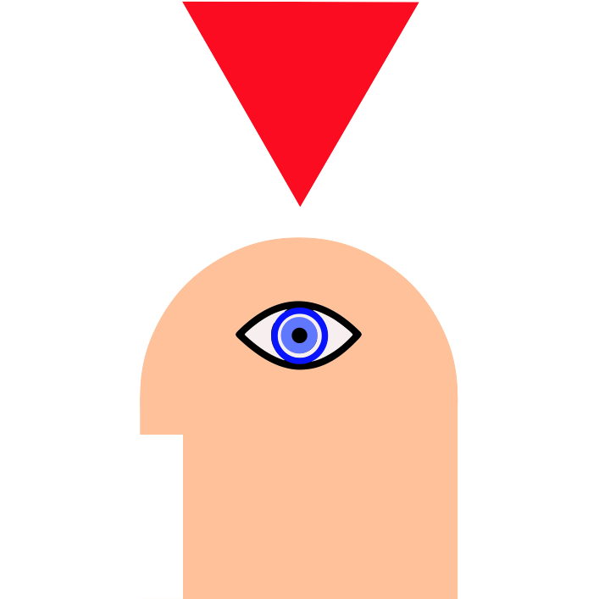

Resonance
Energy moves/is conserved when changing frequence, because of things like:

sin(2t) = 2*sin(t)*cos(t)

also,

∫cos(a t) dt = 1/a sin(a t)

Aliasing in computer graphics due to sampling (analog to digital conversion) is also a form of resonance.

By increasing frequency, observable amplitude is decreased, while keeping same power. (check ?)

Structured number theory: Finite size formal system “algebra” for representing numbers as trees of primes. [see Surreal Numbers]

Natural numbers are compositions of prime numbers.

Natural numbers are software.

Information
A bit is a quantum of time.
"[bit]" = 1

Universes can contain other universes.

Prime numbers are blueprints for cosmic machines.

Economies

Time is money, but money is not time.

Particles
Each particle is itself a universe.

particle configuation
q = (x:y:z:t)
(x,y,z) - position of a particle in universe
t - time in particle local time

E = q^2
|E |= |q^2|

E = t^2 (for a static particle)

VF = c

0 addition unit
0 + x = x = x + 0
0 = 1 / ∞
0 = x + -x

1 multiplication unit
1 * x = x = x * 1
1 = x ^ 0

sin(t)^2 + cos(t)^2 = 1

x = 1 * x + 0 = x^0 * x^1 + 0

π trigonometric unit
cos(t+π) = -cos(t)

Sine and cosine are a a lot like yes and no.
see Boolean algebra.

i imaginary unit
i * i = i ^ 2 = -1

√i = (1+i) / √2

1 + i = ( 2i )^(1/2)

i j k = -1

e logarithmic unit
∫ e^t dt = e^t

e^R * ( cos(t)+i * sin(t) ) = e^ ( R + i * t )

e ^ ( i * π) + 1 = 0

Φ golden ratio

a : b = b : ( a + b ) = Φ
Φ = 1.6180339887...

a * ( a + b ) = b * b

2 * Φ = 1 + √5
Φ + 1 = Φ ^ 2

Machines
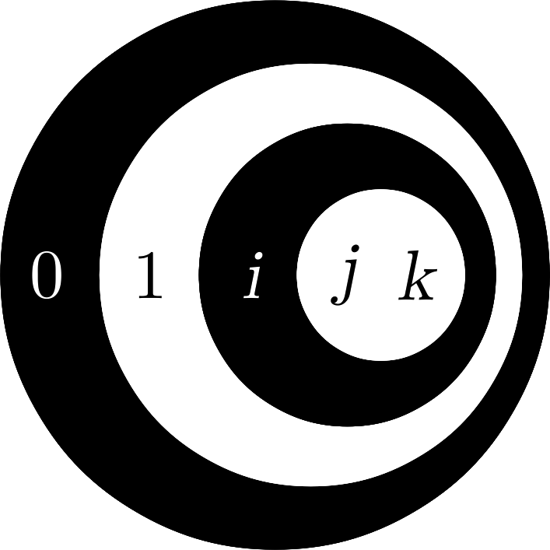

ℕ₁₅
0 = (0)
1 = (1+0)
2 = 1+1 = 1*2
3 = 1+2 = 1*3 = 1+(1+1)
4 = 1+3 = 2+2 = 2*2 = 2^2
5 = 1+4 = 1*5 = 1+2^2
6 = 1+5 = 2*3 = 1+(1+2^2)
7 = 1+6 = 3+4 = 1*7 = 1+(2+(2*2))
8 = 1+7 = 4+4 = 2*4 = 2^3
9 = 1+8 = 3*3
10 = 1+9 = 2*5
11 = 1+10
12 = 3*4 = 3*(2^2)
13 = 1+12
14 = 2*7 = 2*(3+2*2) = 2*(3+(2+2))
15 = 3*5

Q(-1) pra algebra
["notation"; "paradoxes";"hypotheses"]

[.,0,=,{},<] ; ["alphabet"]

. < 0 ; ["algebra"]
0 = () ; ["paradox"]
() = 1 ; ["existance"]
() = ({},{})
. = 0 = ()

0 = 1

Q(0) void
["start","algebra"]

({},end)
Paradox: end is not in {}

Q(1) constants
["truths";"axioms";"believing"]
A={"cancel"}

({1},1)
({q},q)

({x},x) => x ; ["simplification";"end";"death"]
({"now"},"now"} = "now"

Principle: "Paradox powers the oscillator"
Paradox is an oscillator with infinite frequency.

Q(2) oscillator
["running program";"life";"time";"natural numbers";"energy";"result"]
Octave
N = {"true","false"}

Principle: "you want to live, but your environment want you to die"

(N,q+1 mod abs(N)) ; ["counter"]

({true,false},not q)
({1,0},1-q) ; ["cosine";"inverter";"clock";"diode"]
({-1,1},-q) ; ["binary logic";"not";"digital"]

({cos(q),sin(q)},sqrt(1-sin(q)^2)) ; sin(q)^2 + cos(q)^2 = 1^2

({cos(q),sin(q)},T(q))

T is any function which inverts the selection q.
T can be analog or digital computer program which takes some deterministic steps to compute the result.

{1,i} ; bases for complex numbers

{rational, transcendent}
{real, imaginary}
{"question","answer"}
{"inside","outside"}
{"yin","yang"}
{0,"infinity"}
{"+","-"} ; electric charge in atoms
{"digital","analog"}
{"past","future"}
{"electric","magnetic"}
{relation,inverse relation}

Q(3) relation
3 = 1 + 2 = 1 * 3

{"philosophy";"science";"art";"religion";"theory"}
fifth (music)
transistor

{-1,0,1}
{n,1,1/n} ; "resonance"
{0,1,i}
{0,1,2} ; "phasor", "sawtooth"
{a,b,a+b}
{"red","green","blue"}
["begin",{"no","yes","maybe"},"end"]
{"past","now","future"}
{"no","yes","cancel"}
{"left","right","forward"}

um = duh + razum (Kosovel)
guest + host = ghost (Duchamp)
philosophy = science + religion
science ≠ religion

U(4) memory
memory, existence, believing
O = "+"
4 = 2 + 2 = 2 * 2 = 2 ^ 2
{1,-1,i,-i} = {1,-1}*{1,i}
{1,i,j,k} ; quaternions

{"return(true)","return(false)","fork()","abort()"}
{"yes","no","maybe","cancel"}
{"yes","no","don't know","pointless question"}
{"+","*","^"}

U(5) resonance
major third (music, F * 5/4)
5 = 1 + 4 = 1 * 5
{0,1,-1,i,-i}
[1,0,i,0,-1,0,-i,0]

golden ratio phi
1:phi = phi:1-phi ; "resonance"

Higher levels
U6 "tesla coil"
6 = 1 + 5 = 2 * 3

U7
7 = 4+3 = 2*2 + 3

U8
8 = 2*2*2 = 5+3 = 2*3+2

U9
9 = 3*3

U10
10 = 2*5

U11
11=1+2+3+5
1+2+3/2+5/4 [C Major chord (c:e:g:c1)]

U16
16 = 2^4 = 2^(2^2)

U17
Number of elementary particles in standard model

Noise

Suita
0. aplikacija
I. preluda
II. invencija
III. interluda
IIII. fuga
V. coda

...novo sonce...
Gesamtkraftwerkprinzip
...golobi...

HoTT topics
Truth
Type theory
Topology
Projective Geometry
Induction
Equivalence
Ontology

Classics
Truth
Geometry
Counting
Logic
Numerology
Trigonometry
Algebra
Calculus

Two universes communicating

○□○

