9341 Date: February 09, 2018

IT 412A

Members: ANTONIO, Venessa  
BORJE, Ma. Kaye Audrey   
DADAG, Darryl Christian  
DIANO, Leo Evrian  
LACAP, Albert Jr.

Wireframe for Admin

(Login Page)

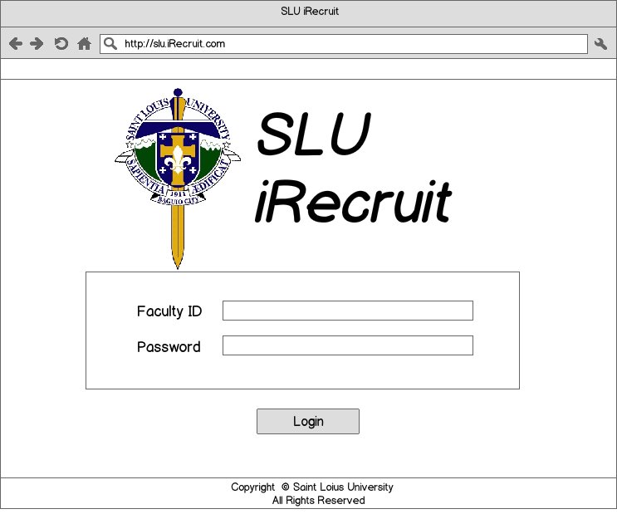

Description:

This is the application’s login page. The faculty’s ID number will be used as login credentials along with his password. Clicking the login button will redirect the user to the Home page.

(Home Page)

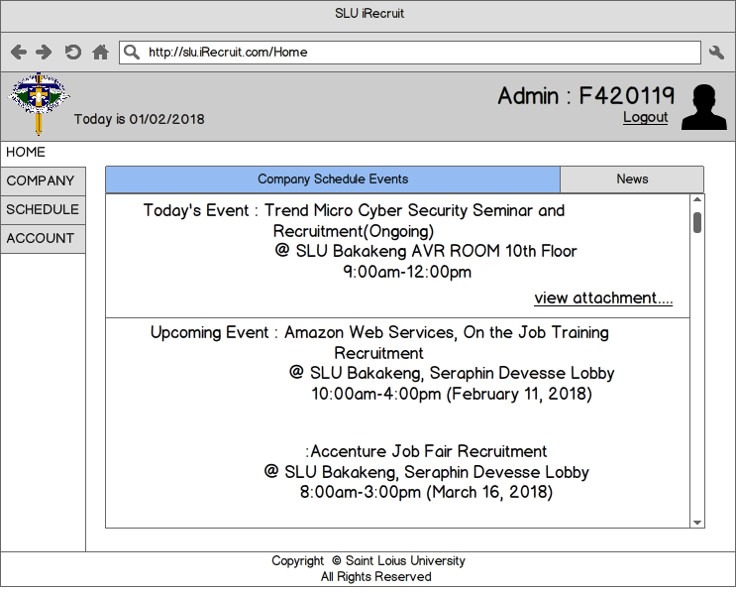

Description:

The Applications Home page comprises of the header which displays the current time stamp at the upper left and the users ID at the upper right along with their Profile Image. The navigations are located at the left side of the page, comprising of the Home, Company, Schedule, and Account tabs. The main body of the home page consists of the upcoming details of scheduled company events.

(Company Page)

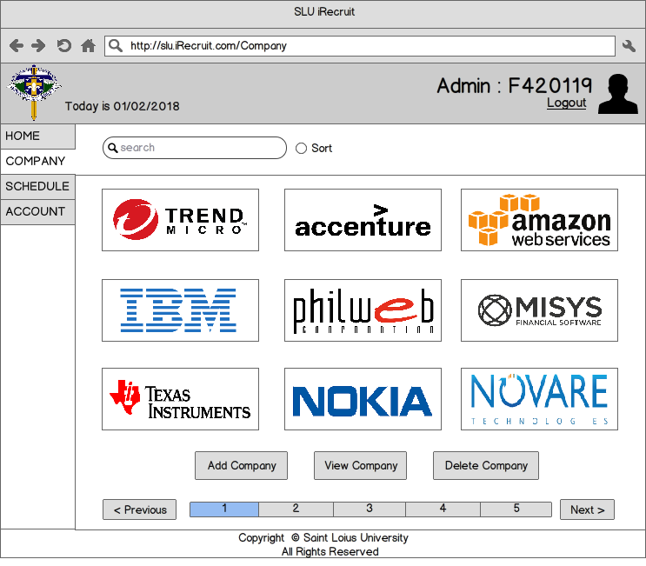

Description:

Under the Company tab, the list of registered companies will be displayed. A search bar on the upper left side will enable the user to easily search companies with their keywords. The bottom portion of the tab composes of the “Add Company”, “View Company”, and “Delete Company” buttons.

(Add Company Page)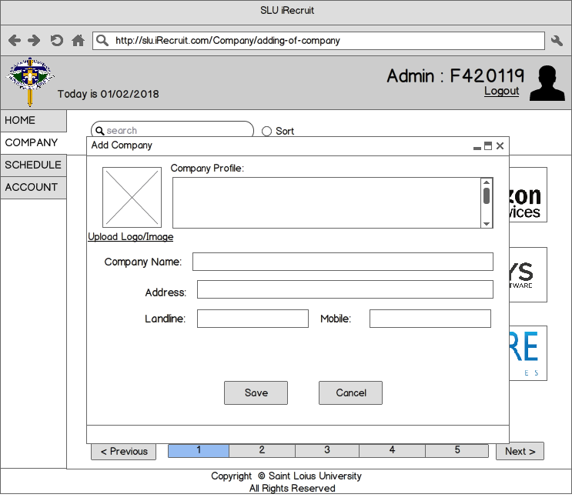

Description:

By Clicking on the “Add Company” button on the Company page, a pop-up message will display a form that will enable to user to create a new company. After filling up the necessary information, clicking the save button saves the given information into the applications memory.

(View Company)

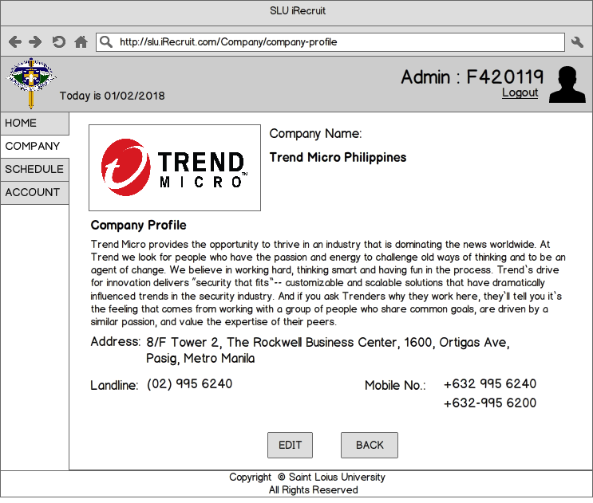

Description:

By clicking on the “View Company” button while a company box was targeted, the page will redirect to the company profile of the targeted company. In this page, the company’s logo/symbol is displayed on the upper left along with the company’s name. Below, the company profile, company address, landline, and mobile number are displayed. There is an option to edit the company’s information by clicking on the “Edit Button”. Clicking the “Back” button will redirect the user back to the Company Page.

(Edit Company Page)

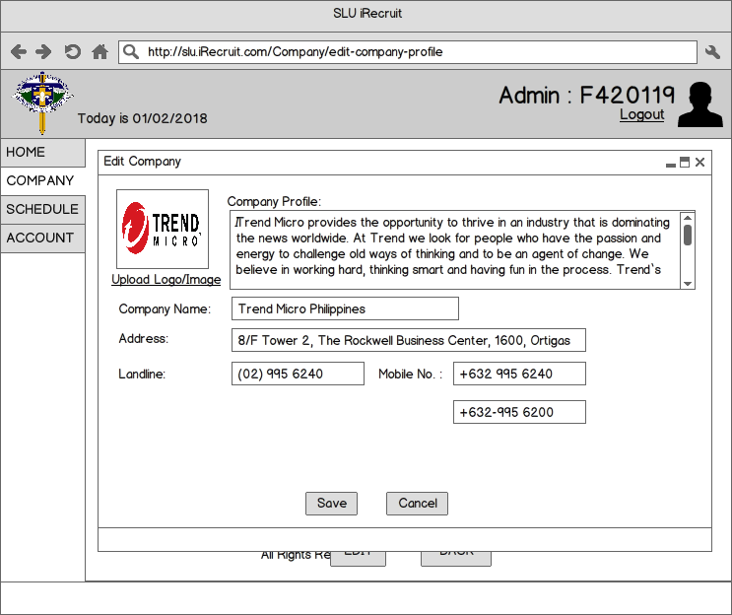

Description:

The edit company page can be access by either targeting a company or clicking on the “Edit” button on the Company page or by clicking the “Edit” button while on the view company page. This portion is just a pop-up message that will enable the user to edit the contents of the targeted or chosen company. Clicking the save button will update any changes to the companies information.

(Delete Company Page)

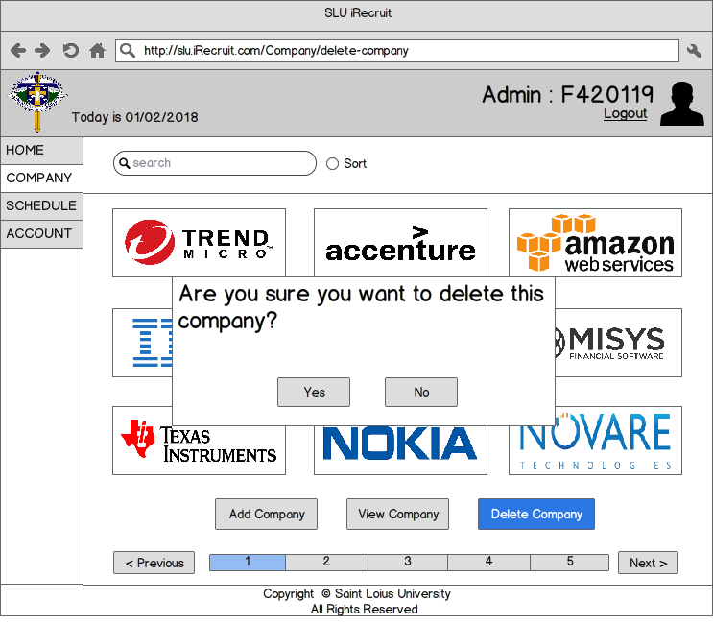

Description:

By clicking on the delete button while a company is being targeted in the Company Page, a pop-up message will appear, prompting the user to confirm the deletion of date of the company being targeted. Clicking the “yes” button will delete the company’s data in the applications memory.

(Schedule Page)

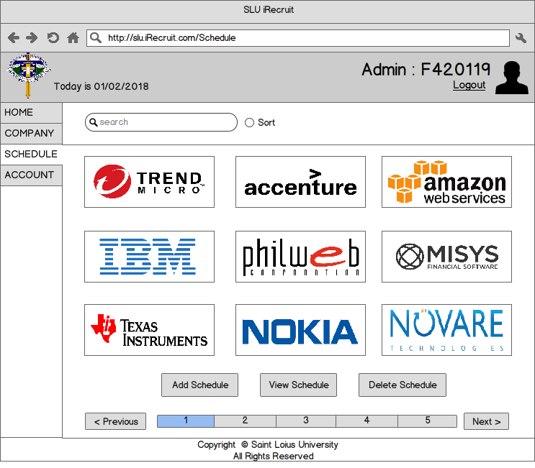

Description:

Under the Schedule tab, the list of upcoming events will be displayed. A search bar on the upper left side will enable the user to easily search events with their keywords. The bottom portion of the tab composes of the “Add Schedule”, “View Schedule”, and “Delete Schedule” buttons.

(Add Schedule Page)

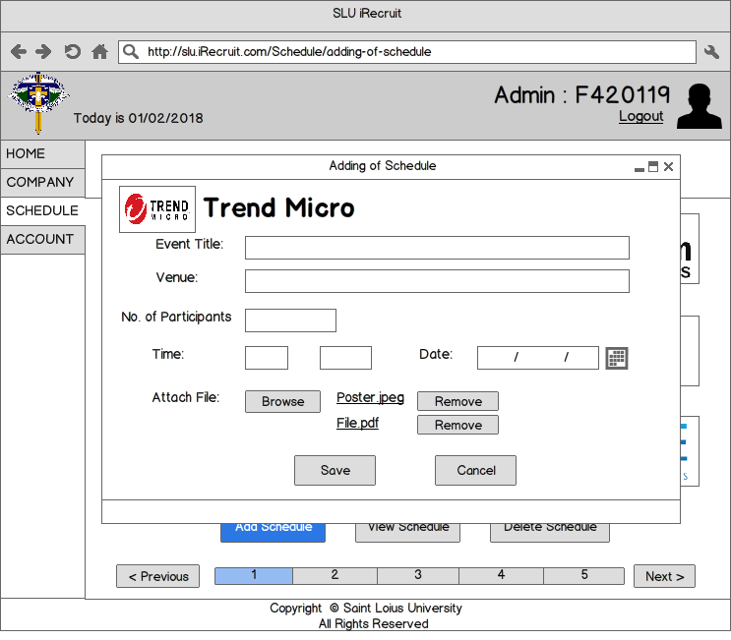

Description:

By Clicking on the “Add Schedule” button on the Schedule page, a pop-up message will display a form that will enable to user to create a new company. The Events title, venue, number of participants, the time and date, as well as the option of adding attachments are to be filled within this portion. After filling up the necessary information, clicking the save button saves the given information into the applications memory.

(View Schedule Page)

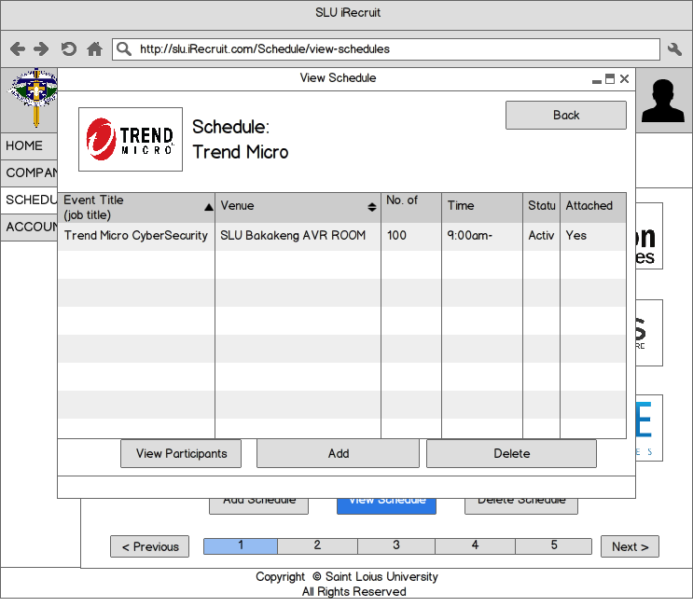

Description:

By clicking on the “View Schedule” button while a company box was targeted, the pop-up massage will display the details of the targeted. In this portion, the company logo hosting the event will be displayed on the upper left side corner and below it is a table showing details about the event’s title, venue, number of participants, scheduled time, and file attachments.

(Delete Schedule)

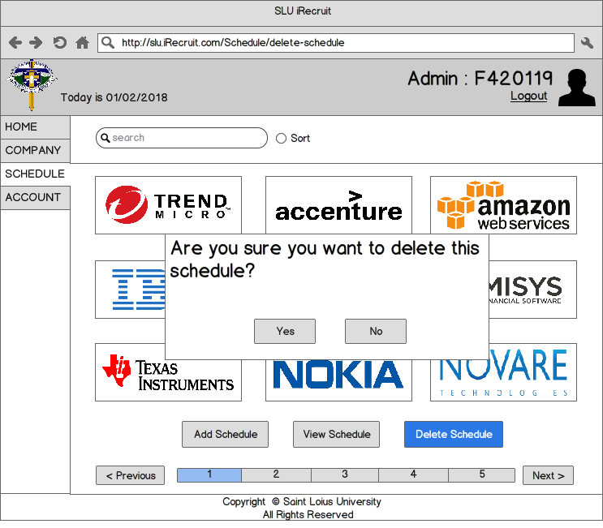

Description:

By clicking on the delete button while a schedule is being targeted in the Schedule Page, a pop-up message will appear, prompting the user to confirm the deletion of date of the schedule being targeted. Clicking the “yes” button will delete the schedules data in the applications memory.

(View Participants Page)

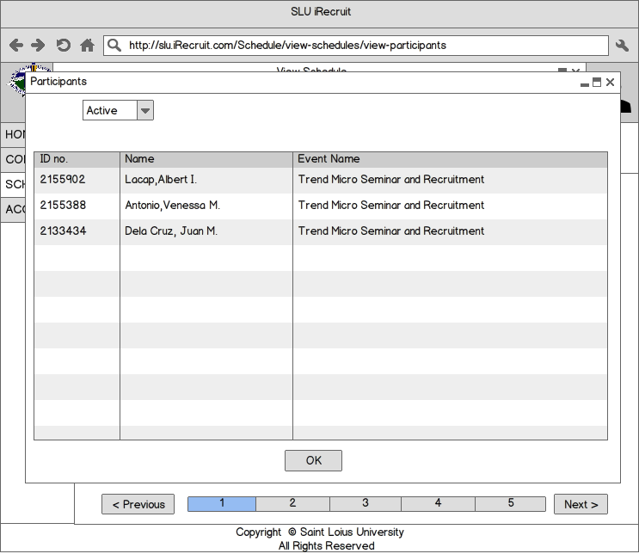

Description:

By clicking on the “View Participants” button while a schedule box was targeted, the pop-up massage will display the details of the targeted schedule. In this portion, the list of all participants undertaking this even will be displayed on a table with their ID number, name, and the event they are participating on.