ANSIBLE AUTOMATION

***\*\*\* I used my Windows WSL subsystem for this demo in place of a Linux machine\*\*\****

***\*\*\* I used my Ubuntu machine in Virtual Box\*\*\****

***\*\*\*\* Git repo: https://github.com/ACloudGuru-Resources/Course_Introduction_to_Ansible.git***





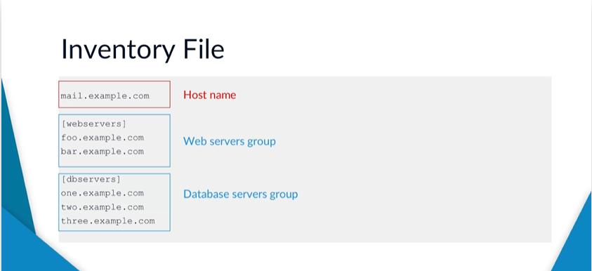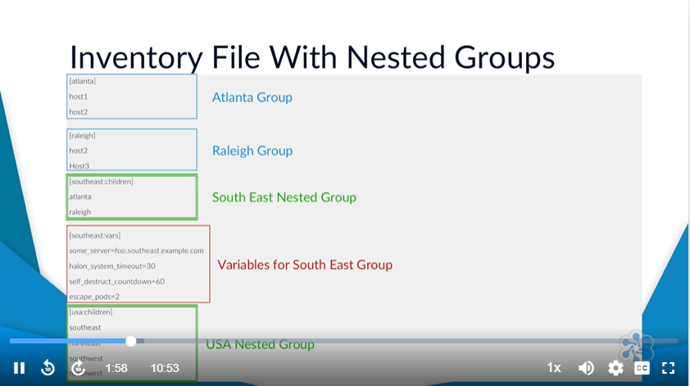

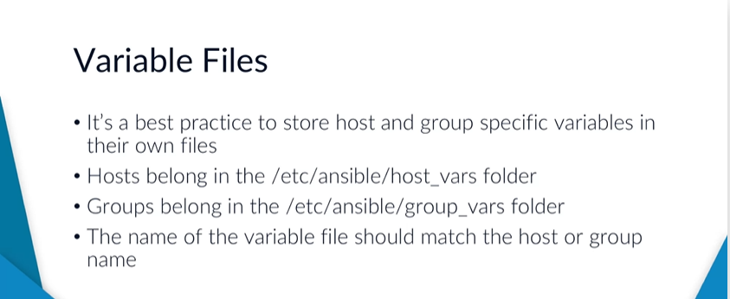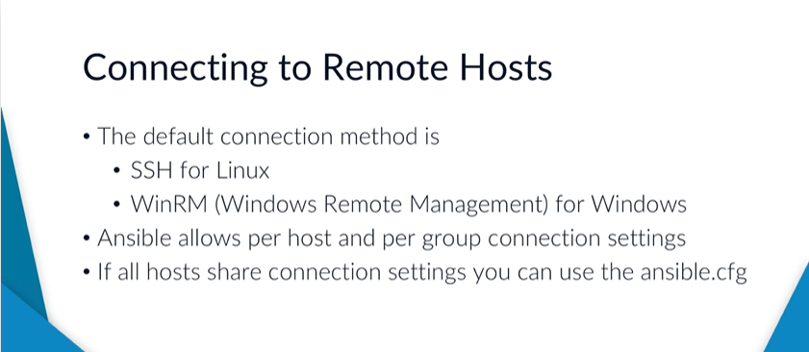

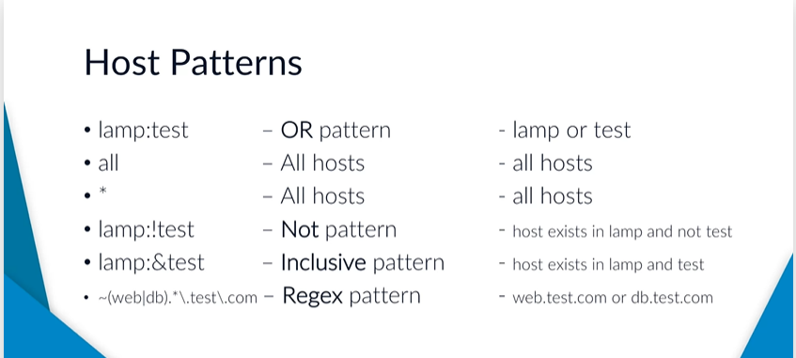

Creating an inventory with Ansible

***Step 1.***

1. Make sure ***Python*** (Windows or Linux, though it comes pre-installed for Linux systems) and ***pip*** are installed on the control/local machine.
2. Install ansible with: ***sudo pip install ansible***
3. Create 3 Ubuntu (open up ports for SSH and HTTP) and 1 Window (open up a port for RDP and HTTP, SSH) servers, EC2 instances with tags named AnsibleDemo, on AWS named and copy the DNS name of each. Also, open the SSH and HTTP port for all servers and also port 5986 on the Windows server

* AnsibleDemo-1
* AnsibleDemo-2
* AnsibleDemo-3
* AnsibleDemoWindows

*Lastly, create an EC2 key/pair to connect to the servers and save it in your desired location preferably in the .ssh directory for Linux or create the .ssh directory if not there and move the key/pair to it. Now change the file permission of the keypair using***: chmod 400 ~/.ssh/keypairname.pem**

***STEP 2.***

We have 3 groups: lamp (Linux, Apache, MySQL, and PHP [but we will use Python instead]), test, and windows.

Create 3 groups by opening the host file and doing the below at the bottom of the file by using the public IPV4 DNS (AWS EC2 instances and run on each: ***sudo apt update*** and ***sudo apt install python***) name of each server by running:

***nano /etc/ansible/hosts***

A terminal editor opens. Create the group as shown below. Then ‘Ctrl + X ‘ to exit and ‘Yes’ to save the file

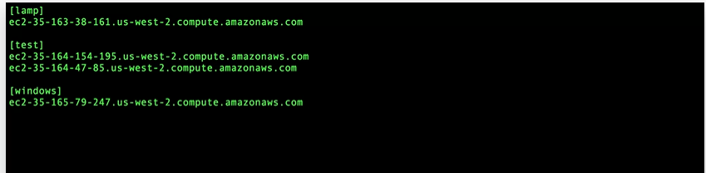

Instead of the above, you could just run, from the cmd to test the connection, for each EC2 instance created: ***ssh -i ~/.ssh/keypairName.pem ec2-user@ec2intsanceIpAddress***

Instead of the above, for my windows computer below is what worked

***Step 3.***

Make sure ***Python*** and ***pip*** are installed on the control/local machine.

Make sure login into the terminal as a root (***sudo -i***) user and then try to connect.

Ansible still cannot connect to the lamp server. If you try using ***ansible lamp -m ping*** or for more debugging output ***ansible lamp -m ping*** ***-vvv***, you get an error

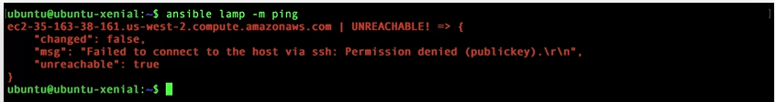

Now we will configure the Linux server connection for Ansible and Windows in the ansible.cfg file.

***For Linux***:

Run the command: ***nano /etc/ansible/ansible.cfg***

Now page down to this line: . Uncomment the line, and change the path to the key/pair file path on your machine. E.g., .

If you try to connect to the lamp and test group now, it will connect successfully as shown below run: ***ansible lamp:test -m ping*** or ***ansible lamp:test -m ping*** ***-vvv***

