**Modelling information:**

**Curated semi-mechanistic modeling of Srxn1 dynamics under various stress conditions**:

$Synthesis of Srxn1= buildSrxn1Base$ Eq. 1

$Degrdation of Srxn1= degradSrxn1 * Srxn1$ Eq. 2

$Fraction_X=\frac{1}{\left(\frac{1}{initial_fraction_X}- 1\right)*exp\left(-t*r\right)+ exp\left(t*decay\right)}$ Eq. 3

**########**

**Fraction_X under repeated dosing scenarios**;

${Fraction}_{X}=\frac{1}{\left(\frac{1}{{initial}_{{fraction}_{X}}}- 1\right)*exp\left(-t*r\right)+ exp\left(t*decay\right)} \{t≥0, t≤t_{dosing}\}+\frac{1}{\left(\frac{1}{initial_fraction_X2}- 1\right)*exp\left(-t_dosing*r2\right)+ exp\left(t_dosing*decay2\right)} \{t≥t_{dosing}\}$ Eq. 4

$Nrf2_{induced}Srxn1_{expression} = \frac{\left({Vmax}_{buildSrxn1}*{Nrf2}^{hill}* Nrf{2^{*}}^{{hill}^{*}} \right)}{\left({Km}^{hill}+ {Nrf2}^{hill}\right)*\left({{Km}^{*}}^{{hill}^{*}}+ Nrf{2^{*}}^{{hill}^{*}}\right)}$#########

Eq. 5

$Nrf2^{*}= NRF2_{T}*\left(Fraction_X\right)$ Modified Nrf2

$Nrf2= NRF2_{T}*\left(1-Fraction_X\right)$ Unmodified Nrf2

$NRF2_{T}= Nrf2+ Nrf2^{*}$ Total Nrf2

$\frac{d}{dt}\left(Srxn1\right) = Synthesis of Srxn1+ Nrf2_{induced}Srxn1_{expression}- Degrdation of Srxn1$

Where,

$buildSrxn1Base$ is the synthesis rate constant of *Srxn1*

$degradSrxn1$ is the degradation rate constant of *Srxn1*

$Fraction_X$ is the unknown molecule X that acts as an activator which dynamics could be regulated either by Nrf2 itself or by many other signaling pathways which then modify Nrf2 either by forming a heterodimer complex withNrf2 (Nrf2_maf) or changes the Nrf2 in different form (acetylation, sumoylation).

$initial_fraction_X$ is the initial amount of *Fraction_X*

$r$ is the rate constant by which *Fraction_X* increases

$decay$ is the rate constant by which *Fraction_X* decreases

####################################

**Fraction_X under repeated dosing scenarios (Eq. 4)**

$initial_fraction_X2$ is the Fraction_X value at the time of the second dosing or the last observation time point of a first dosing

$t$ is the model time

$t_dosing$ is the starting model time at which a second dose is administered that continue till the last observation

$r2$ is the rate constant by which *Fraction_X* increases after a second dosing

$decay2$ is the rate constant by which *Fraction_X* decreases after a second dosing

${Vmax}_{buildSrxn1}$#####################################

is the maximum induction rate of Srxn1 by the $NRF2_{T}$

$Nrf2$ is the Nrf2 that remains unmodified

$Nrf2^{*}$ is the Nrf2 that modified by the activator i.e. *Fraction_X*

$Km$ Michaelis constant for the *Nrf2*

${Km}^{*}$ Michaelis constant for the $Nrf2^{*}$

$hill$ hill coefficient for the *Nrf2*

${hill}^{*}$ hill coefficient for the $Nrf2^{*}$

why semi-mechanistic: Nrf2 experimental data is used as an input to explain the Srxn1 data. And to establish the relationship between the Nrf2 and the Srxn1, we have used a mathematical equation comprised of following **four different processes**:

1) synthesis of Srxn1 -> zero-order reaction

2) degradation of Srxn1 -> first-order reaction

3) Fraction X -> explain via a logistic equation using three parameters, see equation 3, (continuous scenarios and initial/first dosing in the case of repeated dosing) or five parameters, see equation 4, (additional two parameters included to capture the effect of subsequent/second dosing in the case of repeated scenarios). And the maximum value of X was constrained to 1.

4) Nrf2 induced Srxn1 expression -> catalytic activation reaction process i.e.

The 4th process is described by a catalytic activation method comprises of a simple mechanism i.e. direct binding of Nrf2 to ARE, and a complex mechanism i.e. recruitment of activator " Fraction X " that modifies the Nrf2, or form a heterodimer complex, or this " Fraction X " could also be regulated by many other signaling pathways, which ultimately could act as a catalyst that increases the transcriptional strength. This complex mechanism is subject to change under diverse conditions in trans activating target genes complementing the Nrf2 regulation of ARE. So in order to capture the Srxn1 dynamics under diverse conditions such as exposure to different chemicals (chemical specific), and single exposure or multiple stress exposure of different timing (dosage regimen specific), parameters explaining the complex mechanism i.e. recruitment of activator " Fraction X " and it's dynamic were made both chemical and dosage regimen specific. And this " Fraction X " was modeled dynamically and is constrained to a maximum value of 1. Then the " Fraction X " and (1-" Fraction X ") is multiplied to the Nrf2 that provides the **unmodified Nrf2** (Subs) and the **modified Nrf2** (Act) respectively (input for 4th process) keeping the **total experimental Nrf2 constant**.

The model **parameters were categorized** into 1) a common parameter, 2) a chemical-specific, and 3) both a chemical specific and a dosage regimen specific parameter. 1st and 2nd category of parameters was estimated against the 24+24 continuous scenarios data whereas 3rd category of parameters was estimated separately using the repeated dosing scenarios data.

The dynamics of 'Fraction X' was explained by three parameters i.e. “initial fraction”, “r" (synthesis of X) and "decay" (degradation of X), which is a chemical specific. But the “initial fraction” was kept constant for all the chemicals assuming it as a biological variable that’s why it was categorized under common parameters.

Variation in response among different chemicals and among different dosage regimen was accounted for through the “Fraction X” dynamics described via three to five different parameters. This was accomplished with a hierarchical model framework by letting the following “Fraction X” dynamics parameters estimation specific to different chemical treatments and different dosage regimens, for a second dosing in the case of repeated dose.

1st and 2nd category parameters were estimated against the continuous dosing (24 +24) Srxn1 experimental data. And then the same estimated value of “r” and “decay” was used to predict the Srxn1 dynamics for the first dosing in the case of both 8+24 (till 8 hrs.) and 24+24 (till 24 hrs.) repeated scenarios.

But to explain the Srxn1 dynamics i.e. after administration of subsequent (second) dosing i.e. from 8 hrs. till 32 hrs. (8+24) and from 24 hrs. till 48 hrs., 3rd category parameter comprising two extra parameters "r2" and "decay2" that further modify the “Fraction X” dynamics were included in the 3rd process mechanism.

These additional two parameters in 3rd process (“Fraction X” dynamics), assuming them as dosage regimen specific, were estimated separately for 8+24 and 24+24 repeated scenarios utilizing the 8+24 and the 24+24 repeated SRXN1 data respectively for each chemical keeping all other parameters constant i.e. general and chemical-specific.  The 8+24 and 24+24 repeated SRXN1 data, of the dosing matrix comprised of the first dosing from low to high and the fixed highest dosing was selected.

Here is the schematic of Model fitting process:

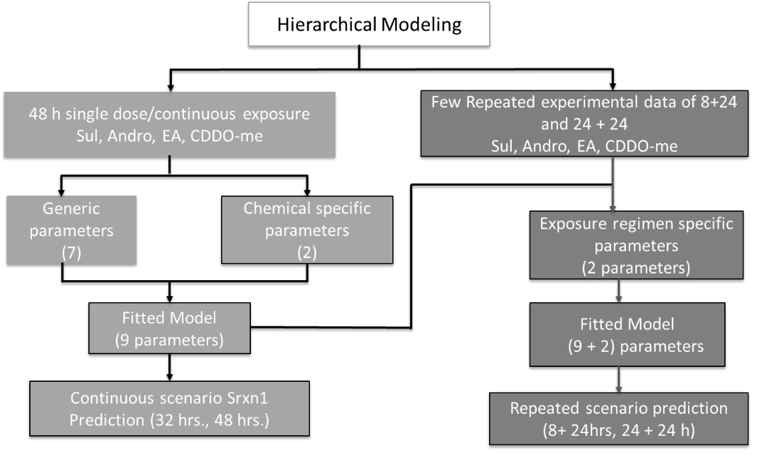

#### Figure 1: Nonlinear mixed modelling framework:

## Assumptions and rationale:

* + Generic Mechanism: Nrf2 activates Srxn1 via simple non-linear mechanism and can be generalized for all considered chemicals.
  + Specific Mechanism: Nrf2 itself can potentiate the Srxn1 activation via an indirect mechanism and the degree of activation can be chemical specific.

Bayesian approach with mixed-effects modeling techniques to estimate both generic and chemical specific dynamic parameters