Lacey Redinger

12-2-19

Foundations of Programming: Python

Assignment 09

<https://github.com/lacerock/IntroToProg-Python-Mod9>

Modules

# Introduction

This week we learned about importing modules into Python. In previous weeks we have imported from the standard library (like pickle or os) but any script with any code can be imported into another script or inherited in order to use its classes and functions. This is just another way of organizing and sharing code. There is no need to recode something that someone else has already done, simply import their code and use it or combine it with your own.

# Assignment 09

This week’s assignment was fairly simple since all the code was already written. I suspect this is similar to what most people do now. It’s still important to know *how* to code so you can read what others have done or improve upon it, but in many cases it’s a lot of copy/paste or importing pre-created classes.

I took the framework from previous assignments, imported the modules provided by Professor Root, and then called the functions needed to create the program.

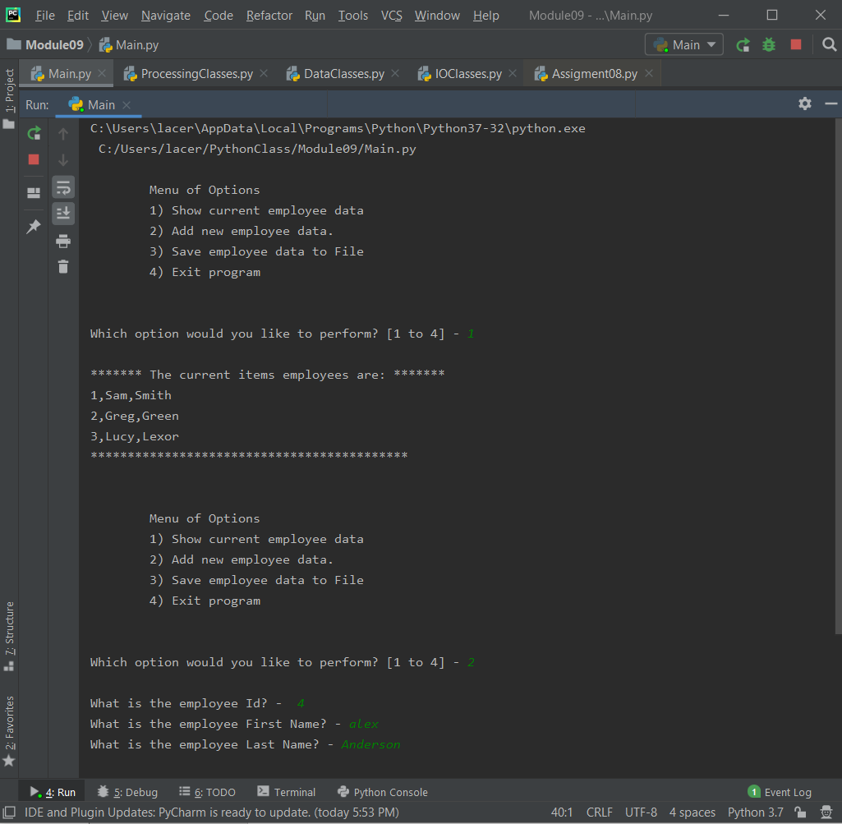

***Figure 1: Script working in PyCharm (Menu Options 1-2)***

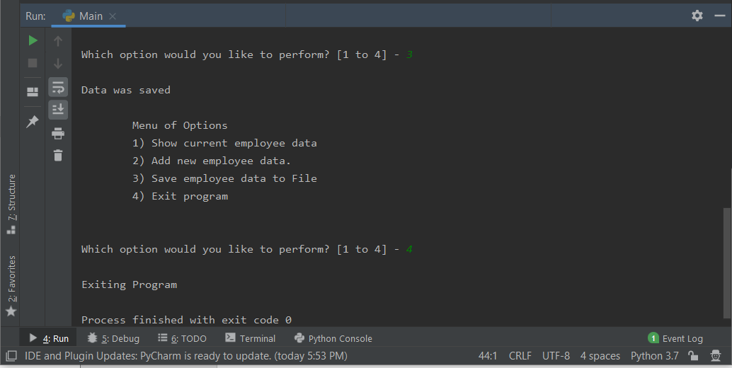

***Figure 2: Script working in PyCharm (Menu Options 3-4)***

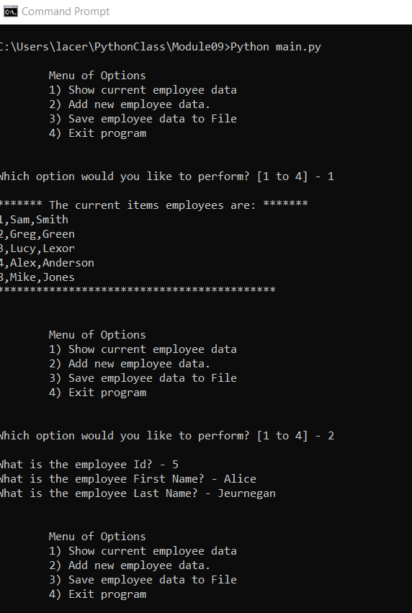

***Figure 3: Script working in Windows CMD (Menu Options 1-2)***

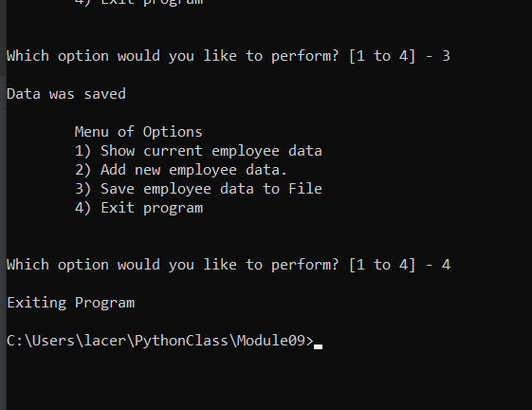

***Figure 4: Script working in Windows CMD (Menu Options 3-4)***

# Summary

Using modules is a great way to create programs and get things done faster. It’s strange for me to create in this way, it feels a bit like plagiarism! Apparently, this is all cool in the coding community and it certainly does make things a lot easier.