Robotics Lab Safety Procedures Guide

Version 1.0
Date: February 23, 2026
Authors: Mary Everett, Dawson Burgess, James Lasso

Lab Manager:
Dawson Burgess
dburgess@vandals.uidaho.edu

Instructor:
John Shovic
jshovic@uidaho.edu

University of Idaho
Center for Intelligent Industrial Robotics
Department of Computer Science
Coeur d’Alene & Moscow Campus

Table of Contents:
A. Understanding Lab Hazards
- Soldering Hazards
- Electric Hazards
- Cobot Hazards
- Non-Cobot Hazards
B. Safety Supplies Locations
- First Aid Kits
- Mobile Eye Wash Stations
- Fire Extinguishers
C. Emergency Procedures
- Fire Evacuation
- Other Emergencies
D. Lab Areas
- General Access
- Food and Drink Policy
E. Training Certification
- General Robotics Lab
- CNC Machine

Guide
A. Understanding Lab Hazards
The Robot Lab has several hazards to be aware of. When in doubt, make sure to ask the Lab Manager for help!
I. Soldering Hazards
The soldering stations are located on the second floor of the Hedlund building in the Coeur d’Alene lab, and in the Robotics lab in Moscow. When soldering, make sure the area is well ventilated (use the fume hoods and/or ensure that doors are open).
Soldering creates potential burn hazards. Be sure to check your soldering station and ensure you do not touch the iron tip if it is heated. Be careful to ensure the station is turned off when you are finished or any time you leave the station.
Solder can be toxic. Lead solder should be handled with care, and non-lead solder can create dangerous fumes. Be sure to wash your hands carefully when you are finished, and do not eat while you are working on projects.
Eye protection is available in the lab. It is a good idea to wear eye protection while soldering, especially if your eyes are sensitive to the fumes.

II. Electric Hazards
Do not plug in or unplug anything in the Robotics Lab without the express permission of the Robot Lab Manager. These can damage components, or create high voltage/high current risks which can endanger your life!
Some PLC projects can involve electrical hazards. Unless you are trained, do not attempt to wire up components yourself. Make sure to keep clear of projects that aren’t your own. If you are working with high volatages/currents, ALWAYS turn off the project when in direct contact with it and any time you leave the area. This can create huge risks for others in the lab! If you have a question about any project in the lab, ask the Lab Manager – do not attempt to investigate yourself. Again, this could create hazards for yourself or for damaging equipment.

III. Cobots Hazards
Most of the robots in the lab are cobots (collaborative robots), which are safe to work with. However, there are still risks to be aware of. Be knowledgeable about the robots working area and keep clear of robot arms while they are moving. Wear eye protection against poke risks any time you are in a cobot’s work area. While the work areas are generally marked, ask if you are unsure if a robot can reach a given area. Be aware that cobots have pinch hazards even at low speeds.
IV. Non-Cobot Hazards
We have several robots in the lab that are not collaborative robots, and have special safety considerations:
Larry (Fanuc P50ib) (CDA only): Larry is a 700-lb Fanuc robot kept in a locked inner cage. The cage has protected access and is not generally available to students. If you have received cage access, NEVER enter the cage while Larry is powered on. NEVER leave the cage unlocked.
Scaramouche (SCARA robot) (CDA only): The Epson SCARA robot is also non-collaborative. We are in the process of installing a light curtain around this robot to control access. In the meantime, stay far away from the work envelope of the robot and never approach it while it is on.
CNC Robot (CDA only): The CNC area is restricted. No student should be working on or near the CNC machine without training one-on-one from Project Manager James Lasso.

B. Safety Supplies Locations
First Aid Kits and Stop the Bleed Kit – mounted on the inner side entrance to the cage.
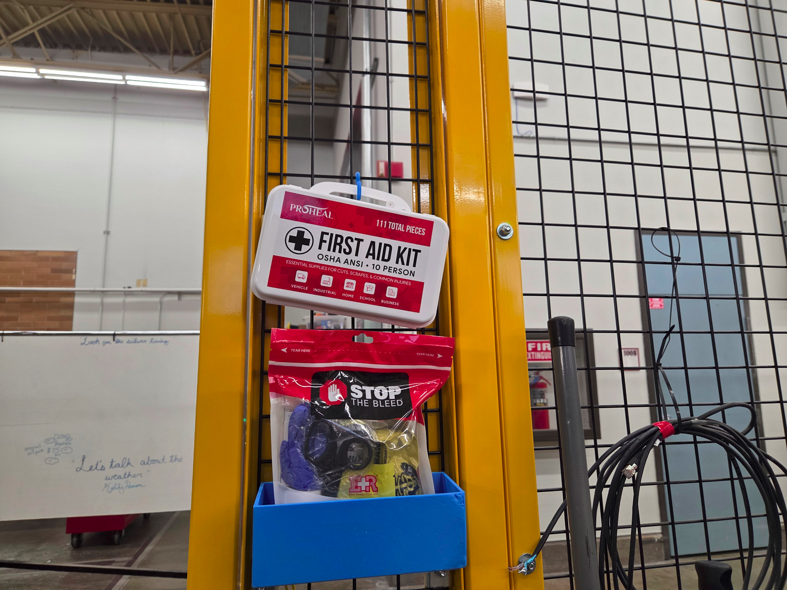
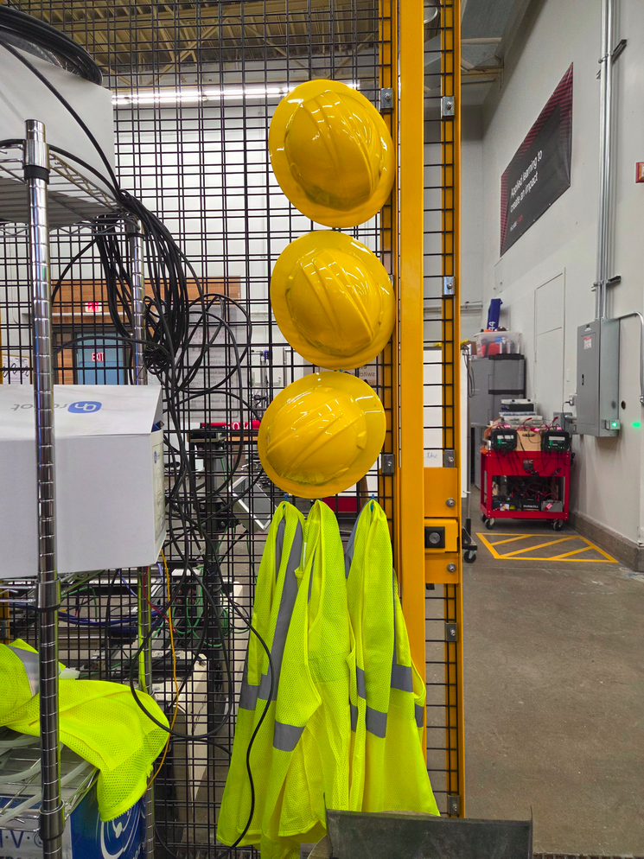
Hard Hats and High-Viz Vests – mounted on inner cage entrance, opposite first aid kits.
Mobile Eye Wash Stations – located on the wall outside the cage near the stairwell.
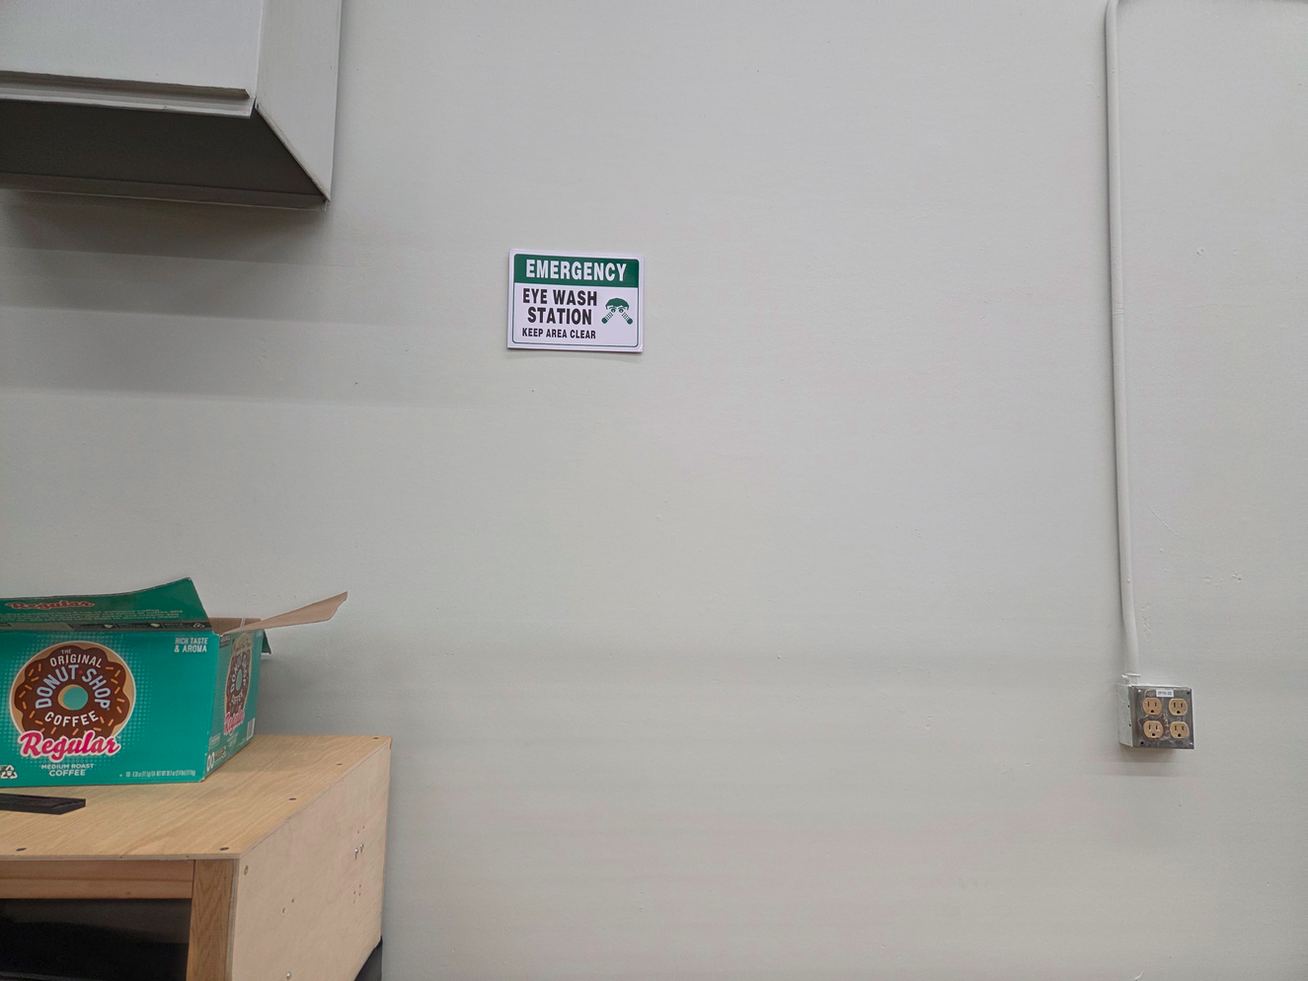
Fire Extinguishers – located near office 100A, wall mounted.
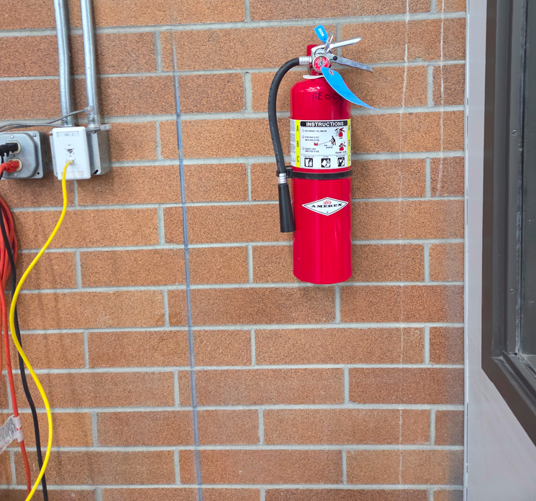

C. Emergency Procedures
Fire Evacuation
The most likely scenario you will run into in the lab is a fire evacuation. The Hedlund building is a shared space and there are several units within it with the capacity to activate the fire alarm. If you hear the fire alarm (accompanied by flashing lights):
1. Leave all items behind in the lab
2. Do not use the elevator, take the stairs.
3. The meeting point for a fire evacuation in CDA is in front of the Hedlund building, next to the outdoor fountain.
4. A firefighter or NIC campus safety/security officer will let you know when it is safe to go back inside.

Other Emergencies
Call 911 for all other emergencies. Follow posted campus and security procedures.

D. Lab Areas
I. General Access
The Robotics class lab manager sets lab access hours and policies. If you do not have keyed access to the labs, be sure to coordinate with the lab manager for dates/times to work on projects and assignments.

If you have keyed lab access, make sure to lock up every time you leave the area. Be sure to turn in your keys after each semester. Lab access is coordinated by Tammy St. John-Tesky, tammy@uidaho.edu. You will need permission from your instructor or project manager before requesting access.

II. Food and Drink Policy
No food or drink is allowed inside the robot cage. It is acceptable outside the cage on chairs/tables. Keep your area clean.

E. Training Certification
I. General Robotics Lab
To use the Robotics Lab, you must first undergo training. This is provided in one of the following classes:
- Robotics Systems Engineering I
- Robotics Systems Engineering II
- Programmable Logic Controllers (PLCs)
- Advanced PLCs
- Real-Time Operating Systems
- Embedded Systems
Or, one-on-one with the Lab Manager.
The Lab Use checklist is as follows:
- In-Person Training Completed
- Risk Waiver Signed
- Safety Manual (this document) Read

II. CNC Machine
The CNC Machine requires one-on-one training with the project manager (James Lasso). The project manager will certify students individually for machine use.

