CIT 140 Analyst Portfolio Review

Prepared by: Lacey Merced
Course: CIT 140
Review date: November 2, 2026
Version: Final Portfolio Review

Client Overview
This portfolio reviews my work from Weeks 1–7 in CIT 140. It gives the client a clear summary of the analysis completed, the evidence supporting each artifact, why the findings matter and what still needs to be checked. Each weekly case is kept separate and the original files remain in their original course folders.

Contents
Week 1 – Problem Brief
Week 2 – Business Case Recommendation
Week 3 – Stakeholder Map
Week 4 – Validated Requirements Set
Week 5 – As-Is Process Model
Week 6 – Data-Flow Model
Week 7 – Data-Quality Report
Closing Review
Evidence List

Week 1 – Problem Brief
What the artifact shows:
This problem brief explains the MR-17 incident, including the repeated retired test command, the effect on production and the information that still needed to be verified.
Why it matters:
It helped separate confirmed facts from assumptions and showed what evidence needed to be checked before deciding what caused the incident.
What still needs to be checked:
The source and ownership of legacy_sync.exe still needed confirmation, along with whether Test K-44 remained in another service or schedule.
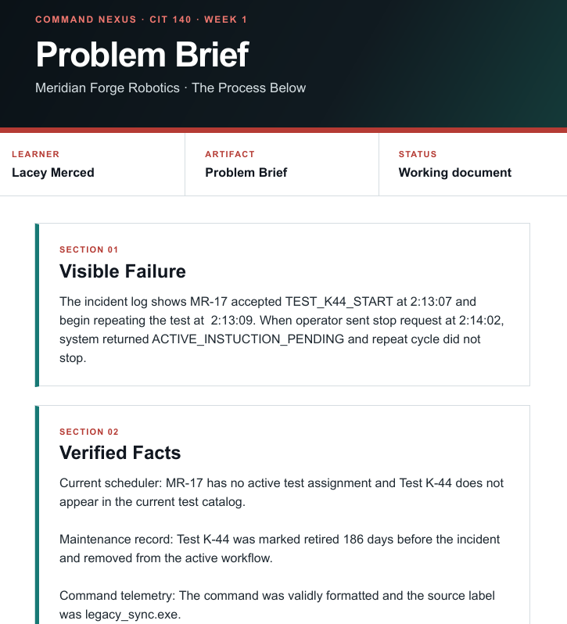
  - Figure 1. Week 1 Problem Brief excerpt. Source: Week 1 Problem Brief PDF.
  - CIT140-Week-1/Merced_Lacey_CIT140_Week01_Problem_Brief.pdf at main · laceymerced/CIT140-Week-1

Week 2 – Business Case Recommendation
What the artifact shows:
This business case reviews whether the proposed work is worth considering and identifies important limits such as scope, time, resources, and available evidence.
Why it matters:
It helps determine whether the proposed work is realistic before time or resources are committed.
What still needs to be checked:
Any remaining assumptions about available resources, access, cost, or approval should be confirmed before moving forward.
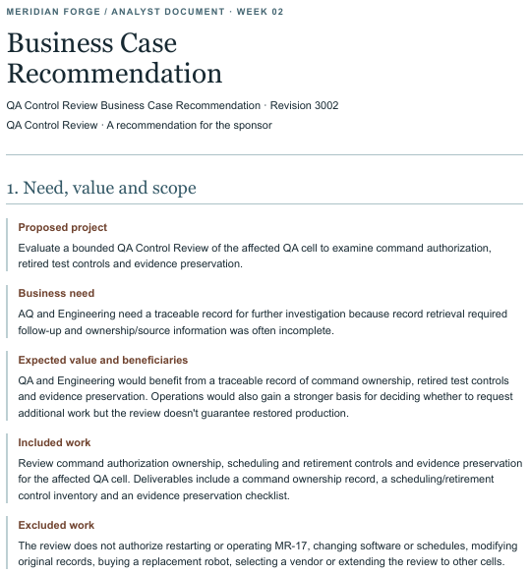
  - Figure 2. Week 2 Business Case Recommendation excerpt. Source: Week 2 Business Case Recommendation PDF.
CIT140-Week-1/Week 2/Merced_Lacey_CIT140_Week02_Business _Case.pdf at main · laceymerced/CIT140-Week-1

Week 3 – Stakeholder Map
What the artifact shows:
This stakeholder map identifies the people affected by the work and the people whose knowledge, input, or authority is needed.
Why it matters:
It helps show who should provide information, who may be affected by decisions, and who has responsibility or approval authority.
What still needs to be checked:
Any missing stakeholder roles, responsibilities, or approval limits should be confirmed before making recommendations.
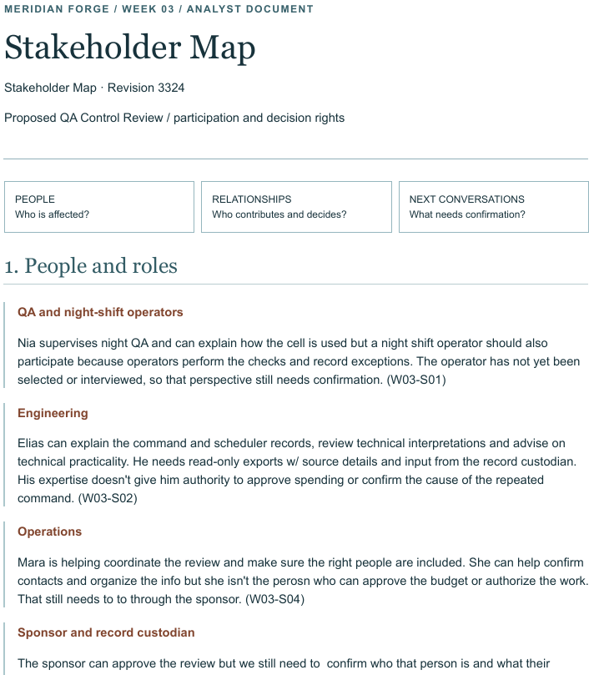
  - Figure 3. Week 3 Stakeholder Map excerpt. Source: Week 3 Stakeholder Map PDF.
CIT140-Week-1/Week 3/Merced_Lacey_CIT140_Week03_Stakeholder_Map.pdf at main · laceymerced/CIT140-Week-1

Week 4 – Validated Requirements Set
What the artifact shows:
These requirements set turns stakeholder needs into clear requirements that can later be checked against a proposed solution.
Why it matters:
Clear requirements give the team a way to evaluate whether a future solution actually meets the identified needs.
What still needs to be checked:
The requirements should be reviewed again when solutions are compared to make sure each requirement can be tested and supported by evidence.
  - 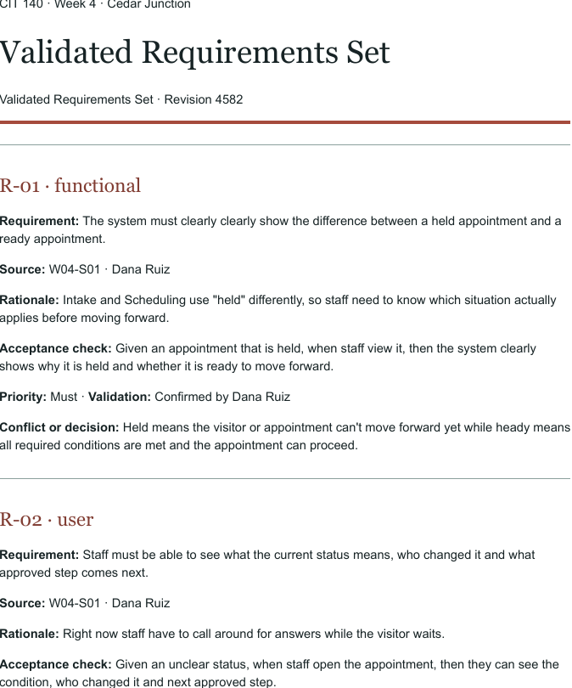
  - Figure 4. Week 4 Validated Requirements Set excerpt. Source: Week 4 Requirements PDF.
CIT140-Week-1/Week 4/Merced_Lacey_CIT140_Week04_Validated_Requirements_Set.pdf at main · laceymerced/CIT140-Week-1

Week 5 – As-Is Process Model
What the artifact shows:
This process model shows how the current work happens, including the major activities, decisions, and handoffs between people or roles.
Why it matters:
It makes the current process easier to understand and helps identify where delays, confusion, or missing information may occur.
What still needs to be checked:
Any unclear handoff or decision point should be confirmed with the appropriate source before recommending a future process.
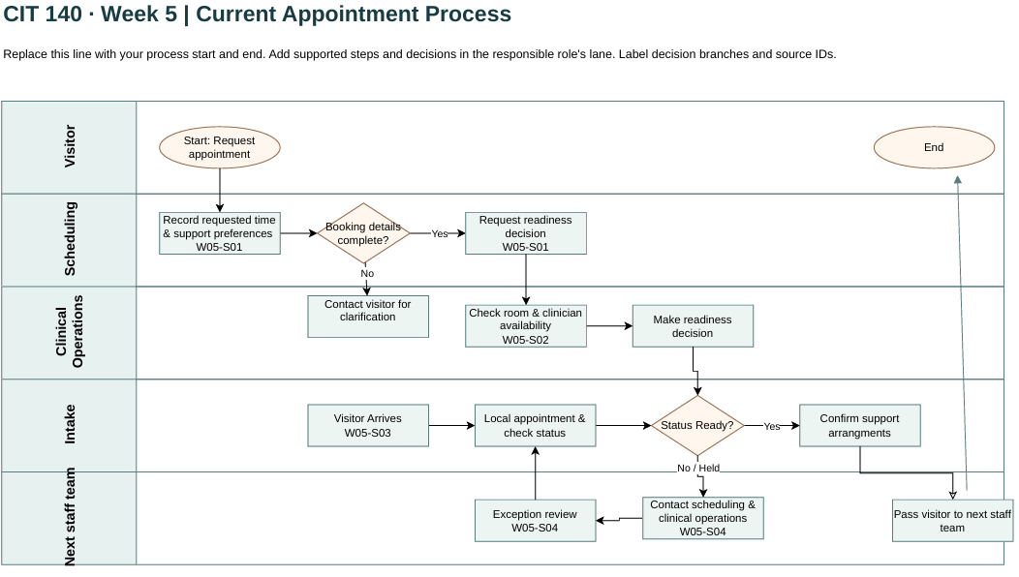
  - Figure 5. Week 5 As-Is Process Model excerpt. Source: Week 5 Process Model PDF.
CIT140-Week-1/Week 5/Artifact/Merced_Lacey_CIT140_Week05_As_Is_Pricess_Model.drawio.pdf at main · laceymerced/CIT140-Week-1

Week 6 – Data-Flow Model
What the artifact shows:
This data-flow model shows how information moves between people, processes, systems, and records.
Why it matters:
It helps identify where information comes from, where it goes, and where missing or unclear data could affect the process.
What still needs to be checked:
Any unclear data source, ownership, or handoff should be confirmed before making a design decision.
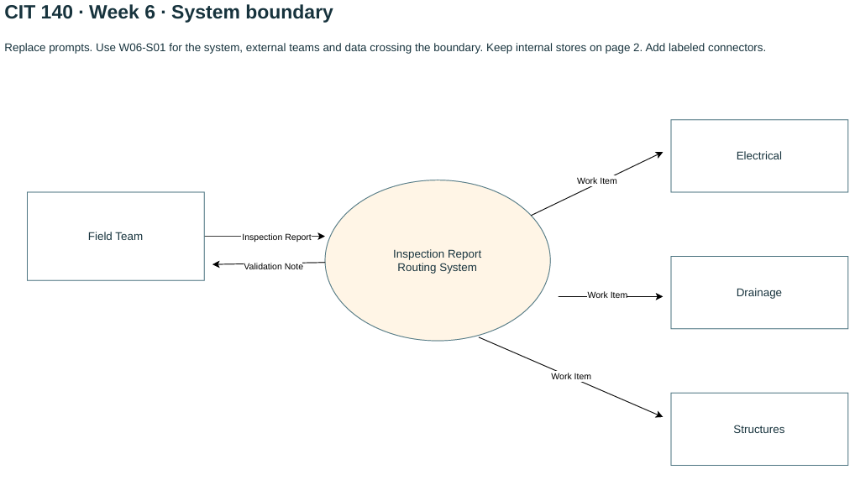
  - Figure 6. Week 6 Data-Flow Model excerpt. Source: Week 6 Data-Flow Model PDF.
CIT140-Week-1/Week06/Artifact/Merced_Lacey_CIT140_Week06.pdf at main · laceymerced/CIT140-Week-1

Week 7 – Data-Quality Report
What the artifact shows:
This data-quality report checks 20 inspection records using rules for required values, repeated work orders, valid status values, inspection duration, and inspector information.
Why it matters:
It identifies records that may not be reliable enough for their intended use and shows which records require follow-up instead of guessing at missing information.
What still needs to be checked:
The repeated Work_Order_ID records should be verified, and the missing or out-of-range inspection durations for R10, R18, and R20 should be checked against the original inspection records.
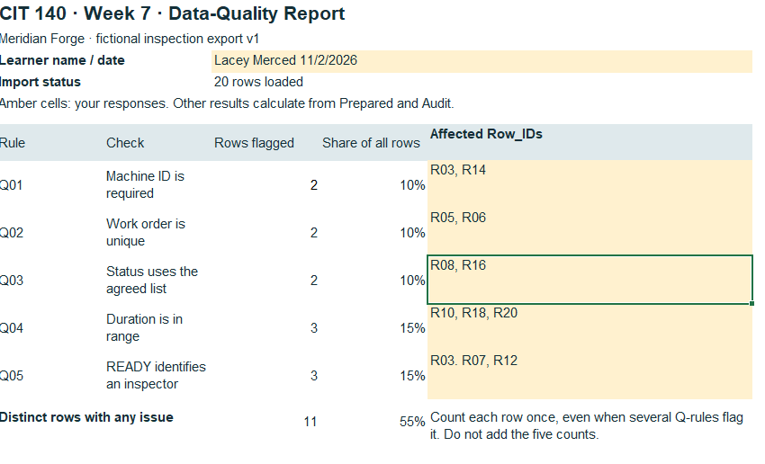
  - Figure 7. Week 7 Data-Quality Report excerpt. Source: Week 7 Data-Quality Report.
CIT140-Week-1/Week07/Artifact/Merced_Lacey_CIT140_Week07 (Revised 11.2.26).pdf at main · laceymerced/CIT140-Week-1

Closing Review
Across Weeks 1–7, my analysis moved from identifying problems to reviewing whether further work was justified, identifying stakeholders, defining requirements, mapping processes and information flow, and checking data quality. The work shows how evidence can be used to support findings instead of relying on assumptions.
Some questions still require confirmation from original records or responsible stakeholders. Before comparing solutions or designing a future system, those remaining gaps should be reviewed so that decisions are based on reliable evidence.

Evidence List

Week 1: Problem Brief – original Week 1 Problem Brief PDF
Week 2: Business Case Recommendation – original Week 2 recommendation PDF
Week 3: Stakeholder Map – original Week 3 map/report PDF
Week 4: Validated Requirements Set – original Week 4 requirements PDF
Week 5: As-Is Process Model – original Week 5 editable diagram and PDF
Week 6: Data-Flow Model – original Week 6 editable diagram and PDF
Week 7: Data-Quality Report – original Week 7 Excel workbook, Report PDF, and Applied Steps screenshot

