Curtin College
Unix and C Programming
Assignment Report

Table of Contents
File Purposes 3
Storing and Loading Implementation 4
Demonstrations 5

File Purposes
AsciiPrinting.c:
This file contains the main animation function which is used to print different frames of the Simon Says character to the screen. It does this by looping through each frame and refreshing the screen, which means it is actually scrolling through the command line. Also in this file are the functions that match each description, pointers of which will be used within the linked list. These functions are a wrapper for the animation function, only with the frames changing for what the actions are.
AsciiPrinting.h:
The header file contains the normal function headers for the .c file as well as macros, which define the various positions or frames that Simon will be iterated through for the animation. Each animation has two frames and a text box with Simon responding to the command. The refresh macro is also defined here and is just many new line characters printed in a row. Sending a system command to clear the command line was tested, but found the new lines were much smoother for the animation.
Command.c
The command.c file is small, consisting only of three functions which all tie in to processing commands to be added to the linked list. There is also a short print command that is used to streamline getting output from each command structs function pointers.
Command.h
This file is header guarded to prevent multiple implementations during the compiling process as it contains a struct that defines what a command is. This is what is contained in the data of each linked list node. It was decided to use this method to better contain the necessary pieces of info that each command consists of, a function pointer to the animation action, and a description of that corresponding action.
Game.c
The game.c file contains the main function for the program. It has been kept purposefully short to allow for better readability of how the program functions and continues to function through menu inputting while running. It also checks for correct usage when called in the command line and issues help statement if incorrectly run. This is where the freeing of the master list which contains the reference list as well as the user commands list is freed from at the exiting of the program.
Game.h
This file does not contain any macros and is only used for the necessary headers of files whose functions are used in game.c.
Input_checking.c
The functions in this file are used to check that the user of the program is inputting the correct information into the program. Separating this out from the rest of the program made all the other files much more readable. This is because all the string manipulation and incorrect usage messaging can convolute the main purpose of the program.
Input_checking.h
This is where the headers of the functions from input_checking are stored, as well as a macro which is used in the scanf function to prevent buffer overflows during the intake of a string from the user. It is important to do this to prevent any vulnerabilities occurring by malicious agents looking to access parts of the program not meant to be open.
List.c
This file contains functions relating to the creation and maintaining of the master linked list used in the program. This is also the location where a file is parsed for input and this input processed into the appropriate command. The true functionality of freeing is inside this file as well, with game.c simply calling it in main as convention recommends. However if a command is deleted, the delete function must also free the command and by calling the dequeue function, also delete the linked list node.
List.h
List.h is where the struct of the ListNode and LinkedList is defined. It is Header Guarded to prevent multiple definitions of the struct. The Linked List is singularly linked with the head pointing to the first node and each node pointing to the node that’s next and the last node pointing to null, daisy chaining together a list that can be iterated through. The Linked List also contains a tail, count and pointer to a second linked list, used as a reference list. The tail is useful to allow for O(1) efficiency, which tying the count of the linked list is essential to limit variables being passed to functions. The count is important to keep track of the number of commands and therefore iterations needed for a variety of functionality including playing Simon Says, deleting, and freeing.
Menu.c
The menu mostly contains functions that are offering choices to the user and then directing that choice to the various functions that allow that action to occur. Through the use of enums and a switch statement the menu options are called by single functions, having abstracted each choice to this level, within the entire program. This is also where conditional compilation comes into play. The Everything Mode is compiled without any extra and specific functions to that mode. Instead the functions that exist for the normal mode were added to with clauses indicating a different path given Everything Mode was defined.
Menu.h
This file contains the usual header functions as well as the definitions for the enums used in the menu switch statement for better readability.
Queue.c
This is where the traditional queue and dequeue functions have been placed to seperate them from the linked list normal functionality. These queue functions make the most sense to use for this program as the animation are meant to happen in a queue like structure. If commands were input from a file and then in the program a command was added, this command is expected to be seen last by the user when playing Simon Says. The functions used to create the command reference list is contained in this file, separating it from the user master list.
Queue.h
A standard header file with a macro very similar to the input_checking.h macro used to prevent buffer overflows in scanf functions.
Makefile
The compilation point for the program. To change from normal mode to Everything Mode first “make clean” then compile with “make CFLAGS=”-D EVERYTHING”.
Everything_mode.txt
Testing all commands and actions in one file, including the actions that Simon will default to if he does not know the command or it is a “Simon didn’t say” command.

Storing and Loading Implementation
Starting from the micro level of where each input goes for a command, either from a user or file, it was decided to process this into its own struct, where the animation function pointer could be added as needed. This way, it could be transported through the program in a self-contained manner. It was important that when parsing the command description, their would be no buffer overflow, ensuring the integrity of the program.
On a macro level there are two linked lists in the program, one is the reference list which is self-contained within the user command list. Structuring it in this manner was decided for to make it simpler to add more Simon Says commands if needed, thus making it more scalable. The reference command is looped through when checking user input for a match to the description entered. This has a time complexity in the worst case of O(n). The linked list structure was also beneficial for the display of commands processed as it acted as a queue, with the correct functions implemented, as is expected performance-wise from a program that takes multiple commands. The complications that were overcome, were mostly to do with the header guards, as with so many files and three different structs, their were dependancies that were breaking the compilation without them.

Demonstrations
Execution without input file (left) and with input file (right)
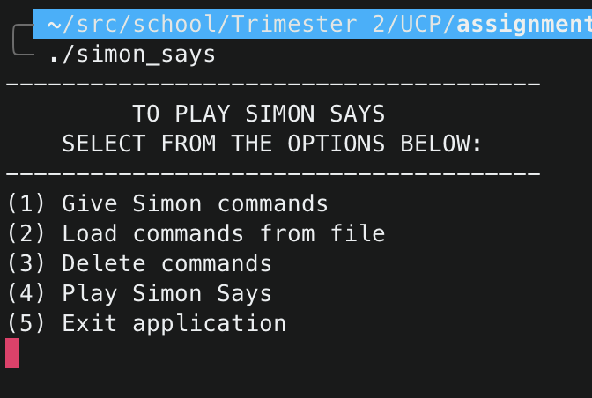
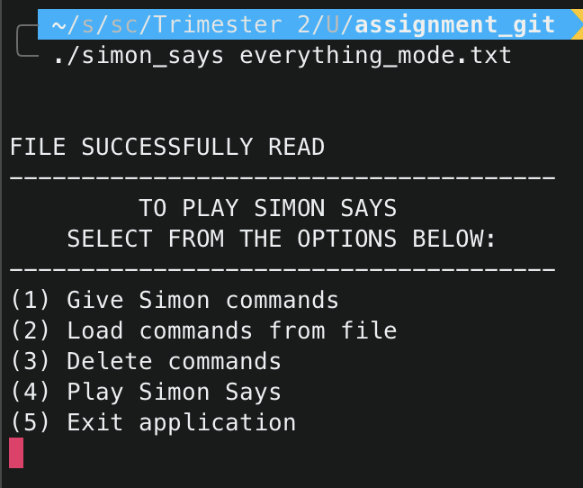

Freeze frame of dance output on left and reaction to didn’t say on right
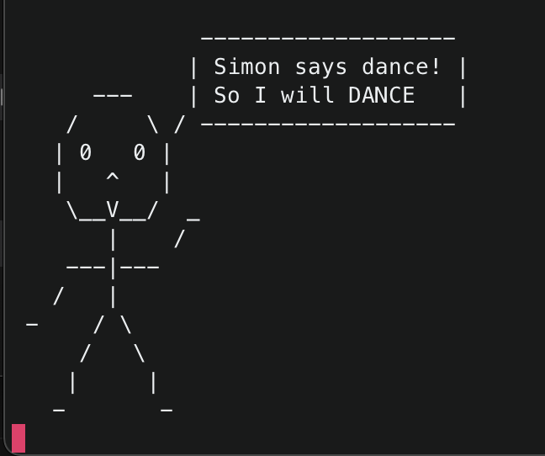
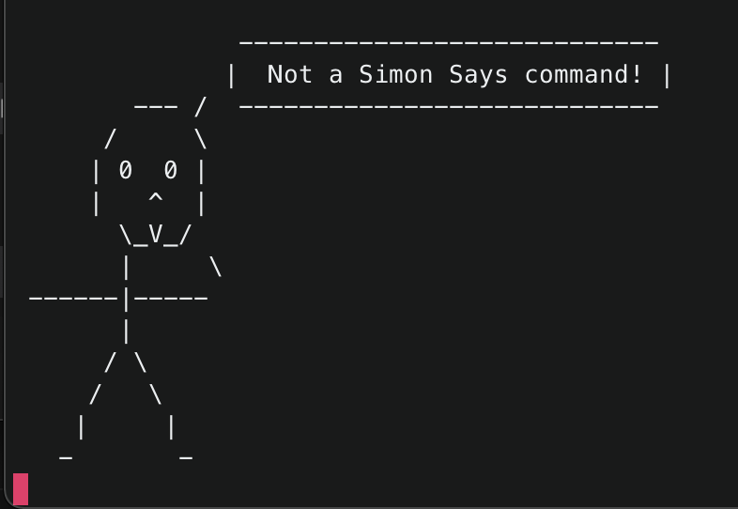

Input of user
1. In the main menu the user makes a selection by choose an option from 1-5 inclusive
2. Option one the Simon Says command to enter should be formatted as “Simon says dance” or “Simon didn’t say touch head”, and an action that is not known will be given the default animation.
3. To load commands enter the text file name with extension e.g. “everything_mode.txt”
4. In the Delete commands mode the user must enter an integer lower or equal to the number of commands loaded into the linked list, if it is too high or none have been loaded the program will not allow any deleting.
5. Playing will play through all animations entered by the user via file and/or command line.
6. Exit will immediately quit the program.
Contents of input file
