Routine Inspection Report
Tilley Reserve, Hancock & Yatala Vale Road, Fairview Park
30/06/2026

Action Items
Area | Comments | Image Reference
Kiosk | Water leaking from rear of ice machine. | 1, 2
Kiosk | Paint peeled above kiosk roller shutter. | 3
Communications Cabinet | Door runner requires repair. | 4
Kitchen Doors | Requires cleaning / painting. | 5
Play Area | Seating stained. | 6
External Public Bathrooms | Require cleaning. | 7, 8, 9
Change Rooms: Home | Toilet seat repairs required. | 10
External Gardens | Weeding required. | 11, 12, 13, 14

Image: | 1 | Area: | Kiosk
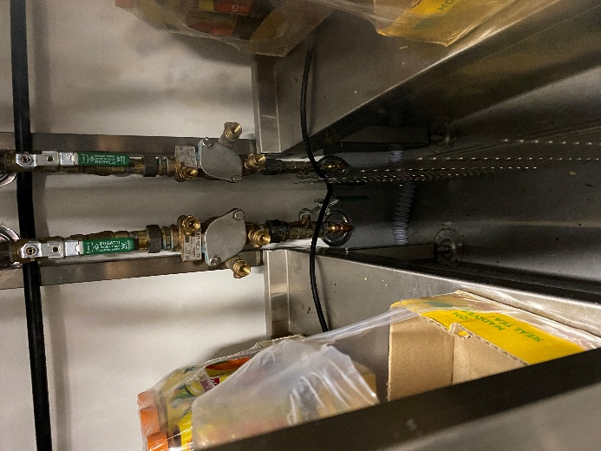 |  |  | Water leaking from rear of ice machine.

Image: | 2 | Area: | Kiosk
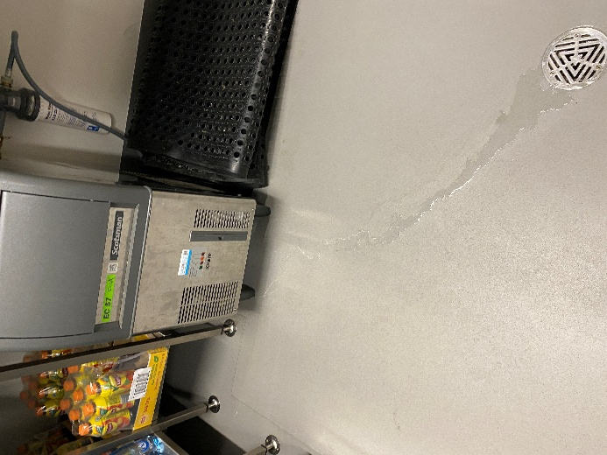 |  |  | Water leaking from rear of ice machine.

Image: | 3 | Area: | Kiosk
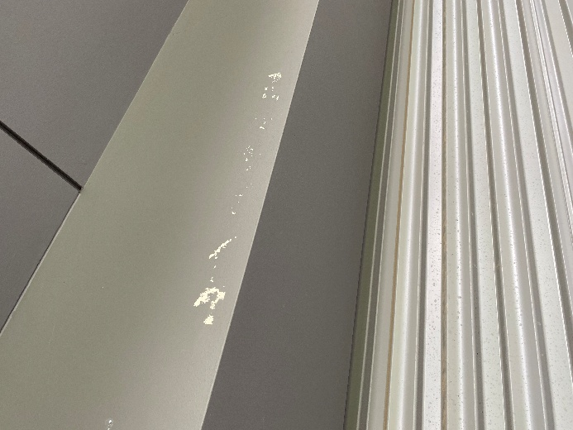 |  |  | Paint peeled above kiosk roller shutter.

Image: | 4 | Area: | Communications Cabinet
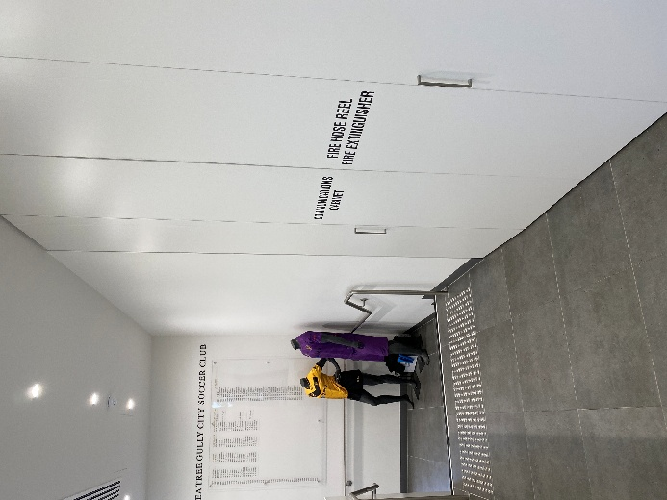 |  |  | Door runner requires repair.

Image: | 5 | Area: | Kitchen Doors
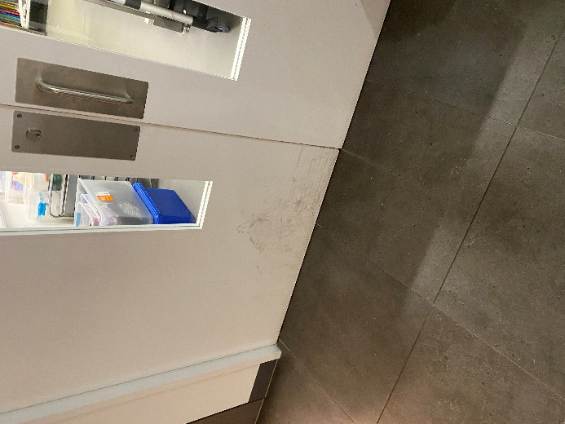 |  |  | Requires cleaning / painting.

Image: | 6 | Area: | Play Area
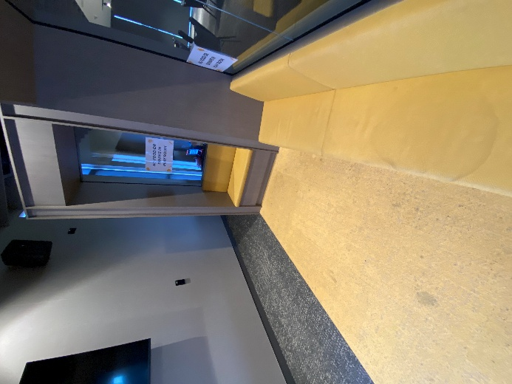 |  |  | Seating stained.

Image: | 7 | Area: | External Public Bathrooms
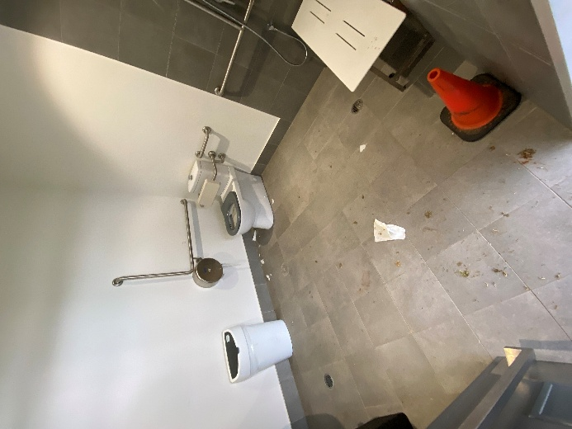 |  |  | Require cleaning.

Image: | 8 | Area: | External Public Bathrooms
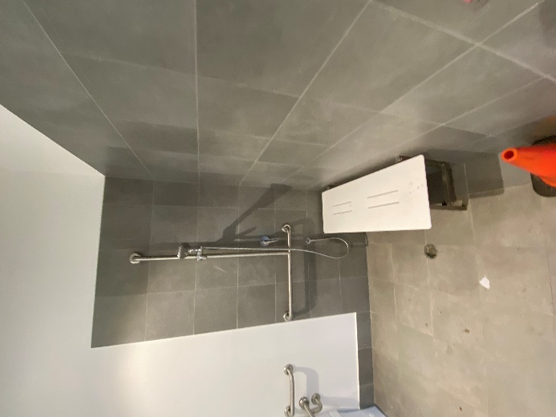 |  |  | Require cleaning.

Image: | 9 | Area: | External Public Bathrooms
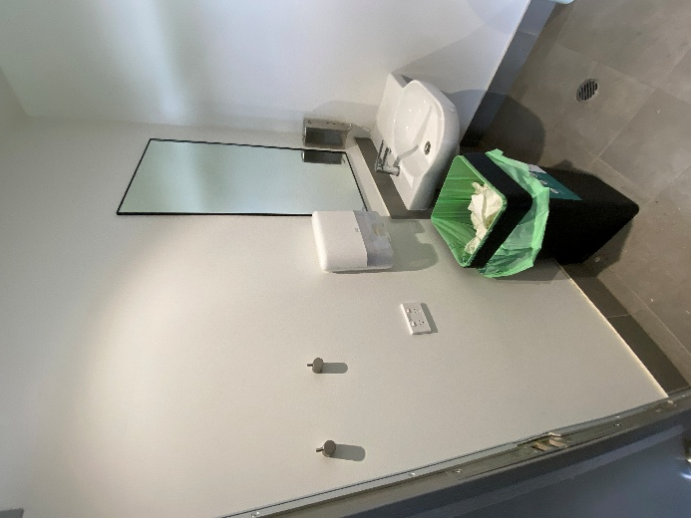 |  |  | Require cleaning.

Image: | 10 | Area: | Change Rooms: Home
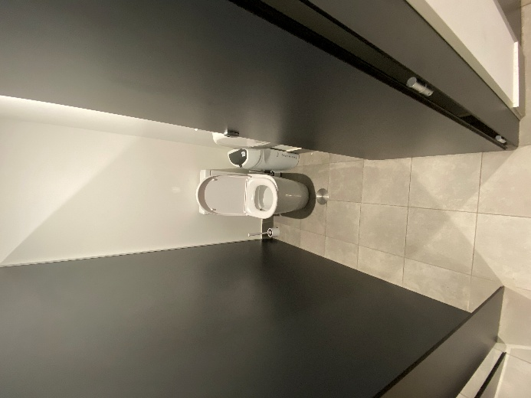 |  |  | Toilet seat repairs required.

Image: | 11 | Area: | External Gardens
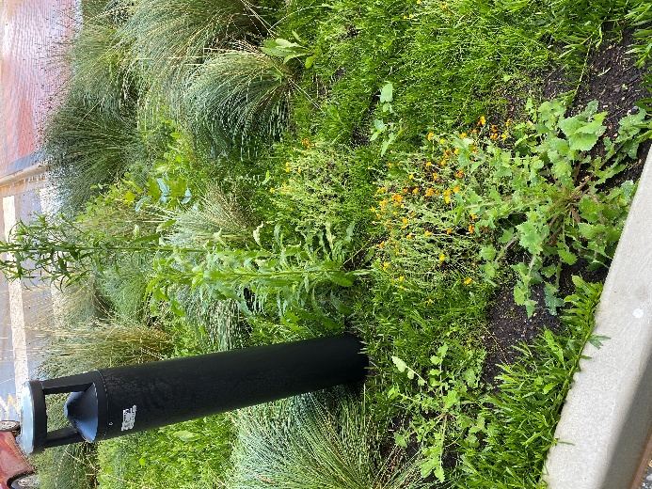 |  |  | Weeding required.

Image: | 12 | Area: | External Gardens
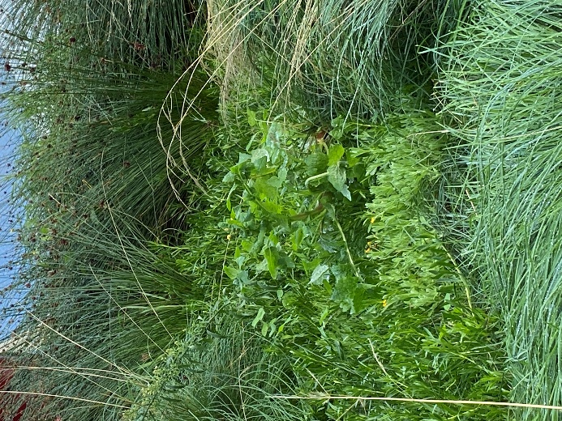 |  |  | Weeding required.

Image: | 13 | Area: | External Gardens
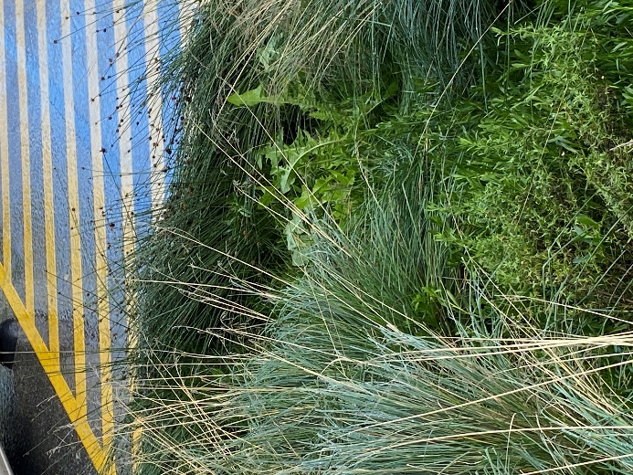 |  |  | Weeding required.

Image: | 14 | Area: | External Gardens
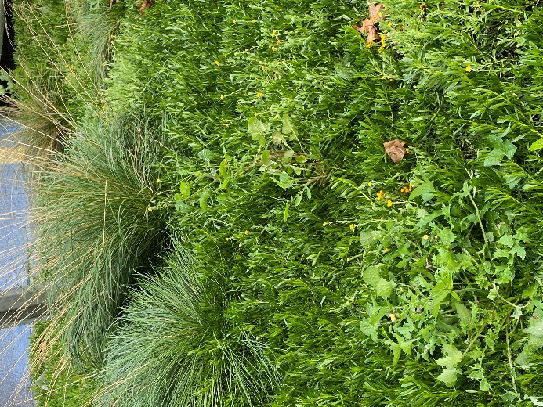 |  |  | Weeding required.

Inspection conducted by: ______________________________________________________________________________________

Print Name: ______________________________________________________________________________________

Position: ______________________________________________________________________________________

Company: ______________________________________________________________________________________

Date: ______________________________________________________________________________________

