SLIM + ABS:
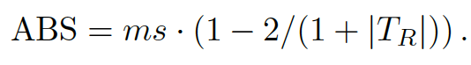

SLIM + ABS with OMS:

SLIM + ABS normalized mutation operator:
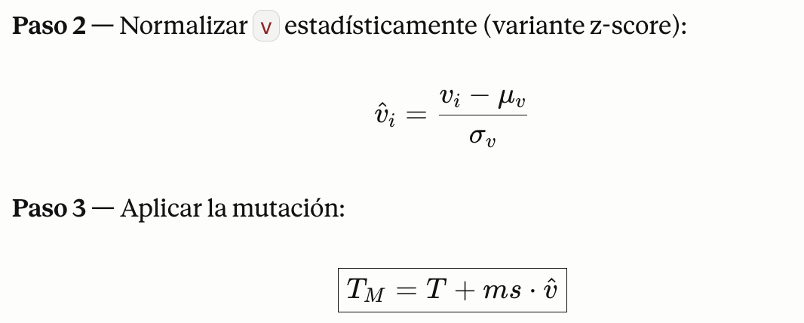

Donde:
