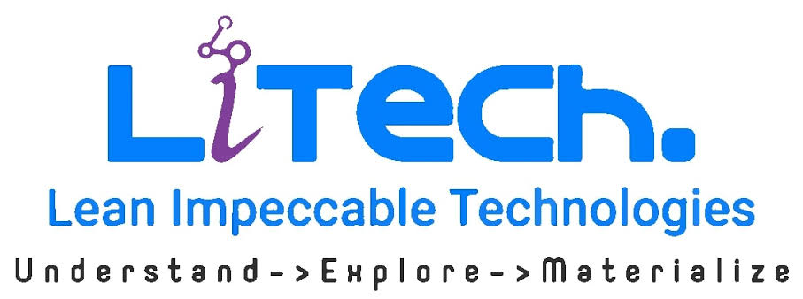 | R&D – INNOVATION LAB  Student Internship Program
ELIGIBILITY, WORKING MODEL & TERMS
Industry-oriented internship with real project execution, Agile discipline and measurable sprint outcomes.
1. STUDENT ELIGIBILITY  • Academic Performance: 80% or above preferred in the current academic program / examinations, with a consistent academic record.  • Backlogs: No active academic arrears/backlogs at the time of selection.  • Attendance: Minimum 90% attendance, subject to institution norms.  • Technical Foundation: Strong fundamentals relevant to AI/ML, Data Science, IoT, Software Development, Cloud, Testing/QA, Data Engineering, Business Analysis or the assigned domain.  • Core Skills: Problem solving, logical thinking, research ability, communication, teamwork, presentation and documentation.  • Selection: Participation is subject to screening/interview and shortlisting by Lean Impeccable in coordination with the institution.  2. TEAM STRUCTURE & AGILE EXECUTION  • Team Size: 4–5 students per team.  • Team Lead: One member will be elected/selected as Team Lead and will act as the primary communication point with Lean Impeccable mentors and the faculty coordinator.  • Agile SDLC: Teams will follow Sprint Planning, stand-ups, backlog refinement, technical discussions, Sprint Review/Demo and Retrospective.  • Two-Week Sprint: Every sprint must end with a working, demonstrable solution or measurable product increment—not only documentation or theoretical research.  • Continuous Increment: Each sprint should build on the previous one, progressing from research/prototype to MVP and progressively improved working solutions. | 3. DELIVERY & ENGINEERING EXPECTATIONS  • Project Tracking: Maintain backlog/tasks, source code, documentation, research findings, test evidence and sprint deliverables using tools recommended by the mentoring team.  • Engineering Practice: Follow coding standards, version control, peer review, testing, secure development and documentation practices wherever applicable.  • Progress Reviews: Periodic reviews will be conducted with Lean Impeccable mentors, the Team Lead and the Faculty Coordinator.  • Original Work: Students must submit original work and acknowledge open-source libraries, AI tools, research papers and other third-party resources used.  • Professional Conduct: Punctuality, discipline, responsible use of resources and professional communication are mandatory.  4. INSTITUTION SUPPORT & PROGRAM TERMS  • Faculty Guidance: The institution should nominate a Faculty Coordinator/Mentor to guide students academically, monitor progress/attendance and coordinate with Lean Impeccable.  • Lab & Infrastructure: The institution should provide required lab facilities, internet connectivity, development systems and necessary infrastructure during the internship/project period.  • Confidentiality & IP: Source code, credentials, datasets, business concepts and confidential information must not be disclosed or reused without authorization. Project-specific NDA/IP terms may apply.  • Security: Passwords, API keys, customer information and production data must not be shared. Only approved development/test environments should be used.  • Evaluation & Continuation: Performance will be reviewed based on technical contribution, sprint delivery, innovation, problem solving, teamwork, communication, documentation, attendance and consistency. Continuation depends on performance and mentor/faculty feedback.
EXPECTED DELIVERY FLOW
Problem Statement → Research & Requirements → Sprint Planning → Design / Prototype → Build → Test → Demo → Feedback → Next Increment
Every 2 weeks: something WORKING, DEMONSTRABLE and BETTER than the previous sprint.

