📘 SYSTEM OPERATIONS & INTERFACE DOCUMENTATION

Core Platform Matrix & Administration Guide

System Engine: LendingSystem Production Terminal v2.1

Author/Publisher: Ramerlabs.com

Deployment Environment: Localhost Sandbox / cPanel Production Environment

Execution Timestamp Indices: Fiscal Period Cycle 2026

📋 About This Documentation

This document contains detailed operational parameters, layout breakdowns, and interface documentation for the LendingSystem framework. It serves as a comprehensive reference manual for navigating user terminals, evaluating administrative dashboard analytics, managing automated database variables, and maintaining core tracking directories.

🛠️ Global System Design Prerequisites

CSS Utility UI Engine: Tailwind CSS Engine Sandbox Layer (@tailwindcss/browser).

Default Responsive Layout: Auto-switching light and dark mode parameters synchronized via user browser configuration tokens (localStorage).

Data Consistency: Relational database mapping run continuously through PHP PDO secure transaction nodes.

Section 1: User Dashboard Interface (dashboard.php)
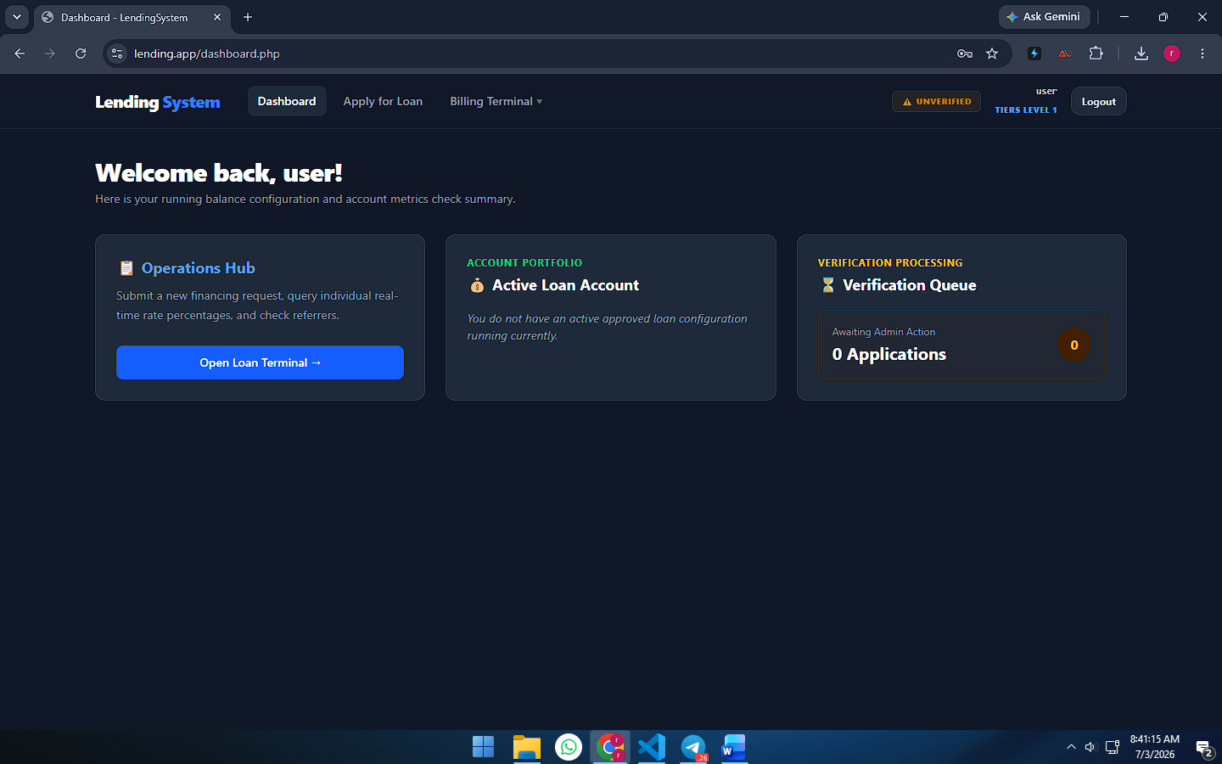
image_b4135a.png
1.1 Overview
The User Dashboard Terminal serves as the central landing hub for logged-in clients. It provides a real-time, high-level summary of the user's account status, active financing profiles, and identity verification tracking. The page adapts its visual sections automatically based on whether a regular user or a platform administrator logs in.
1.2 Header & Global Navigation Breakdown
As shown in image_b4135a.png, the dark-theme global navigation bar header contains the following core interface elements:
- System Branding: A high-contrast brand mark displaying LendingSystem alongside the official platform graphic logo asset.
- Navigation Links: Quick-access directional utilities routing directly to the Dashboard, the Apply for Loan terminal, and a toggleable Billing Terminal dropdown (housing personal invoice archives and payment settlement histories).
- Identity Verification Badge: A contextual system status indicator. If the user's profile has not passed regulatory audits, it renders a pulsing amber ⚠️ UNVERIFIED badge, prompting them to complete their document uploads.
- User Tier Profile Info: Displays the logged-in username handle (user) paired with their dynamically calculated clearance tier status level (TIERS LEVEL 1), which regulates maximum borrow margins and interest scale matrices.
- Logout Mechanism: An isolated security endpoint button allowing the user to safely terminate their active session token.
1.3 Core Panel Layout & Dynamic Sections
The main interface viewport features a personalized title hook reading "Welcome back, user!" and houses a three-column modular card layout designed to track personal accounts:
A. Operations Hub Card
- Purpose: The primary navigational portal for requesting liquid assets.
- Description: Outlines the core steps for submitting new financing requests, querying interest percentage scales in real-time, and reviewing referrer setups.
- Action Target: Contains a primary "Open Loan Terminal →" button linking the client directly to loan_application.php.
B. Account Portfolio (Active Loan) Card
- Purpose: A real-time ledger tracking active approved capital balances.
- Dynamic Response (Empty State): When no running balance exists, it securely logs the notification fallback message: "You do not have an active approved loan configuration running currently."
- Active State: Once an administrator signs off on a pending loan, this card dynamically morphs to show the active principal running balance in PHP alongside the declared referrer agent field.
C. Verification Processing (Queue) Card
- Purpose: A systemic checkpoint showing the exact number of applications currently processing through administration channels.
- Description: Tracks records that are locked down and awaiting auditor review.
- Status Indicator: Displays the numerical count of pending files within a distinct, amber-accented circle alongside the explicit count row text (e.g., "0 Applications"). Once a client submits a new application, this counter increments and locks out new requests until cleared by an administrator.

Section 2: Administrator Dashboard Interface (dashboard.php)
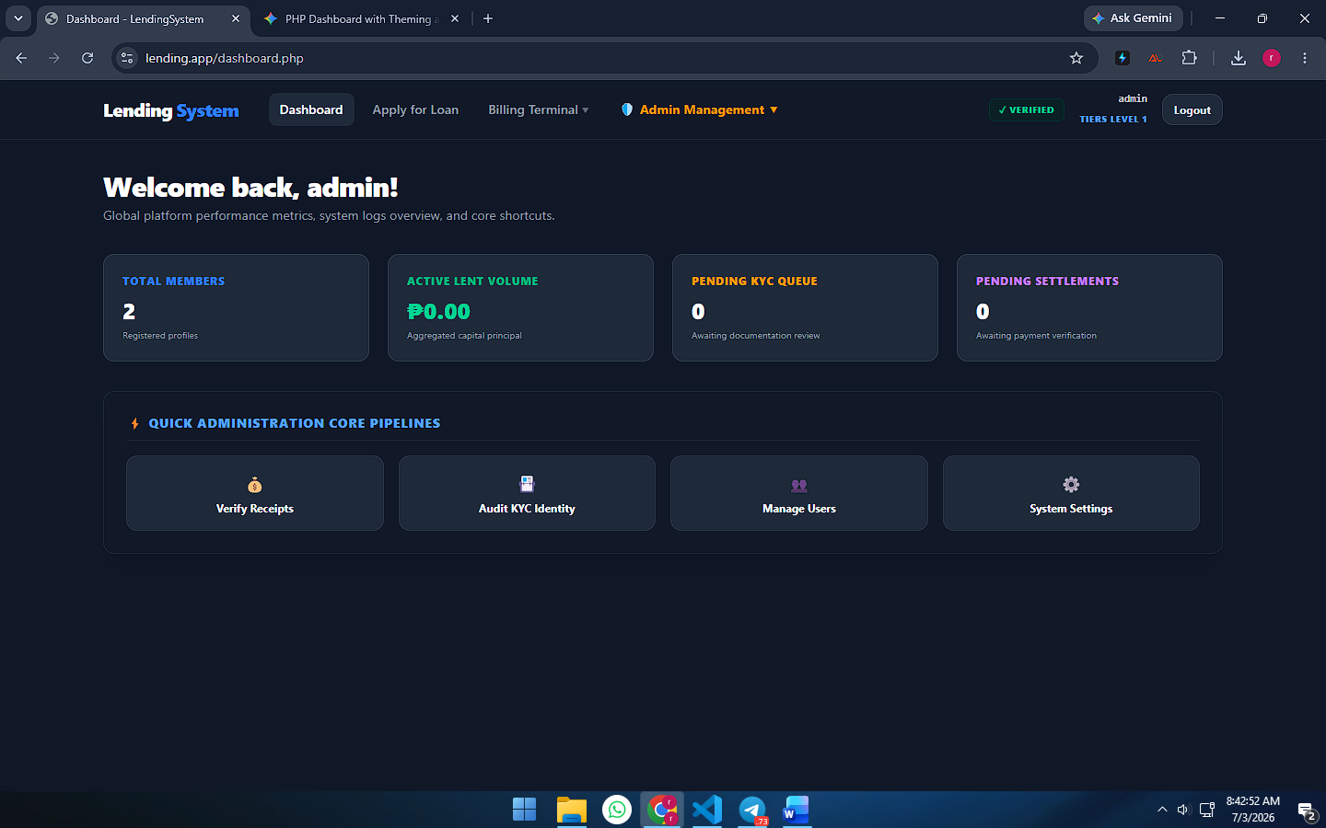
2.1 Overview
When an account with structural admin status credentials authenticates into the system, dashboard.php dynamically filters out the client-side profile widgets and renders the Master Administration Control Center instead. This terminal delivers global micro-financing metrics, broad analytics insight logs, and actionable shortcuts to regulate platform operations.
2.2 Extended Administrative Header Navigation
As shown in image_b41afe.png, the administrator configuration view appends an exclusive, high-visibility operational element to the global top navigation bar:
- 🛡️ Admin Management Dropdown: A specialized, gold-accented navigational toggle that exposes the platform's core administrative utility scripts. Hovering or clicking this container opens paths directly to the inbound payment logs (admin_payments.php), identity request queues (admin_kyc.php), account profile registries (admin_users.php), and systems rule managers (admin_settings.php).
- Contextual Status: The account indicator shows the current active admin handle (admin), sets the structural tier display to TIERS LEVEL 1, and marks the system state with a green ✓ VERIFIED clearance badge.
2.3 System Summary & Live Platform Metrics (4-Grid Data Matrix)
The administrator welcome view features a personalized greeting reading "Welcome back, admin!" alongside the direct context subtitle: "Global platform performance metrics, system logs overview, and core shortcuts." Beneath this header, the layout presents four metric cards tracking system health in real-time:
- TOTAL MEMBERS Card: Displays a live sum of all records registered inside the database user tables. In the dashboard mock review, it reflects an environment total of 2 registered profiles.
- ACTIVE LENT VOLUME Card: Tracks the running total of active cash principal currently dispersed across all approved loans in the system. As visualized in a freshly reset database environment, it defaults to ₱0.00.
- PENDING KYC QUEUE Card: Displays an active tally of incoming member verification portfolios awaiting operator document validation reviews. It lists 0 pending requests.
- PENDING SETTLEMENTS Card: Tracks the raw number of incoming customer payment receipts that have been submitted to the ledger and are waiting for an administrative confirmation or rejection check. It reflects a current workload queue of 0 pending settlements.
2.4 Quick Administration Core Pipelines
Positioned beneath the global platform stats matrix is the ⚡ Quick Administration Core Pipelines panel dashboard container. This module groups the system's day-to-day transaction controls into a balanced, highly scannable grid layout:
- Verify Receipts Button: A direct pipeline routing to the inbound payments ledger table (admin_payments.php), enabling admins to inspect GCash reference number matches and approve or reject client deposits.
- Audit KYC Identity Button: Opens the KYC identity submission queue terminal (admin_kyc.php) to evaluate official IDs, photos, and verification documents.
- Manage Users Button: Direct access link straight into the system account directory (admin_users.php), allowing full permissions to edit member levels, change roles, adjust flags, or delete profiles.
- System Settings Button: Opens the global systemic configuration terminal (admin_settings.php) to fine-tune interest rate tiers, adjust maximum borrowing thresholds, and update server variables.

Section 3: Loan Application Terminal (loan_application.php)
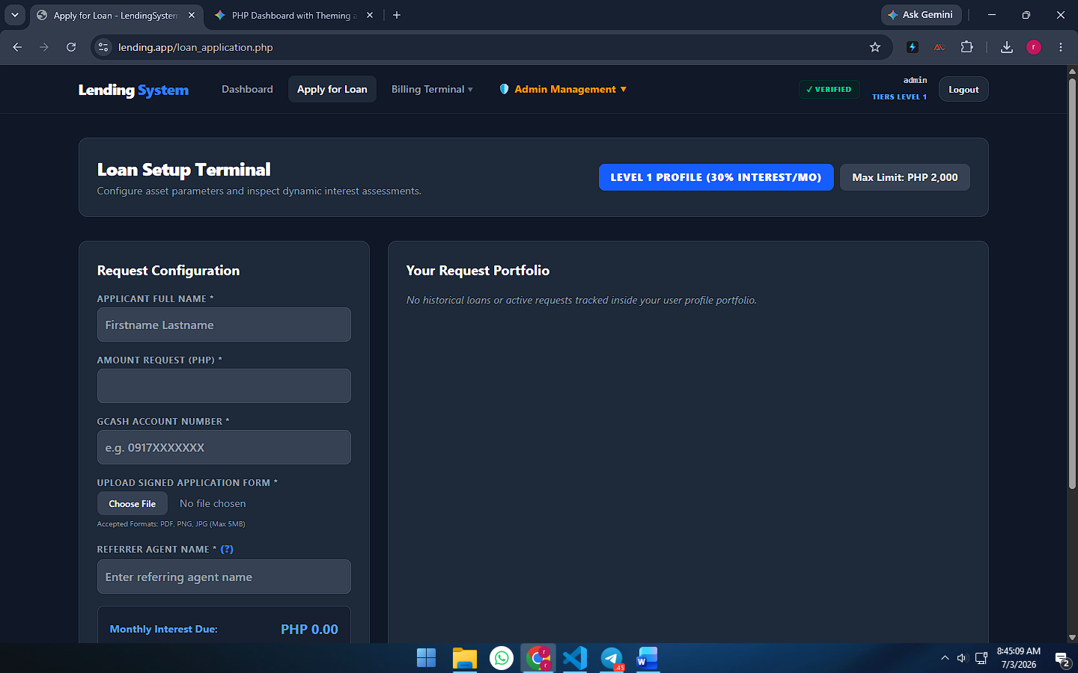
3.1 Overview
The Loan Setup Terminal serves as the primary transaction panel where clients configure financing parameters and submit micro-lending applications. The terminal dynamically pulls configuration rules directly from the database to enforce system constraints based on the user's specific tier level.
3.2 Dynamic Tier Matrix Banners
As shown in image_b421c2.png, the header area features two high-visibility badge blocks that instantly outline the user's current borrowing boundaries:
- Clearance & Interest Rate Indicator: Renders the user's current account bracket alongside their monthly interest scale fee (e.g., LEVEL 1 PROFILE (30% INTEREST/MO)).
- Max Allowed Margin Badge: Displays the absolute maximum monetary ceiling the user is authorized to request per single transaction based on their system tier (e.g., Max Limit: PHP 2,000).
3.3 Request Configuration Form Section
The left column houses the Request Configuration submission input module. This section enforces input validation across several required parameter fields:
- APPLICANT FULL NAME *: A text field requiring the user's formal matching identity entry (Firstname Lastname).
- AMOUNT REQUEST (PHP) *: A numeric field where the user sets their target capital principal amount. The real-time system scripts automatically match this number against the maximum limit.
- GCASH ACCOUNT NUMBER *: Collects the target electronic mobile wallet string (e.g. 0917XXXXXXX) where the automated capital payout will be routed.
- UPLOAD SIGNED APPLICATION FORM *: File upload utility node requiring a signed document attachment. Supported file boundaries are limited to PDF, PNG, or JPG formats with a maximum file size restriction of 5MB.
- REFERRER AGENT NAME * (?): Maps the application back to an authorized tracking agent. Hovering over the (?) utility exposes a warning tip reminding the applicant that entering an unmapped agent will result in an automatic rejection.
- Real-time Interest Calculation Box: A persistent calculation indicator at the bottom of the form that automatically multiplies the principal input by the monthly rate to show the exact fee output (e.g., Monthly Interest Due: PHP 0.00) before submission.
3.4 Request Portfolio Tracking Section
The right column houses the Your Request Portfolio section, which acts as a personal history ledger.
- Dynamic Response (Empty State): When no historical applications exist for the active session account, the panel isolates a clear placeholder text: "No historical loans or active requests tracked inside your user profile portfolio."
- Active Logs State: Once applications are submitted, this panel populates with a paginated data table showing the filing date, full name, capital amount, agent name, and a stylized color-coded status badge (Pending, Approved, Settled, or Rejected).
- Interactive Tooltip Feature: For rows marked as Rejected, hovering over the badge triggers a pure-Tailwind slide-up tooltip window displaying the administrative explanation logged by the auditor during database management review.

Section 4: Billing & Invoices Terminal (invoices.php)
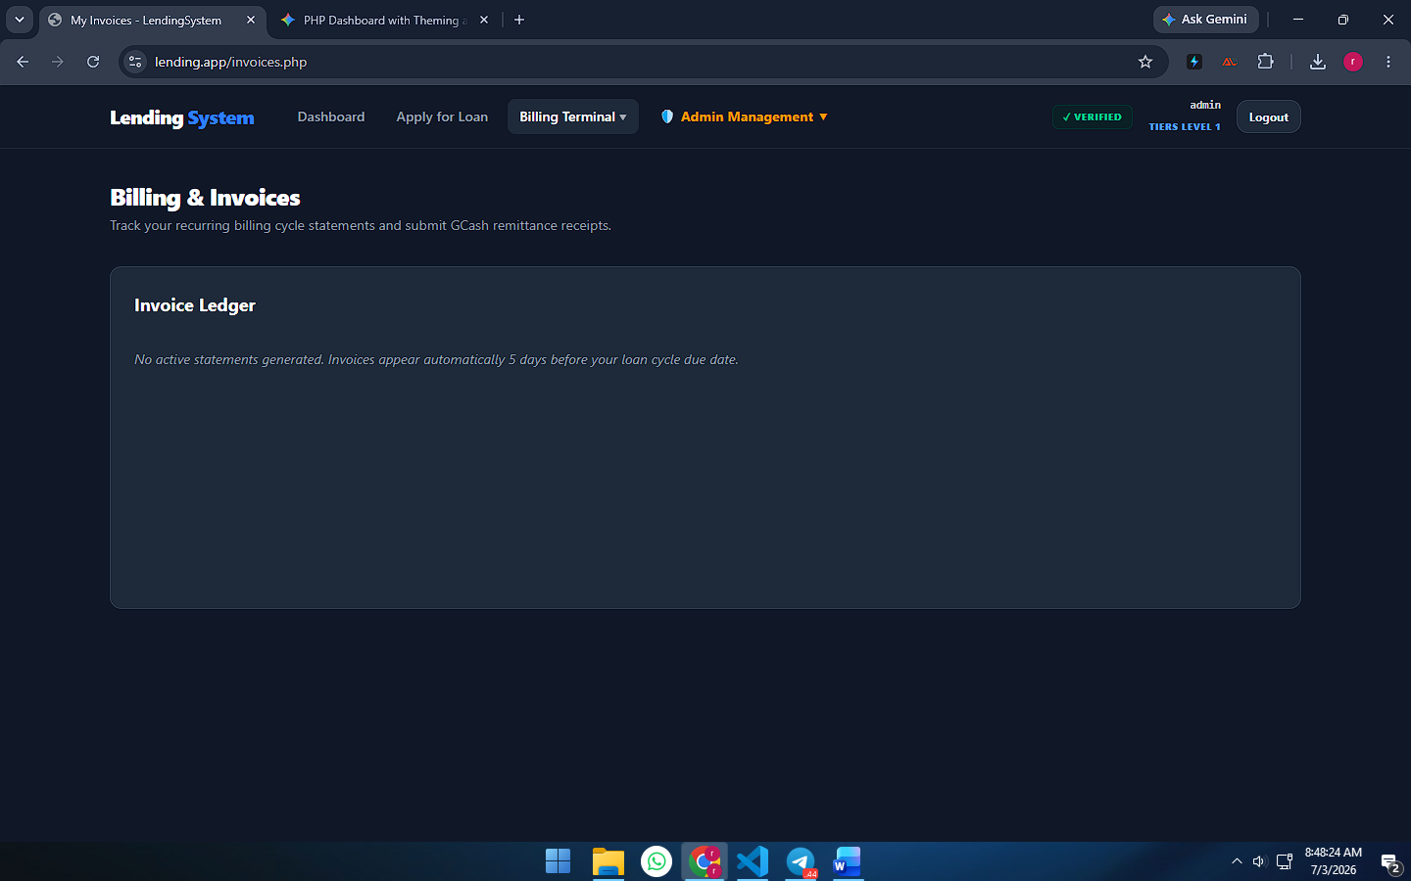
image_b42929.png,
4.1 Overview
The Billing & Invoices Terminal acts as a client-side financial statement hub where users review recurring interest billing parameters and submit remittance details. This module runs in sync with an underlying automated invoice generator engine, which calculates amortization statements relative to active lending cycles.
4.2 Dynamic Layout Header
As shown in image_b42929.png, the dashboard panel introduces a focused structural layout header:
- Module Title: Labeled explicitly as Billing & Invoices.
- Contextual Description: Displays the guiding prompt: "Track your recurring billing cycle statements and submit GCash remittance receipts."
4.3 Invoice Ledger & Automation Lifecycle Behavior
The core interface features a comprehensive data container block titled the Invoice Ledger. This module possesses distinct behaviors based on live database state checks:
- Dynamic Response (Empty State): When an authenticated profile has no active outstanding dues, the panel renders an italicized informational placeholder: "No active statements generated. Invoices appear automatically 5 days before your loan cycle due date."
- Active Statement State: Once the structural system background loop registers that a user's loan cycle is near its expiration threshold, it dynamically generates a table row entry containing the Statement ID, Target Billing Period, Total Amount Due (combining base principal and interest rates), and a "Pay Now" action link.
- Payment Remittance Pathway: Clicking an active invoice statement opens up a submission drawer that presents the official administrator GCash receiving details. It prompts the user to input their transaction reference number string and upload an official screenshot of their digital receipt to initiate an audit verification queue.

Section 5: My Payments Ledger Terminal (user_payments.php)
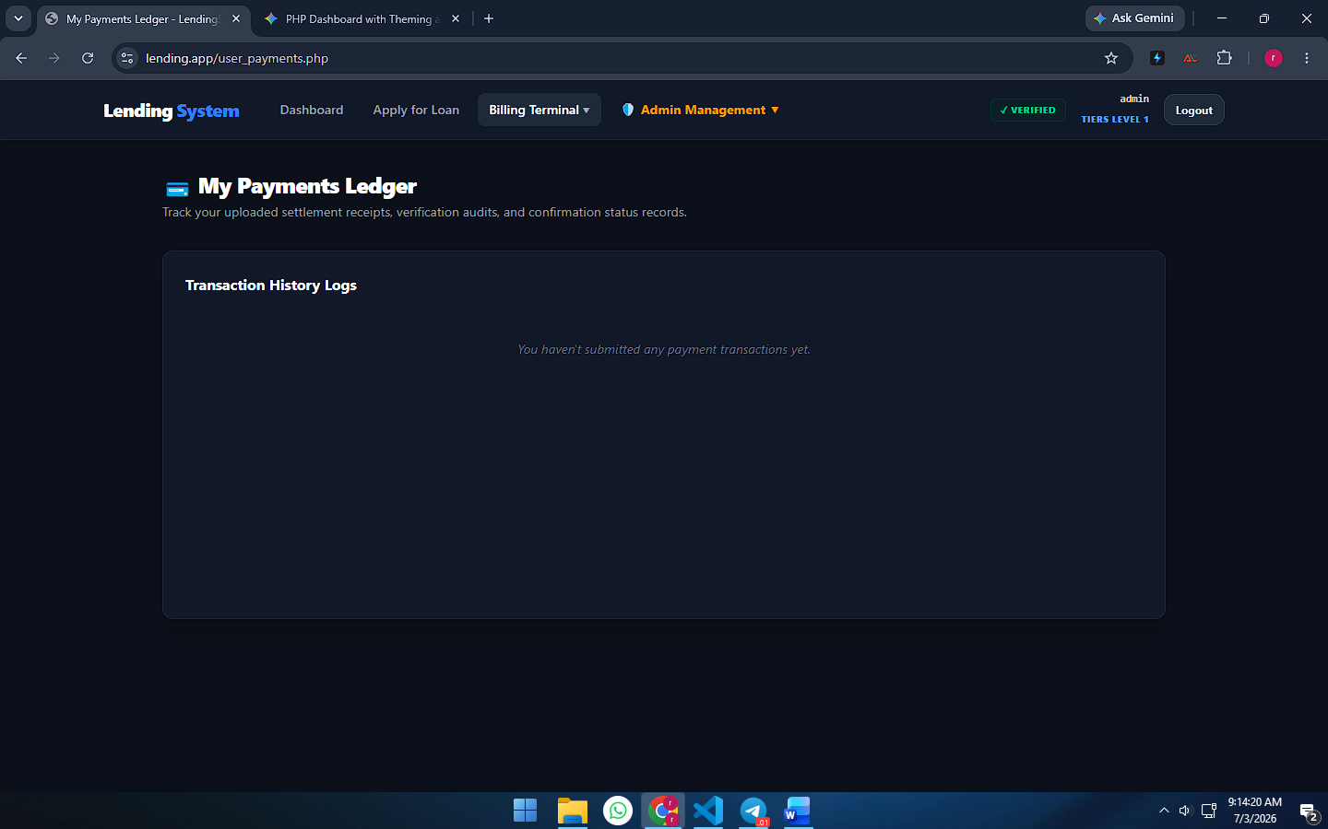
image_be8b82.png
5.1 Overview
The My Payments Ledger Terminal serves as the client-side settlement tracking panel. It consolidates all historical data relating to a user's uploaded payment forms, tracking them from the initial submission checkpoint through the active administrative audit verification workflow.
5.2 Interface Structure Header
As shown in image_be8b82.png, the terminal features a dedicated layout header section:
- Module Title: Labeled explicitly with a card graphic element as 💳 My Payments Ledger.
- Contextual Subtitle: Outlines the core operational intent of the page: "Track your uploaded settlement receipts, verification audits, and confirmation status records."
5.3 Transaction History Logs Control Box
The center of the module is dominated by the Transaction History Logs data container card. This section dynamically updates depending on the status of database inputs:
- Dynamic Response (Empty State): When a user opens a brand-new profile or has not yet initiated any deposits, the interface isolates a centralized, low-contrast placeholder warning text: "You haven't submitted any payment transactions yet."
- Active Logs State: Once a client completes a payment allocation form via an outstanding invoice sheet, this panel transforms into a structured historical tracking table. The resulting columns layout tracks five distinct data fields:
  - Filing Date: Renders a granular server-side timestamp (YYYY-MM-DD HH:MM) marking exactly when the payment notice hit the system repository.
  - Allocation Type: Displays the target categorization category (e.g., Principal Repayment or Interest Settlement fee).
  - Amount Deposited: Shows the raw monetary value field formatted clearly in Philippine Peso (PHP).
  - Reference Number: Isolates the unique digital GCash transaction string input by the client for quick fraud prevention cross-checking.
  - Audit Status: Renders a distinct, color-coded tracking state tag. A yellow indicator denotes a file is in the Pending Review phase, green flags an approved deposit as Settled, and a red badge highlights a Declined transaction. When declined, the system appends a remarks field to display the auditor's review explanation.

Section 6: Inbound Payment Ledgers Control Panel (admin_payments.php)
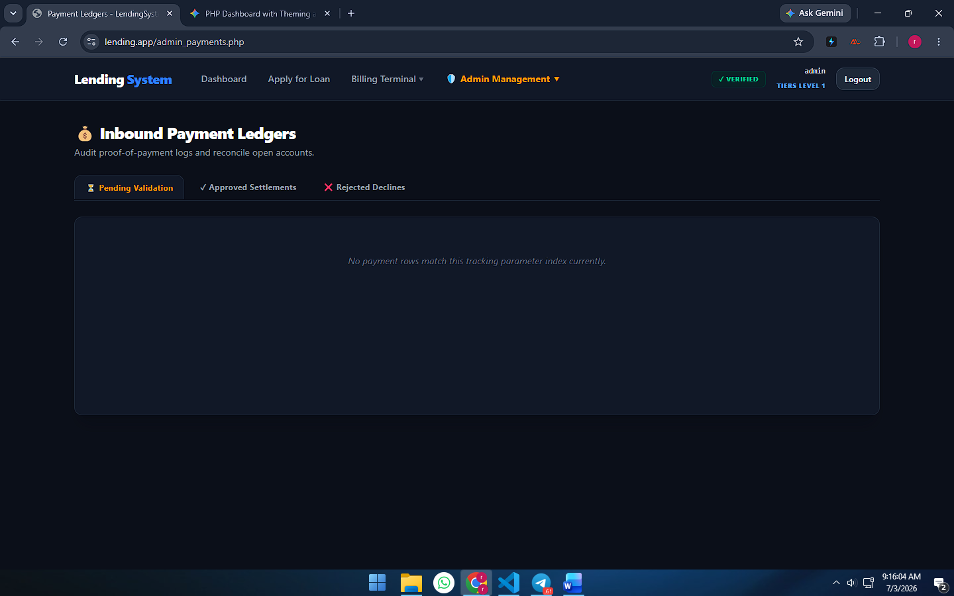
image_be8f69.png
6.1 Overview
The Inbound Payment Ledgers dashboard serves as a secure administrative auditing interface. It centralizes all remittance receipts and proof-of-payment logs submitted by clients, allowing platform managers to reconcile open accounts and verify financial deposits against mobile wallet statement records.
6.2 Structural Module Header
As shown in image_be8f69.png, the administrator view presents a distinct branding header:
- Module Title: Identified clearly with an active coin pouch graphic asset as 💰 Inbound Payment Ledgers.
- Functional Subtitle: Details the terminal’s supervisory objective: "Audit proof-of-payment logs and reconcile open accounts."
6.3 Operational Filter Navigation Tabs
Positioned directly above the data container card is a specialized sub-navigation tab bar layout designed to separate workloads into distinct transactional states:
- ⏳ Pending Validation Tab: Filters out processing tickets that are currently waiting for manual administrator checkouts.
- ✓ Approved Settlements Tab: Hosts historical archives of successfully checked and accepted deposits.
- ❌ Rejected Declines Tab: Stores entries flagged as fraudulent, unmapped, or containing broken reference metrics.
6.4 Ledger Data Container Box (Empty State Configuration)
The core viewport features a centralized, modular data layout container card. This module behaves responsively according to real-time workload queries:
- Dynamic Response (Empty State): When the database logs contain no incoming files within the active target tab parameter, the interface isolates a clear, low-contrast placeholder string: "No payment rows match this tracking parameter index currently."
- Active Audit Record Table View: When files are active, this container transforms into an interactive ledger table displaying the receipt upload date, the user’s full name handle, the principal or interest payment amount, the client-supplied GCash tracking reference number string, and direct quick-action buttons allowing managers to instantly Approve Settlement or Reject Payout with comments.

Section 7: Identity Audit Management Portal (admin_kyc.php)
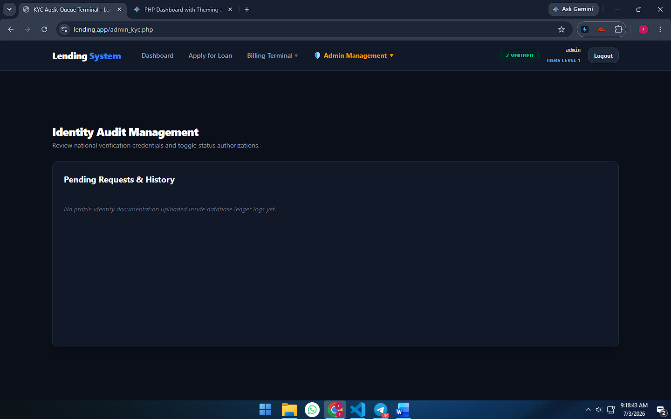
image_be9686.png
7.1 Overview
The Identity Audit Management Portal serves as the administrative gatekeeper for platform user verification. This terminal allows system supervisors to review national identity credentials submitted by users and manually toggle profile verification states to elevate users to higher account tier brackets.
7.2 Header Framework Layout
As shown in image_be9686.png, the administrator dashboard view establishes a clear operational context header:
- Module Title: Labeled explicitly as Identity Audit Management.
- Instructional Subtitle: Outlines the core administrative intent of the module: "Review national verification credentials and toggle status authorizations."
7.3 Workload Management Container (Empty State)
The lower core region of the module contains the master verification ledger layout block titled Pending Requests & History. This system interface adapts dynamically based on backend server requests:
- Dynamic Response (Empty State): When the database logs do not contain any active or historical member document file submissions, the container displays a low-contrast italicized placeholder text: "No profile identity documentation uploaded inside database ledger logs yet."
- Active Audit Matrix State: When active user KYC entries exist, this card transforms into an interactive records table displaying the submission timestamp, the target username, the uploaded identification document type (e.g., Passport or Driver's License), click links to view the original uploaded file path attachments, and direct action control tags allowing admins to instantly mark the user profile as Verified or Rejected with remarks.

Section 8: System Accounts Directory (admin_users.php)
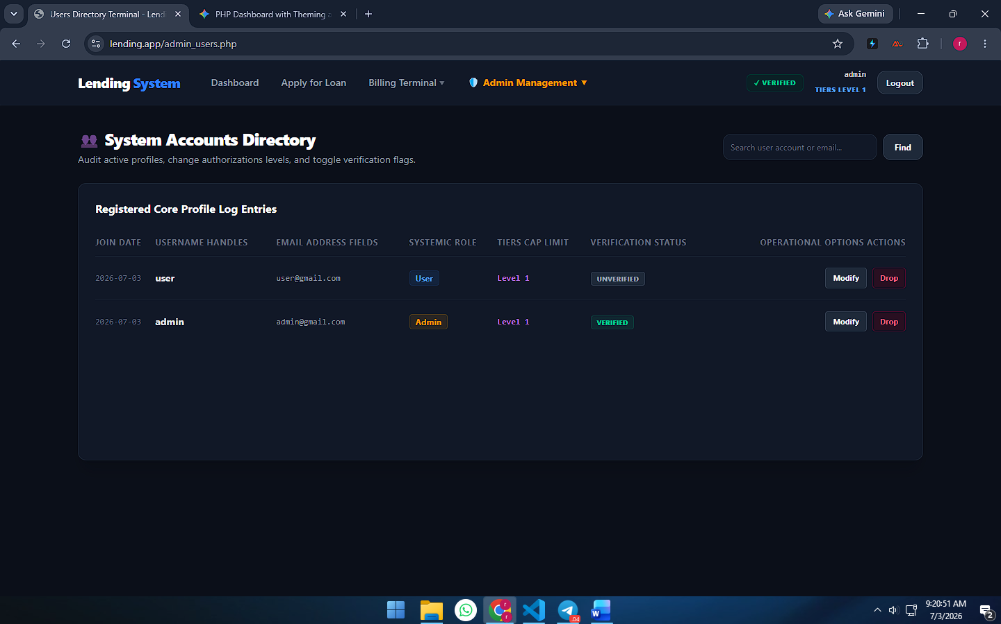
image_be9a89.png
8.1 Overview
The System Accounts Directory serves as the administrative core panel for member control management. It enables system operators to audit active user profiles, safely toggle verification states, scale access clearance levels, and execute secure profile removal actions directly from the backend data tables.
8.2 Top-Level Header Controls & Integrated Search Module
As shown in image_be9a89.png, the directory title row houses a dedicated context header paired alongside a server-side search framework:
- Module Header: Labeled with a community group icon as 👥 System Accounts Directory with the descriptive subtitle: "Audit active profiles, change authorizations levels, and toggle verification flags."
- Inline Query Engine: Includes a search text bar displaying the placeholder: "Search user account or email...". This inputs matching text patterns directly into a database filter query, accompanied by a clean Find trigger button to quickly parse through large sets of database records.
8.3 Registered Core Profile Log Entries Data Table
The primary section of this module consists of a structured, widescreen data ledger tracking user database variables. The layout contains seven informational and operational columns:
- JOIN DATE: Displays a precise database registration date stamp tracking exactly when the account was initialized.
- USERNAME HANDLES: Shows the unique profile system name handle configured by the account holder during the registration phase.
- EMAIL ADDRESS FIELDS: Captures the customer's mapped digital communication routing handle.
- SYSTEMIC ROLE: Renders a stylized, high-contrast role categorization badge. A blue tag isolates regular accounts (User), while a gold tag defines full clearance supervisor accounts (Admin).
- TIERS CAP LIMIT: Displays the user's current account ranking tier status which dictates maximum borrowing margins.
- VERIFICATION STATUS: Highlights the client's current status inside the identity auditing pipeline. Unaudited profiles display a dark UNVERIFIED tag, while signed-off accounts render a bright green VERIFIED badge.
- OPERATIONAL OPTIONS ACTIONS: Groups the direct row modification tools:
  - Modify Button: Triggers a floating script modal popup containing dropdown options to change role tags, rewrite tier ranks, or manually verify profiles.
  - Drop Button: A rose-accented administrative delete button that triggers a JavaScript safety confirmation dialog to permanently remove the user row from the system database.

Section 9: Audit Loan Requests Control Panel (admin_loans.php)
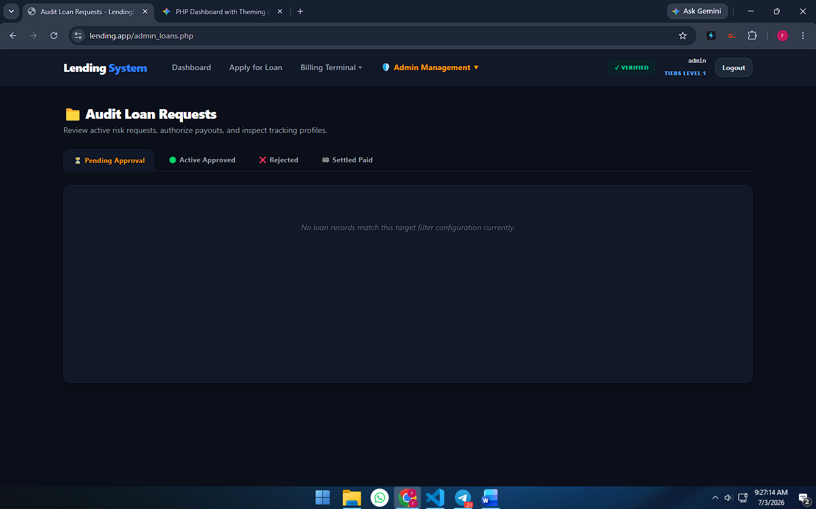
image_bef821.png
9.2 Structural Header Layout
As shown in image_bef821.png, the administrator interface establishes an explicit context header:
- Module Title: Labeled clearly with a yellow folder graphic asset as 📂 Audit Loan Requests.
- Functional Subtitle: Outlines the core operational objective of the workspace: "Review active risk requests, authorize payouts, and inspect tracking profiles."
9.3 Operational Status Filtering Bar
Positioned directly below the title header is a segmented horizontal tab-navigation component designed to filter real-time database queries into structured workloads:
- ⏳ Pending Approval Tab: Isolates newly filed user financing requests that are awaiting direct administrative sign-off or cancellation remarks.
- 🟢 Active Approved Tab: Houses live lending matrices representing capital that has been approved and disbursed into production.
- ❌ Rejected Tab: Stores archived entries that failed risk assessment parameters or utilized unmapped referrer agent details.
- 🏁 Settled Paid Tab: Tracks completed debt lifecycles where users have fully remitted their balances and interest invoices.
9.4 Records Ledger Container Box (Empty State)
The lower section features a centralized data container card designed to display relevant data records responsively:
- Dynamic Response (Empty State): When the database query does not return any logs matching the active selection, the panel falls back to a low-contrast placeholder warning message: "No loan records match this target filter configuration currently."
- Active Audit Record Table View: When data rows populate, this viewport converts into an action table showing the submission date, applicant user handle, requested principal value, destination GCash phone string, linked agent tracking fields, and click tools to dynamically Authorize Payout or Log Decline Reason via popover modal forms.

Section 10: Referral Agents Directory Panel (admin_agents.php)
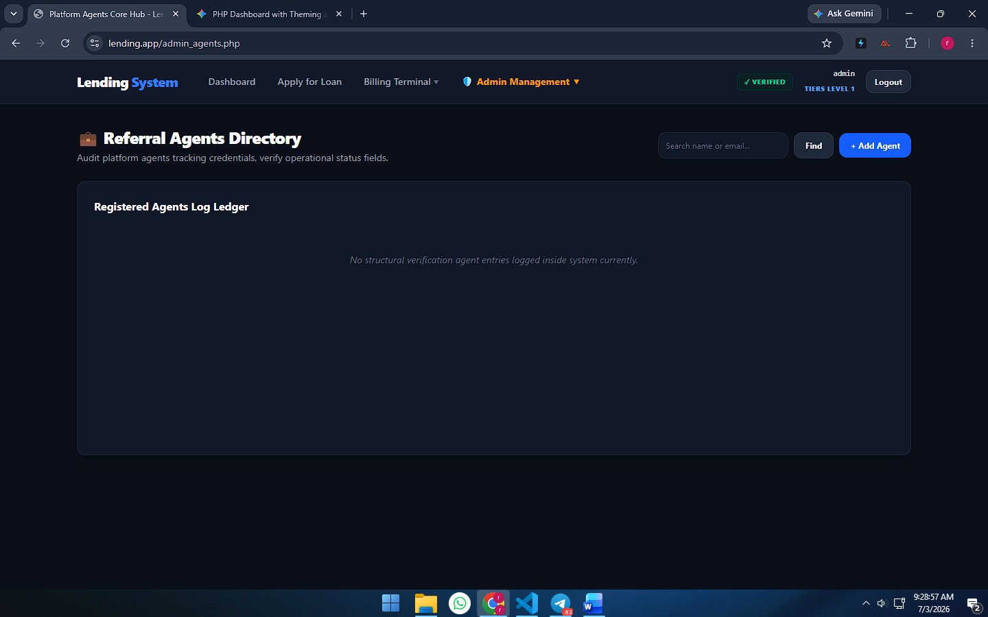
image_befc00.png
10.1 Overview
The Referral Agents Directory Panel serves as a secure administrative master ledger for tracking systemic referrers. This dashboard enables system supervisors to look up active agent verification data, maintain accurate record registries, and manage credential metrics linked to user applications.
10.2 Title Header Controls & Navigation Shortcuts
As shown in image_befc00.png, the workspace header organizes all directory actions into a balanced, highly functional row layout:
- Module Title: Identified clearly with an active briefcase graphic asset as 💼 Referral Agents Directory.
- Functional Description: Details the core operational intent of the page: "Audit platform agents tracking credentials, verify operational status fields."
- Text Filter Engine: Houses an inline search text entry element showing the query placeholder: "Search name or email..." Managers can type text strings and click the matching Find utility button to execute database filtering macros.
- Action Payout Trigger: Features a prominent blue + Add Agent button that serves as a direct navigational shortcut routing to the agent creation wizard (add_agent.php).
10.3 Registered Agents Log Ledger (Empty State)
The lower section features a centralized data card block labeled Registered Agents Log Ledger. This matrix updates responsively relative to backend system checks:
- Dynamic Response (Empty State): When the database table is freshly cleared out or contains no matches for an active search string, the container falls back to a low-contrast placeholder message: "No structural verification agent entries logged inside system currently."
- Active Directory Table View: When agent data records are available, this viewport transforms into a comprehensive database table tracking five core data categories:
  - Agent Full Name: Displays the official name entry paired alongside a unique, system-generated identifier tag (e.g., ID: #1).
  - Contact Metrics: Consolidates the agent’s verified communications paths, tracking their email string and phone number format.
  - Physical Address Location: Displays the localized physical home or office location string of the referrer.
  - Social Handle Links: Provides quick-launch hyperlinks to any linked external handles such as Telegram or Facebook profile URLs.
  - Operational Direct Actions: Groups the maintenance tools, allowing supervisors to click Modify to alter records (edit_agent.php) or click a rose-accented Drop button to trigger a deletion script loop.
Section 11: System Configuration Terminal (admin_settings.php)
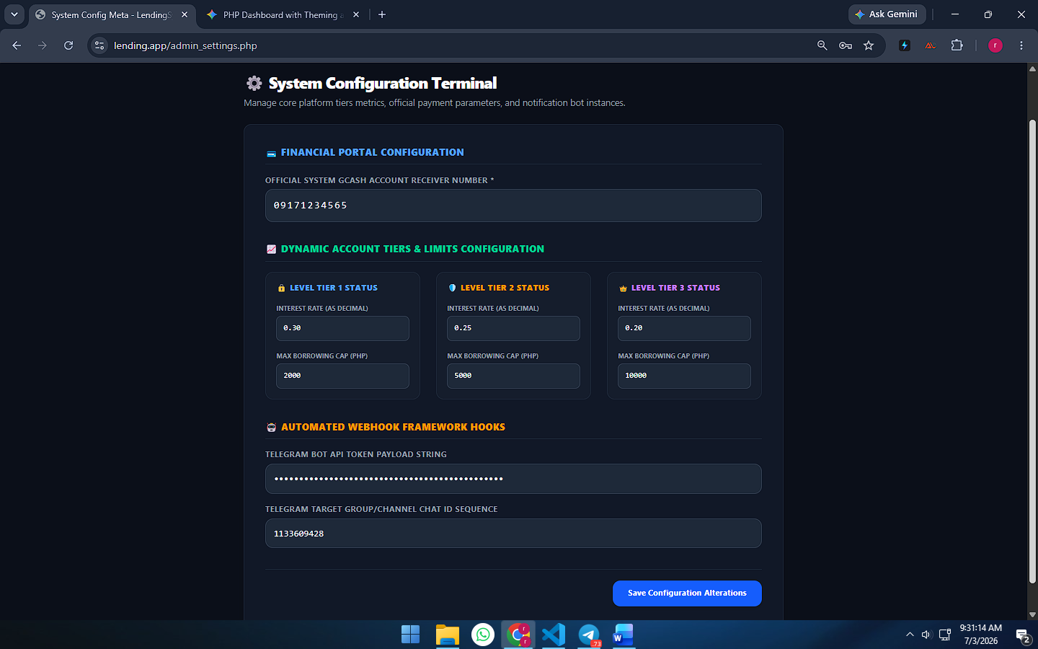
image_bf0025.png
11.1 Overview
The System Configuration Terminal serves as the primary master variables manager for the lending engine. This administrative panel allows top-level supervisors to dynamically alter operational constants—such as global payment receiving targets, risk matrices for dynamic tier limits, and automated micro-service notification links—without editing any source code backend files directly.
11.2 Master Framework Header
As shown in image_bf0025.png, the workspace implements a structured configuration title layout:
- Module Title: Identified explicitly with a gear graphic asset as ⚙️ System Configuration Terminal.
- Functional Description: Outlines the core administrative capabilities of the view: "Manage core platform tiers metrics, official payment parameters, and notification bot instances."
11.3 Configuration Block Breakdowns
The page organizes settings parameters logically into three separate, high-visibility form modules:
A. 💳 Financial Portal Configuration
- Purpose: Establishes the global cash receiving address parameters utilized across the app.
- Field Control: Employs an input element labeled OFFICIAL SYSTEM GCASH ACCOUNT RECEIVER NUMBER *. Any mobile wallet string saved here (e.g., 09171234565) is automatically served down to regular user billing views when they attempt to settle open invoice forms.
B. 📈 Dynamic Account Tiers & Limits Configuration
- Purpose: Configures the borrowing constraints and dynamic math rules evaluated by the platform's automated system engines.
- Modular Grid Layout: Split into three distinct profile boxes mapping parameters to user rankings:
  - 🔒 LEVEL TIER 1 STATUS: Configures default values for entry-level profiles. It sets the INTEREST RATE (AS DECIMAL) to 0.30 (30%) and fixes the MAX BORROWING CAP (PHP) baseline target at 2000.
  - 🛡️ LEVEL TIER 2 STATUS: Configures values for intermediate verified accounts. It establishes a lower INTEREST RATE (AS DECIMAL) of 0.25 (25%) alongside an elevated MAX BORROWING CAP (PHP) limit of 5000.
  - 👑 LEVEL TIER 3 STATUS: Configures constraints for high-tier premium accounts. It scales the INTEREST RATE (AS DECIMAL) down to 0.20 (20%) while extending the MAX BORROWING CAP (PHP) threshold maximum to 10000.
C. 🤖 Automated Webhook Framework Hooks
- Purpose: Connects transactional lifecycles securely to external notification channels.
- Field Controls:
  - TELEGRAM BOT API TOKEN PAYLOAD STRING: A masked text entry box designed to hold secret bot token credentials securely.
  - TELEGRAM TARGET GROUP/CHANNEL CHAT ID SEQUENCE: Accepts a unique numerical chat identifier string (e.g., 1133609428). This tells the system exactly where to broadcast instant event alerts when users submit new loan forms or drop verification uploads into the queue.
11.4 Form Commitment Actions
- Save Configuration Alterations Button: A prominent blue save action mechanism situated at the very bottom right of the main form framework. Clicking this executes a sanitized database update process that commits all modified text string sequences into the global variables database table instantly.

