**ULTIMATE SCI-FI STARSHIPS, STARDOCKS, AND JUMPGATES COLLECTION**

**FOR UNITY3D DOCUMENTATION**

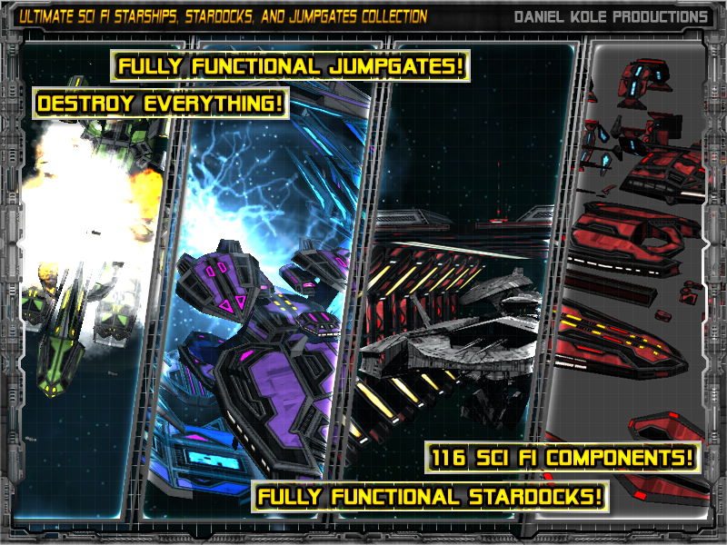

**RELEASE VERSION 4.0**

***CREATED BY: DANIEL KOLE***

*Copywrite 2016 - Daniel Kole Productions*

***Ultimate Sci-Fi Starships, Stardocks, and Jumpgates Collection - Overview:***

Requires Unity 5.1.2 or higher.

***Ultimate Sci-Fi Starships, Stardocks, and Jumpgates Collection*** is a massive collection of premade prefabs and individual components ready to add to your sci-fi game. It includes fully destructible Starships, Jumpgates, Stardocks, and, new in version 2.0, Starbases. Jumpgates, Stardocks, Starbases, and Constructions Starships are included with sample spawn/construction scripts.

***FEATURE LIST:***

*- 146 STARSHIP, STARDOCK, AND JUMPGATE COMPONENTS*

*- BUILD YOUR OWN STARSHIPS, STARDOCKS, AND JUMPGATES*

*- DEMO SCENES AND SCRIPTS INCLUDED IN C#*

*- 20 PREMADE STARSHIPS - READY TO USE – IN 6 COLOR SCHEMES*

*- SMALL, MEDIUM, AND LARGE STARDOCKS AND JUMPGATES*

*- 6 COLOR SCHEMES: RED, GRAY, BLUE, GREEN, PURPLE, AND TEAL*

*- PBR MATERIALS - TEXTURES ARE 2048x2048 (DIFFUSE, EMISSION, METALLIC, AND NORMAL MAPS INCLUDED)*

*- 102 UI ICONS INCLUDED FOR PREMADE STARSHIPS*

*- WEPPLAYER DEMO SCENES AND SCRIPTS INCLUDED IN PACKAGE*

***ULTIMATE SCI-FI STARSHIPS, STARDOCKS, AND JUMPGATES COLLECTION WEBPLAYER DEMO LINK:***

**[Try the Webplayer Demo here!](https://dl.dropboxusercontent.com/u/220399058/AssetStoreDemos/USFSSJC/BFPWebplayer.html)**

***SUPPORT, FEEDBACK, AND FUTURE VERSION INFORMATION CAN BE FOUND AT THE SUPPORT FORUM PAGE HERE:***

**[Visit the Support/Version Information Forum Thread here!](http://forum.unity3d.com/threads/ultimate-sci-fi-starships-stardocks-and-jumpgates-collection-coming-soon.398001/)**

***Ultimate Sci-Fi Starships, Stardocks, and Jumpgates Collection - Usage and Version History:***

***Usage and Installation:***

To use this package:

- Start a new project and import the Ultimate Sci-Fi Starships, Stardocks, and Jumpgates Collection Asset Package into the project.

- Open the ***bloodFleetPackDemo.unity*** scene located in the UltimateSFSSJC/Demo/Scenes folder. This scene contains samples of all the included functionality, prefabs, and uses. This is also the demo scene main menu.

***Version History:***

***Version 1.0 -***

**- First Release Version of Ultimate Sci-Fi Starships, Stardocks, and Jumpgates Collection.**

**- Includes a demo scene.**

**Version 2.0 –**

* **Added Starbases (Models, Textures, and Materials)**
* **Script Fixes and Updates**

**Version 3.0 –**

* **Added Small, Medium, and Large Construction Starships (Models, Textures, Materials, and 15 New Components)**
* **- Script Fixes and Updates**
* **- Add 5 New Space Skyboxes**
* **- PBR Texture Updates for All Textures and Materials**

**Version 4.0 –**

* **Added new demo scene in Demo/Scenes folder called ‘constructionStarshipDemo.unity’ showing simple construction starship functionality**
* **Added Tutorial Document for Construction Starships Setup in Tutorials folder**