Name: Lacksha Jeyabraba

ID: 36441341

Email: [lj8g24@soton.ac.uk](mailto:lj8g24@soton.ac.uk)

Class Diagram:

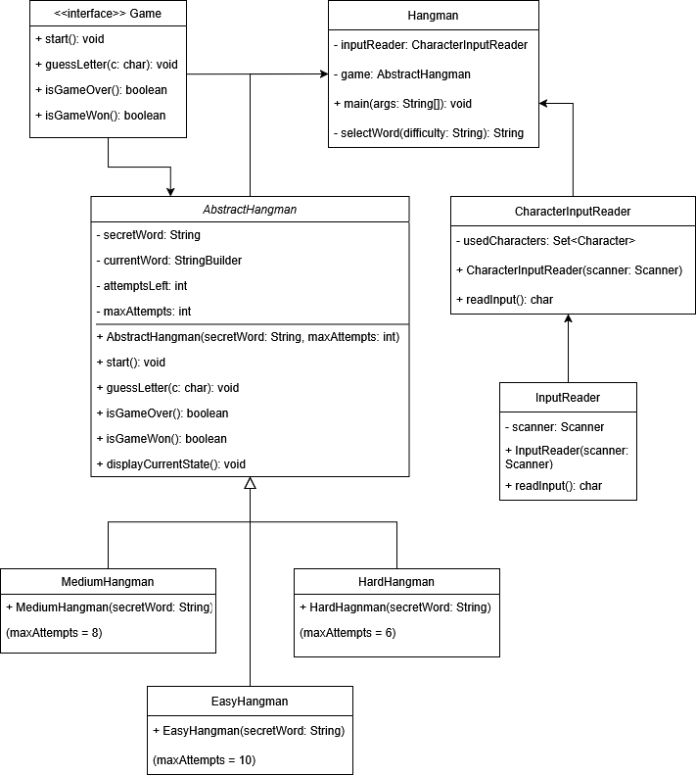

Sequence Diagram:

Key interactions:

* Hangman <-> CharacterInputReader: The Hangman class uses the CharacterInputReader to handle user input and ensure valid guesses.
* Hangman <-> AbstractHangman: The Hangman class interacts with the AbstractHangman class to manage the game state and process guesses
* AbstractHangman: Handles the core game logic, such as updating the word, tracking attempts, and determining if the game is over.