FURTHER WEB PROGRAMMING ASSIGNMENT 1

Name: Nguyen Hoang To Nhu – S3878533

**STUDENT ENROLMENT MANAGER APP**

Github link: <https://github.com/lacnham/Further-Programming-ASM1>

**I. Introduction of the System**

Nowadays, studying has become very important for every person, especially for university students, who are on their long journey to pursue their majors. In order to help the students to decide on their upcoming courses in a logical and easy way, I would like to introduce an app that assists the enrolment process. This app consists of 2 steps: firstly, it shows the desired courses in a list, and secondly, it gives the results of the selected courses. If this app is being used, it will not only assist the students to choose their courses more easily and more carefully, it will also provide an efficient system for the administrators of the courses.

**II. The flow of the program**

Interacting with the system

First when you open the app, you should choose a package Main, find the class Main and then press Start.

The program will display

“Welcome to the student enrolment system. Please choose an option

1. Enrolment

2. List Course of Student and Update Course

3. List Course of Student in a Semester

4. Exit the program “

1. Enrolment

If you choose option 1 Enrolment, you should type in student ID, semester, course ID. The message “successfully enroll!” will appear if the information is right.

2. List Course of Student and Update Course

If you choose option 2, you will be asked to input student ID and semester. Then the list of course that student has enrolled in the semester will appear by row. You will have two option to add more course or delete course.

3. List Course of Student in a Semester

In this option, you will ask to choose student ID and semester to add information to the Enrolment.csv file.

4. Exit the program

To turn back to the previous step or to exit the program, you can type any integer except the ones that describe the options.

**III. The table of the methods**

|  |  |  |
| --- | --- | --- |
| Name () | Return type | Description |
| getId | String | Return the id of student and course |
| getName | String | Return name of student and course |
| getNumberOfCredits | int | Return credit number of the course |
| getBirthday | Date | Return birthdate of student |
| getIdStudent | String | Return the id of student |
| getIdCourse | String | Return the id of course |
| getSemester | String | Return semester |
| StudentEnrolmentManager | Arraylist | Return list of student enrolment |
| add | Arraylist | Add new course for student to the list |
| update | Arraylist | Update student situation in the enrolment list |
| delete | Arraylist | Delete one row of course in 1 student’s course list |
| getOne | Arraylist | Return 1 student the user choose |
| getAll | Arraylist | Return a list of student enrolment |
| main |  | Run the program |

**IV. Diagram**

**USE CASE DIAGRAM**

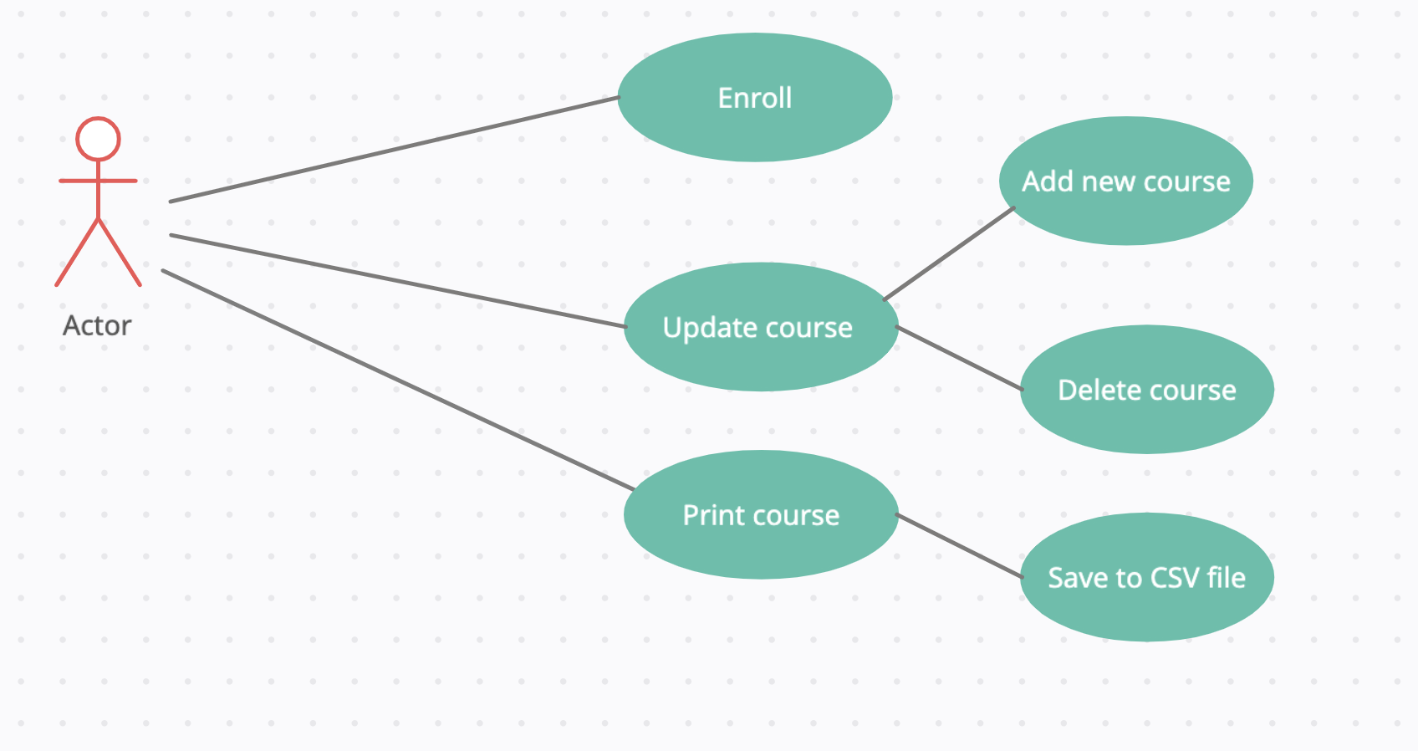

**CLASS DIAGRAM**