
Free Factory

Documentation

by

Jim Hines and Karl Swisher


Licensed under the GPLv3 2013



Table of Contents
Introduction 5
Setting Up Free Factory 5
Notification 5
Free Factory Notify Directories 5
Directory Path 6
Directory Dialog Button - 6
User Name 6
New Button 6
Save Button 6
Update Button 6
Delete Button 6
Rewrite Startup 6
Free Factory Processes 6
Start 6
Restart 6
Stop 6
Kill 7
Free Factory Setting Tab 7
Company Name 7
Apple Delay 7
User Defaults 7
FFMxProgram 7
Run From 7
Enable Factory 7
Delete Source 7
Delete Logs 7
Action 7
FTP Transfer Type 8
FTP Delete After 8
Enable Email 8
Enable Factory Links 8
Email Settings 8
SMTP Email Server 8
Email Port 8
Email User Name 8
Email Password 8
From Name 8
From Address 8
TLS 8
Email Message Button 8
Setting Up Factories 8
New Button 9
Save Button 9
Delete Button 9
Exit Button 9
View Logs Button 9
Edit Settings Button 9
Save Settings Button 10
Help Button 10
About Button 10
License Button 10
Directory Button 10
Email Message Button 10
New Email 10
Save Email Button 10
Update Email Button 10
Remove Email Button 10
Read Only Button 10
Add Link Button 11
Remove Link Button 11
Factory List Box 11
Factory File Name 11
Description 11
Notify Directory 11
Output Directory 11
Output File Suffix 12
FFMx Program 12
Run From 12
Enable Factory 12
Remove Source 12
Remove Log 12
Action 12
FTP Options 13
URL 13
User Name 13
Password 13
FTP Program 13
Transfer Type 13
Delete After 13
Video and Audio Options 13
Factory Email 13
Factory Linking 14
Log Viewing 15
Refresh Button 15
Remove Log Button 15
Close Window Button 16
Settings 16
Display 16
Date/Time 16
PDF Reader Path 17
Select All Text 17
Confirm File Saves 17
Confirm File Deletions 17
Show Tool Tips 17
Bottom Buttons 17
Hot Key Shortcuts 17
How The Run Time Program Works 17
Triggering Multiple Factories 18
How The GUI Program Works 18
Users & Permissions 18
Why both ffmpeg and ffmbc? 19
Free Factory Files 19
Directory Structure 19
Directory & File Descriptions 20
Docs 20
Factories 20
FinishedVideo 20
NotifyVideo 20
NotifyVideo2 20
Pics 20
TestVideos 20
bin 20
FreeFactory.config 20
Free Factory.desktop-gnome 20
Free Factory.desktop-kde 20
FreeFactoryNotifyDirectoryList 20
VERSION 20
About.tcl 20
DirectoryDialog.tcl 20
FileDialog.tcl 20
FreeFactoryConversion.tcl 20
FreeFactoryNotify.sh 20
FreeFactoryViewLogs.tcl 20
FreeFactory.tcl 20
InotifyStartupRoot.sh 20
InotifyStartupUser.sh 21
License.tcl 21
LicenseText.tcl 21
ProgramFrontEnd.tcl 21
ProgramGUIUtilities.tcl 21
Settings.tcl 21
WidgetUpdate.tcl 21
Free Factory Configuration File 22
Free Factory – Factory File 23
To Do 24
Currently 24
Needed 24
Contribute To A/V Options 24
Contribute To Free Factory 25
Bugs 25
Acknowledgments 25

Introduction

Free Factory is a group of TCL and BASH scripts to perform on a professional broadcast level to encode video and files. The goal of this project is to make a contribution toward being able to run a TV station with open source software under Linux. Think of Free Factory like this. It is a program to transfer video files from one directory to another or multiple by linking or multiple triggers, doing a conversion on the fly all done automatically once a video file and completed being copied to a watched notify directory as determined by the user. In many instances it will interface drive shares that are on the outside of your video internal playback network and also interface with the inside drive shares of your video network. Free Factory can interface in both ways. The output directory could be an outside directory where a client has access to preview spots. The source directories can be what ever you want. The output or destination directories can be what ever you want. Transfer can be from the outside in, the inside out, the inside in and the outside out as long as the user running the conversion script is running has read write permissions for all directories involved. Free Factory could be used in the home but is mainly geared to the broadcast market. This is not a GUI front end to manually encode or edit video files. There are much better programs out there to do this. The GUI provided is for administering Free Factory and setting up factories. What Free Factory does is to allow multiple users on different computers to copy video files to a shared networked directory or directories monitored by Free Factory. Free Factory then calls ffmpeg or ffmbc to encode the video file according to the options you give it through the preset factories to the output directory specified in the factory or copies the file there. After a successful conversion the source file can be set to be automatically deleted so your notify directories will not fill up your storage media Free Factory uses the command inotifywait in the recursive mode to monitor directories you select.

The Free Factory run time can be run two different ways. One is by root calling another user the the other is by running under a user. There are two different start up scripts one to be run by root and the other by any user. They are InotifyStartupRoot.sh and InotifyStartupUser.sh. InotifyStartupRoot.sh can be run by root either from a shell or included in rc.local to automatically start on boot. The command path is /opt/FreeFactory/bin/InotifyStartupRoot.sh. Starting Free Factory run time by any user is done by typing in /opt/FreeFactory/bin/InotifyStartupUser.sh or by starting from the administration GUI. The administration GUI can be accessed either by typing in /opt/FreeFactory/bin/FreeFactory.tcl from a shell or clicking on the desktop icon provided.

Setting Up Free Factory
Here is the quickest way to be up and running in Free Factory. The Free Factory settings tab is what needs set first. The other tabs are defaulted to what will work and can be modified later if you wish. Click on the edit settings icon located on the main Free Factory window. This is what you will see after clicking on the Free Factory tab of the edit settings window. The following will take you through this process.

Notification Settings Tab

Free Factory Notify Directories

The two shown here are the default. You can use these, edit them, add new ones and delete these. These are the directories a inotifywait monitors and a factory uses to do the conversions.

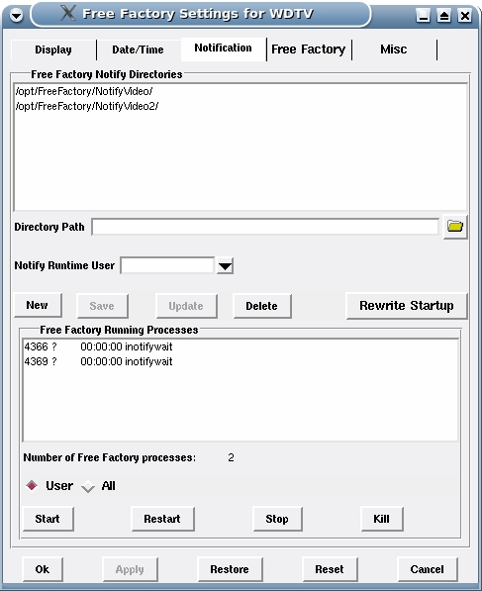
Directory Path - This entry widget allows you to type and and edit a directory path. It also receive the selected output from the directory dialog window produced from the open button next to this widget

Directory Dialog Button - This button opens up a directory dialog window that allows you to browse for a directory.

User Name - Next is the user name. Each notify directory can has a user name associated with it. The ones that do will be placed in the InotifyStartupRoot.sh file when the Rewrite Startup button is pressed. You only put a user name in here is when you want to start Free Factory run time by root in rc.local or from a shell. The called program inotifywait will run under the user name in the script and not root. The combo box lists the users on the system.

New Button - Erases the contents on the Directory Path entry widget and places the cursor inside this widget. Also activates the Save button and deactivates the Update button.

Save Button - Saves a new path in Directory Path to the FreeFactoryNotifyDirectoryList file. This only saves the notify directory paths and a user if selected. This DOES NOT save any of the other settings. All other settings must be saved using the Save Settings button on the main GUI window.

Update Button - Updates an existing Directory Path to the FreeFactoryNotifyDirectoryList file.

Delete Button - Deletes the path in Directory Path from the FreeFactoryNotifyDirectoryList file.

Rewrite Startup - This button rewrites the start up files of InotifyStartupRoot.sh and InotifyStartupUser.sh. After this the run time processes can be started or restarted to reflect the changes made to the notify directories.

Free Factory Processes

Start – Starts Free Factory run time processes.

Restart – Restarts Free Factory run time processes.

Stop – Stops all Free Faction run time processes.

Kill - Stop a single Free Factory run time process.

Free Factory Setting Tab

Company Name - First type replace “Company Name” with your company name.

Apple Delay- Then decide the Apple delay if you have Apple computers copying video to your notified directories. Apple continuously opens and closes the file it writes to multiple times during the copy. This causes false positives triggered by inotifywait. The delay is there to delay the conversion script from starting before the Apple machine has finished copying the file. The copy must be finished before a successful conversion can take place.
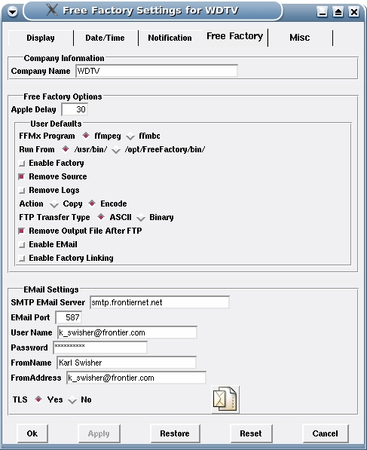

User Defaults
These settings are used when setting up a new factory. When New is clicked the options below will be automatically filled in. If you have some or all that don't change you can set the default value to that and save you a little time.

FFMxProgram - This field must be set in a factory for it to encode. The two choices are ffmpeg and ffmbc. If you use one more than the other set to default to that one here.

Run From - Free Factory installs a complete self contained working copies of ffmpeg and ffmbc within /opt/FreeFactory. See more on this in the Setting Up Factories section.

Enable Factory - Factories must be enable to be use in conversions. You can set the default to checked which is enabled or not checked which is disabled.

Delete Source - To keep drives from filling up you can have the source file deleted after the file is encoded or copied to the output directory.

Delete Logs - Logs can accumulate quickly. Instead of a large log each conversion will generate it's own log with the source file name appended to the root of the log file. If a script fails and stops executing it will not encode or copy the file the log will not be deleted. This can always be turned off in a factory if a problem occurs. See more on this in the Setting Up Factories section.

Action - Sets the default action for the factory of encode or copy to be applied to the source file.

FTP Transfer Type - Sets FTP transfer default to ASCII or Binary

FTP Delete After - Allows for deletion of encoded output file after FTP has completed

Enable Email - Checking this box will check the box on the main window to enable email when the New Factory button is clicked on.

Enable Factory Links – Performs the same function as Enable EMail above except applied to the Factory Linking function.
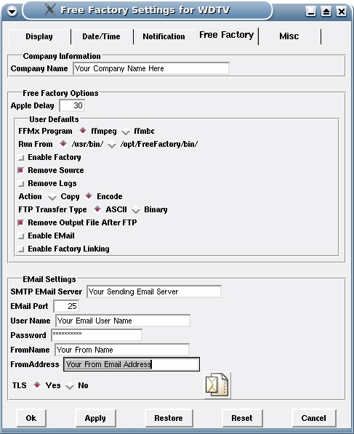

Email Settings

SMTP Email Server – This is where the email server is entered. It can be either a IP address number format such as 10.10.10.10 or a proper name format such as smtp.mydomain.com.

Email Port – This is the port number. The default for many years has been 25. In recent times many are using 587.

Email User Name – The user name used to log on to the sending email server.

Email Password – The password used to log on to the sending email server.

From Name - The name Free Factory uses as the from name in the email.

From Address – The email address used as the from in the email.

TLS - Lets you select whether to use TLS in processing the email connection.

Email Message Button - This adds a message globally that is included in the confirmation emails. This message if used is included in all factories.

Setting Up Factories
Setting up a factory is the next step in getting Free Factory up and running. Factories are what match the notify directories with the desired A/V options in the conversion program along with the output directory. Since inotifywait is run recursively. Any directories created within the path chain will trigger a response to encode. As an example you can can have /video/dropbox as your notification directory in startup. Addition directories can be created within /video/dropbox for different conversion needs. Directory paths in the factories can be like /video/dropbox/AVI, /video/dropbox/MPG or /video/dropbox/MP4 or what ever naming convention you want to use. Each factory will have a unique notify directory that is one of the notify master directories or a sub directory of them. Depending on what notify directory it is, certain conversion options will be applied to the output file.

Next describes the function of the main Free Factory administration window. This is where factories are built. The conversion programs ffmpeg and ffmbc provide many more audio and video options than are currently supported here. More will be added in the future.
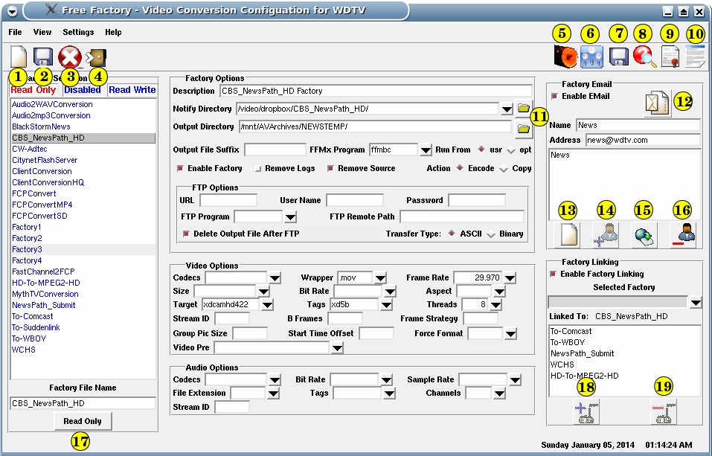
1. New Button. - Clears the GUI fields and makes ready for a new factory. New factories can also be created by clicking on an existing factory, making the changes you want and saving it out under a different file name. If doing this I recommend immediately saving under the new file name after clicking on the file name to be edited. Then edit and save again. This way you don't forget and overwrite the existing factory.

2. Save Button – Saves a new or edited factory.

3. Delete Button – Deletes a factory.

4. Exit Button – Closes and exits the Free Factory GUI.

5. View Logs Button – Will bring up a new window with a list of the logs in /var/log/FreeFactory. When a log file name is clicked on the log details are listed in the scrolled list box on the right side of the window.

6. Edit Settings Button – Allows you to edit settings. Change fonts, colors and the feel of how the GUI operates. Most importantly this is where you initially set up the notify directories for Free Factory.

7. Save Settings Button – This saves the settings. Edited settings are not automatically saved. You must do this. It is an extra safe guard against you screwing the GUI up. You can change the fonts and colors in such a manner that you are unable to navigate the GUI. If this happens and you are unable to click on the Restore or Reset buttons you can exit the program and start over.
8. Help Button – Displays this very document you are reading. Also the F1 key.

9. About Button – Displays the about window.

10. License Button – Displays the license.

11. Directory Button – Clicking on either of these two buttons brings up a dialog requester to select a directory.

12. Email Message Button - Allows a custom message to be added to the factory result email notification.

13. New Email - Sets this portion of the GUI up to add a recipient to the email notification result list for the factory.

14. Save Email Button – Saves the email name and address to the internal variables and displays the name in the list box. To actually save the email list to the drive the factory must be saved.

15. Update Email Button – Allows changes to be made to an email name or address. Update only updates the data to the internal variables and displays the name in the list box. To actually update the email list to the drive the factory must be saved.

16. Remove Email Button – Removes an email recipient from the list. Remove only removes the data from the internal variables and removes the name from the list box. To actually remove the email from the drive the factory must be saved.

17. Read Only Button – This will make the selected factory file a read only file. After a file is made read only it can no longer be saved to. This prevents accidental rewriting of a factory. The a read only factory can be saved with a different file name. You still can delete a read only factory.

18. Add Link Button – Adds the factory in the combo box to the list of factories linked to the current factory being created or edited.
19. Remove Link Button – Removes a factory previously linked to the current factory from the linked factory list for the factory being created or edited.

Factory List Box - Displays all the factory files that can be edited or deleted. Any file item with a gray background is disabled. If file name is in red it means the file is read only. If the file name is in blue it is read writable. Read only files cannot be save over but they can be deleted.

Factory File Name - Either displays the factory file name you clicked on in the list box or when you type in the name of a new factory to add. You can take existing factories and rename the file name to a different one and save as a new one.

Description - You can add a description of what the factory does.

Notify Directory - This field contains the directory path the conversion script compares to the directory path sent by inotifywait. If they match the FFMx (ffmpeg or ffmbc) program is called to encode the file based on the A/V options to the output directory. This is a combo box pre-filled with the directory paths set up in the Free Factory settings window. Form there you can us the directory dialog button to the right to browse for sub-directories if needed.

Output Directory - This is the directory path where the encoded output file will be encoded to.

Output File Suffix - Allows you to append what text is entered here to the output file name before the extension is added.

FFMx Program - You select where you want ffmpeg or ffmbc to encode your file. You must select one or the other.

Run From - You have the option per factory to select where you want FFMx to be run from. The choice is usr or opt. Usually you have these programs in the normal execution path of /usr/bin/. Free Factory installs a complete separate version of ffmpeg and ffmbc inside of /opt/FreeFactory/. This will not interfere with your distribution version. Many distribution updates will be fine however some could not be compatible the preset factories in Free Factory. Also you have some things you don't have in your distribution versions. Free Factory can't be distributed with non free programs. The installation program can and does go out and include them for you on installation. The ffmpeg and ffmbc with in /opt/FreeFactory probably will not be the latest but will have some extras needed in the professional broadcast field. The user has a choice with each factory setup of whether to run FFMx from the distribution version in /usr/bin/ or the version with Free Factory in /opt/FreeFactory/bin.
Enable Factory - When checked enables the factory to be included in the conversion selection process. If unchecked the factory will be excluded from the conversion selection process.

Remove Source – If Yes is selected then the source file is removed after the factory is processed.

Remove Log – Logs are stored in the /var/log/FreeFactory/ directory. This will accumulate many log files and take up disk space. This is a determination made for each factory. If everything is working properly then you don't want to spend time looking at what is working. You want to know what does not work. There is one log generated from the InotifyStartup-xxxx.sh scrip and one from the
FreeFactoryNotify.sh script. It should have very little to zero ever written to it. The main log for each conversion is generated by FreeFactoryConversion.tcl. Here is the format for the log file name.

Conversion-FILENAME.log

Where FILENAME is the name of the input file.

By default the Delete Logs is set to “No” to keep the logs. After you look at a few and everything works you can change this to “Yes” on each factory. If the factory does not FTP then there will not be a FTP log file created. You can also change the default values on the Settings, Free Factory tab so that each time you create a factory the button defaults to Yes or No.

Action – Determines whether the source file is encoded to the output directory or the source file is copied to the output directory. If copy is checked then a straight copy is performed and it does not matter what A/V options are set on the factory, they are ignored and no conversion is done on the file.

FTP Options - If there is something in the URL field and something in the FTP Program field then after the file is encoded it can be sent automatically by ftp.

URL – The IP address you want to FTP to.

User Name – User name if needed.
Password - Password if needed.

FTP Program – The ftp program used.

Transfer Type - Sets the transfer type to ASCII or Binary.

Delete After - If set to Yes will also delete the output destination file after FTP is completed. Is ignored if no FTP is set to be attempted.

Video and Audio Options
This should be straight forward. Set the options you want the output file encoded to in the factory. This documentation does not attempt to address video and audio knowledge. It is up to the user to know how to apply the options.

Factory Email

Free Factory allows for the sending of email confirmation upon completion of a factory. Email functions independently for each factory. There can be unlimited recipients only limited by what your email server will allow.

Enable Email – Enables or disables email notification for the factory. Even if there are recipients listed, email will not occur after factory processing if this is not checked enabled.

Name – Simply the name of the recipient.

Address – The email address of the recipient. Names and addresses are assembled according to the 822 email specification when sending.

Email List Box – Contains the list of email recipients assigned to the factory.
Email Message - Each factory can have an optional message included in the confirmation email sent.

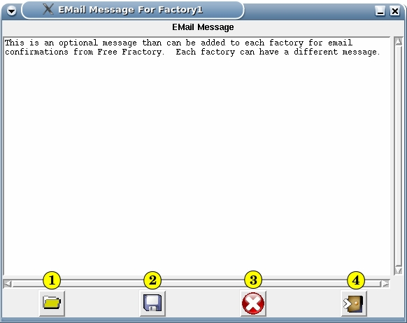
1. Load Text From File - This brings up a file dialog requester and will load in the contents of the file selected.

2. Save And Exit Window – Saves the message to the internal variable and closes the window. For the message to be actually saved on the disk the factory must be saved.

3. Clear Message - This clears the message from the window.

4. Exit - This exits the window but does not save and changes made to the message to the internal variable.

Factory Linking

Factory Linking is the ability of a Factory to have other factories linked to it. What that means is that after the factory has completed it's initial conversion it will apply the output directory , FTP settings and A/V Option settings of any linked factory to the source file of the factory being processed. This can be use to distribute a single video to different destinations in different formats. Links are processed serially in the order listed in the GUI. This differs from multiple triggers where the notify directory is the same in other factories. In that the source file and logs can only be deleted by the last factory. When linking the settings in the master or parent factory are used to determine the removal of source files and logs. If removal is selected they are only done upon completion of all linked factories.

When you select a factory all other factories except the selected factory are loaded into the linking combo box. There is no benefit to link to the same factory. When a factory is selected in the combo box you can then link it to the main selected factory with the plus button. Each factory linked in the list box is then removed from the combo box. This keeps you from linking duplicate factories to the selected factory. Selecting a linked factory in the list box allows for removal of the factory as a link with the minus button.

Log Viewing

The administration GUI also supports viewing of the logs generated by the notification and conversion process. This window will display the contents of the log file clicked on in the list box.

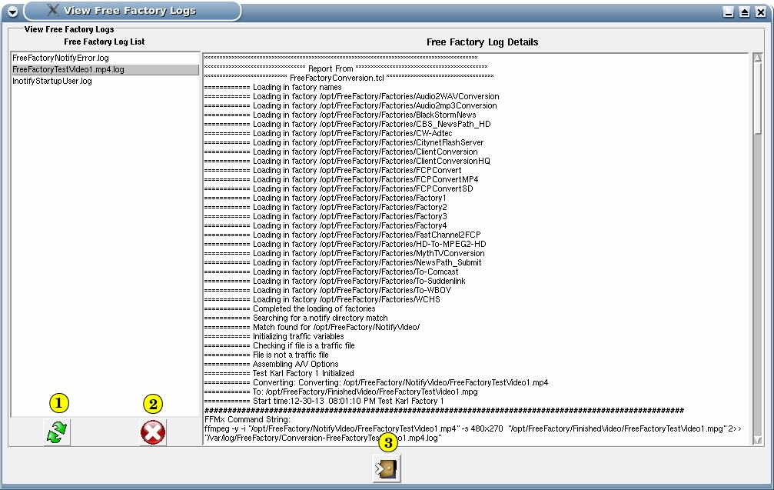
1. Refresh Button – Will clear and reload the log list box with the file names of the log files located in /var/log/FreeFractory.

2. Remove Log Button - This lets you manually remove a selected log. Be careful don't remove a log you need to review or one that has not finished writing.

3. Close Window Button - Close the Free Factory View Logs window.
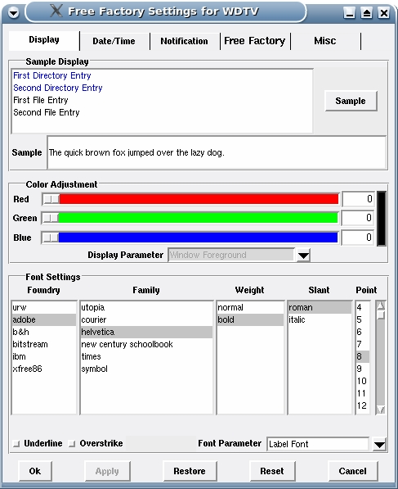

Settings

Display – The top part is a sample of the result when changing colors. You first pick the parameter you want to change from the Display Parameter combo box. The fonts also update the samples.

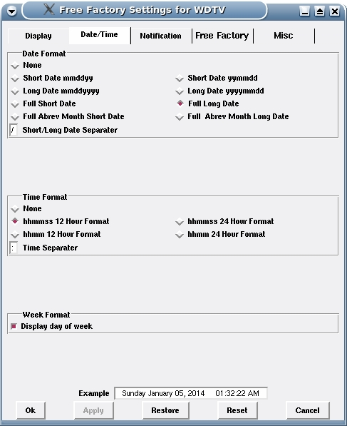

Date/Time - This allows you to pick the date and time format displayed at the bottom right of the main Free Factory window. The example at the bottom will show your changes before they are applied.

MISC

PDF Reader Path – The path to your PDF reader. Acrobat is shown here but it can be any PDF reader. Used to display help.

Select All Text - When you enter a text widget this gives you the option of having all the text selected or not.

Confirm File Saves - If checked will bring up an additional confirmations dialog requiring manual confirmation before a save of a file takes place.

Confirm File Deletions - If checked will bring up an additional confirmations dialog requiring manual confirmation before the deletion of a file takes place.

Show Tool Tips - This turns on and off the display of tool tips over the buttons.

Bottom Buttons

The bottom buttons function as labeled. The Ok and Cancel buttons function the same if nothing is changed. They exit the Settings window. If changes have been make Ok copies the changes to the system preferences. Cancel exits the Settings window without copying those changes.. The Apply button copies the changes to the system preferences but does not exit the Settings window. The Restore button restores any changes you make to the preferences back to the way they were before you made the changes. The Reset button sets the preferences to the programmers preferences when the program was first installed.

Hot Key Shortcuts

On the main factory GUI there are certain key strokes that will initiate a button press. The are:

Ctr-n or Ctr-N = New Factory
Ctr-s or Ctr-S = Save Factory
Ctr-d or Ctr-D = Delete Factory
Ctr-h or Ctr-H = Help
F1 = Help
Escape = Exits all windows

How The Run Time Program Works

The run time is started with one the InotifyStartup-xxxx.sh scripts. This script can have one or multiple lines starting inotifywait waiting to send a signal to FreeFactoryNotify.sh. There will be an inotifywait and a FreeFactoryNotify.sh running for each entry in InotifyStartup-xxxx.sh or each notify directory you have created in the settings GUI. FreeFactoryNotify.sh is an endless loop reading the piped output from inotifywait. The read statement waits on an inotifywait response so the endless loop does not take up CPU cycles. Having an endless loop means FreeFactoryNotify.sh does not end and inotifywait and the pipe between them does not end. It is continuous waiting for each user to copy a video file to one of the directories or sub directories. inotifywait is started recursively so it will also monitor all sub directories below the root parent directory given in InotifyStrtup-xxxxx.sh. Because of this you only need one notify directory setup per directory path. Once a close_write is received by FreeFactoryNotify.sh it passes the directory path and file name to FreeFactoryConversion.tcl which does everything else. There can be multiple copies of FreeFactoryConversion.tcl running at the same time, one for each file being encoded. But only one copy of inotifywait and FreeFactoryNotify.sh has to be running to do this. For many people copying files and multiple files, inotifywait will pass to FreeFactoryNotify.sh as fast as FreeFactoryNotify.sh can call FreeFactoryConversion.tcl which is very fast. The only delay involved is when dealing with Apple machines and is address in the documentation above. The hardware involved will need designed to handle such a load if turn around time is critical.

Triggering Multiple Factories

Multiple factories can be triggered if each factory if set to the same exact notify directory. However for this to work the removal of the source file or log file must be set to No for all factories until the last factory. The conversion script continues to loop through the factories even after a match is made and encoded. If another match is made that factory is encoded too. The factory list is sorted like in the GUI. The list is searched in order from top to bottom. There will be only one log file created for all of this.

How The GUI Program Works

This is very simple. The GUI is started by running FreeFactory.tcl. There is no GUI code in this script but it uses the WISH interrupter which is required for Tk. It calls ProgramFrontEnd.tcl. That is where all the main window GUI is. Settings.tcl is called from the main window. Other scripts are the DirectoryDialog.tcl with allows you to browse for directory selection and ProgramGUIUtilities.tcl which is a script file containing several GUI scripts for user confirmation, information and error reporting. The GUI scripts make use of Iwidgets. It should has been installed along with any other tcl packages needed during installation of Free Factory.

Users & Permissions

Free Factory is a very flexible program. The simplest use of it is under a single user. You can have the notification of different directories run by different users. Care must be take with permissions so that everyone that is suppose to have write access does to a given directory and those that are not suppose to don't. One solution might be through group membership. Create a group and assign everyone to that group that needs to write to the notify directories. All users running Free Factory in run time would need to belong to the same group. As well as have write permission on the output directories. In addition write permissions are needed to the /var/log/FreeFactory log directory and /opt/FreeFactory/bin if FTP is being used.

Why both ffmpeg and ffmbc?

TO BE WRITTEN BY JIM HINES

Free Factory Files

Here is the directory structure and files for /opt/FreeFactory.

Directory Structure
/opt/FreeFactory/
Docs/
Factories/
FinishedVideo/
NotifyVideo/
MP4HQ/
ToDVCPROHD/
ToMkv/
ToMpg2ToHD/
ToMpg2ToSD/
XDCam/
NotifyVideo2/
Pics/
TestVideos/
bin/
About.tcl
DirectoryDialog.tcl
FileDialog.tcl
FreeFactoryConversion.tcl
FreeFactoryNotify.sh
FreeFactoryViewLogs.tcl
FreeFactory.tcl
InotifyStartupRoot.sh
InotifyStartupUser.sh
License.tcl
LicenseText.tcl
ProgramFrontEnd.tcl
ProgramGUIUtilities.tcl
Settings.tcl
WidgetUpdate.tcl
FreeFactory.config
Free Factory.desktop-gnome
Free Factory.desktop-kde
FreeFactoryNotifyDirectoryList
VERSION

Directory & File Descriptions

Docs – Contains the documentation for Free Factory.

Factories – Contains the Factories.

FinishedVideo – Sample finished directory.

NotifyVideo – Sample notify directory 1.

NotifyVideo2 – Sample notify directory 2.

Pics – Icons for the tcl programs and icons for the desktop icon.

TestVideos - Sample test videos.

bin – Execution scripts.

FreeFactory.config - Configuration file for Free Factory.

Free Factory.desktop-gnome – Gnome desktop icon.

Free Factory.desktop-kde – KDE desktop icon.

FreeFactoryNotifyDirectoryList – Notify directories for Free Factory.

VERSION – Version number of Free Factory.

About.tcl – Displays title authors and version.

DirectoryDialog.tcl – Returns the directory path.

FileDialog.tcl - Used in loading a text file in an email message.

FreeFactoryConversion.tcl – The conversion script.

FreeFactoryNotify.sh – This script is call from either one of the InotifyStartup scripts.

FreeFactoryViewLogs.tcl – The script that views the logs generated by the run time scripts.

FreeFactory.tcl – Starts the GUI administration script.

InotifyStartupRoot.sh – The script that starts inotifywait, piping the output to FreeFactoryNotify.sh. Started by root but inotifywait and FreeFactoryNotify.sh are run by the users designated

InotifyStartupUser.sh - The script that starts inotifywait, piping the output to FreeFactoryNotify.sh.
This is the script use when Free Factory run time is started from the GUI.

License.tcl – License script for Free Factory.

LicenseText.tcl – License text for Free Factory.

ProgramFrontEnd.tcl – This is the GUI for Free Factory.

ProgramGUIUtilities.tcl - Utility GUI tcl scripts like save and delete confirmation dialogs.

Settings.tcl – This manages the setting for Free Factory.

WidgetUpdate.tcl – All windows of Free Factory use this script to update the color and fonts to the widgets.

Free Factory Configuration File

# FreeFactory Configuration File

WINDOWFOREGROUND=#000000
WINDOWBACKGROUND=#f0f0f2
ACTIVEFOREGROUND=#000000
ACTIVEBACKGROUND=#fefefe
SELECTIONFOREGROUND=#000000
SELECTIONBACKGROUND=#c4c4c4
WIDGETFOREGROUND=#000000
WIDGETBACKGROUND=#fefefe
DIRECTORYFOREGROUND=#0000ff
FILEFOREGROUND=#000000
SIDEWINDOWBACKGROUND=#999999
TOOLTIPFOREGROUND=#000000
TOOLTIPBACKGROUND=#dfe2ff
FOUNDRYLABEL=adobe
FONTLABEL=-family helvetica -size 8 -weight bold -slant roman -underline 0 -overstrike 0
FOUNDRYTEXT=adobe
FONTTEXT=-family helvetica -size 8 -weight normal -slant roman -underline 0 -overstrike 0
THECOMPANYNAME=WDTV
APPLEDELAY=30
FFMXPROGRAM=ffmpeg
RUNFROM=usr
ENABLEEMAIL=No
ENABLEFACTORYLINKING=No
FTPTRANSFERTYPE=asc
FTPDELETEAFTER=Yes
ENABLEFACTORY=Yes
DELETESOURCE=Yes
DELETELOGS=No
FREEFACTORYACTION=Encode
SMTPEMAILSERVER=
SMTPEMAILPORT=
SMTPEMAILUSERNAME=
SMTPEMAILPASSWORD=
SMTPEMAILFROMNAME=
SMTPEMAILFROMADDRESS=
SMTPEMAILTLS=1
GLOBALEMAILMESSAGESTART=
This is an optional message than can be added globally to all email confirmations from Free Fractory.
GLOBALEMAILMESSAGEEND
PDFREADERPATH=/opt/Adobe/Reader9/bin/acroread
FOUNDRYTOOLTIP=adobe
TOOLTIPFONTS=-family utopia -size 10 -weight bold -slant roman -underline 0 -overstrike 0
SELECTALLTEXT=Yes
CONFIRMFILESAVES=Yes
CONFIRMFILEDELETIONS=Yes
SHOWTOOLTIPS=Yes
DISPLAYDATEFORMAT=FullLong
DATESEPARATER=/
DISPLAYTIMEFORMAT=hhmmss12Hour
DISPLAYTIMESEPARATER=:
DISPLAYDAYOFWEEK=Yes

Free Factory – Factory File

FACTORYDESCRIPTION=Test Factory 1
NOTIFYDIRECTORY=/opt/FreeFactory/NotifyVideo/
OUTPUTDIRECTORY=/opt/FreeFactory/FinishedVideo/
OUTPUTFILESUFFIX=
FFMXPROGRAM=ffmpeg
RUNFROM=usr
FTPPROGRAM=
FTPURL=
FTPUSERNAME=
FTPPASSWORD=
FTPREMOTEPATH=
FTPTRANSFERTYPE=asc
FTPDELETEAFTER=Yes
VIDEOCODECS=
VIDEOWRAPPER=.mpg
VIDEOFRAMERATE=
VIDEOSIZE=480x270
VIDEOTARGET=
VIDEOTAGS=
THREADS=
ASPECT=
VIDEOBITRATE=
VIDEOPRESET=
VIDEOSTREAMID=
GROUPPICSIZE=
BFRAMES=
FRAMESTRATEGY=
FORCEFORMAT=
STARTTIMEOFFSET=
AUDIOCODECS=
AUDIOBITRATE=
AUDIOSAMPLERATE=
AUDIOFILEEXTENSION=
AUDIOTAG=
AUDIOCHANNELS=
AUDIOSTREAMID=
MANUALOPTIONS=
DELETESOURCE=Yes
DELETECONVERSIONLOGS=No
ENABLEFACTORY=Yes
FREEFRACTORYACTION=Encode
ENABLEFACTORYLINKING=No
FACTORYLINKS=Factory2 Factory3 Factory4
FACTORYENABLEEMAIL=Yes
FACTORYEMAILNAME=
FACTORYEMAILADDRESS=
FACTORYEMAILMESSAGESTART=
This is an optional message than can be added to each factory for email confirmations from Free Fractory. Each factory can have a different message.
FACTORYEMAILMESSAGEEND

To Do

Currently

We are looking to add more functionality to Free Factory to duplicate the software currently in place providing this function. The files that are prefixed by traffic are being parsed to capture the spot type code, spot ID and the spot run time. Nothing is being done with them at this time in the conversion program. The program this would replace also sends data to the video server database and some other functions that seem to be proprietary enough that makes interfacing with them impossible for us. The traffic server we think we can work with. The video server needs replaced by an Linux based open source system capable of handling the serial automation at least. The database we would pick is Postgresql when the time comes that we need one. Jim has an AREXX program he wrote way back when on an Amiga that controlled a dish through the serial port. He is trying to find it. If so we will attempt to rewrite it in TCL/Tk and bash. Will be useful code to drop in later when we get to the satellite recording programming.

Needed

What is need right now is documentation on serial commands used in automation. Any other information that could be helpful in constructing a video system for a TV station running open source software on Linux.

Contribute To A/V Options

The current list of A/V Options available in Free Factory has been started with the options Jim uses at the TV station. Both ffmpeg and ffmbc have a more robust option structure than Free Factory currently has. If there are options you want to see added please send them. What is needed is the command option and the list of values accepted for that command option. Next is an example for the video tags option.
-vtag

dvc
mp4v
xd5b

We would need something in this simple format to use. Or just the option if it lends itself to a value being typed in instead of selecting from a combo box. Send options to:

Jim Hines lacojim@gmail.com or Karl Swisher k_swisher@frontier.com and put “Free Factory A/V Options” in the Subject.

Contribute To Free Factory

As always your input is appreciated. Please address them to: Jim Hines lacojim@gmail.com

Bugs

We have done our best at testing but there always can be something we missed. Please report any bugs you find.

Acknowledgments

This project would not have never been created if it were not for ffmpeg and ffmbc. It is those programmers that make projects like this possible.

