Machine Learning Project: Predicting the Victories of Olympique Lyonnais
Théo Lacoste, EDHEC Business School | October 2026
Disclaimer. I hope the ML does not predict well, because what the f***: OL will be 5th this season. (The simulation's average final position for OL is 4.9. So much for my hopes.)
Joke aside, let's start.
Introduction
This project asks a simple question: can a machine-learning model predict what Olympique Lyonnais (OL) will do, and is it better than simple references such as an Elo rating or the betting market? Football is a good test. A match is decided by a handful of goals, the stronger team wins only about one time in two, and one game in four ends in a draw. The same question matters in finance: how much can a model extract from public data, how do we measure it reliably, and does it survive comparison with a liquid market?
OL alone plays about 35 league matches a year, which is far too few to train a model. So I train on all five major leagues (Premier League, La Liga, Serie A, Bundesliga, Ligue 1; 29,239 matches from 2010/11 to October 2026) and use OL as a case study.
The model I chose
Multinomial logistic regression on 100 input variables (Elo rating, squad market value, recent form, shots, schedule), re-fitted every season. For each match it gives three probabilities: home win, draw, away win. I also tested random forest, gradient boosting, a support-vector machine and neural networks (all in scikit-learn). None of them is significantly better, so I kept the simplest and most explainable one (section 4).
Three rules I followed
- No leakage: a feature used to predict a match on date T contains nothing dated T or later. An automated test checks it.
- Temporal validation: train on the past, judge on the future, never on a random split.
- Honest evidence: every claimed improvement comes with a confidence interval, and negative results are reported as negative.

The answer in five lines
- Team strength (Elo and squad value) explains almost everything that can be predicted.
- The chosen model has a test log loss of 0.979, against 1.075 for a model that ignores team quality.
- The bookmaker is better (0.966), and mixing my model into its prices adds nothing.
- For OL in Ligue 1 2026/27: 57.6 expected points, average final position 4.9, 50% chance of the top 4, 4% of the title.
- No clear favourite for the Champions League: five clubs sit around 13% each.

1. Research question and targets
Question: can machine learning predict the sporting performance of OL from team-level, match-level and contextual data, and does it beat simple references (Elo, the betting market)?
My first idea was to feed player data to a neural network to predict OL's final ranking. I dropped it: a final ranking is one observation per team and season (about 20 per league), and OL has only about 350 matches in ten years. So I predict the match result instead, where there are about 29,000 examples, and I obtain season quantities by simulation.
Candidate target | Decision
Win / draw / loss probabilities of a match | Main target (about 29,000 observations)
Expected points | Derived: 3 x P(win) + P(draw)
Final points, rank, Europe, relegation | Not trained (too few observations); obtained by Monte Carlo simulation
Individual player contribution | Dropped: causal question, too little data; replaced by an ablation of data categories

2. Data
Source | Content | Use
football-data.co.uk | Results, shots, corners, cards, bookmaker odds; 5 leagues, 2010/11 to 2026 | Core data
Transfermarkt dataset (CC0) | 656,000 player market valuations | Squad value
Self-computed | Elo ratings, shot-based "xG proxy" | Features

Volume: 29,239 matches (593 for OL), 189 clubs. Training 2011–2020 (about 18,200 matches), validation 2021–22 (3,651), test 2023 to October 2026 (5,602).
Sources rejected. FBref advanced statistics were removed by the provider in January 2026. Understat forbids automated access in its robots.txt. ClubElo was unreachable. There is no free historical source for injuries or line-ups, so I could not test them.
Terms of use. football-data.co.uk allows private, non-commercial use only. This is a private academic study; the raw data are downloaded, kept out of the repository and not redistributed. The Champions League fixtures come from Wikipedia (scores and dates only).
3. Variables (features) and how I avoid leakage
Each variable is computed for the home team, the away team and their difference, using only matches before the one predicted.
Family | Construction
Elo rating | Strength score updated after every match (formula below), one scale per league
Recent form | Average over the last 3 / 5 / 10 matches of points, goals for and against, shots on target
Venue form | Last 5 home (or away) matches
League table | Points and goal difference per match, position before the match
Schedule | Rest days, matches in the previous 14 days
Squad value | ln(total squad value) minus the league average of that month (Transfermarkt)
xG proxy | In practice 0.287 x shots on target (see below)

Elo. Before a match, the expected score of the home team is:
E = 1 / (1 + 10^(−(R_home − R_away + 65) / 400))
65 = home advantage in Elo points
After the match, with S = 1 for a win, 0.5 for a draw and 0 for a loss and a multiplier for the goal difference:
R_home′ = R_home + K · (1 + ln(1 + |goal difference|)) · (S − E), K = 20
The rating stored for a match is the one BEFORE this update.
Squad value is measured relative to the league so that market inflation does not look like strength:
sv_rel = ln(V_team) − average of ln(V) over the league that month
Leakage control. Every rolling variable is shifted by one match; Elo is stored before its update; squad values use valuations dated before the snapshot; bookmaker odds are never a variable. An automated test replaces every result after a cutoff date by random values, re-runs the whole pipeline and requires that all earlier variables are strictly identical. I checked that the test fails on two bugs I injected on purpose (a rolling window without the shift; Elo stored after the update).
Two lessons. (1) The "xG proxy" collapses to 0.287 x shots on target: it is not a real xG. (2) Variables counting how many matches a team has been seen for are just a calendar clock, so I removed them (cost: +0.0011 log loss on validation, not significant).
4. The model I chose: multinomial logistic regression
For a match with input vector x (100 variables), the model computes one linear score per outcome k (home win, draw, away win) and turns the three scores into probabilities with the softmax function:
P(outcome = k | x) = exp(wₖ · x + bₖ) / Σⱼ exp(wⱼ · x + bⱼ)
wₖ = weights of outcome k, bₖ = intercept (it contains the home advantage); j runs over the 3 outcomes
Estimation. The weights are found by maximising the log-likelihood of the training matches (the same idea as the Solver exercise in the course), with an L2 penalty that keeps the weights small:
minimise −(1/N) Σᵢ ln P(yᵢ | xᵢ) + (1 / 2CN) ‖w‖²
The penalty strength 1/C is chosen by time-ordered cross-validation inside the training seasons (each fold trains on the past and scores the next block). Inputs are standardised and missing values replaced by the median, both fitted on the training data only. The model is re-fitted once a year.
Why this model and not a more complex one
- As accurate as the alternatives. Boosting, random forest, SVM and neural networks were tested: none is significantly better (section 7).
- Explainable. Each forecast splits exactly into the contribution of Elo, squad value, form and so on, because the model is linear before the softmax.
- Honest. The probabilities are well calibrated: a 70% forecast comes true about 70% of the time.
- Fast. It lets me simulate 10,000 seasons per league in minutes.

Models compared
Family | Models
Baselines | Class frequencies; league table; Elo (calibrated to 3 classes); independent Poisson goals
Linear (chosen) | Multinomial logistic regression with L2 penalty
Trees | Random forest; gradient boosting
Kernel | RBF support-vector machine (under-tuned)
Neural | MLP with 1 and 2-3 hidden layers (L2, few epochs, average of 5 seeds)
Online | Logistic regression whose weights are updated by gradient descent after each week of results
Reference | Bet365 prices turned into probabilities (margin removed, average margin 5.5%)

Only scikit-learn and numpy are used (what we saw in the course). Dropout and Batch Normalisation do not exist in scikit-learn, so I replaced them by L2, few epochs and seed averaging.
5. How I measure quality
Accuracy is a weak summary here: a draw is almost never the most likely outcome, so a model can be useful while rarely naming a draw. The main metric is the log loss, which rewards honest probabilities and punishes confident mistakes:
log loss = −(1/N) Σᵢ ln pᵢ
pᵢ = probability the model gave to the outcome that actually happened in match i
Example: if the model gave 20% to what happened, that match costs ln(5) = 1.61; if it gave 60%, it costs 0.51. A model that always says (44.7%, 25.2%, 30.0%) scores 1.075; a perfect-knowledge model would score 0.
I also report the Brier score and the calibration error (ECE):
Brier = (1/N) Σᵢ Σₖ ( pᵢₖ − oᵢₖ )²
oᵢₖ = 1 if outcome k happened in match i, 0 otherwise
ECE = Σ over bins of (n_b / N) · | average forecast_b − observed frequency_b |
Significance. Differences between models are tested with a paired block bootstrap on the log loss of each match, resampling whole calendar weeks (matches of the same week are not independent), 4,000 draws, 95% intervals. With 5,600 test matches, a difference below about 0.003 cannot be detected.
6. Validation
Football data are a time series: a random split would let the model learn from matches played after the ones it is tested on.
- Training 2011–2020, validation 2021–22 (used to compare models during development), test 2023 to October 2026 (used once, hyper-parameters frozen).
- Walk-forward: each test season S is predicted by models fitted on seasons 2011 to S-1, as it would run in real life.
- Hyper-parameters are chosen only on the training seasons.

7. Results
7.1 Final test, walk-forward 2023 to October 2026 (5,602 matches)
Model | Accuracy | Log loss [95% CI] | Brier | ECE
Baseline (frequencies) | 43.2% | 1.0754 [1.069, 1.082] | 0.6509 | 0.012
Elo | 52.5% | 0.9888 [0.979, 0.999] | 0.5900 | 0.017
Poisson goals | 52.0% | 0.9902 [0.980, 1.001] | 0.5905 | 0.022
Logistic regression (chosen) | 53.3% | 0.9793 [0.969, 0.990] | 0.5834 | 0.016
Gradient boosting | 53.0% | 0.9787 [0.968, 0.989] | 0.5826 | 0.020
Neural network (MLP) | 53.0% | 0.9796 [0.969, 0.990] | 0.5834 | 0.021
Ensemble of the three | 53.0% | 0.9779 [0.967, 0.988] | 0.5824 | 0.017
Bookmaker (Bet365) | 53.9% | 0.9658 [0.955, 0.977] | 0.5740 | 0.022

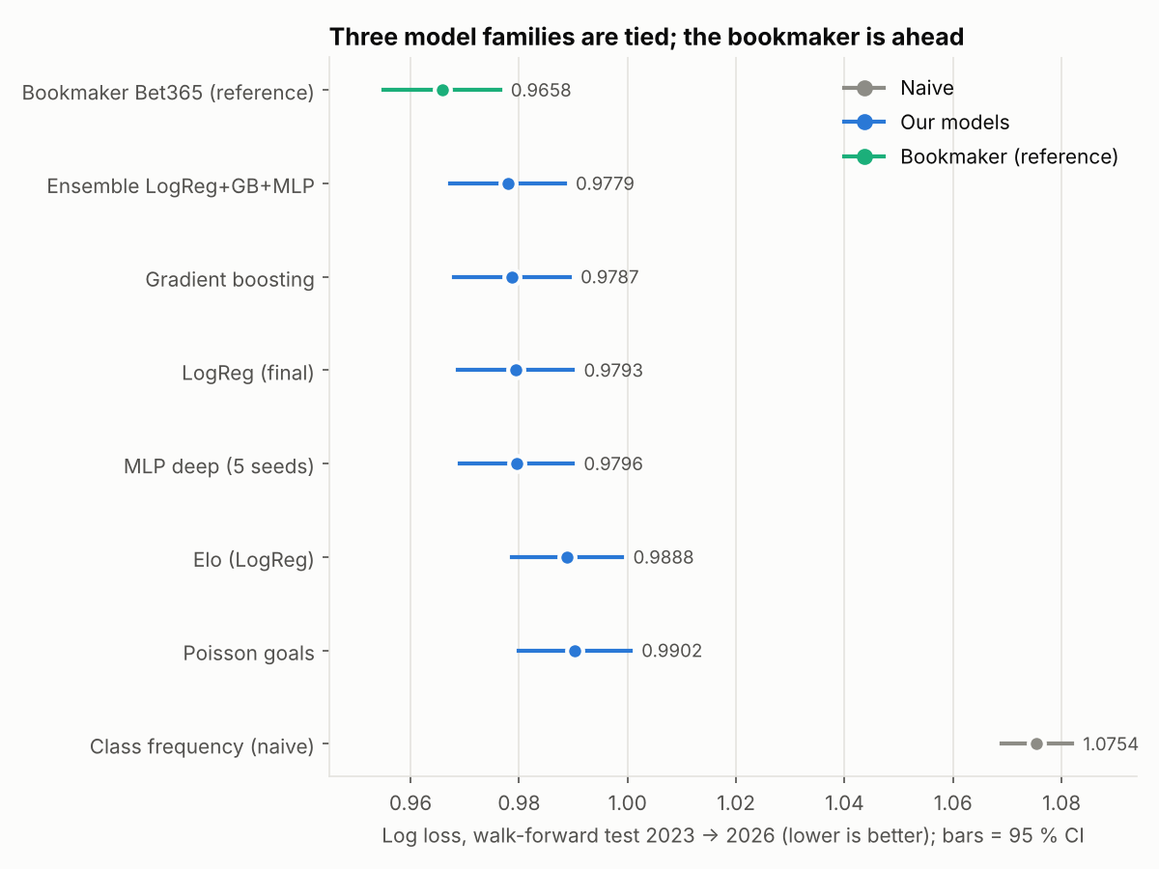
Log loss on the test seasons: three model families are tied, the bookmaker is better.
Reading. The chosen logistic regression beats Elo (difference -0.0095, 95% CI [-0.0135, -0.0056]). Boosting (-0.0007) and the neural network (+0.0003) do not beat it: their intervals contain 0. The bookmaker beats everyone (+0.0135 for my model, CI [+0.0094, +0.0175]). Complexity did not pay.
7.2 Calibration
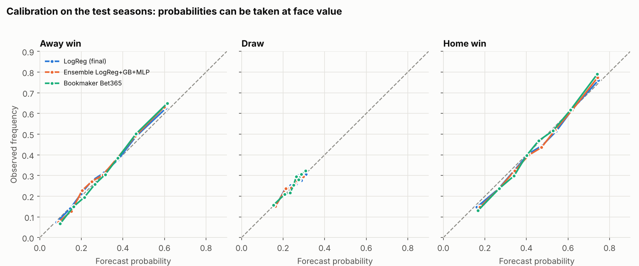
Reliability diagrams: forecasts close to the diagonal are honest.
The probabilities are well calibrated (ECE between 1.6% and 2.2%). The model almost never names a draw as the most likely outcome (6 matches out of 5,602): draws are essentially unpredictable.
7.3 Ablation: which data add value?
Model (logistic regression, validation) | Log loss | Change vs previous [95% CI]
A: Elo only | 0.9957 | -
B: + results form | 0.9931 | -0.0026 [-0.0051, -0.0001]
C: + shots and xG proxy | 0.9887 | -0.0044 [-0.0072, -0.0017]
D: + league table, fatigue | 0.9890 | +0.0003 [-0.0013, +0.0019] (nothing)
E: + squad value (final) | 0.9870 | -0.0020 [-0.0048, +0.0009]

Form and shots each add a small, detectable gain on top of Elo; league position and fatigue add nothing. Squad value is not significant on two validation seasons, although it ranks second in the importance analysis: it overlaps with Elo (both measure long-run strength).
8. What drives the predictions?
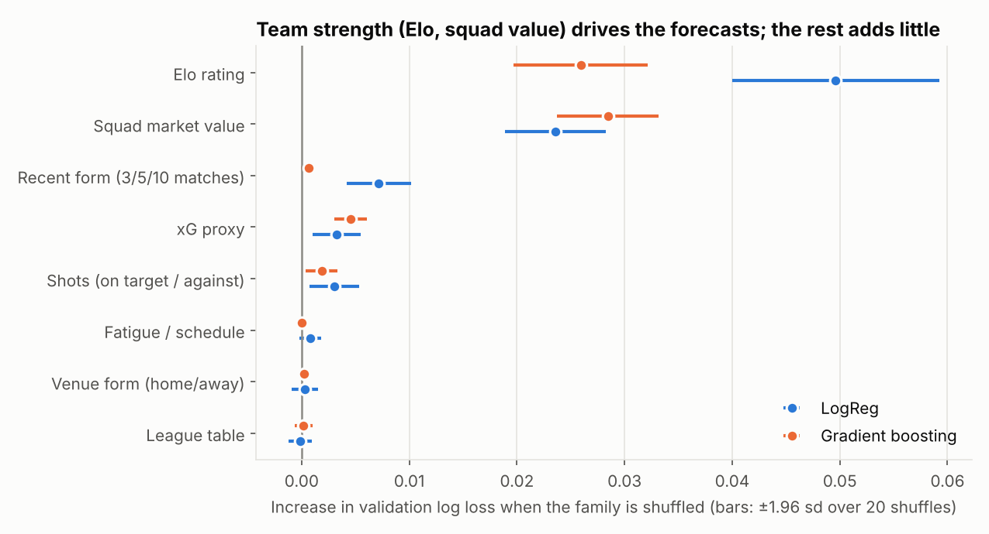
Increase in log loss when a family of variables is shuffled (validation seasons).
Elo (+0.050) and squad value (+0.024) dominate. Recent form adds +0.007, shots +0.003; rest days, league table and venue form are about 0. Home sides win 44.7% of matches, draw 25.2% and lose 30.0%, which sits in the intercept.
Caution. In the linear model, form has a slightly negative effect at fixed Elo and squad value. This is a collinearity artefact (overlapping windows), not evidence that a good run hurts. Importance describes what the model uses, not what causes results.
9. Model versus bookmaker
An academic question only (no betting strategy is built): do my probabilities contain information that the market lacks? I mix the two by log-linear pooling and choose the weight w on validation:
p ∝ p_market^(1 − w) · p_model^w
The best weight on the model, measured on the test seasons, is w = 0.00: the market already contains everything the model knows. The pooled log loss (0.9663) is not better than the market alone (0.9658). The market takes a margin of 5.5% on average and is still sharper than my model: the likely reason is information I do not have (line-ups, injuries, news).
10. Previous results: was the model right?
Important. These forecasts are recomputed after the fact with the walk-forward method (model fitted only on earlier seasons, variables built only from earlier matches). They were not published in advance. "Right" means the most likely outcome happened. A 45% pick is wrong more often than right, by design; log loss and calibration are the fair scores.
Period | Matches | Correct outcome | Log loss: model | Bookmaker | No-skill
Last 7 days | 49 | 57% | 0.927 | 0.902 | 1.052
Last 30 days | 96 | 56% | 0.928 | 0.906 | 1.042
Whole test period (2023 → Oct 2026) | 5602 | 53% | 0.979 | 0.966 | 1.075

Do the percentages mean what they say?
Top pick given | Matches | Average forecast | Came true
0–40% | 802 | 38% | 39%
40–50% | 1791 | 45% | 45%
50–60% | 1440 | 55% | 55%
60–70% | 956 | 65% | 63%
70–100% | 613 | 76% | 78%

When the model gave 60–70% to its top pick, it happened 63% of the time. Over the last 30 days the model is right 56% of the time, a bit less sharp than the bookmaker.
Most recent matches
Date | Match | Score | Home / draw / away | Top pick | Result
10-21 | Levante - Ath Bilbao | 3-1 | 34% / 28% / 38% | Away win 38% | Wrong
10-19 | Getafe - Vallecano | 1-1 | 35% / 28% / 37% | Away win 37% | Wrong
10-19 | Parma - Torino | 0-3 | 40% / 29% / 31% | Home win 40% | Wrong
10-19 | Monza - Cagliari | 4-0 | 29% / 32% / 39% | Away win 39% | Wrong
10-19 | Tottenham - Coventry | 3-1 | 50% / 30% / 20% | Home win 50% | Right
10-18 | Real Madrid - Sevilla | 4-1 | 74% / 16% / 10% | Home win 74% | Right
10-18 | Osasuna - Santander | 2-0 | 56% / 26% / 19% | Home win 56% | Right
10-18 | Malaga - Sociedad | 2-5 | 26% / 27% / 48% | Away win 48% | Right
10-18 | Celta - Alaves | 2-1 | 52% / 25% / 23% | Home win 52% | Right
10-18 | Udinese - Lecce | 0-3 | 58% / 24% / 18% | Home win 58% | Wrong
10-18 | Milan - Atalanta | 3-2 | 52% / 25% / 24% | Home win 52% | Right
10-18 | Juventus - Lazio | 0-3 | 62% / 22% / 16% | Home win 62% | Wrong
10-18 | Fiorentina - Como | 1-3 | 22% / 27% / 51% | Away win 51% | Right
10-18 | Paris FC - Rennes | 4-3 | 45% / 27% / 28% | Home win 45% | Right

11. OL case study
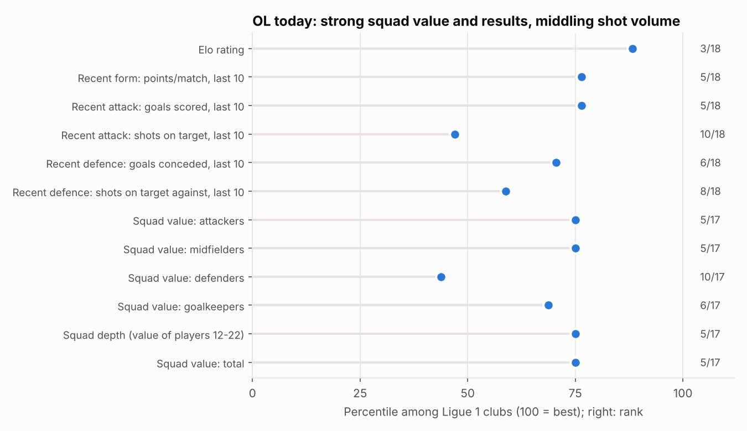
OL's profile in Ligue 1 on 26 October 2026.
OL is 3rd in Ligue 1 by Elo (1,615; Paris SG 1,707), 5th for recent points and goals scored, and 5th by squad value (EUR 305 m; defence only 10th). Results and rating are better than the shot volume (10th for shots on target) would suggest.
Match prediction, Paris SG - Lyon (26 October 2026):
 | OL win | Draw | OL loss | OL expected points
Model | 15% | 21% | 64% | 0.67
Bookmaker (margin removed) | 15% | 20% | 65% | -

Expected points are computed as:
E[points] = 3 · P(win) + 1 · P(draw)
The 90% interval on OL's win probability is 14–17% with model uncertainty only (100 bootstrap refits) and 12–21% once the uncertainty on the true strength of both teams is added (Elo shaken by 60 points).
12. Season simulation (10,000 seasons per league)
Each simulated season shakes the Elo of every team by a random shock, draws every remaining match outcome from the model's probabilities, draws a scoreline (for goal-difference tie-breaks) and ranks the table. The shock size (60 Elo points) was chosen by a backtest: each past season was simulated from 31 October using only what was known then, and compared with the real table.
Elo_team (in a simulation) = Elo_team + ε, ε ~ Normal(0, 60²)
Backtest 2023–2025 (15 league-seasons) | Simulator | Naive reference
Mean absolute error of final points | 6.4 | 8.9
Brier score, title | 0.022 | 0.049
Brier score, top 4 | 0.064 | 0.165
Brier score, relegation | 0.055 | 0.117
Coverage of the 80% interval | 72% | 80%

The simulator beats the naive reference, but its "80%" intervals cover only 72%: read them as lower bounds.
Projected top 3 of each league (expected final position)
League | 1st | 2nd | 3rd
Premier League | Man City (80 pts, title 57%) | Arsenal (76 pts, title 28%) | Brighton (71 pts, title 12%)
La Liga | Barcelona (98 pts, title 93%) | Real Madrid (84 pts, title 6%) | Ath Madrid (79 pts, title 2%)
Serie A | Inter (86 pts, title 71%) | Roma (78 pts, title 19%) | Como (72 pts, title 5%)
Bundesliga | Bayern Munich (83 pts, title 96%) | Dortmund (66 pts, title 3%) | Leverkusen (62 pts, title 1%)
Ligue 1 | Paris SG (72 pts, title 77%) | Monaco (60 pts, title 7%) | Lille (59 pts, title 6%)

Ligue 1 2026/27 (state of 26 October, 7 matches played)
Team | Expected points [80%] | Title | Champions League | Top 4 | Relegation
Paris SG | 71.9 [64–80] | 76.9% | 96.2% | 98.5% | 0.0%
Monaco | 59.9 [51–69] | 7.2% | 47.7% | 62.3% | 0.0%
Lille | 59.0 [50–68] | 5.7% | 41.9% | 56.6% | 0.0%
Lyon | 57.6 [49–66] | 4.0% | 35.7% | 50.4% | 0.0%

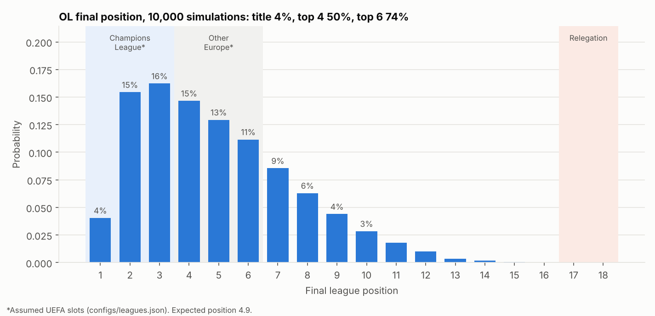
OL's final position over 10,000 simulated seasons.
OL's average final position is 4.9, the most likely finishes are 2nd and 3rd (15% and 16%), but the distribution is wide: after 7 matches six clubs share 13–14 points, so the forecast rests on team strength rather than on the table.
13. Champions League 2026/27
Goal: use the real fixtures and combine each club's performance in its championship. The calendar (144 league-phase matches, 36 clubs) comes from Wikipedia; only 29 matches were recorded when I collected it, the others are simulated.
European strength model. Domestic leagues are only comparable through matches between their clubs, so I fitted a logistic regression on 3,085 past Champions League, Europa League and Conference League matches (2012–2025) with two differences between the clubs:
d_value = ln(squad value_home) − ln(squad value_away)
d_ppg = domestic points per match_home − domestic points per match_away
domestic points per match = average over the last 20 league matches
Model (walk-forward 2023–2025, 943 matches) | Log loss
Class frequency | 1.0351
Squad value only | 0.9840
Domestic form only | 1.0368
Value + domestic form | 0.9834

Squad value carries the signal (-0.051 vs frequencies, significant). Domestic form adds nothing measurable once value is known (-0.0005, CI [-0.0048, +0.0037]); I keep it because the question asked to combine both, but its weight is small.
Simulation. 20,000 runs of the rest of the league phase, the play-offs (ranks 9–24), round of 16, quarter-finals, semi-finals and final.
Club | Top 8 | Semi-final | Final | Winner
Arsenal | 73% | 40% | 23% | 13.5%
Manchester City | 47% | 37% | 23% | 13.4%
Barcelona | 60% | 38% | 23% | 13.3%
Real Madrid | 86% | 39% | 23% | 12.7%
Paris Saint-Germain | 76% | 39% | 23% | 12.6%
Bayern Munich | 67% | 34% | 19% | 9.8%
Liverpool | 70% | 27% | 13% | 6.1%
Inter Milan | 27% | 16% | 7% | 3.0%
Manchester United | 18% | 14% | 6% | 2.7%
Sporting CP | 26% | 12% | 5% | 1.8%

No clear favourite: Arsenal, Manchester City, Barcelona, Real Madrid and Paris SG are each around 13%, Bayern 10%, Liverpool 6%. The differences between the first five are smaller than the uncertainty. This model is validated match by match, not on whole tournaments; the knockout bracket is approximate; AEK, Sabah and Slovan are not in the data and are assumed weak. No Europa League winner is predicted yet.
14. Limitations
- No injuries, suspensions, line-ups or coaching news (the likely reason the bookmaker is better); no real xG.
- Squad values are a crowd-sourced snapshot (June 2026); 13 clubs have no value.
- Bookmaker benchmark: Bet365 pre-match prices with simple margin removal.
- Few validation windows; SVM under-tuned; online updating tested for the linear model only.
- Simulation: intervals too narrow in the backtest; UEFA places are assumptions; strength is constant apart from a random shock.
- Team state excludes results of 23–25 October 2026 that were not yet in the data source.
- football-data.co.uk limits use to private, non-commercial purposes.

15. Conclusion
On public data, football results can be forecast with well-calibrated probabilities that are only modestly sharper than team strength alone. Elo and squad value explain most of what is predictable. A regularised logistic regression, my chosen model, is as good as boosting and neural networks: complexity did not pay. The models cannot beat the betting market and add no information to it, which is consistent with an efficient market. For OL, the model sees a top-five squad with results slightly ahead of its shot volume: about 57.6 points, an average finish of 4.9, and a coin-flip chance of the top four. So the disclaimer at the beginning stands: I really hope the ML is wrong.
Appendix: reproducibility
Code, tests and the interactive website are in the GitHub repository (README). make pipeline rebuilds data, features, OL predictions and simulations; make all reruns every experiment; pytest runs 22 tests including the leakage test. All numbers come from files in reports/tables/.

