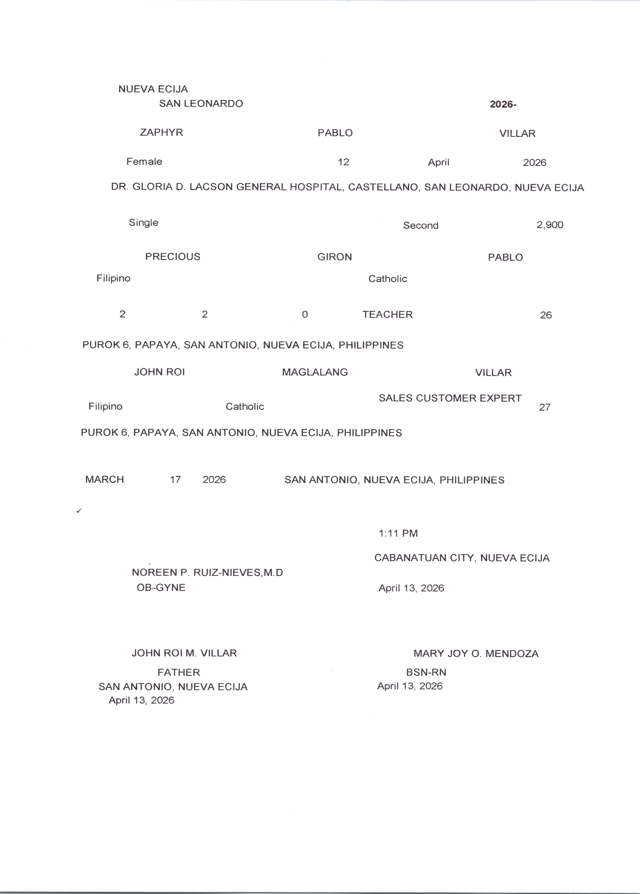
${DATE_TODAY}

${PROVINCE}
${CITY}

${OB_NAME}
${TIME_OF_BIRTH}
${PREPARE_POSITION}

${PREPARED_BY}

OB-GYNE
2026 -
San Leonardo, Nueva Ecija
PLACEHOLDER

${F_ADDRESS}
PLACEHOLDER

${MARRY_PLACE}

${MARRIAGE_DATE}
${F_ADDRESS}

${M_ADDRESS}
${WEIGHT}
${BABY_SEX}
${BABY_BYEAR}
${BABY_BMONTH}
${BABY_BDAY}
${FATHER}

${DATE_TODAY}

FATHER
${DATE_TODAY}

${F_OCCUPATION}
${F_RELIGION}
${F_CITIZENSHIP}
${M_AGE}
${M_OCCUPATION}
${C_LIVING}
${C_DEAD}
${C_ALIVE}
${BABY_FNAME}

${BABY_MNAME}

${BABY_LNAME}
${BIRTH_ORDER}
${MULT_ORDER}
${TYPE_MULTI}
${F_AGE}
${F_FNAME}
${F_MNAME}
${F_LNAME}
${M_FNAME}
${M_MNAME}
${M_LNAME}
${M_CITIZENSHIP}
${M_RELIGION}

