Halma – Part 0
Overview
The architecture I chose to implement for Halma part zero was to have two classes, Logic and Halma.
The Logic class, as it is named, controls the actual game logic which is based on a 2D array of either 0 for empty, and 1 for the pieces. It initializes the array and sets up the one players position at the top right corner in a triangle position. Some of the key methods are:
- get_adjacent_moves() which checks all of the 8 directions that a piece can move to see if there is a 0 or an open position, then it adds this to a list of moves that can be made.
- get_all_jump_moves() is a recursive method which checks the directions for a piece to jump over. To do this it basically sees if the ‘mid’ position has a piece, and if the position after or the position to jump to is open. This would allow a valid jump. It recursively does this to see if there are chained jumps available. Also added a check to make sure we stay inside the bounds of the board. Returns the list of the positions we could jump to.
- move_piece() moves the piece by changing the position we are moving ‘from’ to zero and the new position we move ‘to’ to a one. Zero represents an open position and the one shows a piece is there. This allows us to use the GUI methods to redraw the board with the new positions.
The Halma class, controls the actual GUI and clicking aspects of the game. It initializes the window and the canvas root for the tkinter library and sets up the settings like the width, and height based on what I wanted the cell size to be, attaches to the Logic class to implement the array in a graphical manner, and also binds the mouse click so we can track it. The class has a mainloop() and it has these key methods:
- draw_grid() creates the grid for the window using create_rectangle based on the cell size.
- draw_pieces() loops through the board and adds a black piece where the position is one, also will highlight the piece in pink and red if it is the selected position.
- draw_highlights() highlights the valid moves in green using create_rectangle
- on_click() is the driver for the clicking, it calls get_cell_from_click to get the actual position (row, col), moves the piece if its open, or highlights the selected piece.
- refresh_window() is a function which refreshed the full board for each change. It deletes the positions using canvas.delete then redraws the grid, draws the valid moves highlights, and then adds the pieces again.
Display 8x8 Initial Grid
Initial grid set to an 8 by 8, with one player’s pieces in black on the top-right corner.
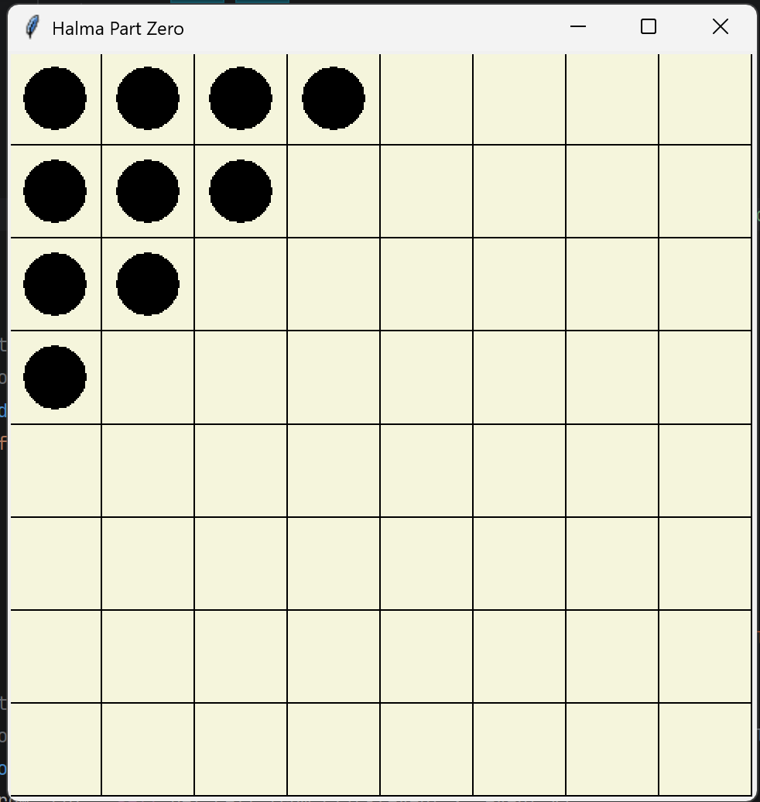

Possible Moves
This screenshot shows me clicking on piece which highlights pink with red outline. It then shows the possible moves by highlighting the square in green and light green fill using create_rectangle.
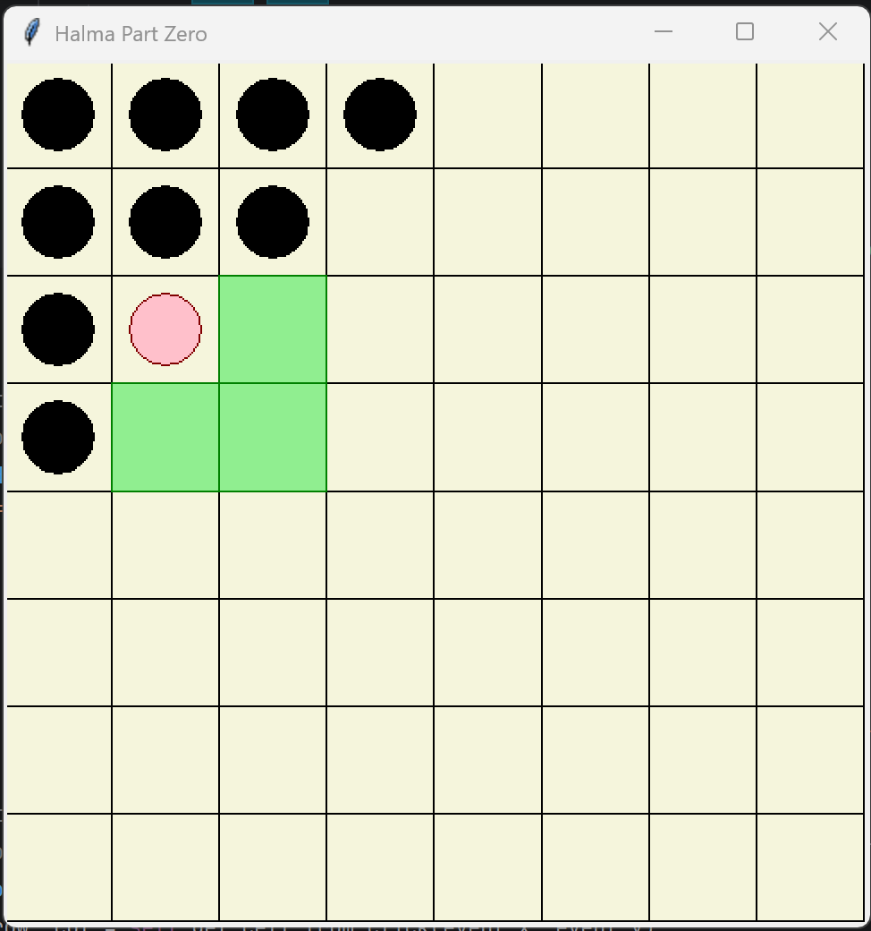
Moved Pieces
This screenshot is after moving some pieces. You can see that the selected piece is higher up and due to some of the pieces being moved it shows the options for chained jumps. When the pieces are moved, it deletes where it was using by changing the board logic to zero erasing everything, then adding pieces and the highlights accordingly to the provided lists (valid_moves and the positions for pieces).
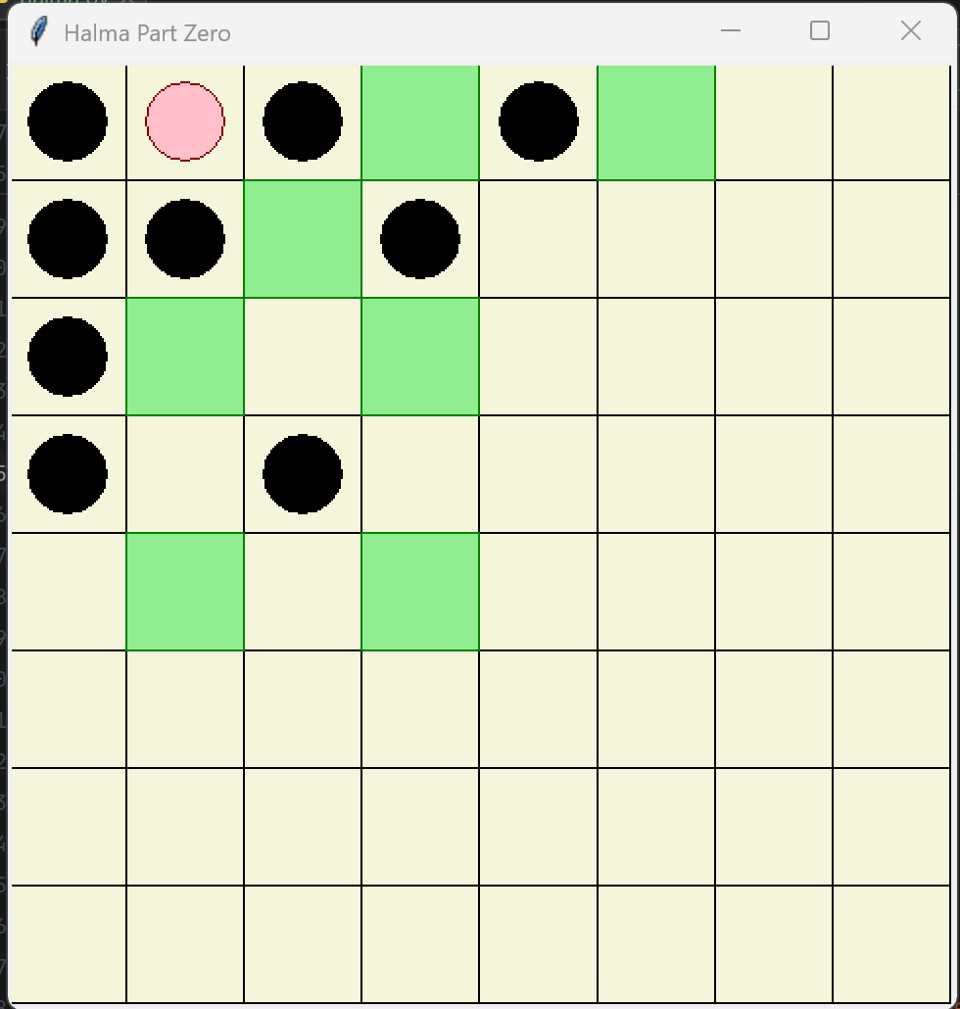

Moves Available after Several Consecutive Jumps
Implementing moves to adjacent squares shows the available jumping and chained jumping. I provided two examples where I move one away from the ability to chain. With the second example I show a piece actually chaining a jump down to a much further position.
Example 1:
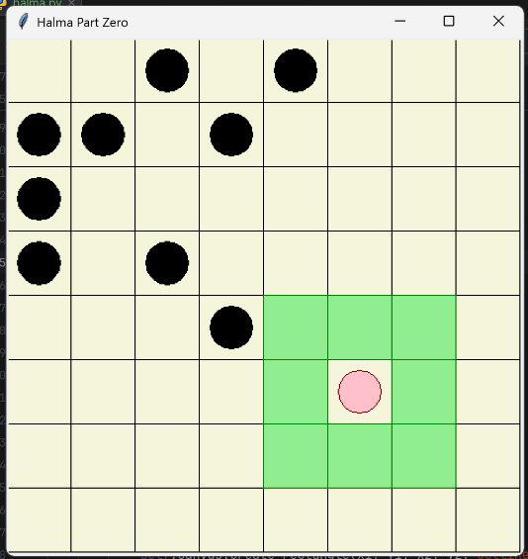
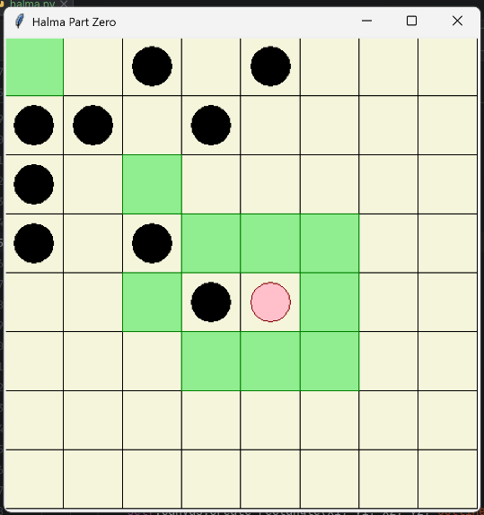

Example 2:
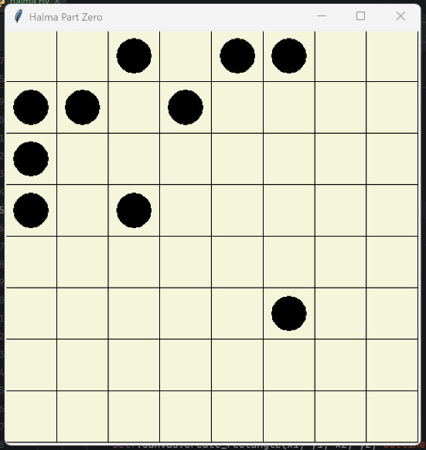
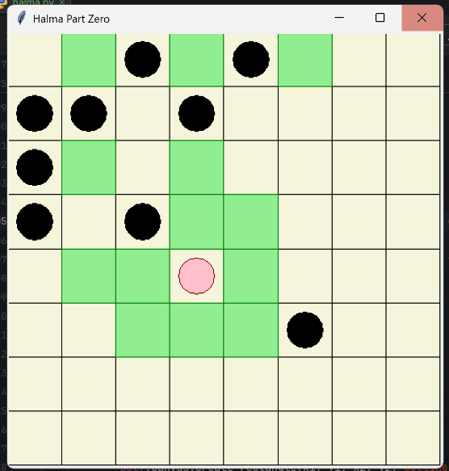

Code
# halma part 0
# process: halma is a two-player, turn-based board game played on a square grid
# header files
import tkinter as tk
# constants
CELL_SIZE = 60
# ========================================================================== #
# GAME LOGIC #
# ========================================================================== #
# class: Logic
# process: logic for the game process
class Logic:
# method: init
# process: creates 2D array, places the pieces in the corners
def __init__(self, size):
self.size = size
# create the 2D array, initialize all spaces to zero
self.board = [[0 for x in range(size)] for y in range(size)]
# halves the board size for the pieces initialization
half = size // 2
# creates the top triangle
for row in range(half):
for col in range(half - row):
self.board[row][col] = 1
# # creates the bottom triangle (not for part 0 add probs in part 1)
# for row in range(half, self.size):
# start_column = self.size - 1 - (row - half)
# for col in range(start_column, self.size):
# self.board[row][col] = 1
# method: move_piece
# process: update the board array
def move_piece(self, from_position, to_position):
# set variables for the coords from and to
from_row, from_col = from_position
to_row, to_col = to_position
# set the old value to zero, new to one
self.board[from_row][from_col] = 0
self.board[to_row][to_col] = 1
# method: get_adjacent_moves
# process: check all 8 directions, return empty places
def get_adjacent_moves(self, row, col):
# initialize variables
moves = []
directions = [(-1,-1), (-1, 0), (-1, 1), (0, -1), (0, 1), (1, -1), (1, 0), (1, 1)]
# traverse the directions
for x, y in directions:
# assign the variables with the next row and col
next_row, next_col = row + x, col + y
# append any positions that are empty to list of moves
if 0 <= next_row < self.size and 0 <= next_col < self.size:
if self.board[next_row][next_col] == 0:
moves.append((next_row, next_col))
# return list of moves
return moves
# method: get_all_jump_moves
# process: recursive function, made to capture potential chained jumps, and simple jumps
def get_all_jump_moves(self, row, col, visited=None):
# base case for the recursion
if visited is None:
visited = set()
# initialize variables
directions = [(-1, -1), (-1, 0), (-1, 1), (0, -1), (0, 1), (1, -1), (1, 0), (1, 1)]
moves = set()
# traverse all the directions
for x, y in directions:
# grab the mid positional value
mid_row, mid_col = row + x, col + y
# grab the position we would be jumping to
jump_row, jump_col = row + 2 * x, col + 2 * y
# check bounds of the board
if not (0 <= jump_row < self.size and 0 <= jump_col < self.size):
continue
# check that it would be a valid jump (mid needs a piece jump needs to be open)
if self.board[mid_row][mid_col] == 1 and self.board[jump_row][jump_col] == 0:
# if the jump has not been visited
if (jump_row, jump_col) not in visited:
# add it to the potential moves
moves.add((jump_row, jump_col))
# mark this visit before recursion
new_visited = visited.copy()
new_visited.add((jump_row, jump_col))
# now call the function to recurse
chained = self.get_all_jump_moves(jump_row, jump_col, new_visited)
# update moves based on chained
moves.update(chained)
# return the valid chained moves
return moves
# method: get_valid_moves
# process: call functions to get all valid moves
def get_valid_moves(self, row, col):
# makes the adjacent moves list
adjacent_moves = self.get_adjacent_moves(row, col)
# gets all the available jumps in a list (comes in as a set)
jump_moves = list(self.get_all_jump_moves(row, col))
# return both lists
return adjacent_moves + jump_moves
# temporary testing for the board logic
def print_board(self):
for row in self.board:
print(row)
print()
# ========================================================================== #
# GUI #
# ========================================================================== #
# class: Halma
# process: class for the gui and tkinter
class Halma:
# method: init
# process: initializes tkinter and creates the canvas and board object
def __init__(self, size=8):
self.size = size
# creates the window, adds a title
self.window = tk.Tk()
self.window.title("Halma Part Zero")
# creates a canvas with a width of board * cell size
self.canvas = tk.Canvas(
self.window,
width = self.size * CELL_SIZE,
height = self.size * CELL_SIZE, )
self.canvas.pack()
# attach the board logic
self.board = Logic(size)
# selection variables
self.selected_piece = None
self.valid_moves = []
# binds the mouse click
self.canvas.bind("<Button-1>", self.on_click)
# initial draw
self.refresh_window()
# main loop
self.window.mainloop()
# method: draw_grid
# process: draw NxN squares using create_rectangle
def draw_grid(self):
# traverse the NxN grid
for row in range(self.size):
for col in range(self.size):
# get the rectangle positions based on position and cell size
x1 = col * CELL_SIZE
y1 = row * CELL_SIZE
x2 = x1 + CELL_SIZE
y2 = y1 + CELL_SIZE
# create the square for the gameboard
self.canvas.create_rectangle(x1, y1, x2, y2, outline = "black", fill = "beige")
# method: draw_pieces
# process: loop through board, if array 1 and a game piece using create_oval
def draw_pieces(self):
# traverse the NxN grid
for row in range(self.size):
for col in range(self.size):
# if the board is supposed to have a piece (per the array)
if self.board.board[row][col] == 1:
# set the values for the oval (add padding to center this)
x1 = col * CELL_SIZE + 10
y1 = row * CELL_SIZE + 10
x2 = x1 + CELL_SIZE - 20
y2 = y1 + CELL_SIZE - 20
# if the piece is the selected piece
if self.selected_piece == (row, col):
# highlight the piece pink
self.canvas.create_oval(x1, y1, x2, y2, outline = "maroon", fill="pink")
# else then make the piece a black piece
else:
self.canvas.create_oval(x1, y1, x2, y2, fill="black")
# method: draw_highlights
# process: draws the highlights using create_rectangle
def draw_highlights(self):
# for each position in the valid moves
for (row, col) in self.valid_moves:
# grab coords for the rectangle creation based on cell size
x1 = col * CELL_SIZE
y1 = row * CELL_SIZE
x2 = x1 + CELL_SIZE
y2 = y1 + CELL_SIZE
# create a green rectangle using create_rectangle
self.canvas.create_rectangle(x1, y1, x2, y2, outline = "green", fill = "lightgreen")
# method: on_click
# process: coverts click to board pos, if clicked piece select piece, if clicked square move piece
def on_click(self, event):
# get the click event positions
row, col = self.get_cell_from_click(event.x, event.y)
# if the position is a valid move square
if (row, col) in self.valid_moves:
# move the piece in the logic
self.board.move_piece(self.selected_piece, (row, col))
# unselect the piece
self.selected_piece = None
# reset the moves
self.valid_moves = []
# redraw the board
self.refresh_window()
# exit function
return
# if the position is a piece on the board
if self.board.board[row][col] == 1:
# make this the selected piece
self.selected_piece = (row, col)
# get the valid moves for the piece
self.valid_moves = self.board.get_valid_moves(row, col)
# redraw the board with the positions
self.refresh_window()
# method: get_cell_from_click
# process: converts a click to the board position
def get_cell_from_click(self, x, y):
# position is the input divided by the cell size
col = x // CELL_SIZE
row = y // CELL_SIZE
# return position
return row, col
# method: refresh_window
# process: this is called as it clears the canvas, calls draw_grid, draw_pieces, draw_highlights
def refresh_window(self):
self.canvas.delete("all") # clears the canvas
self.draw_grid() # draw the grid
self.draw_highlights() # draw the highlights around selected piece
self.draw_pieces() # draw the pieces (canvas.create_oval)
# ========================================================================== #
# MAIN #
# ========================================================================== #
if __name__ == "__main__":
Halma(8)

