Angular_Material_Firebase_Udemy_Course
https://www.udemy.com/angular-full-app-with-angular-material-angularfire-ngrx/learn/v4

Session 3 Angular Material
Lesson_18_Module_Introduction
Lesson_19_Understanding_Angular_Material
Lesson_21_Adding Angular Material to a Project
Lesson_23_. Our First Angular Material Component - The Button - (ng-mat-01-first-components)
Lesson_26_SignUp_Form
Lesson_28_Angular_Flex_Layout integartion
Lesson_29_Confugire_Submit_Button/Validation - (ng-mat-04-form-validation
Lesson_31_Adding a Date picker + Checkbox – (ng-mat-05-datepicker)
Session 4_DeepDive_Angular_Material
Session 5 Working with Data and Angular Materiall

Session 3 Angular Material

Lesson_18_Module_Introduction
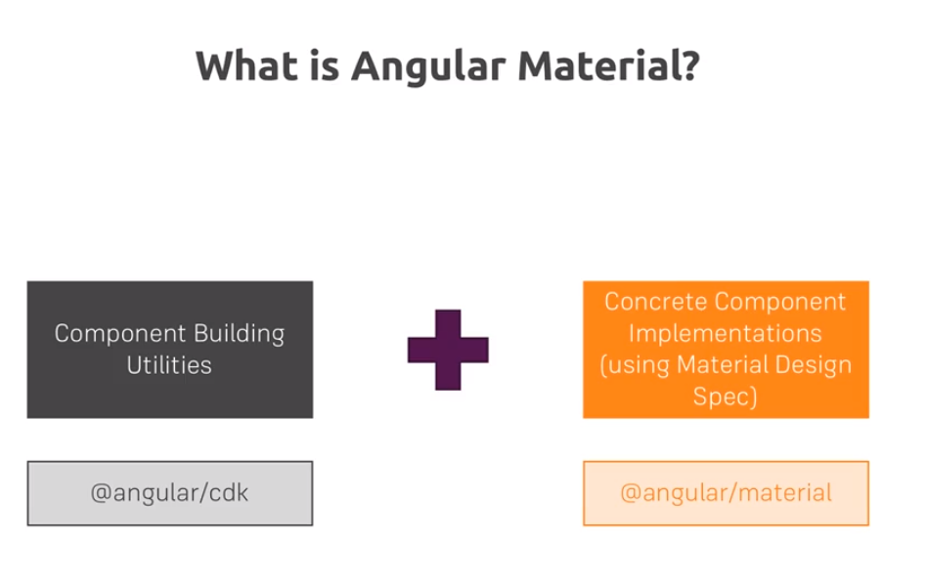

@angular/cdk:
It contains, raw utilites, methods, styless components which can be used from the module.

@angular/material:
It contains all of the ready to use components, with the styles, with the concrete implementations.

Lesson_19_Understanding_Angular_Material

This is where you can get all of the information, from the components.
www.material.angular.io

Lesson_21_Adding Angular Material to a Project

This is the website where you can get the setupInformation

https://material.angular.io/guide/getting-startedű

(ng-mat-01-first-components)
Lesson_23_. Our First Angular Material Component - The Button

So basically, the tag is a simple button, but due to the propery „mat-raised-button”
angular will recognize that this is an attribute selector to execute a directive

<p>You have receive a file called "cat-picture.jpeg".</p>
<button mat-raised-button (click)="openBottomSheet()">Open file</button>

If you cannot access the prebuilt theme, you might remove the ~ character from the styles.css

/* You can add global styles to this file, and also import other style files */
@import "'~angular/material/prebuilt-themes/indigo-pink.css";
And in order to use the button, to tell angular to use the diretive, you have to import that specific button module.

App/material.module
import { NgModule } from '@angular/core';
import {
MatButtonModule,
MatIconModule,
MatFormFieldModule,
MatInputModule
} from '@angular/material';
@NgModule({
imports: [MatButtonModule, MatIconModule, MatFormFieldModule, MatInputModule],
exports: [MatButtonModule, MatIconModule, MatFormFieldModule, MatInputModule]
})
export class MaterialModule {}

Lesson_26_SignUp_Form

app/auth/signup/html

So basically, we have to wrap all of the elements in their tags.
<section>
<form>
//matInput has to be wrapped into mat-form-field tag, to enable the component to have it's full design
<mat-form-field>
<input type="email" matInput placeholder="Your email">
</mat-form-field>
<mat-form-field>
<input type="password" matInput placeholder="Your password">
</mat-form-field>
</form>
</section>
Lesson_28_Angular_Flex_Layout integartion

https://github.com/angular/flex-layout/wiki/Using-Angular-CLI

Demos how to use it:
https://tburleson-layouts-demos.firebaseapp.com/#/docs

(ng-mat-04-form-validation)

Lesson_29_Confugire_Submit_Button/Validation

Will use the templateDriven approach,with FormsModule and everything works as the same with angularMaterial as with normal html.

In the mat-form-field you have some basic, tags, matInput, mat-hint, mat-error which will be used, preconfigured in the mentioned main tag.

</mat-form-field>
<mat-form-field hintLabel="Should be at least 6 characters long.">
<input
type="password"
matInput
placeholder="Your password"
ngModel
name="password"
required
minlength="6"
#pwInput="ngModel">
<mat-hint align="end">{{ pwInput.value?.length }} / 6</mat-hint>
<mat-error>Has to be at least 6 characters long.</mat-error>
</mat-form-field>

(ng-mat-05-datepicker)
Lesson_31_Adding a Date picker + Checkbox

Basically, the documentation is really good here:
https://material.angular.io/components/bottom-sheet/overview

You have to import the respective module, add the necessary tags.

Session 4_DeepDive_Angular_Material

This is actually a summary, everything is documented on the angular website.

More on the Tabs Component: https://material.angular.io/components/tabs/overview
- More on Spinners: https://material.angular.io/components/progress-spinner/overview
- More on Sidenav: https://material.angular.io/components/sidenav/overview
- More on the Toolbar: https://material.angular.io/components/toolbar/overview

The only trick is to add a local #reference to the angularMaterial components, to use their built in methods, like

app.component.html

<mat-sidenav #sidenav role="navigation">
<app-sidenav-list (closeSidenav)="sidenav.close()"></app-sidenav-list>
</mat-sidenav>

Session 5 Working with Data and Angular Material

Lesson_56_Rxjs6_for_Angular6

If you use angular6 you have to use the following module npm install –save rxjs-compat

Lesson_59. Implementing Authentication

Session 10 Theming

Lesson 135 Adding custom theme

Official Theming Guide: https://material.angular.io/guide/theming

If you have an angular.json file, you have to add the theme by adding src/my-theme.scss to your styles[] array in that file instead of just my-theme.scss as shown in the next video.
That's all!

1. Create your theme file

@import '~@angular/material/theming';
@include mat-core();
$candy-app-primary: mat-palette($mat-red);
$candy-app-accent: mat-palette($mat-pink, A200, A100, A400);
// The warn palette is optional (defaults to red).
$candy-app-warn: mat-palette($mat-red);
// Create the theme object (a Sass map containing all of the palettes).
$candy-app-theme: mat-light-theme($candy-app-primary, $candy-app-accent, $candy-app-warn);
@include angular-material-theme($candy-app-theme);
2. Add to your angular-cli.json

"styles": [
"styles.css",
"my-theme.scss"
],

