React_Maximiliam

https://www.udemy.com/react-the-complete-guide-incl-redux/

Session_5_StylingReactomponents
Lesson_64_SettingStyle of a react component
Lesson_67_Using Css Modules
Session_7_Diving Deeper into Components & React Internals
Lesson_82_Stateless_Stateful_Components
Lesson_89_LifyCycleHook
Lesson_90_Pure_Components
Lesson_91_HowReactUpdate the app
Lesson_92_How_react_updates the dom
Lesson_94_ReturningAdjacent_Elements – Avoid wrapper div.
Lesson_95_React 16.2 Feature: Fragments
Lesson_96_Higher order Components
Lesson_98_PassingUnkonwProps
Lesson_99_UsingStateCorrectly! - If previosState can be changed
Lesson_100_Validating Props!
Lesson_102_UsingRefs! - Only in stateful component
Lesson_103_ForwardRef – Tunnel for the references,
Lesson_104_Context_API!
Lesson_107_React.memo() - pureCOmponent with statelessCOmpontents!
Session_8_Burger_App_Basic
Lesson_111_Planning_A_React_App
Lesson_112_Burger_App_Plan
Lesson_113_Planning a State
Lesson_115_Layout_Component(props.children)
Analysis
- Containers used to store the stateful components, where the state is stored!
- Layout component is a wrapper to generate the appropriate resizable mobile version
- In a variable, you can store an array, of valid jsx components!!
Session_11_Routing
Guards
NavigationLink
LazyLoading (older)
Session_14_Redux
Lesson_264_Redux_Store_Setup
1. Install redux, react-redux.
2. Index.js
3. reducer
4. Actions
5. Connect it to the Component
Session_16_Redux_Advanced
Lesson_274_Adding_A_MiddleWare
Lesson_275_Redux DevTools
Lesson_276_Executing_Async_Code with action Creators
Lesson_279_Async_Actions_Redux-thunk
Lesson_281_Where_ToPut_The_Logic?
Lesson_282_Prefetch_The State in the redux_State

Lesson_339_LazyLoading
Session_20_Testing
Lesson_334_Testing_Tools
Lesson_335_What To test?
Lesson_346_Shallow_Component_Test
Lesson_349_Testing_Containers
Lesson_350_Testing_Reducers
Session_24_Animations in React Apps
Lesson_392_Using Css Transition, good tactic!
Lesson_393_CssAnimation (keyframes)
Lesson_394 Transition + Animation limitations
Lesson_395_ReacTransitionGroup
Lesson_397_Wrapping The transition Component
Lesson_398_AnimationTimings
Lesson_400_CSS_TransitionComponent
Lesson_402_AnimatingLists
Session_26_ReactHooks
Lesson_420_What Are Hooks?
Lesson_423_UseState hook()
Lesson_425_Using Multiple States
Lesson_426_UsingOneStateInstead!
Lesson_427_Rules of the Hooks
Lesson_428_Sending Data via HTTP
Lesson_429 UseEffect hook
Lesson_430_Controlling Effect Execution
Lesson_431_Effect CleanUp
Lesson_433_UseContextHook()
Lesson_434_State and Effects Gotchas
Lesson_437_useRef()
Lesson_438_Preparing & Optimizing
Lesson_441_Custom Hooks

Session_5_StylingReactomponents

Lesson_64_SettingStyle of a react component
You can do it, with
1. global style importing in the app.js
2. Inline style, to have a scoped effect (no speudo elements!)

Lesson_64_StylingReactComponents
You can use Radium npm pacakge, to use inline style, and have pseudo selectors!
1. npm is
2. wrap your component
export default Radium( App );

import React, { Component } from 'react';
import './App.css';
import Radium, { StyleRoot } from 'radium';
import Person from './Person/Person';
class App extends Component {
state = {
persons: [
{ id: 'asfa1', name: 'Max', age: 28 },
{ id: 'vasdf1', name: 'Manu', age: 29 },
{ id: 'asdf11', name: 'Stephanie', age: 26 }
],
otherState: 'some other value',
showPersons: false
}

render () {
const style = {
backgroundColor: 'green',
color: 'white',
font: 'inherit',
border: '1px solid blue',
padding: '8px',
cursor: 'pointer',
':hover': {
backgroundColor: 'lightgreen',
color: 'black'
}
};
let persons = null;

if ( this.state.showPersons ) {
persons = (
<div>
{this.state.persons.map( ( person, index ) => {
return <Person
click={() => this.deletePersonHandler( index )}
name={person.name}
age={person.age}
key={person.id}
changed={( event ) => this.nameChangedHandler( event, person.id )} />
} )}
</div>
);
style.backgroundColor = 'red';
style[':hover'] = {
backgroundColor: 'salmon',
color: 'black'
};
}
const classes = [];
if ( this.state.persons.length <= 2 ) {
classes.push( 'red' ); // classes = ['red']
}
if ( this.state.persons.length <= 1 ) {
classes.push( 'bold' ); // classes = ['red', 'bold']
}
return (
<StyleRoot>
<div className="App">
<h1>Hi, I'm a React App</h1>
<p className={classes.join( ' ' )}>This is really working!</p>
<button
style={style}
onClick={this.togglePersonsHandler}>Toggle Persons</button>
{persons}
</div>
</StyleRoot>
);
// return React.createElement('div', {className: 'App'}, React.createElement('h1', null, 'Does this work now?'));
}
}
export default Radium( App );

Lesson_67_Using Css Modules

1. run react-scripts-eject, which will give us access to the configuration
2. config/webpack.config write the options
test: /\.css$/,
use: [
require.resolve('style-loader'),
{
loader: require.resolve('css-loader'),
options: {
importLoaders: 1,
modules: true,
localIdentName: '[name]__[local]__[hash:base64:5]'
},
},

and you can use it
3. Import the css. To the component
4. Use it with className
import React from 'react';
import classes from './Person.css';
const person = ( props ) => {
return (
<div className={classes.Person}>
<p onClick={props.click}>I'm {props.name} and I am {props.age} years old!</p>
<p>{props.children}</p>
<input type="text" onChange={props.changed} value={props.name} />
</div>
)
};
export default person;

Multiple classnames
const assignedClasses = [];
if ( this.state.persons.length <= 2 ) {
assignedClasses.push( classes.red ); // classes = ['red']
}
if ( this.state.persons.length <= 1 ) {
assignedClasses.push( classes.bold ); // classes = ['red', 'bold']
}
return (
<div className={classes.App}>
<h1>Hi, I'm a React App</h1>
<p className={assignedClasses.join( ' ' )}>This is really working!</p>
<button
className={btnClass}
onClick={this.togglePersonsHandler}>Toggle Persons</button>
{persons}
</div>
);

Session_7_Diving Deeper into Components & React Internals

Lesson_82_Stateless_Stateful_Components
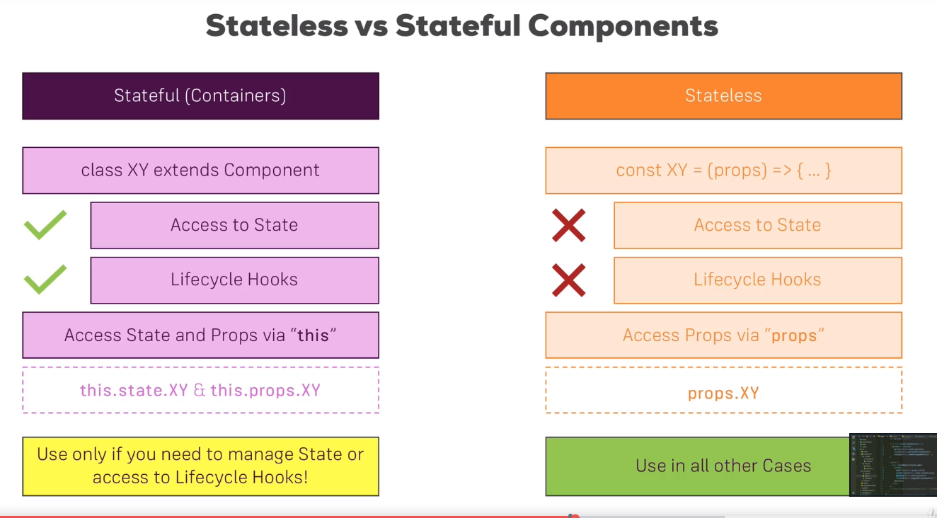

Lesson_89_LifyCycleHook

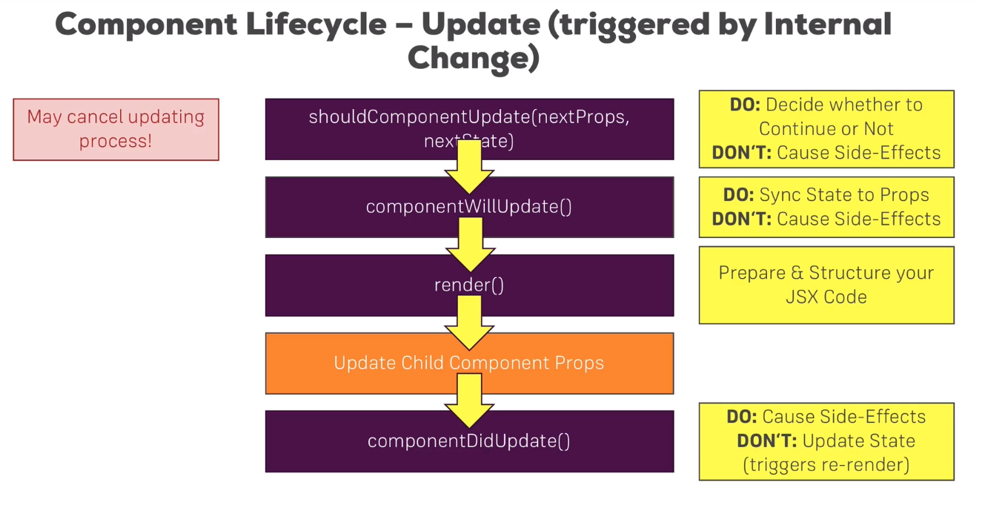
Lesson_90_Pure_Components - shouldComponentUpdate
Pure components, will check the properties, states and will only call the render function, if sth has been changed!
Use only, when you can decide, when the component should be updated!
shouldComponentUpdate

Lesson_91_HowReactUpdate the app
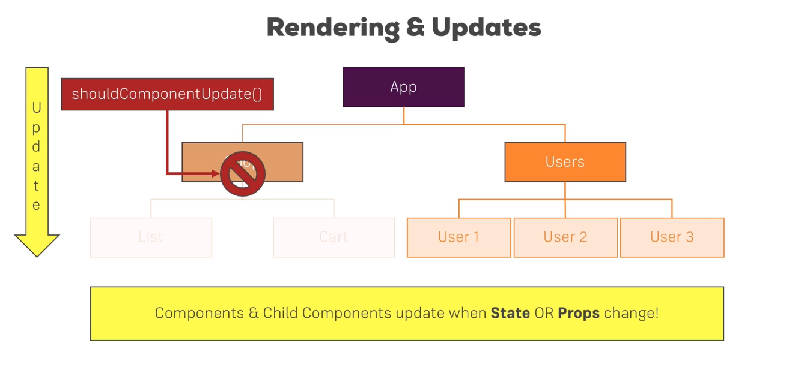
Only use the pure component, if you pass only the states, and withouth it the childs can’t be updated!

Lesson_92_How_react_updates the dom

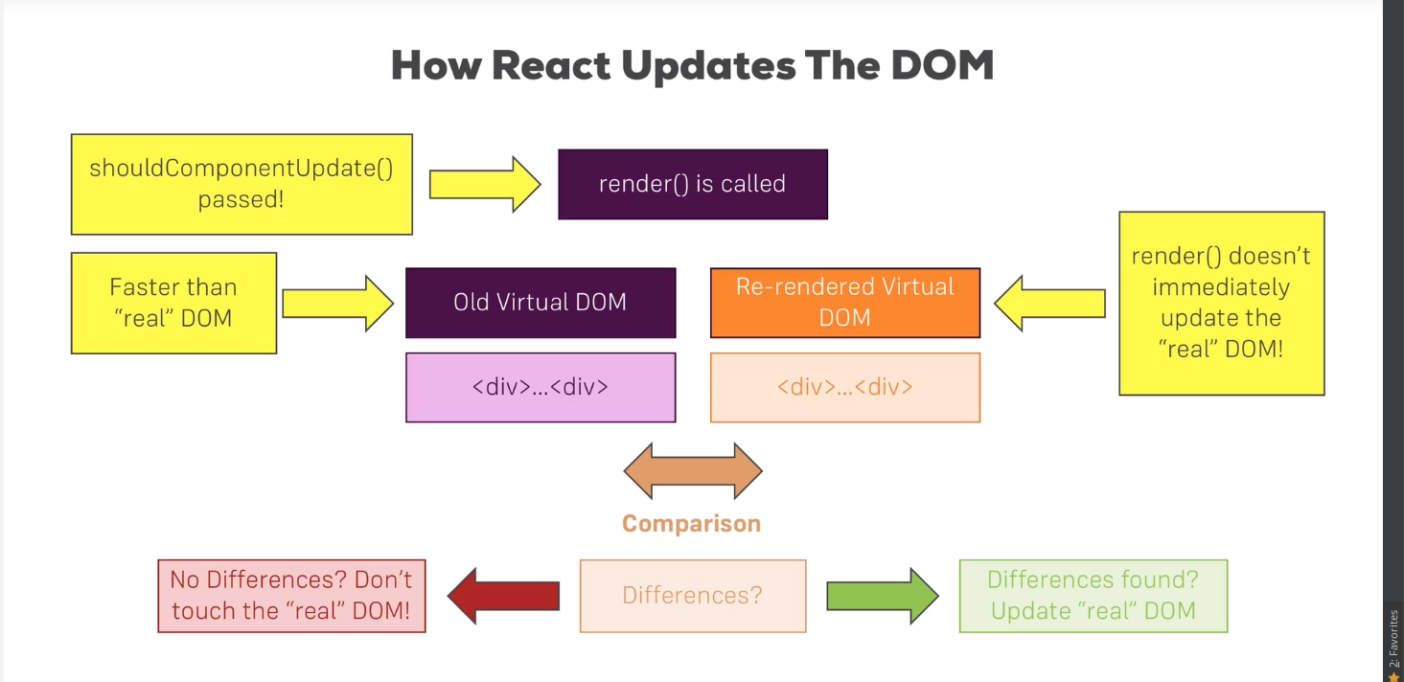

Lesson_94_ReturningAdjacent_Elements – Avoid wrapper div.
1. We can return an array of JSX elements!
}
render () {
console.log( '[Persons.js] Inside render()' );
return this.props.persons.map( ( person, index ) => {
return <Person
click={() => this.props.clicked( index )}
name={person.name}
position={index}
age={person.age}
ref={this.lastPersonRef}
key={person.id}
changed={( event ) => this.props.changed( event, person.id )} />
} );
}
2. You have to add keys, to the array of the returned rendered jsx elements!

You can avoid to have a wrapping div! By using an automatic stateless function!
const aux = (props) => props.children;
export default aux;
cockpit.js
import React from 'react';
import classes from './Cockpit.css';
import Aux from '../../hoc/Aux';
const cockpit = ( props ) => {
const assignedClasses = [];
let btnClass = classes.Button;
if ( props.showPersons ) {
btnClass = [classes.Button, classes.Red].join( ' ' );
}
if ( props.persons.length <= 2 ) {
assignedClasses.push( classes.red ); // classes = ['red']
}
if ( props.persons.length <= 1 ) {
assignedClasses.push( classes.bold ); // classes = ['red', 'bold']
}
return (
<Aux>
<h1>{props.appTitle}</h1>
<p className={assignedClasses.join( ' ' )}>This is really working!</p>
<button
className={btnClass}
onClick={props.clicked}>Toggle Persons</button>
<button onClick={props.login}>Log in</button>
</Aux>
);
};
export default cockpit;

Lesson_95_React 16.2 Feature: Fragments
If your project uses React 16.2, you can now use a built-in "Aux" component - a so called fragment.
It's actually not called Aux but you simply use <> - an empty JSX tag.
So the following code
<Aux> <h1>First Element</h1> <h1>Second Element</h1></Aux>
becomes
<> <h1>First Element</h1> <h1>Second Element</h1></>
Behind the scenes, it does the same our Aux component did.

Lesson_96_Higher order Components

It can perform dynamic operations, on the injected! components as parameters
withClass → This will add a className to the received component!
const withClass = (WrappedComponent, className) => {
return (props) => (
<div className={className}>
<WrappedComponent {...props} />
</div>
)
}

export default withClass(App, classes.App);

So you can use functions, inject any data into the components, and export them normally!

Lesson_98_PassingUnkonwProps
With the spread operator!!
const withClass = (WrappedComponent, className) => {
return (props) => (
<div className={className}>
<WrappedComponent {...props} />
</div>
)
}

Lesson_99_UsingStateCorrectly! - If previosState can be changed

While we are doing this mutation, the prevState can’t be changed!
Best practice if you are relying on the previous state, to use this syntax
togglePersonsHandler = () => {
const doesShow = this.state.showPersons;
this.setState((prevState, props) => {
return {
showPersons: !doesShow,
toggleClicked: prevState.toggleClicked + 1
};
});
};
Also you can update it like the following if you do not rely on the previous value
tis.setState({ persons: persons });

Lesson_100_Validating Props!

Person.propTypes = {
click: PropTypes.func,
name: PropTypes.string,
age: PropTypes.number,
changed: PropTypes.func
};

Lesson_102_UsingRefs! - Only in stateful components!
Ref it is a special attribute in react, where you can access the dom properties!

1. create a React reference
constructor(props) {
super(props);
console.log("[Person.js] Inside Constructor", props);
this.inputElement = React.createRef();
}
2. Assing the ref to the component’s attribute
<input
ref={this.inputElement}
type="text"
onChange={this.props.changed}
value={this.props.name}
/>
3. controlling the dom properties
focus() {
this.inputElement.current.focus();
}

Lesson_103_ForwardRef – Tunnel for the references,

It is used to provide a tunnel between HOC components + normal components react.references!
const withClass = (WrappedComponent, className) => {
const WithClass = class extends Component {
render () {
return (
<div className={className}>
<WrappedComponent ref={this.props.forwardedRef} {...this.props} />
</div>
)
}
}
return React.forwardRef((props, ref) => {
return <WithClass {...props} forwardedRef={ref} />
});
}
export default

It will forward the component’s properties, to this wrapper component. So we will have all of the props of the instantiated component!

Storing the lastReference of the list

constructor( props ) {
super( props );
console.log( '[Persons.js] Inside Constructor', props );
this.lastPersonRef = React.createRef();
}
render () {
console.log( '[Persons.js] Inside render()' );
return this.props.persons.map( ( person, index ) => {
return <Person
click={() => this.props.clicked( index )}
name={person.name}
position={index}
age={person.age}
ref={this.lastPersonRef}
key={person.id}
changed={( event ) => this.props.changed( event, person.id )} />
} );
}
}
componentDidMount () {
console.log( '[Persons.js] Inside componentDidMount()' );
this.lastPersonRef.current.focus();
}

Lesson_104_Context_API!
App.js
1. Create context!
export const AuthContext = React.createContext(false);
2. Add value conditionally

<AuthContext.Provider value={this.state.authenticated}>
{persons}
</AuthContext.Provider>
3. Consume the value in the child component!
The data is passed, and the function as well, as value!

<AuthContext.Consumer>
{auth => auth ? <p>I'm authenticated!</p> : null}
</AuthContext.Consumer>

Lesson_107_React.memo() - pureCOmponent with statelessCOmpontents!
Will only be rerendered only if the props have been changed!

Session_8_Burger_App_Basic

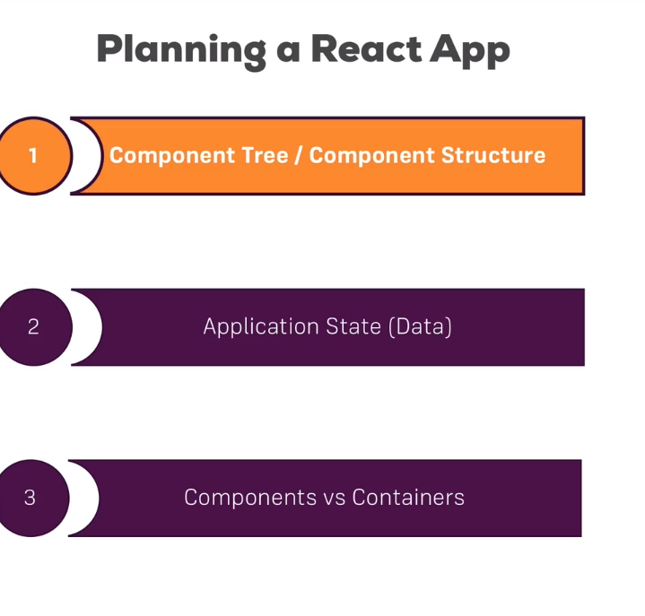
Lesson_111_Planning_A_React_App

Lesson_112_Burger_App_Plan
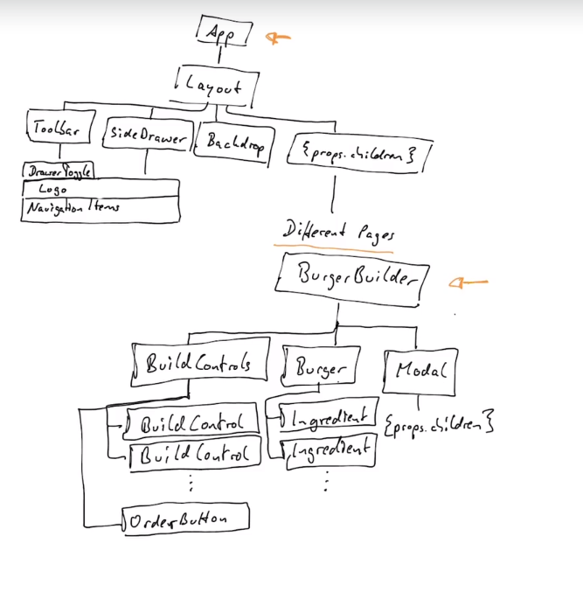

Lesson_113_Planning a State

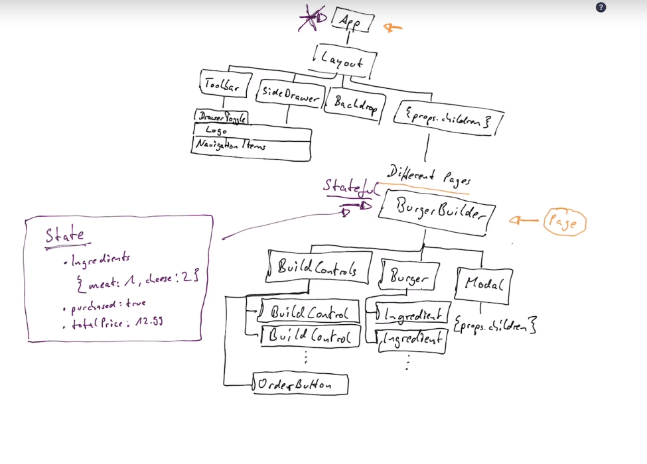
Lesson_115_Layout_Component(props.children)

It is the ngcontent of react
render () {
return (
<Aux>
<Toolbar drawerToggleClicked={this.sideDrawerToggleHandler} />
<SideDrawer
open={this.state.showSideDrawer}
closed={this.sideDrawerClosedHandler} />
<main className={classes.Content}>
{this.props.children}
</main>
</Aux>
)
}

Analysis

- Containers used to store the stateful components, where the state is stored!
- Layout component is a wrapper to generate the appropriate resizable mobile version
- In a variable, you can store an array, of valid jsx components!!
let transformedIngredients = Object.keys( props.ingredients )
.map( igKey => {
return [...Array( props.ingredients[igKey] )].map( ( _, i ) => {
return <BurgerIngredient key={igKey + i} type={igKey} />;
} );
} )
.reduce((arr, el) => {
return arr.concat(el)
}, []);

Session_10_Burger Builder

Global Axios
- You can either import to the app.js or
- create a global instance
import axios from 'axios';
const instance = axios.create({
baseURL: 'https://react-my-burger.firebaseio.com/'
});
export default instance;

extending axios as a wrapper to loader animation
- In order to to add an error to a component, we can dynamically extend the component, to have a modal,which will be shown if an error has been occurred

import React, { Component } from 'react';
import Modal from '../../components/UI/Modal/Modal';
import Aux from '../Aux/Aux';
const withErrorHandler = ( WrappedComponent, axios ) => {
return class extends Component {
state = {
error: null
}
componentWillMount () {
this.reqInterceptor = axios.interceptors.request.use(req => {
this.setState({error: null});
return req;
});
this.resInterceptor = axios.interceptors.response.use(res => res, error => {
this.setState({error: error});
});
}
componentWillUnmount() {
axios.interceptors.request.eject(this.reqInterceptor);
axios.interceptors.response.eject(this.resInterceptor);
}
errorConfirmedHandler = () => {
this.setState({error: null});
}
render () {
return (
<Aux>
<Modal
show={this.state.error}
modalClosed={this.errorConfirmedHandler}>
{this.state.error ? this.state.error.message : null}
</Modal>
<WrappedComponent {...this.props} />
</Aux>
);
}
}
}
export default w

Session_11_Routing

Guards
Simply, you have a condition in front of the <Route>
<Switch>
{this.state.auth ? <Route path="/new-post" component={AsyncNewPost} /> : null}
<Route path="/posts" component={Posts} />
<Route render={() => <h1>Not found</h1>}/>
{/* <Redirect from="/" to="/posts" /> */}
{/* <Route path="/" component={Posts} /> */}
</Switch>

NavigationLink
You can control which parameters should be added, if the active style should be exact
<li><NavLink
to="/posts/"
exact
activeClassName="my-active"
activeStyle={{
color: '#fa923f',
textDecoration: 'underline'
}}>Posts</NavLink></li>
<li><NavLink to={{
pathname: '/new-post',
hash: '#submit',
search: '?quick-submit=true'
}}>New Post</NavLink></li>
</ul>

LazyLoading (older)
import React, { Component } from 'react';
const asyncComponent = (importComponent) => {
return class extends Component {
state = {
component: null
}
componentDidMount () {
importComponent()
.then(cmp => {
this.setState({component: cmp.default});
});
}

render () {
const C = this.state.component;
return C ? <C {...this.props} /> : null;
}
}
}
export default asyncComponent;
LazyLoading + suspense you can use this!
https://medium.freecodecamp.org/how-to-use-react-lazy-and-suspense-for-components-lazy-loading-8d420ecac58

Session_14_Redux

Lesson_264_Redux_Store_Setup

1. Install redux, react-redux.
2. Index.js
import React from 'react';
import ReactDOM from 'react-dom';
import { createStore } from 'redux';
import { Provider } from 'react-redux';
import './index.css';
import App from './App';
import registerServiceWorker from './registerServiceWorker';
import reducer from './store/reducer';
// 1. Create your reducer + actions
// 2. Use react library to create a store
// 3. Wrap everything into a </Provider> tag, and add "store" property
const store = createStore(reducer);
ReactDOM.render(<Provider store={store}><App /></Provider>, document.getElementById('root'));
registerServiceWorker();

3. reducer
import * as actionTypes from './actions';
const initialState = {
persons: []
};
const reducer = ( state = initialState, action ) => {
switch ( action.type ) {
case actionTypes.ADD_PERSON:
const newPerson = {
id: Math.random(), // not really unique but good enough here!
name: action.personData.name,
age: action.personData.age
}
return {
...state,
persons: state.persons.concat( newPerson )
}
case actionTypes.REMOVE_PERSON:
return {
...state,
persons: state.persons.filter(person => person.id !== action.personId)
}
}
return state;
};
export default reducer;
4. Actions

export const ADD_PERSON = 'ADD_PERSON';
export const REMOVE_PERSON = 'REMOVE_PERSON';
5. Connect it to the Component
import React, { Component } from 'react';
import { connect } from 'react-redux';
import Person from '../components/Person/Person';
import AddPerson from '../components/AddPerson/AddPerson';
import * as actionTypes from '../store/actions';
// 1. Using react redux, you can "connect the store, with thhe inserted functions to the component"
// 2. Thus the component will have the functions as props!!
class Persons extends Component {

render () {
return (
<div>
<AddPerson personAdded={this.props.onAddedPerson} />
{this.props.prs.map(person => (
<Person
key={person.id}
name={person.name}
age={person.age}
clicked={() => this.props.onRemovedPerson(person.id)}/>
))}
</div>
);
}
}

const mapStateToProps = state => {
return {
prs: state.persons
};
};
const mapDispatchToProps = dispatch => {
return {
onAddedPerson: (name, age) => dispatch({type: actionTypes.ADD_PERSON, personData: {name: name, age: age}}),
onRemovedPerson: (id) => dispatch({type: actionTypes.REMOVE_PERSON, personId: id})
}
};
export default connect(mapStateToProps,

Session_16_Redux_Advanced

Lesson_274_Adding_A_MiddleWare
const logger = store => {
return next => {
return action => {
console.log('[Middleware] Dispatching', action);
const result = next(action);
console.log('[Middleware] next state', store.getState());
return result;
}
}
};
const composeEnhancers = window.__REDUX_DEVTOOLS_EXTENSION_COMPOSE__ || compose;
const store = createStore(rootReducer, composeEnhancers(applyMiddleware(logger, thunk)));
ReactDOM.render(<Provider store={store}><App /></Provider>, document.getElementById('root'));
registerServiceWorker();
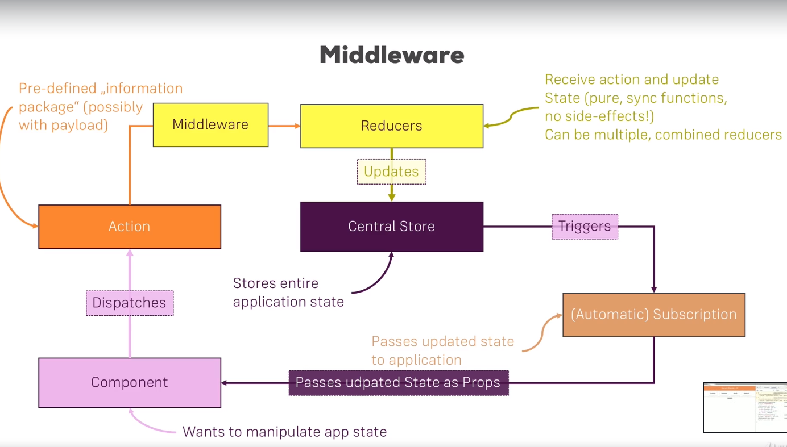

Lesson_275_Redux DevTools

Definetly worth it to use! Just a small configuration (index.js)
const composeEnhancers = window.__REDUX_DEVTOOLS_EXTENSION_COMPOSE__ || compose;
const store = createStore(rootReducer, composeEnhancers(applyMiddleware(logger, thunk)));

and you are ready ->
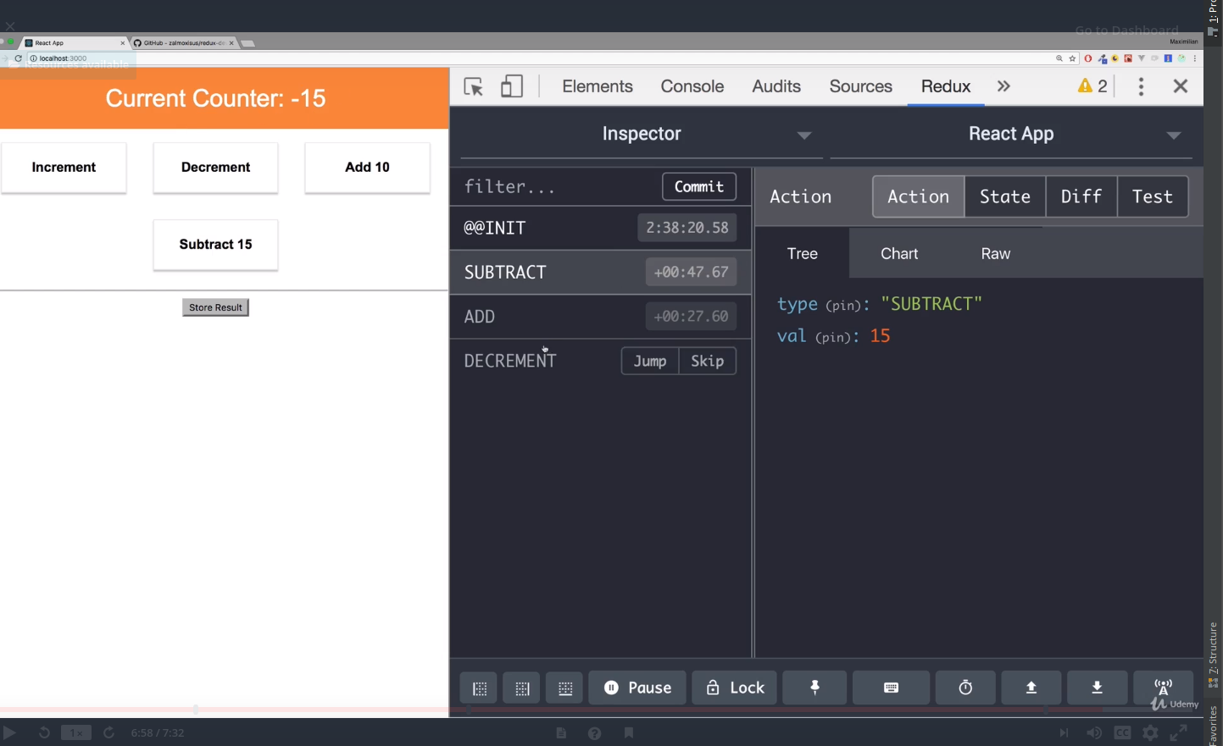

Lesson_276_Executing_Async_Code with action Creators

Simply it will return a action, to be dispatched
import * as actionTypes from './actionTypes';
export const saveResult = ( res ) => {
// const updatedResult = res * 2;
return {
type: actionTypes.STORE_RESULT,
result: res
};
}
export const storeResult = ( res ) => {
return (dispatch, getState) => {
setTimeout( () => {
// const oldCounter = getState().ctr.counter;
// console.log(oldCounter);
dispatch(saveResult(res));
}, 2000 );
}
};
export const deleteResult = ( resElId ) => {
return {
type: actionTypes.DELETE_RESULT,
resultElId: resElId
};
};

Lesson_279_Async_Actions_Redux-thunk

Apply middleware
const store = createStore(rootReducer, composeEnhancers(applyMiddleware(logger, thunk)));

Allow action creators, to have a function, which will eventually be dispatched when the response has been received!
This is how, redux-thunk could actually execute between the reducer and dispatching
export const storeResult = ( res ) => {
return (dispatch, getState) => {
setTimeout( () => {
// const oldCounter = getState().ctr.counter;
// console.log(oldCounter);
dispatch(saveResult(res));
}, 2000 );
}
};

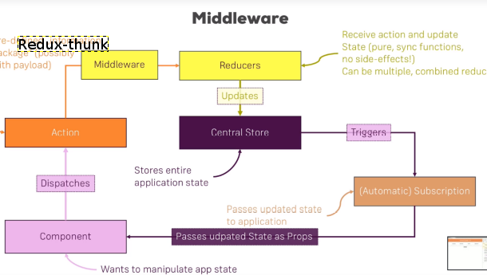

Lesson_281_Where_ToPut_The_Logic?
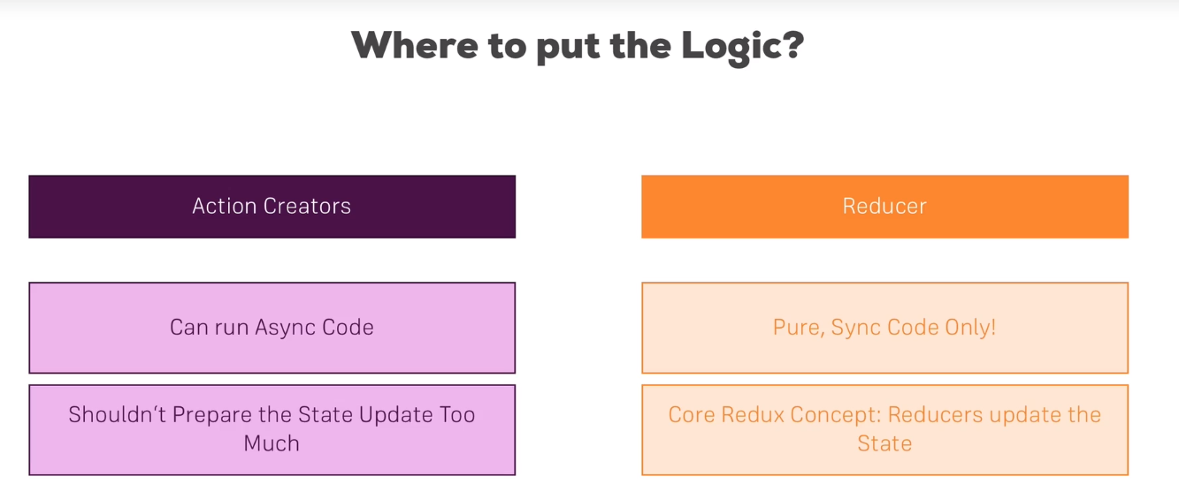

Lesson_282_Prefetch_The State in the redux_State
Since we map the state to the Component, we can extract the data from the Component!
export const storeResult = ( res ) => {
return (dispatch, getState) => {
setTimeout( () => {
// const oldCounter = getState().ctr.counter;
// console.log(oldCounter);
dispatch(saveResult(res));
}, 2000 );
}
};

Lesson_339_LazyLoading
1. Have a functions to wrap the component
asyncComponent
import React, { Component } from 'react';
const asyncComponent = (importComponent) => {
return class extends Component {
state = {
component: null
}
componentDidMount () {
importComponent()
.then(cmp => {
this.setState({component: cmp.default});
});
}

render () {
const C = this.state.component;
return C ? <C {...this.props} /> : null;
}
}
}
export default asyncCom
2. Wrap the components into this “HOC” component
const asyncAuth = asyncComponent(() => {
return import('./containers/Auth/Auth');
});

3. Use this at the Routing

if ( this.props.isAuthenticated ) {
routes = (
<Switch>
<Route path="/checkout" component={asyncCheckout} />
<Route path="/orders" component={asyncOrders} />
<Route path="/logout" component={Logout} />
<Route path="/auth" component={asyncAuth} />
<Route path="/" exact component={BurgerBuilder} />
<Redirect to="/" />
</Switch>
);
}

Session_20_Testing

Lesson_334_Testing_Tools

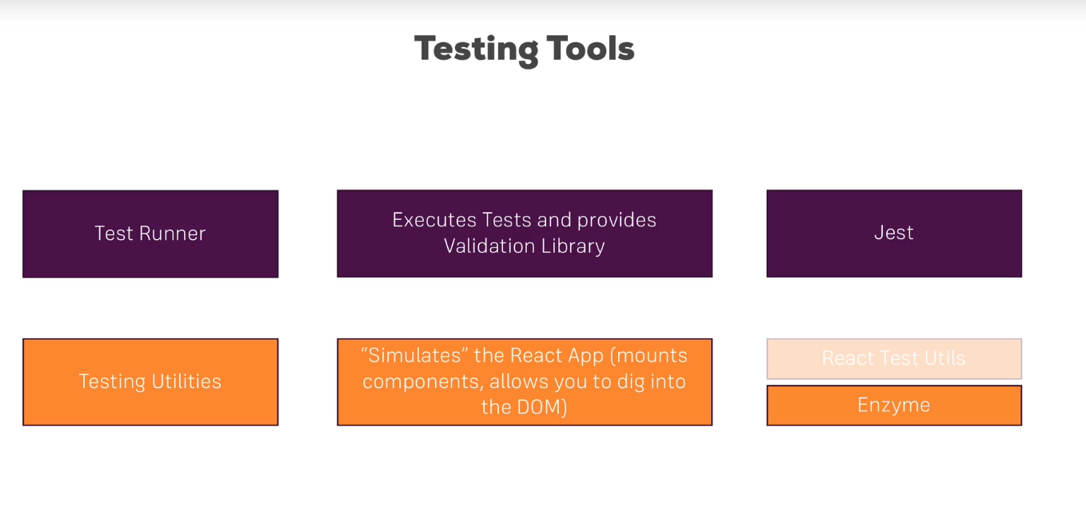

Lesson_335_What To test?
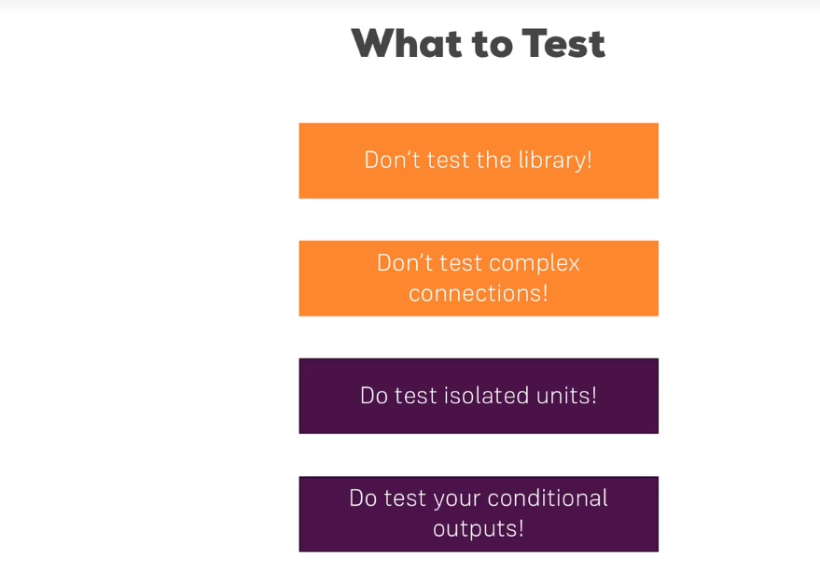

Lesson_346_Shallow_Component_Test
import React from 'react';
import { configure, shallow } from 'enzyme';
import Adapter from 'enzyme-adapter-react-16';
import NavigationItems from './NavigationItems';
import NavigationItem from './NavigationItem/NavigationItem';
configure({adapter: new Adapter()});
describe('<NavigationItems />', () => {
let wrapper;
beforeEach(() => {
wrapper = shallow(<NavigationItems />);
});
it('should render two <NavigationItem /> elements if not authenticated', () => {
expect(wrapper.find(NavigationItem)).toHaveLength(2);
});
it('should render three <NavigationItem /> elements if authenticated', () => {
// wrapper = shallow(<NavigationItems isAuthenticated />);
wrapper.setProps({isAuthenticated: true});
expect(wrapper.find(NavigationItem)).toHaveLength(3);
});
it('should an exact logout button', () => {
wrapper.setProps({isAuthenticated: true});
expect(wrapper.contains(<NavigationItem link="/logout">Logout</NavigationItem>)).toEqual(true);
});
});

Lesson_349_Testing_Containers
import React from 'react';
import { configure, shallow } from 'enzyme';
import Adapter from 'enzyme-adapter-react-16';
import { BurgerBuilder } from './BurgerBuilder';
import BuildControls from '../../components/Burger/BuildControls/BuildControls';
configure({adapter: new Adapter()});
describe('<BurgerBuilder />', () => {
let wrapper;

beforeEach(() => {
wrapper = shallow(<BurgerBuilder onInitIngredients={() => {}}/>);
});
it('should render <BuildControls /> when receiving ingredients', () => {
wrapper.setProps({ings: {salad: 0}});
expect(wrapper.find(BuildControls)).toHaveLength(1);
});
});

Lesson_350_Testing_Reducers
import reducer from './auth';
import * as actionTypes from '../actions/actionTypes';
describe('auth reducer', () => {
it('should return the initial state', () => {
expect(reducer(undefined, {})).toEqual({
token: null,
userId: null,
error: null,
loading: false,
authRedirectPath: '/'
});
});
it('should store the token upon login', () => {
expect(reducer({
token: null,
userId: null,
error: null,
loading: false,
authRedirectPath: '/'
}, {
type: actionTypes.AUTH_SUCCESS,
idToken: 'some-token',
userId: 'some-user-id'
})).toEqual({
token: 'some-token',
userId: 'some-user-id',
error: null,
loading: false,
authRedirectPath: '/'
});
})
});

Session_24_Animations in React Apps

Lesson_392_Using Css Transition, good tactic!
.Modal {
position: fixed;
z-index: 200;
border: 1px solid #eee;
box-shadow: 0 2px 2px #ccc;
background-color: white;
padding: 10px;
text-align: center;
box-sizing: border-box;
top: 30%;
left: 25%;
width: 50%;
transition: all 0.3s ease-out;
}

Lesson_393_CssAnimation (keyframes)
}
@keyframes openModal {
0% {
opacity: 0;
transform: translateY(-100%);
}
50% {
opacity: 1;
transform: translateY(90%);
}
100% {
opacity: 1;
transform: translateY(0);
}
}

Lesson_394 Transition + Animation limitations
- All of our elements are in the Dom, which is slowing us down!

Lesson_395_ReacTransitionGroup
https://github.com/reactjs/react-transition-group

1. install this package
2. Wrap the component into the TransitionGroup
<Transition
in={this.state.showBlock}
timeout={1000}
mountOnEnter
unmountOnExit
onEnter={() => console.log('onEnter')}
onEntering={() => console.log('onEntering')}
onEntered={() => console.log('onEntered')}
onExit={() => console.log('onExit')}
onExiting={() => console.log('onExiting')}
onExited={() => console.log('onExited')}
>
{state => (
<div
style={{
backgroundColor: "red",
width: 100,
height: 100,
margin: "auto",
transition: "opacity 1s ease-out",
opacity: state === "exiting" ? 0 : 1
}}
/>
)}
</Transition>

Lesson_397_Wrapping The transition Component

If you wrap it, you will have access to the state of the transition fo the given component!
{state => (
<div
style={{
backgroundColor: "red",
width: 100,
height: 100,
margin: "auto",
transition: "opacity 1s ease-out",
opacity: state === "exiting" ? 0 : 1
}}
/>
)}

So you execute different logic!

Lesson_398_AnimationTimings
You can customize how long should the component stay in a given state!
Here every state will have a 1 seconds state

<Transition
in={this.state.showBlock}
timeout={1000}
mountOnEnter
unmountOnExit

>

Here they have seperate timings

const animationTiming = {
enter: 400,
exit: 1000
};
const modal = props => {
return (
<CSSTransition
timeout={animationTiming}>
<div className="Modal">
<h1>A Modal</h1>
<button className="Button" onClick={props.closed}>
Dismiss
</button>
</div>
</CSSTransition>
);
};

Lesson_400_CSS_TransitionComponent
We can easily add css classes on the lifecycle of the component,
It does not have any outside wrapper function to access the state!
const modal = props => {
return (
<CSSTransition
mountOnEnter
unmountOnExit
in={props.show}
timeout={animationTiming}
classNames={{
enter: '',
enterActive: 'ModalOpen',
exit: '',
exitActive: 'ModalClosed'
}}>
<div className="Modal">
<h1>A Modal</h1>
<button className="Button" onClick={props.closed}>
Dismiss
</button>
</div>
</CSSTransition>
);
};

Lesson_402_AnimatingLists
1. Wrap everything in a TransitionGroup
(it will control the in property, when are the items are removed, when they are added)
2. wrap the list into a CSSTansition
So it will have the properties
- index for identification
- classNames → basClass which will be used
- timeOut for duration
3. You have to define the states in the css

import React, { Component } from "react";
import TransitionGroup from "react-transition-group/TransitionGroup";
import CSSTransition from "react-transition-group/CSSTransition";
import "./List.css";
class List extends Component {
state = {
items: [1, 2, 3]
};
addItemHandler = () => {
this.setState(prevState => {
return {
items: prevState.items.concat(prevState.items.length + 1)
};
});
};
removeItemHandler = selIndex => {
this.setState(prevState => {
return {
items: prevState.items.filter((item, index) => index !== selIndex)
};
});
};
render() {
const listItems = this.state.items.map((item, index) => (
<CSSTransition key={index} classNames="fade" timeout={300}>
<li
className="ListItem"
onClick={() => this.removeItemHandler(index)}>
{item}
</li>
</CSSTransition>
));
return (
<div>
<button className="Button" onClick={this.addItemHandler}>
Add Item
</button>
<p>Click Item to Remove.</p>
<TransitionGroup component="ul" className="List">
{listItems}
</TransitionGroup>
</div>
);
}
}
export default List;

CSS !!!

.fade-enter {
opacity: 0;
}
.fade-enter-active {
opacity: 1;
transition: opacity 0.3s ease-out;
}
.fade-exit {
opacity: 1;
}
.fade-exit-active {
opacity: 0;
transition: opacity 0.3s ease-out;
}

Session_26_ReactHooks

Lesson_420_What Are Hooks?

New way of creating functional components!
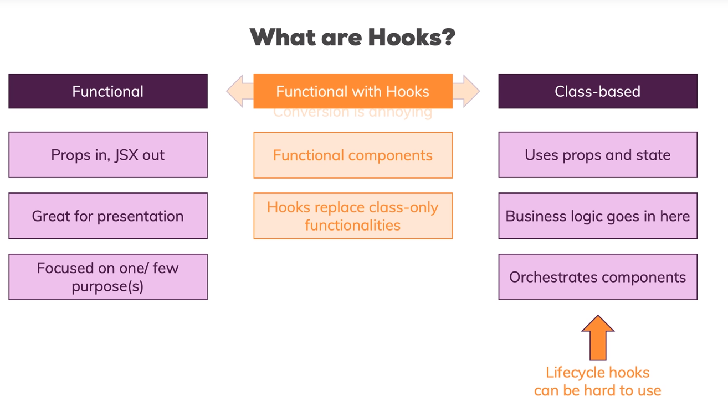

Lesson_423_UseState hook()

We can pass any type of data here.
UseState will return an array.
- 1. Element → Is the initial value of the state
- 2. element is the method to change the state!

const [page, setPage] = useState('auth');
const switchPage = pageName => {
setPage(pageName);
};

Lesson_425_Using Multiple States
You can easily access the previous state and modify it, it can be also an array as well!

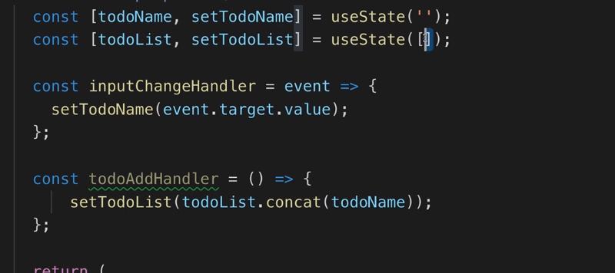

Lesson_426_UsingOneStateInstead!

You can have an object as a state!
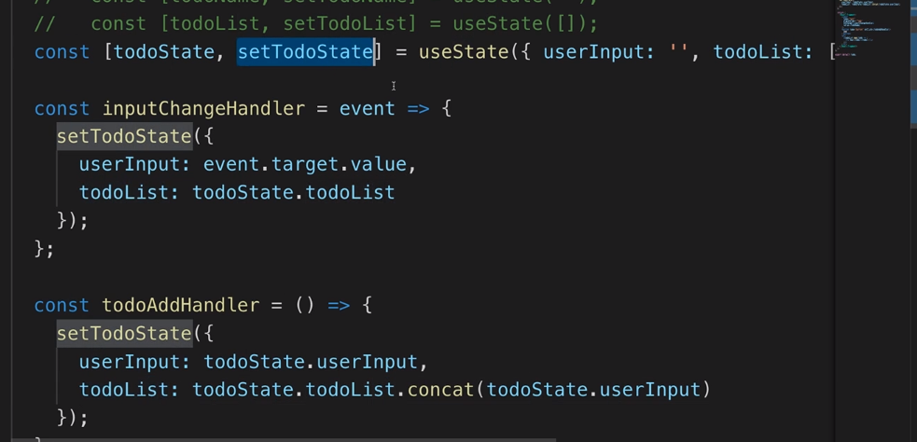

Lesson_427_Rules of the Hooks

- UseState, use them at the top level of your component function!

Lesson_428_Sending Data via HTTP

Easy, you call a function, and change the state with the stateModifier
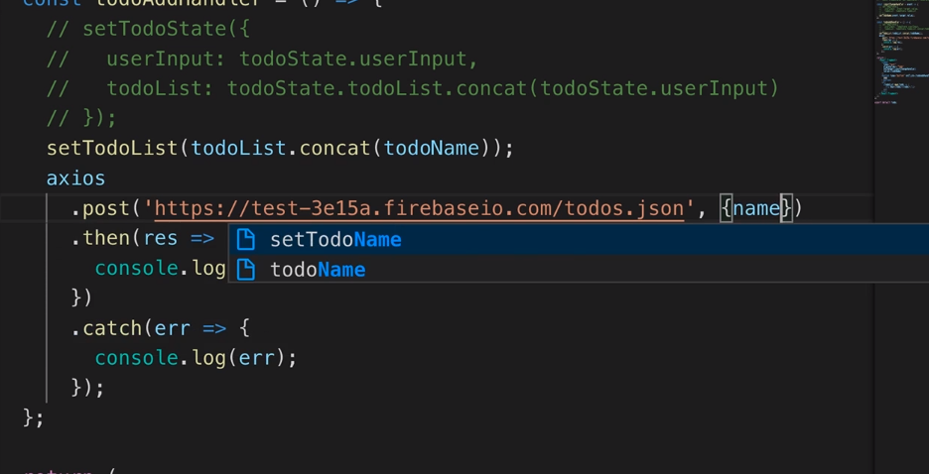

Lesson_429 UseEffect hook

Itt will hook into reacts internals, and it will run only after the rendering of the functional component has been finished.!
useEffect(() => {
axios.get('https://test-3e15a.firebaseio.com/todos.json').then(result => {
console.log(result);
const todoData = result.data;
const todos = [];
for (const key in todoData) {
todos.push({ id: key, name: todoData[key].name });
}
dispatch({ type: 'SET', payload: todos });
});
return () => {
console.log('Cleanup');
};
}, []);

Lesson_430_Controlling Effect Execution

UseEffects will run after every render cycle!!
- it will take a function to be executed, function
- It will change if the values given as a second parameter [] will change array of changes to which useEffect is listening
useEffect(() => {
axios.get('https://test-3e15a.firebaseio.com/todos.json').then(result => {
console.log(result);
const todoData = result.data;
const todos = [];
for (const key in todoData) {
todos.push({ id: key, name: todoData[key].name });
}
dispatch({ type: 'SET', payload: todos });
});
return () => {
console.log('Cleanup');
};
}, []);

Lesson_431_Effect CleanUp
Inside the first function, you will have a function, which is returned and it is executed every time the effect has been executed.
useEffect(() => {
axios.get('https://test-3e15a.firebaseio.com/todos.json').then(result => {
console.log(result);
const todoData = result.data;
const todos = [];
for (const key in todoData) {
todos.push({ id: key, name: todoData[key].name });
}
dispatch({ type: 'SET', payload: todos });
});
return () => {
console.log('Cleanup');
};
}, []);

Before adding eventHandler to a dom element, it will remove the old one!
const mouseMoveHandler = event => {
console.log(event.clientX, event.clientY);
};

useEffect(() => {
document.addEventListener('mousemove', mouseMoveHandler);
return () => {
document.removeEventListener('mousemove', mouseMoveHandler);
};
}, []);

Lesson_433_UseContextHook()

Will let you pass data, without passing data to every component!
1. You create a context
import React from 'react';
const authContext = React.createContext({ status: false, login: () => {} });
export default authContext;
2. Create a useState() for the authState data
const [page, setPage] = useState('auth');
const [authStatus, setAuthStatus] = useState(false);
const switchPage = pageName => {
setPage(pageName);
};
const login = () => {
setAuthStatus(true);
};

3. Wrap the component into a provider
Where you pass the actual value of the state of the app functional component
Also here you pass the modifier function, to the </Header> component, which will be able to execute the change, and change the context from there

const app = props => {
const [page, setPage] = useState('auth');
const [authStatus, setAuthStatus] = useState(false);
const switchPage = pageName => {
setPage(pageName);
};
const login = () => {
setAuthStatus(true);
};
return (
<div className="App">
<AuthContext.Provider value={{ status: authStatus, login: login }}>
<Header
onLoadTodos={switchPage.bind(this, 'todos')}
onLoadAuth={switchPage.bind(this, 'auth')}
/>
<hr />
{page === 'auth' ? <Auth /> : <Todo />}
</AuthContext.Provider>
</div>
);
};
export default app;
4. You can reach the context data from the inner components
import React, { useContext } from 'react';
import AuthContext from '../auth-context';
const header = props => {
const auth = useContext(AuthContext);
return (
<header>
{auth.status ? (
<button onClick={props.onLoadTodos}>Todo List</button>
) : null}
<button onClick={props.onLoadAuth}>Auth</button>
</header>
);
};
export default header;

Lesson_434_State and Effects Gotchas

The states can mutate simultaneously and changing in a way, that might stuck, so a reducer must be used!

Lesson_436_UseReducer()

1. Crete a reducer functional
2. With useReducer you can easily mitigate the useState so you will receive the value of the state, and a function to change it!

const todoListReducer = (state, action) => {
switch (action.type) {
case 'ADD':
return state.concat(action.payload);
case 'SET':
return action.payload;
case 'REMOVE':
return state.filter(todo => todo.id !== action.payload);
default:
return state;
}
};
const [todoList, dispatch] = useReducer(todoListReducer, []);

3. Then you can simply call the dispatch function with the payload!
const todoRemoveHandler = todoId => {
axios
.delete(`https://test-3e15a.firebaseio.com/todos/${todoId}.json`)
.then(res => {
dispatch({ type: 'REMOVE', payload: todoId });
})
.catch(err => console.log(err));
};

Lesson_437_useRef()
You can access the reference of the Dom in the functional component using this

const todoInputRef = useRef();

Lesson_438_Preparing & Optimizing

You can pass the useStates of the reducer to an inner component.
UseMemo, will cache the list of the items to watch, if nothing changes it will won’t change!

{useMemo(
() => (
<List items={todoList} onClick={todoRemoveHandler} />
),
[todoList]
)}

Lesson_441_Custom Hooks
You write a custom function, which will return an object.
But in this functional Closure, you will have a inputChangeHandler which will remember the reference of the funfcitonal object, and can change the states in it’s closure!!

import { useState } from 'react';
export const useFormInput = () => {
const [value, setValue] = useState('');
const [validity, setValidity] = useState(false);
const inputChangeHandler = event => {
setValue(event.target.value);
if (event.target.value.trim() === '') {
setValidity(false);
} else {
setValidity(true);
}
};
return { value: value, onChange: inputChangeHandler, validity };
};
Thus in an object, you wrapped multiple states and a handler for them as well!
<input
type="text"
placeholder="Todo"
onChange={todoInput.onChange}
value={todoInput.value}
style={{ backgroundColor: todoInput.validity === true ? 'transparent' : 'red' }}
/>

