**Feedback/Report.**

First meeting

At the first day I decided to just explore the service. It was very interesting, because for me it’s kind of a new way to programming. First, I read all the documentation from “Quick start”. It seemed easy at that moment. But a little bit later, I’ve met GitHub and cmd… But we'll get to that.

Progression

**Part 1**

I’ve opened 8base and created my first workspace, which I called “Test”. After I got the roots, I set up my workspace and started my work. I built a data model, roles and permissions, authentication profiles and got the workspace API endpoint. At the next point I found a few mistakes.

Syntax –

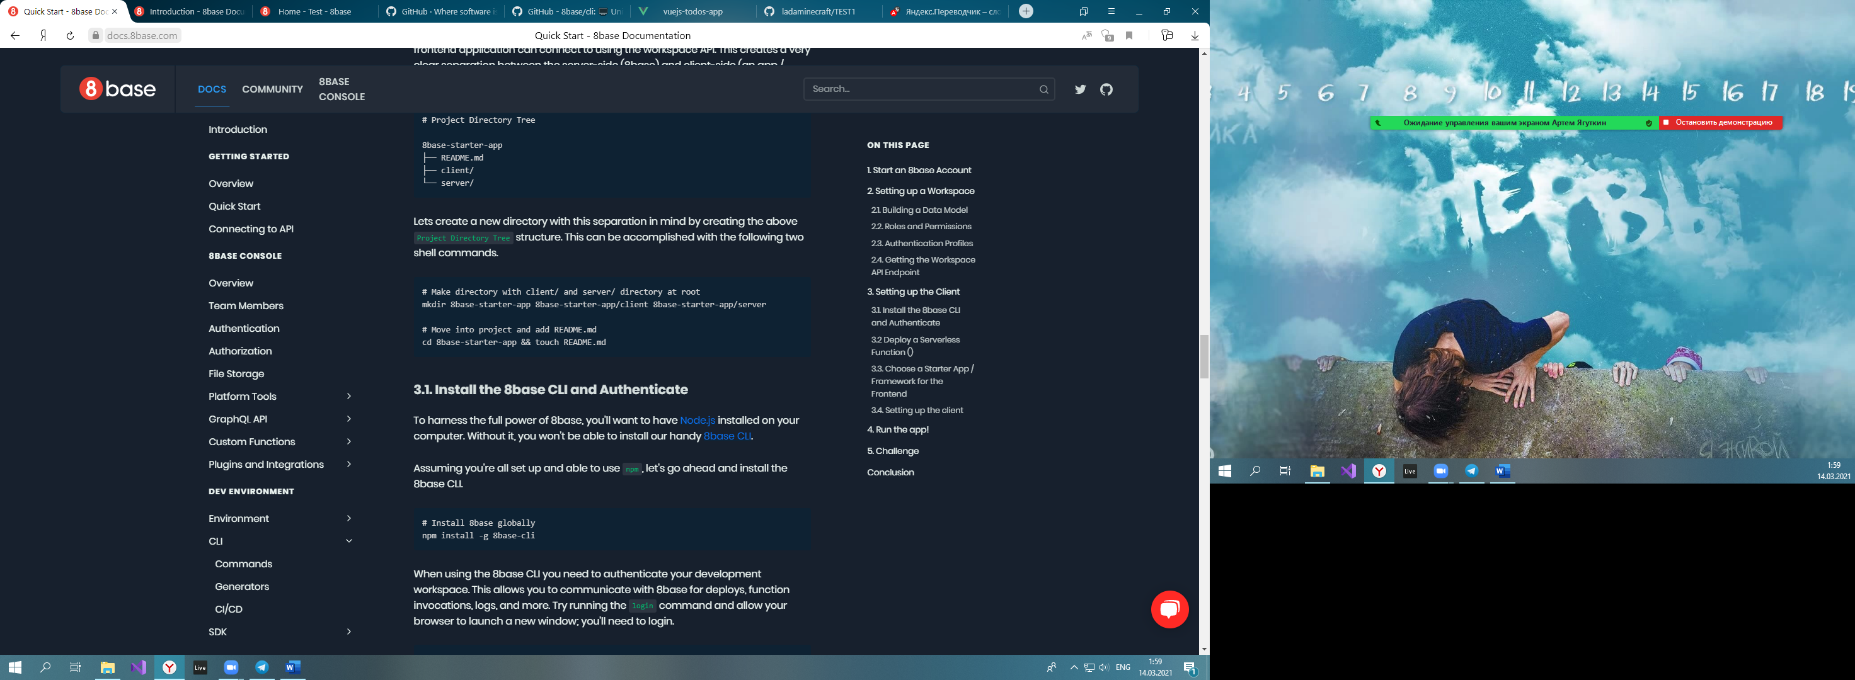

The right way: mkdir 8base-starter-app 8base-starter-app\client 8base-starter-app\server

And also «touch» command doesn’t work. I’m not sure that this is your mistake, but I’ve used command, called “copy con” to make it work.



It was uncomfortable, when I can’t copy text of program. Some texts couldn't be copied. Instead of the desired text it copies the next line.

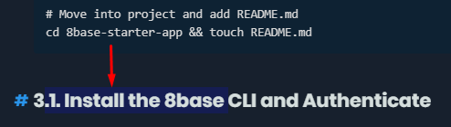

At point 3.2 it didn't say where to install the folder. This created some difficulties.

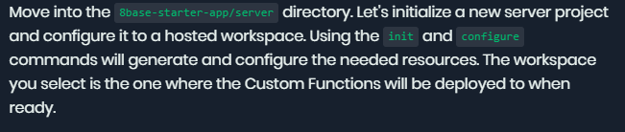

For point 3.3 I must download an extension for cmd to make GitHub commands (like git clone/git status/etc.) work.

At Point 3.4 the path wasn’t written. It means I had to find where environment variables located by myself.

**Part 2.**

To create an environment, I had to change the link in “.workspace”(Located in custom folder from server folder) manually. By default, it shows <https://api.8base.com>. I copied my workspace API endpoint and pasted it directly into the “.workspace” file.

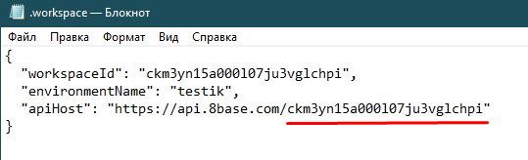

My environment

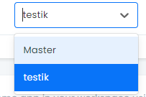

When I read the documentation of migration I noticed that it shows wrong command. It’s missing “8base” in the beginning of the command. The right way is “8base migration generate”.

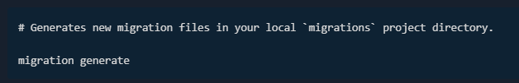

Also, I found minor grammar mistake such as “.yaml” instead of “.yml”.

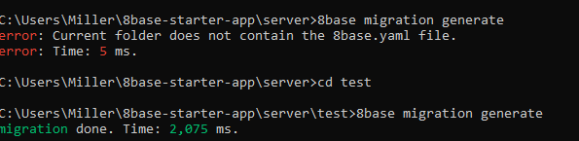



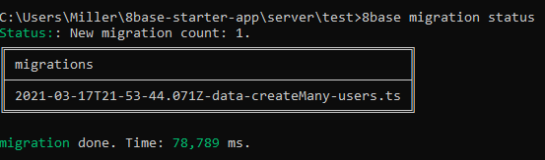





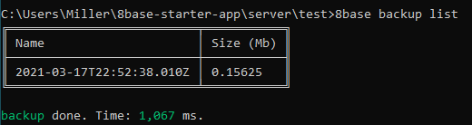

Result

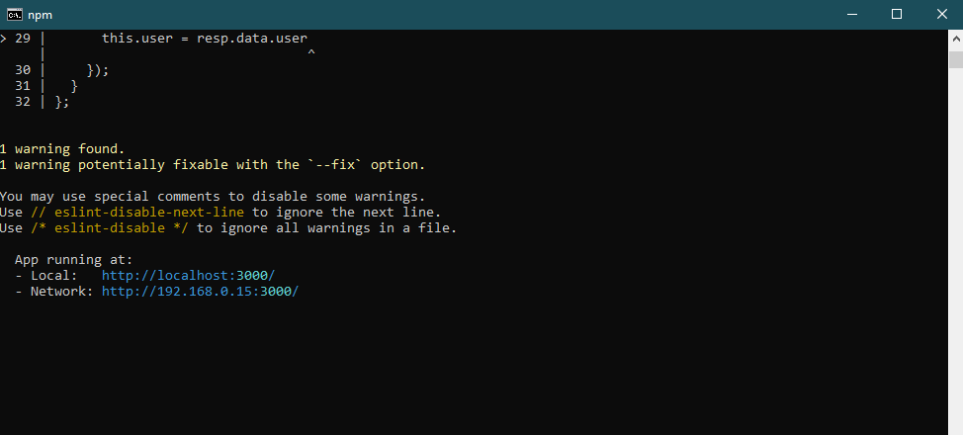

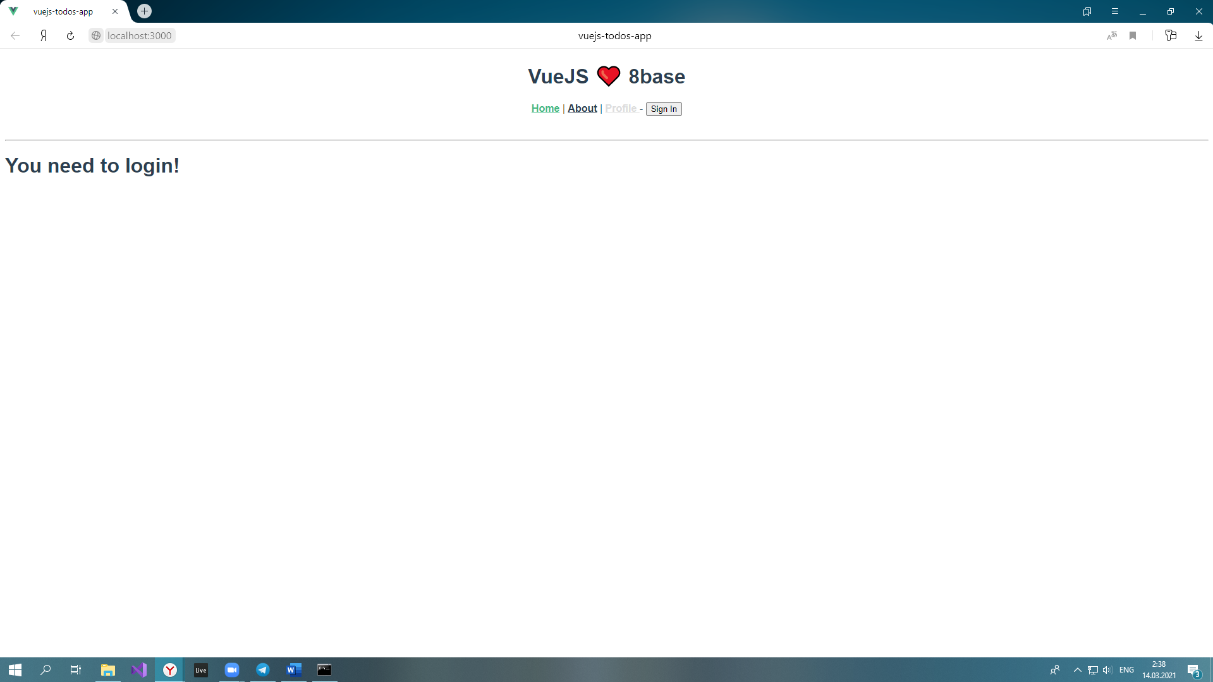

My Problems:

I couldn’t upload on GitHub “vue-8base-starter-app” from “client”. It asked me to use submodules command, because we’re using “vue-8base-starter-app” clone. So, that’s why GitHub does not allow us to upload our client.

Content from vue-8base-starter-app folder.

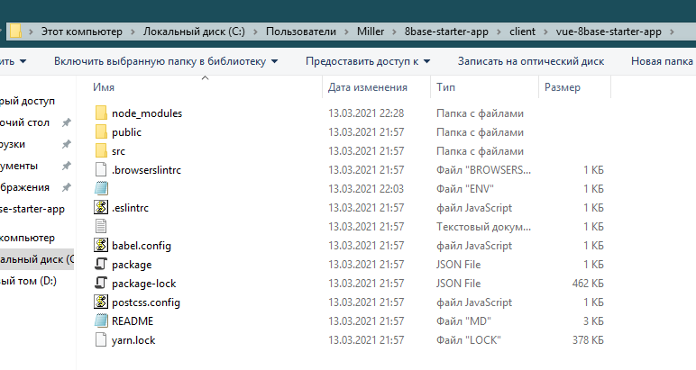

Impression

Well, after the finish, I felt like I'd been through a computer game. It was very interesting and exciting. And I would love to go through the next levels in the form of training!